Lab09 – Deployment Horizontal Autoscaler

- Install the metrics server (https://raw.githubusercontent.com/brahimhamdi/ckad-lab/master/labs/lab09/components.yaml) to actual resource metrics to be collected and displayed by the HorizontalPodAutoscaler.

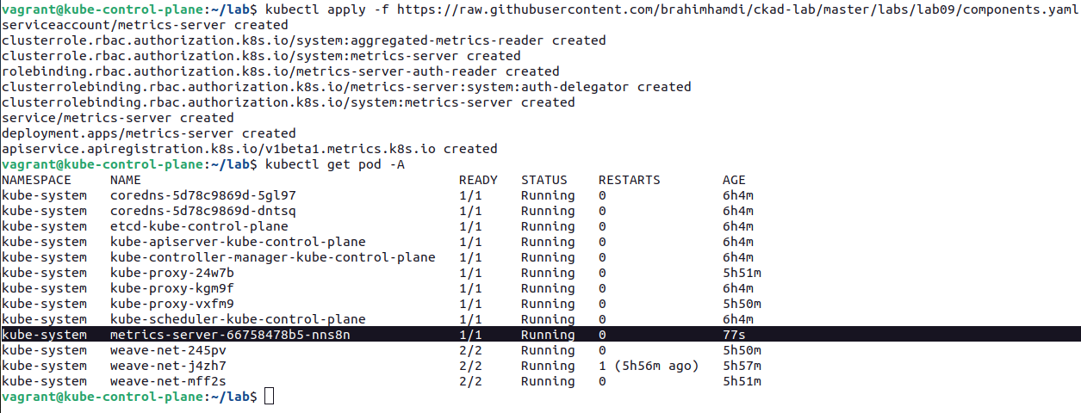
- Create a Deployment named `nginx` with 1 replica. The Pod template of the Deployment should use container image `nginx:1.23.4`, set the CPU resource request to 0.1, and the memory resource request/limit to 100Mi.
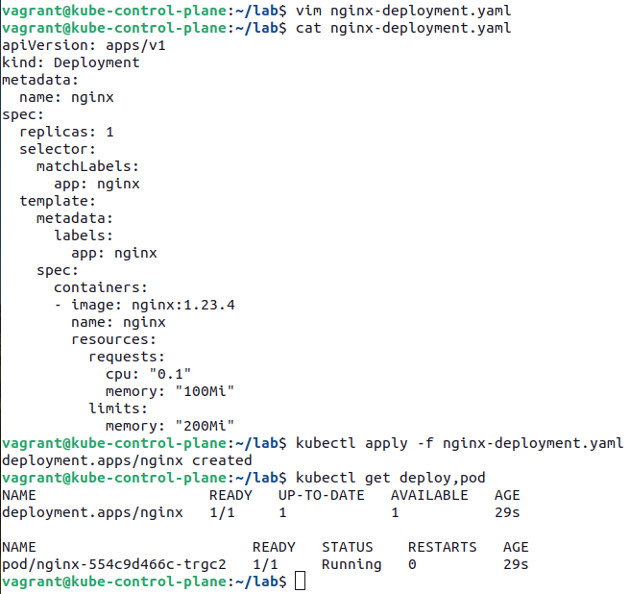

- Create a HorizontalPodAutoscaler for the Deployment named `nginx-hpa` that scales to minium of 2 and a maximum of 5 replicas. Scaling should happen based on an average CPU utilization of 50%, and an average memory utilization of 60%.
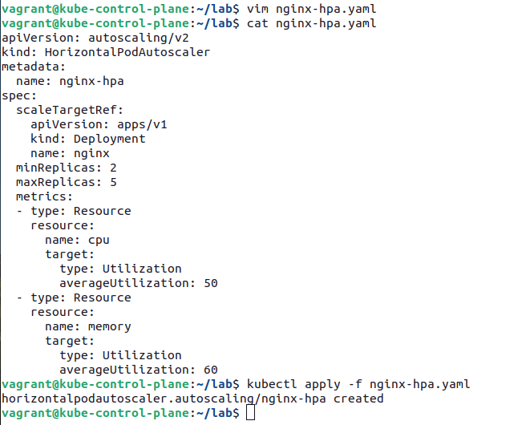

- Inspect the HorizontalPodAutoscaler object and identify the currently-utilized resources. How many replicas do you expect to exist?

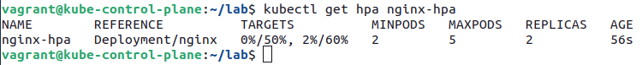

- Create a service to expose nginx deployment. Generate trafic with busybox image and then watch the HPA object.
kubectl run -i --tty load-generator --rm --image=busybox:1.28 --restart=Never -- /bin/sh -c "while true; do wget -q -O- http://my-service; done"

