Lab11 – Configuring Health Probes for a Pod

In this exercise, you will create a Pod running a NodeJS application. The Pod will define readiness and liveness probes with different parameters.

- Create a new Pod named `hello` with the image `bmuschko/nodejs-hello-world:1.0.0` that exposes the port 3000. Provide the name `nodejs-port` for the container port.
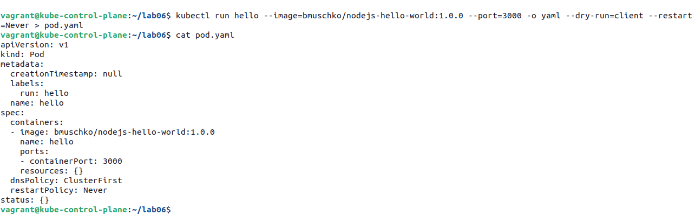

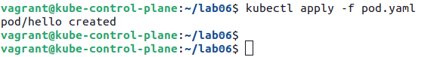

- Add a Readiness Probe that checks the URL path / on the port referenced with the name `nodejs-port` after a 2 seconds delay. You do not have to define the period interval. Add a Liveness Probe that verifies that the app is up and running every 8 seconds by checking the URL path / on the port referenced with the name `nodejs-port`. The probe should start with a 5 seconds delay.

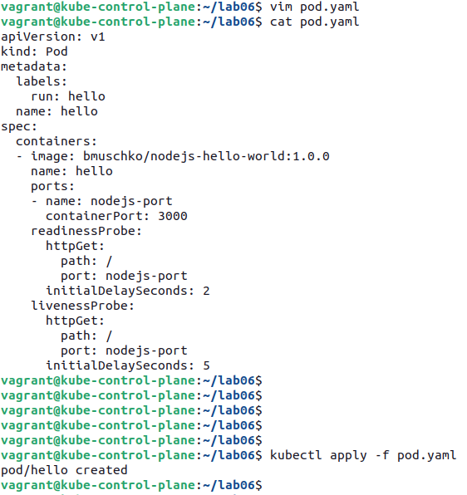

- Shell into container and curl `localhost:3000`. Write down the output. Exit the container.

