Lab13 – CRD

As an application developer, you may want to install Kubernetes functionality that exends the platform using the Kubernetes operator pattern. The objective of this exercise is to familiarize yourself with creating and managing CRDs. You will not need to write a controller.

- Create a CRD resource named `backup.example.com` with the following specification:
  - Group: `example.com`
  - Version: `v1`
  - Kind: `Backup`
  - Singular: `backup`
  - Plural: `backups`
  - Properties of type `string`: `cronExpression`, `podName`, `path`
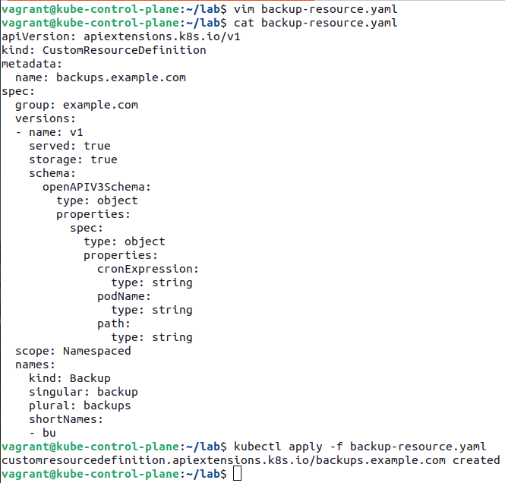

- Retrieve the details for the `Backup` custom resource created in the previous step.

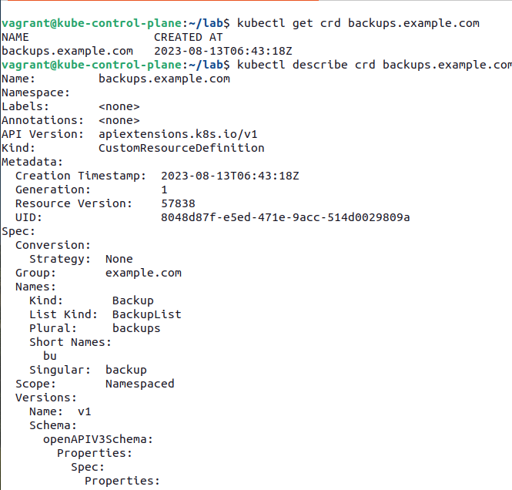

- Create a custom object named `nginx-backup` that uses the CRD kind `Backup`. Provide the following property values:
  - `cronExpression`: `0 0 * * *`
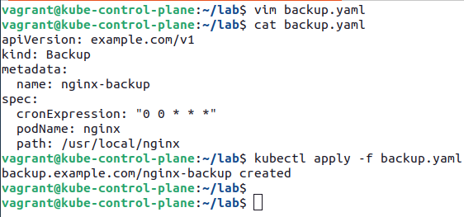
  - `podName`: `nginx`
  - `path`: `/usr/local/nginx`

- Retrieve the details for the `nginx-backup` object created in the previous step.

