Lab14 – RBAC ServiceAccount

In this exercise, you will define Role Based Access Control (RBAC) to grant permissions to a service account. The permissions should only apply to certain API resources and operations.

- Create a new namespace named `t23`. Create the service account `api-call` in the namespace.
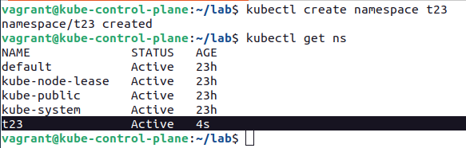

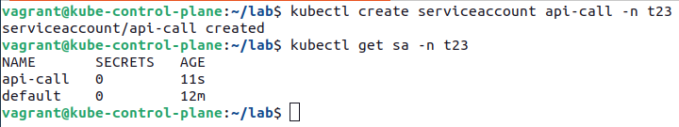

- Create a Pod named `service-list` in the namespace `t23`. The container uses the image `alpine/curl:3.14` and makes a `curl` call to the Kubernetes API that lists Service objects in the `default` namespace in an infinite loop. Attach the service account `api-call` to the Pod.

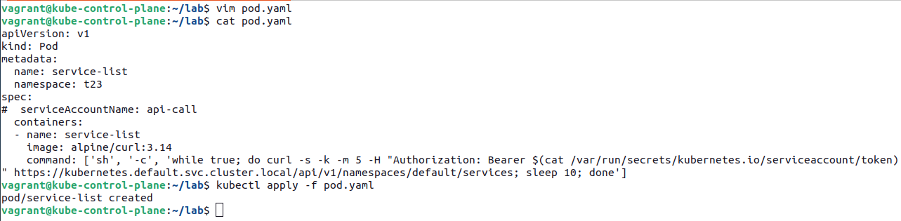

- Inspect the container logs after the Pod has been started. What response do you expect to see from the `curl` command?

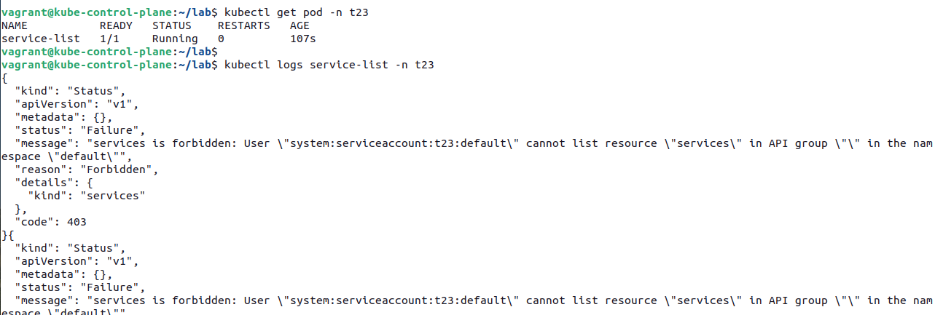
- Assign a ClusterRole and RoleBinding to the service account that only allows the operation needed by the Pod. Have a look at the response from the `curl` command.

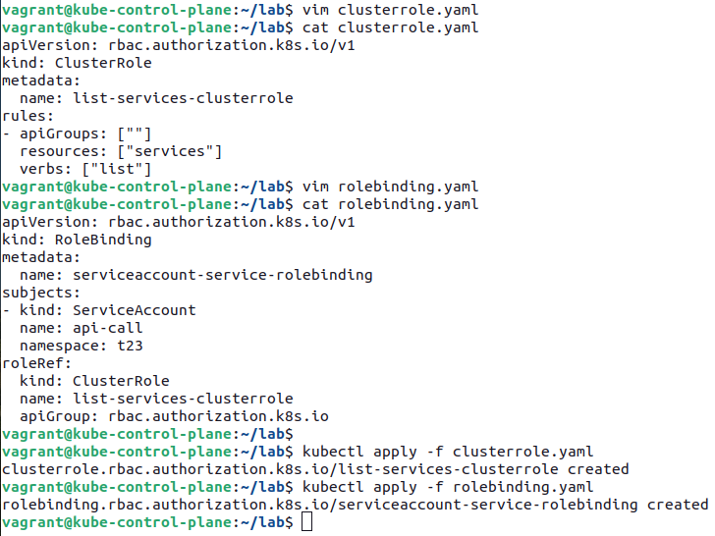

The API call running inside of the container should now be authorized and be allowed to list the Service objects in the `default` namespace. As shown in the output below, the namespace currently hosts at least one Service object, the `kubernetes.default` Service.

