Lab15 – Resources Requirements

Resource requests and limits
You are tasked with creating a Pod for running an application in container. During application development, you ran a load test for figuring out the minimum amount of resources needed and the maximum amount of resources the application is allowed to grow to. Define those resource requests and limits for the Pod.

- Define a Pod named `hello-world` running the container image `bmuschko/nodejs-hello-world:1.0.0`. The container exposes the port 3000.
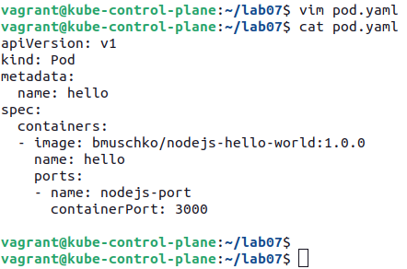

- Add a Volume of type `emptyDir` and mount it the container path `/var/log`.

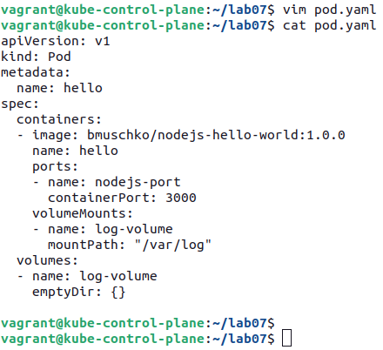

- For the container, specify the following minimum number of resources as follows:
    - CPU: 100m
    - Memory: 500Mi
    - Ephemeral storage: 1Gi
And the following maximum number of resources as follows:
    - Memory: 500Mi
    - Ephemeral storage: 2Gi

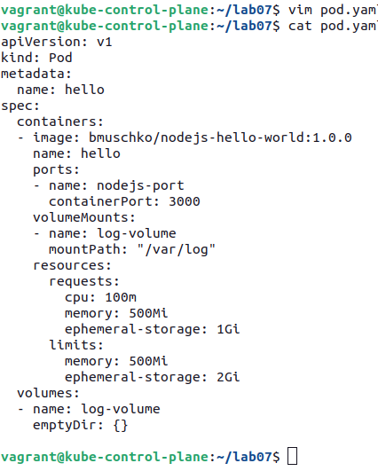

- Create the Pod from the YAML manifest. Inspect the Pod details. Which node does the Pod run on?
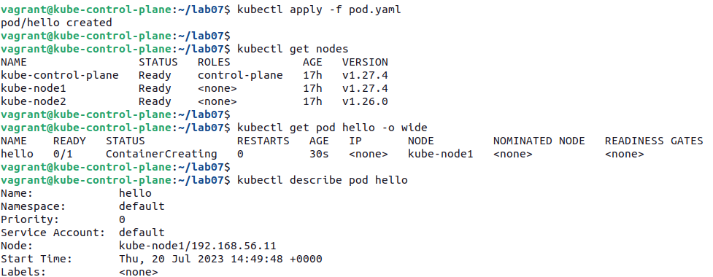

…
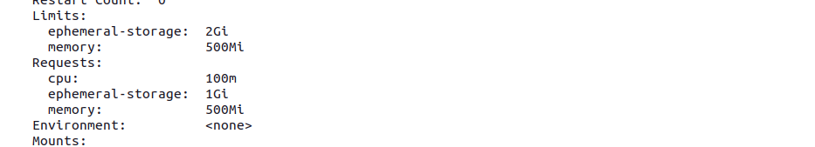

Resource quota
In this exercise, you will create a ResourceQuota with specific CPU and memory limits for a new namespace. Pods created in the namespace will have to adhere to those limits.

- Create a new Pod that exceeds the limits of the resource quota requirements e.g. by defining 1Gi of memory but stays below the CPU e.g. 0.5. Write down the error message.

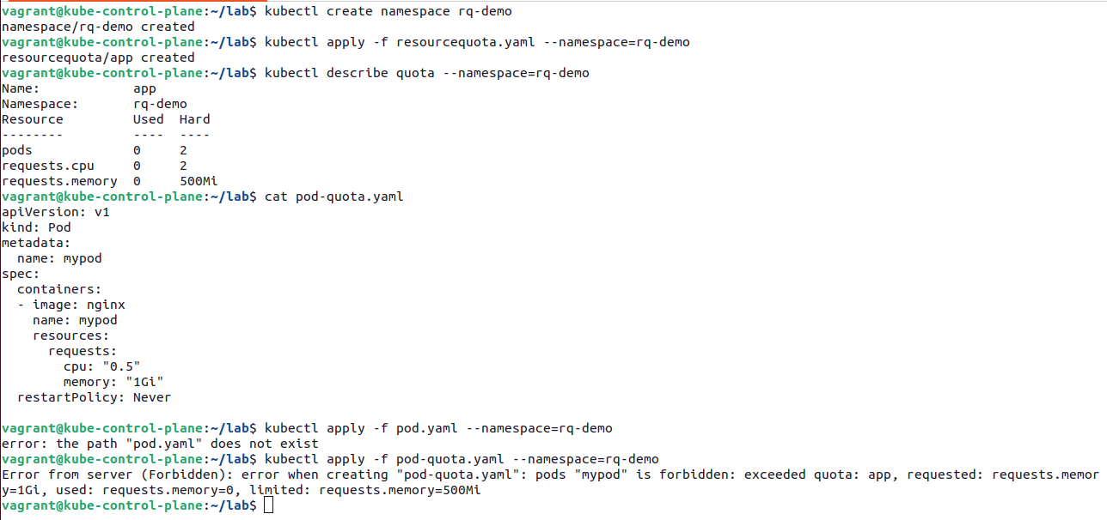

- Change the request limits to fulfill the requirements to ensure that the Pod could be created successfully. Write down the output of the command that renders the used amount of resources for the namespace.

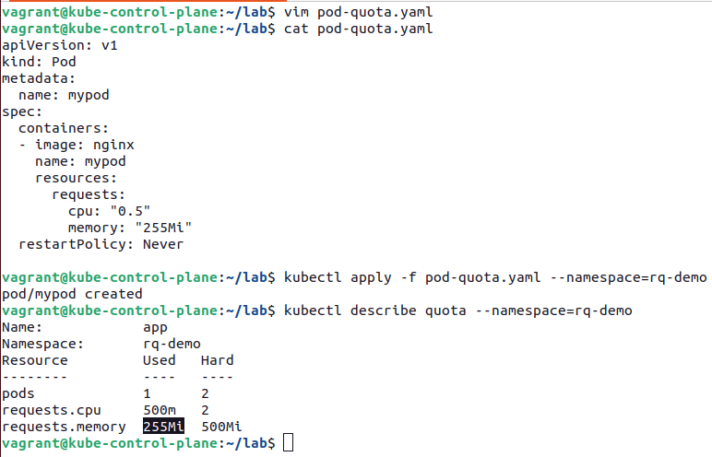

Limit Range
A LimitRange can restrict resource consumption for Pods in a namespace, and assign default computing resource if no resource requirements have been defined. You will practice the effects of a LimitRange on the creation of a Pod in different scenarios.

- Inspect the YAML manifest definition in the file `setup.yaml` (./setup.yaml). Create the objects from the YAML manifest file.

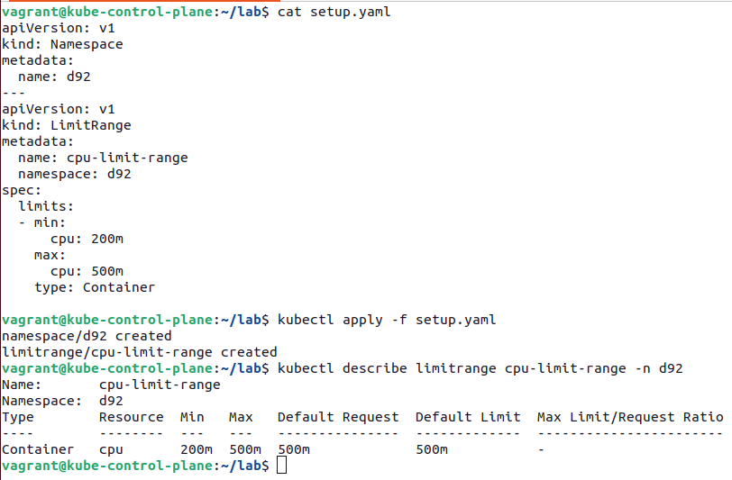

- Create a new Pod named `pod-without-resource-requirements` in the namespace `d92` that uses the container image `nginx:1.23.4-alpine` without any resource requirements. Inspect the Pod details. What resource definitions do you expect to be assigned?
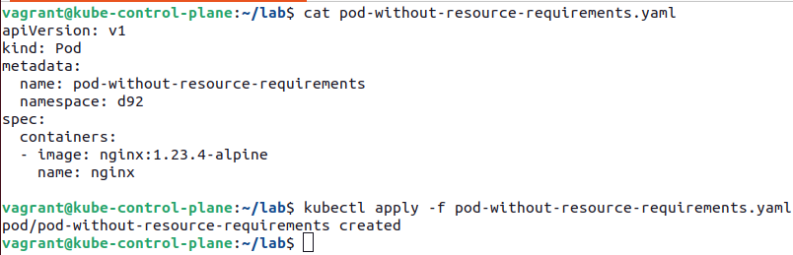

A Pod without specifying resource requirements will use the default request and limit defined by LimitRange, in this case 500m.

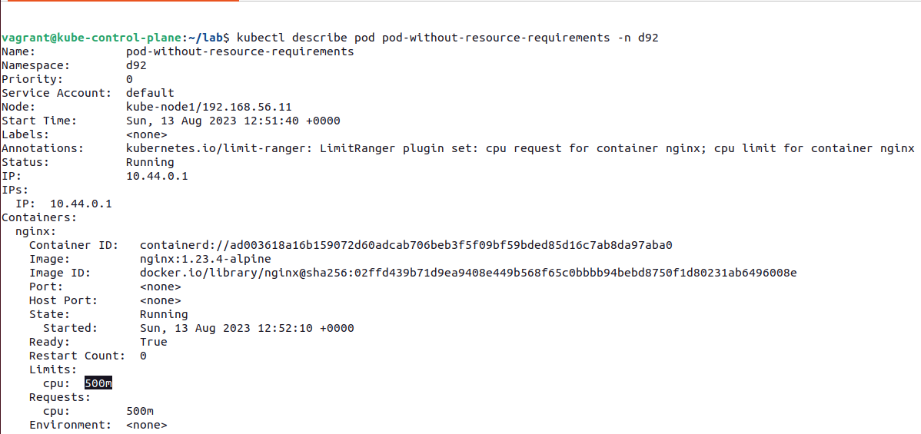

- Create a new Pod named `pod-with-more-cpu-resource-requirements` in the namespace `d92` that uses the container image `nginx:1.23.4-alpine` with a CPU resource request of 400m and limits of 1.5. What runtime behavior do you expect to see?

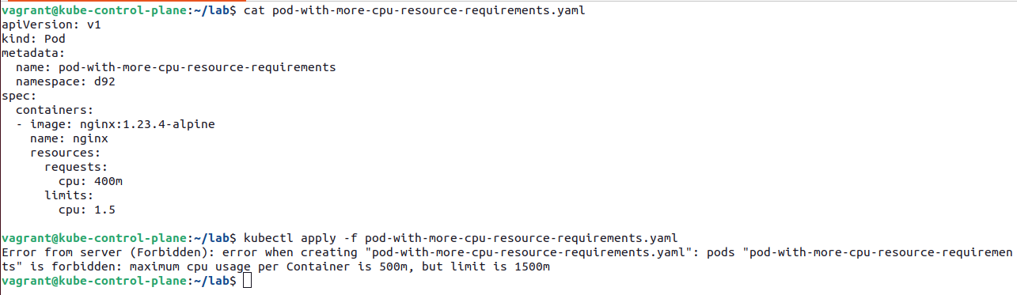
- Create a new Pod named `pod-with-less-cpu-resource-requirements` in the namespace `d92` that uses the container image `nginx:1.23.4-alpine` with a CPU resource request of 350m and limits of 400m. What runtime behavior do you expect to see?

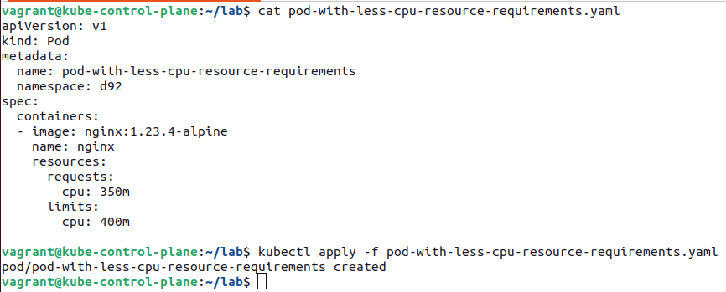

The CPU resource request and limit fits within the boundaries of the LimitRange.
