Lab18 – Service types and Ingress

Service
In this exercise, you will create a Deployment and expose a container port for its Pods. You will demonstrate the differences between the service types ClusterIP and NodePort.

- Create a Service named `myapp` of type `ClusterIP` that exposes port 80 and maps to the target port 80.
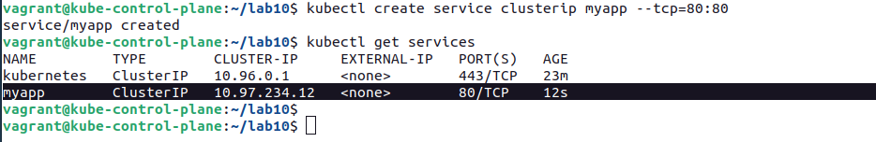

- Create a Deployment named `myapp` that creates 1 replica running the image `nginx:1.23.4-alpine`. Expose the container port 80.
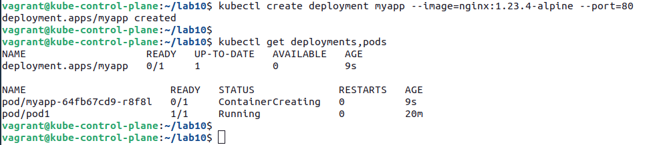

- Scale the Deployment to 2 replicas.

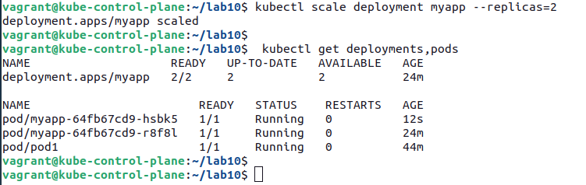

- Create a temporary Pod using the image `busybox` and run a `wget` command against the IP of the service.
Determine the cluster IP and the port for the Service. In this case, it's `10.97.234.12:80`. Alternatively, you can use the DNS name `myapp`. Use the information with the `wget` command.
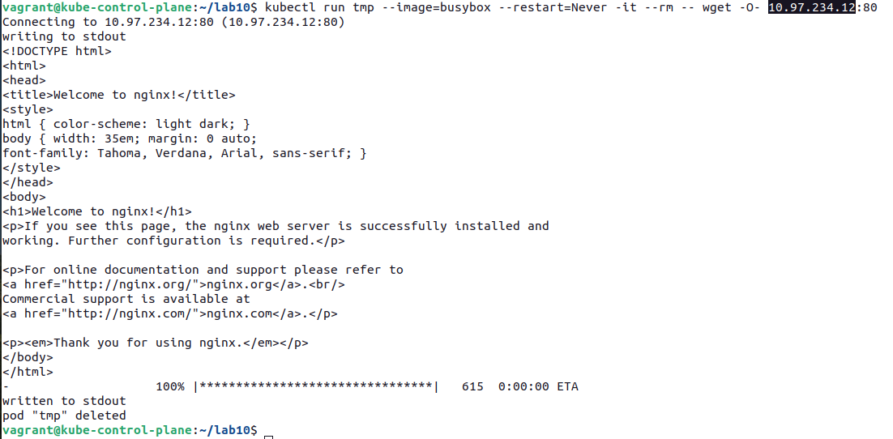

- Change the service type so that the Pods can be reached from outside of the cluster. You muast turn the type of the service into `NodePort` to expose it outside of the cluster. Now, the service should expose a port in the 30000 range.
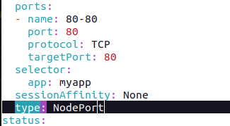

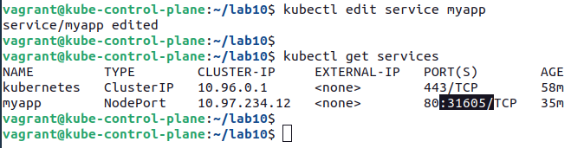

- Run a browser or `wget` command against the service from outside of the cluster.

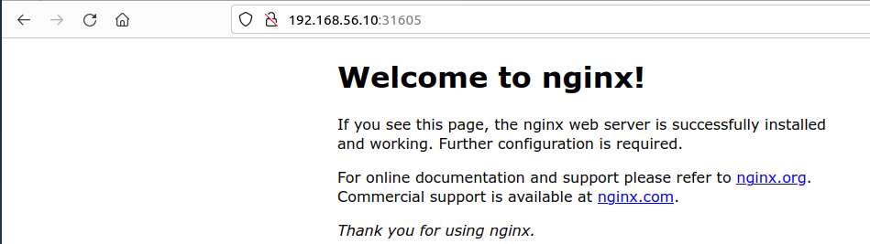

Ingress and Ingress Controller
In this exercise, you will create an Ingress with a simple rule that routes traffic to a Service.
The Kubernetes documentation (https://kubernetes.io/docs/concepts/services-networking/ingress-controllers/) lists a wide range of Ingress Controller implementations.

- Use command bellow to implement an ingress controller.
Kubectl apply -f https://raw.githubusercontent.com/kubernetes/ingress-nginx/controller-v1.1.1/deploy/static/provider/cloud/deploy.yaml

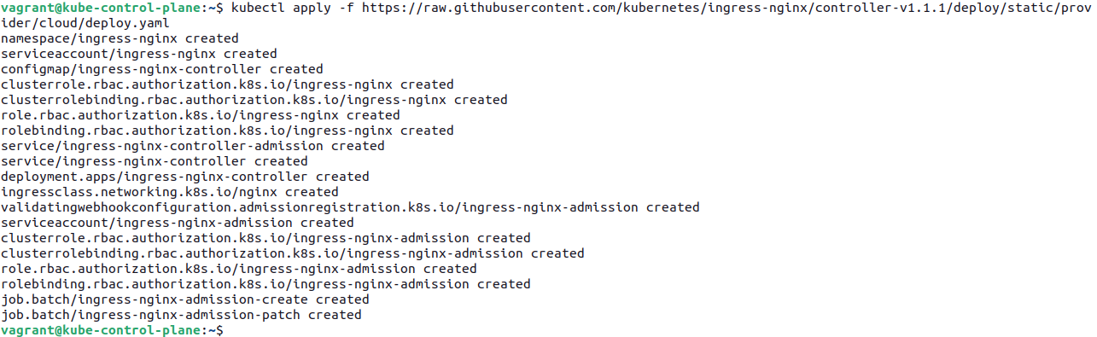

- The Ingress controller will run as a Pod in the `ingress-nginx` namespace. Make sure that the Pod `ingress-nginx-controller-...` transitions into the "Running" status.
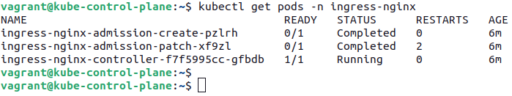

Using Ingress
- Create a new Deployment named `web` that controls a single replica running the image `bmuschko/nodejs-hello-world:1.0.0` on port 3000.
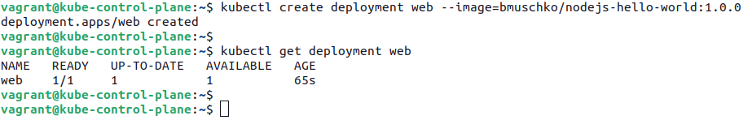

- Expose the Deployment with a Service named `web` of type `NodePort`. The Service routes traffic to the Pods controlled by the Deployment `web`.
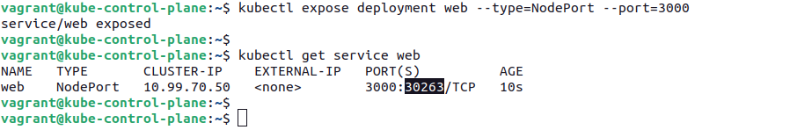

- Make a request to the endpoint of the application on the context path `/`. You should see the message "Hello World".
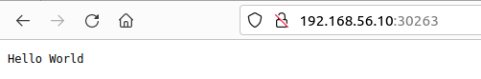

- Create an Ingress that exposes the path `/` for the host `hello-world.exposed`. The traffic should be routed to the Service created earlier.
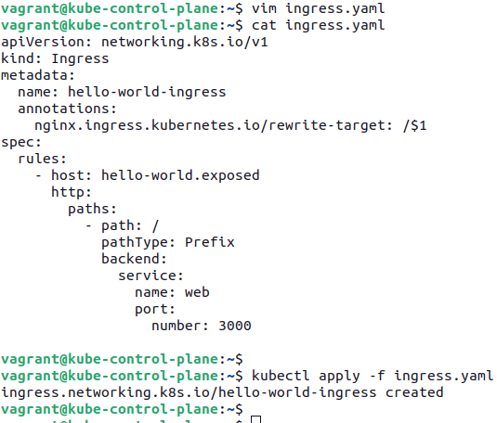

- List the Ingress object. The value for the IP address will populate after waiting for a little while. You may have to run the command multiple times.

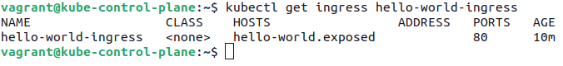

- Add an entry in `/etc/hosts` that maps the virtual node IP address to the host `hello-world.exposed`.
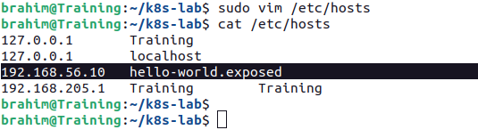

- Make a request to `http://hello-world.exposed`. You should see the message "Hello World".
