**Epicture Louis Brahimi & Aurélien Martin**

Summary

Project Présentation 2

Mock UP 3

Functionalities Description 4

Page de Login 4

Page Feed 4

Page Favori 4

Page Account 4

Import Button 4

Orange square 4

Final app and fonctionnalities 5

# Project Présentation

The goal of this project is to use and implement online photo sharing API platforms.

We had to create a photo finder and browsing application the following platform: Imgur.

The different aspects of mobile (or universal) applications development are to be taken into account during the creation of the project.

The application must be developed in Java or Kotlin (Webviews and NDK Android usage prohibited).

The project must use Gradle as its build automation system.

# Mock UP

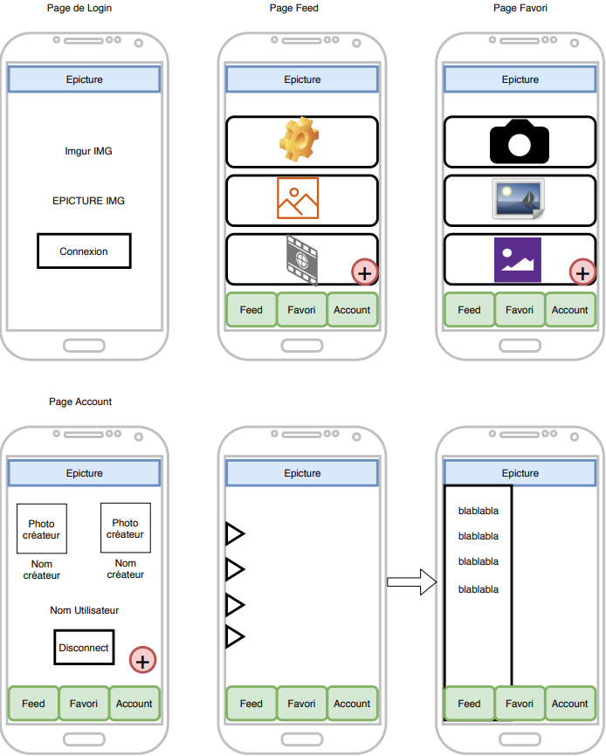

# Functionalities Description

## Page de Login

When you launch the app, this is the first page you can see. The goal of this page is to get connected to imgur. You have to press the button connection and then you’ll be redirected to a chrome page.

On this chrome page you can enter your username and password for imgur and then you’ll go back on the applilcation.

## Page Feed

On this page you’ll have the feed of imgur. There is also three buttons that you can click on. These are the buttons in the navigation bar at the bottom of the application

Favori : This is the button to get to your favori.

Feed : This is the button to get to the feed (this is where you should be after login in)

Account : This button will get you the the account page. This page is also where you’ll disconnect from the application.

## Page Favori

This page is exactly the same as the « Page feed » but the image displayed are only those you have already liked/ put in favori.

The three buttons of the navigation bar do the same from when you were on the « Page Feed »

## Page Account

This page where you can log out from the application. You can also see your imgur pseudo.

The three buttons of the navigation bar do the same from when you were on the « Page Feed »

## Import Button

This little button with « + » sign on a red rounded shape is here to import photo from your phone gallery.

## Orange square

This feature is just a slide navigation menu that will be filled if possible

# Final app and fonctionnalities

|  |  |
| --- | --- |
|  | Connexion page.  There is only one button, the connexion button.  If you click on it you’ll be redirected on chrome to connect your « imgur » account to the app.  Enter you login and password then go back on the app. |
|  | After connecting to the application you’ll be on this page.   * You can see the feed of imgur. * You can scroll down to see more images. * This is an endless scroll.   At the bottom of the application there is a Navigation bar to go on others pages of the application. |
|  | * Here is all the images you’ve liked before on imgur * This is an endless scroll.   At the bottom of the application there is a Navigation bar to go on others pages of the application. |
|  | Account page.   * Here you can see your imgur pseudo * You can also see the application’s creators. * You can disconnect from the app   At the bottom of the application there is a Navigation bar to go on others pages of the application. |