R.V. COLLEGE OF ENGINEERING, BANGALORE - 560059
(Autonomous Institution Affiliated to VTU, Belgaum)

DEPARTMENT OF COMPUTER SCIENCE AND ENGINEERING

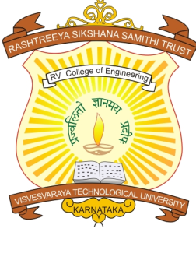

CERTIFICATE

Certified that the project work titled ‘Context Based Information Retrieval using Word Sense Disambiguation’ is carried out by Brahmachaithanya S (1RV07CS025), Bruhnath M (1RV07CS026), Ramanan V R (1RV07CS080), Sandesh M Veerapur (1RV07CS088), who are bonafide students of R.V College of Engineering, Bangalore, in partial fulfillment for the award of degree of Bachelor of Engineering in Computer Science and Engineering of the Visvesvaraya Technological University, Belgaum during the year 2010-2011. It is certified that all corrections/suggestions indicated for the internal Assessment have been incorporated in the report deposited in the departmental library. The project report has been approved as it satisfies the academic requirements in respect of project work prescribed by the institution for the said degree.

Signature of Guide Signature of Head of the Department Signature of Principal
Mr. Vinay Hegde Dr. Prof. N.K Srinath Dr. Prof. B.S. Satyanarayana

External Viva

Name of Examiners Signature with date

1. …………………………….. ………………………………..

2. …………………………….. ………………………………..

