4. Implementation
The automatic disambiguation of word senses has been an interest and concern since the earliest days of Natural Language Processing. Sense disambiguation is an “intermediate task” which is not an end in itself, but rather is necessary at one level or another to accomplish most natural language processing tasks (semantic level).
The problem of word sense disambiguation has been described as AI-complete, that is, a problem which can be solved only by first resolving all the difficult problems in artificial intelligence (AI) it means that solving this problem is equivalent to solving the central Artificial Intelligence problem which is making computers as intelligent as people2.
Although using statistical methods has been very successful for some of important problems in Natural Language Processing such as Part Of Speech tagging and alignment of parallel translation, an effective method for word sense disambiguation does not exist yet, consequently this problem is frequently cited as one of the most important problems in natural language processing research today.
The section below discuses the various issues related to the implementation of the project like the platform used, coding standards and the problems faced during the implementation and also solutions to it.
4.1. Platform
The platform defines a standard around which a system can be developed and is a term often used as a synonym of operating system. With the platform chosen, the application that implements Word Sense Disambiguation has been developed.
4.1.1 Operating System:
The WSD system is designed to work on Windows Operating Systems (specifically tested on Windows 7 and Windows XP). The reason Windows Operating System was chosen was mainly due to relative simplicity of the operating system as well abundant documentation available for it. The system however can be extended to be used on any Operating System that supports Java-based applications, the only requirement therefore being is the Java Runtime Environment (JRE).
4.1.2 Software Framework:
A software platform, simply defined as a place to launch software, is a crucial element in developing the Java-based Word Sense Disambiguation project. Logic code that includes byte code, source code, and machine code will be interpreted consistently as long as the Java Platform is running on top of other platforms.
4.1.2.1 The Java Platform:
Java Platform, Standard Edition or Java SE is a widely used platform for programming in the Java language, used to deploy portable applications for general use and consists of a virtual machine, which must be used to run Java programs, together with a set of libraries (or "packages") needed to allow the use of file systems, networks, graphical interfaces, and so on, from within those programs. The Java Runtime Environment (JRE) and Java Development Kit (JDK) are required in order to run or develop Java programs, respectively.
4.1.2.2 Eclipse IDE:
Eclipse is a multi-language software development environment has been used to develop the back-end of the Java-based Word Sense Disambiguation syatem. It comprises of an integrated development environment (IDE) and an extensible plug-in system. It is written mostly in Java and can be used to develop applications in Java and, by means of various plug-ins, other programming languages. Eclipse, an open source Java based IDE, brings together all of the tools needed to develop an application in Java.
4.1.2.3 LingPipe
LingPipe is tool kit for processing text using computational linguistics. LingPipe is used to do tasks like:
- Find the names of people, organizations or locations in news
- Automatically classify Twitter search results into categories
- Suggest correct spellings of queries
Architecture:
LingPipe's architecture is designed to be efficient, scalable, reusable, and robust. Highlights include:
- Java API with source code and unit tests;
- multi-lingual, multi-domain, multi-genre models;
- training with new data for new tasks;
- n-best output with statistical confidence estimates;
- online training (learn-a-little, tag-a-little);
- thread-safe models and decoders for concurrent-read exclusive-write (CREW) synchronization; and
- character encoding-sensitive I/O.
4.1.2.4 Java NetBeans IDE:
NetBeans refers to both a platform framework for Java desktop applications, and an IDE for developing with Java. The Java NetBeans GUI design-tool has been used to develop the user interface of the Java-based Word Sense Disambiguation system. It enables designing Swing GUIs by dragging and positioning GUI components with built-in support for JSR 296 (Swing Application Framework) and JSR 295 (Beans Binding technology).
4.2 Challenges Encountered and their Solutions
There were a number of challenges faced while implementing the project. A few of the major problems are stated in brief in following section along with their solutions:

Problem 1:
The tool called LingPipe is used for training of data for various contexts. The Problem was integrating the tool with our source code. There were Java Virtual Machine errors.
->The Errors were eliminated by making some major modifications in the tool’s source code thus making it compatible with our code.
Problem 2:
The LingPipe tool required the test cases to begin in specific format and Entered keyword to be identified and surrounded by Angular brackets.
->Seperate Class was implemented to do the above specified work. The class extended and implemented Java String class methods. The major classes used were “StringBuffer” Class and “String” Class. The inbuilt methods such as “toString”, “append” etc were used so that test cases were identified with specific format in which tool could work properly.
Problem 3:
The Front End and User Interface were designed using Java Swing. The Major problems were the interfacing with the back end, appearance of front end, design and validation of input provided by user.
->The Interfacing was designed such that actions and events were introduced so that they are synchronous with running back end code. The Design of appearance of User Interface was based on Research paper provided by our guide. The appearance problem was eliminated using Java s Inbuilt background Layout and Panel frames. The Validation was carried out by inheriting the features of Java's String and Jerror classes.

4.3 Coding Standards
Java, an Object-Oriented language from Sun Microsystems with syntax similar to that of C, draws its roots from the C++ language. The Java programming language and environment is designed to solve a number of problems in modern programming practice. Some of its features that set it apart from other programming languages are:
- It is simple, object oriented and familiar.
- It is robust and secure.
- It has an architecture-neutral and portable environment.
- It executes with high performance.
- It is interpreted, threaded and is dynamic.
To enable a Java application to execute, the Java Compiler generates an architecture neutral object file format called the Java byte codes and this compiled code is executable on many processors, given the presence of the Java Runtime Environment. Java byte codes are translated on the fly to native machine instructions that is they are interpreted and not stored anywhere. Since linking is a more of an incremental and lightweight process, the development process can be much more rapid and exploratory. Coding standards for Java are important because they lead to greater consistency within code of all developers. The standards document contains the standard conventions that cover filenames, file organization, indentation, comments, declarations, statements, and white space, naming conventions, programming practices. Code conventions are important to programmers for a number of reasons:
- Consistency leads to code that is easier to understand, which in turn results in a code, which is easier to develop and maintain. 80% of the lifetime cost of a piece of software goes to maintenance.
- Code conventions improve the readability of the software, allowing engineers to understand new code more quickly and thoroughly.
- Code that is difficult to understand and maintain runs the risk of being scrapped and rewritten.

Some of the conventions followed in implementing the WSD system are stated as follows:
Comments: Comments shall specify what the purpose of the code is; not simply repeat the code. All deviations from coding standards or good programming practice shall have a comment specifying the reasons why. Comments shall be indented to the same level as the code that follows them. End-of-line comments shall be avoided; the exception being in the declaration section if a comment for a variable declaration is required. Document all decision and loop structures.
Declarations: One declaration per line is recommended since it encourages commenting. Initialize local variables where they're declared. Put declarations only at the beginning of blocks.
Procedure Naming: Procedure shall have mixed case descriptive names where the initial character of each word is in upper case. The names shall only exceptionally contain abbreviations, and where abbreviations are used they shall be used consistently throughout the application.
Module Naming: Modules, class, form and standard shall have descriptive names. They shall also have a one character prefix in upper case; F for forms, M for standard modules, and C for class modules. This in particular helps distinguish the name of form modules from variables referencing a form instance.
Member Function Visibility: A good design requires minimum coupling between the classes. The general rule is to be as restrictive as possible when setting the visibility of a member function. If member function doesn’t have to be public then make it protected, and if it doesn’t have to be protected than make it private.
Standards for Packages: Local packages names begin with an identifier that is not all upper case Global package names begin with the reversed Internet domain name for the organization. Package names should be singular.
General Coding Rules for Java Classes: When coding JAVA classes and interfaces, the following formatting rules should be followed:
- No space between a method name and the parenthesis "(" starting its parameter list.
- Open brace "{" appears at the end of the same line as the declaration statement.
- Closing brace "}" starts a line by itself indented to match its corresponding opening statement, except when it is a null statement the "}" should appear immediately after the "{".

5. Results
5.1 Testing
Testing of the components developed during the implementation of a local search engine for android platform that uses the concept of clustering to provide the user with clustered results is of great importance to ensure that the user is assured desirable speed, performance and features.

5.1.1 Unit Testing
The various individual components of the software include the modules that have been discussed in great detail in Design chapter.

5.1.1.1 Testing Strategy
The approach followed is the manual unit testing approach. It usually involves providing a range of inputs which include both valid and invalid inputs and checking the response of the unit. Advantage of manual approach is that it is highly visible to the developer. Since the code is fresh in the developers' minds, any bugs can usually be fixed rather quickly. Each test case includes many features describing the input output transformations.
The features to be tested, most importantly includes the accuracy of the individual unit and also the range of inputs for which the unit functions properly. The items to be tested include all the individual units or functions which collectively form the whole system. In case of unit testing the items to be tested are the individual units. Sample input which can be any valid input for the unit and its corresponding expected output and the actual output. The testing strategy also includes remarks on the performance of unit in that particular test case.

5.1.1.2 Test Cases
The various test cases for different modules are as follows.
Sl No. of test case : | 1
Name of test : | Unit test for keyword processing unit
Item / Feature being tested : | To check for selection of single word query
Sample Input : | Input from drop down menu
Expected output : | Selected input displayed in the keyword field
Actual output : | Selected input displayed in the keyword field
Remarks : | Success
Table 5.1 Test case for single word query processing

Sl No. of test case : | 2
Name of test : | Unit test for Context processing unit
Item / Feature being tested : | To check for words contained in the context field
Sample Input : | A sentence or paragraph
Expected output : | Input should be displayed in ”entered context” field
Actual output : | Input displayed in ”entered context” field
Remarks : | Success
Table 5.2 Test case for checking words contained in the context field

Sl No. of test case : | 3
Name of test : | Unit test for testing module
Item / Feature being tested : | To check for valid context and valid keyword
Sample Input : | Context: I paid the cash to bank  Keyword: bank
Expected output : | Correct sense of bank being resolved
Actual output : | Sense:a financial institution where money transactions are made
Remarks : | Success
Table 5.3 Test case for testing module

Sl No. of test case : | 4
Name of test : | Unit test for testing module
Item / Feature being tested : | To check for valid context and invalid keyword
Sample Input : | Context: I paid the cash to bank  Keyword: cricket
Expected output : | Error message
Actual output : | An invalid keyword has been selected
Remarks : | Failure
Table 5.4 Test case for testing module

Sl No. of test case : | 5
Name of test : | Unit test for testing module
Item / Feature being tested : | To check for invalid context and valid keyword
Sample Input : | Context: I paid the cash to river  Keyword: bank
Expected output : | Error message
Actual output : | Input is an invalid context
Remarks : | Failure
Table 5.5 Test case for testing module

5.1.2 Integration Testing
The main difficulty that arises in integration testing is localizing errors that are discovered during the process. These are complex interactions between the system components and, when an anomalous output is discovered, it may be difficult to find the source of the error. To make it easier to locate the errors, the incremental approach to system integration and testing has been used.

5.1.2.1 Testing Strategies
The strategy comprises of the features to be tested which includes the accuracy with which the integrated modules function and the synchronization of the modules .The items to be tested include the functionality of individual modules taken together. The purpose of testing is to check whether the integrated modules perform as expected. The pass or fail criteria is the matching of the expected and the actual outputs of the integrated modules.

5.1.2.2 Test Cases
The various test cases for the system obtained after the integration of modules are as follows.

Sl No. of test case : | 6
Name of test : | Integration test for test module and testing module
Item / Feature being tested : | Synchronization between training and testing modules
Sample Input : | A valid context and valid keyword with words not being trained
Expected output : | An error message
Actual output : | Training module hasn’t been run
Remarks : | Failure
Table 5.6 Test case for integration of test and training modules

Sl No. of test case : | 7
Name of test : | Integration test for test module and testing module
Item / Feature being tested : | Synchronization between training and testing modules
Sample Input : | A valid context and valid keyword with words being trained
Expected output : | Correct sense of keyword being resolved
Actual output : | Correct sense of keyword displayed
Remarks : | Success
Table 5.7 Test case for integration of test and training modules

Sl No. of test case : | 8
Name of test : | Integration test
Item / Feature being tested : | Integration between back and front ends
Sample Input : | Context: null query  Keyword: valid keyword
Expected output : | Error message
Actual output : | Enter a valid context
Remarks : | Success
Table 5.8 Test case for searching query which returns no results

5.1.3 Interface Testing
Interface testing is done to test the graphical user interface. In interface testing we need to test the text box, buttons, etc

5.1.3.1 Testing Strategy
The approach followed is the manual unit testing approach. It usually involves providing a range of inputs which include both valid and invalid inputs and checking the response of the applications .The features to be tested are the width of the text box, on screen instructions and buttons.

5.1.3.2 Test Cases
The various test cases to test the user interface are as follows.

Sl No. of test case : | 9
Name of test : | Interface test for Context processing unit
Item / Feature being tested : | To check for words contained in the context field
Sample Input : | Null Input
Expected output : | Display error message as ”enter context before pressing button”
Actual output : | Error message ”enter context before pressing button”  Displayed
Remarks : | Success
Table 5.9 Test case to check null input for a context field

Sl No. of test case : | 10
Name of test : | Unit test for keyword processing unit
Item / Feature being tested : | To check for null query
Sample Input : | Null
Expected output : | Gives error message as “ select a keyword from the list”
Actual output : | “ select a keyword from the list”
Remarks : | Success
Table 5.10 Test case for null query processing

5.2 Results
In this section a comparative study of outputs for various inputs are made. The section also includes the snapshots of the local search engine

5.2.1 Comparative study
In this section the variation of the output with different input is discussed. The given inputs can be either valid or invalid or a combination of both. For all the cases the corresponding snapshots are given in the section below.

5.2.2 Snapshots
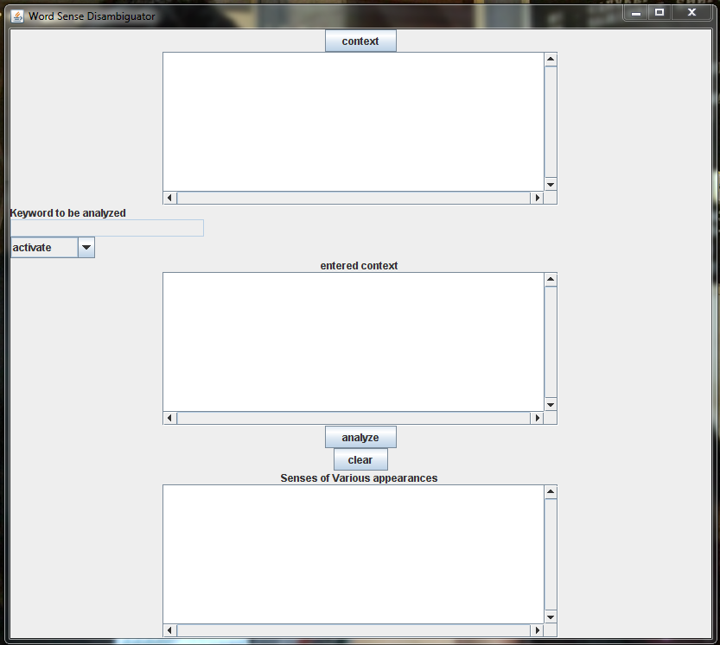
Fig 5.1 home page of the project

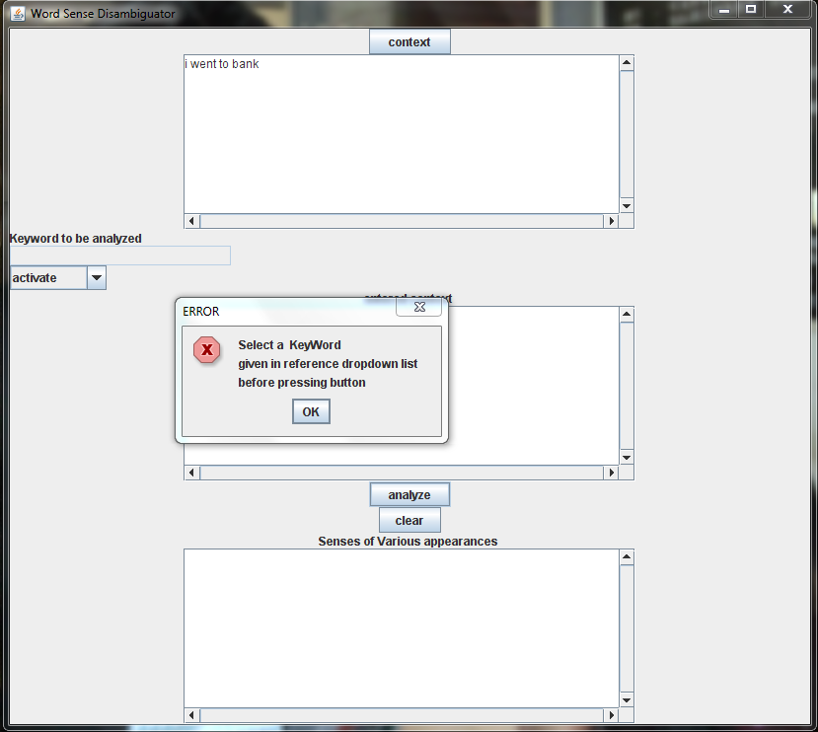
Fig 5.2 Valid context and no keyword selected
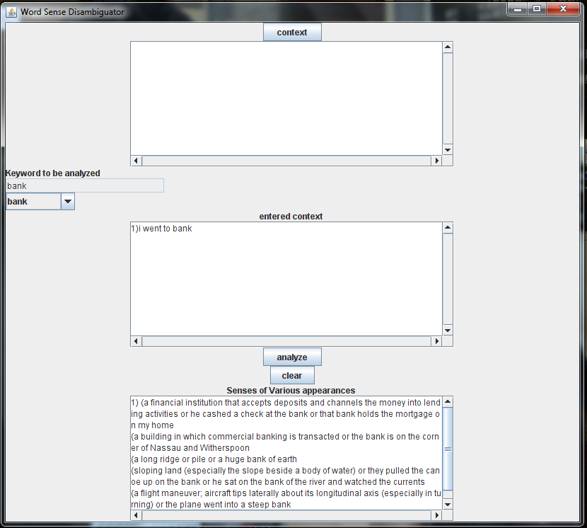
Fig 5.3 valid output
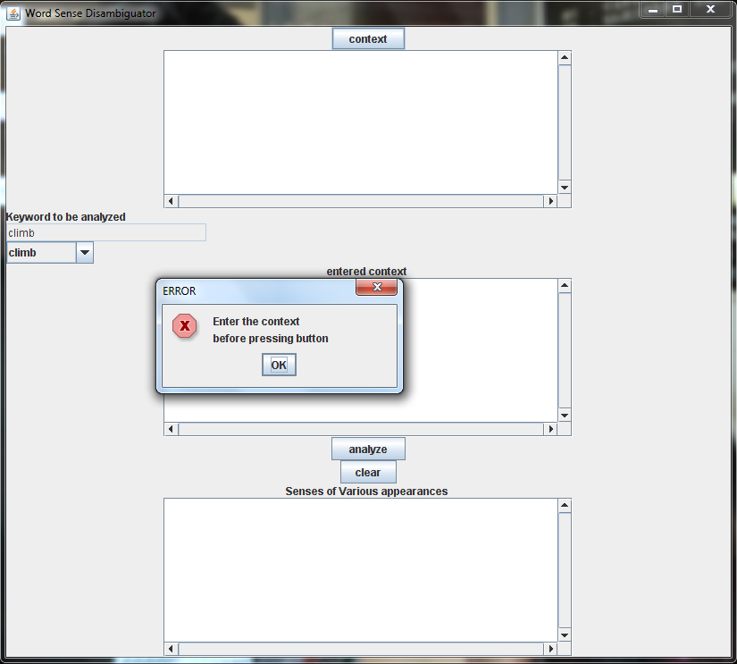
Fig 5.4 Valid keyword and no context entered
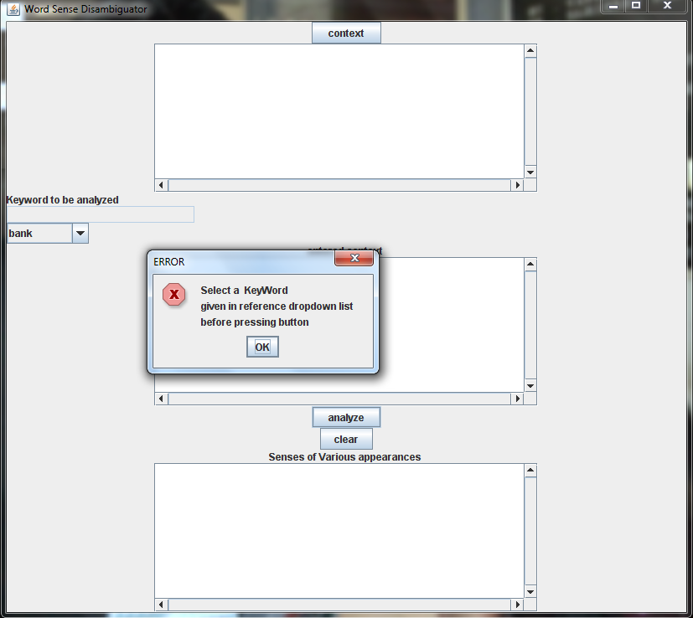
Fig 5.5 Error message

6. Conclusion
Word Sense Disambiguation (WSD) is one of hot topics in the Natural Language Processing (NLP). Though lot of work has been done in the field of NLP in general and WSD in particular but not high success has been seen owing to the difficulty in implementing a WSD system. An attempt was made to implement a WSD on a small scale in this project which can be scaled to larger number of words.

6.1 Summary:
An overview of the design and development of a Word Sense Disambiguation system has been presented. Although some aspects of the system are still under experimental development, the project has resulted in an overall success, being able to perform search operations for relevant documents. The Word Sense Disambiguation System has recorded high accuracy.
The design of the Word Sense Disambiguation system is based upon three major modules and they are,
a. Pre-Processing of the Input provided by the user.
b. Searching of relevant word senses at the back end.
c. Providing proper results to the End users based on the given context.
Word Sense Disambiguation System was accomplished with a very few hundred set of words and their senses in the database and hence all the search cases were not successful due to lack of relevant words and apart from that, the system hits highest accuracy in providing most relevant results to the users when they perform a search operation using our system.

6.2. Limitations:
It is not possible for us to satisfy every minute detail and also populate database with huge number of words and their corresponding senses while developing a project over a fixed period of time. Added to the fact ‘that perfection is not human’ it is extremely natural that every project has some limitations in terms of the functionality it supports, inputs accepted and outputs produced. The major limitations in our Word Sense Disambiguation software are stated as follows:
- Word Sense Disambiguation System works fine only on a Stand-alone computer and not suitable for Centralized or Distributed Environment.
- Limited to only those users who at least know the basics of English language.
- Even though language English has millions of words, we have restricted to only a small set of few words and their senses.
6.3. Further Enhancements:
Any development is a continuous process, which does not terminate once an executable has been generated. Every project has certain limitations due to wide various reasons. Some of these limitations could be overcome, given sufficient time while others could be overcome with better technologies. Hence some of the further enhancements that could be performed on our Word Sense Disambiguation system are as follows:
- Ability to search for both local and remote relevant words.
- Providing more flexibility to users to specify whether the search string is a Start word, middle word or end word.
- Considering the current software, it provides a strong foundation to convert our Word Sense Disambiguation System into a Word Sense Disambiguation Search Engine.
- The software can be used online over the internet once it is Web enabled.

