Jim Fawcett
CSE681 – Software Modeling and Analysis
Fall 2003

These notes show you how to:

- Create a virtual directory for Internet Information Server (IIS)
- Insert a very simple web service
- Execute the web service from a browser
- Create a C# web service client
- Create a proxy, using WSDL.exe, and compile with CSC
- Execute the web service from client
- Set basic security properties for the web service

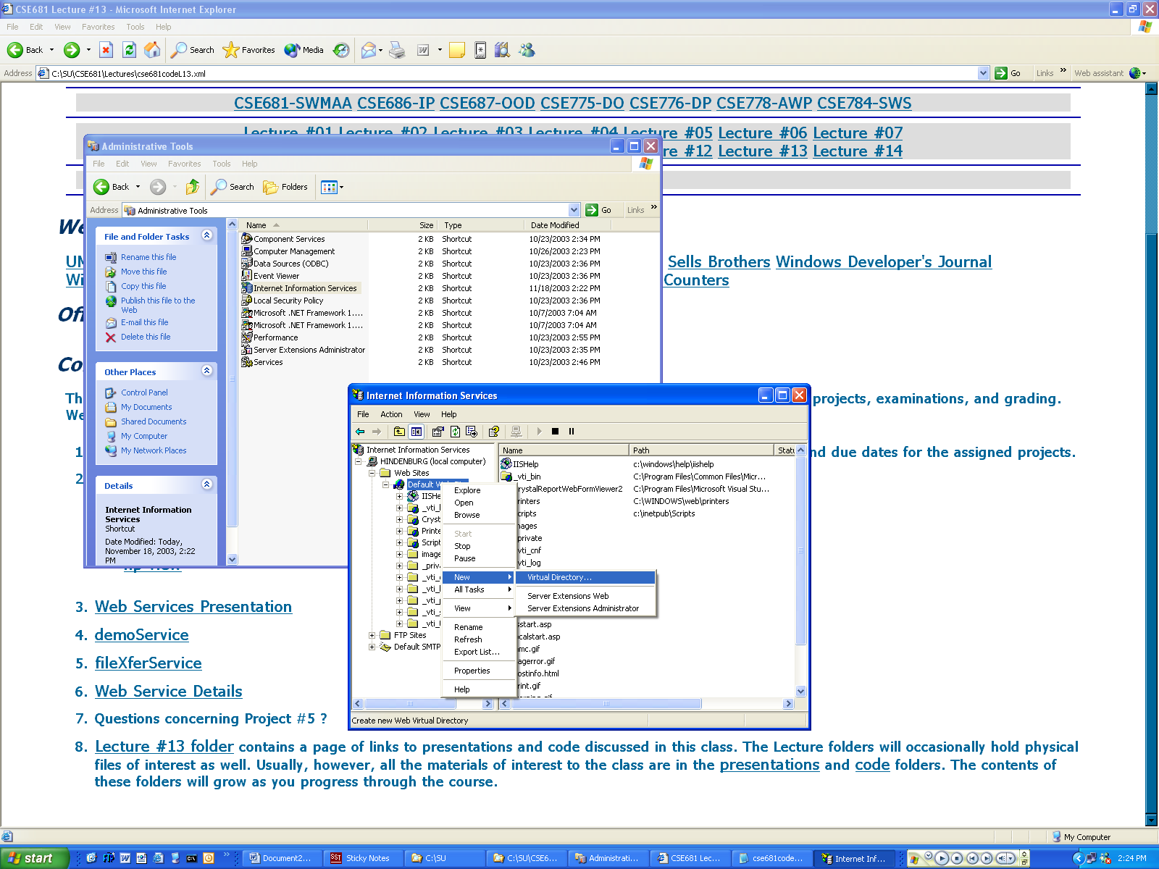
Use Control Panel to open Administrative Tools, then select
Internet Information Server snapin.

Right-click on Default Web Server and select new/Virtual Directory.
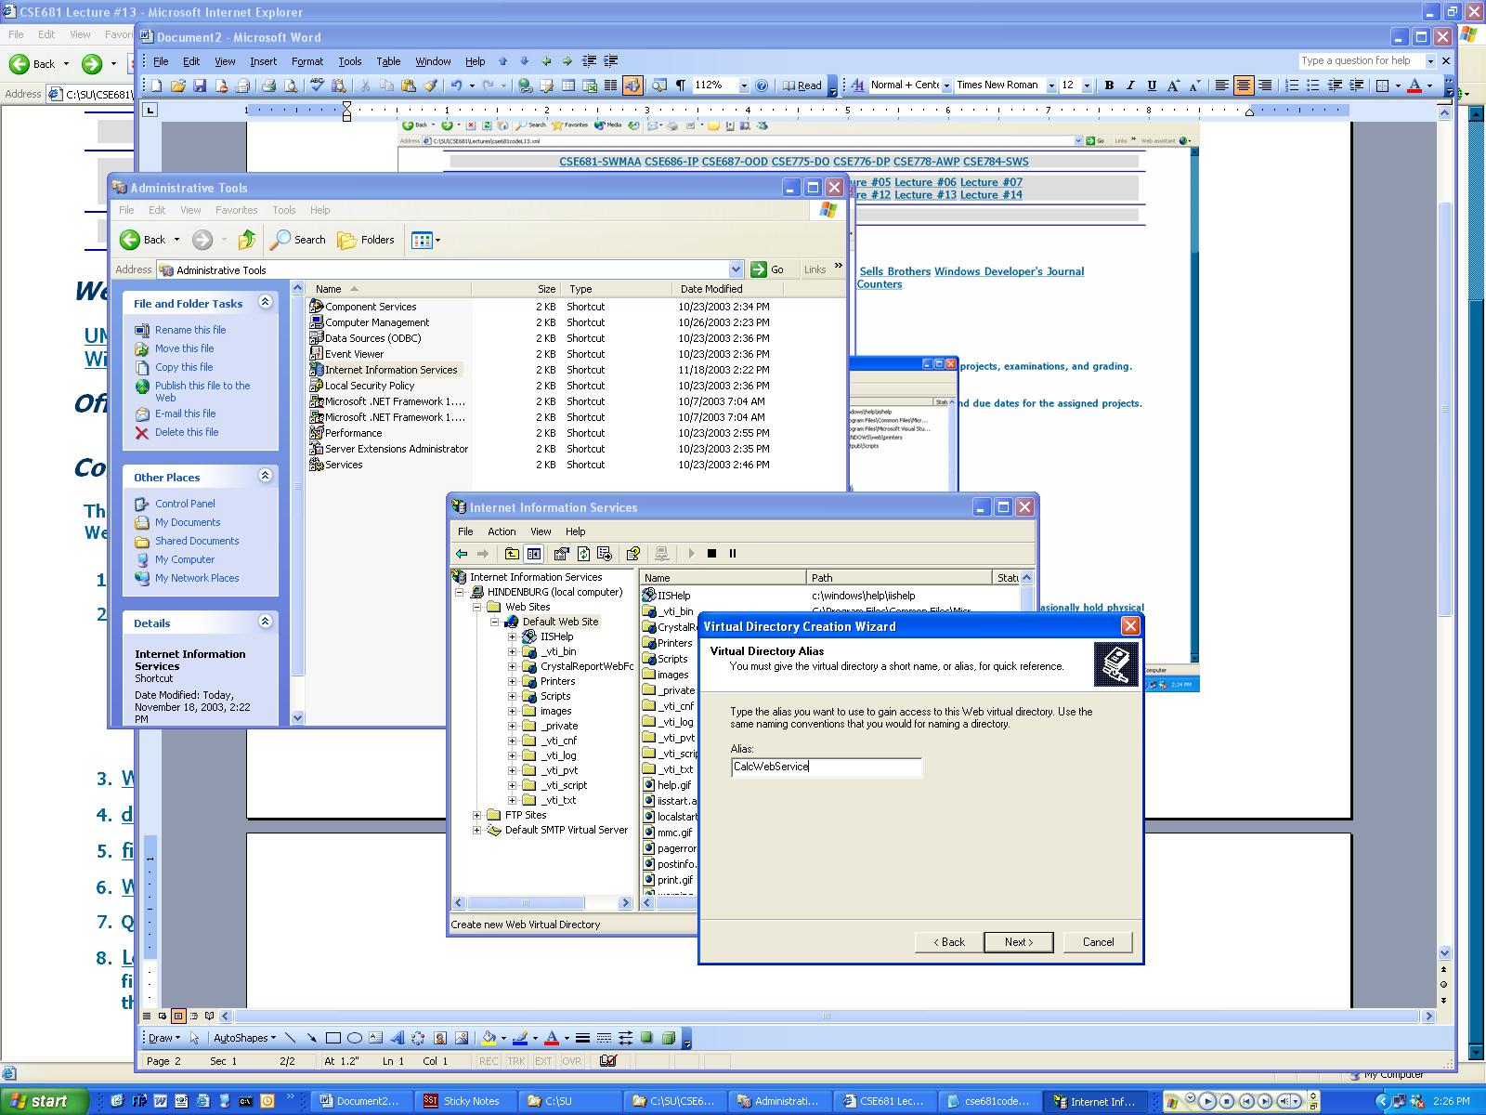
Provide a name for virtual directory that may be the same or different from the physical directory to which it will correspond.
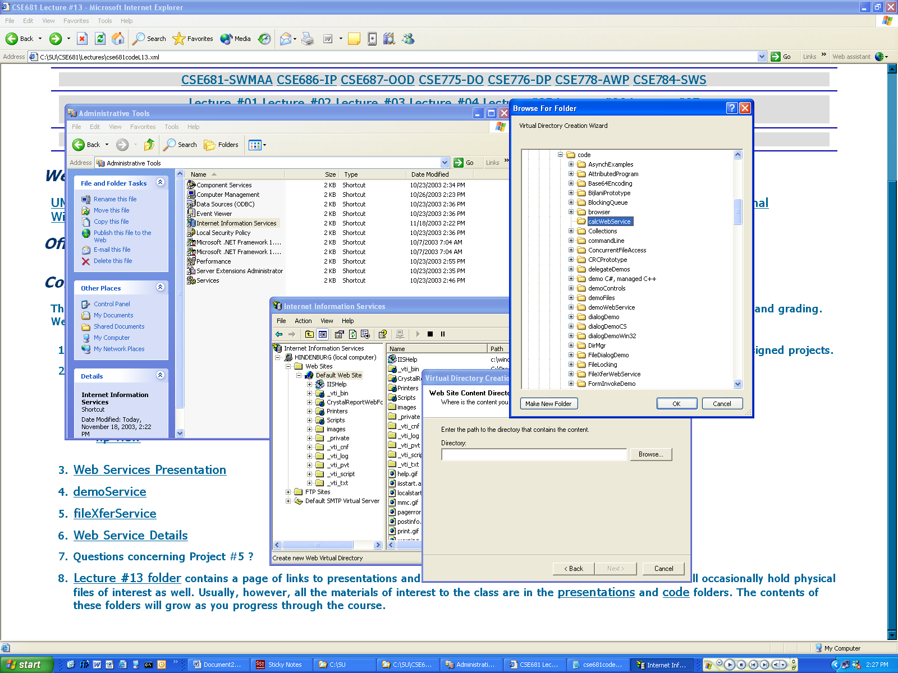
Now browse to an existing directory where you want the virtual directory to reside.
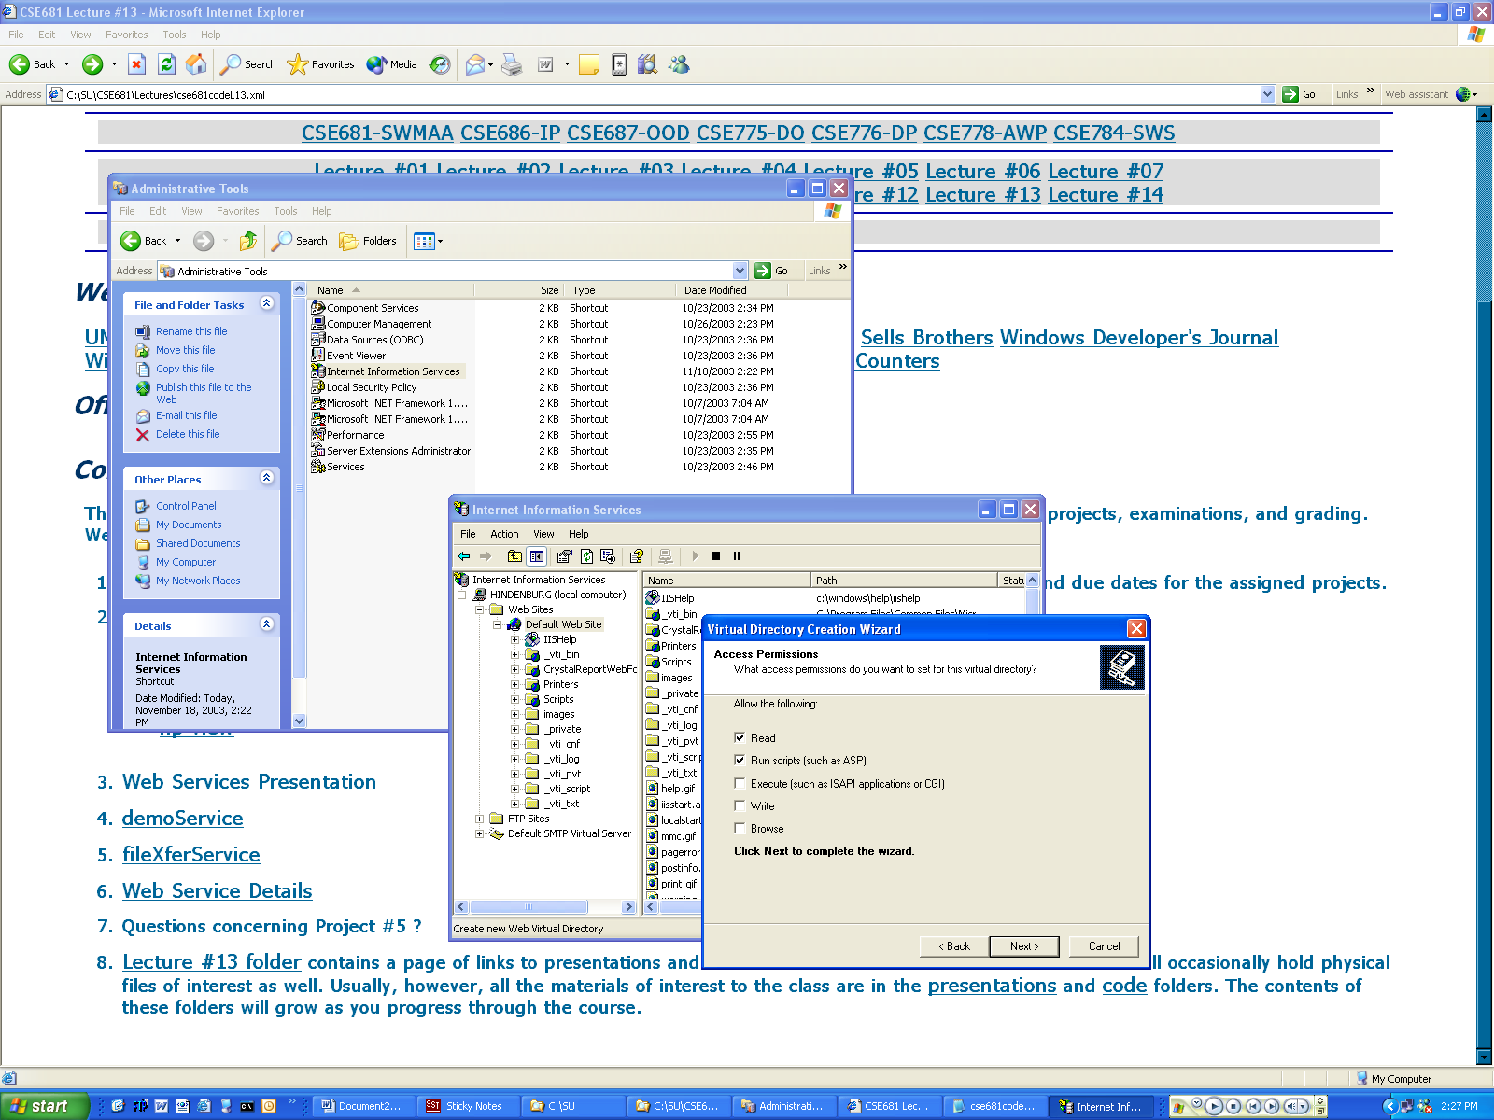
Pick the permissions you want to use.
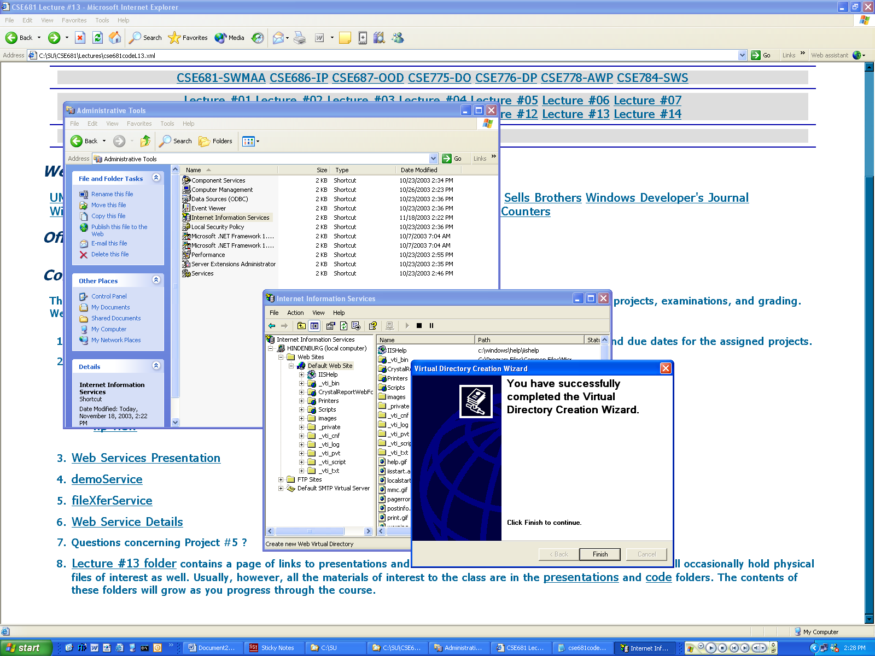
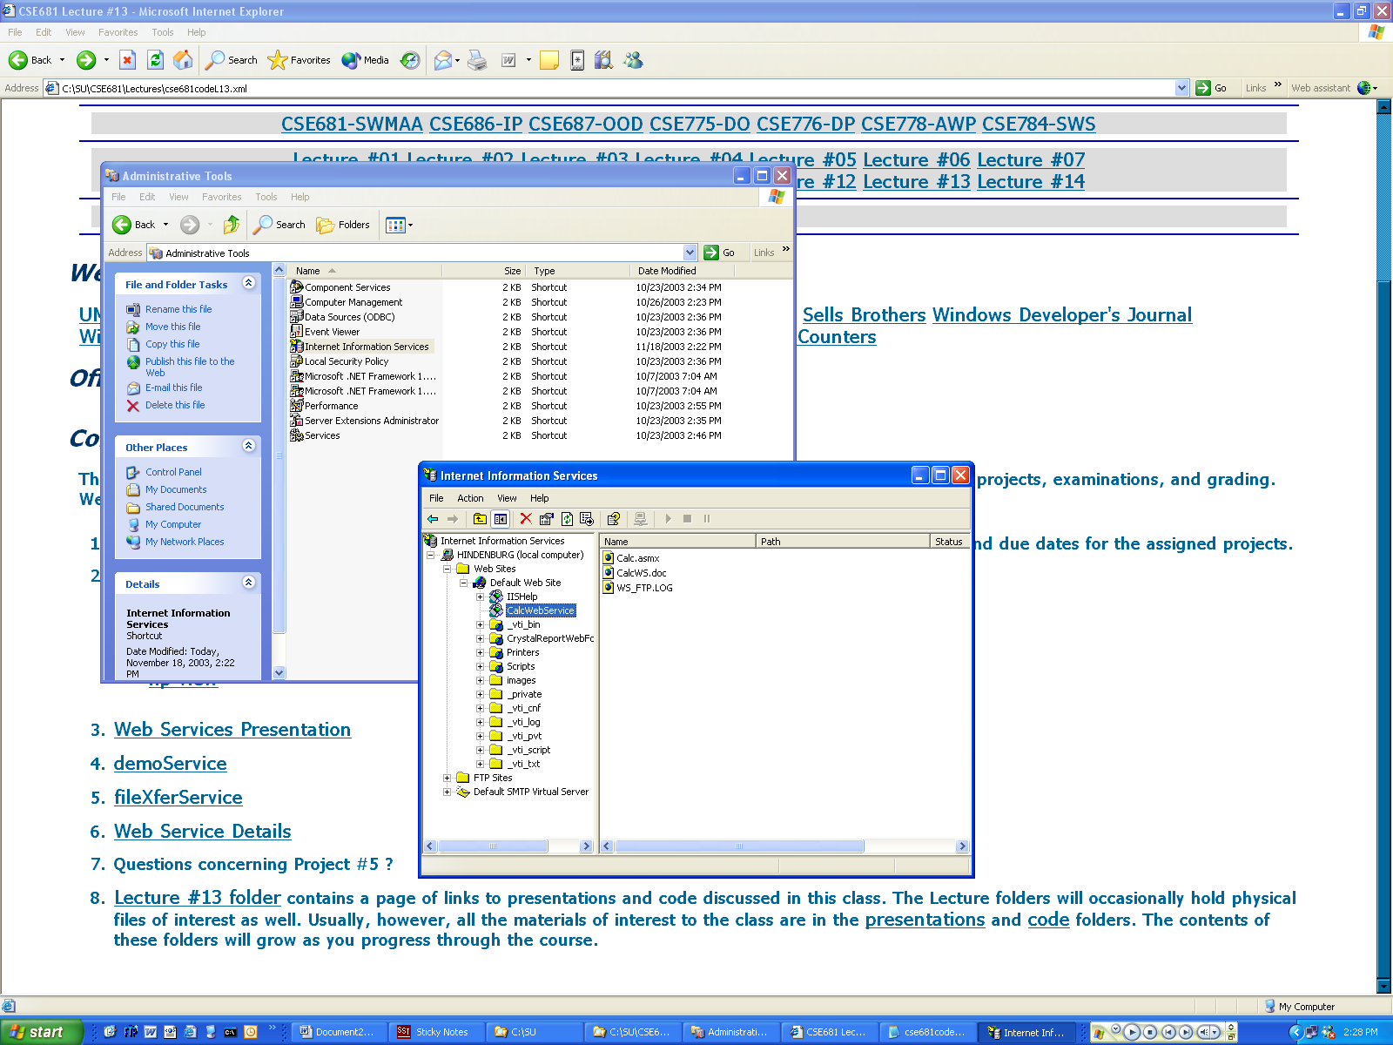
Now you will find the new virtual directory listed under the default root, e.g., c:\inetput\wwwroot
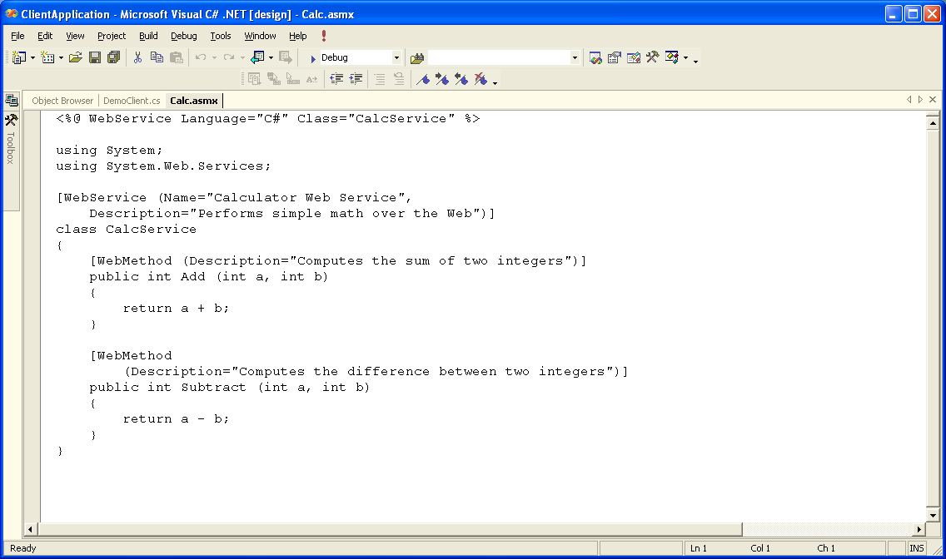
Here is one of the world’s smallest web services – an example provided by Jeff Prosise in the class text.
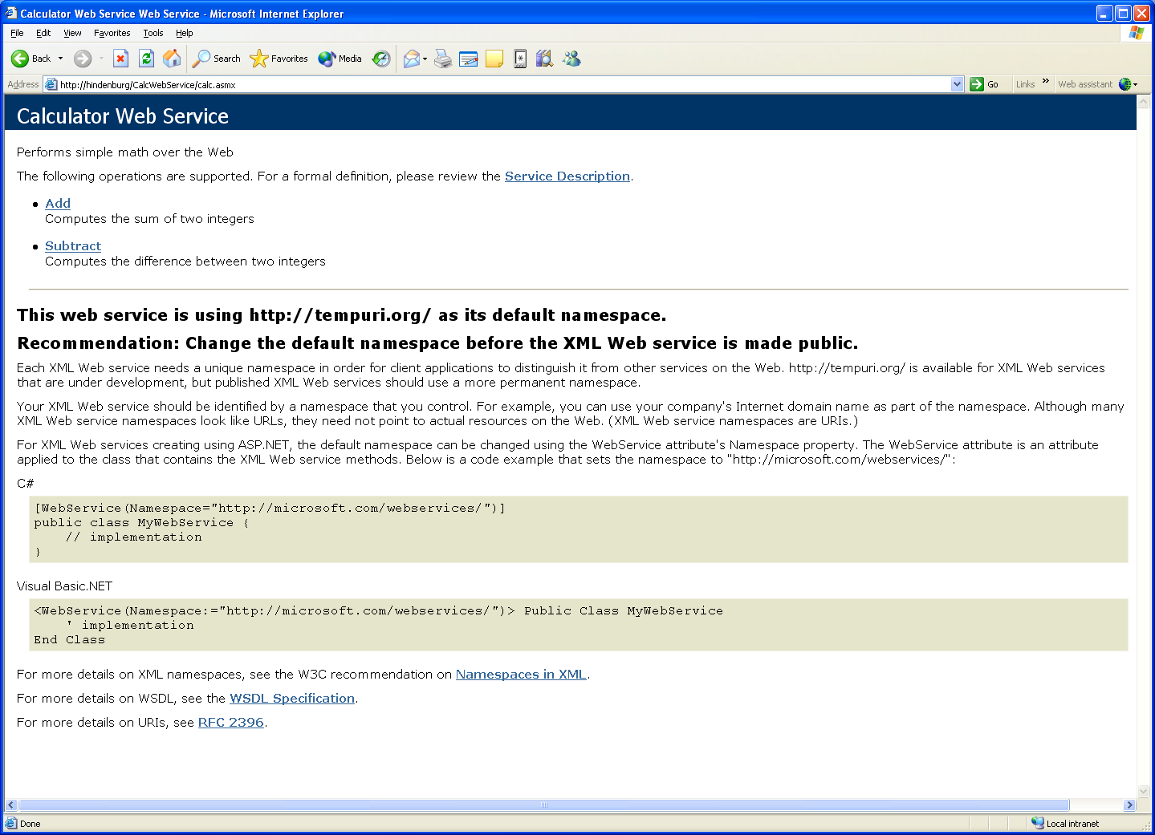
We’ve browsed to the web service.
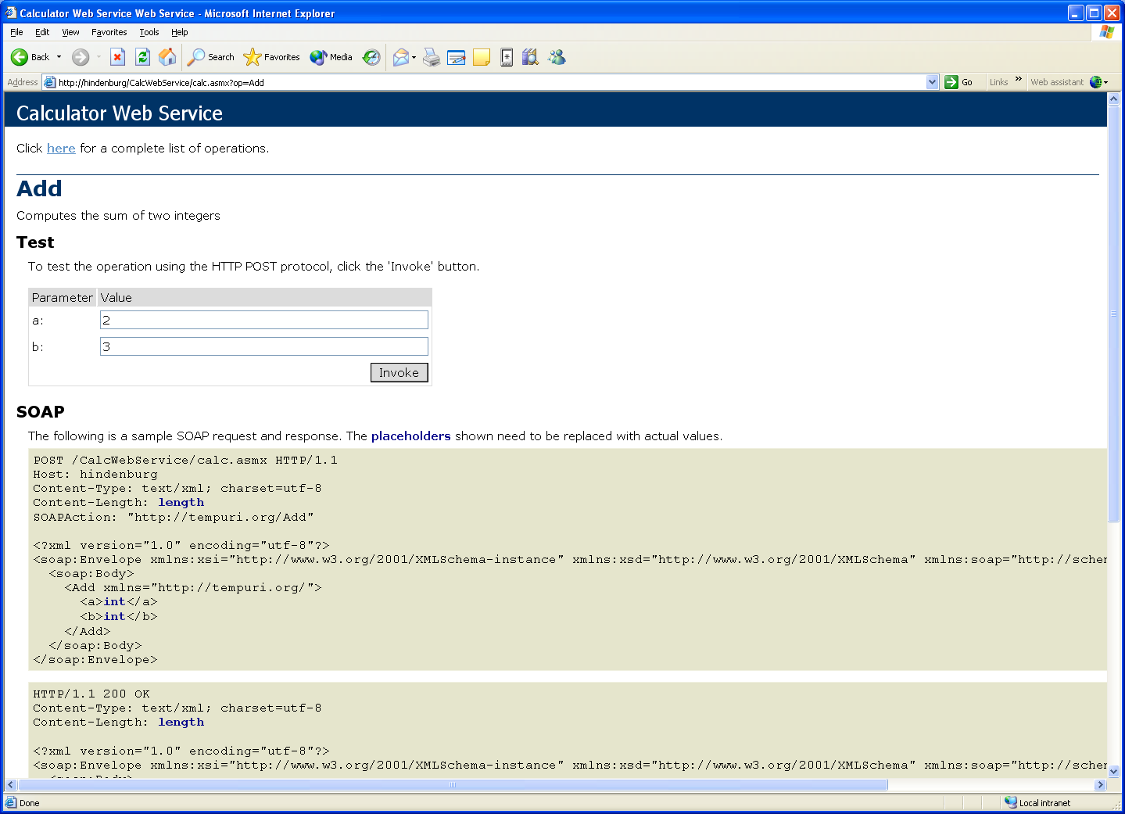
This is a form generated by the web service, which, after we enter values to be added, will be posted back to the service for evaluation.
This is an HTTP post request, using soap. All of this is generated by the web service mechanics.
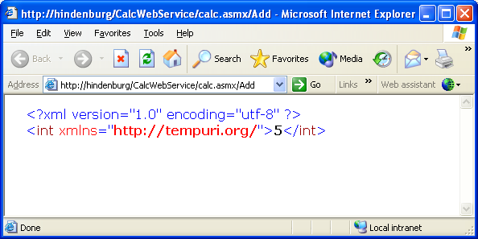
Here is the web service reply.
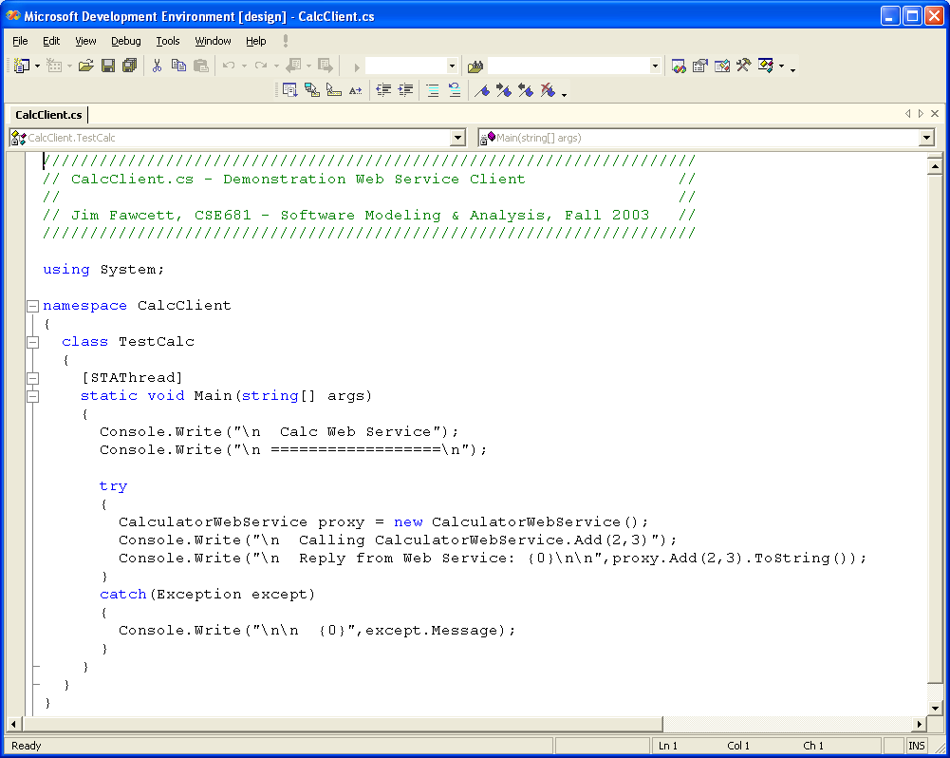
Now, we will use this C# client to access the Calc web service.
We will create code that defines this proxy in the next slide.
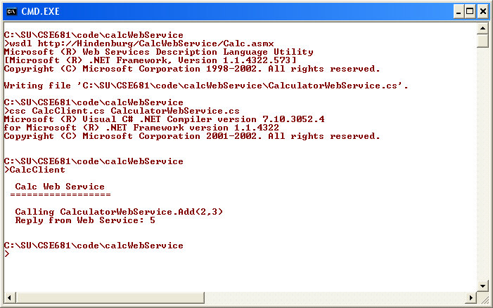
Here we are generating proxy code using WSDL.exe, provided by .Net.
Now we are compiling the client and proxy code to get the client executable.
Finally, we get to run the client and access the Calc web service.
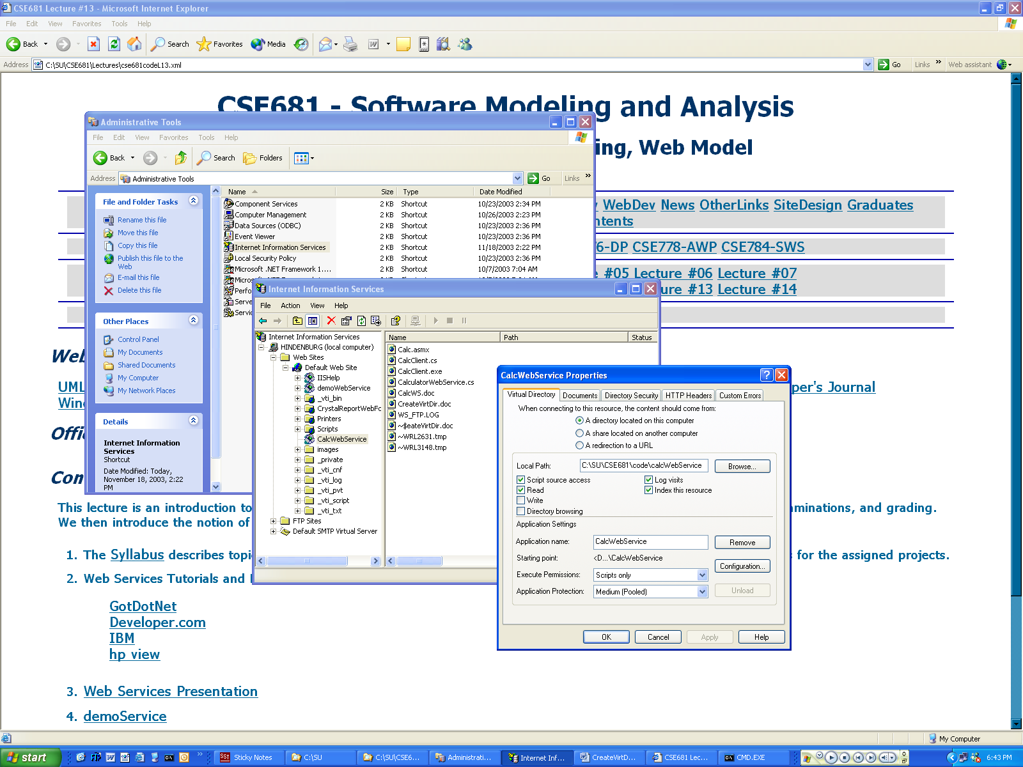
You can configure web service security properties here.
You can configure default web site security properties here.
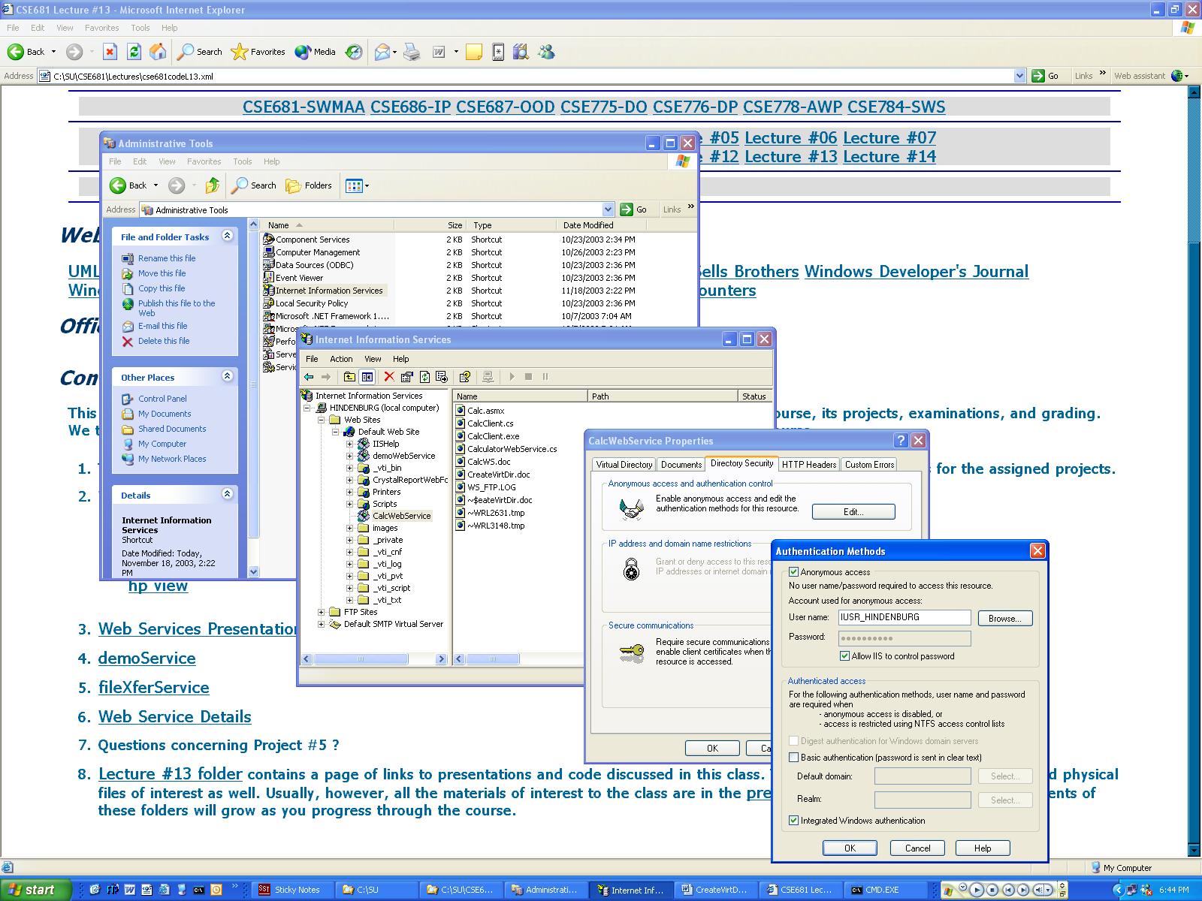
I’ve allowed anonymous access here.
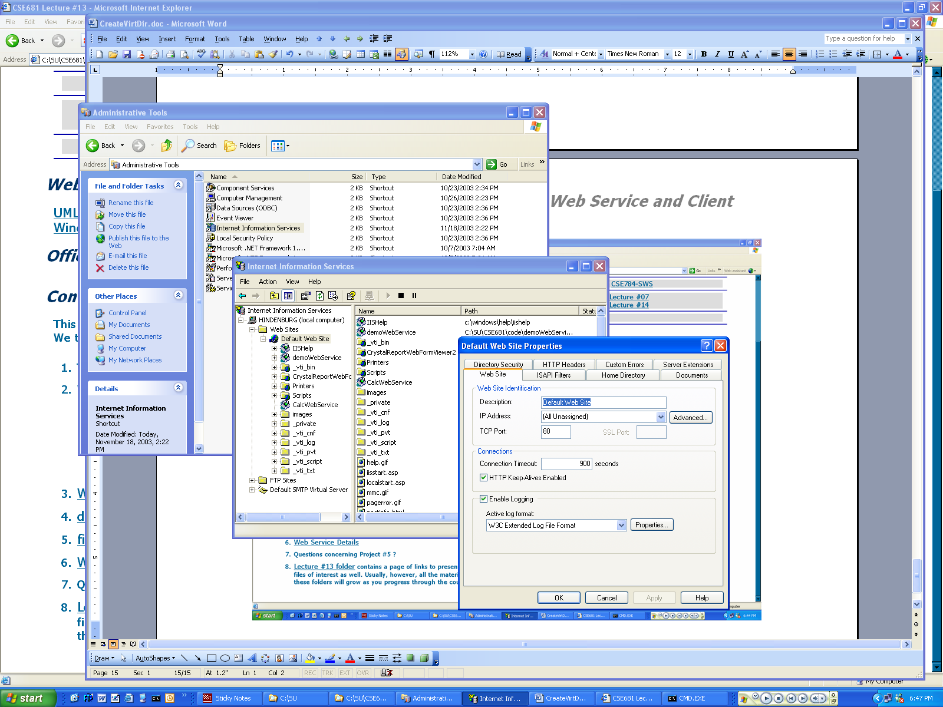
You can configure default web site security properties here.

