Date:24/10/2026

CO2-Assignment Tool 2 SCENARIO BASED

Course code: DSA0308

Course Name: Natural Language Processing

Reg No: 192472286 Name: J. BRAHMAIAH

Morphological Processing for Search Engine Indexing

Introduction
Morphological processing is an NLP method for examining how words are formed. It identifies a word's root and affixes, such as prefixes and suffixes.
Inflectional morphology changes grammatical form without normally changing the word class, as in analyze → analyzing. Derivational morphology creates a related form and may change its grammatical role, as in analyze → analytical.
For search engines, normalizing related word forms can help group documents under a shared index representation. The exact common representation depends on the normalization rules selected.

Problem Statement
A search engine may receive queries containing words such as analyzing, analysis, and analytical. If each form is indexed separately, relevant documents may be missed. A rule-based program is therefore required to identify the specified word components, classify the forms, and map them to a shared representation for retrieval.

Aim
To create a Python program that applies predefined morphological rules to analyzing, analysis, and analytical and prints their root, suffix, transformation type, and normalized form.

Python Program
words = ["analyzing", "analysis", "analytical"]

rules = {
"analyzing": ("analyze", "ing", "Inflectional"), "analysis": ("analysis", "None", "Base/related form"), "analytical": ("analysis", "tical", "Derivational")
}

for word in words:
root, suffix, category = rules[word] normalized = "analysis"

print("Word:", word)
print("Root:", root) print("Suffix:", suffix) print("Type:", category)
print("Normalized Form:", normalized) print()

Sample Output
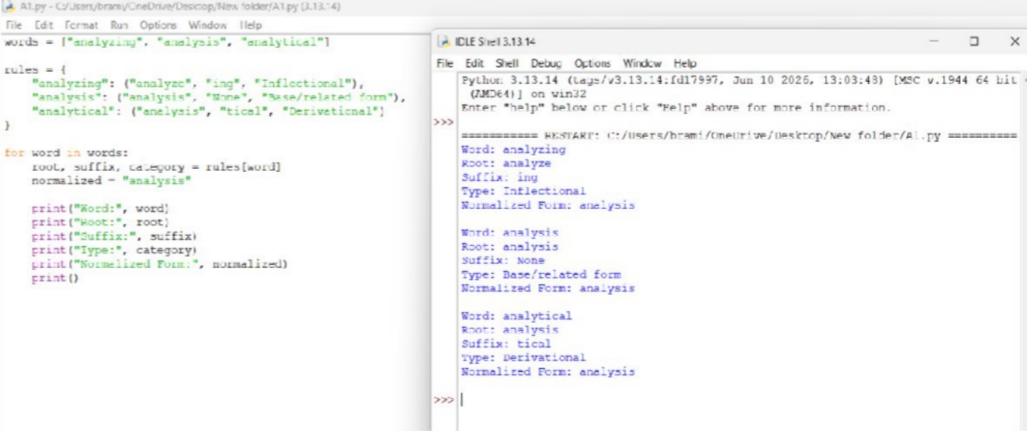

Solution Approach
The input words are stored in a list, and a dictionary provides the predefined analysis for each word. A loop retrieves the information and prints a normalized form. The mapping is an illustrative, word-specific rule set rather than a general morphological analyzer. In particular, analysis and analyze are related forms, but they are not produced from one another by simply removing the suffix -ing.

Result
The Python program displays the predefined root, suffix, category, and normalized representation for all three input words. This demonstrates how a rule-based mapping can group related terms for search indexing.

Morphology-Based Word Normalization Using Python

Introduction
Morphological normalization examines related words and maps them to a shared base representation. Derivational suffixes can form new words from a root. For example, govern is a verb, while government and governance are related nouns.
In a news aggregation system, grouping these forms can support article categorization, topic modeling, and document clustering.

Problem Statement
A news analytics pipeline receives the words govern, government, and governance. Although their meanings are related, their endings and word classes differ. A program is needed to identify their roots, suffixes, word classes, and derivational levels, and then normalize them to a common representation.

Aim
To implement a Python program that analyzes govern, government, and governance and maps them to the shared base govern for text organization and retrieval.

Python Program
words = ["govern", "government", "governance"]

rules = {
"govern": ("govern", "None", "Verb", 0),
"government": ("govern", "ment", "Noun", 1),
"governance": ("govern", "ance", "Noun", 1)
}
print("Morphological Analysis Report") for word in words:
root, suffix, word_class, level = rules[word]

print("\\nWord:", word) print("Root:", root) print("Suffix:", suffix) print("Word Class:", word_class) print("Derivational Level:", level) print("Normalized Form:", root)

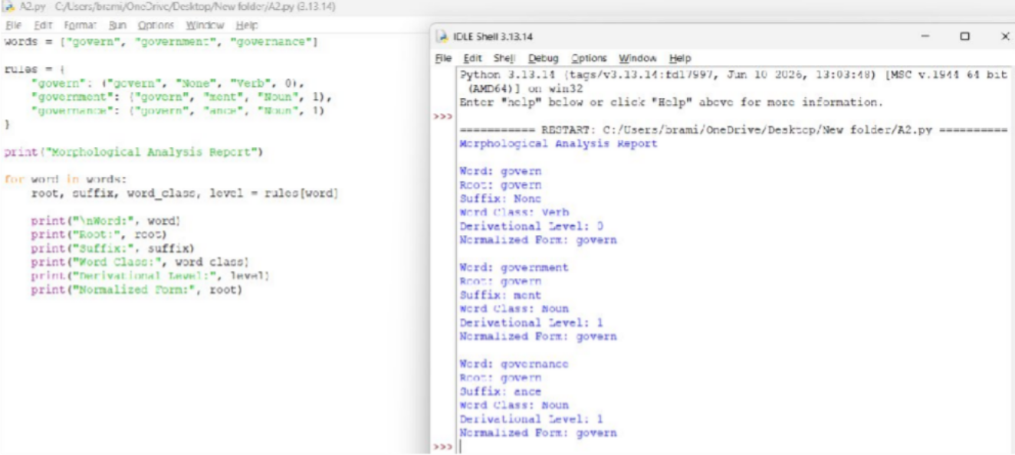
Sample Output
Solution Approach
The words are placed in a list, while a dictionary stores each word's root, suffix, word class, and derivational level. The loop prints these details and uses the root as the normalized form. The suffix labels and levels are predefined for this small example; the code does not infer them automatically for unknown words.

Result
The program identifies the supplied morphological details and maps govern, government, and governance to govern. This shared representation can help group related news articles for categorization and document clustering.

