SIMATS ENGINEERING (SAVEETHA SCHOOL OF ENGINEERING) Department of Artificial Intelligence and Data Science
ASSESSMENT TOOL 1 – ANALYTICAL PROBLEM SOLVING
Course Code: | DSA03 | Course Title: | Natural Language Processing
CO Assessed: | CO2 – Manipulation | Assessment: | Assessment Tool 1 – ANALYTICAL PROBLEM SOLVING
Weightage: | 35% of CIA
CO2 Statement: | Design inflectional, derivational, finite-state parsing, stemming algorithms and for analyse morphological methods. (BL-3)
Student Name: | J. BRAHMAIAH | Reg. No.: | 192472286
Section / Batch: | CSE-AI | Date: | 22-10-26

Code of Conduct
I J. BRAHMAIAH (192472286) certify that this submission is my original work and that I have adhered to the guidelines specified for this assessment. I understand that any violation of academic integrity rules will result in disciplinary action.
Signature of the Student: J. BRAHMAIAH

Instructions
• Read all questions carefully before attempting the answers.
• Answer all five questions. Each question carries equal marks.
• Show all intermediate steps, calculations, probability computations, tagging decisions, and justifications wherever applicable.
• Duration: 30 minutes.
Section / Topic | Focus | Q Nos
English Word Classes, Part of Speech Tagging  English Word Classes, Tagsets for English, Rule-Based Part of Speech Tagging | Morphological decomposition of connected, connecting, and connection; identification of roots, suffixes, inflectional vs. derivational forms, and normalization for document indexing.  Morphological parsing of unhappy, happiness, and happily; identification of prefixes, suffixes, base forms, and semantic effects of derivational morphology. | Q1  Q2
Counting Words, Part of Speech Tagging, English Word Classes | Stemming and root extraction for played, player, and playing; handling grammatical variations and word formation changes for search preprocessing. | Q3

Finite-State Morphological Analysis, Rule-Based Part of Speech Tagging, Transformation-Based Tagging
English Word Classes, Rule-Based Part of Speech Tagging, Counting Words
Finite-state parsing of writes, writing, and written; modeling regular and irregular verb inflections and root normalization.
Porter Stemmer-based processing of relational, relation, and relate; application of derivational suffix removal and stem extraction for retrieval.
Q4 Q5

Annexure A – ANALYTICAL PROBLEM SOLVING
1. Given the input words: “connected”, “connecting”, “connection”, design a morphological analysis pipeline for a document indexing system.
● Apply rules to decompose each word into root and suffix components. ● Differentiate between inflectional and derivational forms within the dataset. ● Normalize all variants to a common base form for efficient retrieval.
● Determine the parsed structure and normalized output for each word. ● Write a Python program to implement the above morphological analysis pipeline. The program should accept the given input words, perform decomposition, classify each suffix as inflectional or derivational, normalize the words to their common base form, and display the parsed structure and normalized output in a tabular format.
2.Given the input words: “unhappy”, “happiness”, “happily”, design a morphological parsing module for sentiment analysis.
● Identify prefixes, suffixes, and base forms using rule-based decomposition. ● Ensure semantic consistency across derived word forms.
● Classify each transformation as inflectional or derivational.
● Produce the root and morphological breakdown for each word.
● Write a Python program to implement the above morphological parsing module. The program should accept the given input words, identify the prefixes, suffixes, and base forms, classify each transformation as inflectional or derivational, and display the morphological breakdown and normalized root word in a tabular format.
3. Given the input words: “played”, “player”, “playing”, design a stemming-based preprocessing module for a search engine.
● Apply morphological rules to strip affixes and identify the base form.
● Handle both grammatical variations and word formation changes.
● Ensure consistent root extraction across all forms.
● Determine the stem and classification for each input word.
● Develop a Python program for a stemming-based preprocessing module used in a search engine. The program should process the input words "played", "player", "playing" by applying appropriate stemming rules to remove prefixes/suffixes where applicable, identify the stem of each word, distinguish between grammatical inflections and word-formation changes, and generate a structured output showing the original word, extracted stem, removed affix (if any), transformation type (inflectional/derivational), and the final normalized form suitable for indexing and information retrieval.
4. Given the input words: “writes”, “writing”, “written”, design a finite-state morphological parsing module for a text processing system.
● Apply state transitions to represent suffix transformations and irregular forms in verb inflection.
● Differentiate between regular and irregular inflectional patterns within the dataset. ● Ensure consistent mapping of all forms to a common root representation. ● Determine the state transitions, morphological breakdown, and normalized output for each word.
● Develop a Python program that implements a finite-state morphological parser for the input words "writes", "writing", "written". The program should construct a finite-state transition model to process regular suffixes and irregular verb forms, identify the corresponding root word, classify each input as a regular or irregular inflection, trace the
sequence of state transitions during parsing, and display the state transition path, morphological components, root form, and normalized representation for each input word in a well-formatted output.
5. Given the input words: “relational”, “relation”, “relate”, design a Porter Stemmer-based preprocessing module for document retrieval.
● Apply stemming rules step-by-step to remove derivational suffixes and obtain base forms.
● Handle variations in suffix patterns while preserving semantic consistency. ● Ensure uniform root extraction across all derived forms.
● Determine the stemming steps, intermediate forms, and final stem for each input word. ● Develop a Python program that implements the Porter Stemming algorithm for the input words "relational", "relation", "relate". The program should apply the Porter stemming rules sequentially to remove derivational suffixes, display the intermediate form obtained after each stemming step, handle different suffix patterns while preserving the word meaning, and generate the final stem for each word. The output should clearly present the original word, applied stemming rule(s), intermediate forms, and the final normalized stem in a structured format suitable for document retrieval applications.

Rubrics for Calculation

Numerical Problems
Criteria | Weightag e | Level 4  (Exemplary) | Level 3  (Proficient) | Level 2  (Developing) | Level 1  (Beginning)
Problem  Understa  nding | 20% | Clearly interprets problem, identifies all parameters and requirements  accurately | Understands  problem with minor gaps | Partial  understanding;  misses key  elements | Misinterprets or unable to  understand  problem
Method  Selection | 20% | Selects most  appropriate  method/formula  with strong  justification | Selects correct  method with minor errors | Inappropriate or  partially correct  method | Unable to  select method

Q. No. / Criteria Level | Problem  Understanding | Method  Solution  Selection  Process | Accuracy  of  Calculation | Interpretation of Results | Sub.  Total | Total  %
1
2
3
4
5

Faculty In-charge | Course Coordinator | Program Director
Signature: _______________ | Signature: _______________ | Signature: _______________

Date: ___________________ Date: ___________________ Date

Aim
To design and implement morphological analysis, rule-based morphological parsing, stemming, finite-state morphological parsing, and Porter Stemmer processing using Python for natural language processing and document retrieval.

Software Requirements
• Python 3.11 or later
• Command Prompt / terminal
• NLTK library for Question 5 (install using: python -m pip install nltk)

Concept Overview
Morphological analysis breaks words into roots, prefixes, and suffixes. Inflection changes grammatical form, while derivation creates a related word or may change its word class. Stemming removes affixes to obtain a stem. A finite-state parser uses states and transitions to recognize word forms. Porter Stemmer applies ordered suffix-removal rules.

QUESTION 1: MORPHOLOGICAL ANALYSIS FOR DOCUMENT INDEXING
Aim: To decompose connected, connecting, and connection into root and suffix components, classify the suffixes, and normalize the words for document indexing.

Analysis
Input Word | Root | Suffix | Type | Normalized Form
connected | connect | -ed | Inflectional | connect
connecting | connect | -ing | Inflectional | connect
connection | connect | -ion | Derivational | connect

Algorithm
1. Read the input words.
2. Check each word for the suffix -ed, -ing, or -ion.
3. Identify the root and classify the suffix as inflectional or derivational.
4. Normalize each word to the common root connect.
5. Display the parsed details in a table.
Source Code
words = input("Enter words separated by spaces: ").lower().split()

print("Word\t\tRoot\t\tSuffix\tType\t\tNormalized")
for word in words:
if word.endswith("ed"):
root, suffix, kind = word[:-2], "ed", "Inflectional"
elif word.endswith("ing"):
root, suffix, kind = word[:-3], "ing", "Inflectional"
elif word.endswith("ion"):
root, suffix, kind = word[:-3], "ion", "Derivational"
else:
root, suffix, kind = word, "-", "Unknown"
normalized = "connect" if word in ["connected", "connecting", "connection"] else root
print(f"{word}\t{root}\t{suffix}\t{kind}\t{normalized}")
Sample Output
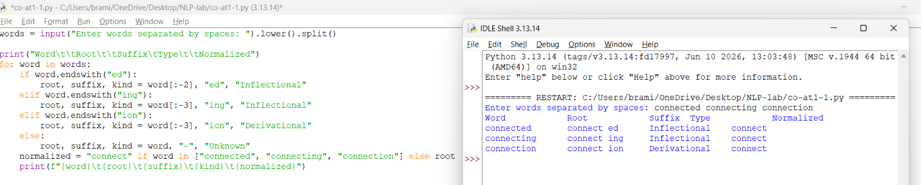
Word Root Suffix Type Normalized
connected connect ed Inflectional connect
connecting connect ing Inflectional connect
connection connect ion Derivational connect

Result Analysis
The program identifies connect as the common root. The endings -ed and -ing represent inflectional forms, while -ion forms the related noun connection and is derivational.

QUESTION 2: MORPHOLOGICAL PARSING FOR SENTIMENT ANALYSIS
Aim: To identify prefixes, suffixes, base forms, and derivational changes in unhappy, happiness, and happily.

Analysis
Word | Prefix | Suffix | Base Form | Type
unhappy | un- | None | happy | Derivational
happiness | None | -ness | happy | Derivational
happily | None | -ly | happy | Derivational

Algorithm
1. Read each input word.
2. Check whether the word starts with un or ends with ness or ly.
3. Identify the base word happy.
4. Classify each transformation as derivational.
5. Display the morphological breakdown and normalized root.
Source Code
words = input("Enter words separated by spaces: ").lower().split()

print("Word\t\tPrefix\tSuffix\tRoot\tType")
for word in words:
if word.startswith("un"):
prefix, suffix, root = "un", "-", word[2:]
elif word.endswith("ness"):
prefix, suffix, root = "-", "ness", "happy"
elif word.endswith("ly"):
prefix, suffix, root = "-", "ly", "happy"
else:
prefix, suffix, root = "-", "-", word
print(f"{word}\t{prefix}\t{suffix}\t{root}\tDerivational")

Sample Output
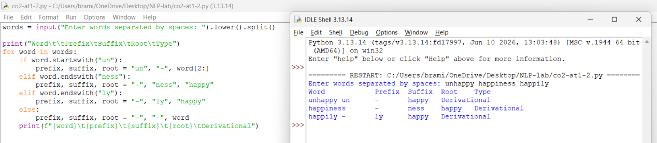
Word Prefix Suffix Root Type
unhappy un - happy Derivational
happiness - ness happy Derivational
happily - ly happy Derivational

Result Analysis
The prefix un- reverses the meaning of happy. The suffixes -ness and -ly create related forms. All three words are derivational forms and are associated with the base happy.

QUESTION 3: STEMMING-BASED SEARCH PREPROCESSING
Aim: To remove affixes from played, player, and playing and normalize them to a common stem for search indexing.

Analysis
Original Word | Removed Affix | Stem | Transformation Type | Normalized Form
played | -ed | play | Inflectional | play
player | -er | play | Derivational | play
playing | -ing | play | Inflectional | play

Algorithm
1. Read each word.
2. Check for the suffix -ed, -er, or -ing.
3. Remove the suffix and identify the stem play.
4. Classify -ed and -ing as inflectional and -er as derivational.
5. Display the original word, removed affix, stem, and normalized form.
Source Code
words = input("Enter words separated by spaces: ").lower().split()

print("Word\t\tStem\tAffix\tType\t\tNormalized")
for word in words:
if word.endswith("ed"):
stem, affix, kind = word[:-2], "ed", "Inflectional"
elif word.endswith("er"):
stem, affix, kind = word[:-2], "er", "Derivational"
elif word.endswith("ing"):
stem, affix, kind = word[:-3], "ing", "Inflectional"
else:
stem, affix, kind = word, "-", "Unknown"
print(f"{word}\t{stem}\t{affix}\t{kind}\t{stem}")
Sample Output

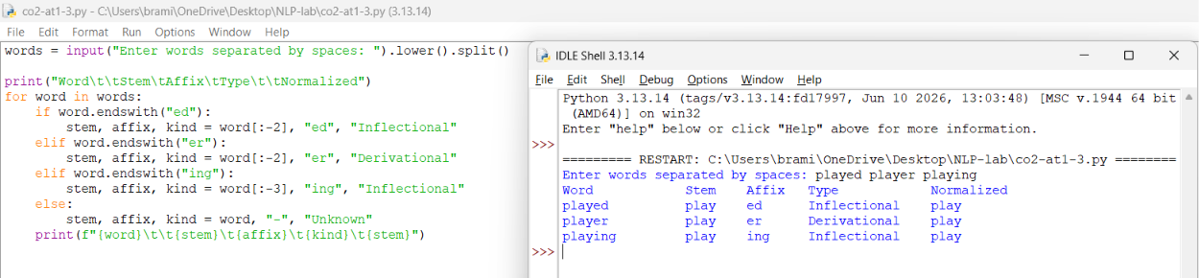
Word Stem Affix Type Normalized
played play ed Inflectional play
player play er Derivational play
playing play ing Inflectional play
Result Analysis
The program maps all three forms to play. Played and playing are grammatical inflections, while player is a derived noun referring to a person who plays.

QUESTION 4: FINITE-STATE MORPHOLOGICAL PARSER
Aim: To model the forms writes, writing, and written using a simple finite-state parsing approach and normalize them to write.

State Model and Analysis
Word | State Transition Path | Morphological Breakdown | Type | Normalized Form
writes | Start → Root → Suffix → Final | write + s | Regular inflection | write
writing | Start → Root → Suffix → Final | write + ing (drop e) | Regular inflection | write
written | Start → Dictionary lookup → Final | irregular form of write | Irregular inflection | write

Algorithm
1. Read each word.
2. Move from the Start state to the root-identification state.
3. For writes and writing, apply the regular suffix rules.
4. For written, use an irregular-form dictionary mapping written to write.
5. Display the transition path, breakdown, type, and normalized root.
Source Code
words = input("Enter words separated by spaces: ").lower().split()
irregular = {"written": "write"}

for word in words:
if word in irregular:
root, parts, kind = irregular[word], "write (irregular form)", "Irregular"
path = "Start -> Dictionary lookup -> Final"
elif word == "writes":
root, parts, kind = "write", "write + s", "Regular"
path = "Start -> Root -> Suffix -> Final"
elif word == "writing":
root, parts, kind = "write", "write + ing (drop e)", "Regular"
path = "Start -> Root -> Suffix -> Final"
else:
print("Word:", word, "- No rule found")
continue

print("Word:", word)
print("Path:", path)
print("Breakdown:", parts)
print("Type:", kind)
print("Normalized:", root)
print()

Sample Output
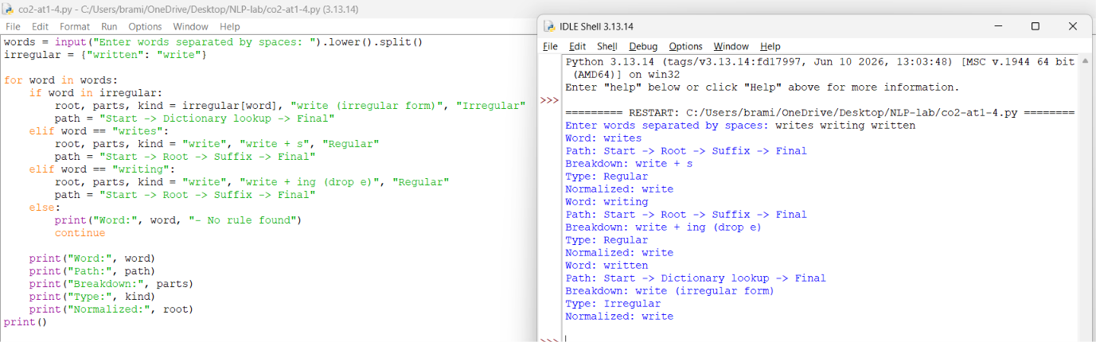
Word: writes
Path: Start -> Root -> Suffix -> Final
Breakdown: write + s
Type: Regular
Normalized: write

Word: writing
Path: Start -> Root -> Suffix -> Final
Breakdown: write + ing (drop e)
Type: Regular
Normalized: write

Word: written
Path: Start -> Dictionary lookup -> Final
Breakdown: write (irregular form)
Type: Irregular
Normalized: write

Result Analysis
The finite-state model handles regular suffixes using rules and handles written through an explicit irregular-form mapping. All three words are normalized to write.

QUESTION 5: PORTER STEMMER FOR DOCUMENT RETRIEVAL
Aim: To apply the Porter Stemmer algorithm to relational, relation, and relate and display their final normalized stems.

Stemming Steps
Original Word | Relevant Porter Rule / Processing | Intermediate Form | Final Stem
relational | ational → ate; then remove final e | relate → relat | relat
relation | remove ion after t | relat | relat
relate | remove final e | relat | relat

Algorithm
1. Import PorterStemmer from nltk.stem.
2. Create a PorterStemmer object.
3. Read the words relational, relation, and relate.
4. Apply the Porter stemming rules to each word.
5. Display each original word and its final stem.
Software Installation
python -m pip install nltk
Source Code
from nltk.stem import PorterStemmer

ps = PorterStemmer()
words = input("Enter words separated by spaces: ").lower().split()

print("Word\t\tFinal Stem")
for word in words:
print(f"{word}\t{ps.stem(word)}")

Sample Output

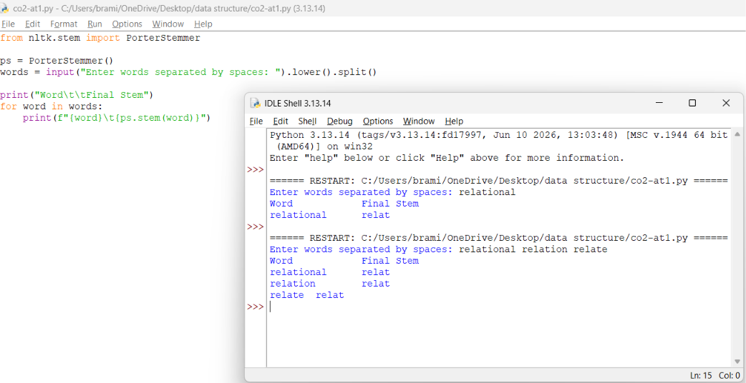
Word Final Stem
relational relat
relation relat
relate relat

Result Analysis
The Porter Stemmer applies ordered suffix-removal rules and reduces the three words to relat. A stem does not always have to be a complete dictionary word; the goal is to group related forms for information retrieval.
CONCLUSION

Morphological analysis helps identify the root words, prefixes, and suffixes of words.

Inflectional morphology explains grammatical changes, such as tense and plural forms, without changing the basic meaning of a word.

Derivational morphology helps create new words by adding prefixes or suffixes to root words.

Stemming reduces related words to a common stem, which is useful in information retrieval and text processing.

Finite-state morphological parsing uses states and transitions to analyze the structure of words.

Regular and irregular word forms can be identified using morphological rules and dictionary entries.

The Porter Stemmer algorithm removes suffixes according to predefined rules to produce word stems.

Python makes it easy to implement morphological analysis and stemming techniques.

User input allows the programs to process different words instead of relying only on predefined examples.

These NLP techniques improve text preprocessing and help search engines retrieve relevant documents efficiently.

