SIMATS ENGINEERING (SAVEETHA SCHOOL OF ENGINEERING) Department of Artificial Intelligence and Data Science
ASSESSMENT TOOL 3 – CODING CHALLENGE
Course Code: | DSA0308 | Course Title: | Natural Language Processing
CO Assessed: | CO1 – Imitation (L1) | Assessment: | Assessment Tool 3 – Coding  Challenge
Weightage: | 30% of CIA
CO5 Statement: | Analyse NLP models, regular expression patterns, finite state automata, morphological processing techniques and to interpret language processing. (BL-3)
Student Name: | J. BRAHMAIAH | Reg. No.: | 192472286
Section / Batch: | CSE-AI | Date: | 15-10-26

Code of Conduct
I J. BRAHMAIAH (192472286) certify that this submission is my original work and that I have adhered to the guidelines specified for this assessment. I understand that any violation of academic integrity rules will result in disciplinary action.
Signature of the Student: J. BRAHMAIAH

Instructions
• Develop a complete and modular Python program that meets all the functional requirements specified in the coding challenge using appropriate algorithms, data structures, and programming practices.
• Test the program using multiple valid and invalid test cases, and clearly display the input, processing, and output to verify the correctness of the implementation.
• Follow standard coding practices by using meaningful variable names, proper indentation, comments, exception handling (where applicable), and upload the source code, sample outputs, and README file to the designated GitHub repository.
• Duration: 40 minutes.

Section / Topic | Focus | Q Nos
Regular Expression Pattern Matching | Regular Expressions, Basic Regular Expression Patterns | 1
Finite State Automata Implementation | Finite State Automata, Models and Algorithms | 2
Advanced Regular Expression Search | Regular Expressions, Basic Regular Expression Patterns | 3

Annexure A – Coding Challenge
Section 1: Intelligent Email and Password Validator using Regular Expressions
1. Problem Statement:
A software company is developing a user registration system. Before creating an account, the system must validate user credentials based on predefined security policies.
Develop a Python application that validates:
Email Address
Password
Mobile Number
using Regular Expressions.
Validation Rules
Email
Must start with an alphabet.
May contain letters, digits, '.', '_' before '@'.
Domain should contain only alphabets.
Valid extensions: .com, .org, .edu, .net, .in
Password
Minimum 8 characters
At least one uppercase letter
At least one lowercase letter
At least one digit
At least one special character (@,#,$,%,&,!)
Mobile Number
Must contain exactly 10 digits.
First digit should be between 6–9.
Expected Output
Display:
Valid Email / Invalid Email
Strong Password / Weak Password
Valid Mobile Number / Invalid Mobile Number

Section 2: Design a Finite State Automata (FSA) Simulator
2. Problem Statement
Develop a Python-based Deterministic Finite Automata (DFA) simulator.
The program should:
• Accept the DFA description
▪ States
▪ Input alphabet
▪ Transition table
▪ Initial state
▪ Final state(s)
• Accept multiple input strings.
• Simulate state transitions.
• Display whether the string is Accepted or Rejected.
Example
Language:
Strings ending with "ab"
Input
abaab

Output
Transition Path:
q0 → q1 → q0 → q1 → q2
Accepted

Section 3: Smart Pattern Matching Engine using Regular Expressions
3. Problem Statement
Develop a Python-based text search engine that performs pattern matching using Regular Expressions.
The system should support:
Word Search
Prefix Search
Suffix Search
Date Search
Phone Number Search
Hashtag Search
Mention (@username) Search
Example Input
Meeting on 12/09/2026
Call 9876543210
#NLP
@OpenAI
natural language processing
User Menu
1.Search Date
2.Search Phone Number
3.Search Hashtag
4.Search Mention
5.Search Prefix
6.Search Suffix
Expected Output
Display all matching patterns based on user selection.

Aim
To develop simple Python programs that validate user details, simulate a Deterministic Finite Automaton (DFA), and identify common patterns in text using regular expressions.

Software Requirements
- Python 3.13.14
- Command Prompt or terminal

QUESTION 1: INTELLIGENT EMAIL AND PASSWORD VALIDATOR
This program checks whether an email address follows the required format, whether a password contains the required character types, and whether a mobile number contains ten digits starting from 6 to 9.

Source code:
import re

def check_email(email):
pattern = r"[A-Za-z][A-Za-z0-9._]*@[A-Za-z]+\.(com|org|edu|net|in)"
return re.fullmatch(pattern, email, re.IGNORECASE) is not None

def check_password(password):
return (
len(password) >= 8
and re.search(r"[A-Z]", password)
and re.search(r"[a-z]", password)
and re.search(r"[0-9]", password)
and re.search(r"[@#$%&!]", password)
)

def check_mobile(mobile):
return re.fullmatch(r"[6-9][0-9]{9}", mobile) is not None

def main():
print("EMAIL, PASSWORD AND MOBILE VALIDATOR")

email = input("Enter email: ").strip()
password = input("Enter password: ")
mobile = input("Enter mobile number: ").strip()

if check_email(email):
print("Email: Valid")
else:
print("Email: Invalid")

if check_password(password):
print("Password: Strong")
else:
print("Password: Weak")

if check_mobile(mobile):
print("Mobile number: Valid")
else:
print("Mobile number: Invalid")

main()

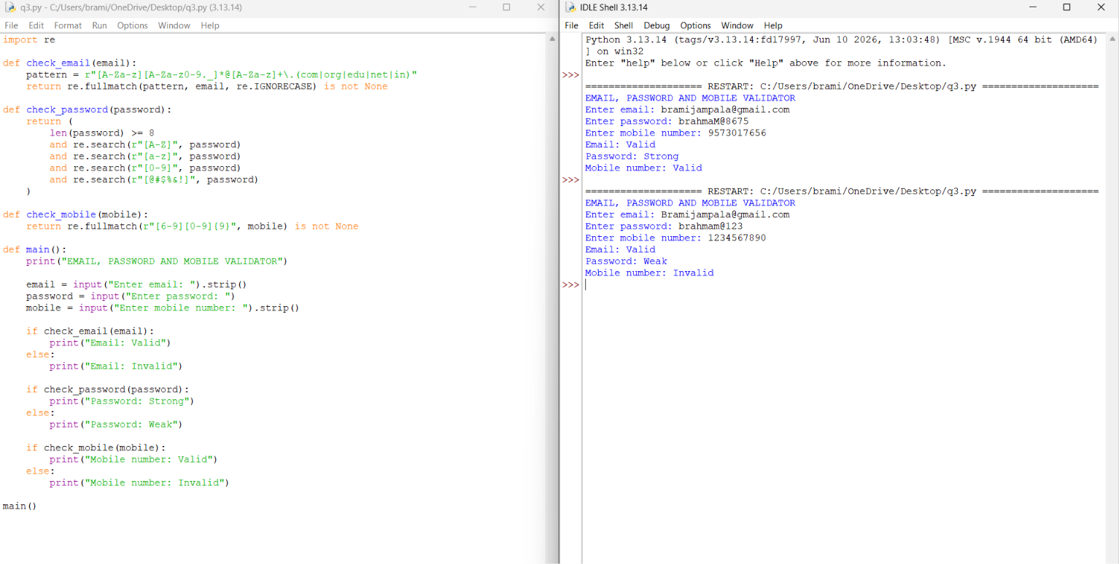

Valid Test Case
Enter email: student@simats.edu
Enter password: Student@123
Enter mobile number: 9876543210
Email: Valid
Password: Strong
Mobile number: Valid

Invalid Test Case
Enter email: studentgmail.com
Enter password: student
Enter mobile number: 1234567890
Email: Invalid
Password: Weak
Mobile number: Invalid

Result Analysis
The valid test case passes all three checks. The invalid email is missing the @ symbol, the weak password does not contain the required combination of characters, and the mobile number does not start with a digit from 6 to 9. The program reports each result separately.

QUESTION 2: DFA SIMULATOR
This program simulates a DFA by reading the current state and input symbol, following the corresponding transition, and checking whether the final state belongs to the set of accepting states.
Example DFA: the machine accepts strings that end with the sequence 'ab'.
Current State | Input Symbol | Next State
q0 | a | q1
q0 | b | q0
q1 | a | q1
q1 | b | q2
q2 | a | q1
q2 | b | q0

Source code:
def simulate_dfa(states, alphabet, transitions, initial, finals, value):
current = initial
path = [current]

for symbol in value:
if symbol not in alphabet:
return False, path, "Invalid alphabet symbol"

key = (current, symbol)

if key not in transitions:
return False, path, "Transition not found"

current = transitions[key]
path.append(current)

return current in finals, path, ""

def main():
print("QUESTION 2: DFA SIMULATOR")

states = input("Enter states separated by spaces: ").split()
alphabet = input("Enter alphabet symbols separated by spaces: ").split()

if not states or not alphabet:
print("States and alphabet cannot be empty.")
return

initial = input("Enter initial state: ").strip()

if initial not in states:
print("Invalid initial state.")
return

finals = input("Enter final states separated by spaces: ").split()

if not finals or any(state not in states for state in finals):
print("Invalid final state.")
return

transitions = {}

for state in states:
for symbol in alphabet:
next_state = input(
f"From {state} on {symbol}, enter next state: "
).strip()

if next_state not in states:
print("Invalid transition state.")
return

transitions[(state, symbol)] = next_state

try:
count = int(input("How many strings do you want to test? "))

if count < 1:
print("Enter at least one string.")
return

except ValueError:
print("Please enter a valid number.")
return

for i in range(count):
value = input(f"Enter string {i + 1}: ")

accepted, path, error = simulate_dfa(
states, alphabet, transitions, initial, finals, value
)

print("Input string:", repr(value))
print("Transition path:", " -> ".join(path))

if error:
print("Result: REJECTED")
print("Reason:", error)
elif accepted:
print("Result: ACCEPTED")
else:
print("Result: REJECTED")

main()
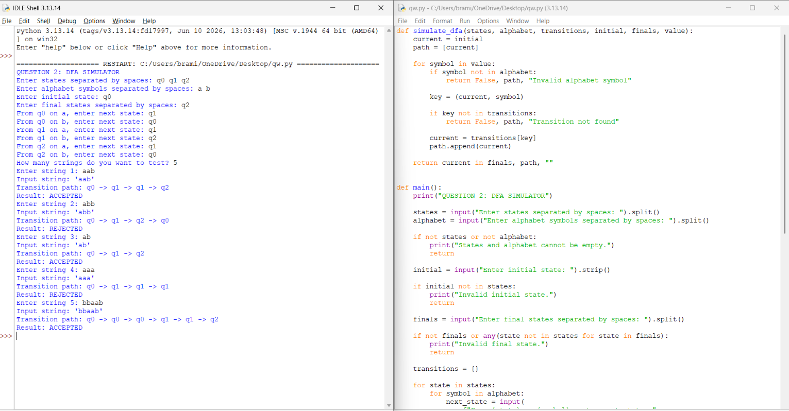

DFA Setup
States: q0 q1 q2
Alphabet: a b
Initial state: q0
Final state: q2

Valid Test Case
Enter string: aab
Transition path: q0 -> q1 -> q1 -> q2
Result: ACCEPTED

Invalid Test Case
Enter string: aba
Transition path: q0 -> q1 -> q2 -> q1
Result: REJECTED

Invalid State Test
Enter states: q0 q1 q2
Enter final state(s): q2w
Output: Invalid final state.

Result Analysis
The string 'aab' ends in final state q2, so it is accepted. The string 'aba' ends in q1, which is not a final state, so it is rejected. The program also rejects a final state that was not included in the state list.

QUESTION 3: SMART PATTERN MATCHING ENGINE
This program uses regular expressions to search a text for dates, ten-digit mobile numbers, hashtags, mentions, words, prefixes, and suffixes.

Source code:
import re

def find_pattern(text, choice, word=""):
patterns = {
"1": r"(?<!\w)" + re.escape(word) + r"(?!\w)",
"2": r"\b\d{1,2}[/-]\d{1,2}[/-]\d{4}\b",
"3": r"\b[6-9]\d{9}\b",
"4": r"(?<!\w)#[A-Za-z0-9_]+",
"5": r"(?<!\w)@[A-Za-z0-9_]+",
"6": r"\b" + re.escape(word) + r"\w*",
"7": r"\b\w*" + re.escape(word) + r"\b"
}

if choice not in patterns:
return []

return re.findall(patterns[choice], text, re.IGNORECASE)

def main():
print("QUESTION 3: SMART PATTERN MATCHING ENGINE")

text = input("Enter text: ")

while True:
print("\n1. Word Search")
print("2. Date Search")
print("3. Phone Number Search")
print("4. Hashtag Search")
print("5. Mention Search")
print("6. Prefix Search")
print("7. Suffix Search")
print("8. Exit")

choice = input("Choose an option (1-8): ").strip()

if choice == "8":
print("Program ended.")
break

if choice not in ["1", "2", "3", "4", "5", "6", "7"]:
print("Invalid option. Try again.")
continue

word = ""

if choice in ["1", "6", "7"]:
word = input("Enter search word: ").strip()

if not word:
print("Search word cannot be empty.")
continue

result = find_pattern(text, choice, word)

print("Matching results:", result)
print("Total matches:", len(result))

if not result:
print("No matching pattern found.")

main()
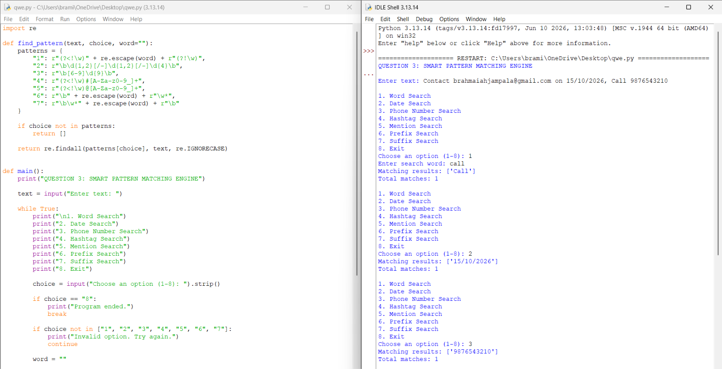

Sample Text
Contact brahmaiahjampala@gmail.com on 15/10/2026.
Call 9876543210. Follow #natural_learning_processing and @brahmaiah
Python programming is useful.

Test Cases and Expected Outputs
Date search (option 2)
Matching results: ['15/10/2026']
Total matches: 1
Phone search (option 3)
Matching results: ['9876543210']
Total matches: 1
Hashtag search (option 4)
Matching results: ['# natural_learning_processing ']
Total matches: 1
Mention search (option 5)
Matching results: ['@brahmaiah']
Total matches: 1
Word search (option 1), search word Python
Matching results: ['Python']
Total matches: 1
Invalid menu choice (option 9)
Invalid option.

Prefix and Suffix Search Examples
In the supplied code, option 6 searches for words beginning with the entered text. Option 7 searches for words ending with the entered text. For a suffix test, use text 'playing saying walking' and search word 'ing'. If the code uses the exact suffix pattern, the expected matches are playing, saying, and walking.

Result Analysis
The program finds matching patterns in the given text and displays the matches and their count. If the selected menu option is outside 1 to 7, it displays an invalid-option message. If no match is present, it reports that no matching pattern was found.

Overall Algorithm
- Read the user's input.
- Validate email, password, and mobile number using regular expressions and conditions.
- For the DFA, read states, alphabet, initial state, final states, and transitions.
- Process each input string by following the DFA transition table.
- For pattern matching, select the required pattern and search the supplied text.
- Display valid/invalid, accepted/rejected, or matching-pattern results.

Conclusion
The three programs demonstrate basic text validation, finite-state simulation, and pattern matching in Python. Testing with valid and invalid inputs helps confirm that the programs handle normal cases and common errors and display understandable results.
1. Email, Password and Mobile Number Validator: Regular expressions and conditional statements were used to validate user details and identify valid and invalid inputs.
2. DFA Simulator: The program demonstrated how a Deterministic Finite Automaton processes input strings using states, alphabet symbols, and transition rules to determine whether a string is accepted or rejected.
3. Smart Pattern Matching Engine: Regular expressions were used to identify dates, phone numbers, hashtags, mentions, words, prefixes, and suffixes from the given text.
4. Input Validation: Both valid and invalid test cases were tested to check the correctness of the programs and handle incorrect inputs.
5. Error Handling: The programs were designed to display suitable messages for invalid states, unsupported symbols, and incorrect menu selections.
6. Modular Programming: Dividing the programs into separate functions made the code easier to understand, test, maintain, and modify.
7. Practical Application: These techniques are useful in online registration forms, password validation, text searching, data cleaning, and language-processing applications.
8. Overall Outcome: The assessment improved understanding of Python programming, regular expressions, finite-state machines, and systematic testing.

Rubrics for Calculation
Criteria | Weightage | Level 4 –  Exemplary | Level 3 –  Proficient | Level 2 –  Developing | Level 1 –  Beginning
Problem  Understanding | 20% | Clearly  understands  problem  constraints, edge cases, and  competitive  requirements | Understands  problem with minor gaps in constraints | Partial  understanding;  misses key  constraints | Misinterprets  problem or  constraints
Algorithm | 25% | Selects optimal  algorithm with best time and space  complexity for  competitive  constraints | Uses efficient  algorithm with  minor scope for  improvement | Uses  basic/inefficient  approach | No clear  algorithmic  approach
Code  Implementation | 20% | Writes correct,  efficient, and clean code that passes all constraints | Code works with minor errors or  inefficiencies | Partially correct  code; fails for some cases | Code does not  execute or gives incorrect results
Competitive  Performance | 20% | Solves problem  within time limits and handles large inputs effectively | Solves within  acceptable time  with minor delays | Struggles with time limits or larger  inputs | Unable to solve  within time  constraints
Test Case  Handling | 15% | Handles all test  cases including  edge and hidden cases | Handles most test cases | Misses important edge cases | Fails on multiple test cases

Q. No. / Criteria | Problem  Understanding | Algorithm | Code  Implementat ion | Competitive Performance | Test Case Handling | Sub.  Total | Total  %
1
2
3

Faculty In-charge | Course Coordinator | Program Director
Signature: _______________ | Signature: _______________ | Signature: _______________
Date: ___________________ | Date: ___________________ | Date: ___________________

