A* PYTHON CODE

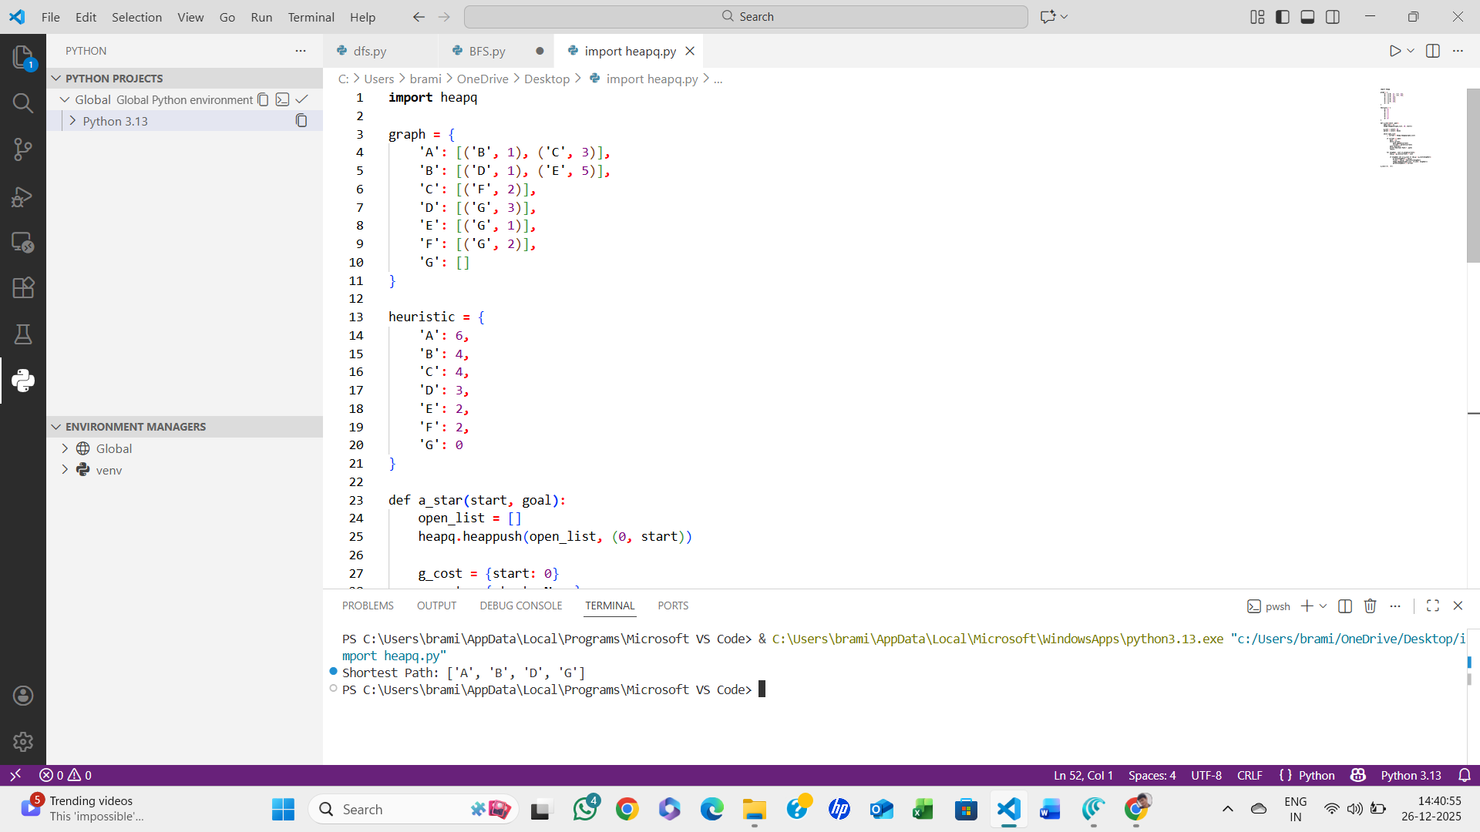

ALGORITHM:
- Start
- Define the graph with edge costs
- Define heuristic values for each node
- Initialize:
  - Open list (priority queue)
  - Cost from start g(n)
  - Parent dictionary
- Add start node to open list
- Repeat until open list is empty:
  - Select node with minimum f(n) = g(n) + h(n)
  - If node is goal → construct path and stop
  - For each neighbor:
    - Compute new cost
    - Update cost and parent if better path found
- Stop

