CAP (Crypt Arithmetic Problem)

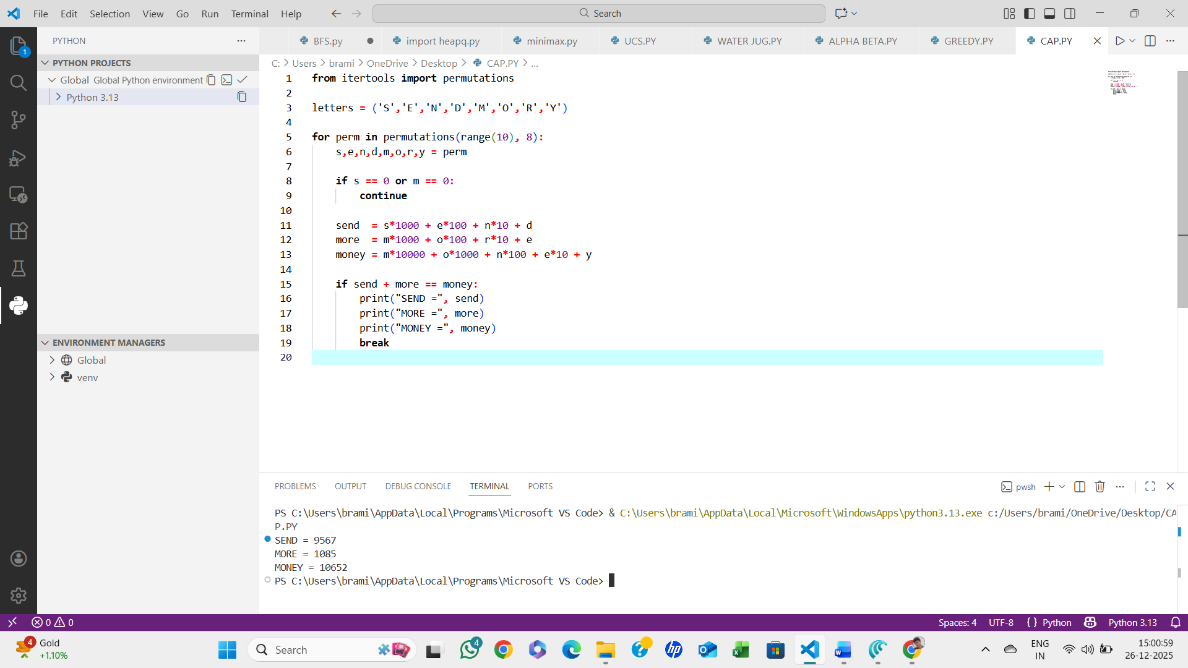

ALGORITHM:
- Take the given arithmetic expression
- Assign digits (0–9) to letters uniquely
- Ensure no leading letter is zero
- Check if the arithmetic constraint is satisfied
- Print valid solution(s)
- STOP.

