BFS PYTHON
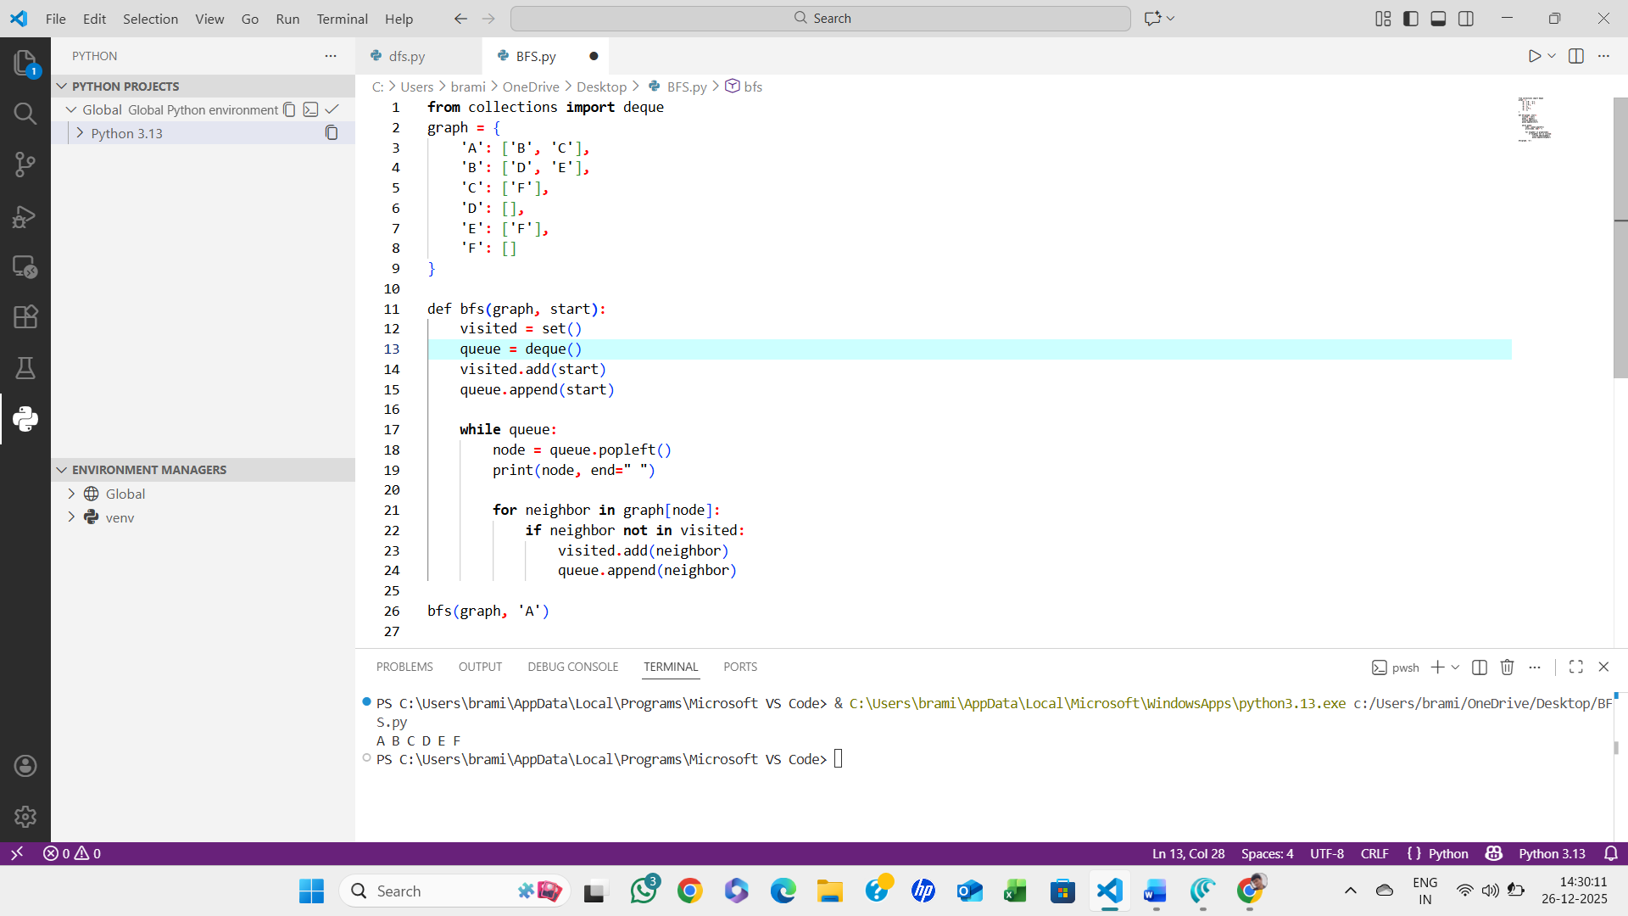

ALGORITHM:
- Start
- Create an empty set called visited
- Create an empty queue
- Add the starting node to visited
- Insert the starting node into the queue
- While the queue is not empty:
  - Remove the front node from the queue
  - Print the removed node
  - For each neighbor of the current node:
    - If the neighbor is not in visited:
      - Add it to visited
      - Insert it into the queue
- Repeat until the queue becomes empty
- Stop

