DFS

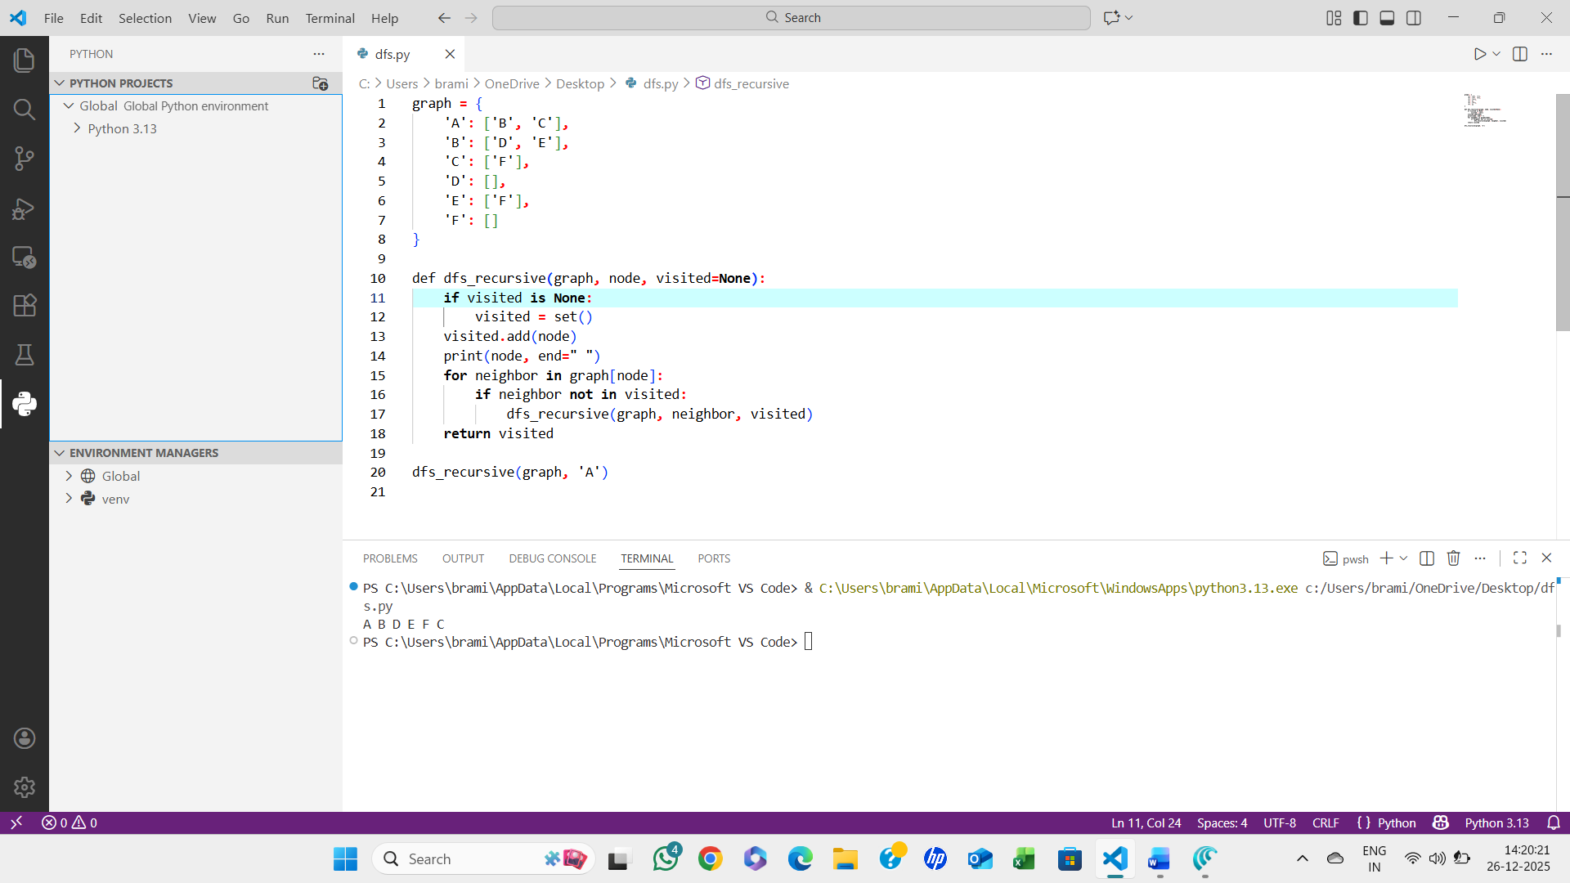

ALGORITHM:
- Start
- Create a function dfs_recursive(graph, node, visited)
- If visited is empty, initialize it as an empty set
- Add the current node to the visited set
- Print the current node
- For each neighbor of the current node in the graph:
  - If the neighbor is not in visited:
    - Recursively call dfs_recursive(graph, neighbor, visited)
- Repeat until all reachable nodes are visited
- Stop

