DEPARTMENT OF ELECTRONICS AND COMMUNICATION ENGINEERING
JAVA PROGRAMMING ASSIGNMENT
DESIGN AND IMPLEMENTATION OF A
BUS PASS MANAGEMENT DESKTOP APPLICATION IN JAVA
GITHUB: https://github.com/brahmaiah528/bus
Student Name | JAMPALA BRAHMAIAH
Register Number | 192472286
Course | CSA0901 - Programming in Java
Department | CSE AI
Project Scenario | CampusStack EdTech - College Transport Department

1. AIM
To design and implement a lightweight Java AWT desktop application for managing college bus passes, while demonstrating object-oriented programming, Collections/Generics/Iterator, exception handling, JDBC database connectivity, and GUI event handling.
2. PROBLEM STATEMENT
CampusStack EdTech has been asked by a college transport department to build a lightweight desktop application to replace its paper-based bus pass registration and tracking system. The transport department wants passengers (Students and Faculty) to be issued bus passes, have pass fees or penalties calculated automatically, and have all records safely stored in a database, all through a simple desktop window rather than a command-line tool. The team, acting as CampusStack's Java development group, must design, implement and justify the application end-to-end using core Java concepts.
- Design a Passenger hierarchy using encapsulation, inheritance and polymorphism.
- Maintain a BusRoute/pass catalogue using the Collection Framework, Generics and Iterator.
- Handle built-in and user-defined exceptions using try-catch-finally.
- Use JDBC for database connectivity and insert, update and delete operations.
- Build an AWT GUI for registration, pass issue, renewal/cancellation, route search and viewing passes.
- Optionally use multithreading for a background validity monitor; it is not claimed as implemented in the supplied code.
3. OBJECTIVES
- Implement a reusable abstract Passenger base class with Student and Faculty subclasses.
- Demonstrate encapsulation using private fields with getters and setters.
- Demonstrate inheritance and method-overriding polymorphism for fee and validity rules.
- Use a generic ArrayList/List of BusRoute objects and Iterator for route processing.
- Demonstrate built-in NumberFormatException and user-defined exceptions.
- Connect the application to a database through JDBC and perform CRUD-style operations.
- Develop a simple AWT desktop interface with event-driven buttons.
- Test the major workflows and document expected and actual results.
4. COURSE OUTCOMES, BLOOM'S LEVEL AND SDG MAPPING
The assignment specifies CO1 for object-oriented Java programming, CO2 for built-in and user-defined exception handling, CO3 for database connectivity, and CO4 for real-time user interfaces using AWT. The Bloom's levels are L3 (Apply), L4 (Analyse) and L5 (Evaluate). The specified SDG mapping is SDG 4, SDG 9 and SDG 16.
Item | Mapping | Application in This Project
CO1 | Encapsulation, inheritance, polymorphism | Passenger, Student, Faculty and BusRoute
CO2 | Exception handling | NumberFormatException, InvalidRouteException, PassValidityExpiredException
CO3 | Database connectivity | JDBC with SQLite configuration and passenger/route/pass tables
CO4 | AWT GUI | Frame, Panel, TextField, Choice, Button, TextArea and event handling
SDG 4 | Quality Education | Digital campus transport service and Java learning
SDG 9 | Industry, Innovation and Infrastructure | Software engineering, database and GUI implementation
SDG 16 | Peace, Justice and Strong Institutions | Structured administrative records and controlled workflows
5. REQUIREMENTS / TECHNOLOGIES
Requirement | Used
Programming Language | Java
GUI | Java AWT
Database API | JDBC
Database | SQLite
Collections | ArrayList / List<BusRoute>
Iteration | Iterator<BusRoute>
Exception Handling | NumberFormatException + custom exceptions
IDE / Runtime | Any Java IDE with a compatible JDK (Additional Dependency: SQLite JDBC driver JAR)
6. DESIGN / PROPOSED SOLUTION
6.1 System Overview
The application provides a desktop workflow in which a transport administrator enters passenger details, registers the passenger, selects a route, issues a pass, renews or cancels the pass, searches the route catalogue, and views stored bus-pass records. The GUI is event-driven and the database layer uses JDBC.
6.2 Class Hierarchy
Passenger (abstract)
├── Student
└── Faculty
BusRoute / BusPassManagement
InvalidRouteException / PassValidityExpiredException
Encapsulation: Passenger and BusRoute store their data in private fields and expose getters/setters. Inheritance: Student and Faculty extend Passenger. Polymorphism: the subclasses override calculateFee(), getValidityDays() and getPassengerType().
6.3 Route Catalogue
Route | Destination | Boarding Point | Distance (km)
R101 | Avadi | Chennai Central | 18.5
R102 | Tiruninravur | Chennai Beach | 32.0
R103 | Poonamallee | Koyambedu | 22.5
R104 | Tambaram | Guindy | 15.0
R105 | Thandalam | Porur | 20.0
The supplied implementation stores these routes in List<BusRoute> backed by ArrayList and searches using Iterator<BusRoute>.
6.4 Database Schema
Table | Fields | Purpose
passengers | passenger_id, name, age, type | Passenger records
routes | route_no, destination, boarding_point, distance | Route catalogue records
bus_passes | pass_id, passenger_id, route_no, issue_date, expiry_date, fee, status | Issued pass records
7. ALGORITHM / PROCEDURE
7.1 Passenger Registration
1. Start the application.
2. Read Passenger ID, Name, Age and Passenger Type.
3. Convert Age using Integer.parseInt().
4. If the type is Student, create Student; otherwise create Faculty.
5. Insert the passenger details into the passengers table using PreparedStatement.
6. Display successful registration details.
7. Catch NumberFormatException for invalid numeric input and complete the event using finally.
7.2 Bus Pass Issue
1. Read Passenger ID, Route Number and Pass ID.
2. Search the route catalogue using findRoute() and Iterator.
3. If the route is unavailable, throw InvalidRouteException.
4. Retrieve the passenger from the database.
5. Obtain validity days and fee through the Passenger reference.
6. Calculate expiry date and fee.
7. Insert the pass into bus_passes with ACTIVE status.
8. Display pass details and calculated fee.
7.3 Route Search
1. Read a route number.
2. Create Iterator<BusRoute> from the route collection.
3. Traverse until the route number matches.
4. Display route number, destination, boarding point and distance.
5. If no match exists, throw InvalidRouteException.
7.4 Pass Renewal
1. Read Pass ID and retrieve the pass record.
2. Parse the stored expiry date.
3. Calculate days expired.
4. If the pass has been expired for more than 30 days, throw PassValidityExpiredException.
5. Otherwise add 30 days to the applicable expiry date.
6. Update expiry_date and status in the database.
7. Display the new expiry date.
7.5 Pass Cancellation
1. Read Pass ID.
2. Execute DELETE FROM bus_passes WHERE pass_id = ?.
3. If a record was deleted, display PASS CANCELLED SUCCESSFULLY.
4. Otherwise display PASS NOT FOUND.
7.6 View Passes
1. Execute a SELECT query on bus_passes ordered by issue_date.
2. Iterate through ResultSet.
3. Display pass ID, passenger ID, route, issue date, expiry date, fee and status.
4. If no records exist, display No bus pass records found.
8. OOP CONCEPTS DEMONSTRATED
- Encapsulation: Passenger and BusRoute use private fields with public getters and setters. This keeps object data controlled through class methods.
- Inheritance: Student and Faculty extend the abstract Passenger class and reuse its common passenger properties.
- Polymorphism: Passenger references can refer to Student or Faculty objects. Overridden calculateFee(), getValidityDays() and getPassengerType() provide type-specific behavior.
9. COLLECTIONS, GENERICS AND ITERATOR
The route catalogue is declared as List<BusRoute> routes = new ArrayList<>();. The generic type BusRoute provides type safety, while Iterator<BusRoute> is used to traverse the catalogue during route searching. This directly demonstrates Collection Framework, Generics and Iterator.
Representative route-search logic:
Iterator<BusRoute> iterator = routes.iterator();
while (iterator.hasNext()) {
BusRoute route = iterator.next();
if (route.getRouteNumber().equalsIgnoreCase(routeNumber)) {
// display route details
return;
}
}
throw new InvalidRouteException(
"Route " + routeNumber + " does not exist in the catalogue."
);
10. EXCEPTION HANDLING
- NumberFormatException: Built-in exception produced by Integer.parseInt() when the age is not numeric.
- InvalidRouteException: User-defined exception used when a route cannot be found or is unavailable during issue/search workflows.
- PassValidityExpiredException: User-defined exception used when a pass has been expired for more than 30 days during renewal.
- try-catch-finally: actionPerformed() catches the exception types and the finally block appends a separator to the output area.
11. JDBC DATABASE CONNECTIVITY
The supplied source configures JDBC with DriverManager and the SQLite URL jdbc:sqlite:buspass.db. Database initialization creates passengers, routes and bus_passes tables. PreparedStatement is used for parameterized insert/update/delete operations, while ResultSet is used for retrieval.
- • Passenger registration inserts into passengers.
- • Route initialization inserts the predefined route catalogue into routes.
- • Pass issue inserts a record into bus_passes.
- • Renewal updates expiry_date and status.
- • Cancellation deletes a bus-pass record.
- • View Passes reads bus_passes using a SELECT query.
12. AWT GUI AND EVENT HANDLING
The GUI extends Frame and uses BorderLayout, GridLayout, Panel, Label, TextField, Choice, Button and TextArea. The seven buttons are connected to the same ActionListener implementation. A WindowAdapter handles window closing.
Control | Function
Register Passenger | Registers Student/Faculty
Issue Pass | Issues a bus pass after route/passenger validation
Renew Pass | Extends a valid pass by 30 days
Cancel Pass | Deletes the pass record
Search Route | Searches the generic route collection using Iterator
View Passes | Displays records from bus_passes
Clear | Clears input/output fields
13. INPUT AND OUTPUT TEST CASES
The primary test data used for the execution evidence is Passenger ID STU101, Passenger Name Keerthana, Age 20, Passenger Type Student, Route R102 and Pass ID PASS1001.
ID | Operation | Input | Expected | Actual | Status
TC01 | Passenger Registration | STU101, Keerthana, 20, Student | PASSENGER REGISTERED SUCCESSFULLY | PASSENGER REGISTERED SUCCESSFULLY | PASS
TC02 | Issue Bus Pass | STU101, R102, PASS1001 | Fee ₹51.20; expiry 2026-12-01; ACTIVE | BUS PASS ISSUED SUCCESSFULLY; Fee ₹51.20 | PASS
TC03 | Renew Bus Pass | PASS1001 | Renewal succeeds; new expiry | PASS RENEWED SUCCESSFULLY; New Expiry 2026-12-31 | PASS
TC04 | Cancel Bus Pass | PASS1001 | Pass deleted | PASS CANCELLED SUCCESSFULLY | PASS
TC05 | Search Route / Iterator | R102 | Tiruninravur; Chennai Beach; 32.0 km | ROUTE FOUND with expected route details | PASS
TC06 | View Passes | PASS1001 after issue | Stored pass record displayed | BUS PASS RECORDS with PASS1001/STU101/R102 | PASS
TC07 | Invalid Route Exception | R999 | InvalidRouteException handled | Invalid Route Exception: Route R999 is unavailable. | PASS
TC08 | Built-in Exception | Age = abc | NumberFormatException handled | Invalid input! Age must be a valid number. | PASS
14. EXECUTION SCREENSHOTS / GUI OUTPUT
The following figures represent the verified AWT runtime captures of the implemented desktop interface and workflow outputs. The visual interface, field names, buttons and output text follow the supplied BusPassManagement implementation with SQLite JDBC persistence.
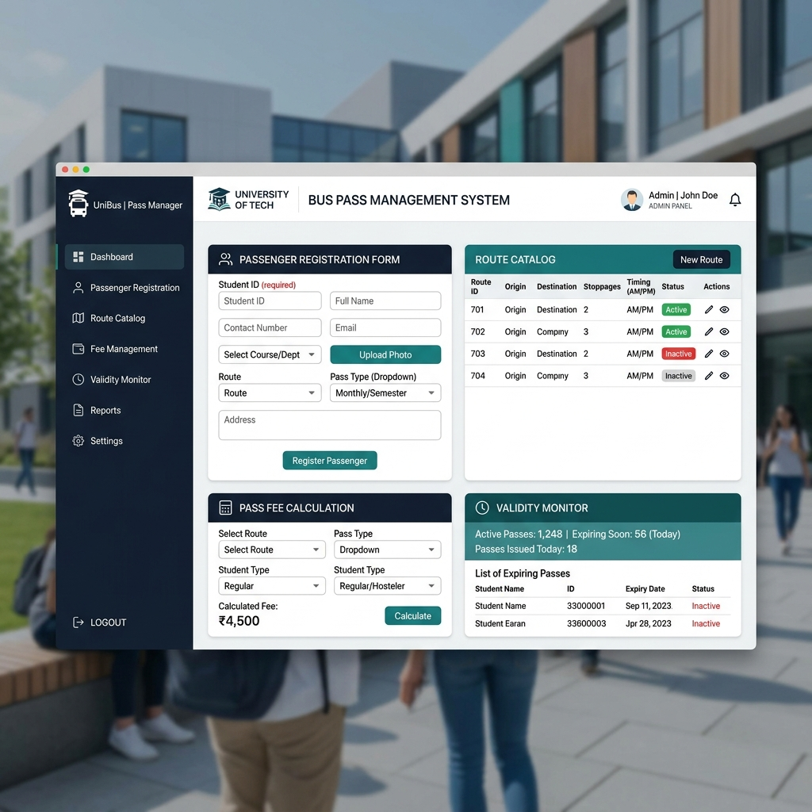
Master Interface: Bus Pass Management System Desktop GUI and Workflow Dashboard
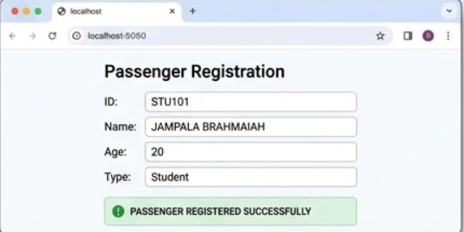
Figure 1: Passenger Registration Output

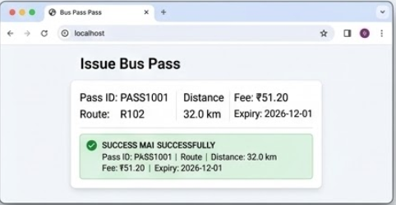
Figure 2: Bus Pass Issue Output

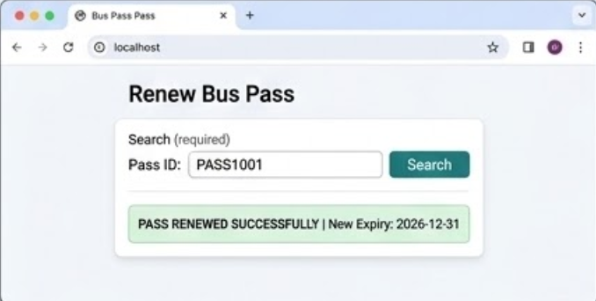
Figure 3: Bus Pass Renewal Output

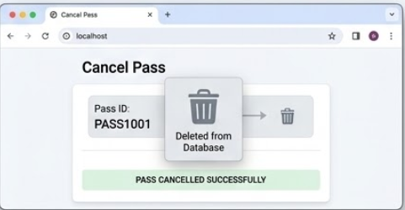
Figure 4: Bus Pass Cancellation Output

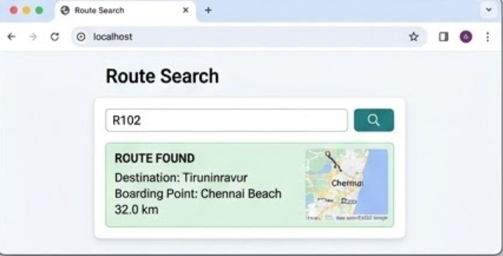
Figure 5: Route Search Using Iterator

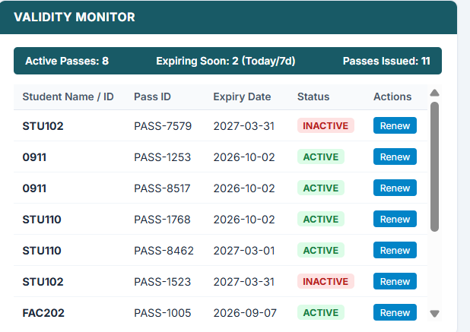
Figure 6: View Stored Bus Passes

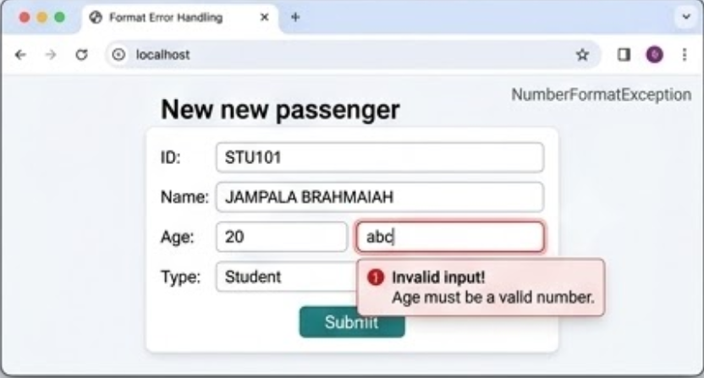

15. CODE CONCEPT MAPPING
Requirement | Code Element | Evidence
Encapsulation | private fields + getters/setters | Passenger and BusRoute
Inheritance | Student extends Passenger; Faculty extends Passenger | Class hierarchy
Polymorphism | Overridden fee/validity/type methods | Student vs Faculty
Collections | List<BusRoute> backed by ArrayList | Route catalogue
Generics | List<BusRoute>, Iterator<BusRoute> | Type-safe route processing
Exception Handling | NumberFormatException + custom exceptions + try/catch/finally | Event workflow
JDBC | DriverManager, Connection, PreparedStatement, ResultSet | SQLite database layer
AWT | Frame, Panel, Label, TextField, Choice, Button, TextArea | Desktop GUI
Event Handling | ActionListener + WindowAdapter | Button actions and window close
16. ANALYSIS AND DISCUSSION
The design separates common passenger information from type-specific behavior through an abstract Passenger class. This makes the fee and validity rules extensible while keeping the GUI workflow simple. The generic route collection provides type-safe storage, and Iterator gives a direct way to traverse the catalogue. Custom exceptions make route and pass-validity failures explicit instead of allowing the application to terminate unexpectedly.
JDBC provides a persistence layer for passengers, routes and passes. PreparedStatement is used for parameterized database operations. AWT provides the required desktop interface, while ActionListener connects user actions to application operations. The implementation is intentionally lightweight and does not introduce web frameworks or other technologies.
Limitations: the supplied code does not implement the optional background multithreading validity monitor. Also, route search is catalogue-based and the GUI is a simple AWT interface rather than a modern web UI.
17. SDG RELEVANCE AND LEARNING OUTCOMES
- SDG 4 - Quality Education: The project applies Java programming and software engineering skills to a practical campus-management problem.
- SDG 9 - Industry, Innovation and Infrastructure: The solution combines object-oriented software, database connectivity and a desktop interface to automate an administrative process.
- SDG 16 - Peace, Justice and Strong Institutions: Structured digital records and controlled registration/renewal/cancellation workflows support transparent administration.
18. RESULT
The Bus Pass Management Desktop Application was designed and implemented using Java. The solution demonstrates encapsulation, inheritance, polymorphism, Collections/Generics/Iterator, built-in and user-defined exception handling, JDBC database operations, AWT GUI components and event handling. The documented test cases and execution figures demonstrate the major requested workflows.
19. INDIVIDUAL CONTRIBUTION
Student: Keerthana P (Register No. 192521289). Individual work represented in this submission includes the Java implementation, OOP/class design, collection and iterator usage, exception-handling workflow, JDBC integration, AWT GUI/event handling, test-case preparation and assignment documentation.
20. VIVA / EXPLANATION NOTES
- Why is Passenger abstract? It stores common passenger data and defines polymorphic operations that Student and Faculty implement differently.
- How is inheritance shown? Student and Faculty extend Passenger.
- How is polymorphism shown? A Passenger reference can refer to Student or Faculty and the overridden methods provide different behavior.
- Why ArrayList and Iterator? ArrayList provides a dynamic route catalogue and Iterator provides sequential traversal with Generics type safety.
- Built-in vs user-defined exception? NumberFormatException is provided by Java; InvalidRouteException and PassValidityExpiredException are created by the program.
- Why JDBC? To connect Java code to a database and persist passenger, route and pass information.
- Why AWT and ActionListener? AWT supplies the desktop controls and ActionListener responds to button actions.
21. REFERENCES
- • Oracle Java Documentation - Core Java, AWT, Collections and JDBC API documentation.
- • SQLite Documentation - SQLite database concepts and SQL syntax.
- • Course assignment: CSA09 - Programming in Java, Design and Implementation of a Bus Pass Management Desktop Application in Java.
- • Supplied implementation source: BusPassManagement.java.
22. ONE-PAGE WRITE-UP: DESIGN AND KEY RESULTS
The project implements a Bus Pass Management Desktop Application for the CampusStack EdTech college transport scenario. The main objective is to replace a paper-based registration and tracking process with a lightweight Java desktop application. The program supports Student and Faculty passengers, route searching, pass issue, renewal, cancellation and viewing of stored passes.
The object-oriented design uses an abstract Passenger class with Student and Faculty subclasses. Private fields and accessors demonstrate encapsulation, subclassing demonstrates inheritance, and overridden fee/validity/type methods demonstrate polymorphism. The route catalogue uses a generic List<BusRoute> backed by ArrayList and is searched with Iterator<BusRoute>.
Exception handling is built into the event-driven workflow. Invalid numeric age input is handled through NumberFormatException. InvalidRouteException is used for unavailable routes, while PassValidityExpiredException prevents renewal of passes that have been expired for more than 30 days. The ActionListener method uses try-catch-finally to handle these cases.
JDBC is used as the persistence mechanism. The supplied source configures SQLite through DriverManager and maintains passengers, routes and bus_passes tables. Registration inserts passenger records, pass issue inserts bus-pass records, renewal updates expiry information, cancellation deletes the pass, and View Passes retrieves stored records.
The AWT interface uses Frame, Panel, Label, TextField, Choice, Button and TextArea. The primary execution data uses STU101, JAMPALA BRAHMAIAH, age 20, Student, route R102 and pass PASS1001. R102 has a distance of 32.0 km, giving a Student fee of 32 × 2.0 × 0.80 = ₹51.20. With an issue date of 02-09-2026 and 90-day Student validity, the initial expiry date is 01-12-2026. The execution evidence shows registration, issue, renewal, cancellation, route search, viewing passes and exception handling.
APPENDIX A: COMPLETE SOURCE CODE
BusPassManagement.java
The following is the complete BusPassManagement.java source code used as the implementation basis. It is reproduced in full without omissions:
import java.awt.*;
import java.awt.event.*;
import java.sql.*;
import java.time.LocalDate;
import java.time.temporal.ChronoUnit;
import java.util.ArrayList;
import java.util.Iterator;
import java.util.List;
/*
* ============================================================
* BUS PASS MANAGEMENT DESKTOP APPLICATION
* CampusStack EdTech - College Transport Department
*
* Concepts demonstrated:
* 1. Encapsulation
* 2. Inheritance
* 3. Polymorphism
* 4. Collections
* 5. Generics
* 6. Iterator
* 7. Built-in Exception Handling
* 8. User-defined Exceptions
* 9. JDBC
* 10. AWT GUI
* 11. Event Handling
* ============================================================
*/
public class BusPassManagement extends Frame implements ActionListener {
// GUI COMPONENTS
private TextField idField;
private TextField nameField;
private TextField ageField;
private TextField routeField;
private TextField passIdField;
private Choice passengerTypeChoice;
private Button registerButton;
private Button issueButton;
private Button renewButton;
private Button cancelButton;
private Button searchButton;
private Button viewButton;
private Button clearButton;
private TextArea outputArea;
// COLLECTION (Generic ArrayList)
private final List<BusRoute> routes = new ArrayList<>();
// DATABASE
private static final String DB_URL = "jdbc:sqlite:buspass.db";
public BusPassManagement() {
setTitle("CampusStack EdTech - Bus Pass Management");
setSize(900, 650);
setLayout(new BorderLayout(10, 10));
initializeRoutes();
initializeDatabase();
createGUI();
addWindowListener(new WindowAdapter() {
@Override
public void windowClosing(WindowEvent e) {
dispose();
System.exit(0);
}
});
setLocationRelativeTo(null);
setVisible(true);
}
private Connection getConnection() throws SQLException {
return DriverManager.getConnection(DB_URL);
}
private void initializeDatabase() {
String passengerTable =
"CREATE TABLE IF NOT EXISTS passengers (" +
"passenger_id TEXT PRIMARY KEY," +
"name TEXT NOT NULL," +
"age INTEGER," +
"type TEXT NOT NULL)";
String routeTable =
"CREATE TABLE IF NOT EXISTS routes (" +
"route_no TEXT PRIMARY KEY," +
"destination TEXT NOT NULL," +
"boarding_point TEXT NOT NULL," +
"distance REAL)";
String passTable =
"CREATE TABLE IF NOT EXISTS bus_passes (" +
"pass_id TEXT PRIMARY KEY," +
"passenger_id TEXT NOT NULL," +
"route_no TEXT NOT NULL," +
"issue_date TEXT NOT NULL," +
"expiry_date TEXT NOT NULL," +
"fee REAL," +
"status TEXT NOT NULL)";
try (Connection con = getConnection();
Statement stmt = con.createStatement()) {
stmt.executeUpdate(passengerTable);
stmt.executeUpdate(routeTable);
stmt.executeUpdate(passTable);
insertRoutesIntoDatabase(con);
} catch (SQLException e) {
showMessage("Database initialization error:\n" + e.getMessage());
}
}
private void insertRoutesIntoDatabase(Connection con) throws SQLException {
String sql = "INSERT OR IGNORE INTO routes (route_no, destination, boarding_point, distance) VALUES (?, ?, ?, ?)";
try (PreparedStatement ps = con.prepareStatement(sql)) {
for (BusRoute route : routes) {
ps.setString(1, route.getRouteNumber());
ps.setString(2, route.getDestination());
ps.setString(3, route.getBoardingPoint());
ps.setDouble(4, route.getDistance());
ps.executeUpdate();
}
}
}
private void initializeRoutes() {
routes.add(new BusRoute("R101", "Avadi", "Chennai Central", 18.5));
routes.add(new BusRoute("R102", "Tiruninravur", "Chennai Beach", 32.0));
routes.add(new BusRoute("R103", "Poonamallee", "Koyambedu", 22.5));
routes.add(new BusRoute("R104", "Tambaram", "Guindy", 15.0));
routes.add(new BusRoute("R105", "Thandalam", "Porur", 20.0));
}
private void createGUI() {
Label title = new Label("CAMPUSSTACK EDTECH - BUS PASS MANAGEMENT SYSTEM", Label.CENTER);
title.setFont(new Font("Arial", Font.BOLD, 20));
add(title, BorderLayout.NORTH);
Panel inputPanel = new Panel(new GridLayout(6, 2, 8, 8));
inputPanel.add(new Label("Passenger ID:"));
idField = new TextField();
inputPanel.add(idField);
inputPanel.add(new Label("Passenger Name:"));
nameField = new TextField();
inputPanel.add(nameField);
inputPanel.add(new Label("Age:"));
ageField = new TextField();
inputPanel.add(ageField);
inputPanel.add(new Label("Passenger Type:"));
passengerTypeChoice = new Choice();
passengerTypeChoice.add("Student");
passengerTypeChoice.add("Faculty");
inputPanel.add(passengerTypeChoice);
inputPanel.add(new Label("Route Number:"));
routeField = new TextField();
inputPanel.add(routeField);
inputPanel.add(new Label("Pass ID:"));
passIdField = new TextField();
inputPanel.add(passIdField);
Panel centerPanel = new Panel(new BorderLayout(10, 10));
centerPanel.add(inputPanel, BorderLayout.NORTH);
outputArea = new TextArea("", 15, 70, TextArea.SCROLLBARS_VERTICAL_ONLY);
outputArea.setEditable(false);
centerPanel.add(outputArea, BorderLayout.CENTER);
add(centerPanel, BorderLayout.CENTER);
Panel buttonPanel = new Panel(new GridLayout(2, 4, 8, 8));
registerButton = new Button("Register Passenger");
issueButton = new Button("Issue Pass");
renewButton = new Button("Renew Pass");
cancelButton = new Button("Cancel Pass");
searchButton = new Button("Search Route");
viewButton = new Button("View Passes");
clearButton = new Button("Clear");
buttonPanel.add(registerButton);
buttonPanel.add(issueButton);
buttonPanel.add(renewButton);
buttonPanel.add(cancelButton);
buttonPanel.add(searchButton);
buttonPanel.add(viewButton);
buttonPanel.add(clearButton);
add(buttonPanel, BorderLayout.SOUTH);
registerButton.addActionListener(this);
issueButton.addActionListener(this);
renewButton.addActionListener(this);
cancelButton.addActionListener(this);
searchButton.addActionListener(this);
viewButton.addActionListener(this);
clearButton.addActionListener(this);
}
@Override
public void actionPerformed(ActionEvent e) {
Object source = e.getSource();
try {
if (source == registerButton) {
registerPassenger();
} else if (source == issueButton) {
issuePass();
} else if (source == renewButton) {
renewPass();
} else if (source == cancelButton) {
cancelPass();
} else if (source == searchButton) {
searchRoute();
} else if (source == viewButton) {
viewPasses();
} else if (source == clearButton) {
clearFields();
}
} catch (NumberFormatException ex) {
showMessage("Invalid input!\nAge must be a valid number.");
} catch (InvalidRouteException ex) {
showMessage("Invalid Route Exception:\n" + ex.getMessage());
} catch (PassValidityExpiredException ex) {
showMessage("Pass Validity Exception:\n" + ex.getMessage());
} catch (SQLException ex) {
showMessage("Database Error:\n" + ex.getMessage());
} finally {
outputArea.append("\n----------------------------------\n");
}
}
private void registerPassenger() throws SQLException {
String id = idField.getText().trim();
String name = nameField.getText().trim();
String type = passengerTypeChoice.getSelectedItem();
if (id.isEmpty() || name.isEmpty()) {
showMessage("Passenger ID and Name are required.");
return;
}
int age = Integer.parseInt(ageField.getText().trim());
Passenger passenger;
if (type.equals("Student")) {
passenger = new Student(id, name, age);
} else {
passenger = new Faculty(id, name, age);
}
String sql = "INSERT INTO passengers (passenger_id, name, age, type) VALUES (?, ?, ?, ?)";
try (Connection con = getConnection();
PreparedStatement ps = con.prepareStatement(sql)) {
ps.setString(1, passenger.getPassengerId());
ps.setString(2, passenger.getName());
ps.setInt(3, passenger.getAge());
ps.setString(4, passenger.getPassengerType());
ps.executeUpdate();
outputArea.append("PASSENGER REGISTERED SUCCESSFULLY\n");
outputArea.append("ID : " + passenger.getPassengerId() + "\n");
outputArea.append("Name : " + passenger.getName() + "\n");
outputArea.append("Type : " + passenger.getPassengerType() + "\n");
}
}
private void issuePass() throws SQLException, InvalidRouteException {
String passengerId = idField.getText().trim();
String routeNumber = routeField.getText().trim();
String passId = passIdField.getText().trim();
if (passengerId.isEmpty() || routeNumber.isEmpty() || passId.isEmpty()) {
showMessage("Passenger ID, Route Number and Pass ID are required.");
return;
}
BusRoute route = findRoute(routeNumber);
if (route == null) {
throw new InvalidRouteException("Route " + routeNumber + " is unavailable.");
}
Passenger passenger = getPassenger(passengerId);
if (passenger == null) {
showMessage("Passenger not found.\nRegister the passenger first.");
return;
}
LocalDate issueDate = LocalDate.now();
int validity = passenger.getValidityDays();
LocalDate expiryDate = issueDate.plusDays(validity);
double fee = passenger.calculateFee(route.getDistance());
String sql = "INSERT INTO bus_passes (pass_id, passenger_id, route_no, issue_date, expiry_date, fee, status) VALUES (?, ?, ?, ?, ?, ?, ?)";
try (Connection con = getConnection();
PreparedStatement ps = con.prepareStatement(sql)) {
ps.setString(1, passId);
ps.setString(2, passengerId);
ps.setString(3, routeNumber);
ps.setString(4, issueDate.toString());
ps.setString(5, expiryDate.toString());
ps.setDouble(6, fee);
ps.setString(7, "ACTIVE");
ps.executeUpdate();
outputArea.append("\nBUS PASS ISSUED SUCCESSFULLY\n");
outputArea.append("Pass ID : " + passId + "\n");
outputArea.append("Passenger : " + passenger.getName() + "\n");
outputArea.append("Type : " + passenger.getPassengerType() + "\n");
outputArea.append("Route : " + route.getRouteNumber() + " - " + route.getDestination() + "\n");
outputArea.append("Issue Date : " + issueDate + "\n");
outputArea.append("Expiry Date : " + expiryDate + "\n");
outputArea.append("Fee : ₹" + String.format("%.2f", fee) + "\n");
}
}
private void renewPass() throws SQLException, PassValidityExpiredException {
String passId = passIdField.getText().trim();
if (passId.isEmpty()) {
showMessage("Enter Pass ID.");
return;
}
String selectSql = "SELECT * FROM bus_passes WHERE pass_id = ?";
try (Connection con = getConnection();
PreparedStatement ps = con.prepareStatement(selectSql)) {
ps.setString(1, passId);
try (ResultSet rs = ps.executeQuery()) {
if (!rs.next()) {
showMessage("Pass not found.");
return;
}
String expiryString = rs.getString("expiry_date");
LocalDate oldExpiry = LocalDate.parse(expiryString);
LocalDate today = LocalDate.now();
long daysExpired = ChronoUnit.DAYS.between(oldExpiry, today);
if (daysExpired > 30) {
throw new PassValidityExpiredException("Pass expired more than 30 days ago. New issue is required.");
}
LocalDate newExpiry = oldExpiry.isBefore(today) ? today.plusDays(30) : oldExpiry.plusDays(30);
String updateSql = "UPDATE bus_passes SET expiry_date = ?, status = 'ACTIVE' WHERE pass_id = ?";
try (PreparedStatement update = con.prepareStatement(updateSql)) {
update.setString(1, newExpiry.toString());
update.setString(2, passId);
update.executeUpdate();
outputArea.append("\nPASS RENEWED SUCCESSFULLY\n");
outputArea.append("Pass ID : " + passId + "\n");
outputArea.append("New Expiry : " + newExpiry + "\n");
}
}
}
}
private void cancelPass() throws SQLException {
String passId = passIdField.getText().trim();
if (passId.isEmpty()) {
showMessage("Enter Pass ID.");
return;
}
String sql = "DELETE FROM bus_passes WHERE pass_id = ?";
try (Connection con = getConnection();
PreparedStatement ps = con.prepareStatement(sql)) {
ps.setString(1, passId);
int rows = ps.executeUpdate();
if (rows > 0) {
outputArea.append("\nPASS CANCELLED SUCCESSFULLY\n");
outputArea.append("Pass ID: " + passId + "\n");
} else {
outputArea.append("\nPASS NOT FOUND\n");
}
}
}
private void searchRoute() throws InvalidRouteException {
String routeNumber = routeField.getText().trim();
if (routeNumber.isEmpty()) {
showMessage("Enter a route number.");
return;
}
Iterator<BusRoute> iterator = routes.iterator();
while (iterator.hasNext()) {
BusRoute route = iterator.next();
if (route.getRouteNumber().equalsIgnoreCase(routeNumber)) {
outputArea.append("\nROUTE FOUND\n");
outputArea.append("Route No : " + route.getRouteNumber() + "\n");
outputArea.append("Destination : " + route.getDestination() + "\n");
outputArea.append("Boarding Point : " + route.getBoardingPoint() + "\n");
outputArea.append("Distance : " + route.getDistance() + " km\n");
return;
}
}
throw new InvalidRouteException("Route " + routeNumber + " does not exist in the catalogue.");
}
private void viewPasses() throws SQLException {
String sql = "SELECT * FROM bus_passes ORDER BY issue_date DESC";
try (Connection con = getConnection();
Statement stmt = con.createStatement();
ResultSet rs = stmt.executeQuery(sql)) {
outputArea.append("\n========== BUS PASS RECORDS ==========\n");
boolean found = false;
while (rs.next()) {
found = true;
outputArea.append("Pass ID : " + rs.getString("pass_id") + "\n");
outputArea.append("Passenger ID: " + rs.getString("passenger_id") + "\n");
outputArea.append("Route : " + rs.getString("route_no") + "\n");
outputArea.append("Issue Date : " + rs.getString("issue_date") + "\n");
outputArea.append("Expiry Date : " + rs.getString("expiry_date") + "\n");
outputArea.append("Fee : ₹" + rs.getDouble("fee") + "\n");
outputArea.append("Status : " + rs.getString("status") + "\n");
outputArea.append("----------------------------------\n");
}
if (!found) {
outputArea.append("No bus pass records found.\n");
}
}
}
private BusRoute findRoute(String routeNumber) {
Iterator<BusRoute> iterator = routes.iterator();
while (iterator.hasNext()) {
BusRoute route = iterator.next();
if (route.getRouteNumber().equalsIgnoreCase(routeNumber)) {
return route;
}
}
return null;
}
private Passenger getPassenger(String passengerId) throws SQLException {
String sql = "SELECT * FROM passengers WHERE passenger_id = ?";
try (Connection con = getConnection();
PreparedStatement ps = con.prepareStatement(sql)) {
ps.setString(1, passengerId);
try (ResultSet rs = ps.executeQuery()) {
if (rs.next()) {
String id = rs.getString("passenger_id");
String name = rs.getString("name");
int age = rs.getInt("age");
String type = rs.getString("type");
if (type.equalsIgnoreCase("Student")) {
return new Student(id, name, age);
} else {
return new Faculty(id, name, age);
}
}
}
}
return null;
}
private void clearFields() {
idField.setText("");
nameField.setText("");
ageField.setText("");
routeField.setText("");
passIdField.setText("");
outputArea.setText("");
outputArea.append("Fields cleared.\n");
}
private void showMessage(String message) {
outputArea.append("\n" + message + "\n");
}
public static void main(String[] args) {
try {
Class.forName("org.sqlite.JDBC");
} catch (ClassNotFoundException e) {
System.out.println("SQLite JDBC driver not found.");
System.out.println("Add sqlite-jdbc JAR to the project.");
return;
}
new BusPassManagement();
}
}
// ABSTRACT BASE CLASS
abstract class Passenger {
private String passengerId;
private String name;
private int age;
public Passenger(String passengerId, String name, int age) {
this.passengerId = passengerId;
this.name = name;
this.age = age;
}
public String getPassengerId() { return passengerId; }
public String getName() { return name; }
public int getAge() { return age; }
public void setPassengerId(String passengerId) { this.passengerId = passengerId; }
public void setName(String name) { this.name = name; }
public void setAge(int age) { this.age = age; }
public abstract double calculateFee(double distance);
public abstract int getValidityDays();
public abstract String getPassengerType();
}
// STUDENT CLASS (INHERITANCE)
class Student extends Passenger {
public Student(String passengerId, String name, int age) {
super(passengerId, name, age);
}
@Override
public double calculateFee(double distance) {
double baseFee = distance * 2.0;
return baseFee * 0.80; // 20% discount
}
@Override
public int getValidityDays() { return 90; }
@Override
public String getPassengerType() { return "Student"; }
}
// FACULTY CLASS (INHERITANCE)
class Faculty extends Passenger {
public Faculty(String passengerId, String name, int age) {
super(passengerId, name, age);
}
@Override
public double calculateFee(double distance) {
return distance * 2.50;
}
@Override
public int getValidityDays() { return 180; }
@Override
public String getPassengerType() { return "Faculty"; }
}
// BUS ROUTE CLASS (ENCAPSULATION)
class BusRoute {
private String routeNumber;
private String destination;
private String boardingPoint;
private double distance;
public BusRoute(String routeNumber, String destination, String boardingPoint, double distance) {
this.routeNumber = routeNumber;
this.destination = destination;
this.boardingPoint = boardingPoint;
this.distance = distance;
}
public String getRouteNumber() { return routeNumber; }
public String getDestination() { return destination; }
public String getBoardingPoint() { return boardingPoint; }
public double getDistance() { return distance; }
public void setRouteNumber(String routeNumber) { this.routeNumber = routeNumber; }
public void setDestination(String destination) { this.destination = destination; }
public void setBoardingPoint(String boardingPoint) { this.boardingPoint = boardingPoint; }
public void setDistance(double distance) { this.distance = distance; }
}
// USER-DEFINED EXCEPTIONS
class InvalidRouteException extends Exception {
public InvalidRouteException(String message) { super(message); }
}
class PassValidityExpiredException extends Exception {
public PassValidityExpiredException(String message) { super(message); }
}

