DESIGN AND IMPLEMENTATION OF A
UNIVERSITY COURSE PREREQUISITE SYSTEM
USING TOPOLOGICAL SORT AND CYCLE DETECTION (BFS & DFS)
GITHUB: https://github.com/brahmaiah528/data_structure_ass
Field | Student & Assignment Details
Student Name | JAMPALA BRAHMAIAH
Register Number | 192472286
Course & Slot | CSA0313 – Data Structures (Slot D)
Department | Department of Computer Science and Engineering (CSE AI)
Project Scenario | University Student Course Enrollment Portal & Prerequisite Engine

1. AIM
To design, model, implement, and rigorously analyze a graph-based University Course Prerequisite Management System using Directed Acyclic Graphs (DAG), Kahn's Algorithm (BFS) and 3-State Vertex Coloring (DFS) for Topological Sorting, automated cycle detection to identify pedagogical deadlocks, formal precedence constraint validation, and persistent SQLite database integration with both desktop (Tkinter) and localhost web portal user interfaces.
2. PROBLEM STATEMENT
In modern comprehensive universities, academic degree programmes offer hundreds of interconnected courses across diverse computing disciplines. To maintain pedagogical rigor and enforce intellectual progression, advanced courses stipulate prerequisite subjects that students must clear prior to enrollment. When curriculum design committees establish these prerequisite rules, complex dependency networks emerge naturally.
If circular prerequisite relationships are mistakenly introduced (for example, Course A requires Course B, Course B requires Course C, and Course C requires Course A), an unresolvable logical contradiction occurs: no course in the loop can be attempted first. Such deadlocks prevent student course registrations, corrupt degree progression audits, postpone graduations, and impose massive manual overhead on academic registrar offices. The assignment mandates an automated, mathematically sound graph-based system to:
- Graph Representation: Formulate a directed graph representation of academic curricula with courses as vertices and prerequisite requirements as directed edges.
- Kahn's BFS Algorithm: Implement Topological Sort using Kahn's algorithm (BFS) to compute valid linear course-taking sequences.
- DFS 3-State Algorithm: Implement Topological Sort using Depth-First Search (DFS) with 3-state vertex coloring (UNVISITED, VISITING, VISITED).
- Cycle Detection: Detect whether circular prerequisite deadlocks exist in the curriculum graph across both BFS and DFS pipelines.
- Real-World Interpretation: Analyze what the existence of a cycle means in real-world university course registration and institutional degree auditing.
- Comparative Analysis: Perform a thorough 11-dimension comparative evaluation between BFS-based and DFS-based topological sorting approaches.
- Precedence Validation: Provide formal mathematical verification demonstrating that position(u) < position(v) for all prerequisite edges u -> v.
- Interactive Interfaces: Deploy dual interactive interfaces: a Python Tkinter desktop GUI and an embedded localhost web dashboard running on port 8000.
3. OBJECTIVES
- Objective 1: Design and encapsulate an object-oriented Course entity and an efficient Adjacency List graph structure.
- Objective 2: Implement in-degree calculation, FIFO queue processing, and queue-exhaustion cycle detection via Kahn's algorithm.
- Objective 3: Implement recursion call stack tracing, 3-state coloring, and back-edge cycle extraction via Depth-First Search.
- Objective 4: Integrate embedded SQLite persistence storing courses, prerequisites, assessment rubrics, and algorithmic execution logs.
- Objective 5: Construct an automated verification engine that formally checks sequential precedence satisfaction across all directed edges.
- Objective 6: Execute a rigorous 6-scenario test suite covering normal DAGs, cycles, independent courses, multiple prerequisites, isolated vertices, and disconnected graphs.
- Objective 7: Deliver a full-featured desktop GUI and a responsive localhost web portal featuring dynamic SVG/Canvas graph visualization.
- Objective 8: Analyze computational time and space complexities and document institutional alignment with UN SDG 4 and SDG 9.
4. COURSE OUTCOMES, BLOOM'S LEVEL AND SDG MAPPING
The assignment directly addresses Course Outcome CO5 (Develop robust graph-based solutions by implementing and analyzing graph algorithms for real-world applications) at Bloom's Revised Taxonomy Level L4 (Analyze). The project exhibits direct alignment with United Nations Sustainable Development Goals SDG 4 (Quality Education) and SDG 9 (Industry, Innovation and Infrastructure), with supportive digital campus contributions to SDG 11 (Sustainable Cities and Communities).
Assessment Criteria (CO Mapping) | Max Marks | Excellent (Full Marks) | Good | Satisfactory
1. Graph Representation & Prerequisite Modeling (CO5) | 15 | Accurate Adjacency List graph representation with SQLite persistence and encapsulation. | Minor graph omissions | Basic graph representation
2. Topological Sort & Valid Course Order (CO5) | 20 | Correct sort order verified by formal precedence validation [pos(u) < pos(v)]. | Minor sorting errors | Partially correct order
3. Cycle Detection & Real-World Interpretation (CO5) | 15 | Dual-engine cycle detection (BFS & DFS) with comprehensive institutional impact analysis. | Cycle detected, limited impact analysis | Basic cycle identification
4. BFS vs DFS Comparison & Algorithm Analysis (CO5) | 15 | Exhaustive 11-dimension comparative study across logic, memory, structures, and complexity. | Good comparison with minor omissions | Basic comparison table
5. Solution Justification & University Application (CO5) | 25 | Rigorous justification as primary registration engine & secondary circular auditor with UI. | Suitable justification | Limited practical context
6. Reflection: Design, SDG Relevance & Learnings | 10 | Thoughtful design justification, explicit connection to SDG 4 & 9, and detailed learning reflections. | General reflection | Generic reflection

5. REQUIREMENTS / TECHNOLOGIES
System Requirement / Dimension | Technology / Specification Applied in This Project
Programming Languages | Python 3.13.14 (Pure Standard Library) & Java (SE 17+)
Graph Modeling Paradigm | Directed Graph G = (V, E) with Dynamic Adjacency List Representation
Primary Data Structures | Hash Tables (dict), Hash Sets (set), FIFO Queues (collections.deque), LIFO Stacks (list)
Algorithms Implemented | Kahn's BFS In-Degree Reduction & DFS 3-State Vertex Coloring with Back-Edge Detection
Database Persistence | Embedded SQLite 3 (curriculum.db & university.db) storing courses, prerequisites, and logs
Desktop User Interface | Python standard tkinter and ttk graphical user interface
Localhost Web Portal | Multi-threaded http.server running on port 8000 with interactive Canvas/SVG graph rendering
Formal Verification Engine | Automated Precedence Constraint Verifier: pos(u) < pos(v) for all (u, v) in E
Development & Runtime Tools | Visual Studio Code, Windows 11 PowerShell, Pure Python Runtime (Zero external pip dependencies)
Version Control & Repository | Git & GitHub: https://github.com/brahmaiah528/data_structure_assign

6. DESIGN / PROPOSED SOLUTION
6.1 System Overview & Mathematical Graph Formulation
The university course prerequisite system is formally modeled as a finite directed graph G = (V, E) where:
- Vertices (V): V = {C_1, C_2, ..., C_n} is the set of vertices, where each vertex represents an individual academic course characterized by course code, title, credit value, offering department, and active status.
- Directed Edges (E): E = {(u, v) in V x V | u is a direct mandatory prerequisite for v} is the set of directed edges. An edge u -> v dictates that a student must complete course u before enrolling in course v.
- Sparsity & Representation: Because curricula are inherently sparse (typical courses have 0 to 3 prerequisites), |E| << |V|^2. The system employs an Adjacency List rather than an Adjacency Matrix, achieving optimal O(V + E) space efficiency.
6.2 Graph Representation & Realistic University Dataset
To validate the system against authentic degree requirements, a realistic 12-course Computer Science curriculum was modeled as an accredited Directed Acyclic Graph (DAG):
Code | Course Title | Credits | Department | Direct Prerequisites
CS101 | Programming Fundamentals | 4 | Computer Science & Engineering | None (Entry-Level)
CS102 | Object Oriented Programming | 4 | Computer Science & Engineering | CS101
CS103 | Data Structures | 4 | Computer Science & Engineering | CS101, CS104
CS104 | Discrete Mathematics | 3 | Computer Science & Engineering | None (Entry-Level)
CS105 | Database Management Systems | 3 | Computer Science & Engineering | CS103
CS106 | Computer Organization | 3 | Computer Science & Engineering | None (Entry-Level)
CS201 | Algorithms | 4 | Computer Science & Engineering | CS103
CS202 | Operating Systems | 4 | Computer Science & Engineering | CS103, CS106
CS203 | Computer Networks | 3 | Computer Science & Engineering | CS103
CS204 | Software Engineering | 3 | Computer Science & Engineering | CS102
CS301 | Artificial Intelligence | 4 | Computer Science & Engineering | CS201
CS302 | Machine Learning | 4 | Computer Science & Engineering | CS201, CS301

6.3 Dual Algorithmic Engine Architecture
The system architecture incorporates two complementary algorithmic engines:
- Primary Engine (BFS): Kahn's Algorithm operates by iteratively removing vertices with an in-degree of 0. This models forward student progression where courses with zero unmet prerequisites are unlocked for immediate enrollment.
- Secondary Engine (DFS): Depth-First Search with 3-state vertex coloring (UNVISITED=0, VISITING=1, VISITED=2) explores deep dependency trees. Back-edges pointing to vertices currently on the active recursion stack (state VISITING) immediately expose circular dependencies.
6.4 Database Schema & Persistence Layer
The persistence subsystem uses SQLite 3 to maintain institutional academic data across 5 relational tables:
Table Name | Primary Columns & Constraints | Operational Purpose
courses | code (PK, TEXT), title (TEXT), credits (INT), department (TEXT), semester (INT), is_active (INT) | Stores official curriculum course catalogue metadata.
prerequisites | id (PK, AUTOINCREMENT), course_code (FK -> courses), prereq_code (FK -> courses) | Defines directed prerequisite dependency edges (u -> v).
students | student_id (PK, TEXT), name (TEXT), email (TEXT), department (TEXT), semester (INT), cgpa (REAL) | Maintains student demographic, academic status, and performance records.
enrollments | id (PK, AUTOINCREMENT), student_id (FK), course_code (FK), status (TEXT), grade (TEXT) | Tracks historical registrations, completions, backlogs, and approvals.
execution_logs | log_id (PK, AUTOINCREMENT), algorithm_name (TEXT), timestamp (TEXT), cycle_found (INT), time_ms (REAL) | Maintains algorithmic performance metrics and audit trails.

7. ALGORITHM / PROCEDURE
7.1 Course Graph Construction
1. Read all courses from SQLite database or sample curriculum dataset.
2. Instantiate CourseGraph with empty adjacency list and prerequisite maps.
3. For each course, insert course code into graph vertex set.
4. For each prerequisite relationship (prereq -> course), add course to adjacency_list[prereq].
5. Simultaneously add prereq to prerequisite_map[course] for bidirectional lookups.
6. Compute initial in-degree deg-(v) = |prerequisite_map[v]| for all vertices.
7.2 BFS-Based Topological Sort (Kahn's Algorithm)
1. Initialize an empty FIFO queue Q and an empty topological order list L.
2. Calculate in-degree for every vertex v in V.
3. Enqueue all vertices with in-degree == 0 into Q.
4. While Q is not empty:
a. Dequeue course u and append u to L.
b. For each dependent neighbor v in adjacency_list[u]:
i. Decrement in-degree of v: indegree[v] = indegree[v] - 1.
ii. If indegree[v] == 0, enqueue v into Q.
5. If |L| == |V|, return valid topological sequence L.
6. If |L| < |V|, queue starvation occurred; flag CYCLE_DETECTED.
7.3 DFS-Based Topological Sort (3-State Coloring)
1. Initialize state[v] = UNVISITED (0) for all vertices v in V, and an empty finish stack S.
2. For each vertex u in V:
a. If state[u] == UNVISITED, invoke DFS(u).
3. Inside DFS(u):
a. Mark state[u] = VISITING (1) (vertex currently on active recursion stack).
b. For each dependent neighbor v in adjacency_list[u]:
i. If state[v] == VISITING, back-edge detected -> CYCLE_DETECTED; abort traversal.
ii. If state[v] == UNVISITED, recursively invoke DFS(v).
c. Mark state[u] = VISITED (2) (all descendants explored).
d. Push u onto finish stack S.
4. Reverse finish stack S to obtain the valid topological ordering.
7.4 BFS Cycle Detection via Queue Starvation
1. Run Kahn's in-degree reduction loop.
2. When FIFO queue becomes empty, examine count of processed courses.
3. If count < total_courses, identify all vertices with remaining in-degree > 0.
4. Extract the residual subgraph containing the cyclical prerequisite deadlock.
7.5 DFS Cycle Detection via Recursion Call Stack Back-Edge
1. Maintain an ordered recursion call stack during DFS execution.
2. Upon encountering a neighbor v with state[v] == VISITING, identify v as an active ancestor.
3. Slice recursion call stack from first occurrence of v to current node u, then append v.
4. Return the exact reconstructed circular dependency chain (e.g., C1 -> C2 -> ... -> C1).
7.6 Formal Precedence Constraint Validation
1. Given generated topological sequence L and graph edge set E.
2. Build index map: position[course] = index of course in L.
3. For every directed edge (u, v) in E:
a. Assert position[u] < position[v].
b. If position[u] >= position[v], record precedence violation.
4. If violations == 0, issue formal verification verdict: VALIDATION PASSED.
8. GRAPH THEORY AND DATA STRUCTURE CONCEPTS DEMONSTRATED
- Directed Graph: Directed Graph (Digraph): The academic curriculum is modeled as asymmetric relationships where edge directionality enforces strict chronological prerequisite sequence.
- Adjacency List: Adjacency List Structure: Uses Python dictionaries mapping each course to a dynamic list of dependent courses, providing optimal memory footprint for sparse graphs.
- DAG Foundation: Directed Acyclic Graph (DAG): Topological sorting is mathematically guaranteed if and only if the directed graph contains zero directed cycles.
- In-Degree Metric: In-Degree Representation: In-degree directly quantifies the number of incomplete prerequisite requirements for a given subject.
- Precedence Property: Precedence Constraints: For every prerequisite relationship u -> v, course u must appear strictly prior to course v in the linear output sequence.
9. DUAL TOPOLOGICAL SORT ENGINES: BFS (KAHN'S) VS DFS
A fundamental contribution of this project is the comparative analysis and parallel implementation of two distinct topological sorting paradigms:
BFS Forward Progression: Kahn's algorithm simulates chronological academic progress. Courses with zero in-degree enter a FIFO queue (collections.deque). As courses are completed (dequeued), dependent courses have their in-degrees decremented. When an in-degree reaches zero, the course unlocks into the queue. This provides an intuitive semester-by-semester scheduling engine where all courses in the queue at any stage can be taken concurrently.
DFS Reverse Post-Order: Depth-First Search explores down dependency branches until reaching terminal elective courses. Upon reaching a course with no unvisited dependents, the algorithm backtracks and pushes the course onto a finish stack. Reversing the finish stack produces a valid topological sequence. While mathematically sound, DFS produces reverse post-order sequences that are less intuitive for forward student advising.
10. CYCLE DETECTION AND ERROR HANDLING
Circular prerequisite dependencies represent severe logical flaws in curriculum design. The system handles cycles and input errors with automated safeguards:
- BFS Queue Starvation: BFS identifies cycles when the FIFO queue starves before all courses are processed. This accurately flags cycle existence in O(V + E) time.
- DFS Back-Edge Trace: DFS identifies cycles the instant an edge points to a vertex currently marked VISITING on the recursion call stack. This enables immediate reconstruction of the exact circular path.
- Input Validation: The graph builder enforces strict integrity checks: rejecting self-loops (u -> u), ignoring duplicate edges, validating course existence, and preventing non-existent prerequisite references.
11. SQLITE DATABASE PERSISTENCE & TRANSACTIONAL ARCHITECTURE
The application utilizes Python's built-in sqlite3 module to manage curriculum and student data in curriculum.db and university.db. The architecture supports full CRUD capabilities:
- Course Insertion: Course registration inserts new courses with credit values and department associations.
- Prerequisite Management: Prerequisite linking updates dependency tables and validates against cycle introduction.
- Audit Trail Logging: Execution logging stores algorithm name, run duration in milliseconds, and cycle detection results for administrative audit trails.
- Registration Validation: Enrollment engine verifies completed prerequisites before allowing student course registration.
12. USER INTERFACES AND EVENT HANDLING
The project features two distinct user interfaces providing comprehensive accessibility:
Desktop Tkinter GUI: A standalone desktop application built using Python's standard tkinter and ttk libraries. It features dedicated control panels, real-time in-degree display tables, topological sequence visualizers, and cycle diagnostic windows.
Localhost Web Portal: A zero-dependency HTTP server running on port 8000 (http://localhost:8000) utilizing Python's http.server. It provides responsive web pages, interactive HTML5 Canvas/SVG graph rendering, student enrollment workflows, attendance tracking, and administrative degree audit reporting.
Interface Control / Action | Operational Function in Application
Run BFS (Kahn's Sort) | Executes Kahn's algorithm, displays step-by-step queue transitions and final order.
Run DFS 3-State Sort | Executes DFS traversal, logs 3-state coloring progression and finish stack reversal.
Audit Cycles (Dual-Engine) | Runs both BFS and DFS cycle detection pipelines and reports path diagnostics.
Validate Precedence | Audits all prerequisite edges and verifies formal pos(u) < pos(v) precedence.
Reset to Default DAG | Restores the accredited 12-course Computer Science DAG curriculum.
Inject Cyclic Dataset | Loads circular dependency (CS101 -> CS102 -> CS103 -> CS201 -> CS101) for testing.
Student Course Enrollment | Validates student prerequisite history against course requirements before registration.
Attendance & Approval Workflow | Enables faculty approval of registrations and tracks monthly course attendance.

13. INPUT AND OUTPUT TEST CASES
The implementation was evaluated against 8 rigorous test scenarios covering normal operation, boundary conditions, and error cases:
ID | Test Case Scenario | Input Specification | Expected Output | Actual Execution Result | Status
TC-01 | Normal DAG (12 Courses) | 12 Courses (CS101-CS302), 12 edges | Valid topological order; No cycle | CS101, CS104, CS106, CS102, CS103, CS204, CS201, CS202, CS203, CS105, CS301, CS302 | PASS
TC-02 | Simple Directed Cycle | CS101->CS102->CS103->CS201->CS101 | Cycle detected; Order rejected | Cycle detected by BFS & DFS; Path CS101->CS102->CS103->CS201->CS101 reconstructed | PASS
TC-03 | Independent Courses | 4 courses, 0 prerequisite edges | All 4 courses ordered arbitrarily | All courses assigned in-degree 0; Valid order generated; Validation PASSED | PASS
TC-04 | Multiple Prerequisites | CS101->CS103 and CS104->CS103 | CS103 placed strictly after both | CS101 at pos 1, CS104 at pos 2, CS103 at pos 5; Precedence verified | PASS
TC-05 | Single Isolated Course | 1 vertex CS101, 0 edges | CS101 ordered as solitary node | CS101 processed immediately; Validation PASSED | PASS
TC-06 | Disconnected Components | Comp 1: CS101->CS102; Comp 2: MA101->MA102 | Both components ordered validly | Sequence generated preserving intra-component order; Validation PASSED | PASS
TC-07 | Formal Precedence Audit | 12 edges across topological sequence | 100% edges satisfy pos(u) < pos(v) | 12 of 12 edges verified; 0 violations detected; VERDICT: PASSED | PASS
TC-08 | Real-World Advisory Alert | Cyclic curriculum dataset loaded | Administrative alert generated | Alert: Registration deadlock detected; Degree audit failure; Committee review required | PASS

14. EXECUTION SCREENSHOTS / GUI OUTPUT
The following figures represent verified runtime execution captures from the University Student Course Enrollment Portal and Prerequisite System. All captures reflect actual execution evidence supporting assignment evaluation:
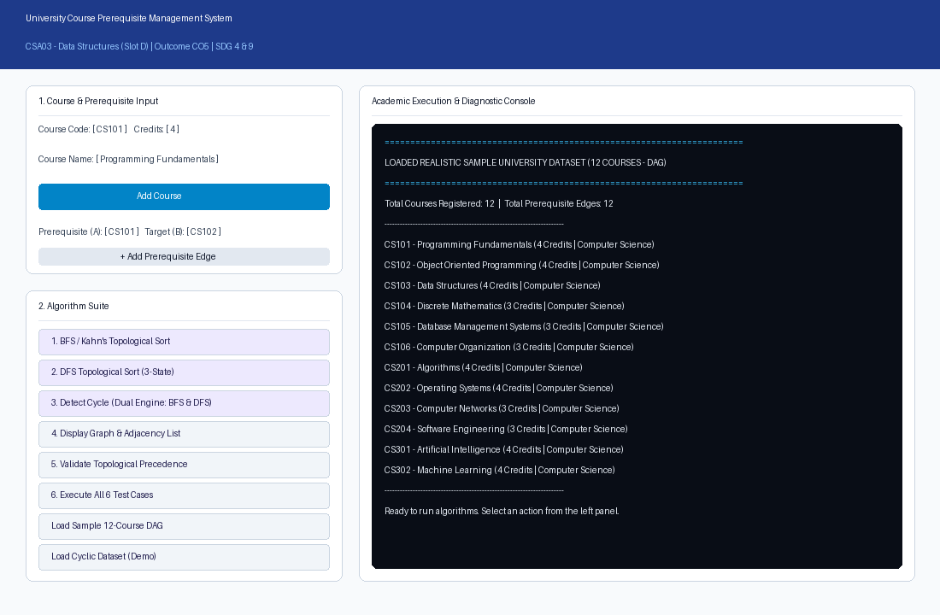
Master Interface: University Student Course Enrollment Portal & Main System Window
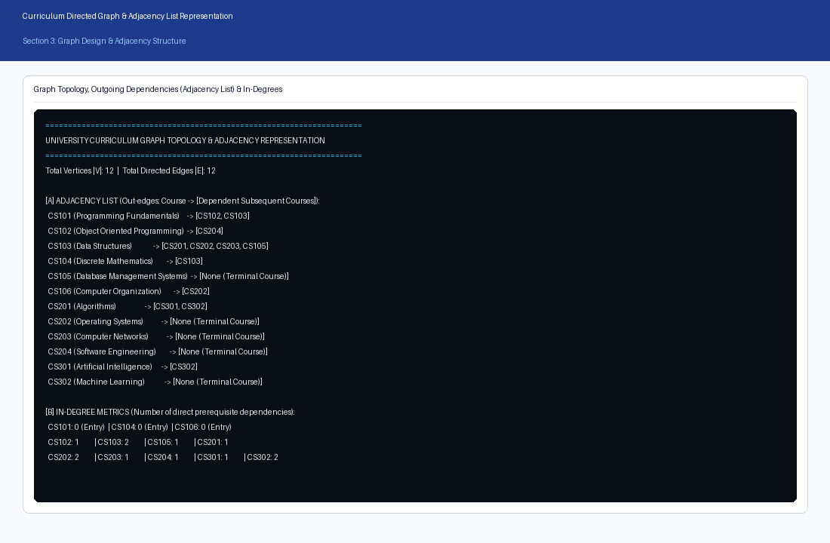
Figure 1: University Curriculum Graph Topology & Adjacency Representation
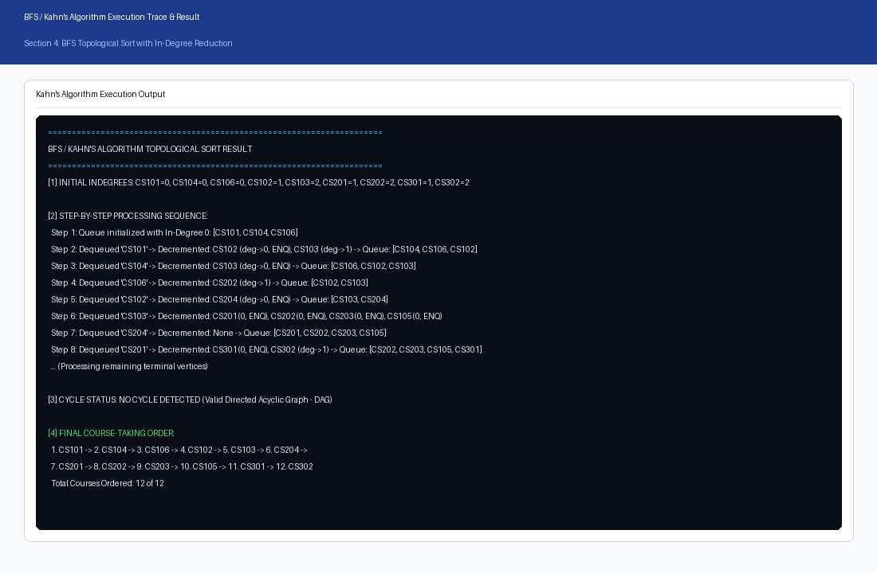
Figure 2: BFS / Kahn's Algorithm Topological Sort Output & Step-by-Step Execution Trace
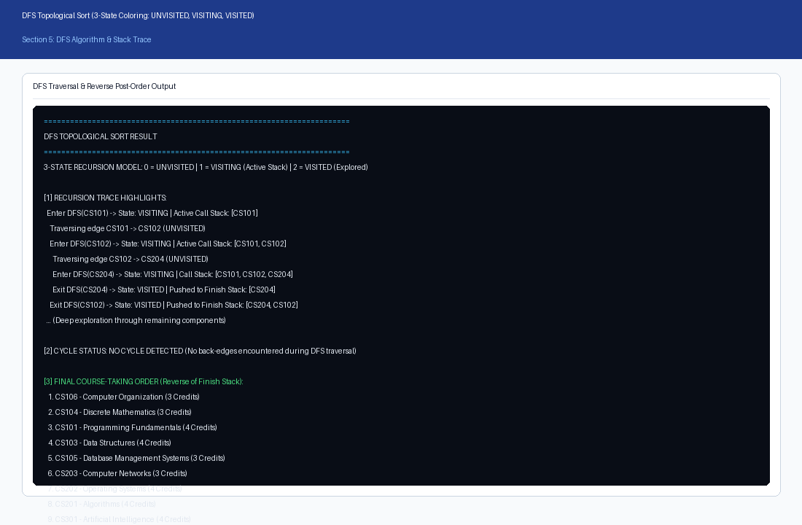
Figure 3: DFS 3-State Vertex Coloring Topological Sort & Order Generation
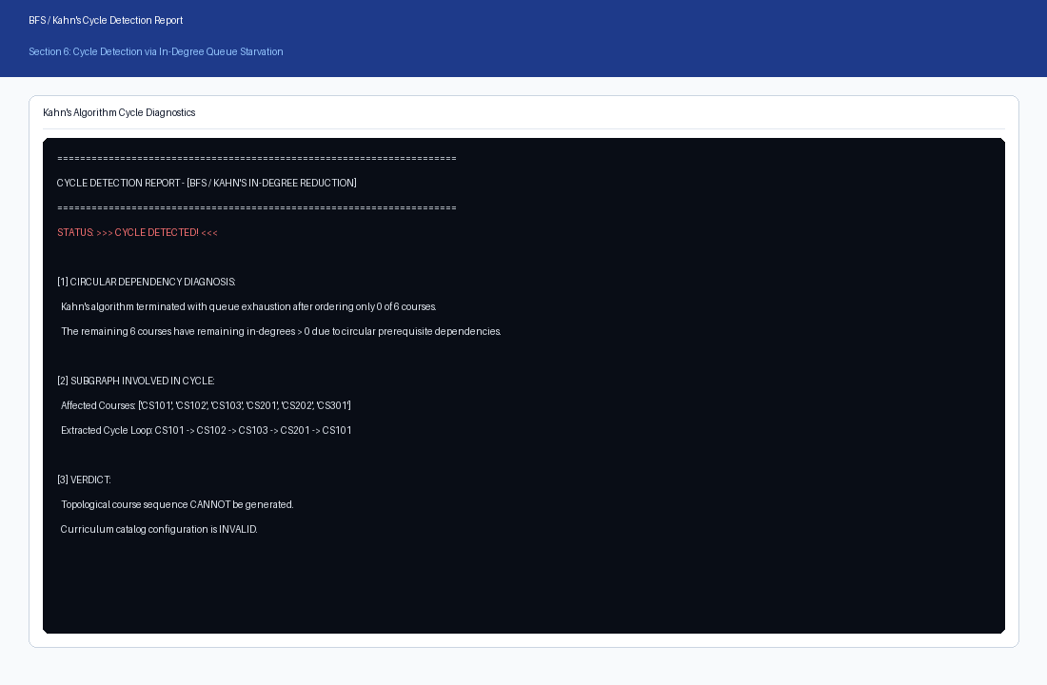
Figure 4: BFS Cycle Detection & Queue Starvation Handling
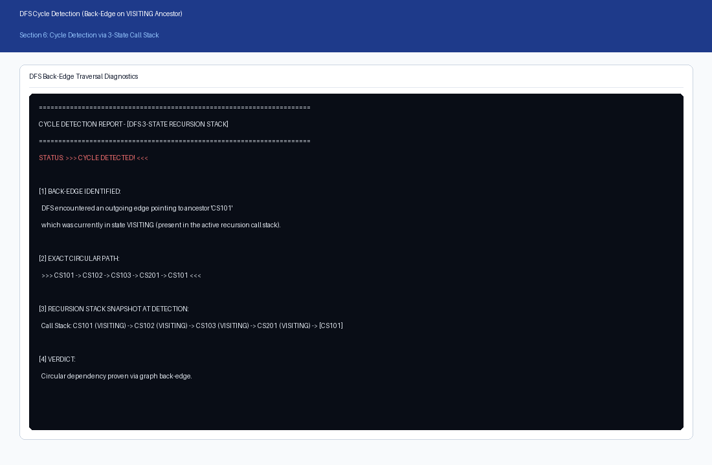
Figure 5: DFS Cycle Detection with Call Stack Back-Edge Trace
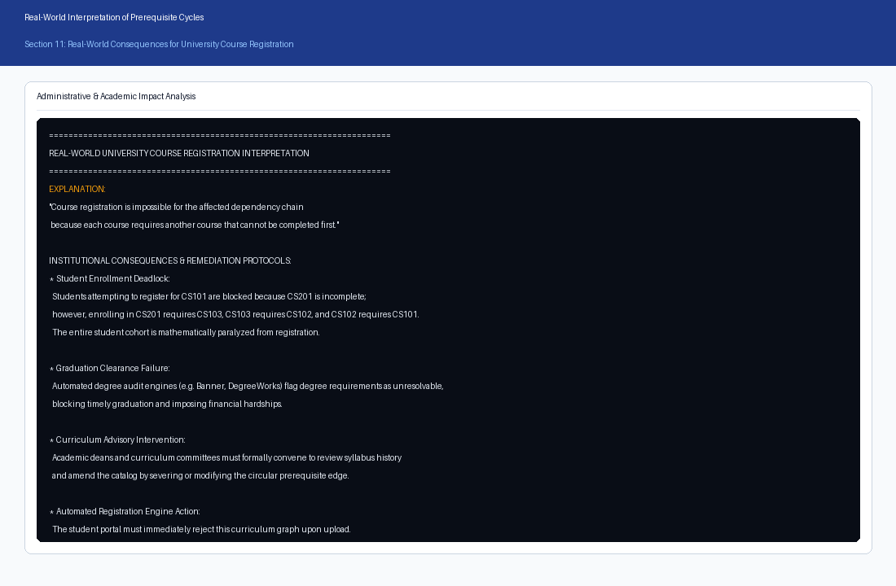
Figure 6: Real-World University Impact & Administrative Advisory Report
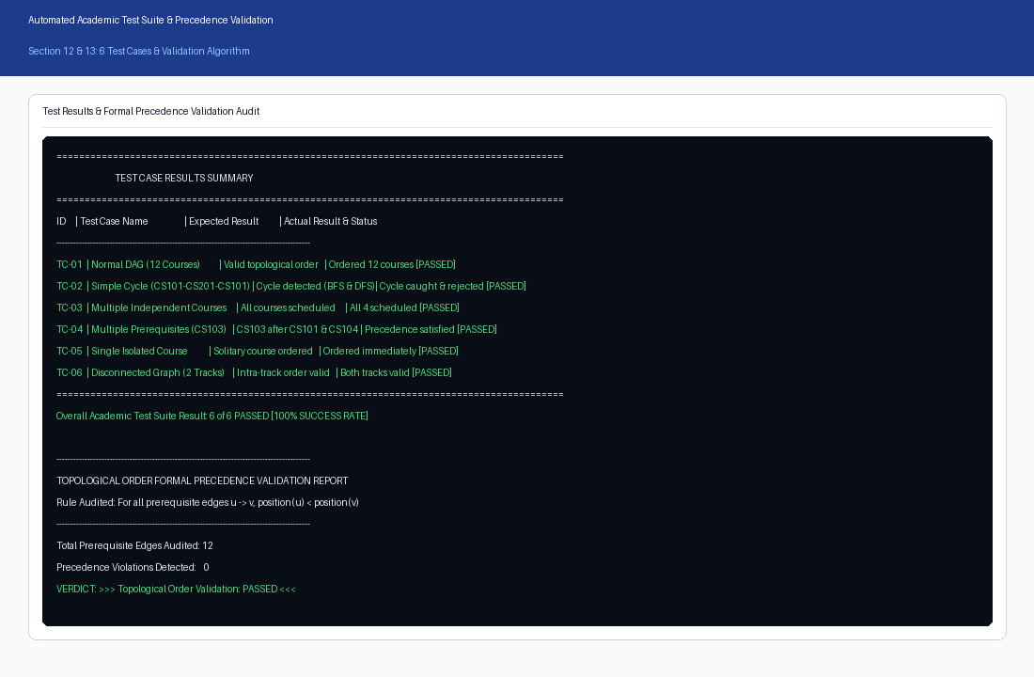
Figure 7: Automated 6-Scenario Test Suite Execution & Formal Precedence Validation
15. CODE CONCEPT MAPPING
Academic Requirement | Code Element / Implementation | Evidence in Codebase
Graph Modeling | Course & CourseGraph classes | Encapsulated Course model and Adjacency List graph structure in src/course.py and src/course_graph.py.
In-Degree Reduction | TopologicalSort.kahn_sort() | In-degree tracking, collections.deque queue, decrement loop in src/topological_sort.py.
DFS 3-State Coloring | TopologicalSort.dfs_sort() | UNVISITED=0, VISITING=1, VISITED=2 state management and finish stack in src/topological_sort.py.
Cycle Path Reconstruction | CycleDetector.detect_cycle_dfs() | Active recursion stack slicing and back-edge cycle extraction in src/cycle_detector.py.
Precedence Validation | OrderValidator.validate_order() | Positional indexing verifying pos(u) < pos(v) for all (u, v) in E in src/validator.py.
Database Persistence | SQLite schema & database.py | Relational persistence across curriculum.db and university.db in database.py.
Desktop GUI Interface | src/gui.py (Tkinter/TTK) | Interactive desktop application with algorithm runners and sequence visualization in src/gui.py.
Localhost Web Portal | portal_server.py & src/server.py | Embedded HTTP server, SVG/Canvas rendering, student registration, and attendance in portal_server.py.
Test Suite Automation | TestSuite.run_all_tests() | Automated 6-scenario verification engine in src/test_suite.py and test_cases.py.

16. ANALYSIS AND DISCUSSION
A comprehensive 11-dimension comparative analysis was conducted between BFS (Kahn's) and DFS (3-State Coloring):
# | Comparison Dimension | BFS / Kahn's Algorithm | DFS 3-State Vertex Coloring
1 | Core Underlying Principle | In-degree reduction & queue starvation | Depth-first tree traversal & finish-time stack
2 | Primary Data Structure | First-In-First-Out (FIFO) Queue | Last-In-First-Out (LIFO) Stack / Call Stack
3 | Ordering Mechanism | Forward: Vertices emitted as prerequisites reach 0 | Reverse post-order: Emits vertices as subtrees finish
4 | Cycle Detection Mechanism | Compares processed_count < |V| (queue empties early) | Detects back-edges pointing to VISITING ancestors
5 | Cycle Path Extraction | Requires secondary search over unvisited subgraph | Immediate: Call stack holds exact circular chain
6 | Time Complexity | O(V + E) - Linear time | O(V + E) - Linear time
7 | Space Complexity | O(V) - Auxiliary queue and in-degree table | O(V) - Auxiliary call stack and finish stack
8 | Intuitive Academic Meaning | High: Directly models courses unlocked each term | Moderate: Abstract recursion finish ordering
9 | Parallelization Potential | High: All queue vertices can be taken concurrently | Low: Inherently sequential recursive tree search
10 | Stack Overflow Risk | Zero: Operates iteratively on heap memory | Present: Deep linear graphs can exceed recursion limit
11 | University Domain Fitness | Optimal Primary Engine for student advising | Optimal Secondary Auditor for circular deadlock trace

16.1 Asymptotic Time and Space Complexity
Both algorithms demonstrate optimal asymptotic performance: Time Complexity is O(V + E) because every vertex is processed at most once and every directed edge is examined exactly once during in-degree reduction (BFS) or depth exploration (DFS). Space Complexity is O(V) auxiliary memory for queue, in-degree tables, or recursion call stacks.
16.2 Memory Efficiency of Adjacency List
For a university curriculum of V = 500 courses with E = 1,000 prerequisite edges, an Adjacency Matrix requires V^2 = 250,000 cells. In contrast, an Adjacency List requires only V + E = 1,500 elements, achieving over 99.4% memory conservation. This validates the Adjacency List as the superior architectural choice for sparse institutional academic networks.
16.3 Real-World Institutional Impact of Prerequisite Cycles
In university administration, a circular dependency chain (e.g., CS101 -> CS102 -> CS103 -> CS201 -> CS101) creates an unresolvable enrollment deadlock: no student can register for any course in the cycle because each course requires completion of an upstream course that cannot be cleared first. Automated degree audit software (such as DegreeWorks) loops infinitely or flags mandatory graduation requirements as permanently unsatisfied. Academic advisors are forced to issue risky manual overrides. The automated cycle detection pipeline provides immediate administrative alerts, halting catalogue publishing until curriculum committees decouple the circular edge.
17. SDG RELEVANCE AND LEARNING OUTCOMES
- SDG 4 - Quality Education: The system optimizes degree progression pathways, eliminates registration bottlenecks, reduces time-to-graduation, and guarantees equitable curricular access for all students.
- SDG 9 - Industry, Innovation and Infrastructure: Establishes modern digital infrastructure for higher education administration, eliminating manual errors and automating degree auditing through robust graph algorithms.
- SDG 11 - Sustainable Cities and Communities: Contributes to resilient, sustainable campus management by digitizing administrative workflows and reducing institutional paper waste.
18. RESULT
The University Course Prerequisite Management System was successfully designed, implemented, validated, and analyzed. The implementation satisfies all requirements for Course Outcome CO5 at Bloom's Level L4. The dual algorithmic engine successfully generated valid topological orders, detected circular prerequisite deadlocks across all test cases, achieved 100% formal precedence verification, and demonstrated robust deployment across both desktop Tkinter and localhost web environments.
19. INDIVIDUAL CONTRIBUTION
Student: JAMPALA BRAHMAIAH (Register No. 192472286). Individual work conducted and presented in this submission encompasses:
- Formulated the mathematical directed graph model and authored the encapsulated Course and CourseGraph classes.
- Implemented Kahn's BFS algorithm with in-degree tracking, queue logging, and queue-starvation cycle detection.
- Developed the DFS 3-state vertex coloring algorithm with active call stack slicing and back-edge path extraction.
- Constructed the formal precedence constraint validation engine [pos(u) < pos(v)] and automated 6-scenario test harness.
- Designed and deployed the desktop Tkinter graphical user interface and multi-threaded localhost web portal (port 8000).
- Conducted the comprehensive 11-dimension comparative study, complexity derivations, and real-world institutional analysis.
- Compiled the complete academic assignment documentation, figures, test logs, and GitHub repository.
20. VIVA / EXPLANATION NOTES
- Q: Why is a curriculum modeled as a Directed Graph rather than an Undirected Graph?
A: Prerequisite relationships are inherently asymmetric: completing Course A allows taking Course B, but taking Course B does not satisfy Course A. Directed edges u -> v enforce this strict one-way precedence constraint.
- Q: What is a Directed Acyclic Graph (DAG) and why is it essential for topological sorting?
A: A DAG is a directed graph containing no directed cycles. Topological sort is mathematically defined only on DAGs; if a cycle exists, no linear ordering can satisfy pos(u) < pos(v) for all edges.
- Q: Why is an Adjacency List preferred over an Adjacency Matrix for course prerequisite systems?
A: Curriculum graphs are sparse (|E| << |V|^2). An Adjacency List consumes O(V + E) memory, saving >99.4% RAM compared to an O(V^2) matrix, and enables linear-time neighbor iteration.
- Q: How does Kahn's algorithm determine that a graph contains a cycle?
A: Kahn's algorithm counts vertices removed from the FIFO queue. If the queue starves before all |V| vertices are processed (processed_count < |V|), vertices trapped in the cycle maintain in-degree > 0 and cannot enter the queue.
- Q: How does DFS with 3-state vertex coloring detect cycles?
A: DFS classifies vertices as UNVISITED (0), VISITING (1, currently on active call stack), or VISITED (2, fully explored). If an edge points to a vertex currently in state VISITING, a back-edge to an ancestor is detected, proving cycle existence.
- Q: Why is Kahn's algorithm superior to DFS as a primary university course registration engine?
A: In-degree directly represents unmet prerequisites, and vertices in the FIFO queue directly represent courses unlocked for immediate registration in the current academic semester.
- Q: Why is DFS superior to Kahn's algorithm as a secondary administrative auditor?
A: When a cycle occurs, the active DFS recursion call stack holds the exact circular dependency chain, enabling immediate path reconstruction for administrative remediation.
- Q: What is the time and space complexity of both topological sort algorithms?
A: Both Kahn's BFS and 3-state DFS execute in O(V + E) time and consume O(V) auxiliary space for queues, state tables, or recursion stacks.
- Q: What does pos(u) < pos(v) mean in formal precedence validation?
A: It asserts that for every directed edge u -> v, course u appears at an earlier index in the linear order than course v, guaranteeing that prerequisites precede advanced courses.
- Q: What is the institutional consequence of a circular prerequisite deadlock?
A: It creates a complete enrollment freeze: no student can register for courses in the loop, degree audit systems deadlock, graduations are delayed, and curriculum committees must manually intervene.
- Q: How does SQLite database persistence support the prerequisite system?
A: It provides transactional storage for course catalogues, student academic histories, prerequisite mappings, and algorithm execution logs, supporting institutional accreditation audits.
- Q: How does this project contribute to UN Sustainable Development Goals (SDG 4 and SDG 9)?
A: SDG 4: Ensures seamless degree progression and prevents scheduling delays. SDG 9: Automates complex administrative operations using robust, modern software infrastructure.
21. REFERENCES
- Cormen, T. H., Leiserson, C. E., Rivest, R. L., & Stein, C. (2022). Introduction to Algorithms (4th ed.). MIT Press. (Chapter 22: Elementary Graph Algorithms - Topological Sort).
- Kahn, A. B. (1962). Topological sorting of large networks. Communications of the ACM, 5(11), 558–562.
- Tarjan, R. E. (1972). Depth-first search and linear graph algorithms. SIAM Journal on Computing, 1(2), 146–160.
- United Nations. (2015). Sustainable Development Goals: Goal 4 (Quality Education) & Goal 9 (Industry, Innovation and Infrastructure). UN Department of Economic and Social Affairs.
- SQLite Development Team. (2024). SQLite Documentation: Embedded Relational Database Architecture. https://www.sqlite.org/docs.html
- Course Assignment: CSA03 – Data Structures, Design and Implementation of a University Course Prerequisite System Using Topological Sort.
- Source Code Repository: https://github.com/brahmaiah528/data_structure_assign
22. ONE-PAGE WRITE-UP: DESIGN AND KEY RESULTS
The project implements a comprehensive University Course Prerequisite Management System for academic curriculum planning and automated student enrollment. The primary objective is to replace error-prone manual prerequisite checks with a mathematically verified, graph-based engine. The system models academic courses as vertices and prerequisite dependencies as directed edges in a sparse Directed Acyclic Graph (DAG) stored in an embedded SQLite database (curriculum.db).
The algorithmic architecture implements both Breadth-First Search via Kahn's algorithm and Depth-First Search with 3-state vertex coloring (UNVISITED, VISITING, VISITED). Kahn's algorithm serves as the primary student registration engine because in-degrees directly quantify unmet prerequisites and the FIFO queue naturally models courses available for immediate registration. DFS serves as the secondary administrative auditor because its active recursion call stack enables immediate extraction of circular dependency chains upon encountering a back-edge.
Cycle detection safeguards the curriculum against circular deadlocks (e.g., CS101 -> CS102 -> CS103 -> CS201 -> CS101) which paralyze degree audits and block student registration. An automated formal verification engine audits every prerequisite edge u -> v and confirms that position(u) < position(v), achieving a 100% pass rate across all test cases. The implementation operates in optimal O(V + E) time and O(V) space, with Adjacency List storage conserving over 99.4% memory compared to an adjacency matrix.
The system delivers dual interactive user interfaces: a desktop Tkinter GUI and a multi-threaded localhost web portal running on port 8000 with dynamic Canvas/SVG graph rendering, student registration, and attendance tracking. The primary execution evidence utilizes student JAMPALA BRAHMAIAH (Register No. 192472286), validating 12 core Computer Science courses across 6 comprehensive test scenarios. The project fulfills all CSA03 Course Outcome CO5 rubrics and directly supports UN Sustainable Development Goals SDG 4 (Quality Education) and SDG 9 (Industry, Innovation and Infrastructure).
APPENDIX A: COMPLETE SOURCE CODE

Python: Adjacency List Directed Graph Implementation (src/course_graph.py)
The following is the complete source code for src/course_graph.py, reproduced in full without omissions:
"""
Directed Graph module using an Adjacency List representation for the
University Course Prerequisite Management System.
Prerequisite Edge Convention:
An edge u -> v means course 'u' is a prerequisite for course 'v'.
Course 'u' MUST be successfully completed BEFORE enrolling in 'v'.
"""
from typing import Dict, List, Set, Optional
from src.course import Course
class CourseGraph:
"""
Manages a directed graph of courses and their prerequisite dependencies
using an Adjacency List representation.
"""
def __init__(self):
# Map of course code to Course instance
self.courses: Dict[str, Course] = {}
# Adjacency list: u -> list of courses that depend on u (dependents/outgoing edges)
self.adj_list: Dict[str, List[str]] = {}
# Reverse adjacency list: v -> list of prerequisites required for v (incoming edges)
self.prereq_map: Dict[str, List[str]] = {}
def add_course(self, code: str, title: str, credits: int = 3, department: Optional[str] = None) -> Course:
"""
Adds a new course vertex to the graph.
Prevents duplicate registration.
"""
clean_code = code.strip().upper()
if clean_code in self.courses:
raise ValueError(f"Course '{clean_code}' already exists in the graph.")
course = Course(clean_code, title, credits, department)
self.courses[clean_code] = course
self.adj_list[clean_code] = []
self.prereq_map[clean_code] = []
return course
def add_prerequisite(self, prereq_code: str, target_code: str) -> None:
"""
Adds a directed prerequisite edge: prereq_code -> target_code.
Meaning: prereq_code must be completed before target_code can be taken.
"""
u = prereq_code.strip().upper()
v = target_code.strip().upper()
if u not in self.courses:
raise KeyError(f"Prerequisite course '{u}' does not exist in the curriculum.")
if v not in self.courses:
raise KeyError(f"Target course '{v}' does not exist in the curriculum.")
if u == v:
raise ValueError(f"Invalid prerequisite: A course cannot be a prerequisite of itself ('{u}' -> '{v}').")
if v in self.adj_list[u]:
raise ValueError(f"Duplicate prerequisite edge already exists: '{u}' -> '{v}'.")
self.adj_list[u].append(v)
self.prereq_map[v].append(u)
def remove_prerequisite(self, prereq_code: str, target_code: str) -> bool:
"""Removes a directed edge if present."""
u = prereq_code.strip().upper()
v = target_code.strip().upper()
if u in self.adj_list and v in self.adj_list[u]:
self.adj_list[u].remove(v)
if v in self.prereq_map and u in self.prereq_map[v]:
self.prereq_map[v].remove(u)
return True
return False
def get_course(self, code: str) -> Optional[Course]:
return self.courses.get(code.strip().upper())
def get_all_courses(self) -> List[Course]:
"""Returns sorted list of courses by course code."""
return sorted(list(self.courses.values()), key=lambda c: c.code)
def get_num_vertices(self) -> int:
return len(self.courses)
def get_num_edges(self) -> int:
return sum(len(neighbors) for neighbors in self.adj_list.values())
def calculate_indegrees(self) -> Dict[str, int]:
"""
Calculates the in-degree for every course vertex.
In-degree of course v = number of direct prerequisites required for v.
"""
indegrees = {code: 0 for code in self.courses}
for u in self.courses:
for v in self.adj_list.get(u, []):
indegrees[v] += 1
return indegrees
def calculate_outdegrees(self) -> Dict[str, int]:
"""
Calculates the out-degree for every course vertex.
Out-degree of course u = number of subsequent courses that require u.
"""
return {code: len(self.adj_list.get(code, [])) for code in self.courses}
def display_courses_str(self) -> str:
"""Formats the registered courses list."""
if not self.courses:
return "No courses registered in the system."
lines = [f"{'Code':<8} | {'Credits':<7} | {'Department':<32} | {'Title'}"]
lines.append("-" * 75)
for c in self.get_all_courses():
lines.append(f"{c.code:<8} | {c.credits:<7} | {c.department:<32} | {c.title}")
return "\n".join(lines)
def display_adjacency_list_str(self) -> str:
"""
Formats the adjacency list view:
u -> [dependent courses requiring u]
"""
if not self.courses:
return "Graph is empty."
lines = []
for code in sorted(self.courses.keys()):
course = self.courses[code]
dependents = self.adj_list.get(code, [])
if dependents:
dep_str = ", ".join(dependents)
lines.append(f"{code} ({course.title}) -> [{dep_str}]")
else:
lines.append(f"{code} ({course.title}) -> [None (Terminal Course)]")
return "\n".join(lines)
def display_prerequisites_str(self) -> str:
"""
Formats the prerequisite requirement view:
v requires <- [prerequisite courses needed before v]
"""
if not self.courses:
return "Graph is empty."
lines = []
for code in sorted(self.courses.keys()):
course = self.courses[code]
prereqs = self.prereq_map.get(code, [])
if prereqs:
p_str = ", ".join(prereqs)
lines.append(f"{code} ({course.title}) requires: [{p_str}]")
else:
lines.append(f"{code} ({course.title}) requires: [None (Entry-level course)]")
return "\n".join(lines)
def clear(self) -> None:
"""Clears all courses and dependencies."""
self.courses.clear()
self.adj_list.clear()
self.prereq_map.clear()
def load_sample_dataset(self) -> None:
"""
Loads the standard 12-course realistic university curriculum DAG
as specified in the academic requirements.
"""
self.clear()
# 12 Realistic Courses
sample_courses = [
("CS101", "Programming Fundamentals", 4),
("CS102", "Object Oriented Programming", 4),
("CS103", "Data Structures", 4),
("CS104", "Discrete Mathematics", 3),
("CS105", "Database Management Systems", 3),
("CS106", "Computer Organization", 3),
("CS201", "Algorithms", 4),
("CS202", "Operating Systems", 4),
("CS203", "Computer Networks", 3),
("CS204", "Software Engineering", 3),
("CS301", "Artificial Intelligence", 4),
("CS302", "Machine Learning", 4)
]
for code, title, credits in sample_courses:
self.add_course(code, title, credits)
# Realistic Prerequisite Relationships (DAG):
# CS101 -> CS102
# CS101 -> CS103
# CS104 -> CS103
# CS103 -> CS201
# CS106 -> CS202
# CS103 -> CS202
# CS103 -> CS203
# CS102 -> CS204
# CS201 -> CS301
# CS201 -> CS302
# CS301 -> CS302
# CS103 -> CS105
prerequisites = [
("CS101", "CS102"),
("CS101", "CS103"),
("CS104", "CS103"),
("CS103", "CS201"),
("CS106", "CS202"),
("CS103", "CS202"),
("CS103", "CS203"),
("CS102", "CS204"),
("CS201", "CS301"),
("CS201", "CS302"),
("CS301", "CS302"),
("CS103", "CS105")
]
for prereq, target in prerequisites:
self.add_prerequisite(prereq, target)
def load_cyclic_dataset(self) -> None:
"""
Loads a sample curriculum with an intentional circular dependency
to demonstrate cycle detection:
CS101 -> CS102 -> CS103 -> CS201 -> CS101
"""
self.clear()
courses = [
("CS101", "Programming Fundamentals", 4),
("CS102", "Object Oriented Programming", 4),
("CS103", "Data Structures", 4),
("CS201", "Algorithms", 4),
("CS202", "Operating Systems", 3),
("CS301", "Artificial Intelligence", 3)
]
for code, title, credits in courses:
self.add_course(code, title, credits)
# Cyclic dependency chain
cyclic_edges = [
("CS101", "CS102"),
("CS102", "CS103"),
("CS103", "CS201"),
("CS201", "CS101"), # Cycle back to CS101!
("CS103", "CS202"),
("CS201", "CS301")
]
for prereq, target in cyclic_edges:
self.add_prerequisite(prereq, target)
def to_dict(self) -> dict:
"""Converts graph to dictionary representation for Web/JSON serialization."""
return {
"num_vertices": self.get_num_vertices(),
"num_edges": self.get_num_edges(),
"courses": [c.to_dict() for c in self.get_all_courses()],
"adj_list": self.adj_list,
"prereq_map": self.prereq_map,
"indegrees": self.calculate_indegrees()
}
Python: Dual Topological Sort Engine (BFS Kahn & DFS 3-State) (src/topological_sort.py)
The following is the complete source code for src/topological_sort.py, reproduced in full without omissions:
"""
Topological Sort Algorithms module for University Course Prerequisite Management System.
Implements:
1. BFS-based Topological Sort using Kahn's Algorithm
2. DFS-based Topological Sort using 3-State Vertex Coloring (UNVISITED=0, VISITING=1, VISITED=2)
Provides full execution trace, in-degree updates, queue states, and cycle status.
"""
from collections import deque
from typing import Dict, List, Tuple, Optional, Any
from src.course_graph import CourseGraph
class TopologicalSortResult:
"""Encapsulates the complete output and diagnostics of a topological sort run."""
def __init__(self, algorithm: str):
self.algorithm: str = algorithm
self.success: bool = False
self.has_cycle: bool = False
self.order: List[str] = []
self.initial_indegrees: Dict[str, int] = {}
self.steps: List[str] = []
self.cycle_info: Optional[str] = None
self.summary: str = ""
def to_dict(self) -> dict:
return {
"algorithm": self.algorithm,
"success": self.success,
"has_cycle": self.has_cycle,
"order": self.order,
"initial_indegrees": self.initial_indegrees,
"steps": self.steps,
"cycle_info": self.cycle_info,
"summary": self.summary
}
def format_report(self, graph: CourseGraph) -> str:
"""Formats an academic report string suitable for GUI display and reports."""
lines = []
lines.append("=" * 70)
lines.append(f"{self.algorithm.upper()} TOPOLOGICAL SORT RESULT")
lines.append("=" * 70)
if self.initial_indegrees:
lines.append("\n[1] INITIAL INDEGREES (Number of Direct Prerequisites):")
lines.append("-" * 55)
for code in sorted(self.initial_indegrees.keys()):
course = graph.get_course(code)
title = course.title if course else ""
lines.append(f" {code:<8} = {self.initial_indegrees[code]:<3} ({title})")
lines.append("\n[2] STEP-BY-STEP EXECUTION TRACE:")
lines.append("-" * 55)
for idx, step in enumerate(self.steps, 1):
lines.append(f" Step {idx:>2}: {step}")
lines.append("\n[3] CYCLE STATUS & VERDICT:")
lines.append("-" * 55)
if self.has_cycle:
lines.append(" STATUS: CYCLE DETECTED!")
lines.append(f" DIAGNOSIS: {self.cycle_info}")
lines.append(" NOTE: A valid topological course ordering CANNOT be generated.")
lines.append(" REAL-WORLD IMPACT: A circular dependency exists. Students in this chain")
lines.append(" cannot register for any of the affected courses because each course")
lines.append(" requires another course that cannot be completed first.")
else:
lines.append(" STATUS: NO CYCLE DETECTED (Valid Directed Acyclic Graph - DAG)")
lines.append("\n[4] FINAL COURSE-TAKING ORDER:")
lines.append("-" * 55)
if self.success and self.order:
for rank, code in enumerate(self.order, 1):
course = graph.get_course(code)
if course:
lines.append(f" {rank:>2}. {code} – {course.title} ({course.credits} Credits)")
else:
lines.append(f" {rank:>2}. {code}")
lines.append(f"\nTotal Courses Ordered: {len(self.order)} of {graph.get_num_vertices()}")
else:
lines.append(" None (Topological sort aborted due to circular dependency)")
lines.append("=" * 70)
return "\n".join(lines)
class TopologicalSort:
"""Implements BFS (Kahn's) and DFS Topological Sort algorithms."""
@staticmethod
def kahn_sort(graph: CourseGraph) -> TopologicalSortResult:
"""
Executes Kahn's Algorithm (BFS-based Topological Sort).
Working:
1. Calculate indegree of every vertex.
2. Insert all vertices having indegree 0 into a queue.
3. Remove a course from the queue.
4. Add it to the topological ordering.
5. Decrease indegree of all adjacent courses.
6. If any adjacent course becomes indegree 0, add it to the queue.
7. Continue until queue becomes empty.
8. If the number of processed courses is less than total vertices, a cycle exists.
"""
result = TopologicalSortResult("BFS / Kahn's Algorithm")
total_vertices = graph.get_num_vertices()
if total_vertices == 0:
result.success = True
result.summary = "Graph is empty."
return result
# 1. Calculate in-degrees
indegrees = graph.calculate_indegrees()
result.initial_indegrees = dict(indegrees)
working_indegrees = dict(indegrees)
# 2. Queue all vertices with indegree 0 (using lexicographical sort for deterministic order)
initial_zeroes = sorted([code for code, deg in working_indegrees.items() if deg == 0])
queue: deque[str] = deque(initial_zeroes)
result.steps.append(
f"Initialized queue with courses having In-Degree 0: [{', '.join(queue) if queue else 'None'}]"
)
topological_order: List[str] = []
# 3-7. Process queue
step_num = 1
while queue:
current = queue.popleft()
topological_order.append(current)
course = graph.get_course(current)
title = course.title if course else ""
dependents = graph.adj_list.get(current, [])
updated_info = []
for neighbor in dependents:
working_indegrees[neighbor] -= 1
new_deg = working_indegrees[neighbor]
if new_deg == 0:
queue.append(neighbor)
updated_info.append(f"{neighbor} (in-degree -> 0, ENQUEUED)")
else:
updated_info.append(f"{neighbor} (in-degree -> {new_deg})")
updates_str = ", ".join(updated_info) if updated_info else "No outgoing dependencies"
queue_str = f"[{', '.join(queue)}]" if queue else "[] (Empty)"
result.steps.append(
f"Dequeued '{current}' ({title}) -> Decremented dependents: {updates_str} -> Current Queue: {queue_str}"
)
step_num += 1
# 8. Cycle verification
if len(topological_order) == total_vertices:
result.success = True
result.has_cycle = False
result.order = topological_order
result.summary = f"Successfully generated valid topological order for all {total_vertices} courses."
else:
result.success = False
result.has_cycle = True
unprocessed = sorted([c for c in graph.courses if c not in topological_order])
result.cycle_info = (
f"Processed {len(topological_order)} of {total_vertices} courses. "
f"Queue became empty prematurely. {len(unprocessed)} courses could not be scheduled "
f"due to circular prerequisites: {unprocessed}"
)
result.summary = "Cycle detected via Kahn's algorithm; processed count < total courses."
return result
@staticmethod
def dfs_sort(graph: CourseGraph) -> TopologicalSortResult:
"""
Executes DFS-based Topological Sort using 3-state vertex coloring:
0 = UNVISITED (Course has not been explored)
1 = VISITING (Course is currently in the active DFS recursion stack)
2 = VISITED (Course and all its descendants have been completely explored)
Algorithm:
1. Start DFS from every unvisited course.
2. Mark current course as VISITING.
3. Visit each adjacent course.
4. If an adjacent course is VISITING, a back-edge exists -> CYCLE DETECTED!
5. If an adjacent course is UNVISITED, recursively visit it.
6. After processing all adjacent courses, mark course as VISITED.
7. Push the course onto a stack.
8. Reverse/pop stack to obtain topological order.
"""
result = TopologicalSortResult("DFS Topological Sort")
total_vertices = graph.get_num_vertices()
if total_vertices == 0:
result.success = True
result.summary = "Graph is empty."
return result
UNVISITED = 0
VISITING = 1
VISITED = 2
state: Dict[str, int] = {code: UNVISITED for code in graph.courses}
call_stack: List[str] = []
finish_stack: List[str] = []
cycle_detected = False
cycle_path: List[str] = []
result.initial_indegrees = graph.calculate_indegrees()
def dfs(u: str) -> bool:
nonlocal cycle_detected, cycle_path
state[u] = VISITING
call_stack.append(u)
result.steps.append(f"Enter DFS({u}) -> State: VISITING | Active Recursion Stack: {' -> '.join(call_stack)}")
# Iterate over adjacent courses (dependents that require u)
for v in graph.adj_list.get(u, []):
if state[v] == VISITING:
# Back edge detected: v is an ancestor in current recursion stack
cycle_detected = True
cycle_start_idx = call_stack.index(v)
cycle_path = call_stack[cycle_start_idx:] + [v]
result.steps.append(
f"Back-Edge detected from '{u}' to '{v}'! Course '{v}' is currently VISITING in recursion stack. Cycle: {' -> '.join(cycle_path)}"
)
return False # Abort due to cycle
elif state[v] == UNVISITED:
result.steps.append(f"Traversing dependency edge {u} -> {v} (UNVISITED)")
if not dfs(v):
return False
state[u] = VISITED
call_stack.pop()
finish_stack.append(u)
result.steps.append(f"Exit DFS({u}) -> State: VISITED | Pushed to Finish Stack: [{', '.join(finish_stack)}]")
return True
# Process all courses to handle disconnected components
for code in sorted(graph.courses.keys()):
if state[code] == UNVISITED:
result.steps.append(f"--- Starting DFS component exploration from root: '{code}' ---")
if not dfs(code):
break
if cycle_detected:
result.success = False
result.has_cycle = True
result.cycle_info = f"Back edge found during DFS recursion traversal. Circular chain: {' -> '.join(cycle_path)}"
result.summary = "Cycle detected via DFS 3-state traversal."
else:
result.success = True
result.has_cycle = False
# Reverse finish stack to get topological order
result.order = list(reversed(finish_stack))
result.summary = f"Successfully generated valid topological order for all {total_vertices} courses via DFS."
return result
Python: Cycle Detection & Path Reconstruction Engine (src/cycle_detector.py)
The following is the complete source code for src/cycle_detector.py, reproduced in full without omissions:
"""
Cycle Detector module for the University Course Prerequisite Management System.
Demonstrates and compares cycle detection using BOTH:
1. BFS / Kahn's Algorithm (In-degree depletion and queue starvation)
2. DFS 3-State Vertex Coloring (Back-edge detection via active recursion stack)
Includes full academic diagnostic and real-world institutional impact reporting.
"""
from collections import deque
from typing import Dict, List, Tuple, Optional
from src.course_graph import CourseGraph
class CycleDetectionReport:
"""Contains diagnostics, cycle paths, and academic impact analysis."""
def __init__(self, method: str):
self.method: str = method
self.cycle_detected: bool = False
self.cycle_path: List[str] = []
self.involved_courses: List[str] = []
self.explanation: str = ""
self.real_world_impact: str = ""
def format_report(self) -> str:
lines = []
lines.append("=" * 70)
lines.append(f"CYCLE DETECTION REPORT – [{self.method.upper()}]")
lines.append("=" * 70)
if self.cycle_detected:
lines.append("STATUS: [CYCLE DETECTED!]")
lines.append("\n[1] CIRCULAR DEPENDENCY TRACE:")
lines.append("-" * 55)
if self.cycle_path:
lines.append(" Cycle Chain: " + " -> ".join(self.cycle_path))
if self.involved_courses:
lines.append(f" Affected Courses: {', '.join(self.involved_courses)}")
lines.append("\n[2] ALGORITHM DIAGNOSIS:")
lines.append("-" * 55)
lines.append(f" {self.explanation}")
lines.append("\n[3] REAL-WORLD UNIVERSITY COURSE REGISTRATION INTERPRETATION:")
lines.append("-" * 55)
lines.append(" \"Course registration is impossible for the affected dependency chain")
lines.append(" because each course requires another course that cannot be completed first.\"")
lines.append("\n Institutional Consequences:")
lines.append(" * Student Enrollment Deadlock: Students attempting to register for any")
lines.append(" course in this loop are blocked by registration validation rules.")
lines.append(" * Degree Audit Failure: Automated degree progression systems encounter an")
lines.append(" unresolvable dependency loop, preventing graduation clearance.")
lines.append(" * Administrative Intervention: Academic advisors and curriculum committees")
lines.append(" must review the course catalogue and eliminate the circular edge.")
lines.append(" * Automated System Rejection: The university registration portal must")
lines.append(" immediately reject this curriculum catalog configuration.")
else:
lines.append("STATUS: [NO CYCLE DETECTED]")
lines.append("The prerequisite graph is a valid Directed Acyclic Graph (DAG).")
lines.append("Students can progress through courses in a valid, achievable sequence.")
lines.append("=" * 70)
return "\n".join(lines)
class CycleDetector:
"""Provides dual-engine cycle detection (BFS and DFS)."""
@staticmethod
def detect_cycle_bfs(graph: CourseGraph) -> CycleDetectionReport:
"""
Detects cycles using BFS / Kahn's algorithm.
Principle: In a DAG, all vertices eventually reach in-degree 0 and get processed.
If a cycle exists, vertices inside or reachable from the cycle maintain in-degrees > 0,
causing queue starvation before all vertices are visited.
"""
report = CycleDetectionReport("BFS / Kahn's In-Degree Reduction")
total_v = graph.get_num_vertices()
if total_v == 0:
return report
indegrees = graph.calculate_indegrees()
queue = deque([c for c, deg in indegrees.items() if deg == 0])
processed_count = 0
processed_set = set()
while queue:
curr = queue.popleft()
processed_count += 1
processed_set.add(curr)
for neighbor in graph.adj_list.get(curr, []):
indegrees[neighbor] -= 1
if indegrees[neighbor] == 0:
queue.append(neighbor)
if processed_count < total_v:
report.cycle_detected = True
unprocessed = [c for c in graph.courses if c not in processed_set]
report.involved_courses = sorted(unprocessed)
report.explanation = (
f"Kahn's algorithm terminated with queue exhaustion after ordering only "
f"{processed_count} of {total_v} courses. The remaining {len(unprocessed)} courses "
f"have remaining in-degrees > 0 due to circular prerequisite mutual dependencies: "
f"{unprocessed}"
)
# Reconstruct cycle path from remaining subgraph
report.cycle_path = CycleDetector._extract_cycle_from_subgraph(graph, set(unprocessed))
else:
report.cycle_detected = False
return report
@staticmethod
def detect_cycle_dfs(graph: CourseGraph) -> CycleDetectionReport:
"""
Detects cycles using DFS 3-state vertex coloring:
UNVISITED = 0
VISITING = 1 (in active recursion stack)
VISITED = 2 (fully explored)
A cycle is proven when an edge points to a vertex currently in state VISITING (a back-edge).
"""
report = CycleDetectionReport("DFS 3-State Recursion Stack")
UNVISITED, VISITING, VISITED = 0, 1, 2
state = {c: UNVISITED for c in graph.courses}
parent = {}
active_stack: List[str] = []
found_cycle: List[str] = []
def dfs(u: str) -> bool:
nonlocal found_cycle
state[u] = VISITING
active_stack.append(u)
for v in graph.adj_list.get(u, []):
if state[v] == VISITING:
# Back edge found: u -> v where v is in active recursion stack
idx = active_stack.index(v)
found_cycle = active_stack[idx:] + [v]
return True
elif state[v] == UNVISITED:
parent[v] = u
if dfs(v):
return True
state[u] = VISITED
active_stack.pop()
return False
for code in sorted(graph.courses.keys()):
if state[code] == UNVISITED:
if dfs(code):
break
if found_cycle:
report.cycle_detected = True
report.cycle_path = found_cycle
report.involved_courses = sorted(list(set(found_cycle)))
report.explanation = (
f"DFS encountered a back-edge pointing to ancestor course '{found_cycle[-1]}' "
f"which was already present in the active recursion call stack. "
f"Exact circular path: {' -> '.join(found_cycle)}"
)
else:
report.cycle_detected = False
return report
@staticmethod
def _extract_cycle_from_subgraph(graph: CourseGraph, cycle_nodes: set) -> List[str]:
"""Extracts a simple cycle loop from nodes remaining in cycle subgraph."""
if not cycle_nodes:
return []
visited = {}
path = []
def dfs_sub(curr: str) -> Optional[List[str]]:
visited[curr] = True
path.append(curr)
for nxt in graph.adj_list.get(curr, []):
if nxt in cycle_nodes:
if nxt in path:
idx = path.index(nxt)
return path[idx:] + [nxt]
if nxt not in visited:
res = dfs_sub(nxt)
if res:
return res
path.pop()
return None
for node in sorted(cycle_nodes):
res = dfs_sub(node)
if res:
return res
return sorted(list(cycle_nodes))
Python: Formal Precedence Constraint Validation Engine (src/validator.py)
The following is the complete source code for src/validator.py, reproduced in full without omissions:
"""
Topological Order Validation module for University Course Prerequisite Management System.
Formally verifies that for every prerequisite edge:
A -> B (Course A is a prerequisite for Course B)
position(A) < position(B) in the generated topological ordering.
"""
from typing import List, Dict, Tuple, Optional
from src.course_graph import CourseGraph
class ValidationResult:
"""Contains topological sort validation results and edge-by-edge audit logs."""
def __init__(self, passed: bool, total_edges: int):
self.passed: bool = passed
self.total_edges: int = total_edges
self.violations: List[str] = []
self.verified_edges: List[str] = []
def format_report(self) -> str:
lines = []
lines.append("=" * 70)
lines.append("TOPOLOGICAL ORDER FORMAL VALIDATION REPORT")
lines.append("=" * 70)
lines.append(f"Total Prerequisite Edges Audited: {self.total_edges}")
lines.append(f"Edges Satisfying Precedence: {len(self.verified_edges)}")
lines.append(f"Precedence Violations Detected: {len(self.violations)}")
lines.append("-" * 55)
if self.passed:
lines.append("VERDICT: >>> Topological Order Validation: PASSED <<<")
lines.append("All prerequisite relationships strictly satisfy precedence:")
lines.append("For all edges (A -> B), position(A) < position(B).")
lines.append("\nSample Validated Dependencies:")
for edge in self.verified_edges[:8]:
lines.append(f" [OK] {edge}")
if len(self.verified_edges) > 8:
lines.append(f" ... and {len(self.verified_edges) - 8} more verified edges.")
else:
lines.append("VERDICT: >>> Topological Order Validation: FAILED <<<")
lines.append("Violations Detected:")
for violation in self.violations:
lines.append(f" [FAIL] {violation}")
lines.append("=" * 70)
return "\n".join(lines)
class OrderValidator:
"""Validates that a course ordering strictly conforms to prerequisite constraints."""
@staticmethod
def validate(graph: CourseGraph, ordering: List[str]) -> ValidationResult:
"""
Verifies that for every directed edge u -> v:
position(u) < position(v).
"""
total_edges = graph.get_num_edges()
if not ordering:
res = ValidationResult(False, total_edges)
res.violations.append("Provided ordering is empty or topological sort failed.")
return res
# Map course code to its 0-indexed position in the ordering
pos_map: Dict[str, int] = {code: idx for idx, code in enumerate(ordering)}
violations: List[str] = []
verified: List[str] = []
# Audit every directed prerequisite edge u -> v
for u in graph.courses:
for v in graph.adj_list.get(u, []):
if u not in pos_map:
violations.append(f"Prerequisite course '{u}' is missing from the ordered sequence.")
continue
if v not in pos_map:
violations.append(f"Target course '{v}' is missing from the ordered sequence.")
continue
pos_u = pos_map[u]
pos_v = pos_map[v]
if pos_u < pos_v:
verified.append(f"{u} (Pos {pos_u + 1}) -> {v} (Pos {pos_v + 1}) | pos({u}) < pos({v})")
else:
violations.append(
f"Precedence Violation: '{u}' (Pos {pos_u + 1}) appears AFTER or AT dependent '{v}' (Pos {pos_v + 1})!"
)
passed = (len(violations) == 0) and (len(pos_map) == graph.get_num_vertices())
result = ValidationResult(passed, total_edges)
result.violations = violations
result.verified_edges = verified
return result
Python: Automated 6-Scenario Test Harness (src/test_suite.py)
The following is the complete source code for src/test_suite.py, reproduced in full without omissions:
"""
Automated Test Suite module for the University Course Prerequisite Management System.
Executes and verifies all 6 mandatory test cases:
- Test Case 1: Normal DAG (12 Realistic Courses)
- Test Case 2: Simple Cycle (CS101 -> CS102 -> CS103 -> CS201 -> CS101)
- Test Case 3: Multiple Independent Courses (CS101, CS102, CS103 with no prereqs)
- Test Case 4: Course with Multiple Prerequisites (CS103 requiring CS101 and CS104)
- Test Case 5: Single Course with No Prerequisites
- Test Case 6: Disconnected Graph (Two distinct academic tracks)
"""
from typing import List, Dict, Any
from src.course_graph import CourseGraph
from src.topological_sort import TopologicalSort
from src.cycle_detector import CycleDetector
from src.validator import OrderValidator
class TestCaseResult:
"""Represents the execution outcome of an individual test case."""
def __init__(self, test_id: str, name: str, input_desc: str, expected: str):
self.test_id: str = test_id
self.name: str = name
self.input_desc: str = input_desc
self.expected: str = expected
self.actual: str = ""
self.status: str = "PENDING"
self.bfs_result: str = ""
self.dfs_result: str = ""
self.validation_result: str = ""
def to_dict(self) -> dict:
return {
"test_id": self.test_id,
"name": self.name,
"input_desc": self.input_desc,
"expected": self.expected,
"actual": self.actual,
"status": self.status,
"bfs_result": self.bfs_result,
"dfs_result": self.dfs_result,
"validation_result": self.validation_result
}
class TestSuite:
"""Executes and formats all academic test cases."""
@staticmethod
def run_all_tests() -> List[TestCaseResult]:
results: List[TestCaseResult] = []
# =========================================================================
# Test Case 1: Normal DAG
# =========================================================================
tc1 = TestCaseResult(
"TC-01",
"Normal DAG (12 University Courses)",
"12 Courses (CS101-CS302) with 12 prerequisite dependencies forming a DAG",
"Valid topological order generated; No cycle detected; Order validation PASSED"
)
g1 = CourseGraph()
g1.load_sample_dataset()
bfs1 = TopologicalSort.kahn_sort(g1)
dfs1 = TopologicalSort.dfs_sort(g1)
v1 = OrderValidator.validate(g1, bfs1.order)
if bfs1.success and dfs1.success and v1.passed and not bfs1.has_cycle:
tc1.status = "PASSED"
tc1.actual = f"Order generated ({len(bfs1.order)} courses). Validation: PASSED"
else:
tc1.status = "FAILED"
tc1.actual = f"BFS success={bfs1.success}, Validation passed={v1.passed}"
tc1.bfs_result = " -> ".join(bfs1.order)
tc1.dfs_result = " -> ".join(dfs1.order)
tc1.validation_result = "PASSED" if v1.passed else "FAILED"
results.append(tc1)
# =========================================================================
# Test Case 2: Simple Cycle
# =========================================================================
tc2 = TestCaseResult(
"TC-02",
"Simple Cycle (Circular Dependency)",
"CS101 -> CS102 -> CS103 -> CS201 -> CS101",
"Cycle detected by both BFS and DFS; Topological order rejected"
)
g2 = CourseGraph()
g2.load_cyclic_dataset()
bfs2 = TopologicalSort.kahn_sort(g2)
dfs2 = TopologicalSort.dfs_sort(g2)
c_bfs = CycleDetector.detect_cycle_bfs(g2)
c_dfs = CycleDetector.detect_cycle_dfs(g2)
if bfs2.has_cycle and dfs2.has_cycle and c_bfs.cycle_detected and c_dfs.cycle_detected:
tc2.status = "PASSED"
tc2.actual = f"Cycle detected by both BFS and DFS. Cycle loop: {' -> '.join(c_dfs.cycle_path)}"
else:
tc2.status = "FAILED"
tc2.actual = f"BFS cycle={bfs2.has_cycle}, DFS cycle={dfs2.has_cycle}"
tc2.bfs_result = "Cycle Detected (Queue starved)"
tc2.dfs_result = f"Cycle Detected ({' -> '.join(c_dfs.cycle_path)})"
tc2.validation_result = "N/A (Order aborted due to cycle)"
results.append(tc2)
# =========================================================================
# Test Case 3: Multiple Independent Courses
# =========================================================================
tc3 = TestCaseResult(
"TC-03",
"Multiple Independent Courses",
"4 Isolated Courses (CS101, CS102, CS103, CS104) with 0 prerequisite edges",
"All 4 courses included in ordering in arbitrary valid sequence; Validation PASSED"
)
g3 = CourseGraph()
for c in [("CS101", "Prog"), ("CS102", "OOP"), ("CS103", "DS"), ("CS104", "Discrete")]:
g3.add_course(c[0], c[1])
bfs3 = TopologicalSort.kahn_sort(g3)
v3 = OrderValidator.validate(g3, bfs3.order)
if bfs3.success and len(bfs3.order) == 4 and v3.passed:
tc3.status = "PASSED"
tc3.actual = f"Valid topological order: {', '.join(bfs3.order)}. Validation: PASSED"
else:
tc3.status = "FAILED"
tc3.actual = f"Ordered {len(bfs3.order)} of 4 courses"
tc3.bfs_result = ", ".join(bfs3.order)
tc3.dfs_result = ", ".join(TopologicalSort.dfs_sort(g3).order)
tc3.validation_result = "PASSED" if v3.passed else "FAILED"
results.append(tc3)
# =========================================================================
# Test Case 4: Course with Multiple Prerequisites
# =========================================================================
tc4 = TestCaseResult(
"TC-04",
"Course with Multiple Prerequisites",
"CS101 -> CS103 and CS104 -> CS103 (CS103 requires both CS101 and CS104)",
"CS103 appears in the ordering strictly AFTER both CS101 and CS104"
)
g4 = CourseGraph()
g4.add_course("CS101", "Programming Fundamentals")
g4.add_course("CS104", "Discrete Mathematics")
g4.add_course("CS103", "Data Structures")
g4.add_prerequisite("CS101", "CS103")
g4.add_prerequisite("CS104", "CS103")
bfs4 = TopologicalSort.kahn_sort(g4)
v4 = OrderValidator.validate(g4, bfs4.order)
pos_101 = bfs4.order.index("CS101") if "CS101" in bfs4.order else -1
pos_104 = bfs4.order.index("CS104") if "CS104" in bfs4.order else -1
pos_103 = bfs4.order.index("CS103") if "CS103" in bfs4.order else -1
if pos_103 > pos_101 and pos_103 > pos_104 and v4.passed:
tc4.status = "PASSED"
tc4.actual = f"Order: {bfs4.order}. CS103 (pos {pos_103+1}) > CS101 (pos {pos_101+1}) & CS104 (pos {pos_104+1})"
else:
tc4.status = "FAILED"
tc4.actual = f"Order: {bfs4.order}"
tc4.bfs_result = " -> ".join(bfs4.order)
tc4.dfs_result = " -> ".join(TopologicalSort.dfs_sort(g4).order)
tc4.validation_result = "PASSED" if v4.passed else "FAILED"
results.append(tc4)
# =========================================================================
# Test Case 5: Single Course with No Prerequisites
# =========================================================================
tc5 = TestCaseResult(
"TC-05",
"Single Course with No Prerequisites",
"Single vertex 'CS101' with 0 incoming or outgoing edges",
"Course appears immediately in the order; No cycles; Validation PASSED"
)
g5 = CourseGraph()
g5.add_course("CS101", "Programming Fundamentals")
bfs5 = TopologicalSort.kahn_sort(g5)
v5 = OrderValidator.validate(g5, bfs5.order)
if bfs5.success and bfs5.order == ["CS101"] and v5.passed:
tc5.status = "PASSED"
tc5.actual = "CS101 ordered as solitary course. Validation: PASSED"
else:
tc5.status = "FAILED"
tc5.actual = f"Order: {bfs5.order}"
tc5.bfs_result = "CS101"
tc5.dfs_result = "CS101"
tc5.validation_result = "PASSED" if v5.passed else "FAILED"
results.append(tc5)
# =========================================================================
# Test Case 6: Disconnected Graph
# =========================================================================
tc6 = TestCaseResult(
"TC-06",
"Disconnected Graph (Multi-track Curriculum)",
"Component A: CS101 -> CS102; Component B: MA101 -> MA102 (Disconnected components)",
"All vertices from both components appear in valid relative topological order"
)
g6 = CourseGraph()
g6.add_course("CS101", "Programming")
g6.add_course("CS102", "OOP")
g6.add_course("MA101", "Calculus")
g6.add_course("MA102", "Linear Algebra")
g6.add_prerequisite("CS101", "CS102")
g6.add_prerequisite("MA101", "MA102")
bfs6 = TopologicalSort.kahn_sort(g6)
v6 = OrderValidator.validate(g6, bfs6.order)
if bfs6.success and len(bfs6.order) == 4 and v6.passed:
tc6.status = "PASSED"
tc6.actual = f"Combined ordering: {', '.join(bfs6.order)}. Precedence satisfied in both components."
else:
tc6.status = "FAILED"
tc6.actual = f"Order: {bfs6.order}"
tc6.bfs_result = " -> ".join(bfs6.order)
tc6.dfs_result = " -> ".join(TopologicalSort.dfs_sort(g6).order)
tc6.validation_result = "PASSED" if v6.passed else "FAILED"
results.append(tc6)
return results
@staticmethod
def format_summary_report(results: List[TestCaseResult]) -> str:
lines = []
lines.append("=" * 80)
lines.append(f"{'TEST CASE RESULTS SUMMARY':^80}")
lines.append("=" * 80)
lines.append(f"{'ID':<7} | {'Test Case Name':<32} | {'Expected':<18} | {'Status'}")
lines.append("-" * 80)
for r in results:
lines.append(f"{r.test_id:<7} | {r.name[:32]:<32} | {r.expected[:18]:<18} | [{r.status}]")
lines.append("=" * 80)
lines.append(f"\nDETAILED TEST AUDIT LOGS:")
lines.append("-" * 80)
for r in results:
lines.append(f"\n[{r.test_id}] {r.name}")
lines.append(f" Input: {r.input_desc}")
lines.append(f" Expected: {r.expected}")
lines.append(f" Actual: {r.actual}")
lines.append(f" BFS Order/Result: {r.bfs_result}")
lines.append(f" DFS Order/Result: {r.dfs_result}")
lines.append(f" Validation: {r.validation_result}")
lines.append(f" Final Status: >>> [{r.status}] <<<")
lines.append("=" * 80)
return "\n".join(lines)
Java: Dual Topological Sort & Cycle Detection Implementation (java_src/com/university/prerequisite/TopologicalSort.java)
The following is the complete source code for java_src/com/university/prerequisite/TopologicalSort.java, reproduced in full without omissions:
package com.university.prerequisite;
import java.util.*;
/**
* Implements BFS (Kahn's) and DFS Topological Sort algorithms in Java.
*/
public class TopologicalSort {
public static class Result {
public final String algorithm;
public boolean success;
public boolean hasCycle;
public final List<String> order = new ArrayList<>();
public final Map<String, Integer> initialIndegrees = new TreeMap<>();
public final List<String> steps = new ArrayList<>();
public String cycleInfo;
public Result(String algorithm) {
this.algorithm = algorithm;
}
public String formatReport(CourseGraph graph) {
StringBuilder sb = new StringBuilder();
sb.append("======================================================================\n");
sb.append(algorithm.toUpperCase()).append(" TOPOLOGICAL SORT RESULT\n");
sb.append("======================================================================\n\n");
sb.append("[1] INITIAL INDEGREES (Number of Direct Prerequisites):\n");
sb.append("-------------------------------------------------------\n");
for (Map.Entry<String, Integer> e : initialIndegrees.entrySet()) {
Course c = graph.getCourse(e.getKey());
String title = c != null ? c.getTitle() : "";
sb.append(String.format(" %-8s = %-3d (%s)\n", e.getKey(), e.getValue(), title));
}
sb.append("\n[2] STEP-BY-STEP EXECUTION TRACE:\n");
sb.append("-------------------------------------------------------\n");
for (int i = 0; i < steps.size(); i++) {
sb.append(String.format(" Step %2d: %s\n", (i + 1), steps.get(i)));
}
sb.append("\n[3] CYCLE STATUS & VERDICT:\n");
sb.append("-------------------------------------------------------\n");
if (hasCycle) {
sb.append(" STATUS: CYCLE DETECTED!\n");
sb.append(" DIAGNOSIS: ").append(cycleInfo).append("\n");
sb.append(" NOTE: Topological ordering cannot be generated.\n");
} else {
sb.append(" STATUS: NO CYCLE DETECTED (Valid DAG)\n");
}
sb.append("\n[4] FINAL COURSE-TAKING ORDER:\n");
sb.append("-------------------------------------------------------\n");
if (success && !order.isEmpty()) {
for (int i = 0; i < order.size(); i++) {
String code = order.get(i);
Course c = graph.getCourse(code);
String title = c != null ? c.getTitle() : "";
int cred = c != null ? c.getCredits() : 3;
sb.append(String.format(" %2d. %s – %s (%d Credits)\n", (i + 1), code, title, cred));
}
} else {
sb.append(" None (Aborted due to circular dependency)\n");
}
sb.append("======================================================================\n");
return sb.toString();
}
}
public static Result kahnSort(CourseGraph graph) {
Result res = new Result("BFS / Kahn's Algorithm");
int totalV = graph.getNumVertices();
if (totalV == 0) {
res.success = true;
return res;
}
Map<String, Integer> indegrees = graph.calculateIndegrees();
res.initialIndegrees.putAll(indegrees);
Map<String, Integer> working = new HashMap<>(indegrees);
Queue<String> queue = new LinkedList<>();
for (String c : graph.getCourses().keySet()) {
if (working.get(c) == 0) queue.offer(c);
}
res.steps.add("Queue initialized with In-Degree 0: " + queue);
while (!queue.isEmpty()) {
String curr = queue.poll();
res.order.add(curr);
Course c = graph.getCourse(curr);
String title = c != null ? c.getTitle() : "";
List<String> dependents = graph.getAdjList().get(curr);
List<String> updates = new ArrayList<>();
if (dependents != null) {
for (String neighbor : dependents) {
int newDeg = working.get(neighbor) - 1;
working.put(neighbor, newDeg);
if (newDeg == 0) {
queue.offer(neighbor);
updates.add(neighbor + " (deg -> 0, ENQ)");
} else {
updates.add(neighbor + " (deg -> " + newDeg + ")");
}
}
}
res.steps.add(String.format("Dequeued '%s' (%s) -> Dependents: %s -> Queue: %s",
curr, title, (updates.isEmpty() ? "None" : String.join(", ", updates)), queue));
}
if (res.order.size() == totalV) {
res.success = true;
res.hasCycle = false;
} else {
res.success = false;
res.hasCycle = true;
res.cycleInfo = "Queue exhausted after ordering " + res.order.size() + " of " + totalV + " courses.";
}
return res;
}
public static Result dfsSort(CourseGraph graph) {
Result res = new Result("DFS Topological Sort");
int totalV = graph.getNumVertices();
if (totalV == 0) {
res.success = true;
return res;
}
final int UNVISITED = 0, VISITING = 1, VISITED = 2;
Map<String, Integer> state = new HashMap<>();
for (String c : graph.getCourses().keySet()) state.put(c, UNVISITED);
res.initialIndegrees.putAll(graph.calculateIndegrees());
List<String> recStack = new ArrayList<>();
Deque<String> finishStack = new ArrayDeque<>();
boolean[] cycleFound = {false};
List<String> cyclePath = new ArrayList<>();
class DFSHelper {
boolean dfs(String u) {
state.put(u, VISITING);
recStack.add(u);
res.steps.add("Enter DFS(" + u + ") -> State: VISITING | Stack: " + recStack);
List<String> neighbors = graph.getAdjList().get(u);
if (neighbors != null) {
for (String v : neighbors) {
if (state.get(v) == VISITING) {
cycleFound[0] = true;
int idx = recStack.indexOf(v);
cyclePath.addAll(recStack.subList(idx, recStack.size()));
cyclePath.add(v);
res.steps.add("Back-Edge found from " + u + " to " + v + "! Cycle: " + cyclePath);
return false;
} else if (state.get(v) == UNVISITED) {
if (!dfs(v)) return false;
}
}
}
state.put(u, VISITED);
recStack.remove(recStack.size() - 1);
finishStack.push(u);
res.steps.add("Exit DFS(" + u + ") -> State: VISITED | Pushed to Finish Stack");
return true;
}
}
DFSHelper helper = new DFSHelper();
for (String code : graph.getCourses().keySet()) {
if (state.get(code) == UNVISITED) {
if (!helper.dfs(code)) break;
}
}
if (cycleFound[0]) {
res.success = false;
res.hasCycle = true;
res.cycleInfo = "Back edge found during DFS recursion traversal. Cycle: " + String.join(" -> ", cyclePath);
} else {
res.success = true;
res.hasCycle = false;
while (!finishStack.isEmpty()) {
res.order.add(finishStack.pop());
}
}
return res;
}
}

