**Assignment Part 3: Answers**

Playing with files

1. Create a file like nano file1.txt and edit some data and then save the file

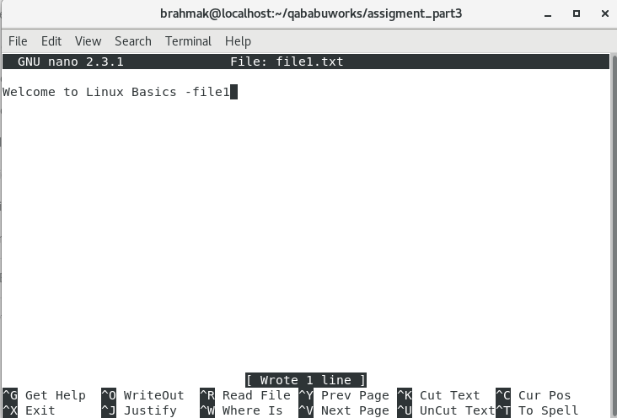

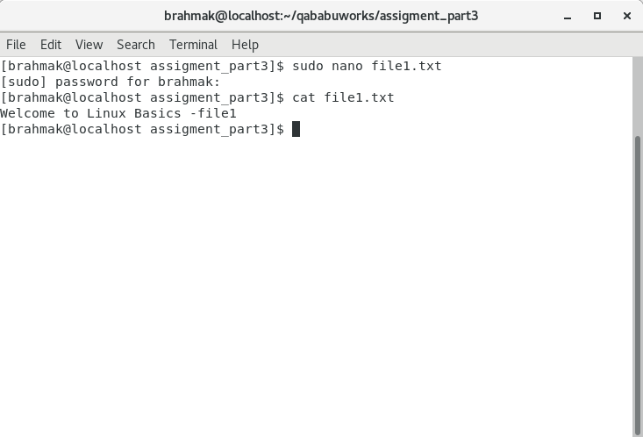

1. Copy text from file1.txt to file2.txt and view it

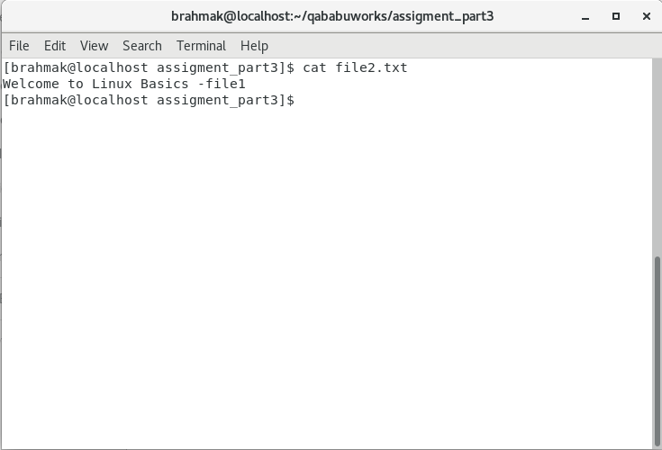

1. Moving file2.txt to the home folder

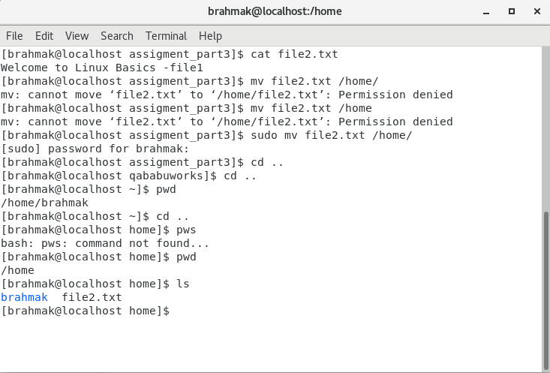

1. Creating fil3 and file4 in home directory

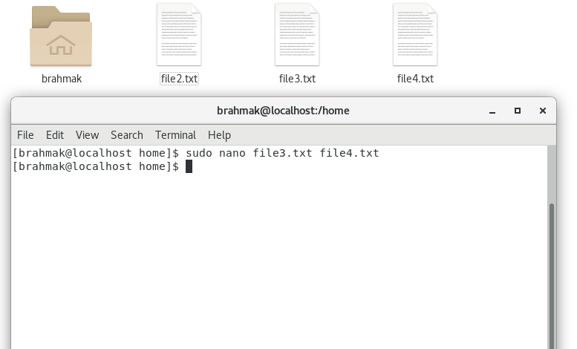

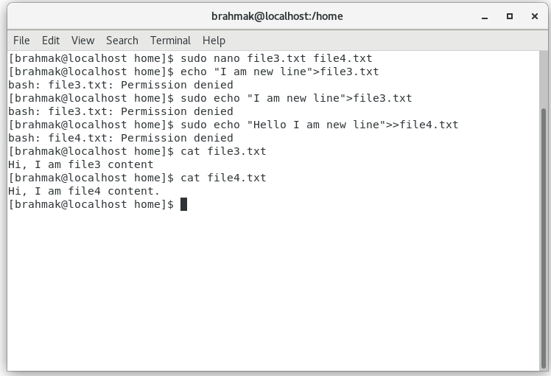

Somehow permissions were denied in both the cases.

1. Removing file or directory

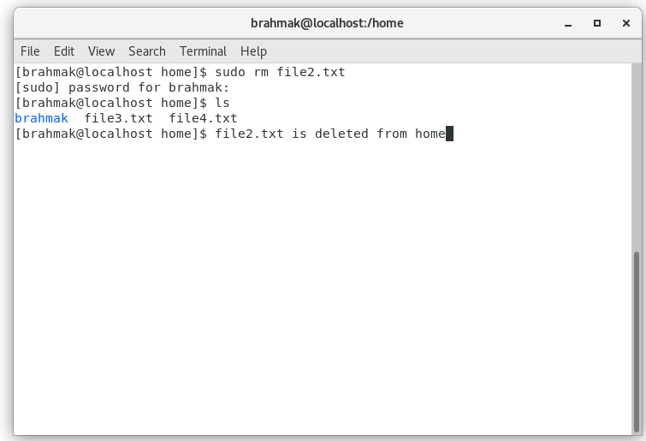

Remove directory

