

**Basic Linux Commands Assignments**

Assignment-1

Connect and disconnect with login Access

* What happens when you login a non-existent users or username?
  + Provide Screenshot and What you understand, explain in short brief?

Ans: Even when we enter a non-existent user and clicks on Next button, system accepts the user and navigates to the password screen as shown in the below screenshots

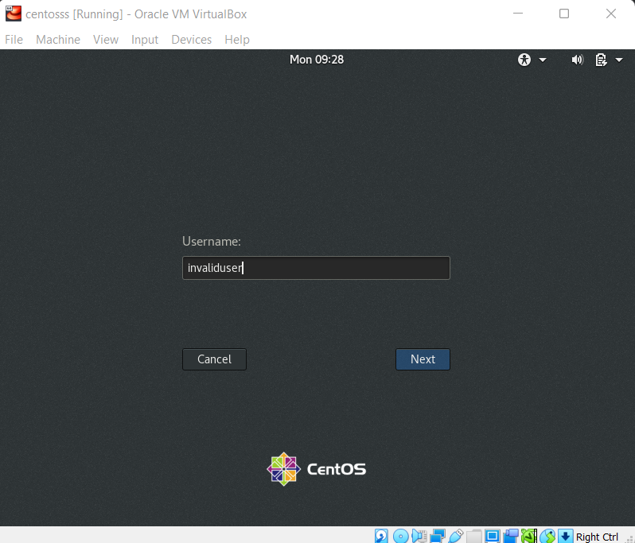

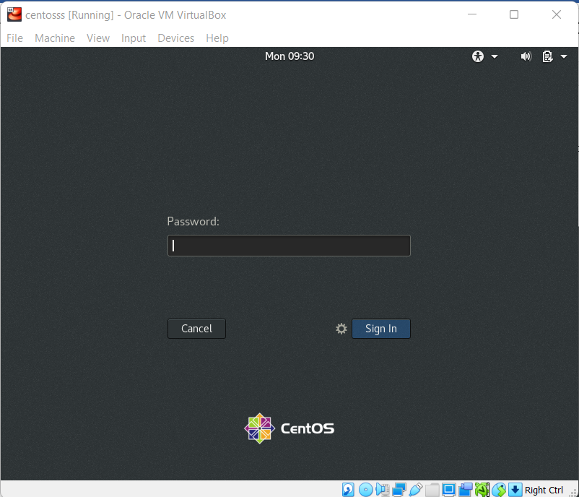

Assignment-2

Password changing

* Login into your account and then change password?
  + Change your password into **IneuR0n#42** and hit the **Enter** key
    - Explain what happen and give screenshot?

1. When the command “sudo passwd username” executed in terminal, it asked for the user password

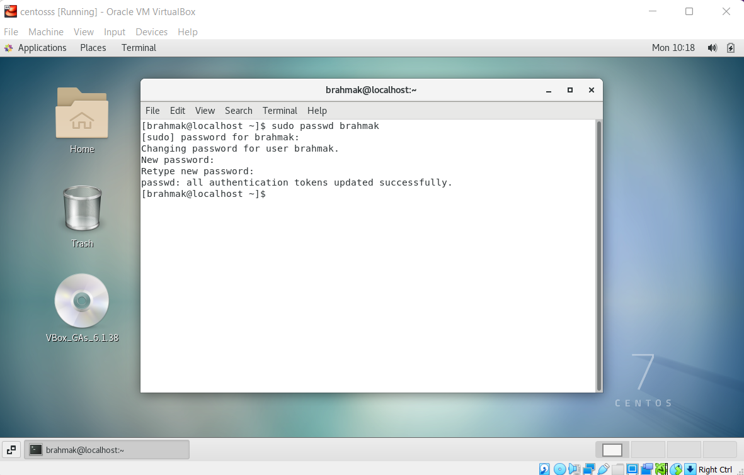

After entering the password, we are asked to enter new password and retype the new password. Once the password is changed successfully we got a message “all authentication tokens updated successfully.”

* + Try again to change password but use like password ***1234*** or ***abcd***
    - Explain what happen and give screenshot?

Password is changed but gave “BAD Password” warning as shown in the below screenshot.

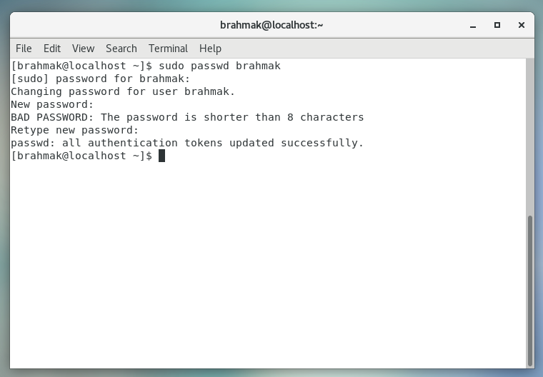

* + Try again to change password but now don’t use any password just hit **Enter** key
    - Explain what happen and give screenshot?

When no password entered and hitting the **Enter** key, it gave warning

“BAD PASSWORD: No password supplied”

And gave the warning: Authentication token manipulation error. Which means system did not accept the empty password.

And previous password is not changed.

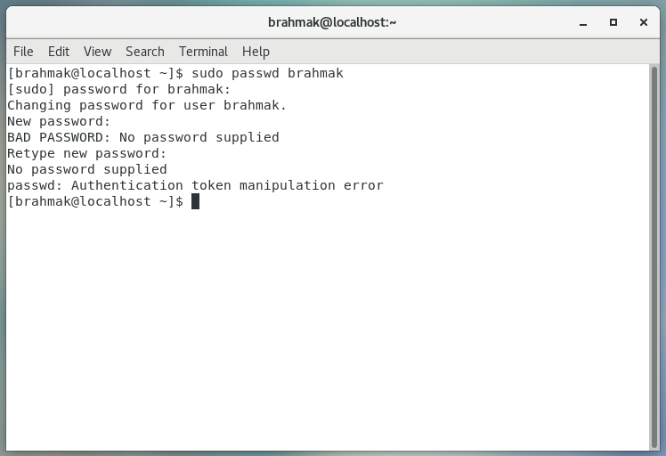

Assignment-3

Working with Directories

* Enter the command **cd /** and then **ls** and then hit **Enter** key
  + Take screenshot and explain what output we got?

After opening a new terminal, run the command “pwd”, gives the present working director as “/home/barhmak” shown in below screenshot.

Now run the command “cd /”, then directory is changed to top most or highest hierarchy directory (slash). Again run “pwd”, now it just gives “/”

After running the “ls” it gave all the available directories under the slash (/) as shown in the below directory

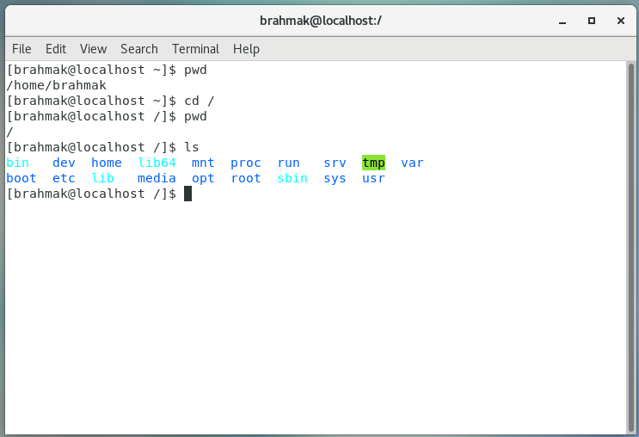

* Enter the command now **cd /home** and then hit **Enter** key
  + Do **ls,** provide screenshot and explain what is **/home** directory used for?

When we run “cd /home”, the directory will be changed to the home director inside the slash (/) directory. “/home” specifies the path of the home directory.

“ls” lists directories inside home directory

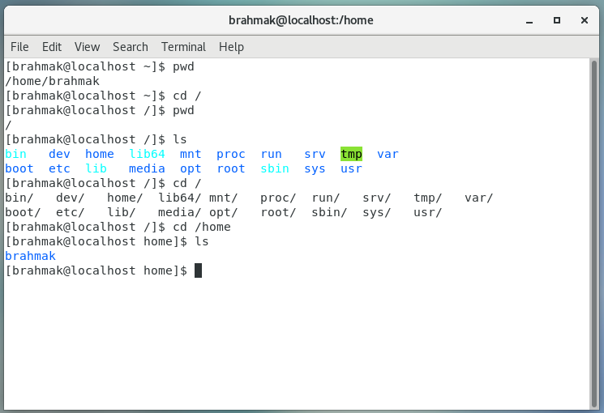

* Enter **cd ..** and hit **Enter** key [ *Note: here we have space after cd then use double dot*]
  + Check what happen and give screenshot?

After running “cd ..” command user was navigated to the parent directory that is “/”

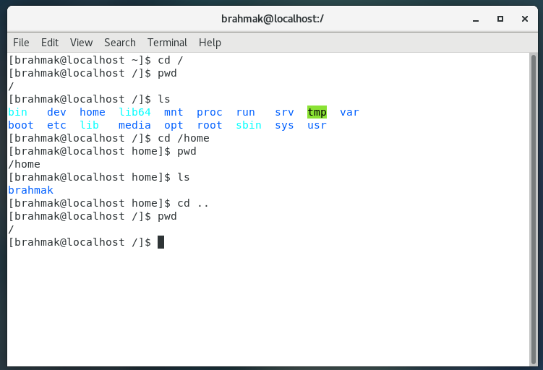

* Now enter **cd /var/www/html** and then type **cd** and hit **Enter** key
  + Explain what happen and give screenshot?

When I run the command “cd /var/www/html”, No such file or directory message was displayed as there is no directory called “www”

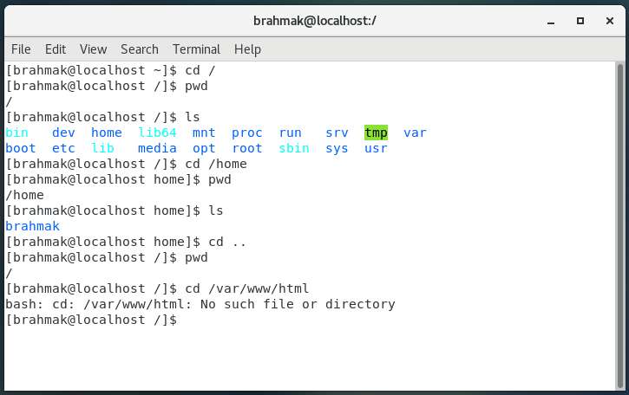

When I just run “cd” command, user was navigated to the user director under the home directory as shown in the below screenshot

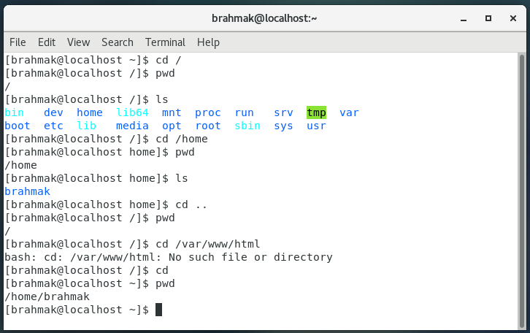

* Now type **cd /root** and then hit **Enter** key
  + Do **ls,** check any output we have on screen if yes then take screenshot?

User was not allowed to navigate to the root directory, permission was denied

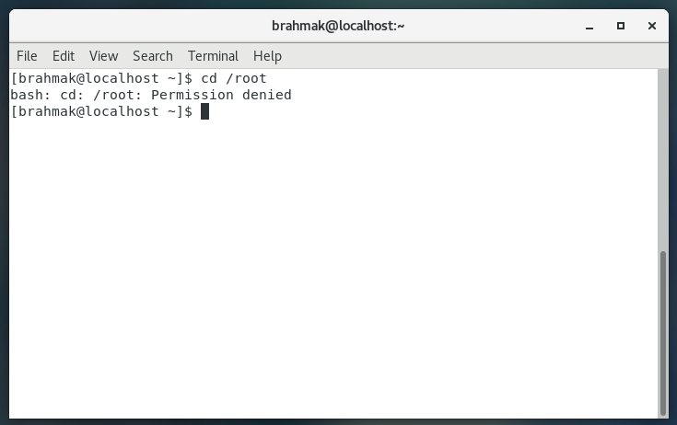

Assignment-4

Working with File Listing

* Go to **cd /etc** and type **ls**
  + Take screenshot and explain what files you have seeing?

The user navigated to the “etc” directory, and the “ls” command listed all the directories and files present in it. This directory contains many directories/files related packages, system and OS.

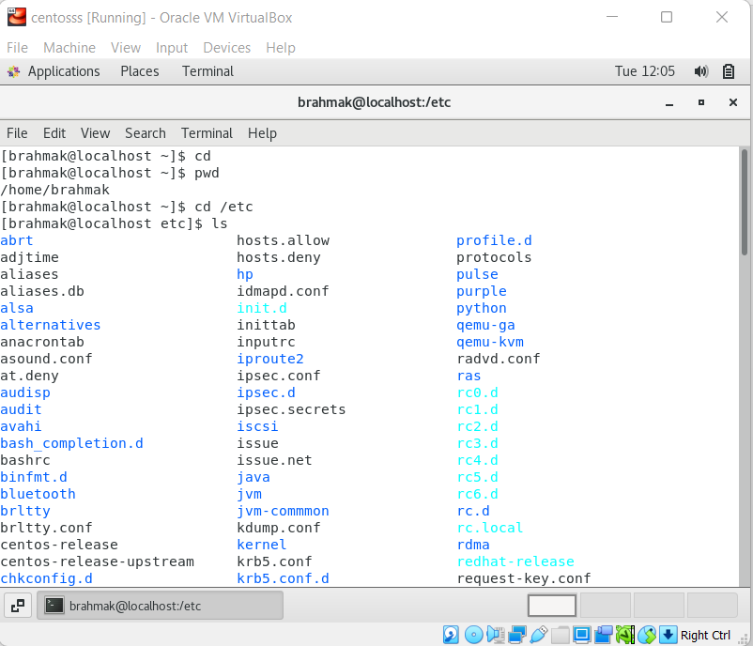

* + Take screenshot and explain what different output you found compare to previous command you used?
* Then type **ls -al** and hit **Enter** key
  + Take screenshot and explain what new file or directory you found?

The above “ls -al”, displayed all the files/directories along with hidden files. And the permissions of the file, size of the file are displayed

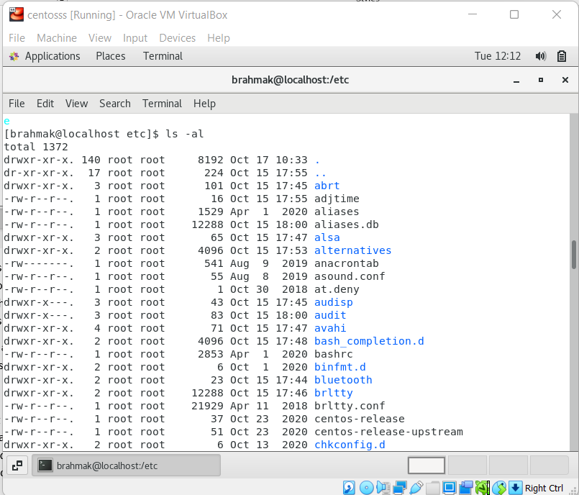

* Then use **ls -i** and hit **Enter** key
  + Now see what different output its shows and take screenshot?

The above command gave all the files or directories along with “inode” (Internal node) number. Which is used for internal operations in maintenance. It is a unique number.

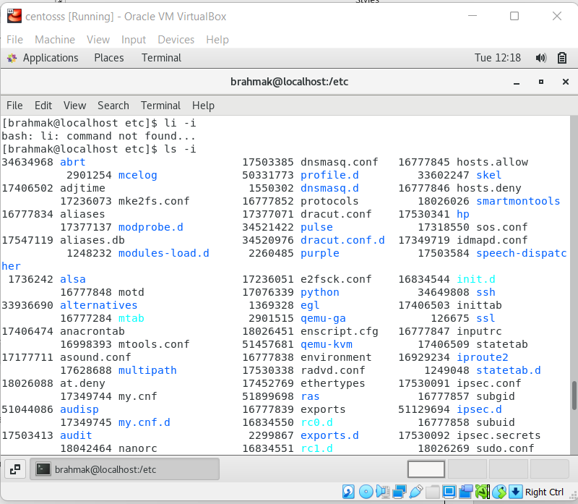

* Then use **ls –help** and see other options about **ls** command
  + Explore it and try with other attribute we can use with **ls** command

The “ls –help” command provide or displayed all the available flags that can be used along with the “ls” command for different operations.

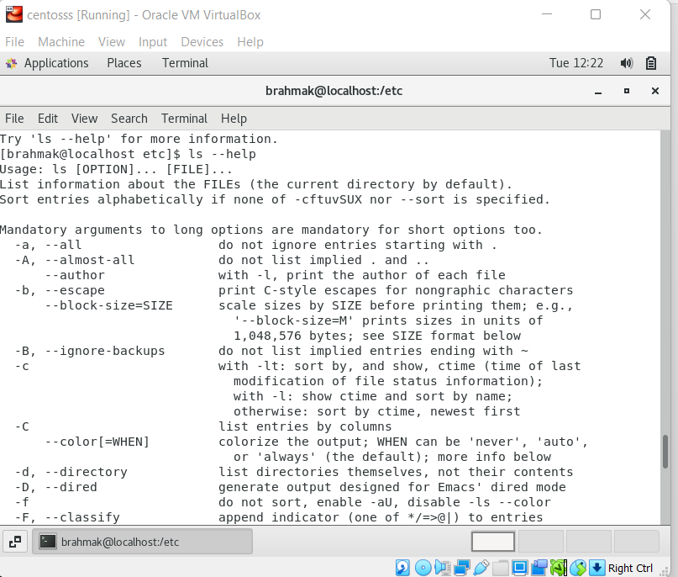

Assignment-5

Know where you are and where you working

*Here we use* ***pwd, cd and ls*** *as combine task to understand where you working on terminal and how you can switch from one directory to another one.*

* Open terminal after restart the linux
  + Check which location you working, type **pwd** and take screenshot

The user is in the user directory as shown below

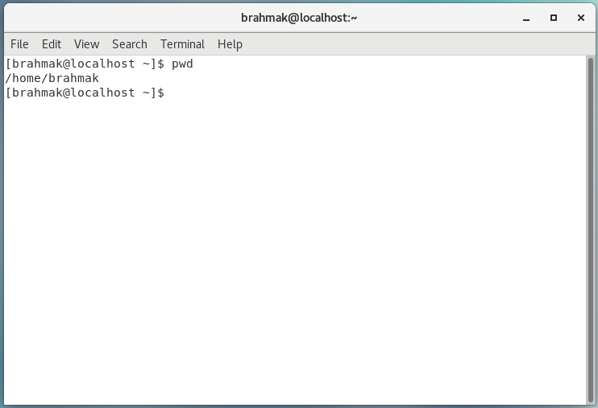

* Now use **cd /var** and hit **Enter** key
  + Do **ls,** and see what output comes, give screenshot?

The user is navigated to the “var” directory under the “/”

And it has files directories cache, games, temp and etc.

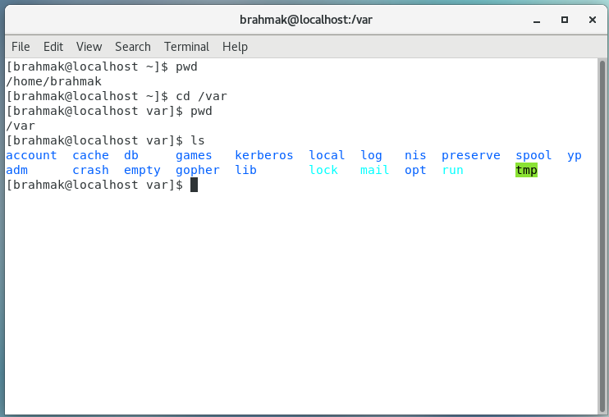

* Do explore other help options of each command to learn more other things we can do with these commands

**ls -1:** Listed one directory for 1 line

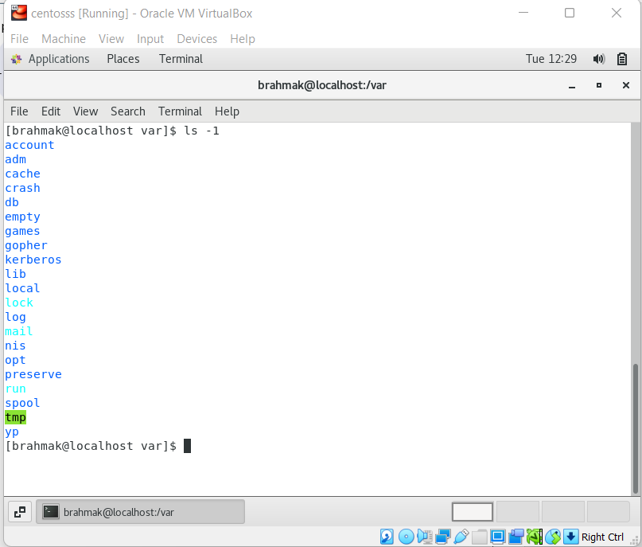

**Ls -r:** prints the directory in reverse order

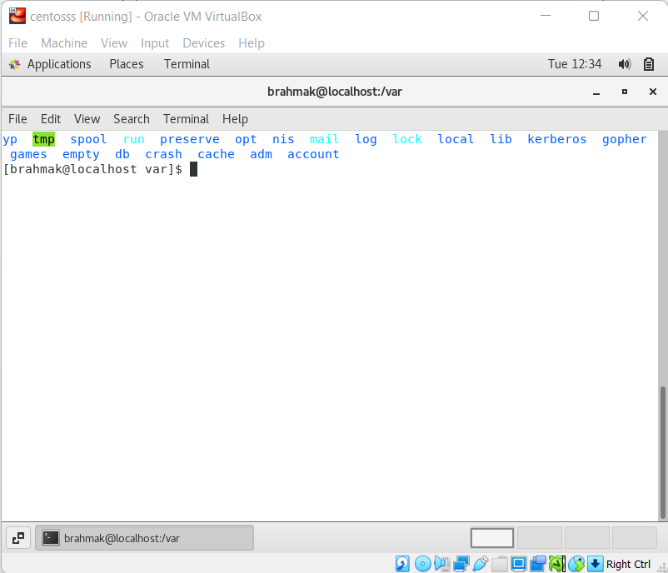

**ls -s -1:** prints the files along with its size in kb, one line each

