The distribution of average scores, or the percentage of total points earned by all students, is shown in the plot below.

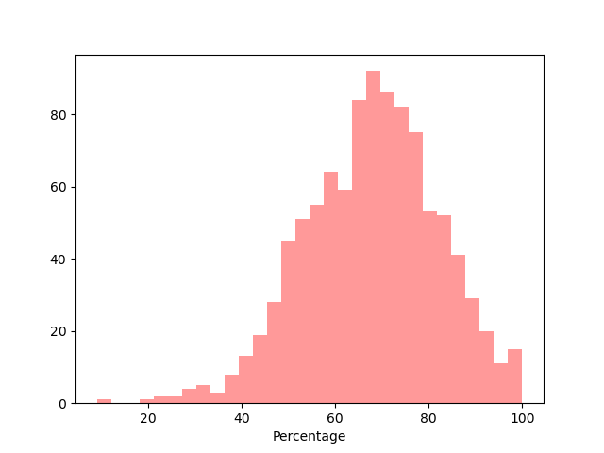

Below plot illustrates the grade secured by female and male.

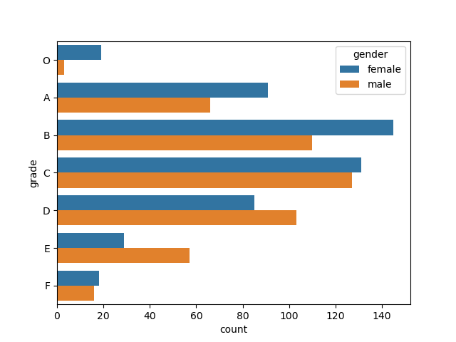

This plot indicates the distribution of lunch option preferred by the students. We can observe that A,B and c prefers more standard meal.

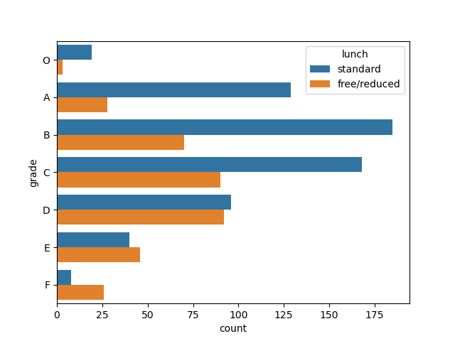

Below count plot illustrates the grades secured by students grouped by ethinicity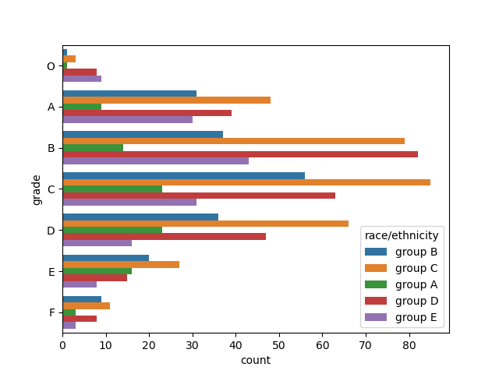

Below count plot illustrates hue course completion effects the student grade.

