MySql Joins And Unions

Description:

The abstract of this concept is to learn about the mysql joins to combine data or rows from two or multiple tables based on a common field between them in a database.

Things I have learned:

There are four types of mysql joins.They are

1. Inner Join
2. Left Outer Join
3. Right Outer Join
4. Full Join

1. Inner Join:

The Inner join keyword selects all the rows from both the tables with only matching values.

Eg: For example take a customer table and orders table.
Customers table


Orders Table



Inner join query and result set

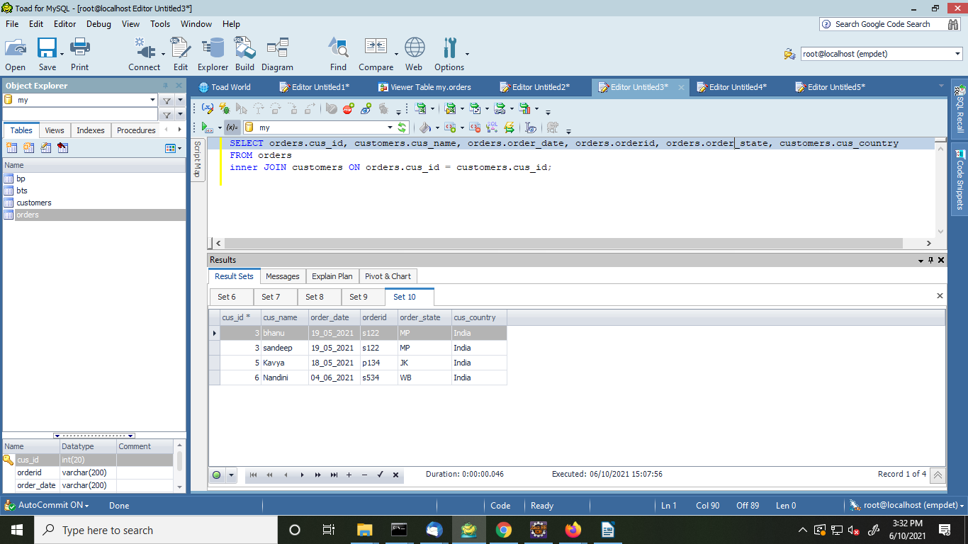

2. Left Outer Join:

This join returns all the rows of the table on the left side of the join and matching rows for the table on the right side of join. The rows for which there is no matching row on right side, the result-set will contain "null".

Query and Result set:

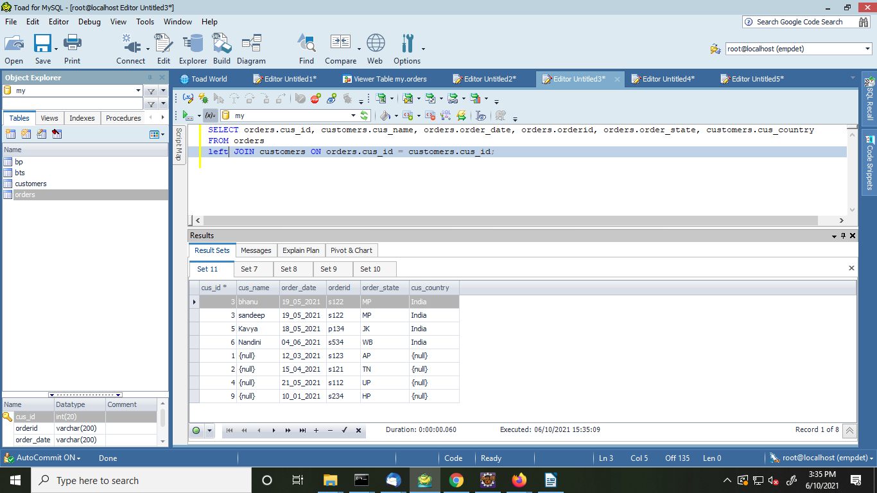

3. Right Outer Join:

This join is similar to left join. This join returns all the rows of the table on the right side of the join and matching rows for the table on the left side of join. The rows for which there is no matching row on left side, the result-set will contain "null".

Query and Result set:

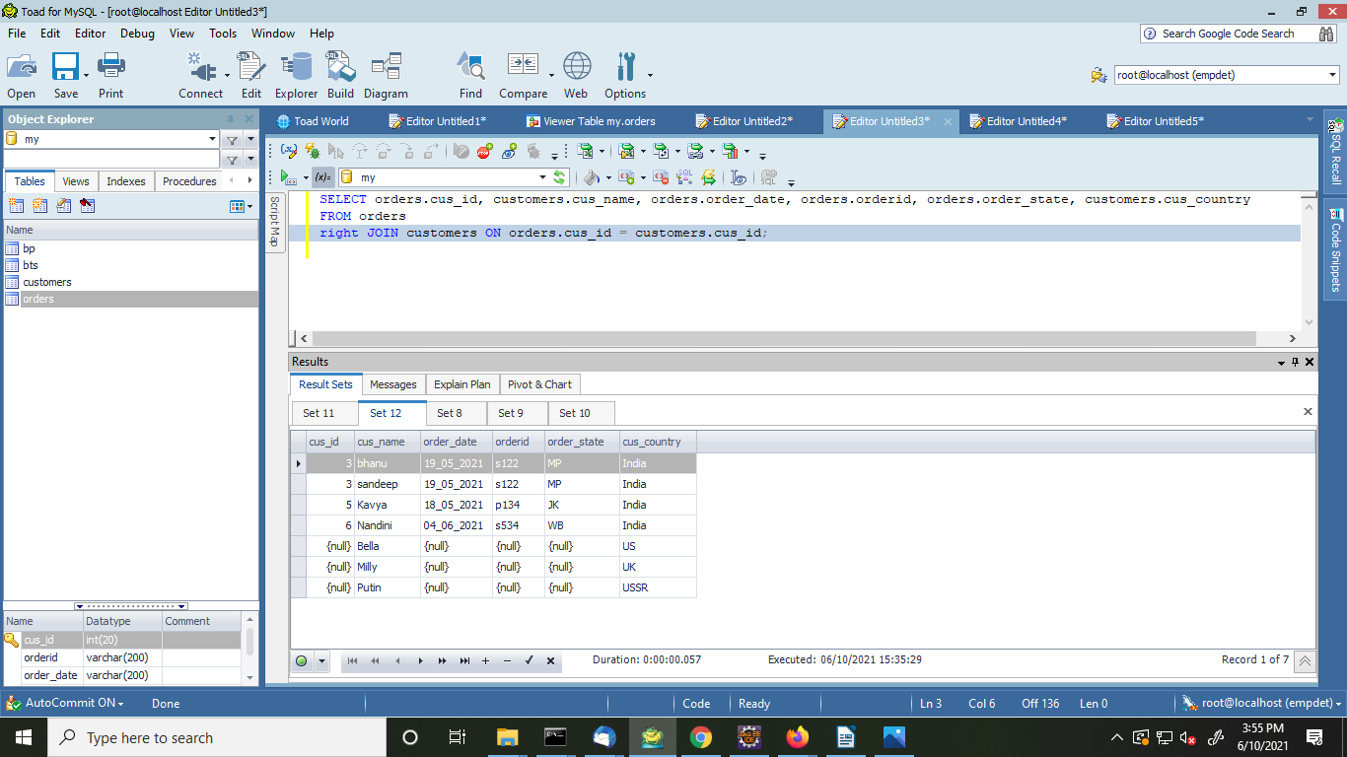
4. Full Join:

FULL JOIN creates the result-set by combining result of both LEFT JOIN and RIGHT JOIN. The result-set will contain all the rows from both the tables. The rows for which there is no matching, the result-set will contain "null" values

Union:

MySQL Union is an operator that allows us to combine two or more results from multiple SELECT queries into a single result set. It comes with a default feature that removes the duplicate rows from the result set.

Eg:
here we take two tables

1.students1:


2.students2:



Query and Result set:

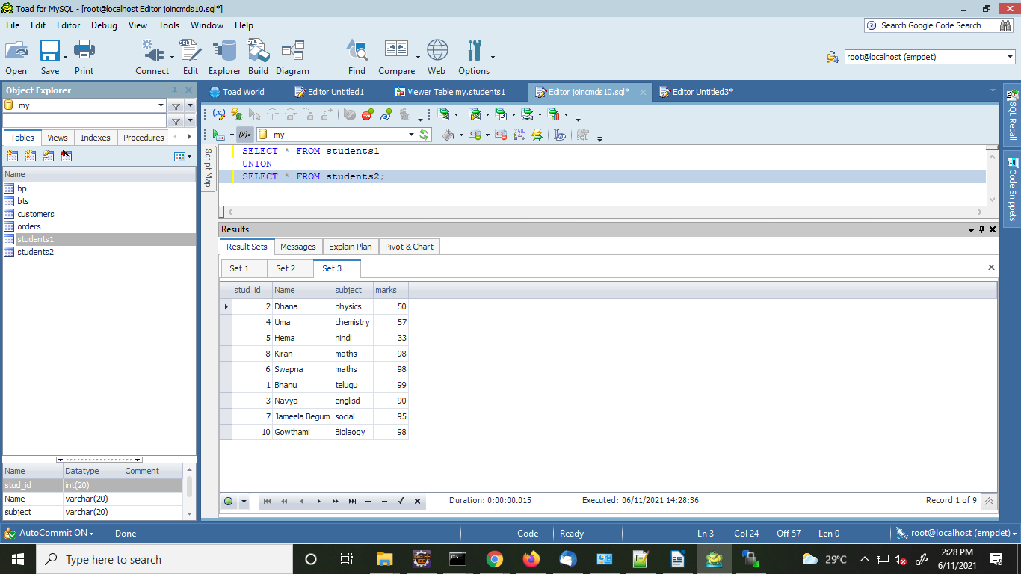

Union All:

This operator returns all rows by combining two or more results from multiple SELECT queries into a single result set. It does not remove the duplicate rows from the result set.

Eg:

Query and Result set:

