EMPLOYEE DETAILS OF AN ORGANISATION

Description:

The abstract of the project is to store the details of an employee in a database which we can update as well as delete the employee details and to display the details in web when login by a particular user.

Screen Shots related to project:

user login page

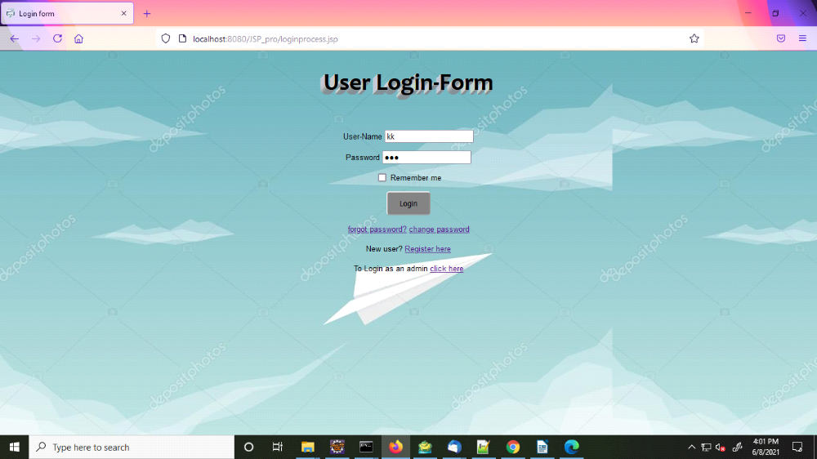

Employee details

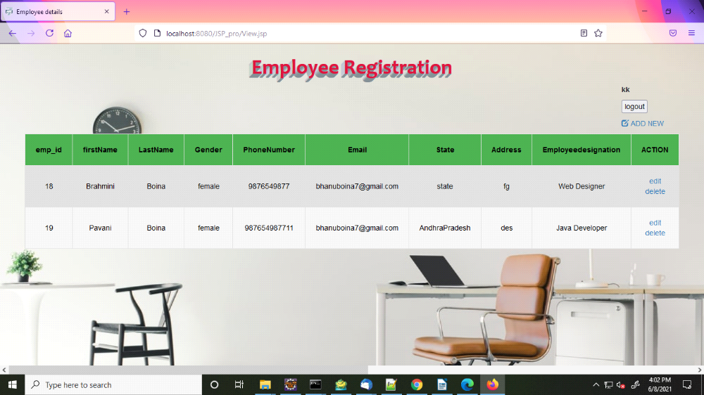

Add New Employee

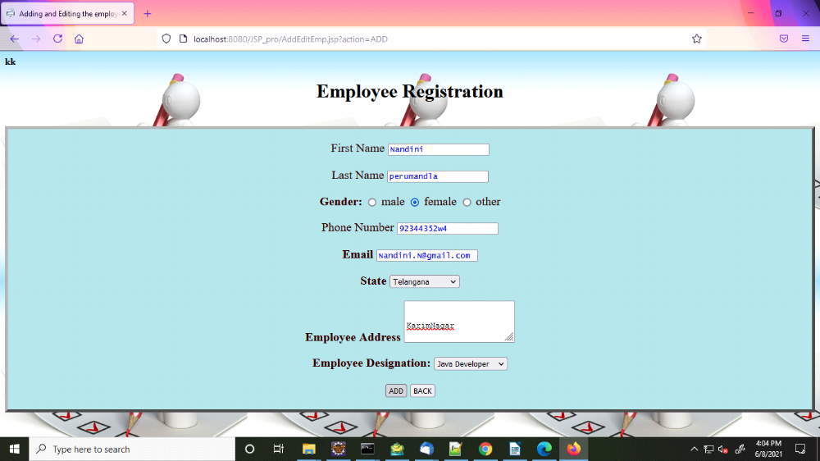

Edit Employee details

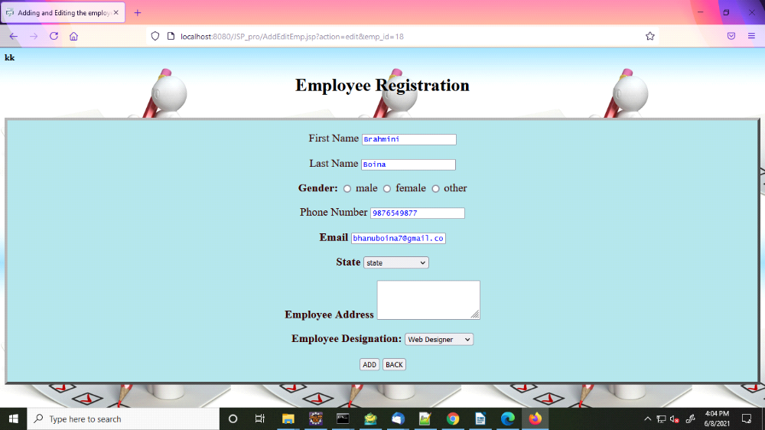

Delete Employee Details

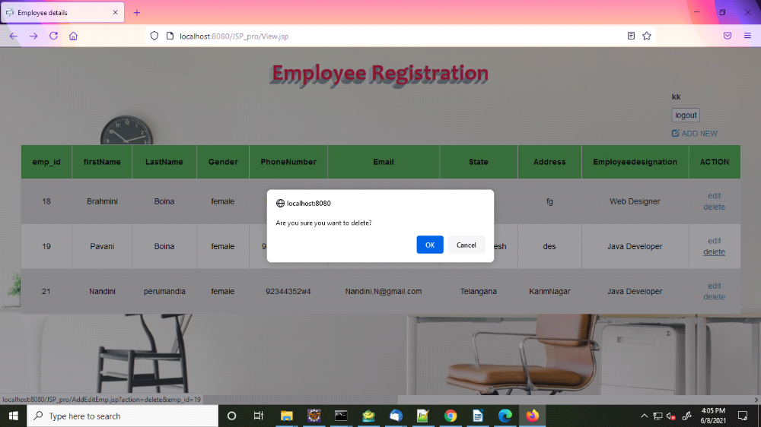

Logout Page

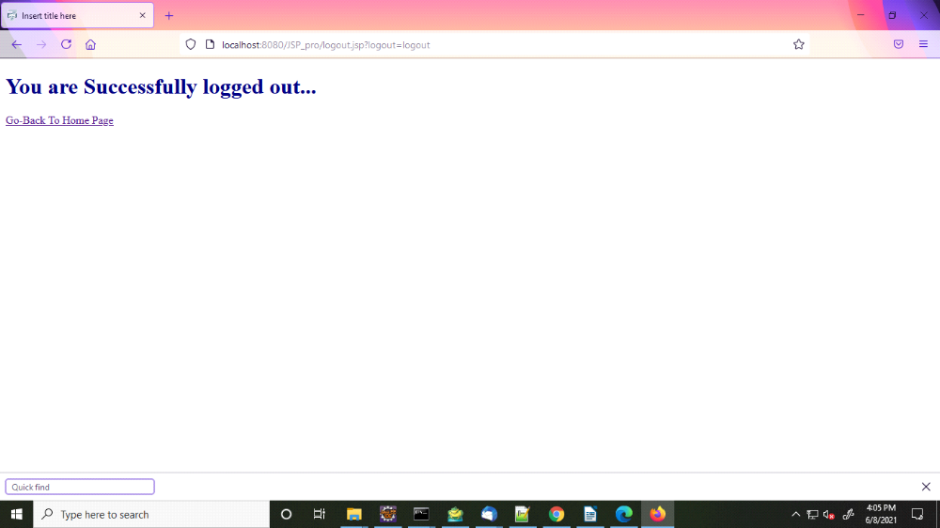

Session TimeOut page

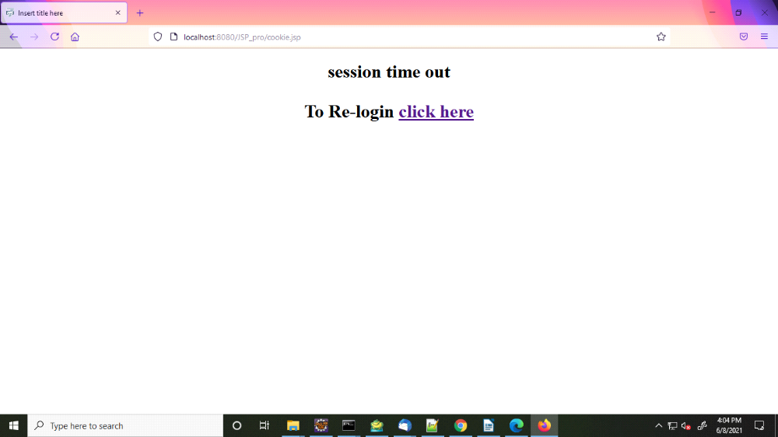

New User Registratioin

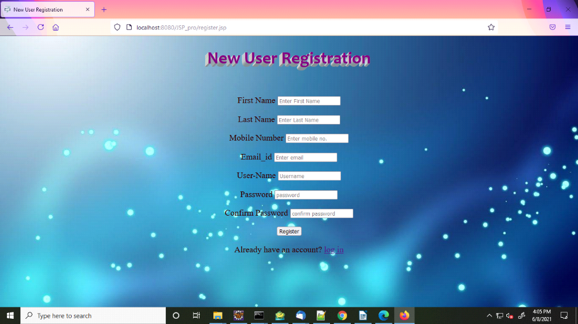

Admin Login Page

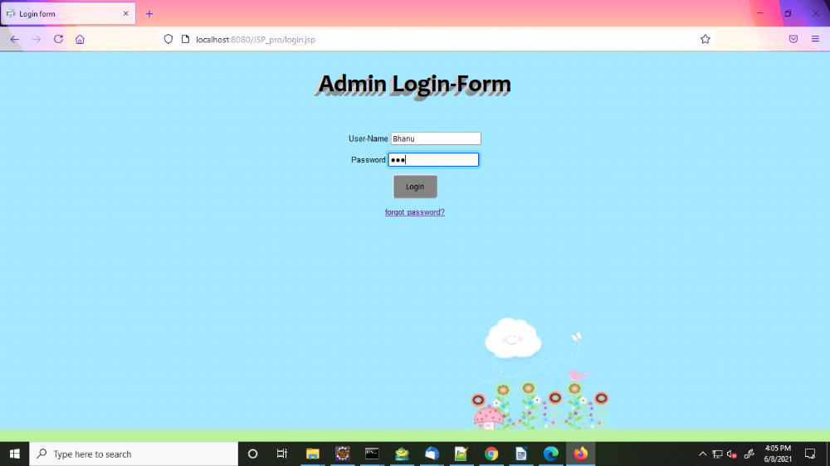

User Credentials

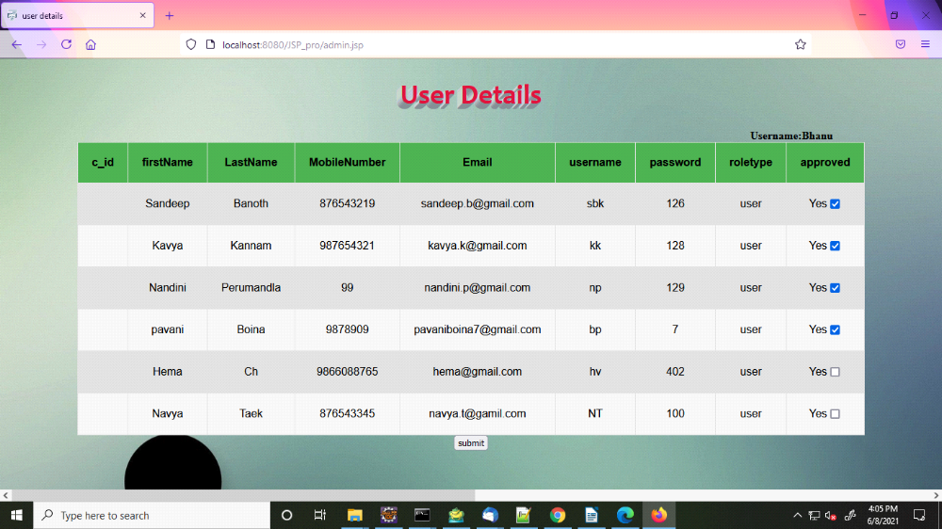

Approve the users

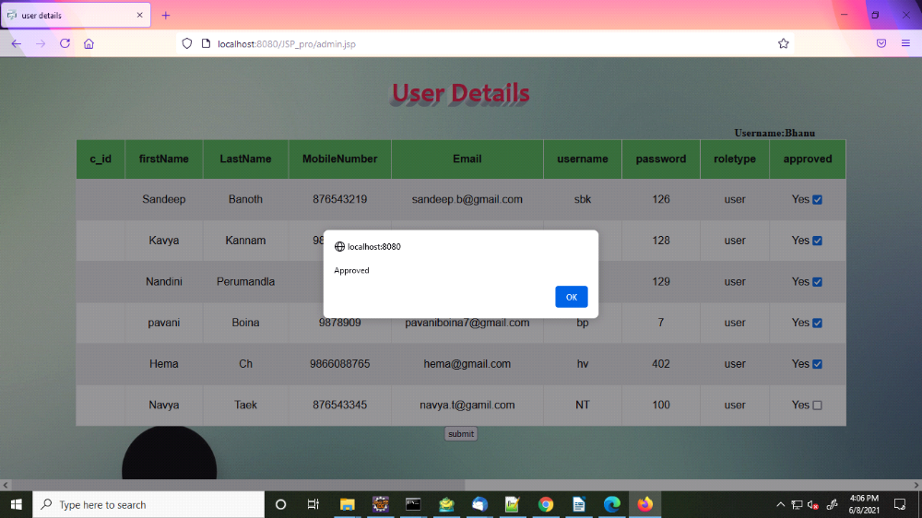

Change Password

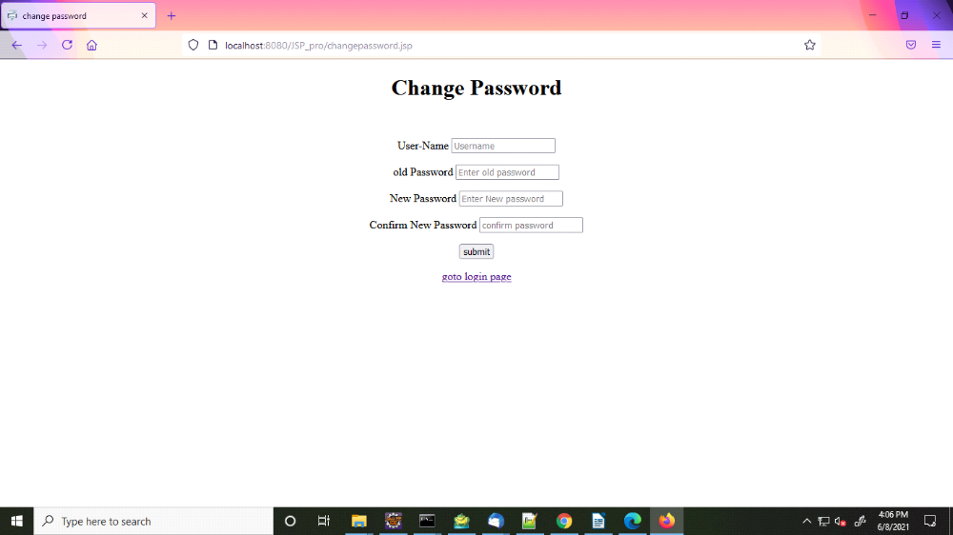

Database of employee details

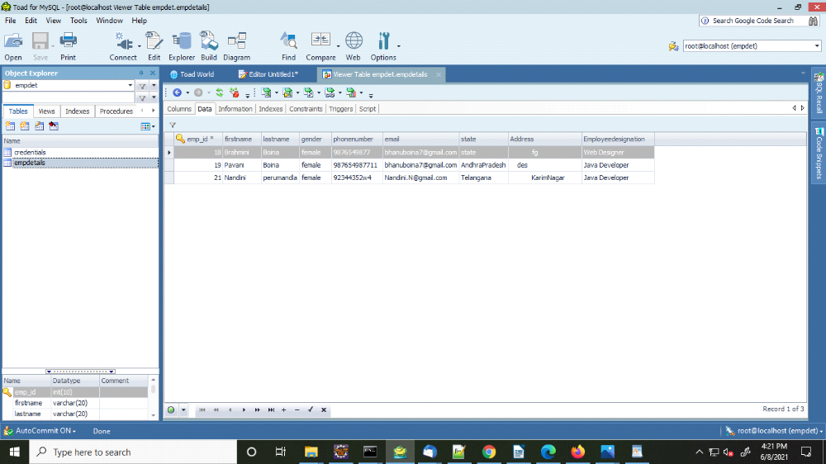

Database of User Credentials

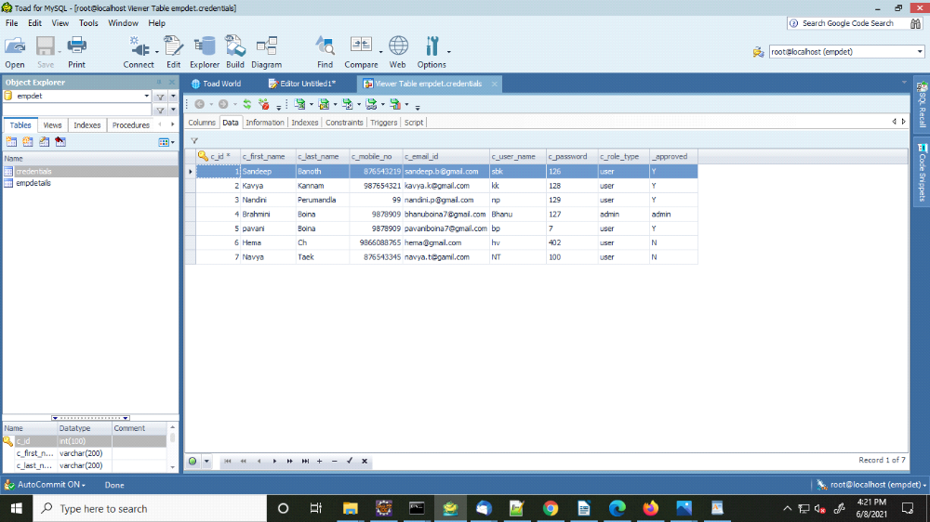

Things I have learned from this project:

- In this project I have used the eclipse IDE to wite my overall code.
- I've written the code using java, servlets, JDBC, JSP, html, css, javascript . Inorder to store the details in a database I used "mysql database" and to connect the server I used "JBOSS server".

JBOSS Server:

- Installation:
- Here I used the JBOSS 7.1.1 version to connect the server.

2. Starting the Server:
- Set the path in Environment Variables. And run the server in command prompt

3. Creating a Web Application

4. Creating war file

5. Deployment:
- Deploying the war file in deployments

6. Display:
- Opening the web application in web.

SERVLETS:

- Creating the servlet.java:
- Writing the necessary code in the servlet.java

2. Creating web.xml file:
- for servlet mapping we have to create web.xml file

3. Adding Jars:
- Adding the required external jars to the project

4. Display
- Searching the webpage in the following format as <http://localhost:8080:/war file/url> pattern (or) html file (or) JSP file

5. Cookies
- cookie() - constructs a cookie.

- setMaxAge(int expiry) - sets the max. Age of the cookie in seconds

- getName() - returns the name of the cookie.

- getValue() - returns the value of the cookie

- addCookie(Cookie ck) - used to add cookie in response object.

- Cookie[] getCookies() - used to return all the cookies
from the browser.

- SetMaxAge(0) - deletes the cookie

Commands used in the project:

1. request.getParameter()
- used to retrieve the input values from HTML page

2. request.getParameterValues()
- used to retrieve more than one element

3.PrintWriter out = response.getWriter()
- returns a PrintWriter object that can send character text to the client.

4.response.setContentType("text/html")
- sending HTML response to the client.

5.doget()
- is used for getting the information from server.

6.dopost()
- is used for sending the information to the server.

JDBC:

1. classforName() - Registering the driver class

2. getConnection() - Creating the connection between server and database.

3. con.createStatement() - used to create the statement

4. executequery() - used to execute queries to the database.

5. con.close() - used to close the connection automatically.

6. Statement - provides methods to execute queries with the db

7. PreparedStatement - it is sub-interface of statement. Used to execute parameterized query.

8. ResultSet - maintains a cursor pointing to a row of a table.

9. executeUpdate() - used to execute specified query (create, insert, update, delete etc.,).

10.rs.next() - used to move the cursor to the one row next from the current position

11.rs.getString()- used to return the data of specified column index of the current row as String.

12.rs.getInt() - is used to return the data of specified column index of cursor row as int.

JSP:

1. Scriptlet tag [<% %>] – ability to insert the java code inside JSP.

2. Expression tag [ <%= %>] - is written to the output stream of the response.

3. Declaration tag [<%! %>] - to declare fields and methods.

MY SQL:

1. Creating a data base - creation of new data base

2. Creating a table - creating a new table

3. Truncating the table - deleting the data in the table

4. Altering table - changing the columns like adding , deleting .

5. Adding a Primary Key - unique identification of each record in a table

6. Updating the table name - changing the name of the table

Challenges faced in the project:

1.ClassNotFoundException - during loading the class

2.IllegalStateOfException - during redirecting between JSP files

3.NullPointerException - during comparing with other variables

4.SQLException - during mistakes in the where clause.

5. Issue of adding jars - during adding the jars in Build Path

6.Connecting with JDBC Driver class - during loading of JDBC drivers

----------------------------------THE END-----------------------------------

