**WiApp Admin User Manual**

**Steps to create portal in WiApp:**

**Service Creation:**  [WiAppAdmin 🡪 Administration 🡪 Manage Service]

Service creation is used to include the various services

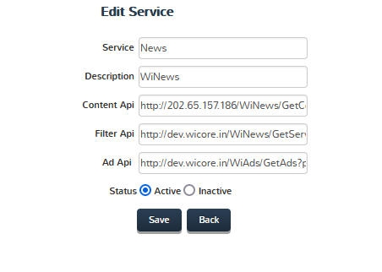

Service: Name of the service

Description: Description of the service

Content Api: Content Api Url. For fetching service content.

Filter Api: Content Api Url. For fetching filter content.

**Customer Creation: [Administration 🡪**

PageSettings