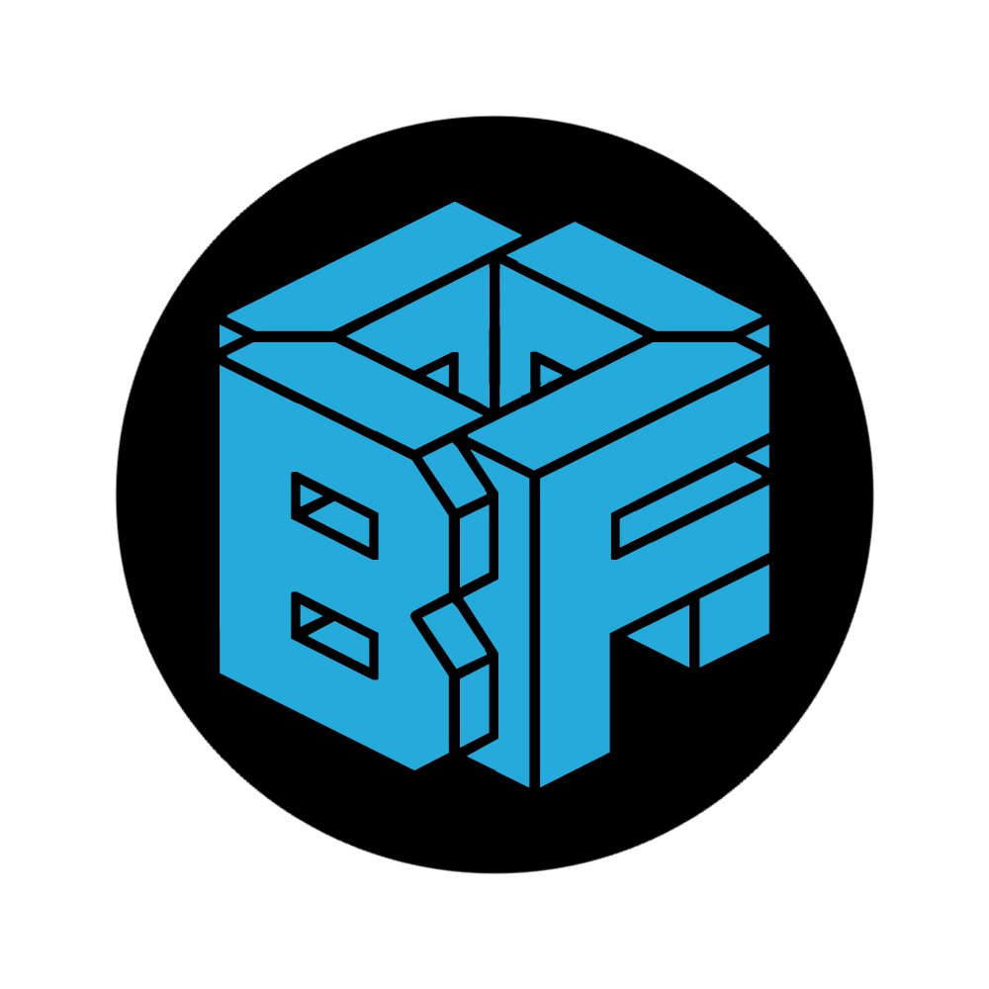

**Brian Finck**

**A Front-end Websmith**

Email: [brian@brianfinck.com](mailto:brian@brianfinck.com)

Phone: (805) 705-8412

Website: brianfinck.com

## Extracurricular Projects

**Intelly Blog CRUD Application October 2015**

Fully-functional MEAN Stack API CRUD application, built from a desktop view comp into a web application tailored for handheld mobile device and desktop responsive views, Built in a group of three. Employed MongoDB, Node Express server, AngularJS, JavaScript, Sass, CSS, semantic HTML, Gulp, Git, GitHub, responsive web design, object-oriented design, front-end design, back-end design, mobile-first approach, debugging testing, refactoring

# [Blog CRUD GitHub](https://github.com/brain11f/mean-stack-1)

## Morningsong Farm

**A flower farm website In progress**

Used the instagram API to make a beautiful banner of their instagram photos.

# [Morningsong Farm GitHub](https://github.com/brain11f/moringSongFarm)

## APPBOX

**A mobile first site April 2015**

Fully-functional front-end prototype for a marketing site, built from a desktop view comp and reimagined using a mobile-first approach, tailored for handheld mobile device, tablet, and desktop responsive web views. Built in a group of four. Employed Sass, CSS, semantic HTML, JavaScript, jQuery, Git, GitHub, Surge deployment, responsive web design, object-oriented design, front-end design, mobile-first approach, debugging, testing, refactoring

# [APPBOX GitHub](https://github.com/mbuchthal/project_week_one)

## Education Code Fellows

**Front End Development March 2015 - October 2015**

The curriculum includes fullstack development with Node.js, REST and MongoDB as sever environments. Front end technologies includes Angular.js, SASS and jQuery.

## Self Education

**Web Development & Design January 2015 - Present**

I attend between two and three meetups every week covering a wide range of new and developing technologies. I am a member of treehouse a online web development school.

## Bellevue College Web design

**January 2015 - February 2015**

Studied web design and graphic design

## Brooks Institute Bachelor of Fine Arts

**August 2009 - August 2012**

Studied art, design, photography and color theory.

## Work Experience Photographer

**Zulily**

**November 2013 - November 2014**

Utilized style, design and color theory skill sets.

## Digital Technician Zulily

**February 2012 - November 2013**

Worked with the development team to implement a new internal web application that automated the process of moving images from the photography set's computers to the correct corresponding assigned image editor.

## Volunteer Give Camp

**Developing technologies to help non-profits October 2015**

Delivered a web application to track the attendance of students with hearing disabilities in 30 hours.