Task: Advanced NAT and PAT Investigation
Objective
Configure a private enterprise network accessing an external network through NAT and PAT. Implement static NAT for an internal server, dynamic NAT for selected hosts, and PAT for normal users.
Topology and Addressing Plan
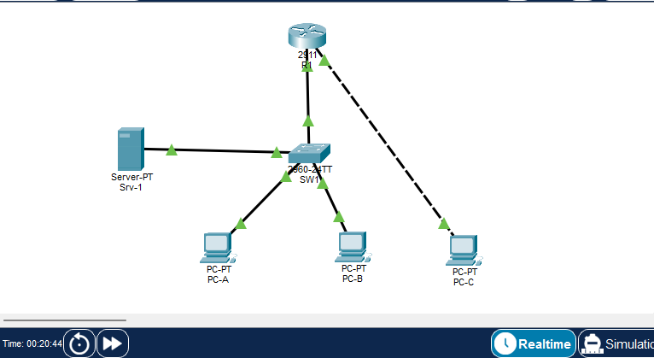

Phase 1: Baseline connectivity
What was done: all six devices were cabled, renamed. On R1 both interfaces were configured with their NAT roles and a default route pointing out the public link. NAT roles are declared but no translation rules exist yet.
Verification:
- Both interfaces came up
- PC-A pinged PC-C (203.0.113.2) successfully by plain routing.
- Baseline capture, the request leaves R1’s outside interface with its original private source nothing is translated.
- show ip nat translations on R1 returned an empty
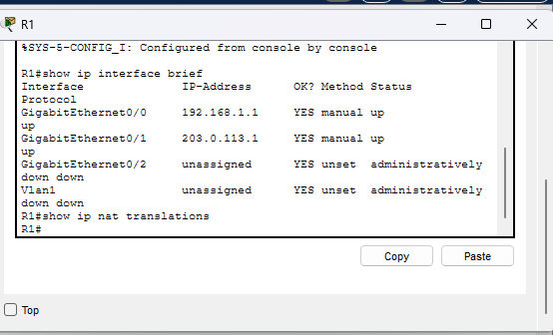
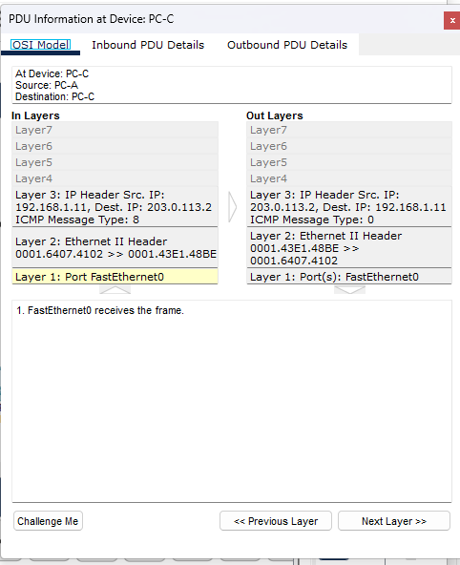
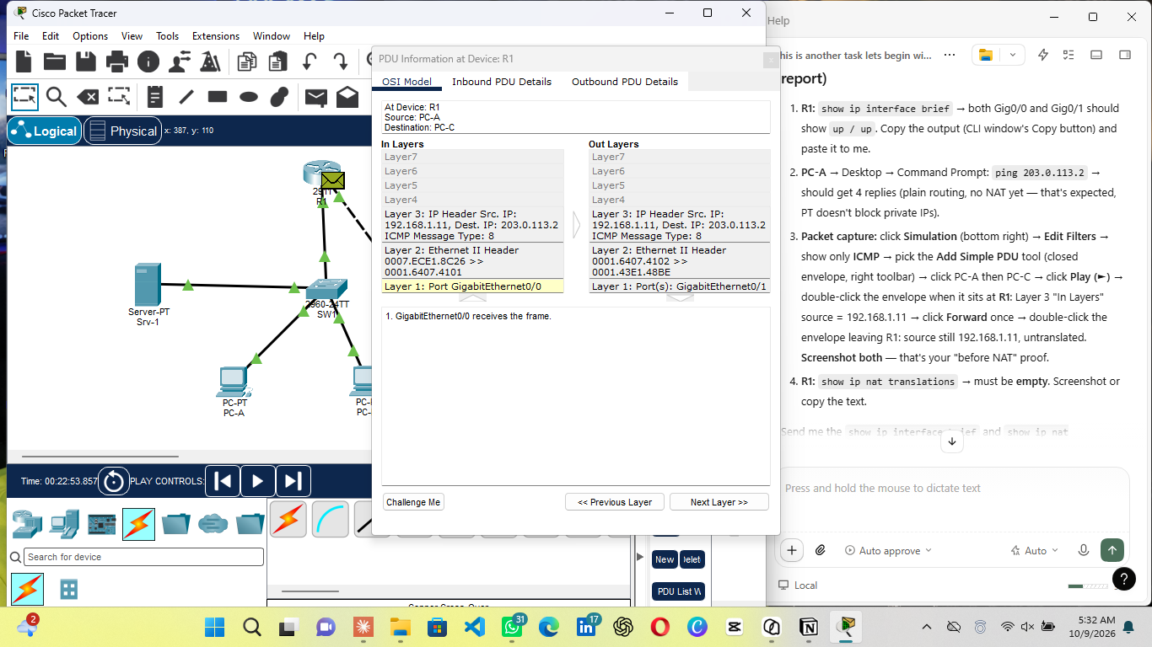
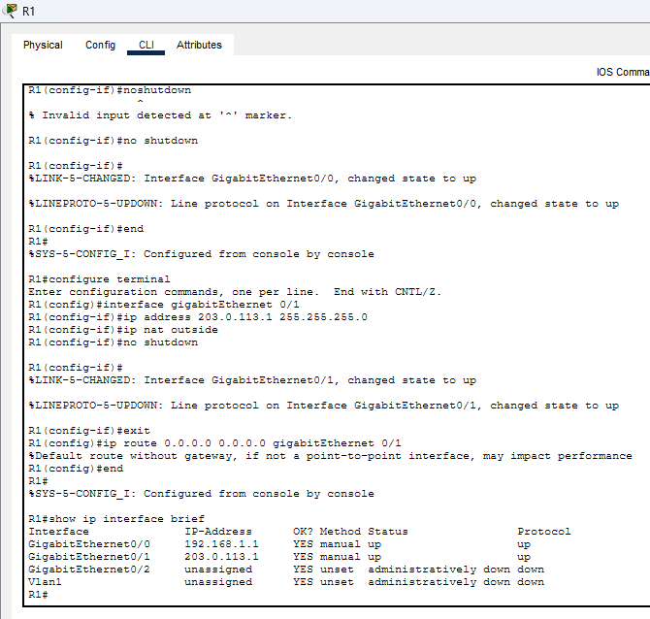
Phase 2: Static NAT for the Internal Server
What was done: a permanent one-to-one mapping was configured between the server’s private address and a dedicated public address
- The entry appeared in the translation table immediately, before any traffic .
- External reachability test: PC-C pinged 203.0.113.10 and received all four replies. The outside world uses and only knows 203.0.113.10, but the private 192.168.1.10 is never seen by PC-C.
- Destination translation captured: PC-C’s request is addressed and the same packet leaving R1 toward the LAN has its destination rewritten. The reply leaves the server with source 192.168.1.10, which R1 rewrites back to 203.0.113.10 on the way out.
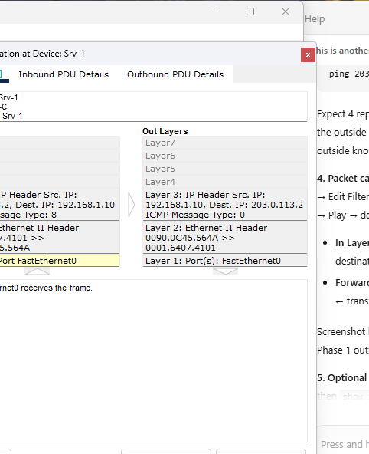
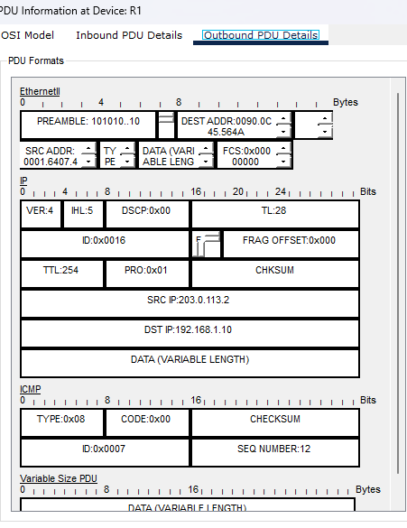
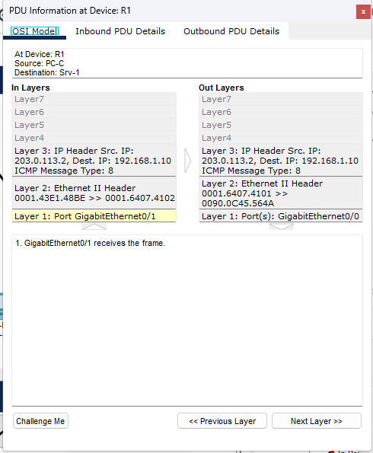
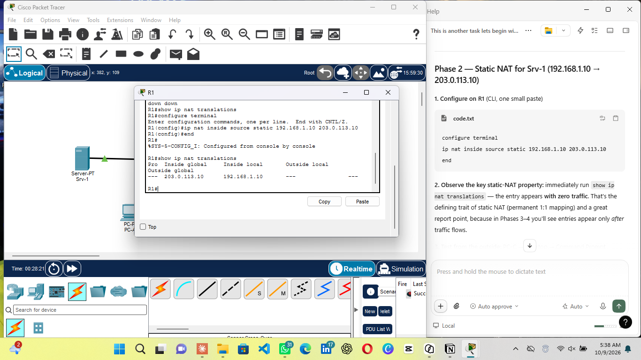
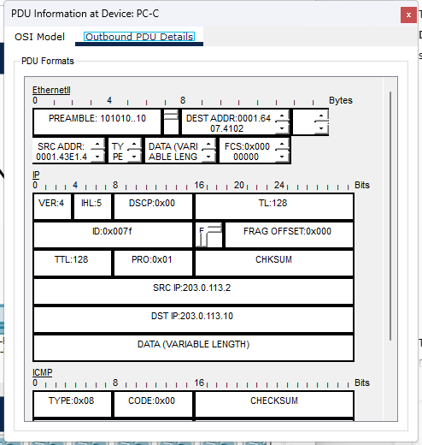
Phase 3: Dynamic NAT for selected hosts (PC-A)
What was done: a public address pool was created and an ACL was used to select which inside host may use it:
Observations:
- Before any traffic, the table still contained only the static entry — dynamic mappings create entries on demand, unlike the Phase-2 static entry.
- PC-A pinged 203.0.113.2, immediately afterwards the table showed icmp entries mapping 192.168.1.11 to 203.0.113.20 the first address of DYN-POOL.
- The request leaves R1’s outside interface with source 203.0.113.20 compared to the Phase-1 baseline where the same host’s traffic crossed untranslated as 192.168.1.11.
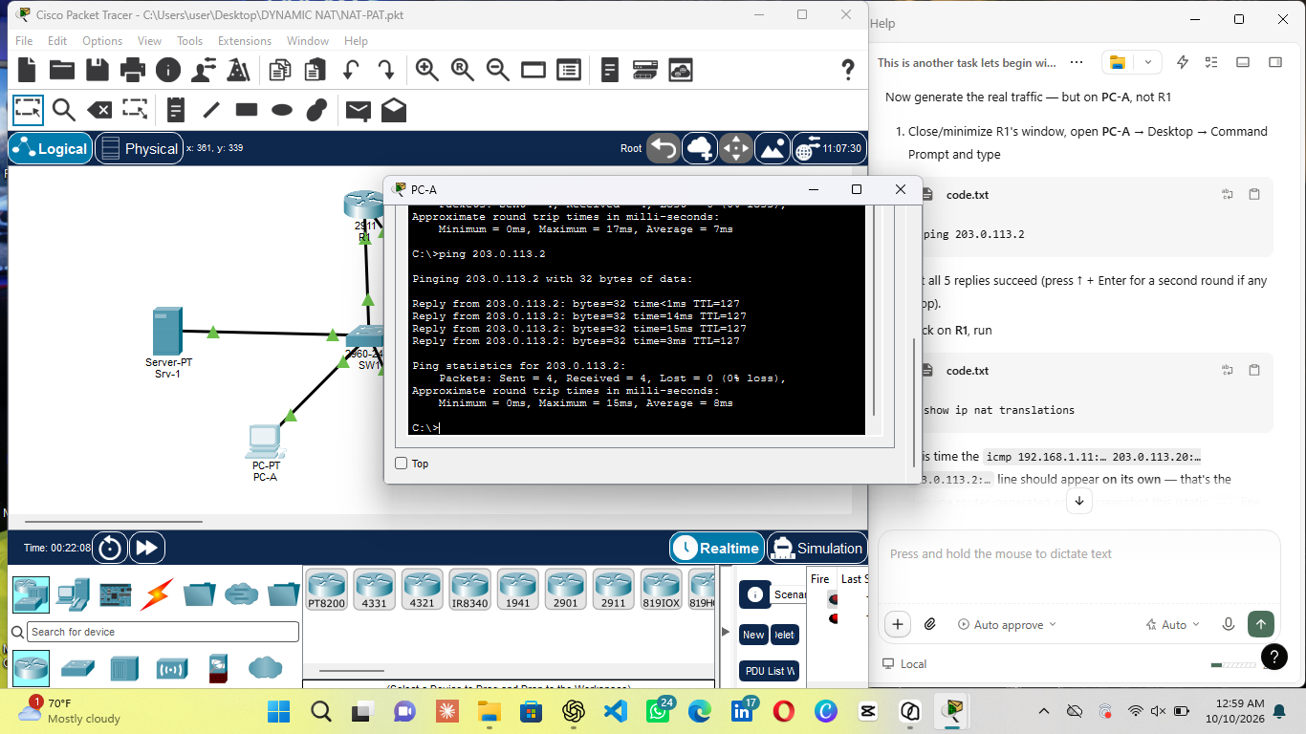
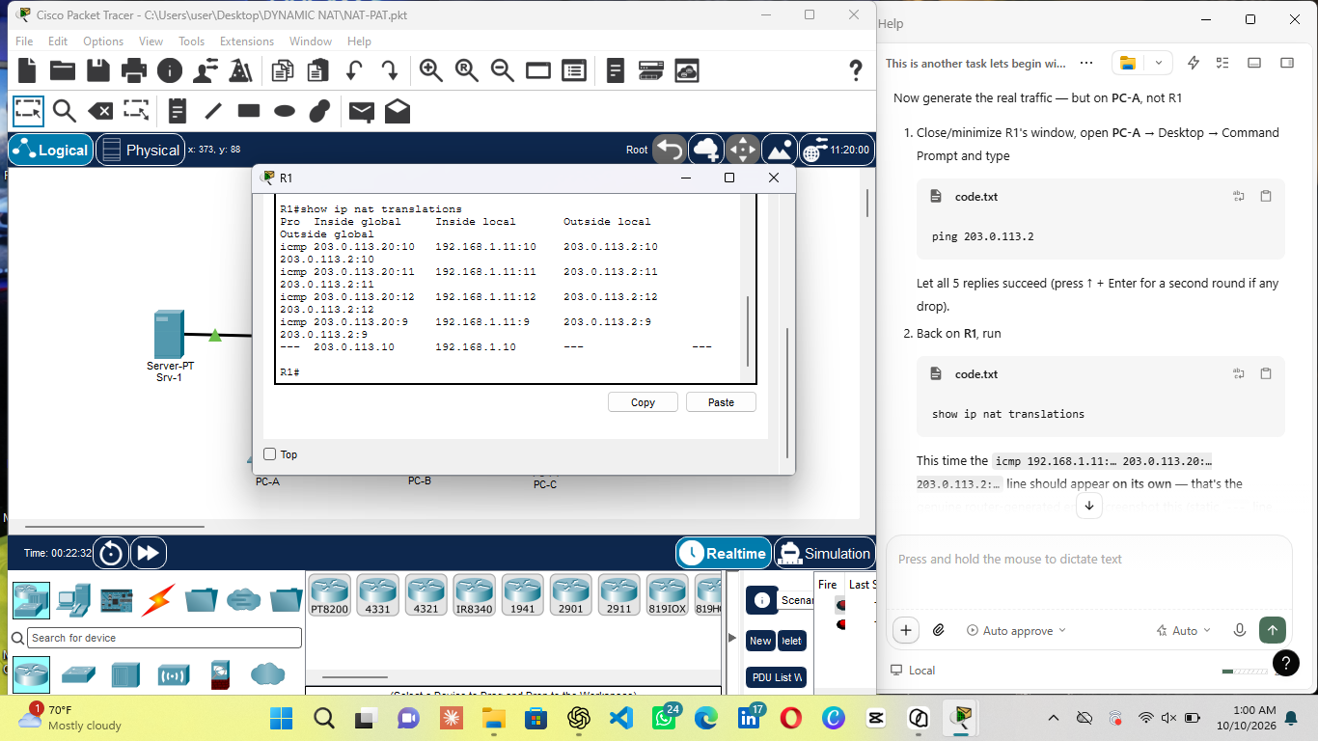
- The selected-hosts proof, PC-B also pinged 203.0.113.2 successfully plain routing delivers it but no translation entry for 192.168.1.12 ever appeared.
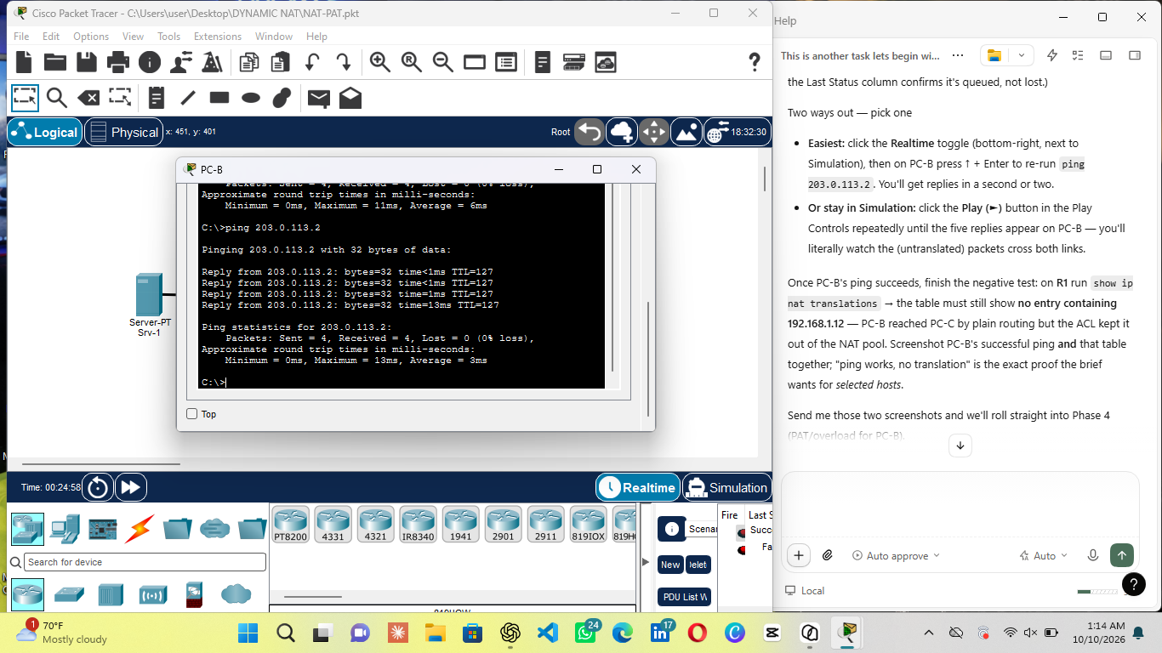
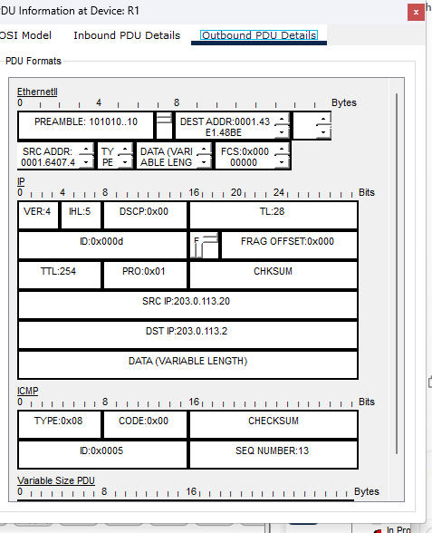

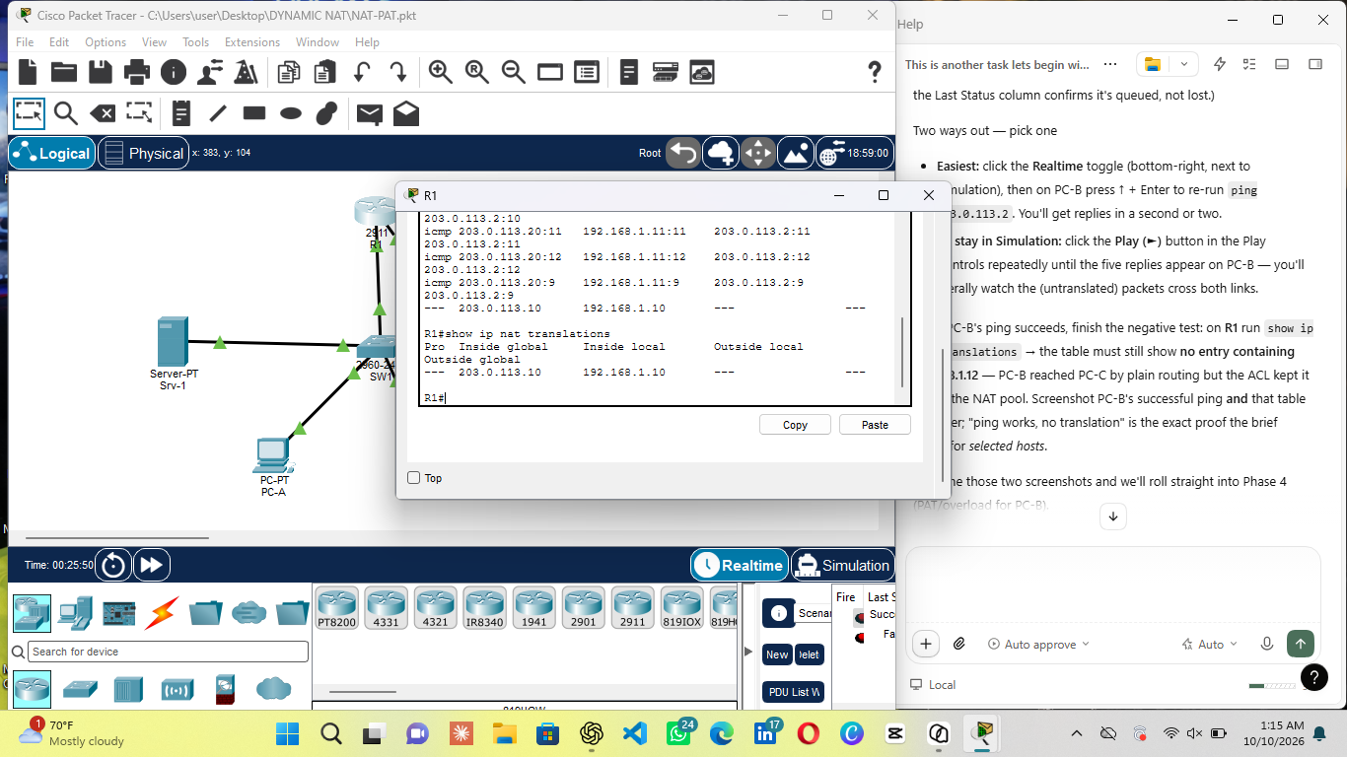
Phase 4: PAT for Normal User (PC-B)
What was done: PC-B was configured for Port Address Translation, sharing the router’s own outside address instead of a pool address:
Observations:
- Before traffic, the table contained only the static entry.
- PC-B pinged 203.0.113.2; new entries appeared with inside global 203.0.113.1, R1’s own gigabitEthernet 0/1 address, one entry per icmp identifier.
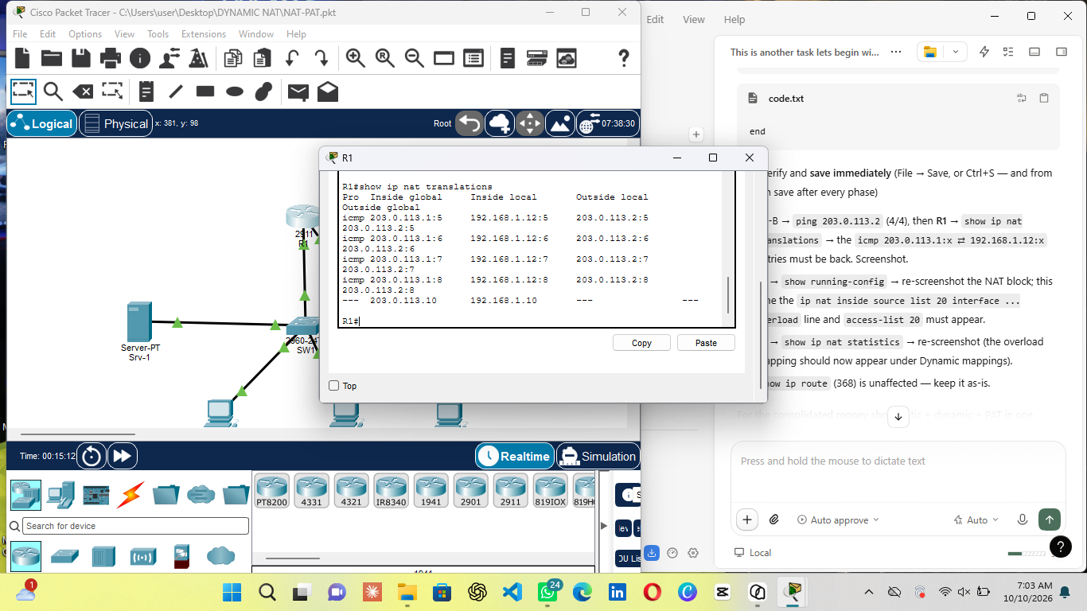
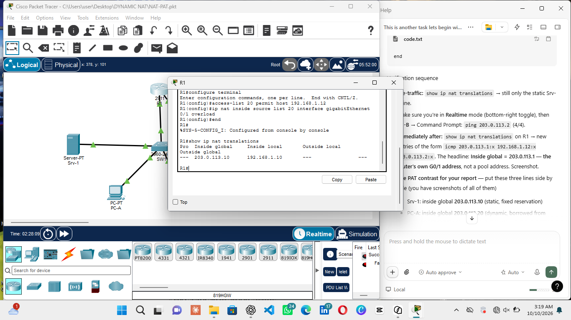
- PC-B transmits with its private source 192.168.1.12, and the same packet leaves R1 with source rewritten to 203.0.113.1.
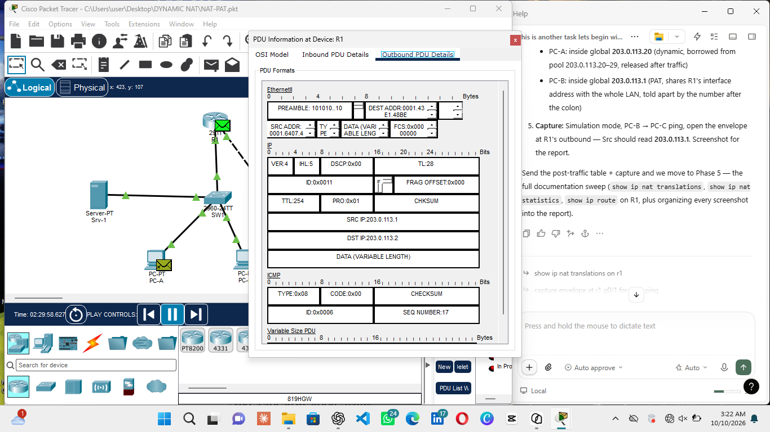
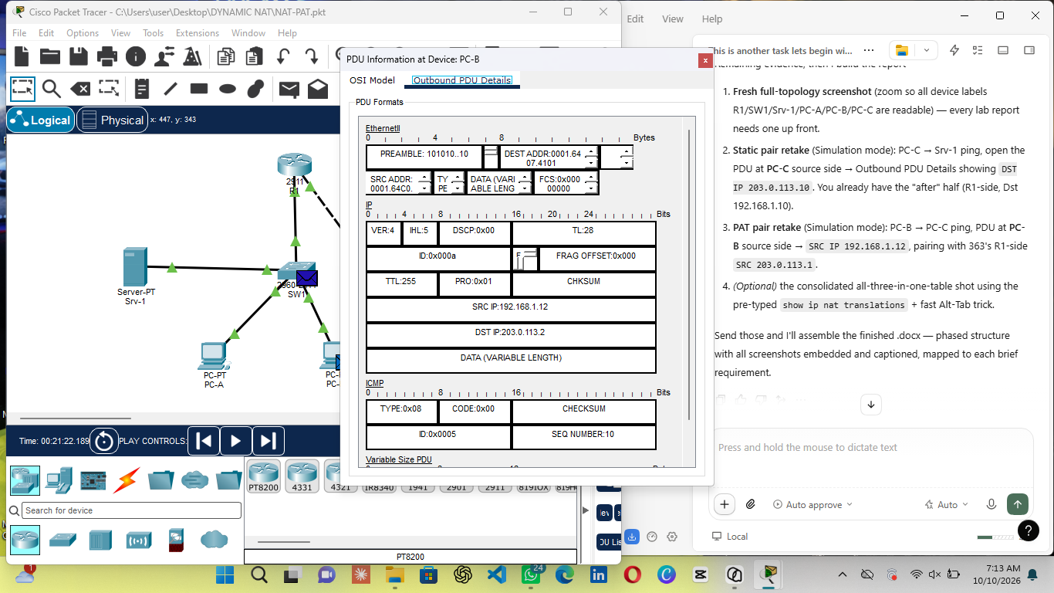
Phase 5: Documentation
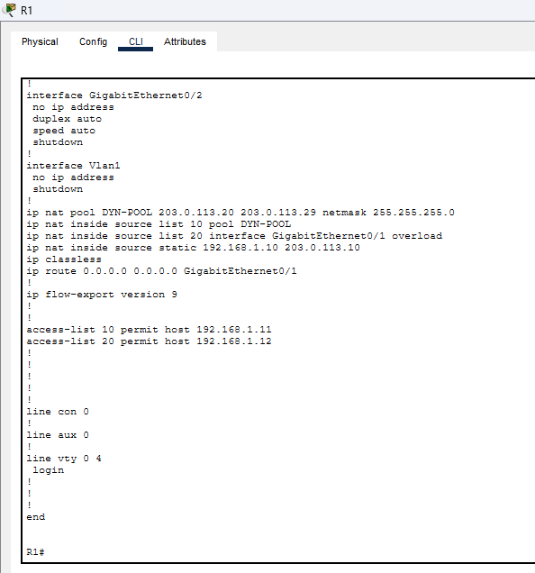
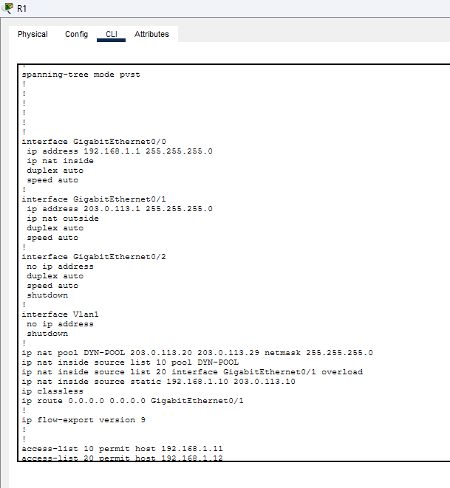
The complete NAT configuration as applied on R1, taken from show running-config — interface NAT roles, the pool, both dynamic mappings and the static mapping.
.
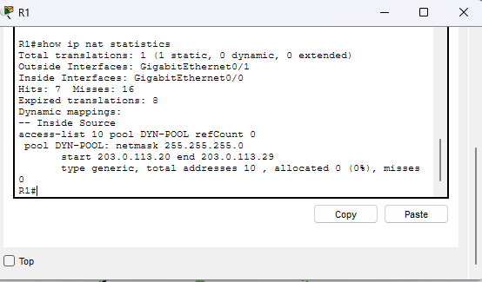
Translation statistics: hits/misses counters, expired translations, the declared inside/outside interfaces, and the pool definition. Packet Tracer’s statistics display lists only pool-based mappings under “Dynamic mappings” the interface-overload mapping is verified through the translation table and the running-config instead.

Routing table, connected routes for both /24 links with their local /32 host routes, plus the static default route pointing out GigabitEthernet 0/1 — the path all translated traffic takes toward the external network.
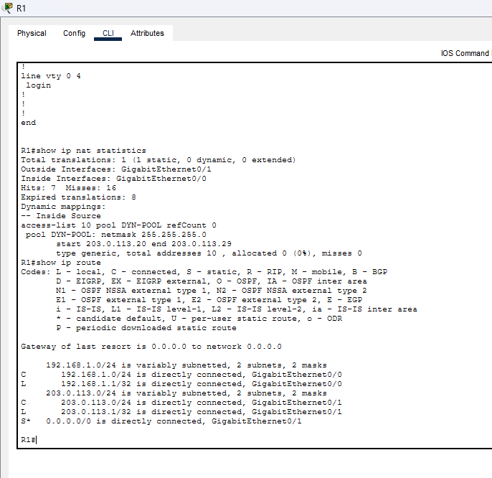

Conclusion: all four brief requirements are met and evidenced — static NAT presents server to the outside world as 203.0.113.10, dynamic NAT loans PC-A an address from a ten address pool under ACL control, PAT lets PC-B share the router’s single public address, and every translation is documented with paired packet captures, the translation table, NAT statistics and the routing table.

