TASK: DHCP Snooping and Dynamic ARP Inspection
Task overview
The task was to build a switched network, introduce a rogue DHCP server and a simulated ARP-spoofing attack, then show how DHCP Snooping and Dynamic ARP Inspection (DAI) detect and block the malicious traffic.
Phase 1: Design and implementation of the topology
A router, switch, three PCs and two servers where cabled with copper straight-through cables, created VLAN 10
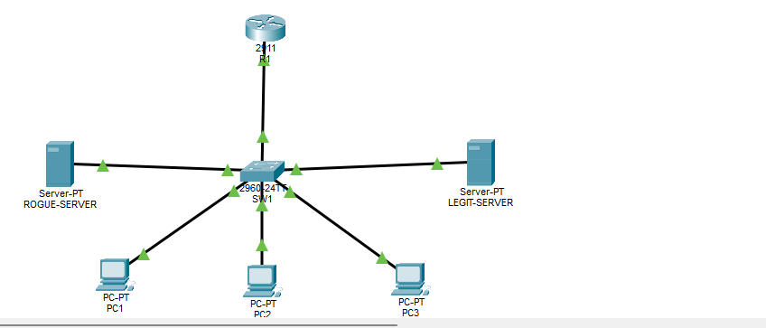
Phase 2: Baseline build
What was done:
- Configured the pool LAN10 on R1, configured the VLAN 10 clients on SW1 with ports fastEthernet 0/1-6
- Configured the LEGIT-SERVER and ROGUE-SERVER per table
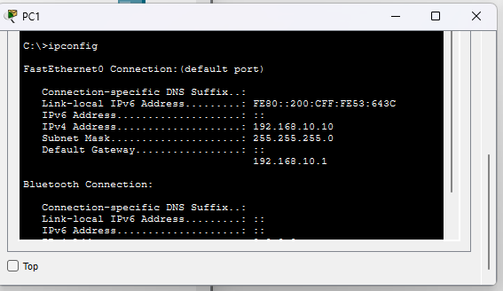
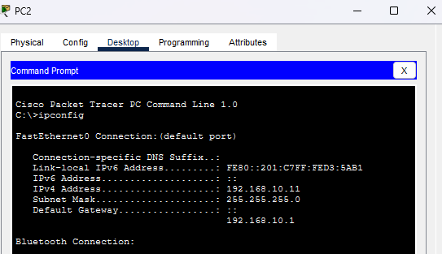
- PC1 and PC2 first leases recorded

- PC! Pings : 192.168.10.1, PC2 current lease: 192.168.10.10 at recapture, and PC3 static IP:192.168.10.50 all reply
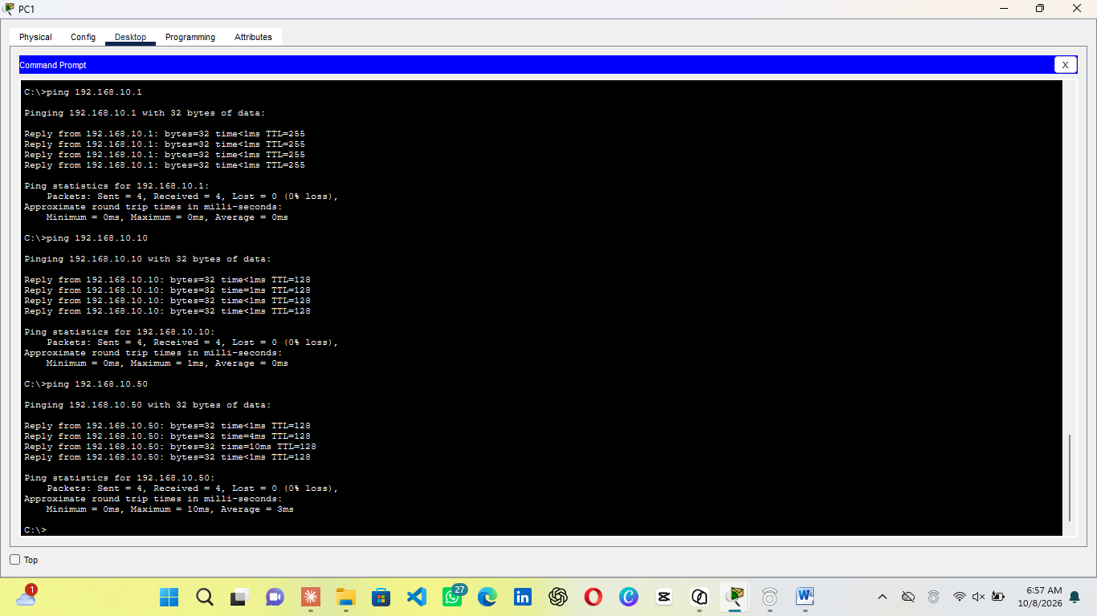

Phase 3: Unprotected attacks
What done
- ROGUE-SERVER DHCP services set on
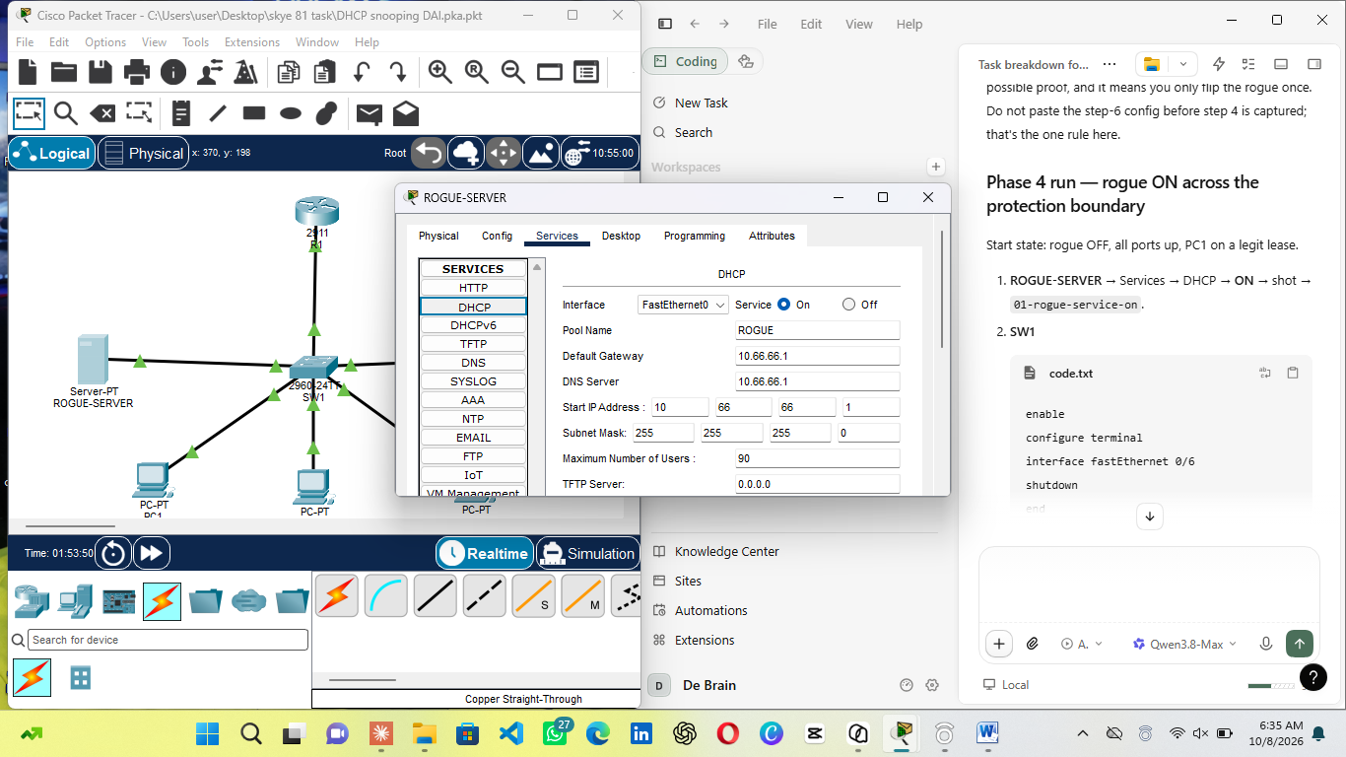
- PC1: toggle static and DHCP, with both servers up PT can merge the 2 offers which are legit address and rouge gateway/DNS, which alone proves the rogue reached the client
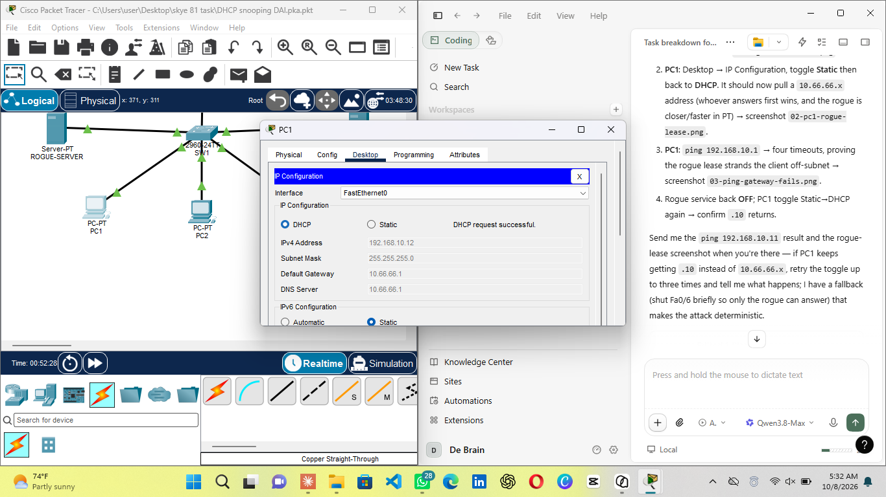
- SW1 was configured and the fastEthernet port for legit-server shutdown to determine pure rogue-lease
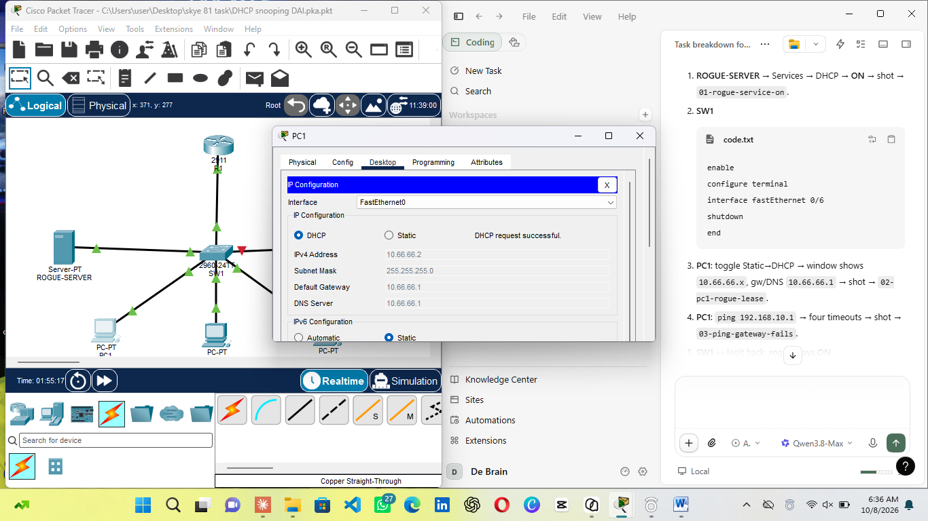
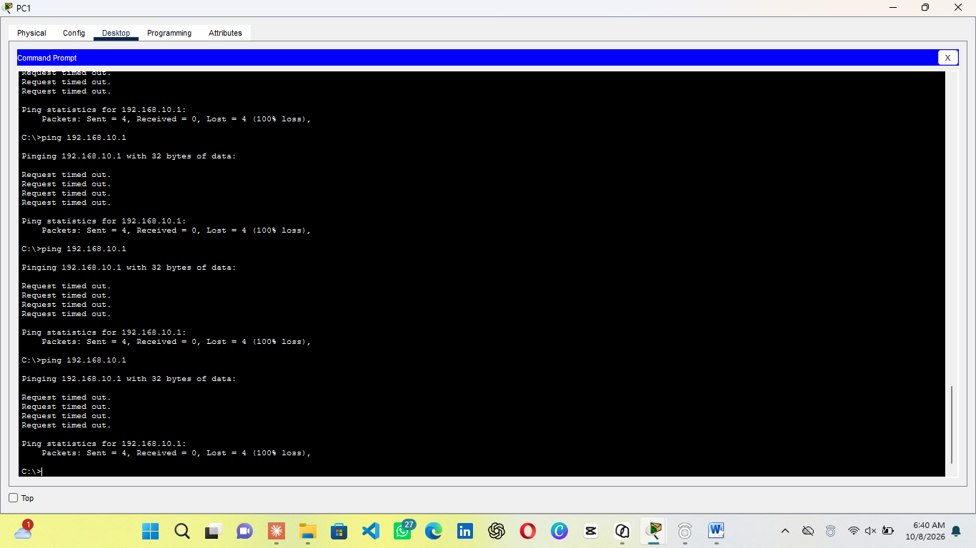
- PC1 ping 192.168.10.1 four timeouts off subnet, indicating rogue gateway does not route

- SW1 is configured and the legit server port enabled to no shutdown. PC1 is toggle between static and DHCP with legit lease returning and legit pool hand out the next free address
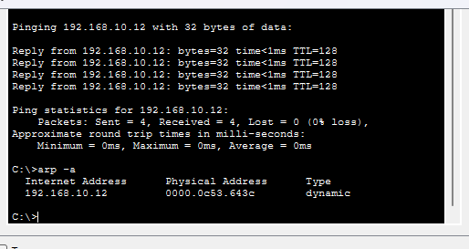
- PC2 ping 192.168.10.12(the new IP of PC1), arp –a which displays PC1 real MAC and arp before

- SW1 is configured and PC interface port is shutdown
- PC3 static ip is then configured to PC1 ip indicating the attacker disguising as victim
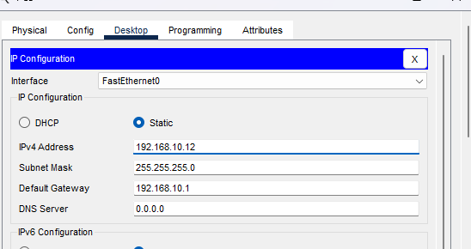
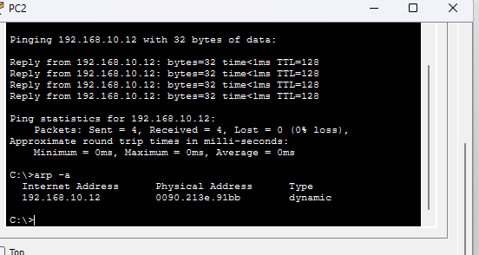
- PC2 arp –d, ping 192.168.10.12 replies attacker with arp –a entry displaying PC3 MAC address indicating poisoning

- PC3 static ip is configured back to 192.168.10.50 and PC1 port interface is configured back on SW1 to up

Phase 4: DHCP snooping
What was done
- Enabled snooping globally and for VLAN 10, trusted only Fa0/6(access port for legit server)
- PC1 and PC2 toggle between static and DHCP to renew under snooping with legit server leases restored

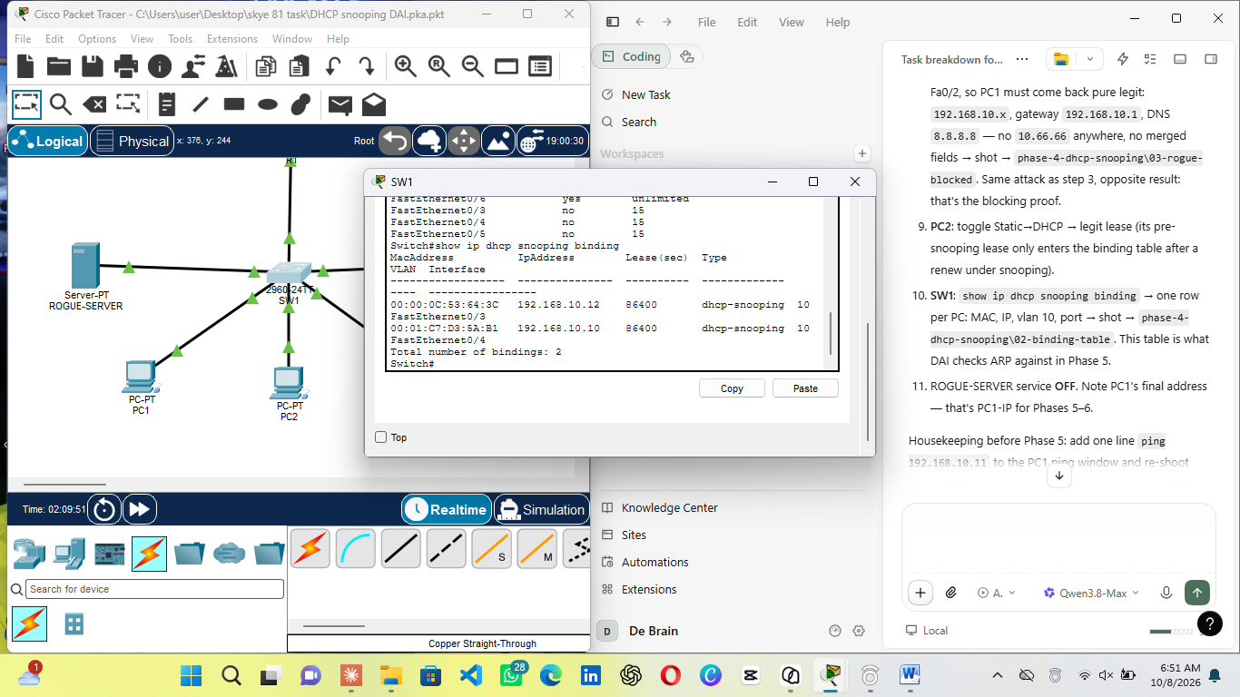
- Rogue on with PC1 and PC2 toggle between static and DHCP with PC1 and PC2 getting 192.168.10.12 and 192.168.10.10 respectively indicating rogue offers dropped at untrusted(blocked)
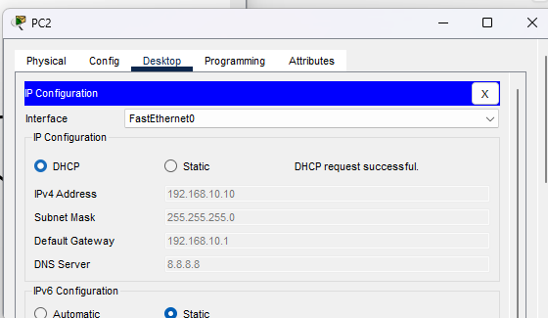
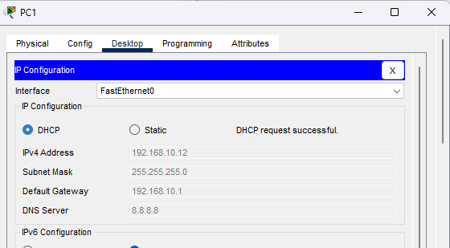

Phase 5: Dynamic ARP inspection
What was done
- Enabled DAI on VLAN 10

Phase 6: blocking proof
What was done
- Attacked replayed with DAI active, PC2 pings to 192.168.10.12 all time out and arp –a displayed no entries found meaning spoofed reply dropped, cache never poisoned
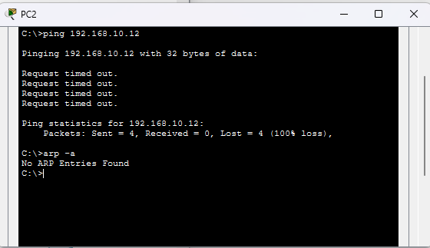

- Challenges and solutions
During the lab I ran into several problems, and each one taught me something about how the network behaves. The first was in the rogue DHCP attack, the server was still set to obtain its address by DHCP, so it leased 192.168.10.13 from the router instead of acting as a server. I fixed this by giving it a static address and configuring its DHCP pool separately under Services. The client also sometimes kept the legitimate lease because the winning offer depends on timing, so I used ipconfig /release and /renew and briefly shut down the router port to make the attack repeatable. For the ARP attack, Packet Tracer has no real spoofing tool, so I simulated it by giving the attacker the gateway's IP address and clearing PC1's ARP table with arp -d before each test.
- Conclusion
The lab showed that DHCP and ARP trust every device on a VLAN by default, so a rogue DHCP server and a spoofed ARP reply both succeeded on the unprotected network. Once DHCP Snooping was enabled, the rogue offers were dropped and clients received only legitimate addresses. Adding Dynamic ARP Inspection then blocked the forged ARP packets, and the switch logged them. Each problem was solved by configuring every device for its specific role, testing before and after each protection. The result is that snooping and DAI together protect the access layer without any changes to the client PCs.

