TASK: Multi area OSPF 3 company sites
Task overview
The task was to build three simulated company sites connected through routers, configure multi-area OSPF, assign a different subnet to each site, implement route summarization, and verify network convergence after deliberately taking links down.

Phase 1: design and implementation
The network consists of three company sites — HQ, Site A, and Site B — each with a Cisco 2911 router, a Catalyst 2960 switch, and one PC, interconnected arranged in a triangle . HQ (R1) belongs to the OSPF backbone, Area 0. Site A (R2) and Site B (R3) each join the backbone while their LANs live in Area 1 and Area 2 respectively. Because every router has interfaces in Area 0 as well as in another area, all three routers act as Area Border Routers (ABRs). Each router also has a loopback interface representing a second subnet for its site.
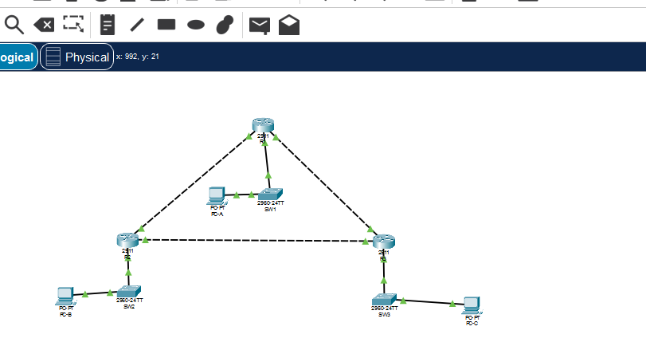

- Interface verification
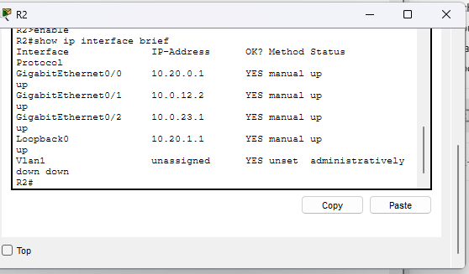
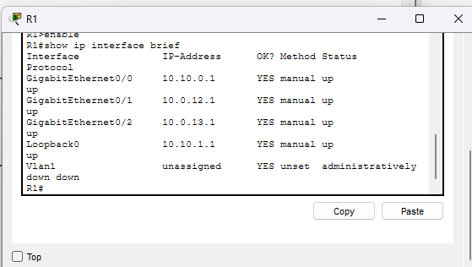
Interface verification on all three routers confirms every interface is up with the planned address, including the loopbacks.

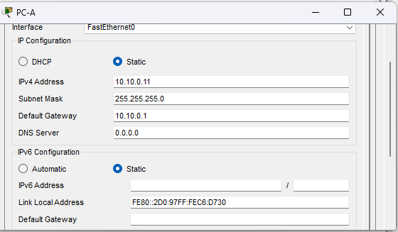
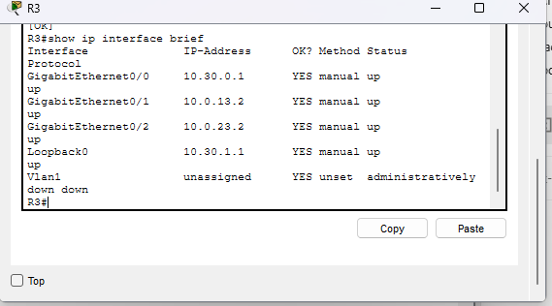
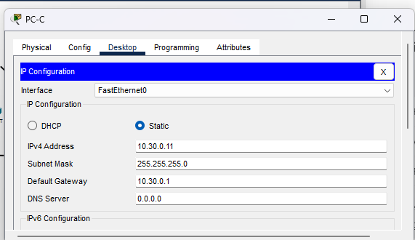

Phase 3: multi-area ospf configuration
- design
OSPF process 1 was configured on all three routers with static router IDs 1.1.1.1, 2.2.2.2, and 3.3.3.3. The LAN-facing interface of each router is declared passive, so no OSPF hellos are sent toward the end hosts. Each loopback is advertised so that every site summarize cleanly.
- Neighbor verification
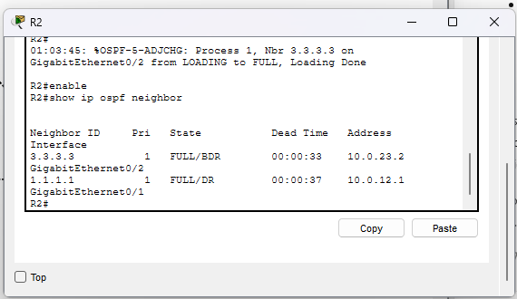
Neighbor verification shows two FULL adjacencies on every router.
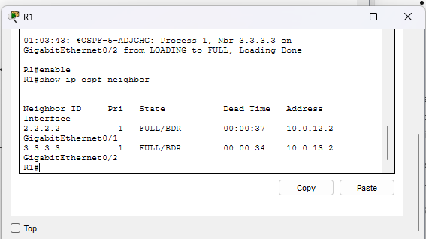

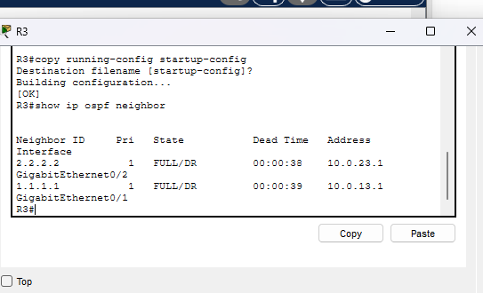
- OSPF process verification
“show ip protocols” on R2 confirms Router ID 2.2.2.2, participation in two areas (0 and 1), and the passive LAN interface.
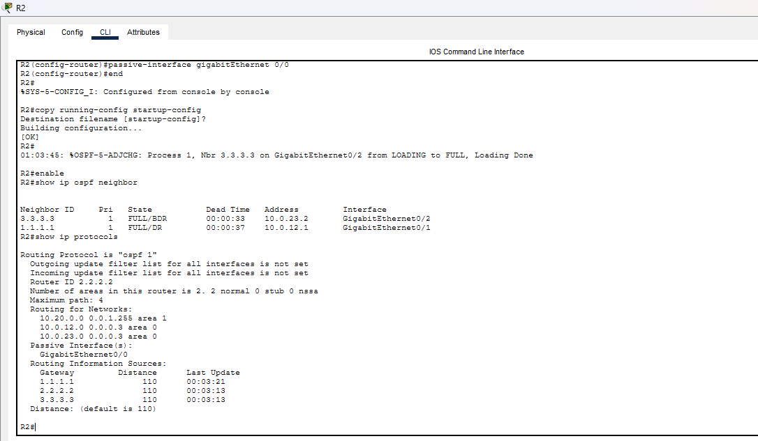

Phase 4: Baseline connectivity
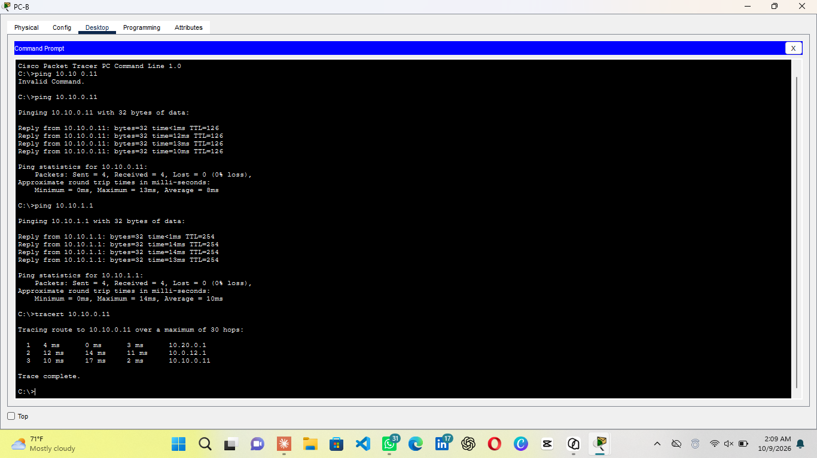
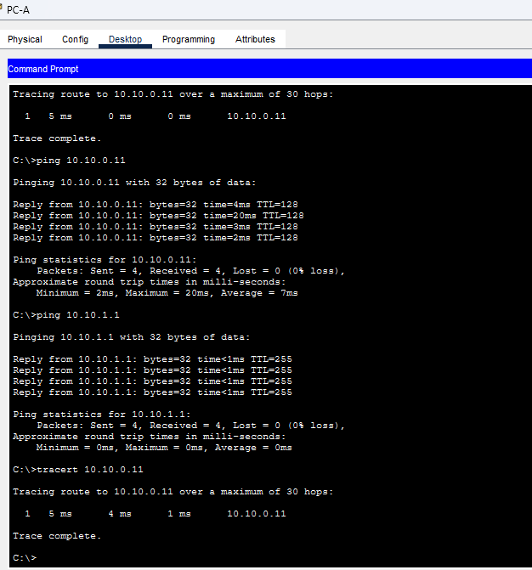
Before summarization, full connectivity was verified between all sites. PC-B pinged PC-A with 0% loss. The tracert shows the expected three-hop direct path.

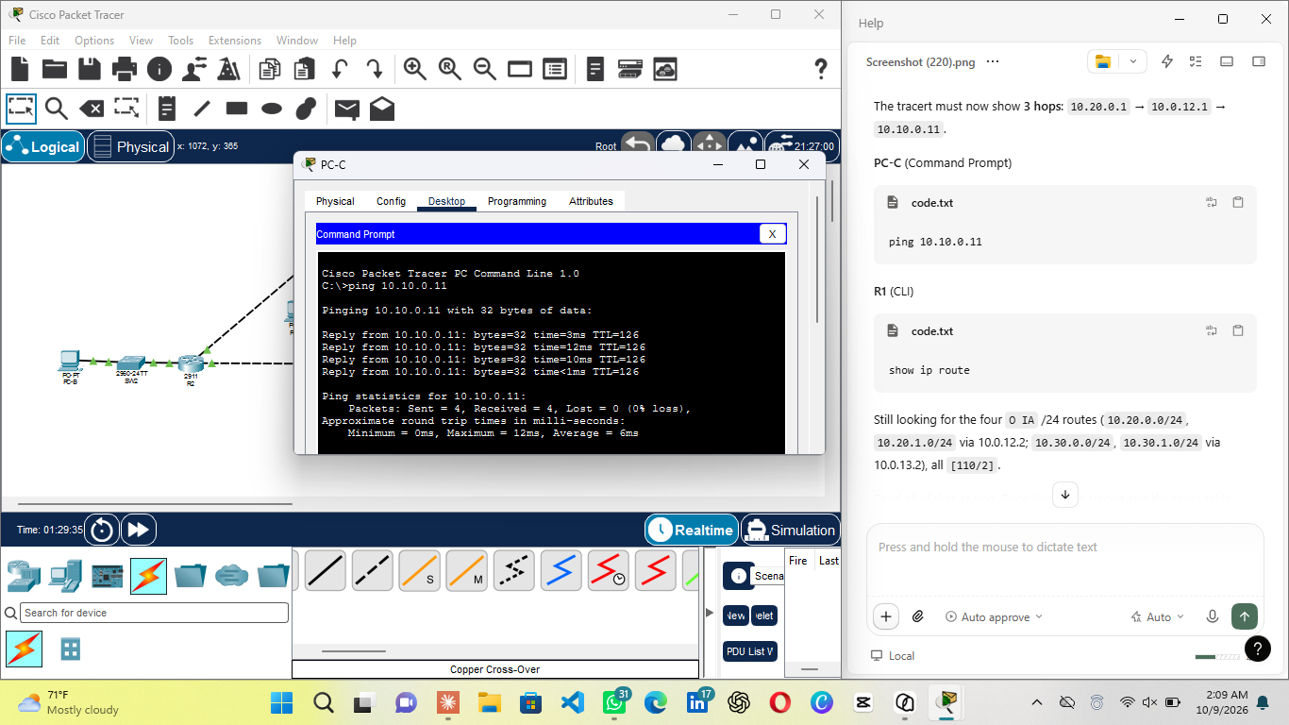

Phase 5: route summarization
- Method
Each site advertises two contiguous networks, Its LAN and its loopback. Each ABR automatically installs a local discard route for its summary, guaranteeing that traffic attracted to the summary but destined for an unallocated address inside it is dropped locally instead of looping.
- Result on R1(Backbone router)
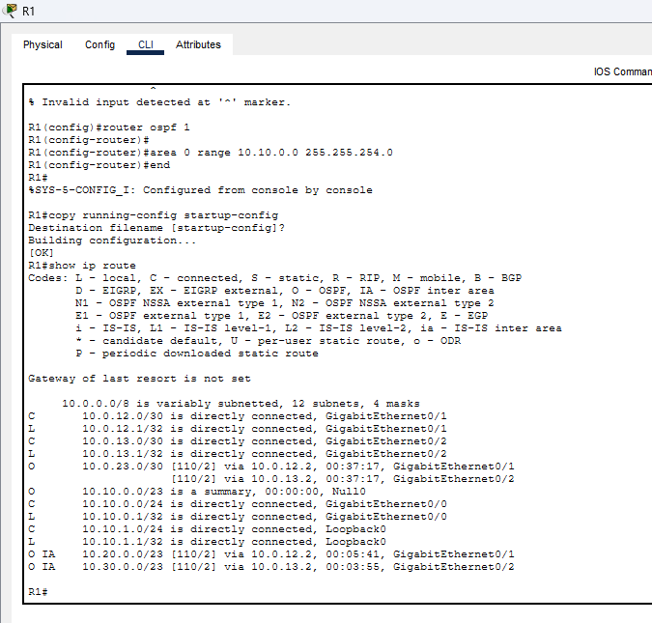
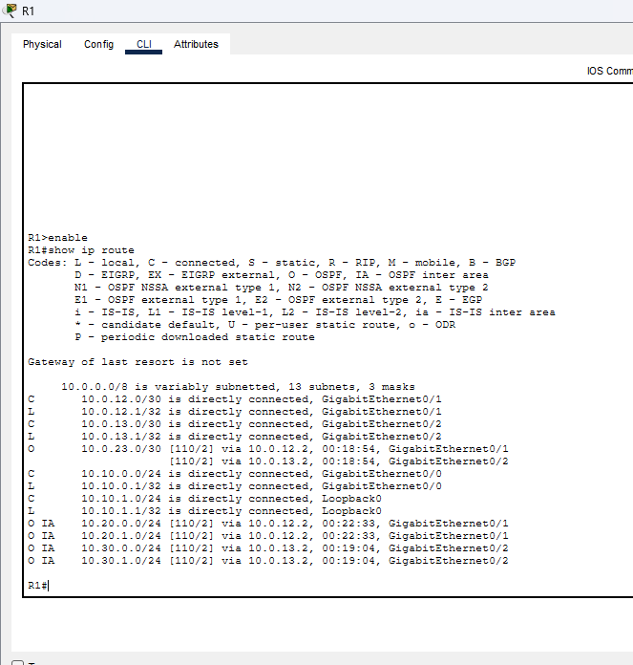
R1’s table before summarization. After the area range commands were applied, R1’s table contains just two inter-area routes plus R1’s own Null0 discard route for. The remote-network entries in R1’s table were halved, exactly the intended effect.

Results on R2 and R3
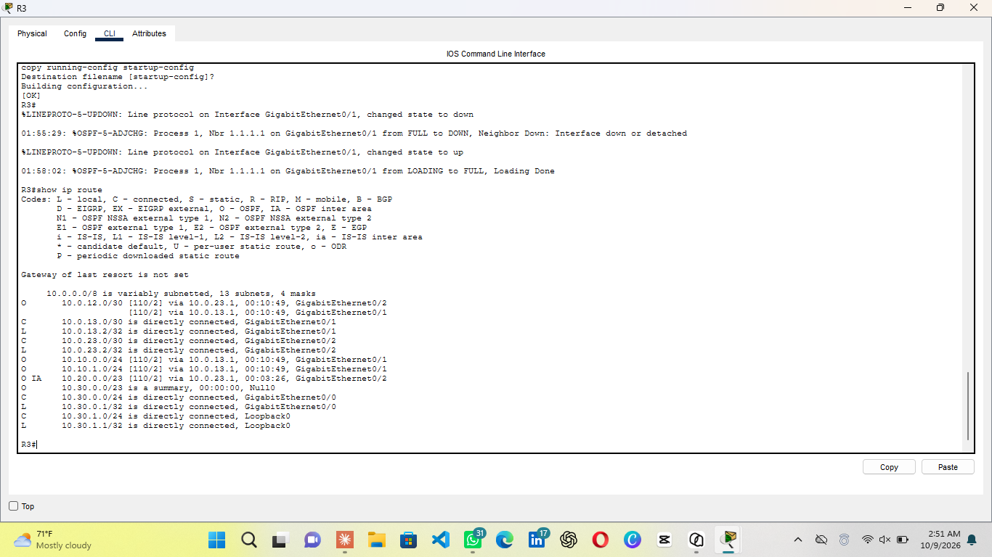
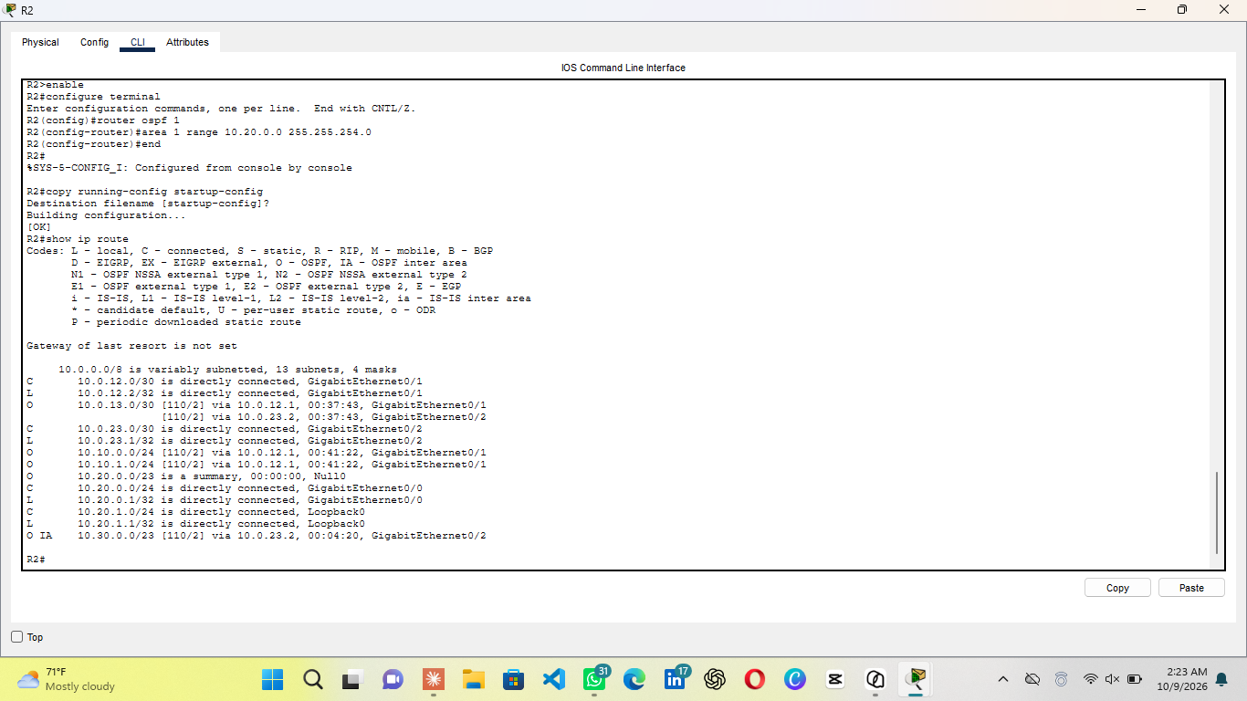
On R2 the received summary appears as an inter-area route, while R2’s own summary exists only as a Null0 discard route. The same pattern holds on R3, which additionally reaches the R1–R2 link subnet over two equal-cost paths demonstrating equal-cost multi-path in the triangle.

Phase 6: convergence testing
Convergence was tested by administratively shutting down each of R1’s WAN links in turn, observing traffic from the PCs during the outage, and restoring the link. An interface shutdown is an event OSPF detects immediately — unlike a silent cable failure, which would wait for the 40-second dead timer — so reconvergence begins instantly.
- Test A: R1–R2 Link Down
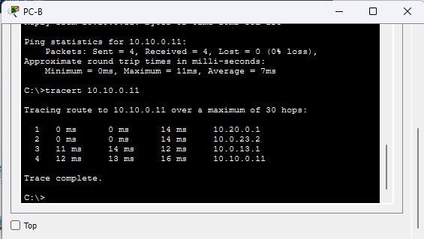
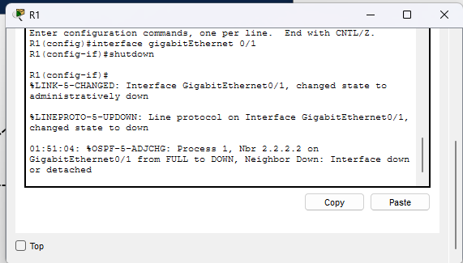
Neighbor 2.2.2.2 goes from FULL to DOWN . During the outage, PC-B’s tracert to PC-A crossed four hops over the backup path through Site B. After “no shutdown”, the direct three-hop path returned.

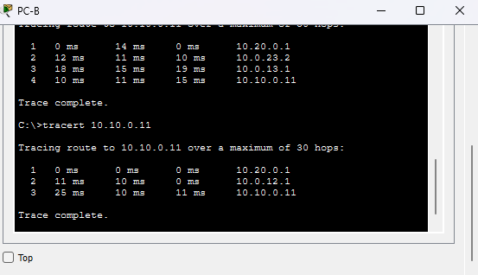
- Test B — R1–R3 Link Down
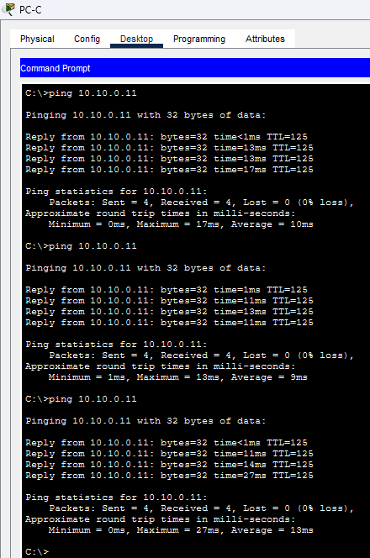
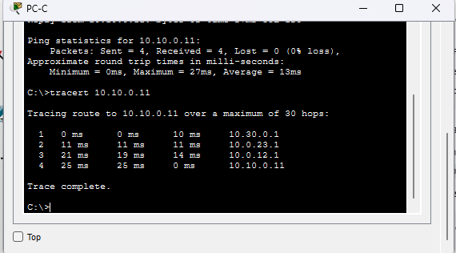
From R3, the adjacency to 1.1.1.1. During the outage, PC-C’s pings to PC-A returned and its tracert crossed four hops via Site A. After restoration, the direct three-hop path returned
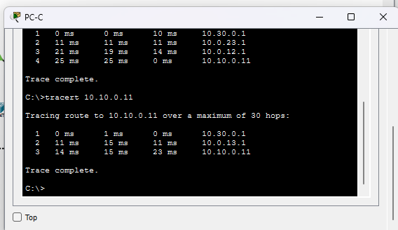
- Analysis
Convergence time: reconvergence after a shutdown completes in roughly 1–3 seconds in this topology. The manual, one-at-a-time pings used during the tests were spaced many seconds apart, so every probe left the PC either before the failure or after convergence had already completed — which is why the captures show 0% loss despite the path change. The four-hop tracerts prove the reroute happened mid-test.

- Issues Found and Resolved During Testing
PC-B gateway misconfiguration: PC-B’s default gateway was initially set to its own address instead of R2’s LAN address. R2 masked the fault, pings still succeeded but tracert showed every destination as one hop. Correcting the gateway restored a truthful path display.

- Conclusion
All objectives of Task were met. Three company sites were built and interconnected through routers in a triangle, multi-area OSPF was configured with Areas 0, 1, and 2 across and verified through neighbor and protocol output, each site was assigned distinct subnet, route summarization was implemented, halving the inter-area entries in R1’s table, with automatic Null0 discard routes, and convergence was verified under two deliberate link failures, with documented backup path forwarding, evidence of live rerouting, 0% observed packet loss, and successful restoration of the direct paths. Configurations were persisted on all routers with “copy running-config startup-config”.

