Coxswain Product Design Specification
Android companion app for WaterRower | Material Design 3 | Sideloaded | v1.2
LOCKED: HOME SCREEN
The Home screen layout and behavior in this document are approved and locked. Future edits must preserve the established structure unless a request explicitly names a Home-screen change.

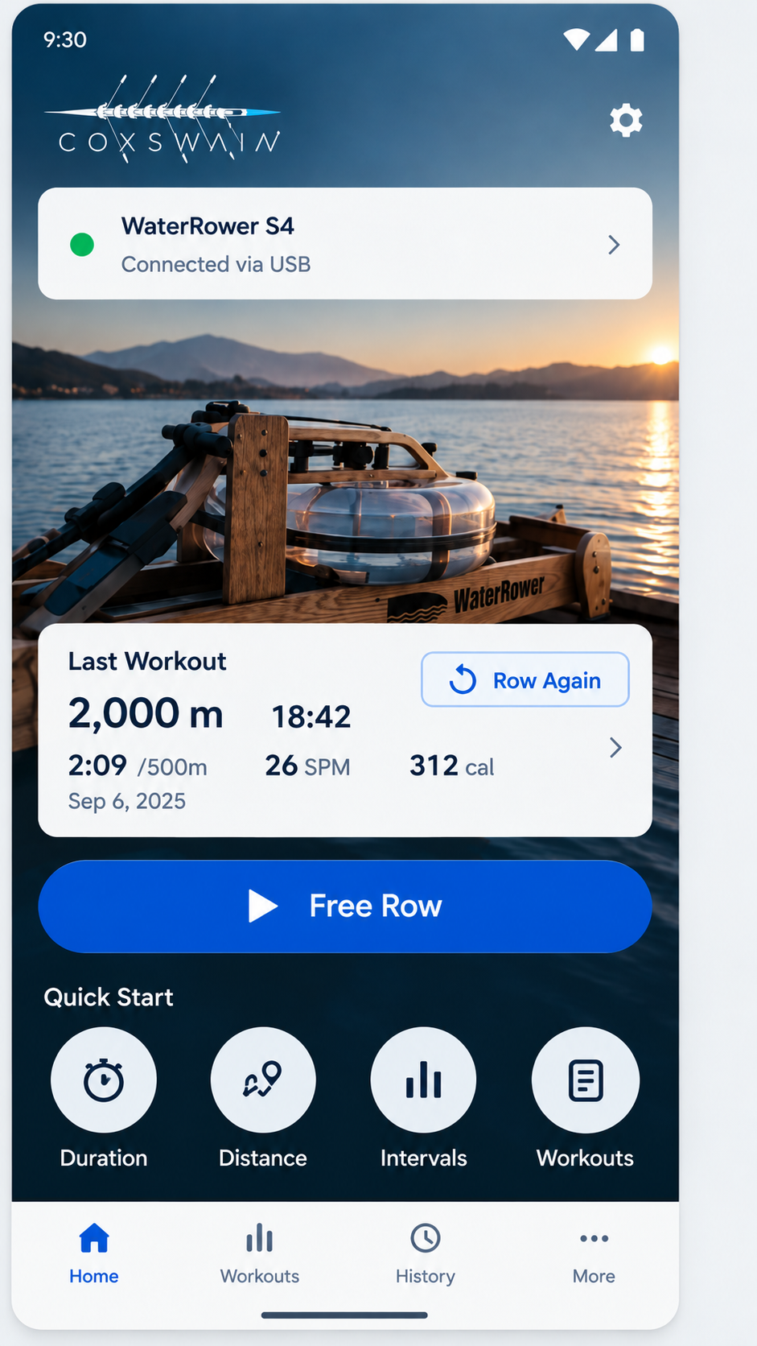
Product intent: Coxswain is a fast, local-first rowing companion for WaterRower hardware. It does not require login, account creation, onboarding, or a splash experience. The app should feel like a modern rowing computer rather than a generic fitness dashboard.
Primary experience: connect the rower, choose a workout mode, row with large live metrics, review history, and optionally race against a prior workout.

01. Locked Home Screen
Canonical structure, controls, and navigation behavior

Home screen hierarchy
- Coxswain logo in the upper-left of the hero area. Settings icon remains upper-right.
- WaterRower connection card appears directly below the brand area.
- Hero WaterRower image remains the primary visual background.
- Last Workout card overlays the lower hero area and contains a Row Again CTA.
- Free Row is the large primary CTA directly beneath Last Workout.
- Quick Start contains four actions: Duration, Distance, Intervals, Workouts.
- Bottom navigation remains Home, Workouts, History, More.

Home control behavior
Control | Behavior | Route / destination | Notes
Settings | Open app settings. | settings | No workout state change.
Connection card | Open rower connection/details and diagnostics. | connect | Shows USB/Bluetooth status.
Last Workout card | Open full details for the most recent completed workout. | history/{workoutId} | Read-only session view.
Row Again | Repeat the same workout configuration as the most recent workout. | repeat/{workoutId} | Recreates mode, target, interval structure, and workout settings. Does not reuse prior results.
Free Row | Start an open-ended rowing session immediately. | live/free | No distance or duration target.
Duration | Open duration setup. | setup/duration | User selects a time period, then starts a timed row.
Distance | Open distance setup. | setup/distance | User selects a target distance, then starts a distance row.
Intervals | Open the user interval list/builder. | intervals | User can create, edit, save, and start custom interval workouts.
Workouts | Open the premade workout library. | workouts | Content will be supplied by the product owner.
Home nav | Return to Home. | home | Selected state uses primary blue.
Workouts nav | Open workout library and workout setup flows. | workouts | Same destination as Quick Start Workouts.
History nav | Open completed workout history. | history | Allows detail, repeat, and Race Yourself actions.
More nav | Open secondary tools and settings. | more | Export, diagnostics, settings, connection.

Connection behavior
If the rower is disconnected, tapping an action that would start rowing first surfaces a lightweight connection prompt. Setup and library screens remain available while disconnected. The Home connection card itself is always available.

Row Again rules
- Free Row repeats as Free Row.
- Duration repeats the same target duration.
- Distance repeats the same target distance.
- Intervals repeat the same saved interval configuration.
- Premade workouts repeat the same workout definition and any user-adjustable settings.
- Race Yourself is not automatically enabled unless it was explicitly part of the prior workout configuration.

02. Duration Workout Setup
  - Locked setup behavior for timed workouts and performance goals

Purpose
The Duration Setup screen configures only the workout duration and an optional performance goal. Connection, audio feedback, and live-display configuration do not belong on this screen. The setup should remain fast enough to use immediately before rowing.

Approved goal-state design
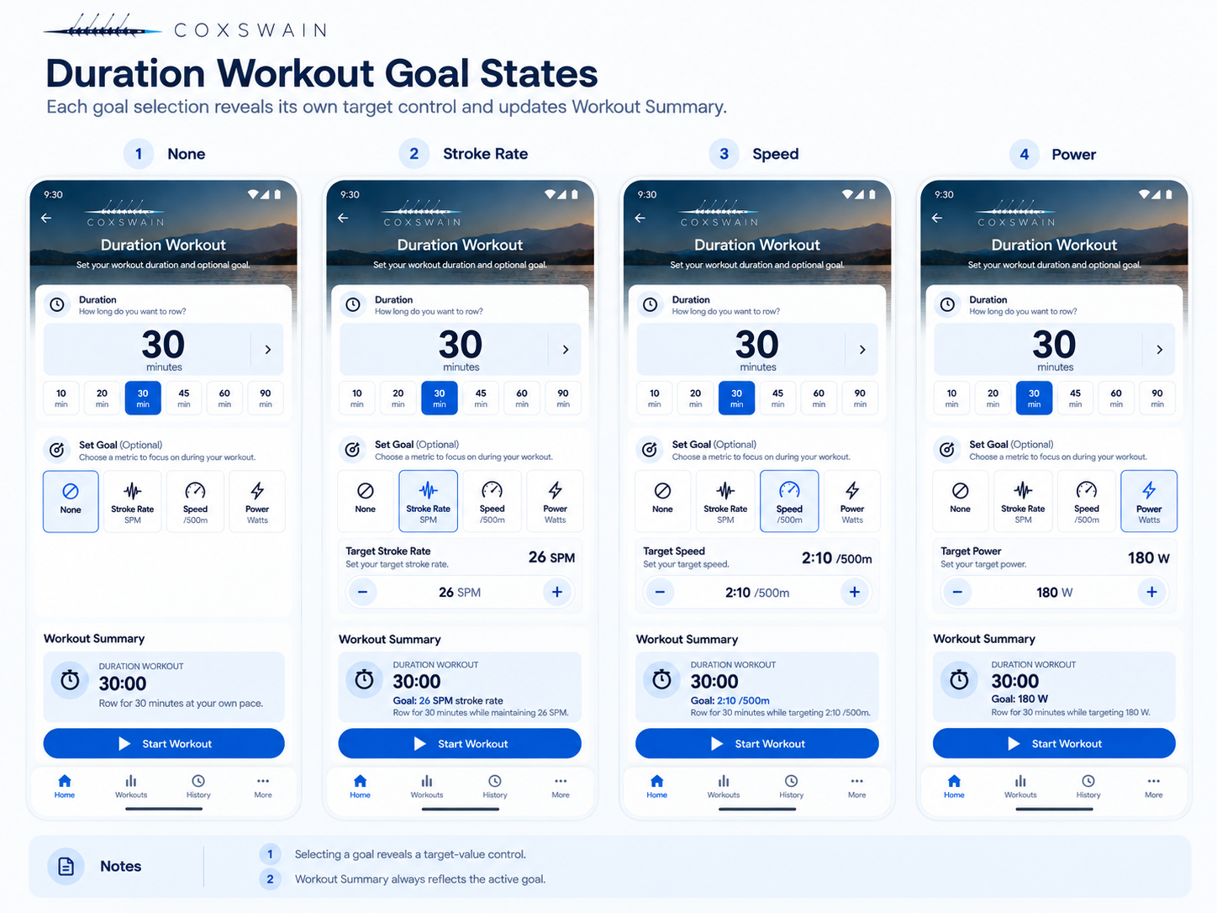
Figure 2. Duration Workout goal states: None, Stroke Rate, Speed, and Power. Selecting a goal reveals its target-value control and updates Workout Summary.

Duration control
The main duration value is directly selectable. Tapping the large duration field opens a numeric time-entry control so long workouts such as 75 or 90 minutes do not require repeated button presses.
Common presets remain visible for one-tap selection: 10, 20, 30, 45, 60, and 90 minutes. A custom value may be entered directly. Changing either the preset or custom value immediately refreshes Workout Summary.

Set Goal
Set Goal is optional and has exactly four mutually exclusive states: None, Stroke Rate, Speed, and Power. The selected goal uses the Material 3 selected state. There is no separate “None” row or secondary selector.
Goal | Behavior | Target control | Summary example
None | No performance target. The row ends when the selected duration is reached. | No target-value control is shown. | 30:00 — Row for 30 minutes at your own pace.
Stroke Rate | Targets stroke cadence during the timed workout. | SPM value control, e.g. 26 SPM. | Goal: 26 SPM stroke rate.
Speed | Targets rowing speed/pace during the timed workout. | Uses the app’s configured speed/pace unit, e.g. 2:10 /500m. | Goal: 2:10 /500m.
Power | Targets rowing power during the timed workout. | Watt value control, e.g. 180 W. | Goal: 180 W.

Goal-value interaction
Selecting Stroke Rate, Speed, or Power reveals a compact target-value control directly below the goal buttons. The control must allow rapid adjustment and direct value entry where practical. It must not require dozens of taps to reach normal rowing values.
The target is guidance for the live workout. The Live Row screen is responsible for showing current performance relative to the selected goal and for letting the user change display metrics.

Workout Summary
Workout Summary is always visible immediately above Start Workout and is the final confirmation of what will run. It updates in real time whenever duration or goal changes.
When Goal = None, show workout type, duration, and plain-language description. When a goal is selected, add the goal name and value to the summary and update the description, for example: “Row for 30 minutes while maintaining 26 SPM.”

Start Workout
Start Workout creates the configured duration workout and opens Live Row. The duration and selected goal are passed into the active workout/session state. If the rower is disconnected at this point, use the app-level connection flow rather than adding connection controls to this setup screen.

Explicitly excluded from this screen
- Display View: managed on the Live Row screen.
- Audio Feedback: managed globally in Settings.
- Connect Rower: handled when the app/device connects and through the app-level connection flow.
- Heart-rate and target-pace-specific rows: replaced by the generic Set Goal model above.

Functional mapping to existing Coxswain concepts
Duration, stroke rate, speed, and power are represented in Coxswain’s workout/program domain. The redesigned screen should reuse those existing workout values rather than introducing parallel concepts. The UI layer should translate the selected Material 3 controls into the existing workout/session model.

Locked Duration rules
- Duration Setup contains only Duration, Set Goal, Workout Summary, and Start Workout.
- Preset durations and direct custom duration entry are both supported.
- Goal choices are None, Stroke Rate, Speed, and Power.
- Only one goal is active at a time.
- Selecting a goal reveals its value control.
- Workout Summary always reflects the current duration and goal.
- Display, audio, and connection controls remain outside Duration Setup.

03. Distance Workout Setup

Purpose
Distance Setup lets the user define a target rowing distance, optionally add a performance goal, review the resulting workout, and start the session. Its interaction model intentionally mirrors Duration Setup so users only need to learn one setup pattern.

Approved design
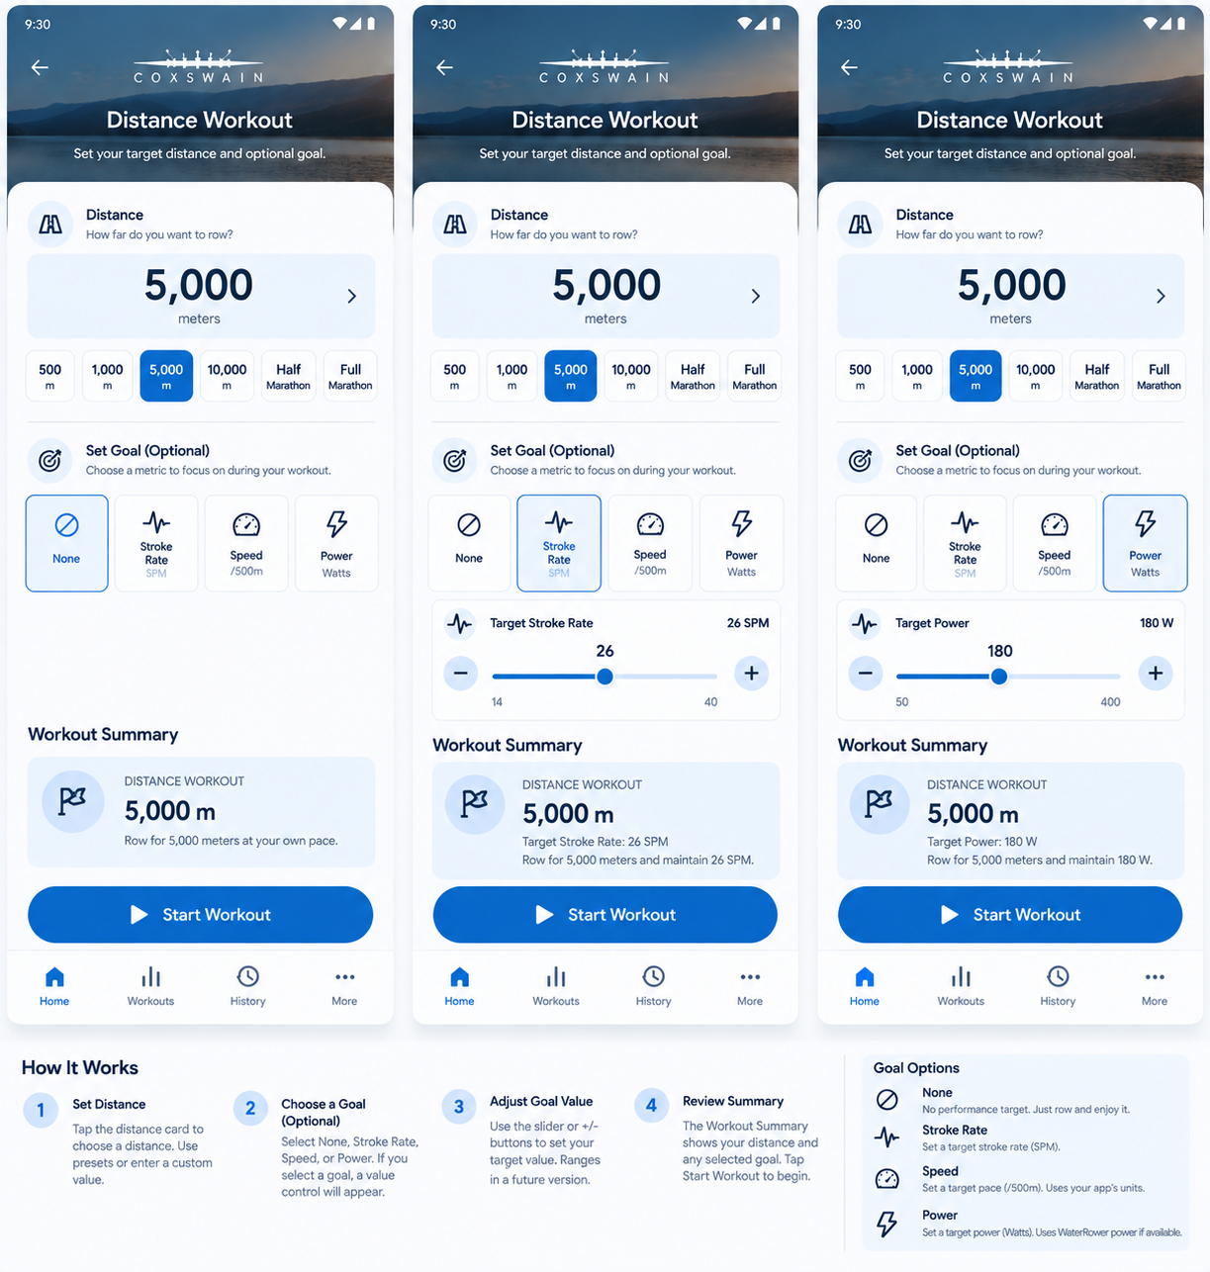
Approved Distance Workout setup states. The same layout and interaction language as Duration Setup is preserved.

Distance control
- The current target distance is the dominant value on the screen.
- Tapping the large distance value opens direct numeric entry for arbitrary distances.
- Common presets remain visible for one-tap selection: 500 m, 1,000 m, 5,000 m, 10,000 m, Half Marathon, and Full Marathon.
- Selecting a preset immediately updates the large distance value and Workout Summary.
- The control must support distances outside the presets without repeated increment tapping.

Set Goal
Set Goal uses the same four-state control as Duration Setup. Only one goal may be active at a time.
- None: no performance target. The workout ends when the selected distance is reached.
- Stroke Rate: sets a target stroke rate in SPM.
- Speed: sets a target pace/speed using the app's configured speed representation. The current design shows /500 m.
- Power: sets a target power value in watts.

Goal-value interaction
- Selecting None hides the target-value control.
- Selecting Stroke Rate reveals a stroke-rate target control, for example 26 SPM.
- Selecting Speed reveals a pace/speed target control, for example 2:10 /500 m.
- Selecting Power reveals a power target control, for example 180 W.
- The active goal tile receives the Material 3 selected state.
- Changing the target value updates the Workout Summary immediately.

Workout Summary
The Workout Summary is always visible above Start Workout and is the confirmation of exactly what will be launched.
- None example: Distance Workout | 5,000 m | Row for 5,000 meters at your own pace.
- Stroke Rate example: Distance Workout | 5,000 m | Goal: 26 SPM stroke rate.
- Speed example: Distance Workout | 5,000 m | Goal: 2:10 /500 m.
- Power example: Distance Workout | 5,000 m | Goal: 180 W.
- Any distance or goal change updates the summary without requiring an extra confirmation step.

Start Workout
Start Workout creates a distance-based workout using the selected distance and optional goal, then opens the Live Row screen. If no rower is connected, connection handling occurs at the app/session level rather than adding a connection control to this setup screen.

Explicitly excluded from this screen
- Display View: managed on the Live Row screen.
- Audio Feedback: managed globally in Settings.
- Connect Rower: handled when the app establishes rower connectivity.
- Pace-boat selection: not part of the approved Distance Setup design at this stage.

Locked Distance rules
- Distance Setup mirrors the approved Duration Setup layout and component language.
- Direct distance entry plus common presets is required.
- Goal choices are exactly None, Stroke Rate, Speed, and Power.
- Workout Summary remains visible and reflects the current distance and selected goal.
- Start Workout remains the primary CTA.
- Bottom navigation remains Home, Workouts, History, More.

04. Screen Map and Functional Inventory
Screens to design and track as the app evolves
# | Screen | Status | Purpose
01 | Home | LOCKED | Primary launcher for rowing modes, last workout, connection status.
02 | Live Row: Free | Planned | Open-ended live workout with large rowing metrics.
03 | Duration Setup | Planned | Select target time, then start timed workout.
04 | Distance Setup | Planned | Select target distance, then start distance workout.
05 | Intervals List | Planned | Saved user-created interval workouts.
06 | Interval Builder | Planned | Create/edit work and rest segments, targets, order.
07 | Premade Workouts | Planned | Curated workout library supplied by product owner.
08 | Workout Detail / Start | Planned | Review workout description and configuration before start.
09 | Live Row: Target | Planned | Live duration/distance/workout mode.
10 | Race Yourself Setup | Planned | Select prior workout to use as pace boat.
11 | Live Row: Race Yourself | Planned | Live current-vs-pace comparison with distance/time delta.
12 | Pause / End | Planned | Pause, resume, end, discard safeguards.
13 | Workout Complete | Planned | Summary and quick actions after a workout.
14 | History | Planned | Completed sessions, filters, totals.
15 | Workout Details | Planned | Metrics, graphs, export, repeat, Race Yourself.
16 | Race Comparison Details | Planned | Compare current workout with prior pace workout.
17 | Connect Rower | Planned | USB/Bluetooth connection and device status.
18 | Settings | Planned | Display, units, defaults, HR, data, advanced.
19 | Display Customization | Planned | Choose/reorder live-row metrics.
20 | Heart Rate Source | Planned | Select supported heart-rate source.
21 | Data / Export | Planned | Export, backup, storage management.
22 | More / Diagnostics | Planned | Diagnostics, protocol info, about, advanced tools.

Core navigation model
Home, Workouts, History, and More are the persistent bottom-level destinations. The bottom navigation disappears during an active live-row session to maximize readability and prevent accidental navigation.
Workout configuration screens are pushed from Home or Workouts and return to their originating context after cancel. Starting a workout transitions to the immersive Live Row experience.

Race Yourself / pace boat
Race Yourself is a first-class feature built on Coxswain pace-boat behavior. A user selects a completed workout, then rows against its snapshot data. The live screen should emphasize how far and how many seconds the user is ahead or behind. History and Workout Details are the natural entry points.

05. Material 3 Design System
Locked visual language for consistency across screens

Color tokens
Token | Hex | Usage
Primary | #0B63F6 | Primary CTAs, selected navigation, key controls
Primary dark | #084DBD | Pressed/emphasis state and gradients where needed
On primary | #FFFFFF | Text/icons on primary actions
Primary container | #DCEBFF | Selected surfaces and low-emphasis highlights
Deep navy | #10213F | Primary text, icons, brand utility color
Surface | #FFFFFF | Cards, sheets, dialogs
Background | #F4F7FB | Standard non-hero screen background
On surface variant | #53647C | Secondary text and metadata
Outline | #CAD4E1 | Dividers, low-emphasis strokes
Connected / success | #22C55E | Connected device indicator and positive states
Error | #BA1A1A | Disconnected/error states requiring attention
Live row background | #042C3D | Immersive live-row base surface
Live accent | #1E7A8A | Secondary live-row visualization accent

These are product tokens derived from the approved Home direction and should be represented as semantic Material theme roles rather than hard-coded directly into individual composables.

Typography
Role | Spec | Usage
Font family | Roboto | Material 3 default. Use system fallback only if Roboto is unavailable.
Brand wordmark | Coxswain artwork | Do not recreate the logo using a text font.
Screen title | 24sp / 32sp, Medium or Semibold | Top-level screen headings.
Card title | 16sp / 24sp, Semibold | Section cards and primary card labels.
Body | 14sp / 20sp, Regular | Descriptions and standard controls.
Label | 12sp / 16sp, Medium | Metadata, chips, navigation labels.
Live primary metric | 48sp to 72sp, Medium | Scale based on available screen size. Glanceable while rowing.
Live secondary metric | 24sp to 36sp, Medium | Pace, SPM, heart rate, deltas.

Shape, spacing, elevation
Token | Spec | Use
Spacing grid | 8dp base | Primary rhythm. 4dp allowed for optical/internal adjustments.
Screen padding | 16dp phone / 24dp wide | Standard content inset.
Card radius | 20dp to 24dp | Home cards, workout cards, setup cards.
Primary button radius | 28dp pill | Free Row and other primary CTA buttons.
Quick action diameter | 72dp minimum visual | Icon circle on Home. Maintain 48dp minimum touch target.
Touch target | 48dp minimum | All tappable controls.
Card elevation | 1 to 3dp equivalent | Subtle only. Prefer tonal surfaces over heavy shadows.
Bottom navigation | Material 3 NavigationBar | Four fixed destinations.

06. Component and Interaction Rules
Reusable components for implementation in Material 3 / Jetpack Compose

Home components
Component | Material basis | Specification
Coxswain Brand Header | Custom image/logo | Preserve artwork aspect ratio. White version on hero image. Do not substitute WaterRower brand.
Connection Card | ElevatedCard or custom Surface | Status dot, rower name, transport/status, chevron. Entire card tappable.
Last Workout Card | ElevatedCard | Summary metrics plus dedicated Row Again outlined/tonal CTA.
Free Row CTA | Button | Full-width primary button. Starts immediately when connected.
Quick Start Action | Custom circular Surface + label | Duration, Distance, Intervals, Workouts. 4 evenly distributed actions.
Bottom Navigation | NavigationBar | Home, Workouts, History, More. Active item uses primary color.

Live Row principles
- Do not force the Live Row screen into a card-heavy dashboard. It should behave like a dedicated rowing computer.
- Use a dark immersive surface with very high contrast and very large metrics.
- Hide bottom navigation during an active row.
- Prioritize glanceability from rowing distance, not handheld reading distance.
- Allow configurable metric slots without changing the overall live layout.
- Race Yourself mode should visually prioritize distance delta and time delta over decorative charts.

Dialogs and setup flows
- Use Material 3 modal bottom sheets for lightweight selections when the content fits comfortably.
- Use full screens for interval building, workout libraries, and multi-step configuration.
- A start action should remain visible without excessive scrolling on setup screens.
- Destructive actions such as Discard Workout require explicit confirmation.

Accessibility and ergonomics
- Minimum touch target: 48dp.
- Do not rely on color alone for connected, disconnected, ahead, or behind states.
- Support system font scaling without truncating critical live metrics.
- Live-row text and controls must meet high-contrast requirements against dark backgrounds.
- Primary actions must remain reachable and visually distinct on common phone and small-tablet sizes.

State model guidance
UI components should consume rower/session state rather than directly handling USB or Bluetooth details. A recommended flow is: hardware connection layer -> rower repository -> session state / ViewModel -> Compose UI. This preserves Coxswain hardware logic while allowing the Material 3 UI to evolve independently.

07. Design Lock and Change Control
How to evolve the app without accidental redesign drift

Locked items in v1.2
- Home screen layout and content hierarchy.
- Coxswain branding on the Home screen.
- Free Row as the large primary Home CTA.
- Last Workout card with Row Again CTA.
- Quick Start actions: Duration, Distance, Intervals, Workouts.
- Bottom navigation: Home, Workouts, History, More.
- No login, no account requirement, no splash/onboarding flow.
- Material 3 visual direction and semantic color system defined in this document.
- Duration Setup structure: duration selector, four-state Set Goal control, Workout Summary, Start Workout.
- Duration goal states: None, Stroke Rate, Speed, Power.

- Distance Setup structure and interactions are locked: direct/preset distance selection, four-state Set Goal control, dynamic Workout Summary, Start Workout.

Change request format
Recommended request format
Screen: [name]
Change: [specific requested change]
Preserve: [everything that must remain unchanged]
Scope: [this screen only / global component / all screens]

Example
Screen: Home
Change: Replace the connection-status subtitle wording.
Preserve: Logo, hero image, card size and placement, Last Workout card, Free Row CTA, Quick Start, bottom navigation, colors, typography, spacing.
Scope: Home only.

Version log
v1.1 — Added and locked Duration Workout Setup, direct/preset duration entry, Set Goal states, target controls, dynamic Workout Summary, and exclusions for display/audio/connection settings.
v1.2 — Added and locked Distance Workout Setup, distance presets/direct entry, goal states, dynamic Workout Summary, and Start Workout behavior.
Version | Status | Key decisions
1.0 | Previous baseline | Home approved. Coxswain branding. Free Row primary. Row Again on Last Workout. Duration, Distance, Intervals, Workouts quick actions. Material 3 token baseline established.
1.1 | Current / locked | Added Duration Setup with preset/direct duration entry, goals None / Stroke Rate / Speed / Power, dynamic Workout Summary, and Start Workout behavior.

Next design sequence
Recommended next screens to define and lock: 1) Intervals List and Builder, 2) Premade Workouts Library, 3) Live Row (standard), 4) Live Row goal states, 5) History and Workout Details.

