Coxswain Product Design Specification
Android companion app for WaterRower | Material Design 3 | Sideloaded | v2.0
LOCKED: HOME SCREEN
The Home screen layout and behavior in this document are approved and locked. Future edits must preserve the established structure unless a request explicitly names a Home-screen change.

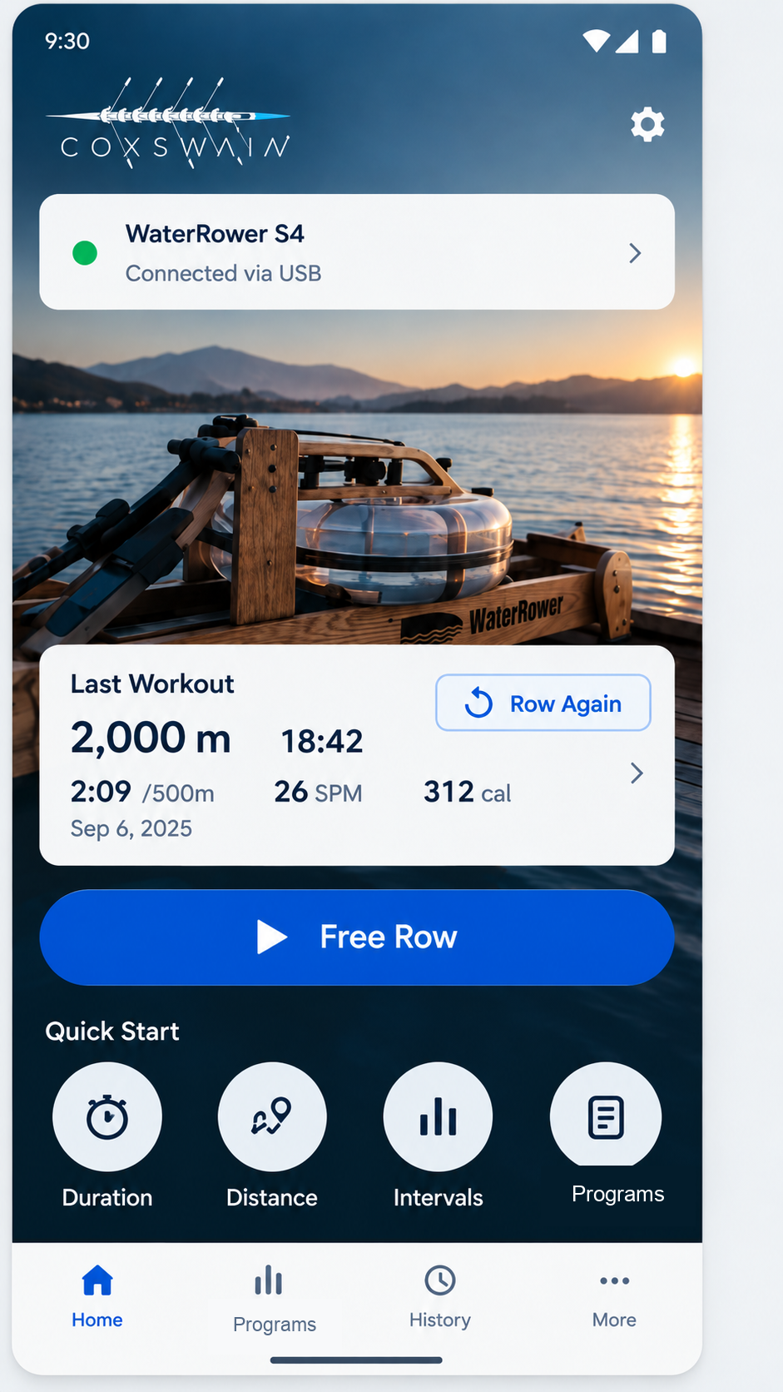
Product intent: Coxswain is a fast, local-first rowing companion for WaterRower hardware. It does not require login, account creation, onboarding, or a splash experience. The app should feel like a modern rowing computer rather than a generic fitness dashboard.
Primary experience: connect the rower, choose a workout mode, row with large live metrics, review history, and optionally race against a prior workout.

01. Locked Home Screen
Canonical structure, controls, and navigation behavior

Home screen hierarchy
- Coxswain logo in the upper-left of the hero area. Settings icon remains upper-right.
- WaterRower connection card appears directly below the brand area.
- Hero WaterRower image remains the primary visual background.
- Last Workout card overlays the lower hero area and contains a Row Again CTA.
- Free Row is the large primary CTA directly beneath Last Workout.
- Quick Start contains four actions: Duration, Distance, My Programs, Library.
- Bottom navigation remains Home, Programs, History, More.

Home control behavior
Control | Behavior | Route / destination | Notes
Settings | Open app settings. | settings | No workout state change.
Connection card | Open rower connection/details and diagnostics. | connect | Shows USB/Bluetooth status.
Last Workout card | Open full details for the most recent completed workout. | history/{workoutId} | Read-only session view.
Row Again | Repeat the same workout configuration as the most recent workout. | repeat/{workoutId} | Recreates mode, target, interval structure, and workout settings. Does not reuse prior results.
Free Row | Start an open-ended rowing session immediately. | live/free | No distance or duration target.
Duration | Open duration setup. | setup/duration | User selects a time period, then starts a timed row.
Distance | Open distance setup. | setup/distance | User selects a target distance, then starts a distance row.
My Programs | Open saved reusable rowing programs. | programs | Duration, distance, and interval templates that can be viewed, edited, or started.
Library | Open the curated Workout Library. | programs/library | Premade reusable programs supplied by the product owner.
Home nav | Return to Home. | home | Selected state uses primary blue.
Programs nav | Open Programs with My Programs and Workout Library. | programs | Reusable plans are kept separate from completed workout history.
History nav | Open completed workout history. | history | Allows detail, repeat, and Race Yourself actions.
More nav | Open secondary tools and settings. | more | Export, diagnostics, settings, connection.

Connection behavior
If the rower is disconnected, tapping an action that would start rowing first surfaces a lightweight connection prompt. Setup and library screens remain available while disconnected. The Home connection card itself is always available.

Row Again rules
- Free Row repeats as Free Row.
- Duration repeats the same target duration.
- Distance repeats the same target distance.
- Intervals repeat the same saved interval configuration.
- Premade workouts repeat the same workout definition and any user-adjustable settings.
- Race Yourself is not automatically enabled unless it was explicitly part of the prior workout configuration.

02. Duration Workout Setup
  - Locked setup behavior for timed workouts and performance goals

Purpose
The Duration Setup screen configures only the workout duration and an optional performance goal. Connection, audio feedback, and live-display configuration do not belong on this screen. The setup should remain fast enough to use immediately before rowing.

Approved goal-state design
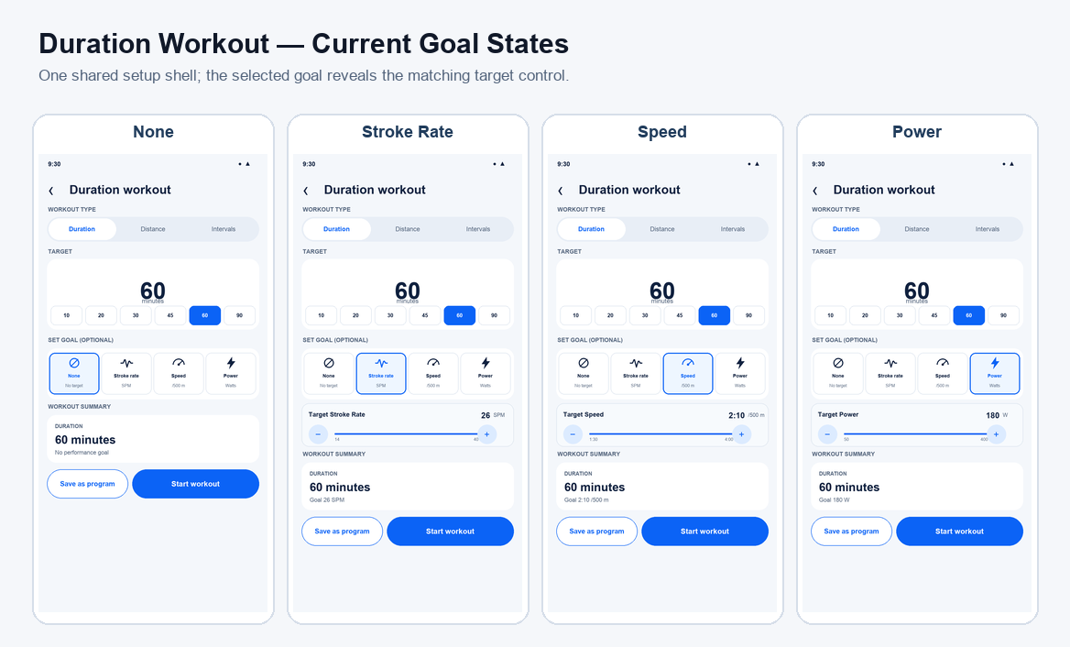
Figure 2. Current Duration Workout goal states: None, Stroke Rate, Speed, and Power. All four use the shared Workout Setup shell; selecting a goal reveals its target control, updates Workout Summary, and preserves the Quick Row option to save the configuration as a program.

Duration control
The main duration value is directly selectable. Tapping the large duration field opens a numeric time-entry control so long workouts such as 75 or 90 minutes do not require repeated button presses.
Common presets remain visible for one-tap selection: 10, 20, 30, 45, 60, and 90 minutes. A custom value may be entered directly. Changing either the preset or custom value immediately refreshes Workout Summary.

Set Goal
Set Goal is optional and has exactly four mutually exclusive states: None, Stroke Rate, Speed, and Power. The selected goal uses the Material 3 selected state. There is no separate “None” row or secondary selector.
Goal | Behavior | Target control | Summary example
None | No performance target. The row ends when the selected duration is reached. | No target-value control is shown. | 30:00 — Row for 30 minutes at your own pace.
Stroke Rate | Targets stroke cadence during the timed workout. | SPM value control, e.g. 26 SPM. | Goal: 26 SPM stroke rate.
Speed | Targets rowing speed/pace during the timed workout. | Uses the app’s configured speed/pace unit, e.g. 2:10 /500m. | Goal: 2:10 /500m.
Power | Targets rowing power during the timed workout. | Watt value control, e.g. 180 W. | Goal: 180 W.

Goal-value interaction
Selecting Stroke Rate, Speed, or Power reveals a compact target-value control directly below the goal buttons. The control must allow rapid adjustment and direct value entry where practical. It must not require dozens of taps to reach normal rowing values.
The target is guidance for the live workout. The Live Row screen is responsible for showing current performance relative to the selected goal and for letting the user change display metrics.

Workout Summary
Workout Summary is always visible immediately above Start Workout and is the final confirmation of what will run. It updates in real time whenever duration or goal changes.
When Goal = None, show workout type, duration, and plain-language description. When a goal is selected, add the goal name and value to the summary and update the description, for example: “Row for 30 minutes while maintaining 26 SPM.”

Start Workout
Start Workout creates the configured duration workout and opens Live Row. The duration and selected goal are passed into the active workout/session state. If the rower is disconnected at this point, use the app-level connection flow rather than adding connection controls to this setup screen.

Explicitly excluded from this screen
- Display View: managed on the Live Row screen.
- Audio Feedback: managed globally in Settings.
- Connect Rower: handled when the app/device connects and through the app-level connection flow.
- Heart-rate and target-pace-specific rows: replaced by the generic Set Goal model above.

Functional mapping to existing Coxswain concepts
Duration, stroke rate, speed, and power are represented in Coxswain’s workout/program domain. The redesigned screen should reuse those existing workout values rather than introducing parallel concepts. The UI layer should translate the selected Material 3 controls into the existing workout/session model.

Locked Duration rules
- Duration Setup contains only Duration, Set Goal, Workout Summary, and Start Workout.
- Preset durations and direct custom duration entry are both supported.
- Goal choices are None, Stroke Rate, Speed, and Power.
- Only one goal is active at a time.
- Selecting a goal reveals its value control.
- Workout Summary always reflects the current duration and goal.
- Display, audio, and connection controls remain outside Duration Setup.

03. Distance Workout Setup

Purpose
Distance Setup lets the user define a target rowing distance, optionally add a performance goal, review the resulting workout, and start the session. Its interaction model intentionally mirrors Duration Setup so users only need to learn one setup pattern.

Approved design
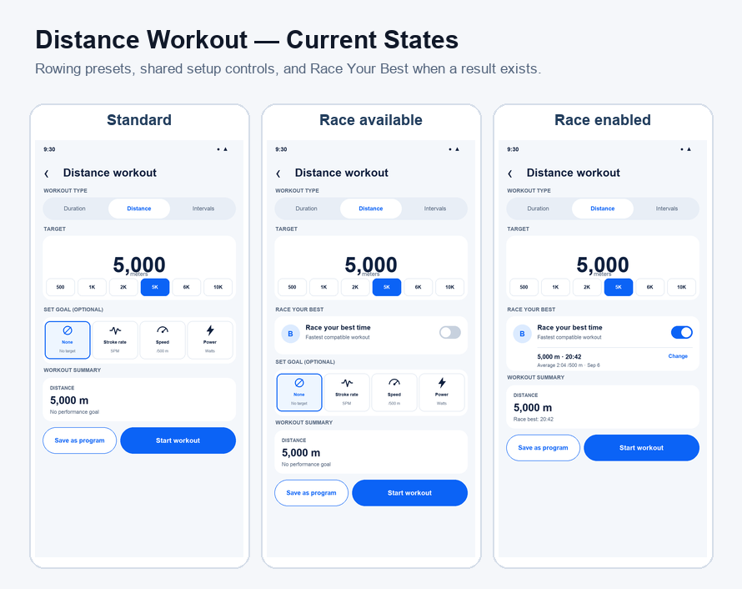
Figure 3. Current Distance Workout states: standard setup, Race Your Best available, and Race Your Best enabled. Distance uses rowing-specific presets, the shared Workout Setup components, and the same Quick Row save-as-program behavior as Duration and Intervals.

Distance control
- The current target distance is the dominant value on the screen.
- Tapping the large distance value opens direct numeric entry for arbitrary distances.
- Common presets remain visible for one-tap selection: 500 m, 1,000 m, 2,000 m, 5,000 m, 6,000 m, and 10,000 m.
- Selecting a preset immediately updates the large distance value and Workout Summary.
- The control must support distances outside the presets without repeated increment tapping.

Set Goal
Set Goal uses the same four-state control as Duration Setup. Only one goal may be active at a time.
- None: no performance target. The workout ends when the selected distance is reached.
- Stroke Rate: sets a target stroke rate in SPM.
- Speed: sets a target pace/speed using the app's configured speed representation. The current design shows /500 m.
- Power: sets a target power value in watts.

Goal-value interaction
- Selecting None hides the target-value control.
- Selecting Stroke Rate reveals a stroke-rate target control, for example 26 SPM.
- Selecting Speed reveals a pace/speed target control, for example 2:10 /500 m.
- Selecting Power reveals a power target control, for example 180 W.
- The active goal tile receives the Material 3 selected state.
- Changing the target value updates the Workout Summary immediately.

Workout Summary
The Workout Summary is always visible above Start Workout and is the confirmation of exactly what will be launched.
- None example: Distance Workout | 5,000 m | Row for 5,000 meters at your own pace.
- Stroke Rate example: Distance Workout | 5,000 m | Goal: 26 SPM stroke rate.
- Speed example: Distance Workout | 5,000 m | Goal: 2:10 /500 m.
- Power example: Distance Workout | 5,000 m | Goal: 180 W.
- Any distance or goal change updates the summary without requiring an extra confirmation step.

Start Workout
Start Workout creates a distance-based workout using the selected distance and optional goal, then opens the Live Row screen. If no rower is connected, connection handling occurs at the app/session level rather than adding a connection control to this setup screen.

Explicitly excluded from this screen
- Display View: managed on the Live Row screen.
- Audio Feedback: managed globally in Settings.
- Connect Rower: handled when the app establishes rower connectivity.
- Pace-boat selection: not part of the approved Distance Setup design at this stage.

Locked Distance rules
- Distance Setup mirrors the approved Duration Setup layout and component language.
- Direct distance entry plus common presets is required.
- Goal choices are exactly None, Stroke Rate, Speed, and Power.
- Workout Summary remains visible and reflects the current distance and selected goal.
- Start Workout remains the primary CTA.
- Bottom navigation remains Home, Programs, History, More.

04. Screen Map and Functional Inventory
Screens to design and track as the app evolves
# | Screen | Status | Purpose
01 | Home | LOCKED | Primary launcher for rowing modes, last workout, connection status.
02 | Live Row: Free | LOCKED | Open-ended live workout with large rowing metrics.
03 | Duration Setup | LOCKED | Select target time, then start timed workout.
04 | Distance Setup | LOCKED | Select target distance, then start distance workout.
05 | My Programs | IN PROGRESS | Saved reusable duration, distance, and interval templates.
06 | Program Builder | Planned | Create or edit a reusable duration, distance, or interval program.
07 | Workout Library | Planned | Curated reusable programs supplied by the product owner.
08 | Program Detail / Start | Planned | Review a reusable program and start a new workout session.
09 | Live Row: Target | Planned | Live duration/distance/workout mode.
10 | Race Reference Picker | Planned | Choose another compatible completed workout; Workout Setup defaults to the best result.
11 | Live Row: Race Yourself | Planned | Live current-vs-pace comparison with distance/time delta.
12 | Pause / End | Planned | Pause, resume, end, discard safeguards.
13 | Workout Complete | Planned | Summary and quick actions after a workout.
14 | History | Planned | Completed sessions, filters, totals.
15 | Workout Details | Planned | Metrics, graphs, export, repeat, Race Yourself.
16 | Race Comparison Details | Planned | Compare current workout with prior pace workout.
17 | Connect Rower | Planned | USB/Bluetooth connection and device status.
18 | Settings | Planned | Display, units, defaults, HR, data, advanced.
19 | Display Customization | Planned | Choose/reorder live-row metrics.
20 | Heart Rate Source | Planned | Select supported heart-rate source.
21 | Data / Export | Planned | Export, backup, storage management.
22 | More / Diagnostics | Planned | Diagnostics, protocol info, about, advanced tools.

Core navigation model
Home, Programs, History, and More are the persistent bottom-level destinations. The bottom navigation disappears during an active live-row session to maximize readability and prevent accidental navigation.
Workout configuration screens are pushed from Home or Workouts and return to their originating context after cancel. Starting a workout transitions to the immersive Live Row experience.

Race Yourself / pace boat
Race Yourself is a first-class feature built on Coxswain pace-boat behavior. A user selects a completed workout, then rows against its snapshot data. The live screen should emphasize how far and how many seconds the user is ahead or behind. History and Workout Details are the natural entry points.

05. Material 3 Design System
Locked visual language for consistency across screens

Color tokens
Token | Hex | Usage
Primary | #0B63F6 | Primary CTAs, selected navigation, key controls
Primary dark | #084DBD | Pressed/emphasis state and gradients where needed
On primary | #FFFFFF | Text/icons on primary actions
Primary container | #DCEBFF | Selected surfaces and low-emphasis highlights
Deep navy | #10213F | Primary text, icons, brand utility color
Surface | #FFFFFF | Cards, sheets, dialogs
Background | #F4F7FB | Standard non-hero screen background
On surface variant | #53647C | Secondary text and metadata
Outline | #CAD4E1 | Dividers, low-emphasis strokes
Connected / success | #22C55E | Connected device indicator and positive states
Error | #BA1A1A | Disconnected/error states requiring attention
Live row background | #042C3D | Immersive live-row base surface
Live accent | #1E7A8A | Secondary live-row visualization accent

These are product tokens derived from the approved Home direction and should be represented as semantic Material theme roles rather than hard-coded directly into individual composables.

Typography
Role | Spec | Usage
Font family | Roboto | Material 3 default. Use system fallback only if Roboto is unavailable.
Brand wordmark | Coxswain artwork | Do not recreate the logo using a text font.
Screen title | 24sp / 32sp, Medium or Semibold | Top-level screen headings.
Card title | 16sp / 24sp, Semibold | Section cards and primary card labels.
Body | 14sp / 20sp, Regular | Descriptions and standard controls.
Label | 12sp / 16sp, Medium | Metadata, chips, navigation labels.
Live primary metric | 48sp to 72sp, Medium | Scale based on available screen size. Glanceable while rowing.
Live secondary metric | 24sp to 36sp, Medium | Pace, SPM, heart rate, deltas.

Shape, spacing, elevation
Token | Spec | Use
Spacing grid | 8dp base | Primary rhythm. 4dp allowed for optical/internal adjustments.
Screen padding | 16dp phone / 24dp wide | Standard content inset.
Card radius | 20dp to 24dp | Home cards, workout cards, setup cards.
Primary button radius | 28dp pill | Free Row and other primary CTA buttons.
Quick action diameter | 72dp minimum visual | Icon circle on Home. Maintain 48dp minimum touch target.
Touch target | 48dp minimum | All tappable controls.
Card elevation | 1 to 3dp equivalent | Subtle only. Prefer tonal surfaces over heavy shadows.
Bottom navigation | Material 3 NavigationBar | Four fixed destinations: Home, Programs, History, and More.

06. Component and Interaction Rules
Reusable components for implementation in Material 3 / Jetpack Compose

Home components
Component | Material basis | Specification
Coxswain Brand Header | Custom image/logo | Preserve artwork aspect ratio. White version on hero image. Do not substitute WaterRower brand.
Connection Card | ElevatedCard or custom Surface | Status dot, rower name, transport/status, chevron. Entire card tappable.
Last Workout Card | ElevatedCard | Summary metrics plus dedicated Row Again outlined/tonal CTA.
Free Row CTA | Button | Full-width primary button. Starts immediately when connected.
Quick Start Action | Custom circular Surface + label | Duration, Distance, My Programs, Library. Four evenly distributed actions.
Bottom Navigation | NavigationBar | Home, Programs, History, More. Active item uses primary color.

Live Row principles
- Do not force the Live Row screen into a card-heavy dashboard. It should behave like a dedicated rowing computer.
- Use a dark immersive surface with very high contrast and very large metrics.
- Hide bottom navigation during an active row.
- Prioritize glanceability from rowing distance, not handheld reading distance.
- Allow configurable metric slots without changing the overall live layout.
- Race Yourself uses the same configurable metric grid as Live Row Free. A compact panel below the grid compares two progress lines: You and the best compatible result from saved program History.

Dialogs and setup flows
- Use Material 3 modal bottom sheets for lightweight selections when the content fits comfortably.
- Use full screens for interval building, workout libraries, and multi-step configuration.
- A start action should remain visible without excessive scrolling on setup screens.
- Destructive actions such as Discard Workout require explicit confirmation.

Accessibility and ergonomics
- Minimum touch target: 48dp.
- Do not rely on color alone for connected, disconnected, ahead, or behind states.
- Support system font scaling without truncating critical live metrics.
- Live-row text and controls must meet high-contrast requirements against dark backgrounds.
- Primary actions must remain reachable and visually distinct on common phone and small-tablet sizes.

State model guidance
UI components should consume rower/session state rather than directly handling USB or Bluetooth details. A recommended flow is: hardware connection layer -> rower repository -> session state / ViewModel -> Compose UI. This preserves Coxswain hardware logic while allowing the Material 3 UI to evolve independently.

07. Design Lock and Change Control
How to evolve the app without accidental redesign drift

Locked items in v2.0
- Home screen layout and content hierarchy.
- Coxswain branding on the Home screen.
- Free Row as the large primary Home CTA.
- Last Workout card with Row Again CTA.
- Quick Start actions: Duration, Distance, Intervals, Workouts.
- Bottom navigation: Home, Programs, History, More.
- No login, no account requirement, no splash/onboarding flow.
- Material 3 visual direction and semantic color system defined in this document.
- Duration Setup structure: duration selector, four-state Set Goal control, Workout Summary, Start Workout.
- Duration goal states: None, Stroke Rate, Speed, Power.

- Distance Setup structure and interactions are locked: direct/preset distance selection, four-state Set Goal control, dynamic Workout Summary, Start Workout.

Change request format
Recommended request format
Screen: [name]
Change: [specific requested change]
Preserve: [everything that must remain unchanged]
Scope: [this screen only / global component / all screens]

Example
Screen: Home
Change: Replace the connection-status subtitle wording.
Preserve: Logo, hero image, card size and placement, Last Workout card, Free Row CTA, Quick Start, bottom navigation, colors, typography, spacing.
Scope: Home only.

Version log
v1.1 — Added and locked Duration Workout Setup, direct/preset duration entry, Set Goal states, target controls, dynamic Workout Summary, and exclusions for display/audio/connection settings.
v1.2 — Added and locked Distance Workout Setup, distance presets/direct entry, goal states, dynamic Workout Summary, and Start Workout behavior.
Version | Status | Key decisions
1.0 | Previous baseline | Home approved. Coxswain branding. Free Row primary. Row Again on Last Workout. Duration, Distance, My Programs, Library quick actions. Material 3 token baseline established.
1.1 | Previous / locked | Added Duration Setup with preset/direct duration entry, goals None / Stroke Rate / Speed / Power, dynamic Workout Summary, and Start Workout behavior.

Next design sequence
Recommended next screens to define and lock: 1) Race Reference Picker, 2) Pause / End, 3) Workout Complete, 4) History and Workout Details, 5) Connect Rower.

08 Live Row Free
Approved design added in v1.3. Live Row Free is an open-ended rowing display whose metric selection reflects each user’s needs. All selected numbers share the largest common font size that fits cleanly. The screen has no fixed primary metric.

Display layout
Use the approved dark immersive background #042C3D and equal-sized metric areas. No hero metric, decorative chart, or bottom navigation.
Use Roboto with tabular numerals. Every selected metric uses the same numeric font size. Calculate the largest shared size that fits the available width and height of every slot, retaining balanced margins and room for labels and units. Do not cap live numbers at the earlier 48–72sp range. Recalculate when metric selection, count, orientation, or available space changes.
Keep the font size stable during normal value changes; reserve width for the expected numeric format. Longer values must remain fully visible.
Keep labels and units compact and readable in #CAD4E1. Retain the 8dp spacing grid, 16dp phone inset, and minimum 48dp touch targets.

Metric configuration
Edit display enters an explicit edit mode. Outside that mode, metric blocks are read-only. In edit mode, the user taps a metric position and chooses its replacement from visible radio options, then selects Done editing. The number and arrangement of blocks do not change on this screen.
Users can replace the metric type in each existing slot. Preserve the saved configuration across sessions and use the same live display layout for ordinary rowing and Race Your Best.
Available choices follow the current picker: distance, duration, strokes, energy, speed, heart rate, stroke rate, stroke ratio, power, clock time, split, average split, distance delta, and time delta.
The display supports portrait and landscape. Exact automatic grid breakpoints remain implementation details to validate on phones and tablets; the preview’s arrangements are illustrative.

Session controls
Header: Free Row, a labeled connection indicator using #22C55E for the connected dot, and Edit display.
Pause and End session remain visible side by side below the metric grid. Pause uses primary blue #0B63F6 with white text. End session uses #DCEBFF with #10213F text; finishing a session is distinct from discarding it. Both use the established pill shape.
Pause changes to Resume when paused. Resume returns to the active session.
End session opens a confirmation with Keep rowing and End session. If already paused, the cancel action is Stay paused. Cancel preserves the previous session state. Confirm finishes the session and proceeds to workout review. The full Workout Complete screen remains to be designed.
The preview uses sample values and local interactions; it is not connected to rowing hardware and does not save workout data.

Approval scope
Approved: configurable equal-area metrics, a shared maximized number size, dark live-row surface, coordinated brand styling, Edit display, Pause or Resume, and End session with confirmation.
Not yet specified: full connection-loss recovery, missing-sensor behavior, detailed Workout Complete design, and device-specific layout validation. These are follow-up states, not implied approvals.

Source and design reference
Code reviewed: https://github.com/svenmeier/coxswain — WorkoutActivity.java, BindingView.java, BindingDialogFragment.java, and ValueBinding.java.
An editable copy of the approved interactive design is stored beside this document as Coxswain_Live_Row_Free.html. Its orientation and layout controls are design-preview controls, not added product settings.
- Live performance goals: When Stroke Rate, Speed, or Power has a goal, its assigned metric card becomes a dedicated variance card. The card shows only the signed difference from the target at the same large size as the other live metrics. Its full background is red while below target and green when the target is met or exceeded. The label identifies the metric and says To Target.

Version update
v1.3 — Added the approved Live Row Free design and controls. Corrected screen inventory statuses for Duration Setup and Distance Setup to match their existing locked sections. Home, Duration, and Distance designs remain unchanged.

09 Terminology and Information Architecture
This section defines the product language and the complete screen contract for v2.0. It supersedes older navigation labels shown in retained v1.0-v1.2 mockup images.

Program and workout definitions
Program: a reusable rowing template. A program may contain a duration target, a distance target, or an ordered set of work and rest intervals. It may also contain an optional performance goal. Programs can be started repeatedly without changing the saved definition.
Workout: an active or completed rowing session. Starting a program creates a workout. History contains completed workouts and their measured results.

Primary navigation
Destination | Contains | Purpose
Home | Connection, last workout, Free Row, Quick Start | Start common rowing flows quickly.
Programs | My Programs and Workout Library | Find, create, manage, and start reusable plans.
History | Completed workouts and results | Review, compare, export, repeat, or race past sessions.
More | Settings, connection, data, diagnostics, about | Access secondary tools and configuration.

Home launcher revision
Home Quick Start uses Duration, Distance, Intervals, and Programs. Programs opens the reusable-template area with My Programs selected; Workout Library remains its second tab. The persistent navigation uses Home, Programs, History, and More.

10 Complete Screen Specification Register
Every screen below has a defined role, primary content, actions, and state requirements. LOCKED means the design has been approved. IN PROGRESS means the current direction is being reviewed. PLANNED screens have a functional contract but still need visual approval.

01 Home
LOCKED
Purpose: Launch rowing modes and show connection and recent activity.
Primary content: Coxswain brand, connection card, hero image, Last Workout with Row Again, Free Row, Quick Start.
Primary actions: Settings; connection details; workout details; Row Again; Free Row; Duration; Distance; My Programs; Library.
States and rules: Disconnected start actions show the app-level connection prompt. Persistent navigation: Home, Programs, History, More.

02 Live Row Free
LOCKED
Purpose: Run an open-ended rowing session.
Primary content: Equal-area configurable metric slots on #042C3D. All values use one maximized shared size.
Primary actions: Edit display; tap a block and replace its metric with a radio choice; Done editing; Pause/Resume; End session with confirmation.
States and rules: No bottom navigation. Metric blocks are read-only until Edit display is selected. Connection-loss and missing-sensor states remain to be finalized.

03 Duration Setup
LOCKED
Purpose: Configure a timed workout.
Primary content: Direct duration entry, presets, optional goal, live Workout Summary.
Primary actions: Choose duration; choose None, Stroke Rate, Speed, or Power; set target; Start Workout. Save as Program stores the current configuration without starting it.
States and rules: Connection, audio, and display controls remain outside setup. Starting creates a workout session.

04 Distance Setup
LOCKED
Purpose: Configure a target-distance workout.
Primary content: Direct distance entry, presets, optional goal, live Workout Summary.
Primary actions: Choose distance; choose None, Stroke Rate, Speed, or Power; set target; Start Workout. Save as Program stores the current configuration without starting it.
States and rules: Uses the Duration Setup interaction pattern. Pace-boat selection remains outside this screen.

05 My Programs
LOCKED
Purpose: Manage saved reusable programs.
Primary content: Compact cards for duration, distance, and interval programs, with type-specific summaries.
Primary actions: Create Program; View Program; Start; Duplicate; Delete.
States and rules: Delete requires confirmation. Empty state explains programs and offers Create Program. Order programs by most recently used. Tapping the card name opens Program Detail; Start remains explicit. Show search and filters when the collection reaches 10 programs. Programs navigation is selected.

06 Program Builder
IN PROGRESS
Purpose: Create a reusable program or customize a duplicated definition.
Primary content: The shared Workout Setup shell with program name, type choice, configuration, optional Set Goal component, interval segment list when applicable, and live summary.
Primary actions: Save Program; add, edit, reorder, or remove segments; preview summary; cancel.
States and rules: Supports duration, distance, and interval definitions. A saved program becomes immutable when created; changing it requires Duplicate so its existing workout History remains comparable. Validate mixed-unit and empty-segment cases.

07 Workout Library
IN PROGRESS
Purpose: Browse curated reusable programs.
Primary content: Categories or grouped list, concise program cards, description and difficulty metadata supplied by the product owner.
Primary actions: View Program; Start; optionally save a copy to My Programs. The library has no Create Program action.
States and rules: Library content is read-only. Use the same compact card system as My Programs, omit the Create Program button, and omit owned-program management actions. Empty and loading states depend on how content is packaged.

08 Program Detail Start
LOCKED
Purpose: Review a program before starting a workout.
Primary content: Program source, name, description, read-only workout configuration, performance goal, completion history, and Race Your Best when compatible history exists.
Primary actions: Start Workout or Start Race; view program History; Duplicate; Delete; back. Library programs use the same review structure without owned-program management actions.
States and rules: Saved definitions are immutable so their History and best result always describe the same workout. Duplicate creates a new editable definition with no History. Delete removes the definition but retains completed workouts in History. Best is type-specific: timed programs use greatest distance; distance programs use fastest completion time. Interval programs preserve the exact free-form ordered segment list from the builder and have no separate rounds model. Time-only work segments rank by greatest work distance; distance-only work segments rank by lowest cumulative work time; mixed work segments use average work pace across the identical ordered structure. Rest is excluded from performance ranking. Race Your Best appears only with compatible completed workouts.

09 Live Row Target
LOCKED
Purpose: Run duration, distance, interval, or library workouts.
Primary content: The approved configurable metric grid plus a compact progress panel. Duration shows elapsed and remaining time; distance shows completed and remaining meters; intervals show the complete saved sequence as one continuous segmented line.
Primary actions: Edit display; Pause/Resume; End session.
States and rules: The metric grid, Pause, and End session match Live Row Free during Row segments. The progress panel is fixed below the grid. Free-form intervals advance through their saved order and never introduce rounds. During Rest, the metric grid becomes a large countdown and identifies the next Row segment. When Stroke Rate, Speed, or Power has a goal, its assigned card shows only the large signed variance. The full card is red while below target and green when the target is met or exceeded.

10 Race Reference Picker
LOCKED
Purpose: Choose an alternative compatible completed workout for Race Your Best.
Primary content: The current program and compatibility rule, selectable completed workouts, date, type-specific result, supporting pace, best-result marker, and an expandable list of excluded History.
Primary actions: Select a compatible workout; inspect unavailable History; Start Race; Cancel or Back.
States and rules: The best compatible result is selected by default. Distance programs compare identical target distance and rank fastest time. Duration programs compare identical target duration and rank greatest distance. Interval programs require the exact ordered Row and Rest structure and use the program-specific ranking rule. Unavailable History stays collapsed until requested and gives a concrete mismatch reason. Starting the race locks the selected result as the reference snapshot.

11 Live Row Race Yourself
PLANNED
Purpose: Race against snapshot data from a prior workout.
Primary content: The same configurable metric grid as Live Row Free, followed by two labeled progress lines for You and Best from History.
Primary actions: Edit display; Pause/Resume; End session.
States and rules: The user’s live metric layout is shared with Live Row Free. The race panel is fixed below it. The best compatible saved workout remains fixed for the session; the You marker updates live. Ahead or behind status uses text and distance as well as color.

12 Pause End
PLANNED
Purpose: Safely pause, resume, finish, or discard an active workout.
Primary content: Paused state, elapsed status, resume action, end choices.
Primary actions: Resume; End and Save; Discard Workout; cancel.
States and rules: Discard requires explicit confirmation. End and Save proceeds to Workout Complete.

13 Workout Complete
PLANNED
Purpose: Confirm completion and summarize results.
Primary content: Key measured totals, achieved target, interval results, date/time.
Primary actions: View Details; Row Again; Race Yourself when eligible; export; Done.
States and rules: Handle short, disconnected, and manually ended sessions without misleading summaries.

14 History
PLANNED
Purpose: Browse completed workouts.
Primary content: Chronological workout list, filters, totals, and search if needed.
Primary actions: Open details; repeat; race; filter.
States and rules: History contains executed workouts, never reusable program definitions.

15 Workout Details
PLANNED
Purpose: Inspect one completed workout.
Primary content: Metrics, graphs, interval breakdown, equipment/source metadata.
Primary actions: Export; Row Again; Race Yourself; delete with confirmation.
States and rules: Use real recorded values and make unavailable sensor series explicit.

16 Race Comparison Details
PLANNED
Purpose: Compare a completed workout with its pace workout.
Primary content: Result summary, distance/time deltas, aligned splits or snapshots.
Primary actions: Switch compared metrics; open either workout; repeat race.
States and rules: Keep comparison scales and signs consistent. Explain incomplete comparisons.

17 Connect Rower
PLANNED
Purpose: Connect and inspect WaterRower hardware.
Primary content: USB and Bluetooth status, device name, transport, troubleshooting state.
Primary actions: Scan/connect; disconnect; retry; open diagnostics.
States and rules: UI consumes repository/session state rather than handling protocols directly.

18 Settings
PLANNED
Purpose: Set global app behavior.
Primary content: Units, live-display defaults, audio feedback, heart-rate source, data, advanced options.
Primary actions: Change settings; open sub-screens; reset applicable defaults.
States and rules: Settings apply consistently and should not clutter workout setup.

19 Display Customization
PLANNED
Purpose: Choose and order live-row metrics.
Primary content: Available metrics and ordered active slots for normal and race modes.
Primary actions: Add; remove; replace; reorder; preview; restore defaults.
States and rules: At least one metric is required. The shared live-number size recalculates from the final set.

20 Heart Rate Source
PLANNED
Purpose: Choose the source of pulse data.
Primary content: WaterRower, Android sensor, Bluetooth LE, and ANT+ options when supported.
Primary actions: Select; connect/authorize as needed; test reading.
States and rules: Show unavailable hardware and permission states clearly.

21 Data Export
PLANNED
Purpose: Export, back up, and manage stored data.
Primary content: TCX, calendar, supported integrations, backup/storage information.
Primary actions: Export selected workout; export archive; import/restore if supported; storage management.
States and rules: Confirm destructive storage actions and show success/failure details.

22 More Diagnostics
PLANNED
Purpose: Collect secondary tools in one place.
Primary content: Connection, settings, data/export, diagnostics, protocol info, about.
Primary actions: Open each destination; copy diagnostic information where appropriate.
States and rules: Keep this screen concise; detailed controls live on destination screens.

11 My Programs Design Direction
The Programs destination contains two tabs: My Programs and Workout Library. My Programs is selected in the current design. It uses compact cards because users may save many programs.

My Programs card content
Each card shows a user-defined name and a one-line summary suited to its type. Examples include “60 min · No goal,” “5,000 m · Target 26 SPM,” and “6 × 500 m · 1 min rest.” The card does not assume every program is an interval workout.

Actions and behavior
Create Program begins a reusable duration, distance, or interval definition. View Program opens Program Detail / Start. Start creates a new workout from the saved program. The overflow menu contains Edit, Duplicate, Export, and Delete. Delete requires confirmation.

Layout and navigation
Use a plain #F4F7FB header without a scenic image. Compact white cards use 20dp corners, restrained elevation, 48dp action targets, and small vertical gaps. The bottom navigation shows Home, Programs, History, and More, with Programs selected.

Version update
v2.0 - Replaced ambiguous reusable-workout terminology with Programs. Added My Programs and Workout Library under the Programs destination, revised Home Quick Start and primary navigation labels, and added functional specifications for all 22 screens.

12 Workout Library and Program Builder Direction

Workout Library
Workout Library uses the same compact list and card components as My Programs. The tab, card density, type-specific one-line summaries, View Program action, Start action, and Programs navigation remain consistent.
Because the library is a curated read-only collection, it does not show Create Program. Library cards also omit Edit, Duplicate, Export, and Delete. A future Save to My Programs action may create an owned copy without changing the library item.

Program Builder
Program Builder reuses the approved Duration and Distance setup components: large direct target entry, familiar preset choices, optional goal selection, goal target entry, and an always-visible summary. It adds a program name and replaces Start Workout with Save Program.
The type selector supports Duration, Distance, and Intervals. Duration and Distance display their existing target and preset controls. Intervals replace the single target with an ordered segment list. Each segment is exactly Duration, Distance, or Rest and reuses the corresponding large target-entry and preset component. Users can add, edit, reorder, or delete segments.
Save Program validates a non-empty name and a complete configuration, then returns the saved definition to My Programs. Back with unsaved changes asks whether to discard them. Saving a program does not start a workout.

Version update
v2.0 - Applied the compact Programs card system to Workout Library without a Create Program action. Added the Program Builder design direction using the approved Duration and Distance setup components, with interval segment support.

13 Approved My Programs Decisions
The My Programs screen and the decisions in this section are approved and locked.
- Ordering: Sort by most recently used, with newly created programs treated as most recent.
- Card interaction: Tapping the program name or View Program opens Program Detail. Start remains a separate explicit action.
- Duplicate: Duplicate appends “copy” to the name and immediately opens the new owned program for editing.
- Library ownership: Workout Library items remain read-only. Save to My Programs creates a separate editable copy.
- Large collections: Keep the default screen compact. Show search and type filters when My Programs contains 10 or more items.
- Empty state: Explain that programs are reusable duration, distance, or interval templates and provide a prominent Create Program action.

Version update
v2.0 - Locked the My Programs layout and behavior, including ordering, card interaction, duplicate behavior, library ownership, large-collection controls, and the empty state.

14 Shared Set Goal and Distance Presets

Shared Set Goal component
Program Builder uses the approved Distance Workout Set Goal component instead of a separate simplified control. Duration Setup, Distance Setup, and Program Builder therefore share the same four icon tiles: None, Stroke Rate, Speed, and Power.
Selecting a performance goal reveals its target panel. The panel provides minus and plus controls, an appropriate slider, and a tappable central value for direct entry. The selected tile uses the Material 3 selected state, and every change immediately updates the summary.

Rowing distance presets
The approved distance presets are 500 m, 1,000 m, 2,000 m, 5,000 m, 6,000 m, and 10,000 m. Half Marathon and Full Marathon are removed because their running terminology does not fit the rowing product. Direct entry continues to support any distance outside these presets.
This written v2.0 rule supersedes the Half Marathon and Full Marathon labels visible in the retained earlier Distance Setup mockup image.

Version update
v2.0 - Standardized Program Builder on the approved Set Goal component and replaced running-oriented marathon presets with rowing distances.

15 Unified Workout Setup Experience
Duration, Distance, Interval Quick Start, and Program Builder use one shared Workout Setup shell. The target selector, rowing presets, Set Goal tiles, goal adjustment panel, and live summary keep the same layout and behavior across every entry point.

Quick workout context
Home Quick Start opens the shell with the selected type already active. The title reads Duration Workout, Distance Workout, or Interval Workout. Program Name is hidden. Start Workout is the primary action and creates an active workout. Save as Program is a secondary action that preserves the current configuration for reuse.

Program context
Create Program opens the same shell with Program Name visible and the Duration, Distance, and Intervals type selector available. Save Program is the primary action. Editing an owned program uses the same screen with saved values loaded and Save Changes as the primary action.

Terminology and behavior
The interface uses Save as Program because a workout is an active or completed session and a program is its reusable definition. Saving never starts a workout. Starting a quick workout does not require saving. Saving from Quick Start transfers the current configuration into Program context so the user can name and confirm it without re-entering values.

Shared component contract
Changing between Duration, Distance, and Intervals replaces only the configuration area. Set Goal and Summary remain in stable positions. Each type preserves its draft configuration while the screen is open. Back asks about discarding changes only after the user has modified the setup.

Version update
v2.0 - Unified quick Duration, Distance, and Interval setup with Program Builder. Added Save as Program to quick setup while preserving Start Workout as the primary action and the established Program versus Workout terminology.

16 Current Visual Screen Atlas
This section is the current visual source of truth for every screen and interaction state designed through v2.0. Each state has its own screenshot so reviewers can assess component changes without interpreting a composite image. Earlier composite mockups remain in the document as design history; where labels or controls differ, this atlas supersedes them.

Shared interaction model
- Quick Duration, Distance, and Intervals use one Workout Setup shell. Only the target configuration area changes by type.
- Quick setup keeps Start Workout primary and Save as Program secondary. Program creation adds Program Name and changes the primary action to Save Program.
- Set Goal uses the same None, Stroke Rate, Speed, and Power tiles. Selecting a goal reveals its value controls and updates Summary immediately.
- Interval segments use three choices: Duration, Distance, and Rest. Each choice reuses the large value-entry card and relevant presets. Existing rows open Edit with Save and Delete.
- Race Your Best is selected in Distance Workout Setup and replaces Set Goal while active. Live Row displays the fixed ahead/behind comparison.
Entry context | Program name | Primary action | Secondary action
Quick workout | Hidden | Start Workout | Save as Program
Create program | Visible | Save Program | Cancel / Back
Edit program | Visible | Save Changes | Cancel / Back
Library program | Read-only | Start Workout | Save to My Programs

16.01 Home
Current v2.0 state: Home

Interaction changes
- Quick Start exposes Duration, Distance, Intervals, and Programs.
- Free Row remains the dominant action.

16.02 Quick Duration — no goal
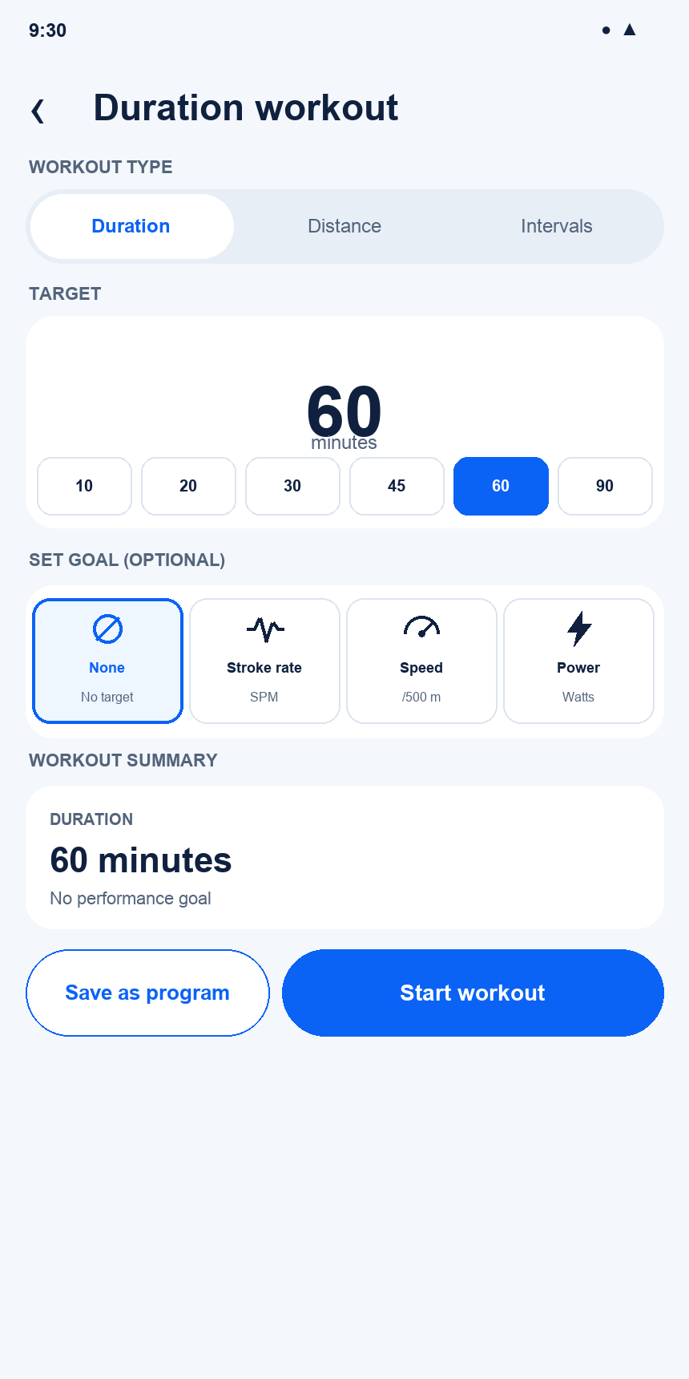
Current v2.0 state: Quick Duration — no goal

Interaction changes
- Duration is preselected from Home.
- No target-value panel is shown while Goal is None.
- Start Workout is primary; Save as Program preserves the setup.

16.03 Quick Duration — stroke rate
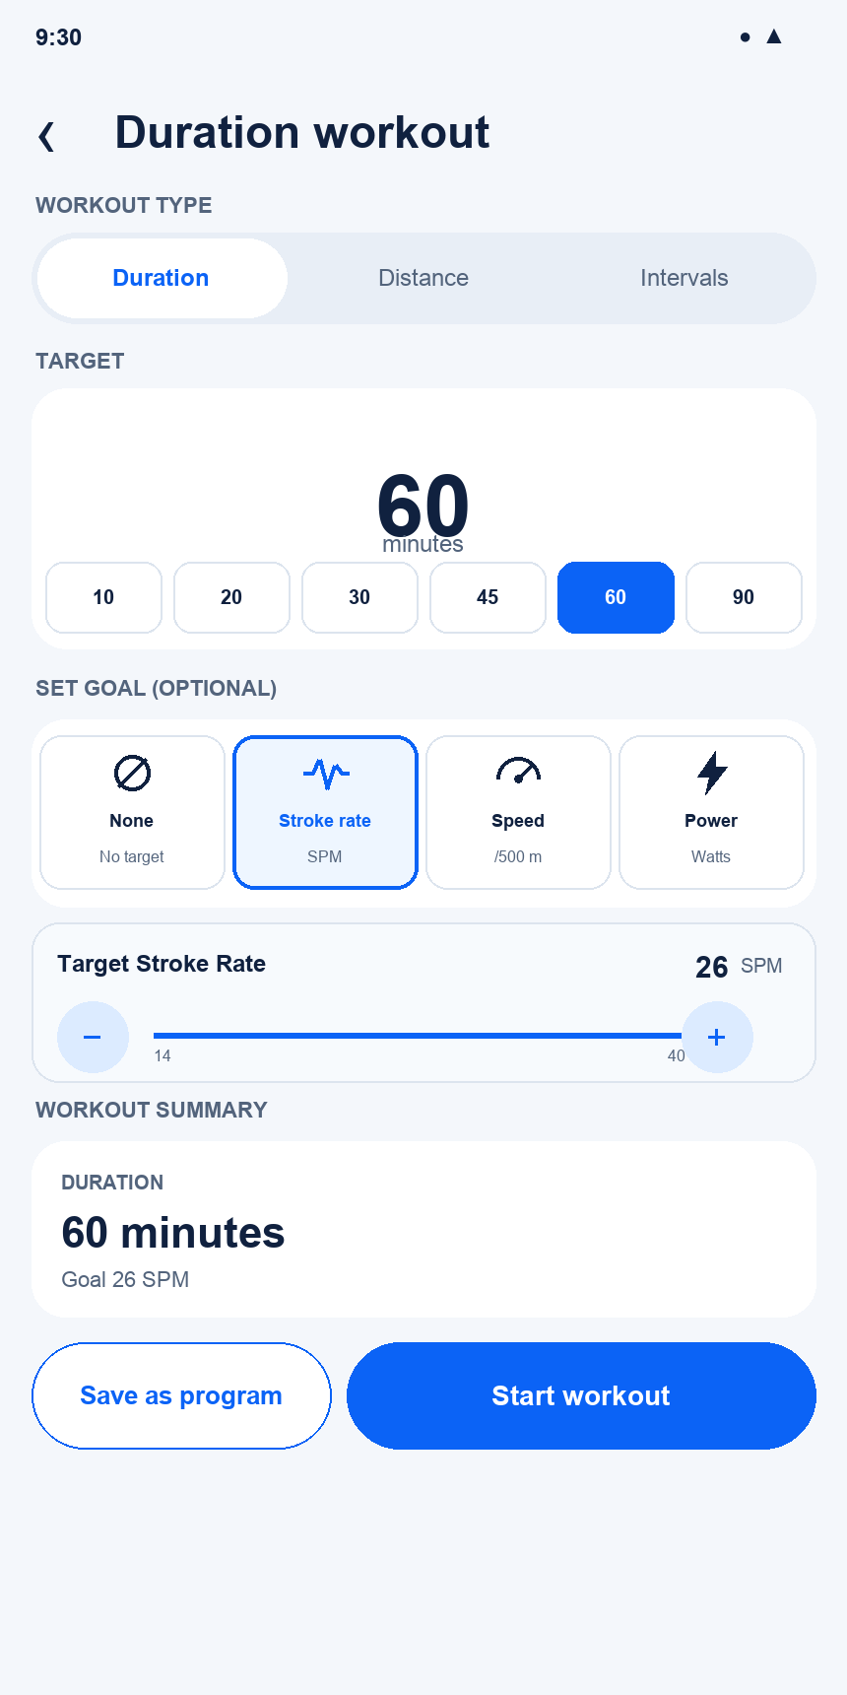
Current v2.0 state: Quick Duration — stroke rate

Interaction changes
- Selecting Stroke Rate reveals its target controls.
- Summary changes immediately to Goal 26 SPM.

16.04 Quick Duration — speed
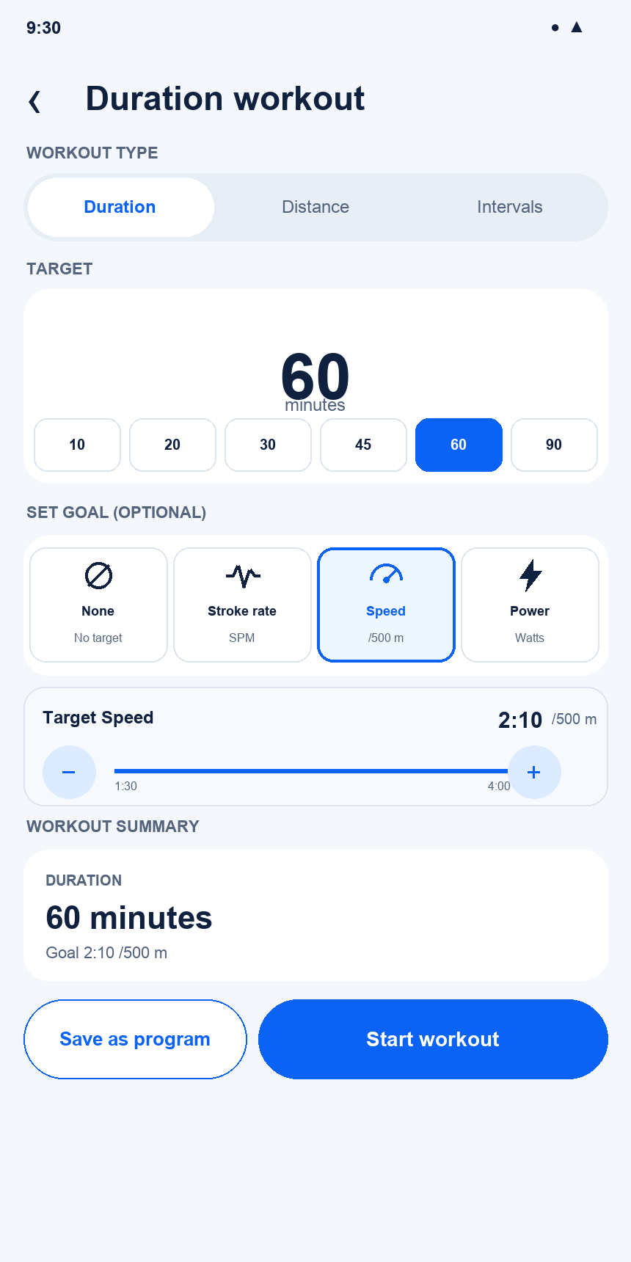
Current v2.0 state: Quick Duration — speed

Interaction changes
- Selecting Speed reveals pace controls in the configured /500 m representation.
- Summary changes immediately to Goal 2:10 /500 m.

16.05 Quick Duration — power
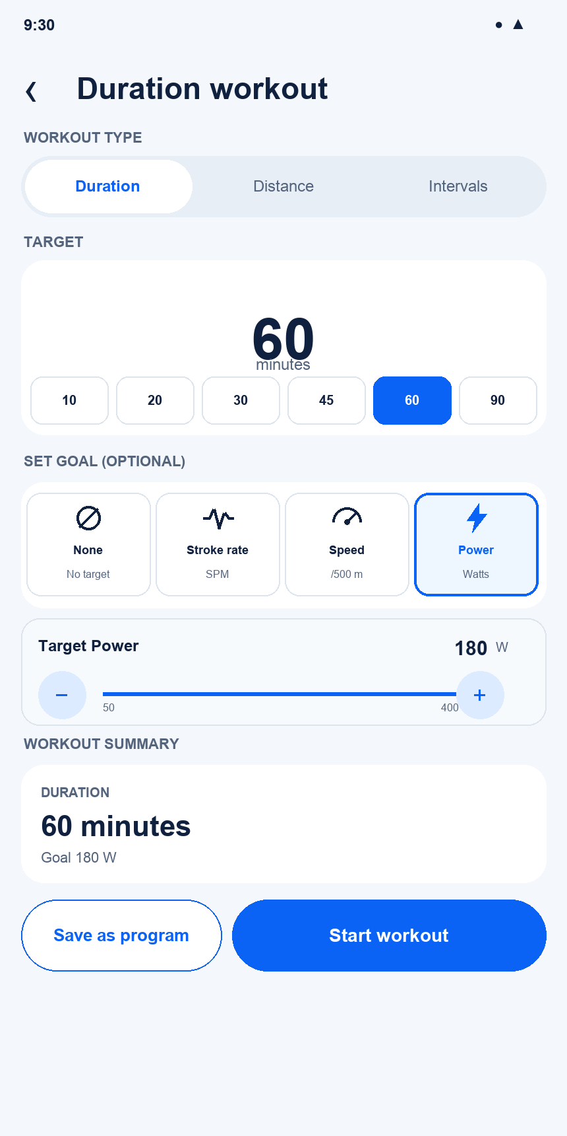
Current v2.0 state: Quick Duration — power

Interaction changes
- Selecting Power reveals watt controls.
- Summary changes immediately to Goal 180 W.

16.06 Quick Distance
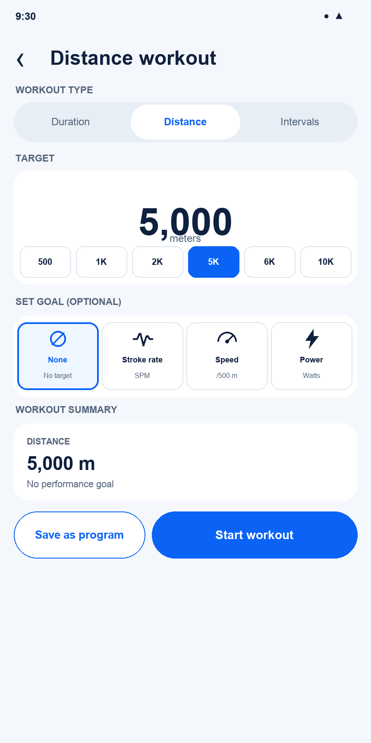
Current v2.0 state: Quick Distance

Interaction changes
- Distance uses rowing presets: 500 m, 1K, 2K, 5K, 6K, and 10K.
- Direct entry supports any distance.

16.07 Distance — race available
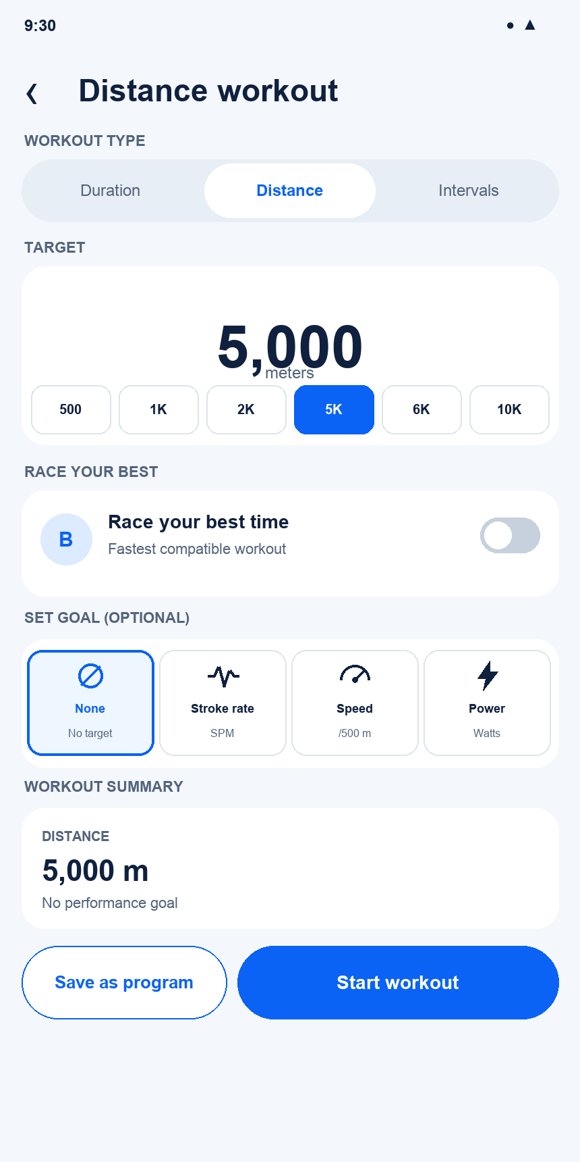
Current v2.0 state: Distance — race available

Interaction changes
- Race Your Best appears only when a compatible result exists.
- Set Goal remains available while racing is disabled.

16.08 Distance — race enabled
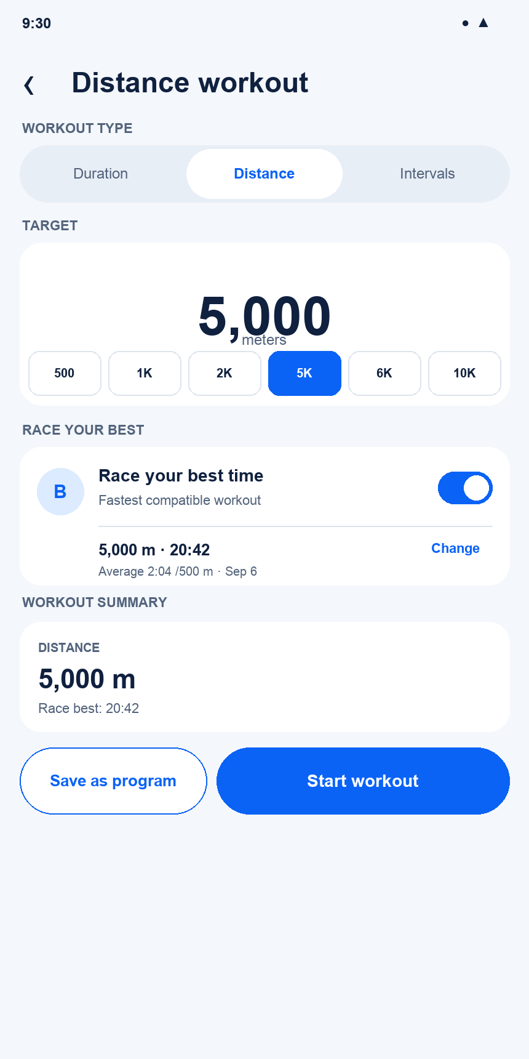
Current v2.0 state: Distance — race enabled

Interaction changes
- The best compatible result and comparison pace are shown.
- Race mode replaces Set Goal to avoid competing guidance.

16.09 Quick Intervals
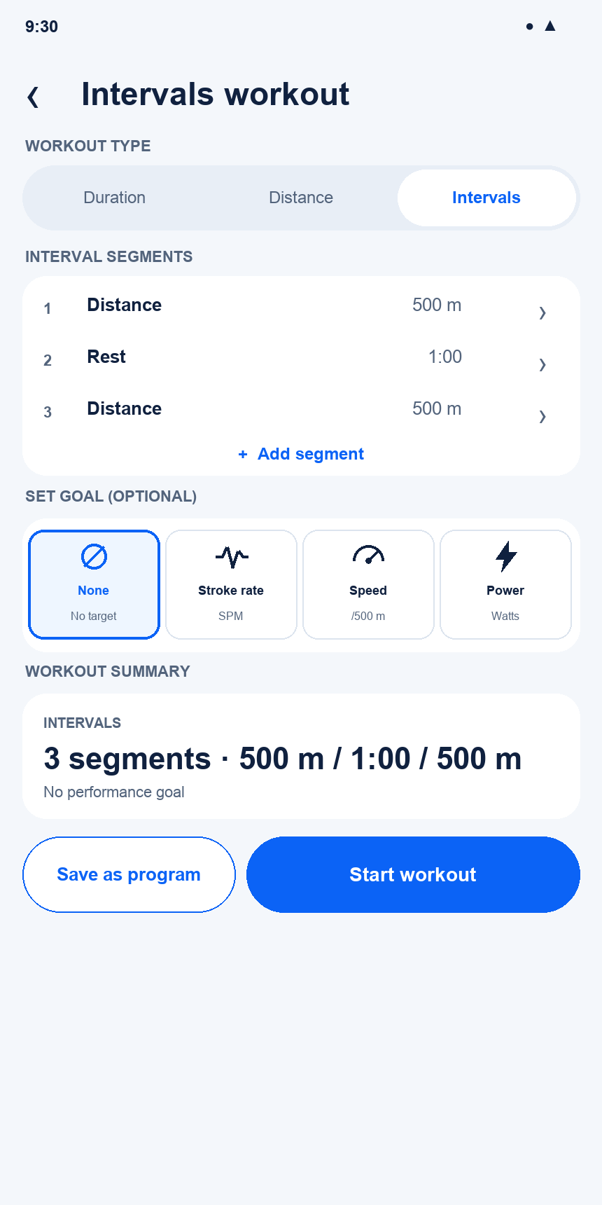
Current v2.0 state: Quick Intervals

Interaction changes
- Segments are compact, ordered, and individually editable.
- Add Segment appends a new Duration, Distance, or Rest segment.

16.10 Add Segment — Duration
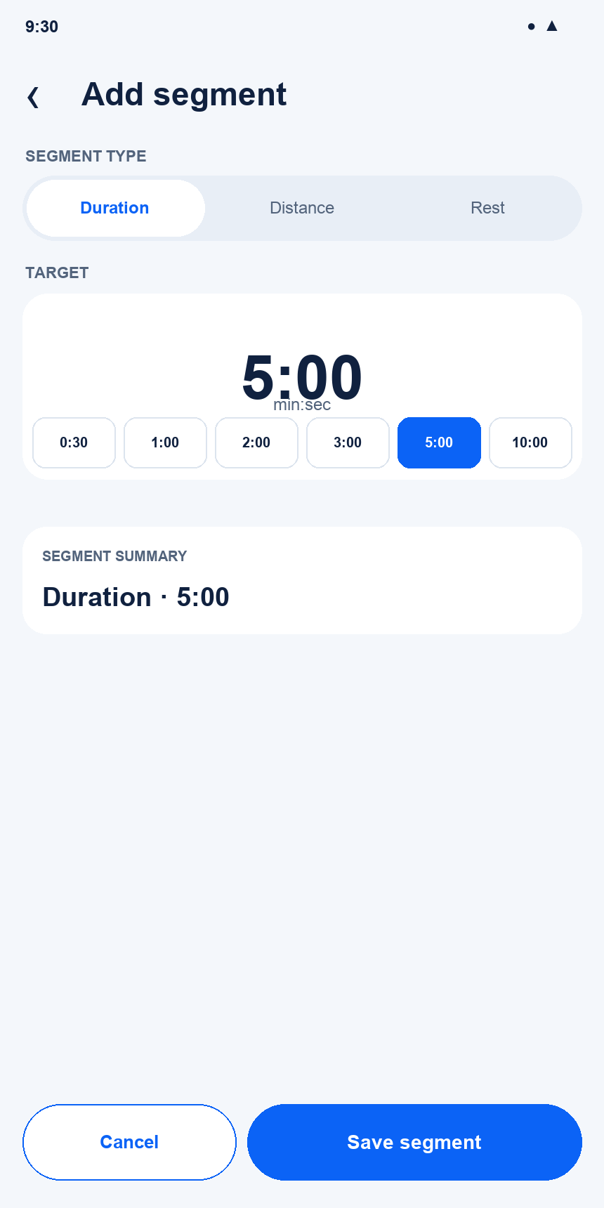
Current v2.0 state: Add Segment — Duration

Interaction changes
- Duration uses direct min:sec entry and duration presets.
- Save adds or updates the segment and refreshes the summary.

16.11 Add Segment — Distance
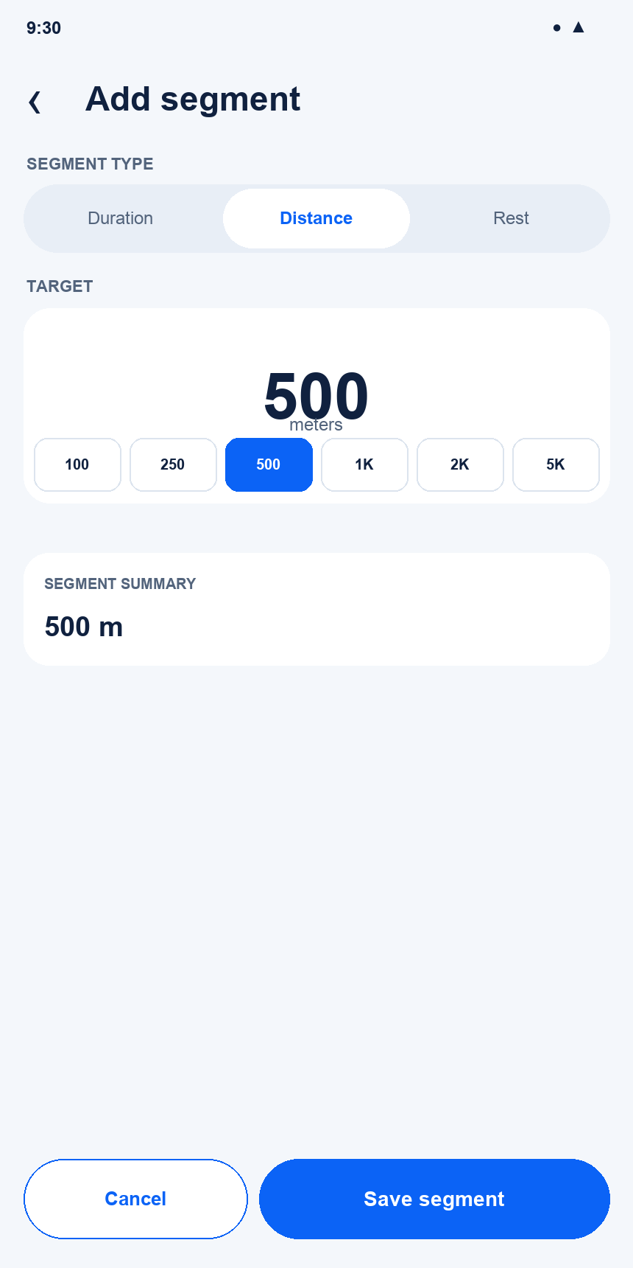
Current v2.0 state: Add Segment — Distance

Interaction changes
- Distance uses direct meter entry and interval-distance presets.
- Edit mode adds a Delete action.

16.12 Add Segment — Rest
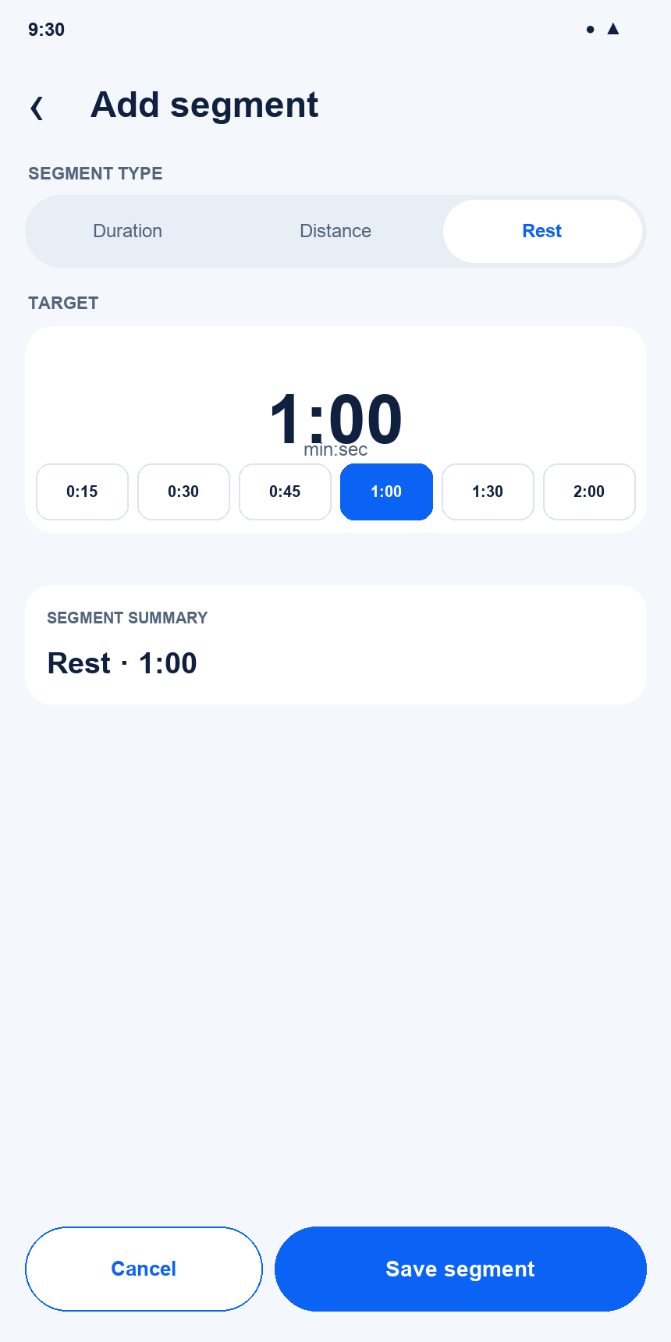
Current v2.0 state: Add Segment — Rest

Interaction changes
- Rest is a first-class segment type and always uses time.
- Rest presets favor short recovery periods.

16.13 New Program — Duration
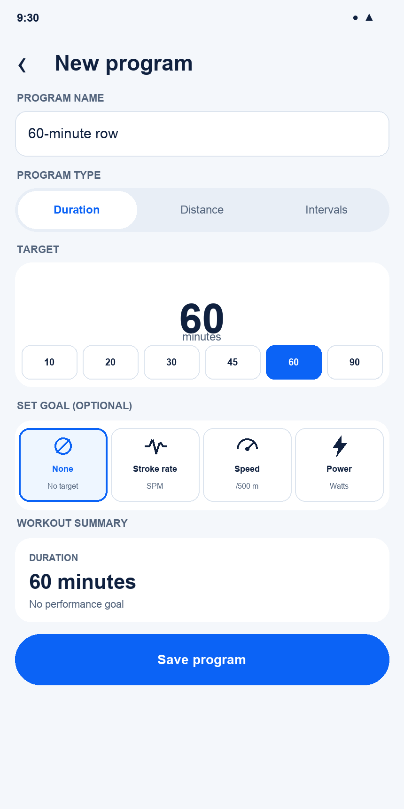
Current v2.0 state: New Program — Duration

Interaction changes
- Program context adds Program Name.
- Save Program replaces Start Workout.

16.14 New Program — Distance
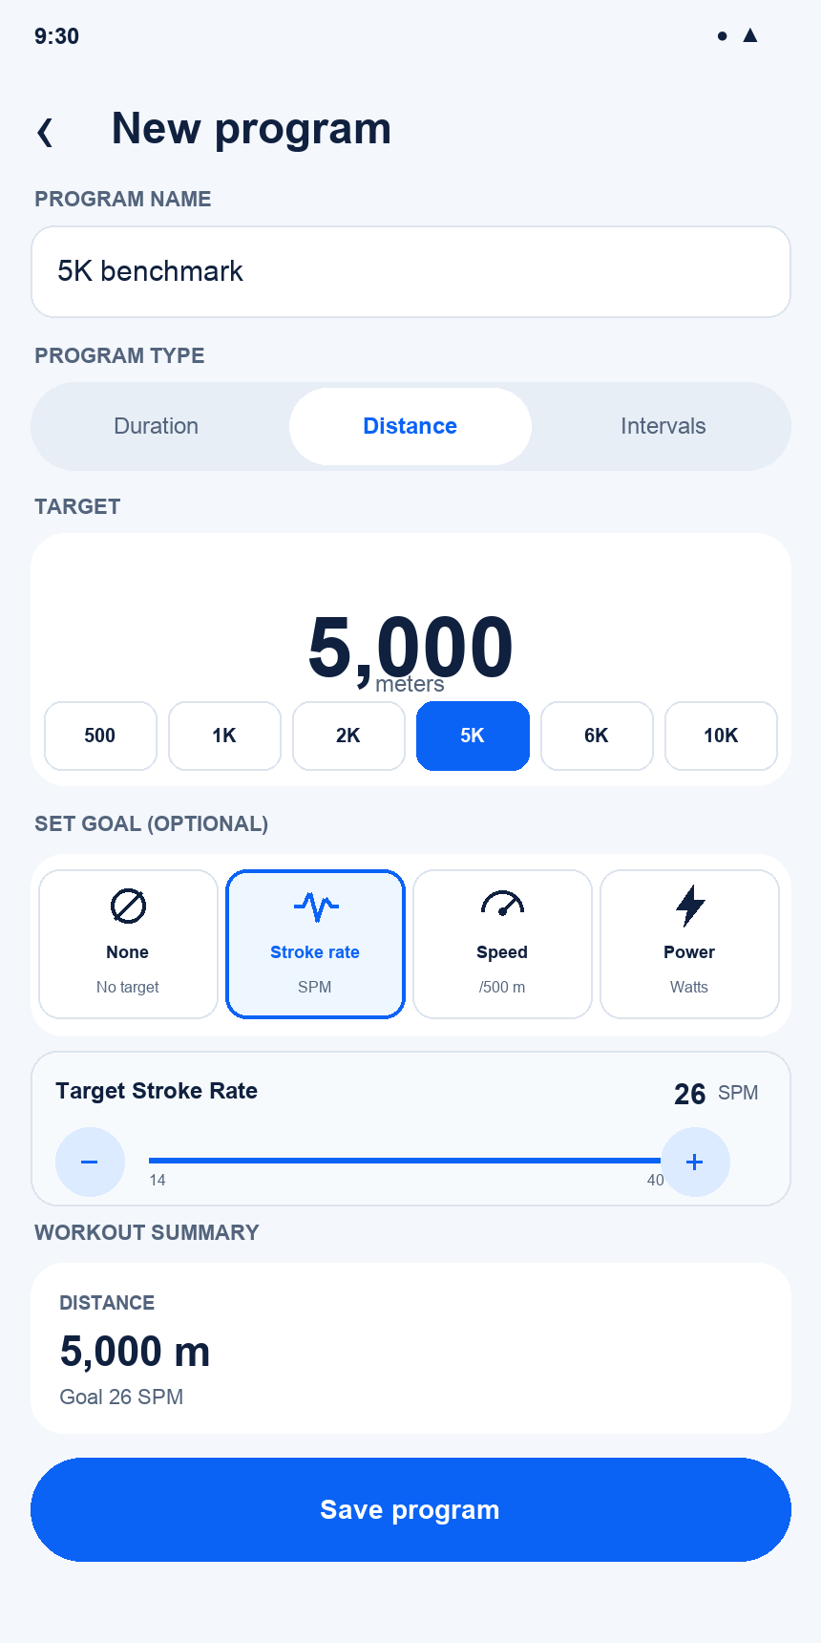
Current v2.0 state: New Program — Distance

Interaction changes
- Program Builder reuses the same target, goal, and summary components.
- Race Your Best is session guidance and is not saved into a program.

16.15 New Program — Intervals
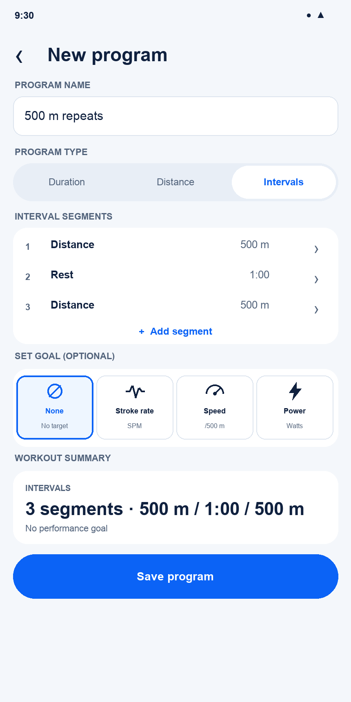
Current v2.0 state: New Program — Intervals

Interaction changes
- The type selector swaps only the configuration area.
- Set Goal and Summary keep stable positions.

16.16 My Programs
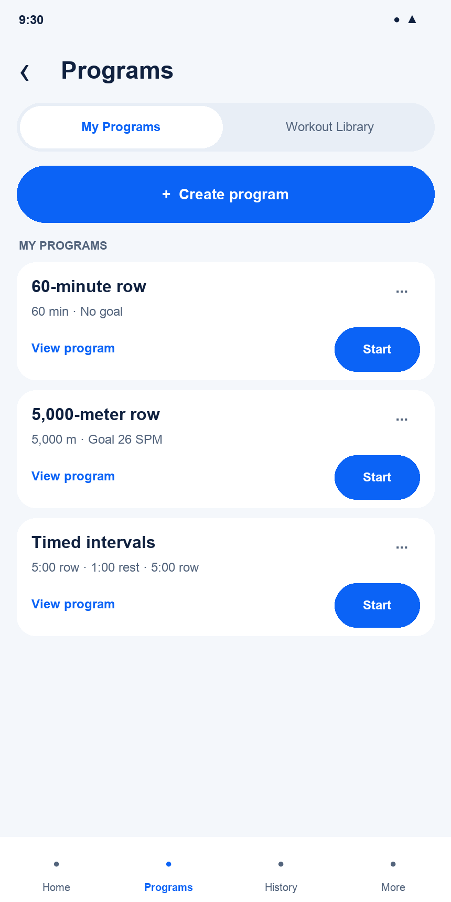
Current v2.0 state: My Programs

Interaction changes
- Owned programs include View, Start, and an overflow menu containing only Duplicate and Delete.
- Create Program appears only on My Programs.

16.17 Workout Library
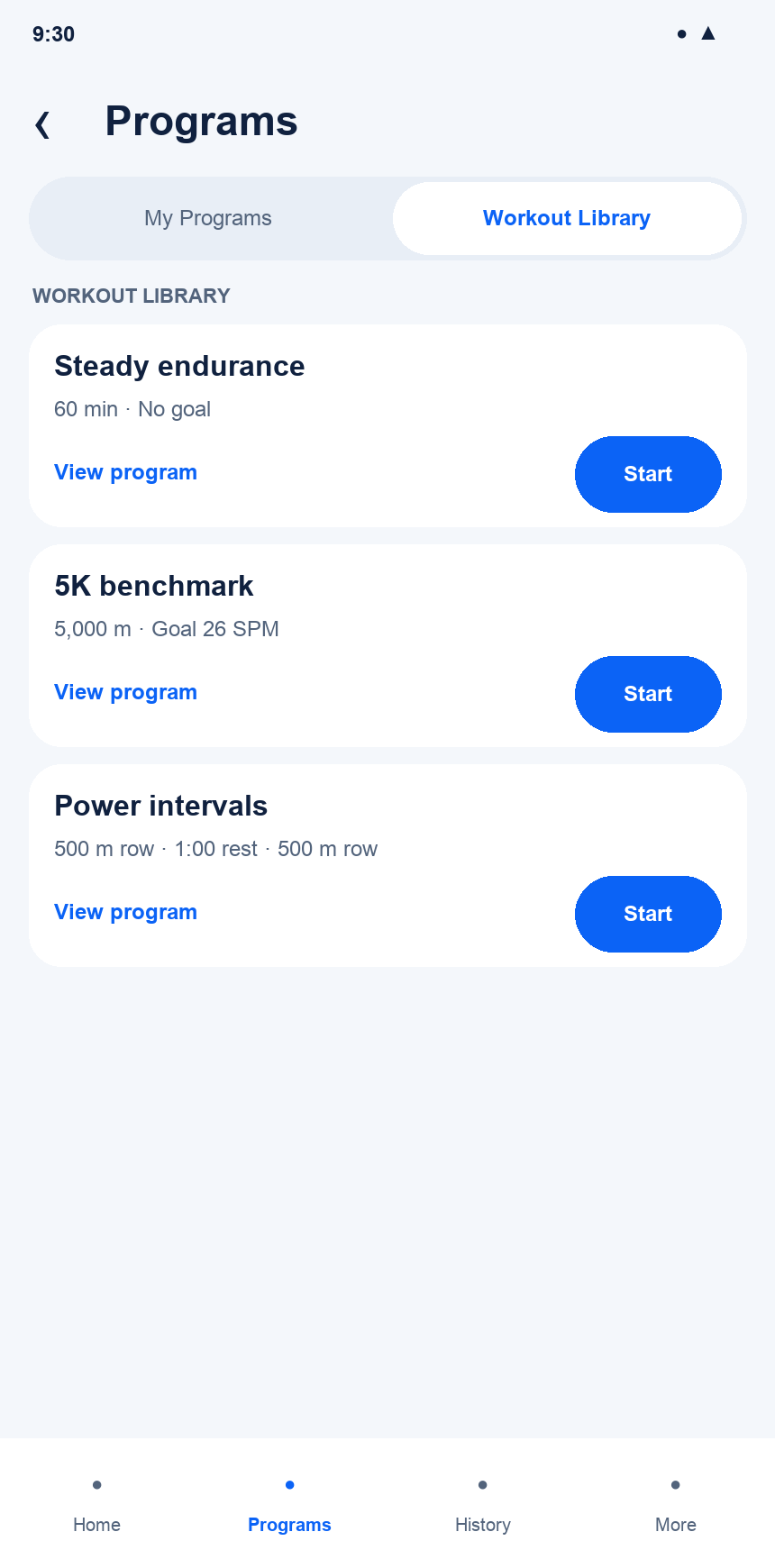
Current v2.0 state: Workout Library

Interaction changes
- Library uses the same compact cards.
- Curated items are read-only and omit Create Program and management actions.

16.18 Live Row — Free
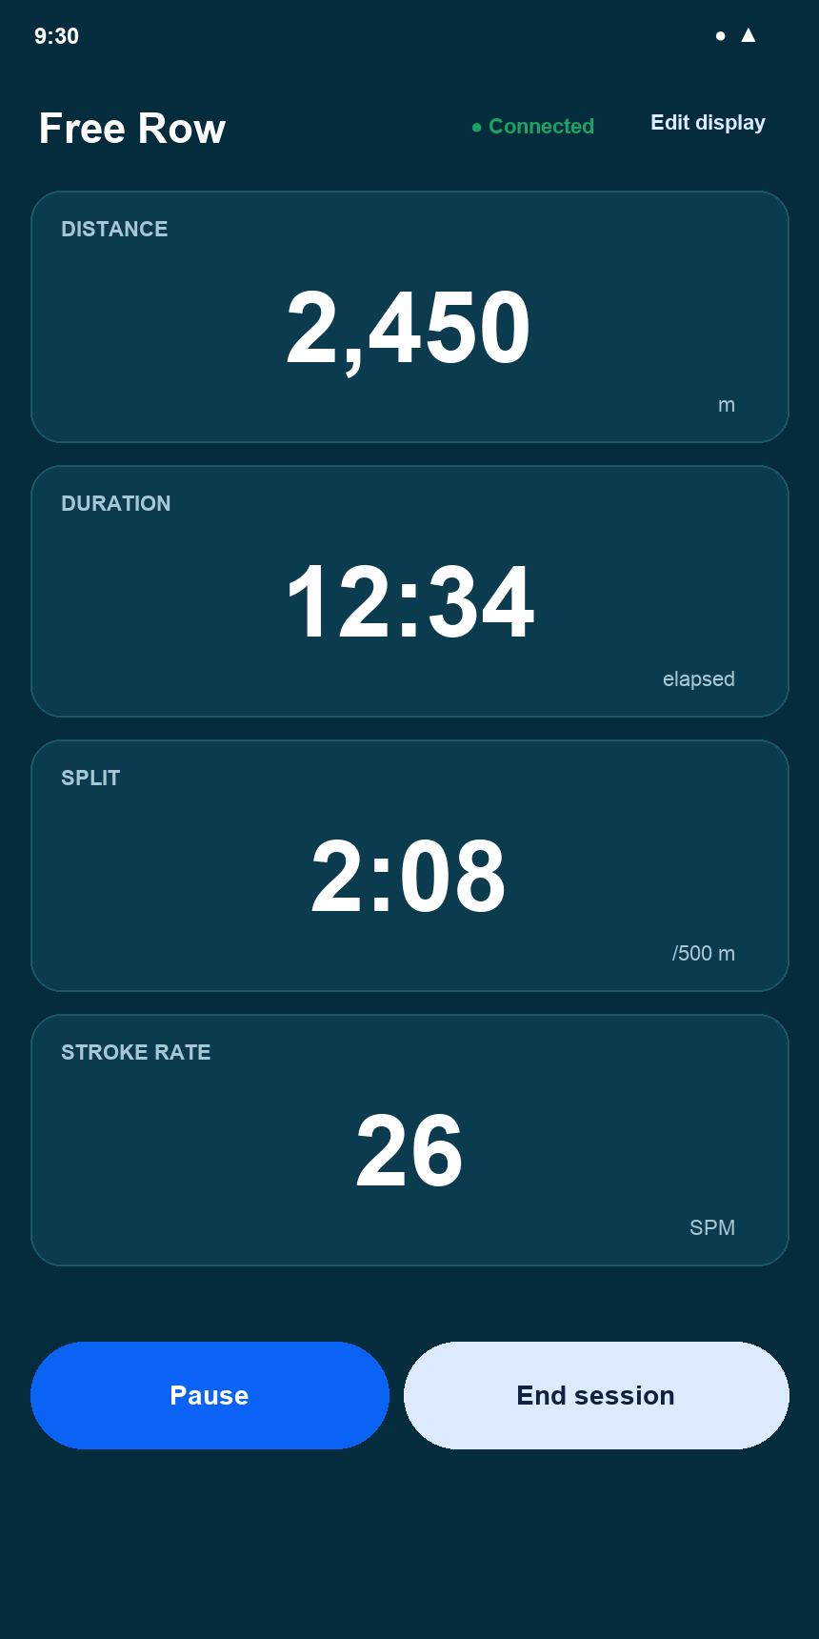
Current v2.0 state: Live Row — Free

Interaction changes
- All metric values use the same maximum readable size.
- Edit Display, Pause, and End remain available.

16.19 Live Row — Race
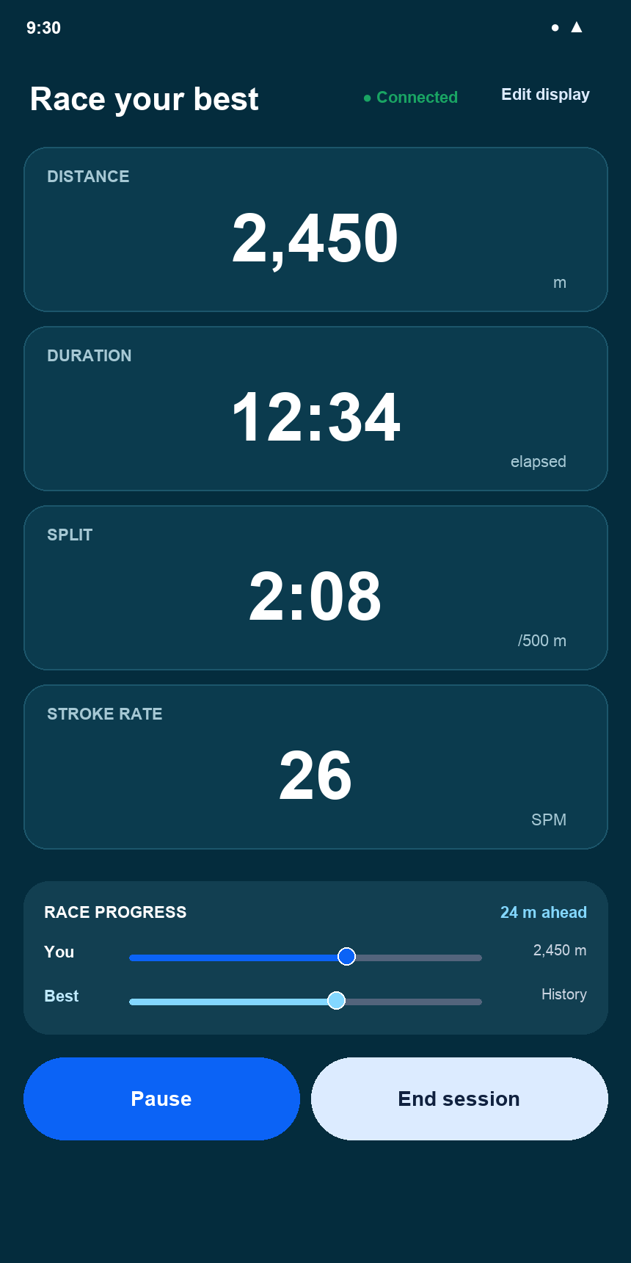
Current v2.0 state: Live Row — Race

Interaction changes
- The ordinary configurable metric slots remain unchanged. A compact panel below them shows two progress lines, You and Best, plus a text distance indicating ahead or behind.
- The saved comparison remains fixed for the session.

16.20 Program Detail — Duration
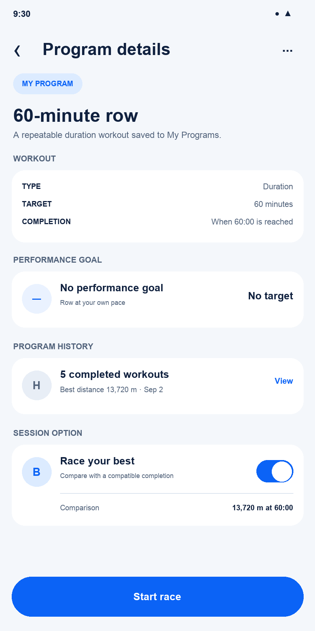
Current v2.0 state: Program Detail — Duration

Interaction changes
- Duration shows its fixed time target and completion rule without making the saved definition editable.
- History ranks a timed program by greatest distance at the fixed elapsed time.

16.21 Program Detail — Distance
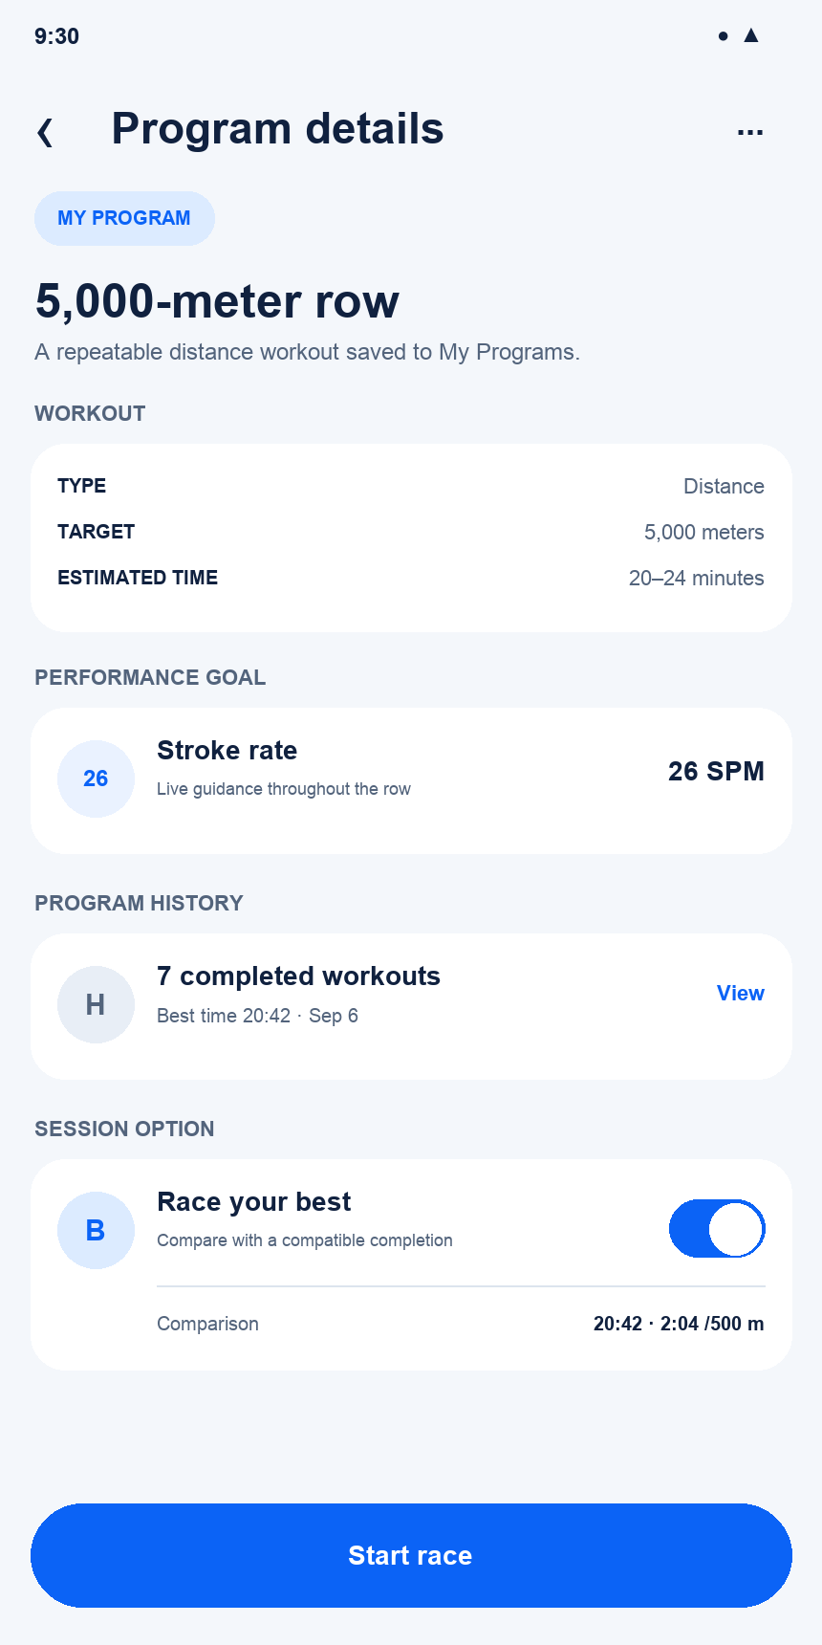
Current v2.0 state: Program Detail — Distance

Interaction changes
- Distance may show an estimated range while History ranks completions by fastest time.
- A compatible previous result enables Race Your Best.

16.22 Program Detail — Intervals
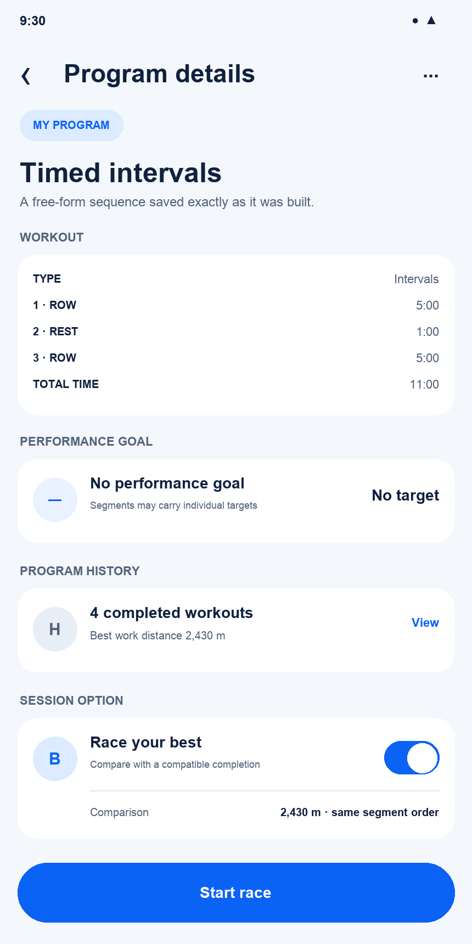
Current v2.0 state: Program Detail — Intervals

Interaction changes
- Intervals display the exact ordered Row and Rest segments saved by the free-form builder; they do not introduce rounds.
- Time-only sequences can show an exact total and rank by greatest work distance. Mixed time-and-distance sequences omit exact duration; Race Your Best requires the identical ordered segment structure.

16.23 Live Row Target — Duration
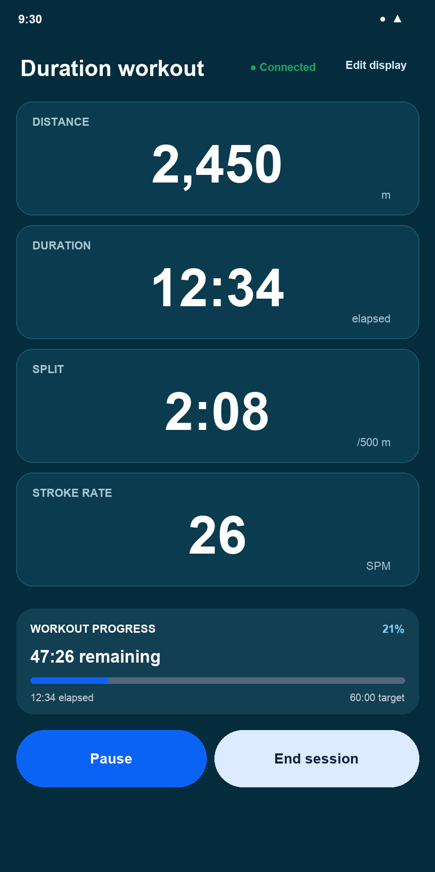
Current v2.0 state: Live Row Target — Duration

Interaction changes
- The metric grid remains unchanged while progress shows elapsed time, remaining time, and the fixed target.
- The progress panel does not consume a configurable metric position.

16.24 Live Row Target — Distance
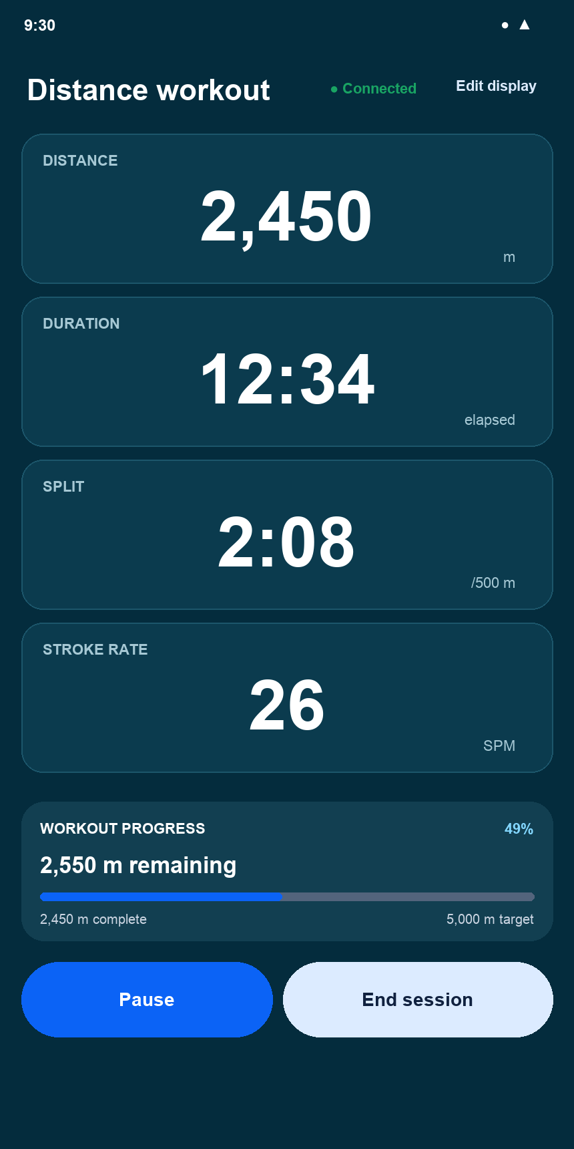
Current v2.0 state: Live Row Target — Distance

Interaction changes
- Progress shows completed meters, remaining meters, and the fixed distance target.
- All configurable metric values retain one shared maximum font size.

16.25 Live Row Target — Intervals
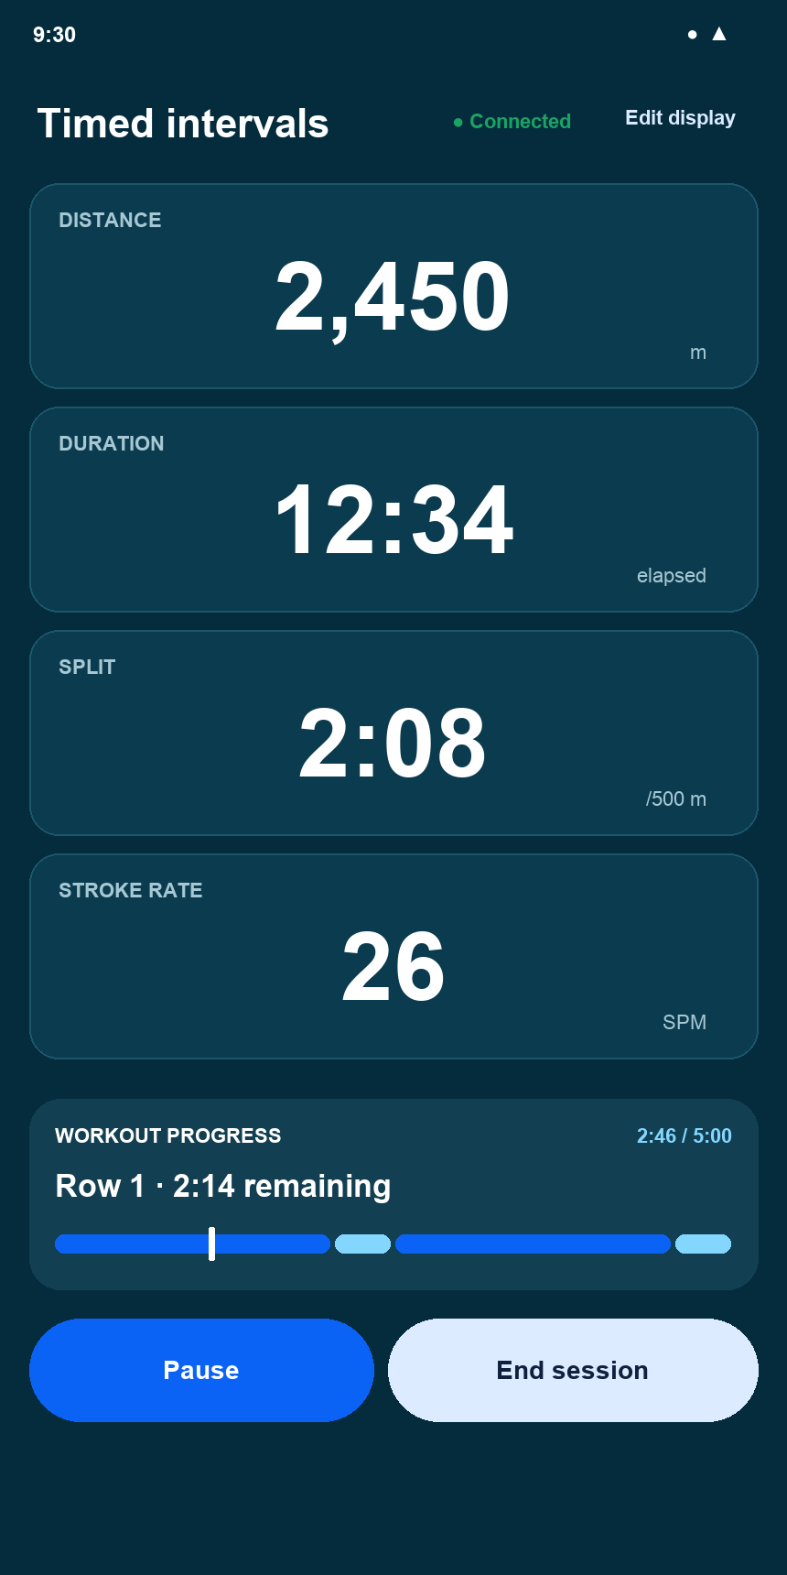
Current v2.0 state: Live Row Target — Intervals

Interaction changes
- One continuous segmented line represents the complete saved sequence. Blue sections are Row and lighter sections are Rest.
- A small marker shows current progress. The heading identifies the active segment and remaining time; the line does not repeat segment labels or durations.

16.26 Live Row Target — Stroke-rate Goal
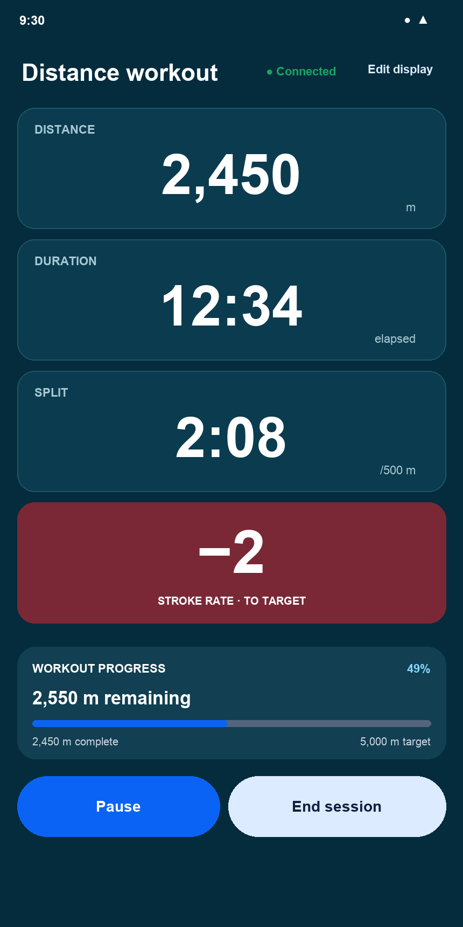
Current v2.0 state: Live Row Target — Stroke-rate Goal

Interaction changes
- The large -2 value is the signed difference from the stroke-rate target.
- The entire card uses the below-target red state and is labeled Stroke Rate · To Target. The current reading is not repeated in this card.

16.27 Live Row Target — Speed Goal
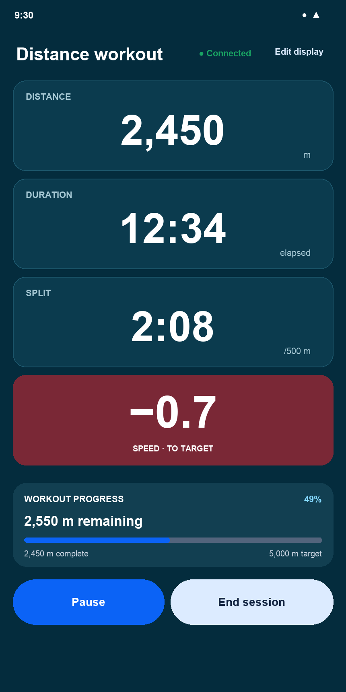
Current v2.0 state: Live Row Target — Speed Goal

Interaction changes
- The large 13.8 km/h value is current speed.
- The card shows only the signed speed variance and is labeled Speed · To Target. Its full background communicates whether the target is being met.

16.28 Live Row Target — Power Goal
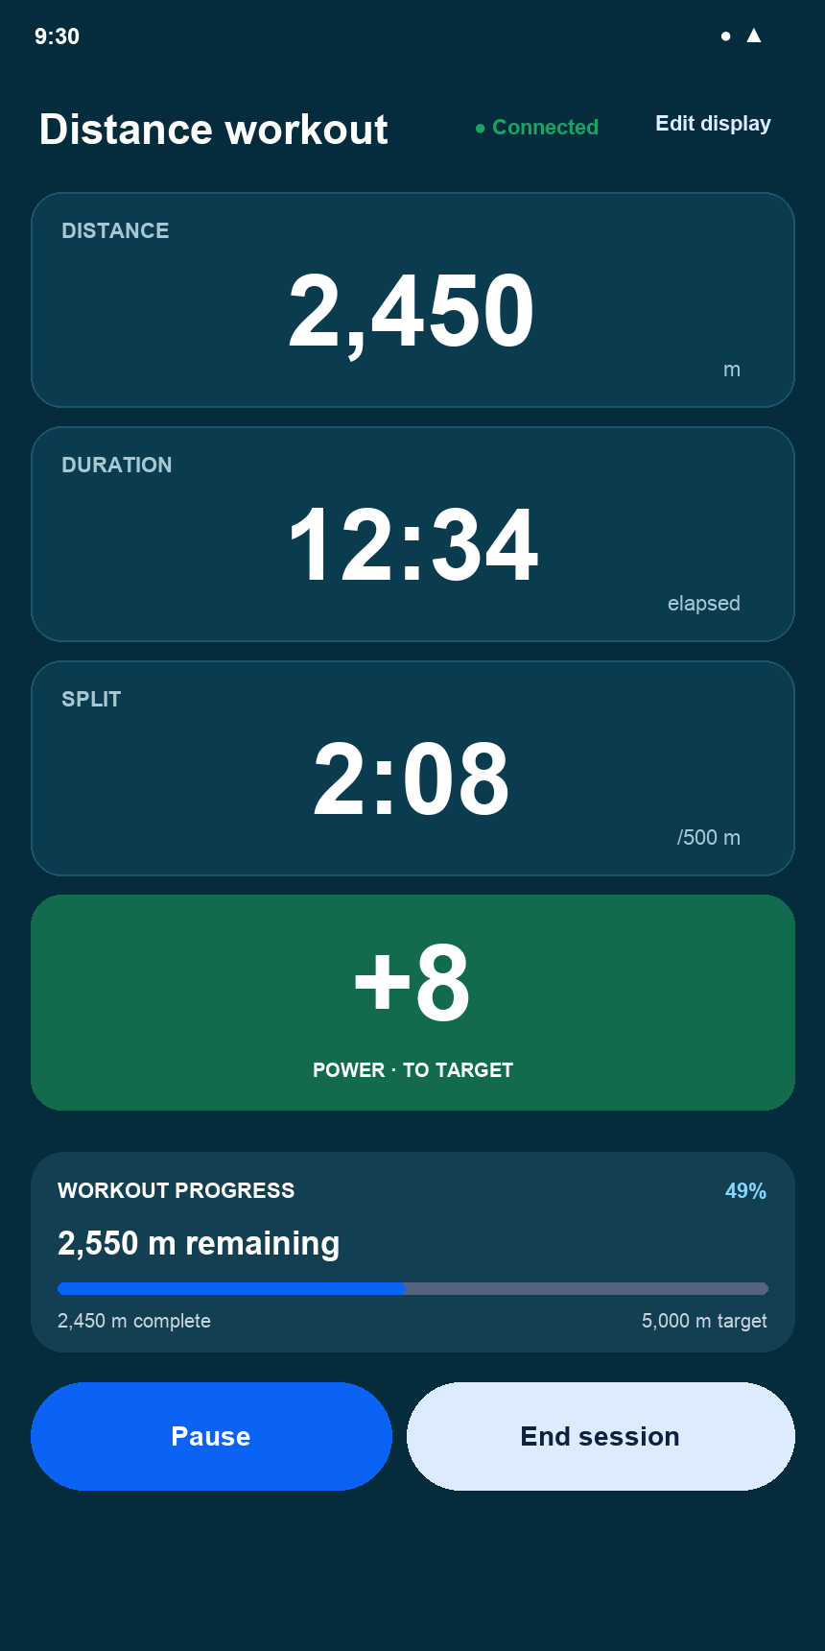
Current v2.0 state: Live Row Target — Power Goal

Interaction changes
- The large 188 W value is current power.
- The card shows only the large +8 power variance. Its full green background indicates that the target is being met or exceeded.

16.29 Live Row Target — Interval Rest
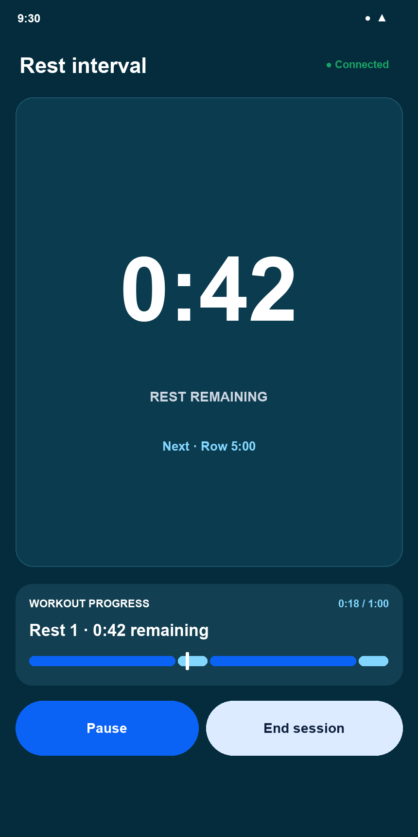
Current v2.0 state: Live Row Target — Interval Rest

Interaction changes
- When a Rest segment begins, the configurable metric grid becomes a large countdown for the remaining rest time.
- The next Row segment, segmented sequence line, current-position marker, Pause, and End session remain visible.

16.30 Race Reference Picker
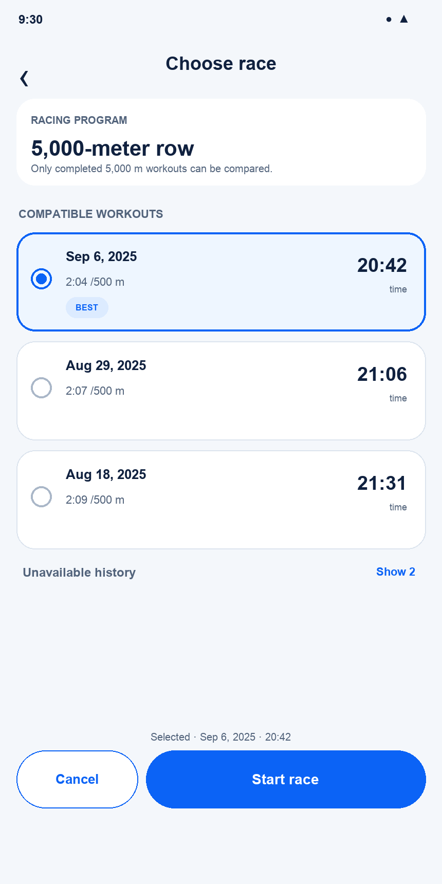
Current v2.0 state: Race Reference Picker

Interaction changes
- The screen shows only completed workouts compatible with the current program definition.
- The best compatible result is selected by default, while any listed result can become the fixed race reference.
- Result values adapt by program type: fastest time for distance, greatest distance for duration, and the correct work result for an identical interval sequence.
- Unavailable History is collapsed by default and explains each target or structure mismatch when opened.
- Start Race opens Live Row Race with the selected historical snapshot; Back and Cancel return without changing the reference.

17 v2.0 Consolidated Decisions
- Designed screens: Home, Quick Duration, Quick Distance, Quick Intervals, Segment Entry, Program Builder, My Programs, Workout Library, Program Detail / Start, Race Reference Picker, Live Row Free, Live Row Target, and Live Row Race are represented in the atlas.
- Rowing distances: Presets are 500 m, 1K, 2K, 5K, 6K, and 10K. Direct entry supports other distances.
- Segment model: A segment is Duration, Distance, or Rest. Add and Edit share the same component; Edit adds Delete.
- Race placement: Selection belongs in Workout Setup. Live Row displays comparison. Race Your Best and Set Goal are mutually exclusive.
- Terminology: Programs are reusable definitions. Workouts are active or completed sessions. Quick setup therefore uses Save as Program.
- Supersession: The v2.0 atlas replaces obsolete Quick Start labels, marathon presets, separate goal controls, and earlier interval-segment forms shown in retained figures.

Version update
v2.0 - Consolidated all designed screens into an individual-state visual atlas, documented component changes by interaction, unified quick workout and program setup, simplified interval segments to Duration / Distance / Rest, and incorporated Race Your Best across setup, reference selection, and Live Row.

18. Complete Screen Inventory
This single-page inventory is the navigation map for the product design. Current tiles correspond to individual screenshots in Section 16; placeholder tiles reserve every screen that still needs design work. Replace a placeholder with its approved screenshot as the design is completed.
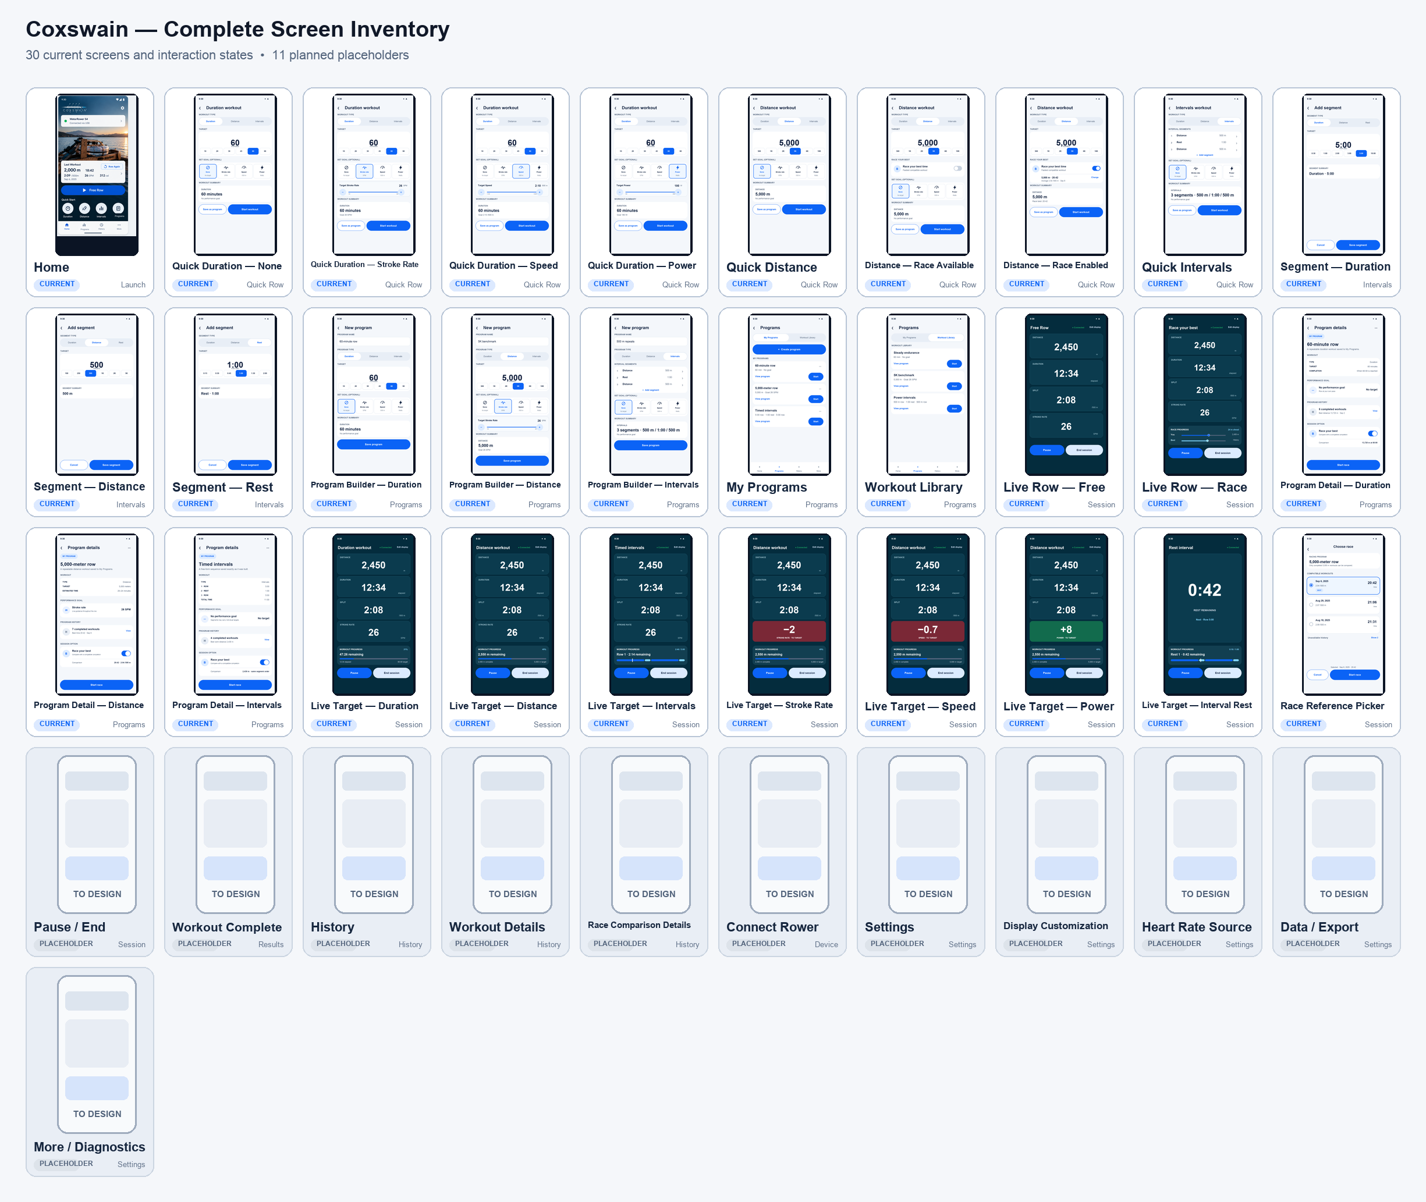
Figure 33. Complete Coxswain screen inventory: 30 current screens and interaction states, plus 11 planned placeholders.

