1. Run xampp as administrator

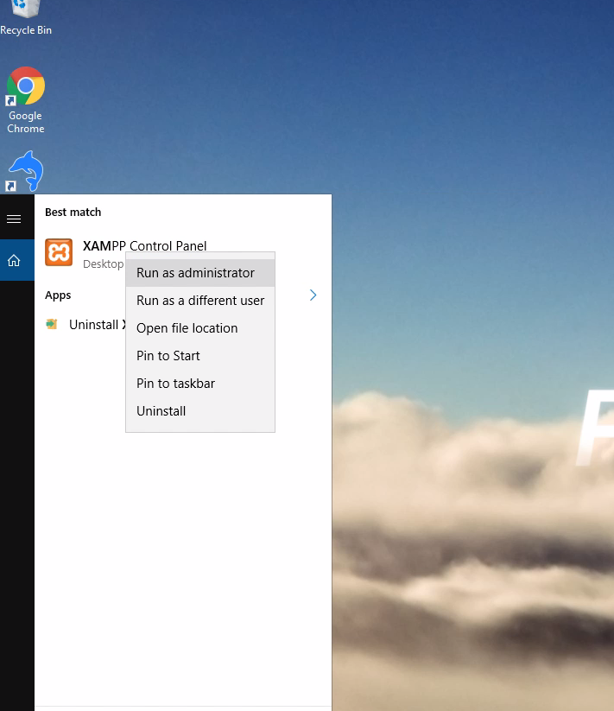

1. Run mysql as start button like below image

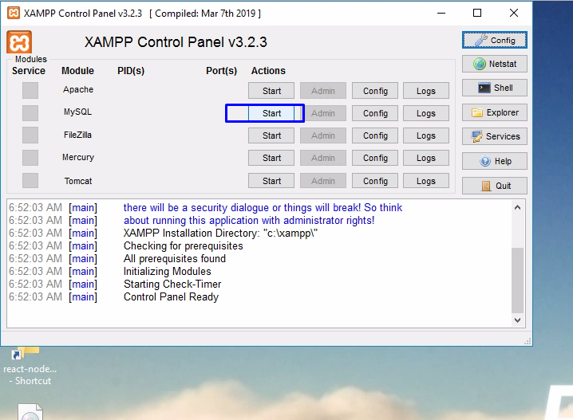

1. Go to backend/stravapy folder. And run start_python.bat

So python flask succeed as like below.

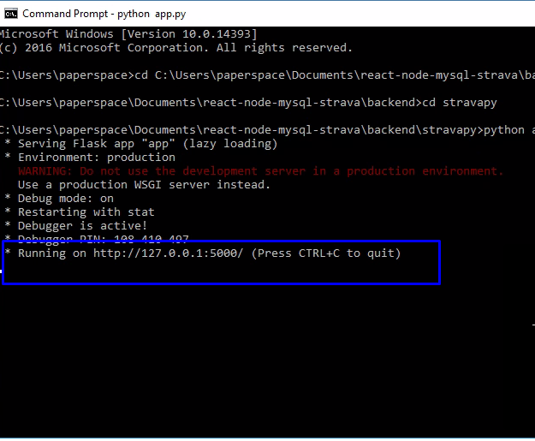

1. Then go to backend folder. Then run server.bat file
2. Go to client folder. Then run client.bat