ENEL4CB – Computer engineering design project

The Vitality Watchdog System
Phase 2 report 2026
Prepared by Orien S. Harichand (222012115)
Supervisor: Prof. T. Quazi
Project focuses:
Area/Field | Weight in project (%)
Biomedical engineering and  Instrumentation | 30
Computer Vision, Signal and Image  processing | 30
Embedded systems, IoT and edge  computing | 10
Artificial intelligence and machine learning | 10

AI declaration statement:
I, Orien S. Harichand, student number 222012115, have made use of generative AI in this report and in all instances, the content generated by AI was fully interrogated for applicability, accuracy of content, and plagiarism. Citations were added to statements where applicable, to assign credit to authors. Detailed use of all AI instances can be found in the AI appendix.
Signed: 
Date: 15 September 2026

GA assessment table:
GA | ECSA definition | Implementation | Status
1 - Problem solving | Identify, formulate, analyse, solve CEP | Researching and identifying a CEP that falls under my topic, while providing an acceptable solution and discussing other available options according to the literature sourced. | GREEN
2 - Application of scientific and engineering knowledge | Apply knowledge of math, natural science, engineering  fundamentals and an engineering speciality to solve CEP | Research into heart health metrics, Pulse-to-pulse intervals (PPI) and photoplethysmography (PPG) signals; and how heart health metrics can be extracted from PPG signals via mathematical methods and implementation of said methods to extract heart rate. Research into the relationship between stress and the heart health metrics and how leveraging machine learning models to analyse metrics can improve accuracy of stress detection of stress states in a person. | GREEN
3 - Engineering design | Perform creative, procedural and non-procedural design and synthesis of components, systems,  engineering works, products and processes | Pairing procedural signal processing (filtering and baseline-deviation rules) with non-procedural machine learning (a decision-tree HRV classifier) to process PPG waveforms, organised into a creative multi-tiered alert network featuring haptic and auditory feedback as well as local push and remote notification generation. | BLACK
6 - Professional and technical communication | Communicate effectively in oral and written mediums with engineering  audiences and community | Creation, editing and review of design report documents to be submitted for phases 1, 2 and 3 of this module, along with demonstrations to be performed and oral presentations to be held. | BLACK

Abstract
The Vitality Watchdog System is a low-cost wearable that continuously monitors heart rate (HR), breath rate (BR), and heart rate variability (HRV) from a photoplethysmography (PPG) signal, to detect dangerous physiological or stress states and automatically alert the wearer and their emergency contacts – addressing a gap in existing devices, which are either costly or lack automated alerting. A mobile application receives the PPG signal via Bluetooth Low Energy (BLE) from an optical sensor, filters motion artifacts (MAs), and classifies the wearer's state using a baseline-deviation rule and an on-device decision-tree classifier trained on the SWELL dataset; detected severe states trigger local haptic/auditory alerts and remote notifications, with no cloud dependency. This report covers Phase 2 progress: functional Bluetooth pairing with the chosen sensor (Polar Verity Sense), partial SDK feature implementation, a feasibility analysis of alert latency, sensor and component selection, and ethical testing protocols under South Africa's Protection of Personal Information Act (POPIA). Remaining work for Phase 3 includes completing stress-classification, building the haptic-cuff hardware, and validating system accuracy, latency, and false-alert rate.
Table of Contents
Abstract ii
Table of figures iii
1. Introduction 1
1.1. Conceptual Block diagram 1
1.2. Functional block diagram 2
2. The Problem 3
2.1. Problem identification 3
2.2. Requirements and specifications 4
2.3. Constraints 6
2.4. Assumptions 6
3. Literature Review 6
4. The solution 9
4.1. Proposed solution 9
4.2. Alternative solutions 9
4.3. Feasibility study of proposed solution 10
5. Analysis and design of solution 11
5.1. System design 11
5.2. Subsystem design 12
5.2.1. Subsystem 1: Signal Processing layer 12
5.2.2. Subsystem 2: Data Analysis layer 14
5.2.3. Subsystem 3: Alert and response layer 16
5.3. Target/Performance metrics 17
5.4. Feasibility of system 17
6. Overview of progress 19
7. Conclusion 20
8. References 20
AI APPENDIX a

Table of figures
Figure 1 Conceptual block diagram of system 2
Figure 2 Functional block diagram of system 3
Figure 3 Layered system architecture model 11
Figure 4 Signal processing layer flow diagram 12
Figure 5 Flow diagram representing Subsystem 2 14
Figure 6 circuit diagram for the haptic feedback cuff 16
Figure 7 GAANT chart of progress 19
Figure a AI evidence – document editing………………………………………………………………………b
Figure b AI evidence – GAANT chart generation………………………………………..……………………c
Figure c AI evidence - conceptual block diagram generation……………………………………..d

Introduction
Motivation: Individuals, particularly geriatric patients, often fail to recognize the severity of physiological stress and acute cardiac anomalies, frequently dismissing indicators such as sustained high and low heart rates. During sudden, severe cardiac events or acute distress, they may experience impaired consciousness or physical incapacitation, preventing them from manually initiating emergency calls. Delayed intervention in these critical windows significantly increases the risk of irreversible physiological damage or mortality. Furthermore, existing commercial health-monitoring solutions with continuous tracking and automated alerting capabilities remain economically inaccessible to average households, particularly within resource-constrained South African environments.
Continuous physiological monitoring systems provide critical windows for early intervention, yet current market solutions present distinct implementation gaps. High-end consumer devices incorporate continuous tracking but omit direct, automated emergency escalation to external contacts, relying instead on passive user-facing UI updates. Affordable alternative devices frequently require manual activation of monitoring sessions, failing to capture unexpected continuous physiological declines.
To bridge this gap, The Vitality Watchdog System is designed as an integrated, low-cost wearable solution engineered for non-invasive, continuous physiological tracking and automated multi-tier emergency response. Incorporating biomedical signal processing, edge computing, and local machine learning models, the system processes optical photoplethysmography (PPG) waveforms to derive heart rate (HR), breath rate (BR), and heart rate variability (HRV) metrics in real time. By deploying a personalized baseline-deviation rule alongside an on-device decision-tree classifier, the system executes continuous stress and cardiac risk stratification without reliance on cloud infrastructure. In severe or critical events, the system autonomously triggers escalating local haptic and auditory feedback alongside automated remote notification to pre-designated emergency contacts, guaranteeing immediate escalation even if the wearer is incapacitated.

Conceptual Block diagram
Below is a visual representation of how the system will work in operation. Heart rate data (for example) is streamed by the wearable sensor to the person’s mobile phone where it is processed. When an individual experiences severe cardiac issues such as a very rapid or retarded heart rate, it is regarded as dangerous and the phone displays this state, actuates a haptic feedback cuff (also worn by the individual), creates audible alarms and remotely notifies selected contacts.
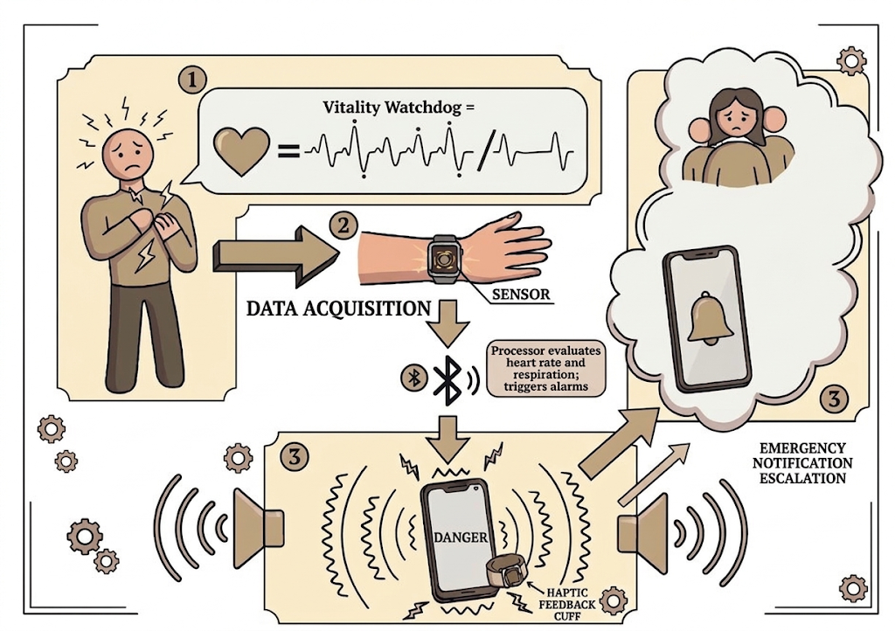
Figure 1 Conceptual block diagram of system

Functional block diagram
Below is the full functional block diagram of the system. The various functions are organised according to what hardware/device the function operates from. Full details of different aspects seen and reasoning behind the choices made can be found in the literature review, feasibility studies and system/subsystem design sections later in the report.
To summarise the diagram; a photoplethysmogram (PPG)[1] is obtained from an optical sensor and transmitted via Bluetooth to an application on the user’s mobile device. Within the application, the signal is pre-processed to remove noise, namely Motion Artifacts (MAs)[2], after which 3 different areas of calculations are performed to extract heart rate (HR), various heart rate variability (HRV) metrics and breath rate (BR). Each of these are then analysed either by detecting the deviation from the baseline or via an AI classifier to determine the stress type, and various alert mechanisms are triggered depending on this.
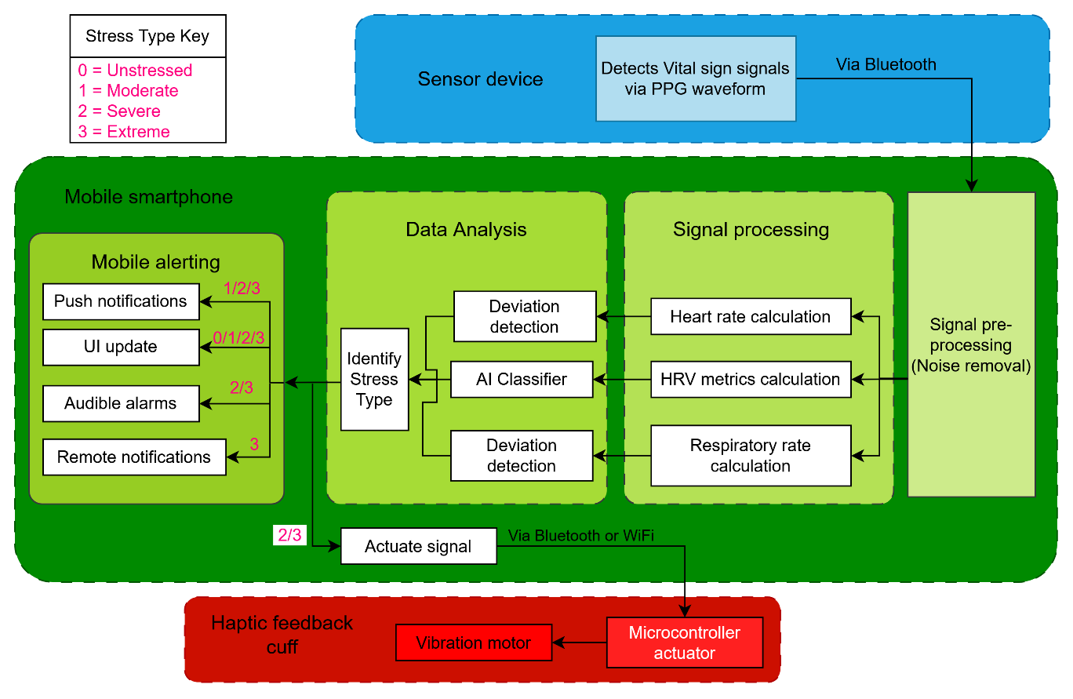
Figure 2 Functional block diagram of system

The Problem
This project is scoped to the design and implementation of a wearable heart-health and stress-monitoring system, encompassing the sensor hardware needed to acquire a PPG signal, the signal processing required to extract heart rate, breath rate and heart rate variability metrics from that signal, the analysis layer that interprets these metrics to classify a wearer’s stress state, and the alerting subsystem that notifies the wearer and their emergency contacts when a dangerous state is detected. The system does not extend to the clinical diagnosis or treatment of any cardiac or psychological condition; its role is limited to detection, classification and notification of general wellness and stress states.

Problem identification
There exist many devices that can measure heart health and detect stress levels in a person, such as the Google Fitbit Versa 4 (~R3000) [3], Garmin Vivosmart 5 (~R2500) [4], Wellue O2Ring (~R3000) [5] and Hume Band (~R4600), and others that feature subscription-based models to unlock the full benefits of the device – the Whoop band (~R6000/year for full benefits). These devices are problematic in the sense that they are far too costly for the average consumer who may require heart monitoring solutions. Cheaper options exist, such as the Polar H10 (~R1800) [6] and Polar Verity Sense (~R1600)[7], but this range of alternatives provide only a select amount of features, such as dedicated heart rate monitoring sessions that need to be manually activated. Some of the solutions that exist are bulky (the Wellue O2Ring) and can inconvenience/discomfort the user during long-term wear. Furthermore, none of the devices identified had the ability to automatically alert others when periods of high stress were detected – they simply observed and informed the user via a watch interface/mobile application that they were indicating high stress levels when.
This highlights the need for a low-cost device that performs all the functions of higher-end alternatives (continuous heart rate monitoring in a non-invasive manner [8], stress detection and mobile interface) as well as possessing the ability to automatically alert the user and others when high stress states are detected.
Detecting heart and breath rates via non-invasive means was a challenge solved with the introduction of the electrocardiogram (ECG) [9] and photoplethysmography (PPG)[1]. However, real world factors affect these readings, such as motion artifacts [1], that can hamper accuracy of readings obtained. The accuracy can be improved upon by utilizing various types of filters[1], [10] and signal processing/preprocessing [1], but at the cost of power consumption experienced by the hardware and computational overhead taken for signal processing. This indicates the need for a balance between accuracy of results obtained, the hardware (sensors/filters etc.) that is used to implement the system and signal processing algorithms employed.
Detecting stress in a person can be achieved via a plethora of approaches. Some of the non-invasive approaches include image-based detection via digital cameras[11] and via wearable health devices [12]. This project focuses on a mobility-driven approach so as to allow stress monitoring that isn’t constrained to a singular room/place and will thus focus entirely on a wearable device approach.
Relating stress to heart health metrics can be achieved by analysing heart rate variability (HRV) [13] or Pulse rate variability (PRV) [14] metrics which are derived from ECG and PPG waveforms respectively. These metrics can be derived from the respective waveforms and analysed via various methods, which can be grouped into 2 categories – machine learning and algorithmic approaches[15], [16], [17], [18], [19], [20], [21] , with each approach and method offering different trade-offs. Machine learning approaches typically offer higher predictive accuracy, whereas algorithmic approaches provide deterministic, transparent calculations. Machine learning workflows require higher computational resources and training data, while algorithmic methods deliver low-latency and computationally efficient processing suitable for real-time edge devices, but remain more sensitive to motion artifacts and signal noise. This presents a further balance that is required between accuracy and computational efficiency of the system.

Requirements and specifications
Below is a table of the requirements derived from the problem statement, complex problem identification and literature reviewed further down in the report. The project specifications are derived from the requirements.
 | Requirements | Specifications
Functional | Continuous monitoring of vital signs. | Successful Bluetooth pairing to hardware sensor.
Functional | Continuous monitoring of vital signs. | Implementation of rolling buffers to store data continuously.
Functional | Computation of heart rate, breath rate and HRV metrics. | Calculated heart rate accuracy of 65% before MA mitigation.
Functional | Evaluation of heart rate/HRV metrics to classify physiological stress states. | Accuracy of stress-state evaluation of 70%.
Functional |  | Identification of elevated sustained heart rates for 5 minutes.
Functional |  | Classification of stress states into unstressed, moderately stressed, severely stressed or extremely stressed for sustained heart rates.
Functional |  | Classification of HRV-based determination of stress into no stress, moderate stress or severe stress.
Functional | Alerting the user/others nearby of heart rate/stress state | Successful UI update of heart rate and stress state.
Functional | Alerting the user/others nearby of heart rate/stress state | Push notifications to device upon detection of moderate, severe or extreme stress states.
Functional | Alerting the user/others nearby of heart rate/stress state | Remote notifications are sent out to selected emergency contacts when extreme stress states are detected.
Functional | Alerting the user/others nearby of heart rate/stress state | Successful audible alerts for 5 to 10s (seconds) upon detection of severe/extreme heart rates/stress.
Functional | Alerting the user/others nearby of heart rate/stress state | A physical feedback (haptic feedback) device is triggered for 5 to 10s upon detection of severe/extreme heart rates/stress.
Functional | Alerting the user/others nearby of heart rate/stress state | The system dispatches alerts within 60s from the moment extreme heart/stress states are determined.
Functional | Alerting the user/others nearby of heart rate/stress state | The system dispatches alerts within 10s from the moment the “alarm window” lapses for severe stress/heart rates.
Non-functional | The full system should be cost-friendly. | The prototype of the system should cost less than R2500.
Non-functional | The system must be ergonomic for users. | Majority of users (greater than 50% of people to be surveyed consider the system “comfortable to use”).

Constraints
The system will NOT diagnose any specific diseases or health conditions; it will only determine general wellness and indicate stress levels of a person.
The system will focus on heart rate, heart rate variability and breath rate metrics only.

Assumptions
The user owns a modern smartphone that has:
- Bluetooth, Wi-Fi and messaging capabilities (such as email and SMS)
- A WiFi connection or enough mobile data and/or airtime on their phone such that a message can be sent out from their phone successfully.
- A working audio speaker.
The user’s phone is kept within the broadcast range of the system’s sensor.

Literature Review
Heart rate is the most commonly used physiological marker of stress in the literature[11], [12], [22], [23], [24], [25]. It rises reliably under both physical and psychological stressors, can be sensed cheaply and continuously and many studies report a clear increase in heart rate during a stressor compared to a resting baseline [11], [12], [23], [24], [26], [27]. This has been shown using stimuli such as (but not limited to) the Stroop test[18], mental arithmetic[15] and cold-water immersion[15]. Reported classification accuracies for stressed-versus-relaxed states, using only heart-rate features and simple classifiers such as AdaBoost, discriminant-function analysis, or SVM, range from roughly 83% to 92% [22]. This confirms heart rate as a workable primary signal.
The initial detection strategy proposed for this system establishes a baseline heart-rate pattern for each person, then flags stress as a percentage deviation from that baseline. A larger deviation indicates greater stress, and a top threshold triggers a "danger" state. This approach is supported in the literature – Sacha's [13] analysis of the link between heart rate and heart rate variability shows that both measures should be interpreted relative to a person's own resting physiology, not against a single population-wide value, because the same autonomic change produces different absolute shifts depending on a person's baseline heart rate. Using continuous data from a large number of wearable users, Presby et al. showed that resting heart rate and heart rate variability follow a predictable daily rhythm for each individual. By first correcting each user's readings for their own time-of-day baseline, the researchers were able to detect and measure the size of both physical and psychological stress events in everyday conditions. Heart rate stayed measurably raised for up to 30 minutes after a high-stress work period, and for several hours after vigorous exercise [23]. Natarajan et al.'s analysis likewise shows that normal heart rate and heart-rate-variability values shift with age, sex, and time of day. This supports the case for a baseline that is personal to each user, rather than one fixed cut-off applied to everyone [28].
In terms of what percentage deviation to use, a clinical study that continuously monitored hospitalised patients found that a change of roughly 20% in heart rate or breath rate, sustained for at least 20 minutes, worked well as an “alarm window rule”[29]. It reliably picked up genuine physiological decline while ignoring short-lived noise [29]. Hospital early-warning systems such as NEWS2 give their highest deterioration score to any HR at or below 40 beats per minute (bpm) or above 131bpm; and to any BR below 8 breaths/min or above 25 breaths/min, regardless of the patient's own normal range, because at those extremes the absolute rate is dangerous on its own [30]. Therefore, the system will organise the “danger” tiers as follows: HR deviation or BR deviation between 0-14% from the baseline as “safe heart rate/breath rate/unstressed”, HR deviation or BR deviation between 15-20% from the baseline as “moderately dangerous heart rate/ breath rate /moderately stressed”, deviations greater than 20% as “severely dangerous heart rate/ breath rate/severely stressed” and heart rates lower than 40bpm/greater than 131bpm or breath rates below 8 breaths/min/greater than 25 breaths/min as “extremely dangerous heart rate/breath rate /extremely stressed”. Due to the system focusing on deployment in real-world environments (non-clinical/hospital/lab-controlled conditions), the “alarm window rule” will be shortened to 5 minutes.
Heart rate has traditionally been measured using the electrocardiogram (ECG), still the clinical reference standard for the heart's electrical activity [9]. Its wired, multi-electrode setup, however, is not practical for a device that is worn continuously[12]. Photoplethysmography (PPG) is the usual wearable alternative. It works by shining light into the skin and sensing the resulting change in reflected light caused by blood-volume changes with each heartbeat, following the Beer–Lambert law of light absorption [1]. Importantly for this project, Tsai et al. showed that pulse intervals measured with PPG correlate very strongly with the intervals measured at the same time using ECG $R^{2}=(0.9837)$. This directly supports using PPG instead of ECG for both heart-rate sensing and for computing heart rate variability afterwards [18]. Other sensing methods exist, such as ballistocardiography and phonocardiography, which sense the heart's mechanical movement or its sounds rather than its electrical or optical signal[31]. These require more complex hardware and are less developed for low-cost consumer wearables than PPG [8], which supports the choice of a PPG-based sensor for this system.
Heart rate variability refers to the small fluctuations in the time between heartbeats, and it is a well-established, non-invasive marker of autonomic nervous system activity[32]. It is usually analysed using time-domain measures such as the standard deviation of normal-to-normal intervals (SDNN), the root mean square of successive differences (RMSSD), and the percentage of successive normal-to-normal intervals differing by more than 50 milliseconds (pNN50); geometric measures taken from the histogram of RR intervals, such as the stress index; frequency-domain measures such as high-frequency (HF), low-frequency (LF), and very-low-frequency (VLF) power and the LF/HF ratio; and nonlinear measures such as Poincaré-plot descriptors, entropy, and fractal dimension [32].
In terms of method, the literature splits stress-analysis approaches into rule-based (algorithmic) and machine-learning approaches, and both appear across heart rate, heart-rate-variability, and breathing-rate studies[18], [19]. On the rule-based side, Luo et al.[19] built a purely algorithmic, weighted composite index of heart-rate-variability parameters on a wearable ECG platform. Each parameter was weighted by its known influence on stress, so no single noisy parameter could dominate the score, while keeping the computation light enough for basic wearable hardware[19]. This is a genuine fallback option if a trained classifier turns out to be too demanding for the target hardware. On the machine-learning side, Tsai et al. [18] trained a decision-tree classifier on a 34-parameter heart-rate-variability feature set drawn from the Koldijk et al. SWELL dataset[33], and validated it against psychological questionnaire scores. The model reached 99.96% classification accuracy under lab conditions, with precision, recall, and F1 all around 0.999, and was compared directly against several alternatives on related tasks: a support vector machine (79.54%), a decision tree using voice and skin-conductance data instead of HRV (92.60%), a random forest (90.01%), and a convolutional neural network (94.8%) [18]. Tsai et al.’s classifier organises stress states either no stress, moderate stress or severe stress.
All of these alternatives’ accuracies were obtained on carefully curated datasets rather than real-world wearable data. PPG is sensitive to physical movement which makes it highly vulnerable to motion artifacts in wearable applications [1]. These motion artifacts corrupt the optical signal and introduce missing data, which can lead to estimation errors in both calculated heart rate and ultra-short-term heart rate variability metrics[2]. This is why a more conservative accuracy target is chosen as 70% after mitigation of MAs and 65% before mitigation is implemented. It is also why, of the two approaches mentioned prior, the decision tree is a better consideration for this project specifically: it combines the lightest computational complexity of the machine-learning options tested with accuracy that matches or exceeds heavier alternatives.
The specification that a local alert be sent within 60s (seconds) of extreme stress identification fits with the minimum window lengths shown to give reliable ultra-short-term heart-rate-variability estimates[21]: heart rate itself can be reliably estimated within about 10s, and the full set of frequency-domain features, including the LF/HF ratio, within about 50s. This leaves a workable margin of 10s for computing features, classifying stress, and sending the alert. For severe stress, the same 10s margin is used to trigger alerts after a heart rate that differs by 20% from the baseline is sustained during the “alarm window”.
The choice to trigger 5–10 seconds of vibration feedback also fits with what is known about how reliably people notice such alerts, even under high mental or physical load - a study on driver alerting found that a vibration lasting longer than about 3 seconds was accurately noticed under all tested conditions, including high-stress driving, while shorter or paused pulses were often misread [34]. The same reasoning is used for the 5-10s of audible alerts.
Taken together, this literature review establishes several criteria that an acceptable solution for this project must satisfy. It must be low-cost and non-invasive, since consumer affordability was identified as a key gap in existing devices; it must sense heart-related metrics using a wearable-compatible modality (PPG rather than ECG) while addressing PPG’s known susceptibility to motion artefacts; it must classify stress relative to a personalised baseline rather than a single population-wide threshold, since resting heart/breath rate and HRV vary meaningfully between individuals; it must perform signal processing and classification locally on-device rather than relying on a cloud connection, avoiding the added latency, connectivity dependence and privacy risk of transmitting continuous physiological data off-device; and it must meet defined accuracy and timing targets (heart/breath rate accuracy of 65-70% and stress-classification accuracy of at least 70%, and alert dispatch within 60 seconds of a dangerous state being identified) that remain achievable within the computational constraints of a mobile device. These criteria, derived directly from the gaps and trade-offs identified above, inform the requirements and specifications already established and the solution proposed in the following section.

The solution

Proposed solution
The proposed solution is a low-cost, wearable heart-health and stress-monitoring system built around a PPG sensor, a mobile application, and a wireless haptic feedback cuff. The PPG sensor is worn continuously and streams optical waveform data over Bluetooth Low Energy to the companion mobile application, which performs signal processing to extract heart rate, breath rate and heart rate variability metrics from the incoming signal. These metrics are passed to a lightweight decision-tree classifier running on the mobile device, which determines the wearer’s current stress state using both a personalised heart-rate-deviation-from-baseline rule and the classifier’s HRV-based assessment. Depending on the severity of the detected state, the system escalates its response: moderate stress states trigger a push notification to the user via the mobile application, while severe or extreme states trigger audible alerts from the phone’s speaker and haptic feedback from the wearable cuff, and for the most dangerous states, automatic remote notifications are sent to the user’s pre-selected emergency contacts. This tiered response is intended to keep the wearer informed of their own state while ensuring that, in a genuine emergency, help can be summoned even if the wearer is incapacitated or unable to act themselves.

Alternative solutions
While the proposed solution uses PPG as its sensing modality, alternative sensing technologies could achieve comparable heart-monitoring capability. Chest-worn ECG straps provide the clinical-reference electrical signal directly and are less susceptible to motion artefacts than PPG sensors, but require multi-point electrode contact and a chest-strap form factor that is less comfortable for continuous, all-day wear than a wrist- or finger-based PPG sensor. Ballistocardiography and phonocardiography, which sense the heart’s mechanical motion or acoustic signature respectively, are further non-invasive alternatives, but require more specialised hardware that is not yet mature for low-cost consumer wearables. On the software side, an alternative to a locally-run mobile application would be a cloud-based analysis pipeline, where raw PPG data is streamed to a remote server for processing and classification. This would allow more computationally demanding models to be used, but introduces a dependency on network connectivity that undermines the system’s reliability during an emergency, along with additional latency and privacy considerations around transmitting continuous physiological data off-device. Alternative alert mechanisms considered include continuous audible-only alerting without haptic feedback. Audible-only alerting risks being missed in noisy environments or by users with hearing impairments, both of which motivated the combined haptic-and-audible approach adopted in the proposed solution.

Feasibility study of proposed solution
The feasibility of the proposed solution rests on three considerations: the sensing approach, the computational approach, and the suitability of the training data used for the stress classifier. Regarding sensing, PPG hardware is inexpensive, already miniaturised for wearable form factors, and well supported by literature describing extraction of heart rate, breath rate and HRV metrics from its output, making it feasible to implement without specialised fabrication or clinical-grade hardware. Regarding the computational approach, a decision tree was selected because it has been shown to achieve accuracy exceeding heavier machine learning alternatives such as random forests and convolutional neural networks, while remaining light enough to run locally on a mobile device rather than requiring a cloud inference service. This directly satisfies the project’s cost and continuous-monitoring requirements, since it removes the need for a persistent network connection or additional server infrastructure, and keeps physiological data on-device. Regarding training data, the decision tree classifier used in this project is trained on the SWELL knowledge-work dataset, which was collected from participants performing realistic desk-based work tasks under controlled stressors (time pressure and interruptions) while HRV and other physiological signals were recorded. While SWELL was not collected in South Africa specifically, the autonomic stress response that the dataset captures through HRV is not population-specific in the way that, for example, cultural or dietary factors might be: the classifier is trained on the same category of features (time-domain, frequency-domain and nonlinear HRV parameters) that this project also derives from its own PPG-based pipeline, rather than on population-specific absolute baseline values. This makes SWELL a reasonable, cost-free training source for validating the general decision-tree approach. The system’s own personalised baseline heart-rate-deviation method is retained specifically to correct for any individual or population-level differences in resting physiology that a dataset collected elsewhere may not fully capture, which supports the feasibility of deploying a SWELL-trained classifier within a South African context without requiring locally-collected training data before a working prototype can be built.

Analysis and design of solution

System design
At a system level, the Vitality Watchdog is organised into three layers (as seen in the figure hereafter): a signal processing layer that converts the raw PPG waveform into heart rate, breath rate and heart rate variability metrics; a data analysis layer that evaluates these metrics using both a personalised baseline-deviation rule for HR/BR and a decision-tree classifier for HRV-based stress classification; and an alert subsystem that escalates the wearer’s classified state into the appropriate user-facing or remote notification. The decision tree was selected over other machine-learning approaches discussed in the Literature Review as it offers accuracy competitive with heavier models while remaining lightweight enough to run locally on a mobile device, avoiding the latency, connectivity dependence and privacy concerns of a cloud-based inference approach.
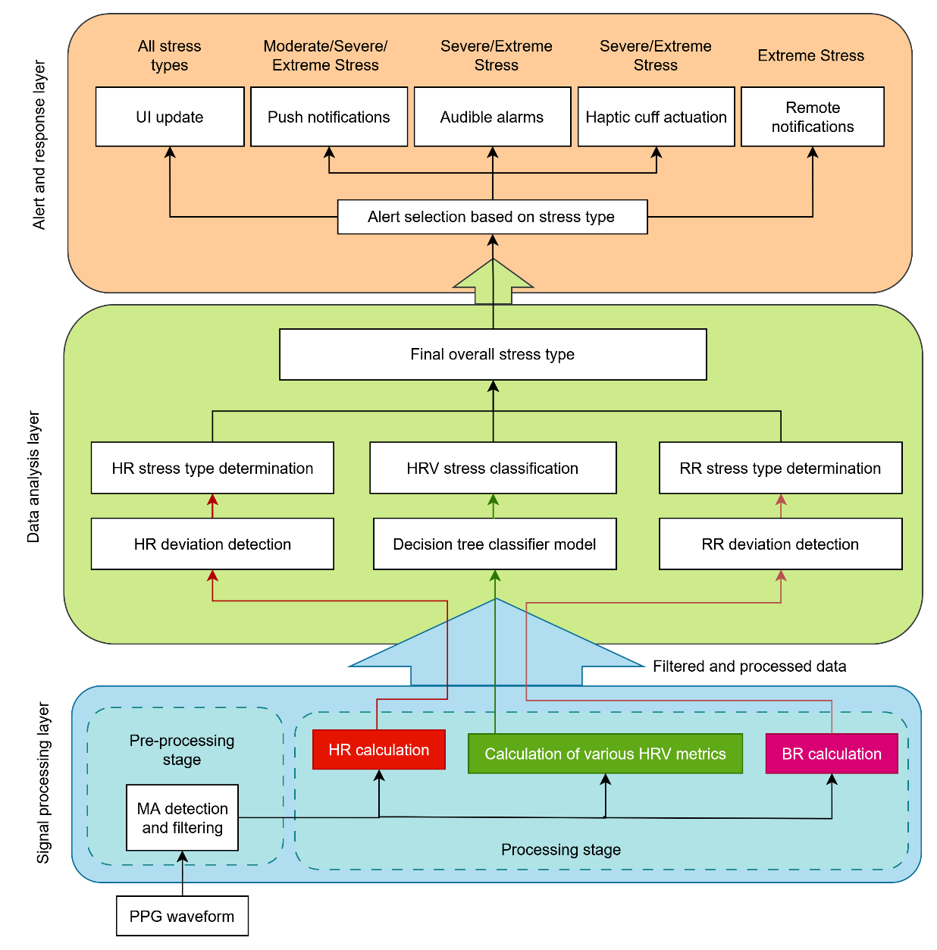
Figure 3 Layered system architecture model

Subsystem design

Subsystem 1: Signal Processing layer
This subsystem converts data made available by the wearable sensor into the outputs required by the data analysis layer: heart rate, heart rate variability metrics, and breath rate. The intended hardware choice is a Polar verity sense[7] – the full justification can be found in the system feasibility further in the report. This subsystem is structured around two concurrent data paths (as seen in the figure below) sourced from the sensor's online streaming service[35], reflecting a deliberate design choice to apply custom signal processing where it adds value and to rely on a validated existing solution where reimplementation would not.
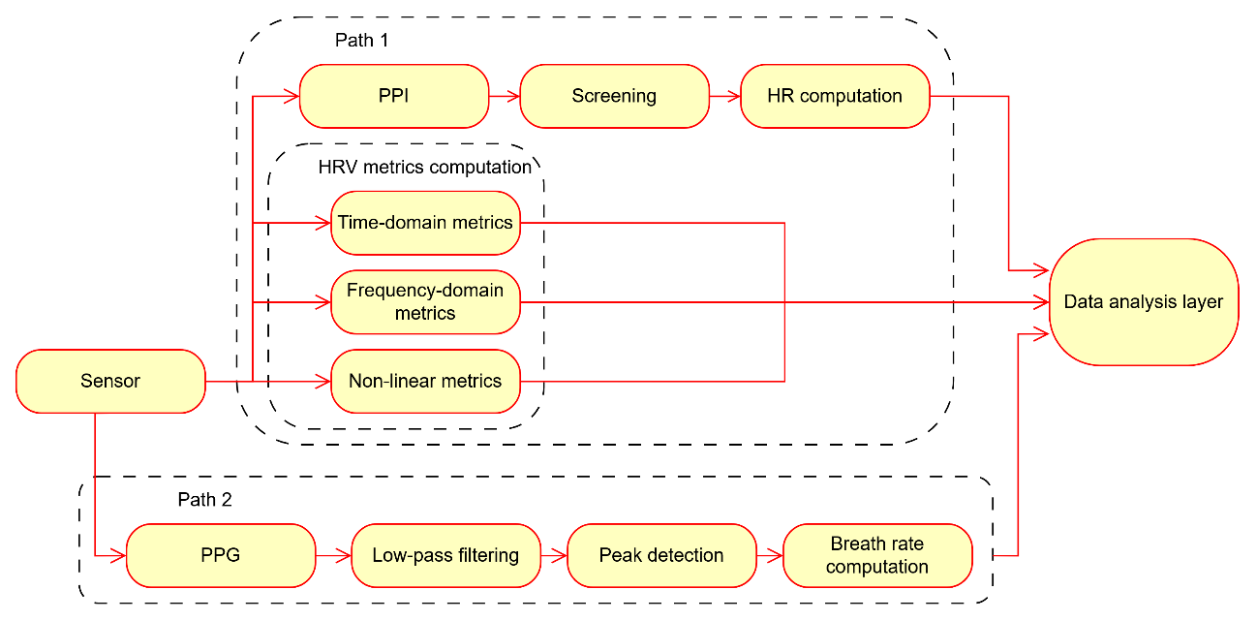
Figure 4 Signal processing layer flow diagram
Path 1 – Pulse-interval acquisition for HR and HRV. The sensor's online streaming interface exposes a pulse-to-pulse interval (PPI) stream, derived on-device from the optical PPG signal using the manufacturer's own validated extraction algorithm [35]. Rather than duplicating pulse detection – a problem already solved and certified against reference instrumentation by the sensor manufacturer – this subsystem consumes the PPI stream directly, reserving custom development effort for the parts of the pipeline the hardware does not provide natively. Each interval is screened before use: intervals corresponding to a physiologically implausible instantaneous heart rate (below 40bpm or above 131bpm, per the danger thresholds established in the literature review) are tracked and rejected as motion artefacts if not sustained [2]. Instantaneous heart rate is computed as:
$HR =\frac{60,000}{PPI}$bpm (1)
(with PPI in ms), and the reported value over a window is the arithmetic mean of accepted instantaneous values[1].
Path 2 – Raw PPG acquisition for breath rate. The same online streaming service supplies raw PPG concurrently [35]. Breathing modulates the PPG signal in three known ways: respiratory-induced intensity variation (baseline/DC shift), amplitude variation, and frequency variation (via respiratory sinus arrhythmia) [10], [36], [37]. This subsystem extracts the intensity-variation component by band-pass filtering the raw PPG signal into the 0.1Hz–0.5Hz band in which normal breathing occurs (6–30 breaths/min) [10], [36], [37]. A fourth-order Butterworth filter is used for this band-pass stage, consistent with the filter order and near-identical cut-off frequencies reported in PPG-derived respiration literature [10], [36]; the Butterworth response is chosen for its maximally flat passband, which preserves the relative amplitude of the extracted respiratory waveform rather than distorting it with passband ripple. The filter is implemented as a cascade of two second-order sections, since a direct-form fourth-order implementation is numerically unstable at cut-off frequencies this low relative to the sensor's sampling rate. Each second-order section takes the standard digital form:
$y[n]=​b_{0}x[n]+b_{1}​x[n-1]+b_{2}​x[n-2]-a_{1}​y[n-1]-a_{2}​y[n-2]$ (2)
with coefficients $b_{k}$​, $a_{k}$ obtained by applying the bilinear transform to the analog Butterworth band-pass prototype for $f_{low}=0.1$Hz and $f_{high}=0.5$Hz, at the sensor's PPG streaming rate. Peaks in the filtered respiratory waveform are detected using the event-related moving-average algorithm of Elgendi et al. [37], applied here to the respiratory waveform. Breath-to-breath interval $T$(s) yields breath rate
$BR=\frac{60}{T}​ (breaths / min)$ (3)
reported as a windowed average with the same implausible-value rejection applied to HR, with the minimum and maximum values used being 8 and 25 breaths/min, respectively
HRV computation: The accepted pulse-interval series from Path 1 feeds HRV computation across three domains [16], [18], [32]: Time-domain (meanNN, SDNN, RMSSD, NN50/pNN50, SDSD, and relative measures normalised against meanNN); Frequency-domain (VLF, LF, HF power, normalised LF/HF, LF/HF ratio); Nonlinear (Poincaré SD1/SD2, ApEn, SampEn, DFA scaling exponents). Details of these calculations can be found in Malik et al.’s paper [38]. Because RR intervals are not evenly sampled in time, frequency-domain estimation requires interpolating the interval series onto a uniform time base before spectral analysis can be applied[38].
Sampling rate and window size: Because PP-interval extraction for HR is performed by the sensor's own validated algorithm rather than by peak detection on raw samples within this subsystem, the timing precision of each interval is fixed upstream and is not sensitive to this subsystem's own processing choices. For the respiratory path, the target band (0.1Hz–0.5Hz) requires a Nyquist minimum under 1Hz, which the sensor's default PPG streaming rate exceeds comfortably [35]; sampling rate is therefore not a limiting factor for respiratory extraction. Window size remains the binding constraint on HRV quality: heart rate and time-domain HRV parameters are reliable from ~10s windows [20], while frequency-domain parameters – particularly LF power – need ~50s or longer to capture enough low-frequency cycles without spectral leakage [20]. A sliding, overlapping window update is used so metrics refresh faster than the window length itself, and windows containing artefact-corrupted or missing samples are handled by pulse rejection, since including them introduces significant error into ultra-short-term HRV estimates [2].

Subsystem 2: Data Analysis layer
This layer provides analytical services to be used by the danger alert system. It takes in the values derived (heart rate, breath rate, HRV metrics) from the signal produced by the signal processing layer and utilizes deviation rules and a lightweight machine learning model to analyse them (visualised in the figure below). A decision tree was chosen as the machine learning model as it provided high accuracies (99.96%) [18] while remaining lightweight. This project will attempt to achieve an accuracy of 70% due to majority of signal processing being done from first principles and due to the other justifications presented in the literature review.
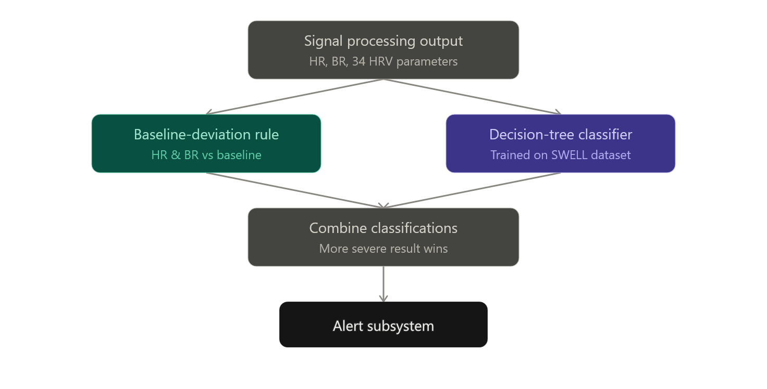
Figure 5 Flow diagram representing Subsystem 2
Two independent methods are implemented in this layer to determine a wearer’s stress state, matching the two categories of approach identified in the Literature Review. The first method is the personalised heart-rate-deviation-from-baseline rule. A resting baseline heart rate, ${HR}_{baseline}$ (measured in beats per minute, bpm), is established for each user during an initial calibration period and is periodically updated to account for gradual physiological change over time. The time taken to record a resting baseline heart rate is 5 minutes, informed by the standard physiological benchmark set by Malik et al [38] to accurately calculate and determine stable average resting heart rate values and to accurately calculate time/frequency-domain metrics used for HRV calculations.
For each new heart rate reading, ${BR}_{current}$ (bpm), the percentage deviation from baseline, D (measured in %), is calculated as:
$D = \left(\frac{ \left|{HR}_{current}- {HR}_{baseline}\right|}{{HR}_{baseline}}\right)× 100$. (4)
Following the danger tiers established in the Literature Review, a deviation sustained for the 5-minute alarm window is classified as: 0–14% – safe/unstressed; 15–20% – moderately dangerous/moderately stressed; and greater than 20% – severely dangerous/severely stressed. Independently of this deviation calculation, any valid instantaneous heart rate below 40bpm or above 131bpm is classified directly as extremely dangerous/extremely stressed, since at those extremes the absolute heart rate is dangerous regardless of the wearer’s personal baseline. This method is fully algorithmic and deterministic: it requires no training data and produces the same classification for the same inputs every time, which keeps it computationally lightweight and easy to verify.
For breath rate deviation, the exact same process and calculations are used but with the breath rate instead of heart rate:
$D = \left(\frac{ \left|{BR}_{current}- {BR}_{baseline}\right|}{{BR}_{baseline}}\right)× 100$ (5)
where ${BR}_{current}$ = current breath rate and ${BR}_{baseline}$= resting baseline breath rate.
The same danger tiers previously established are used, with the same stress classifications. Independent of deviation calculations, any valid instantaneous breath rate below 8 or above 25 breaths/min is classified as extremely dangerous/extremely stressed, similar to absolute extreme heart rates.
The second method is a decision-tree classifier, trained offline on the 34 HRV parameters described previously, that determines whether the wearer is in a state of no stress, moderate stress or severe stress. A decision tree makes its classification by asking a sequence of yes/no questions of the form “is parameter X above threshold T?”, arranged as a binary tree: starting at the root node, each new set of HRV parameter values is compared against the threshold stored at that node and directed to the corresponding child node, and this process repeats until a leaf node is reached. Each leaf node stores a class label (no stress, moderate stress or severe stress), which becomes the model’s output for that input. The tree structure and thresholds are not hand-designed; they are learned from labelled training data (the SWELL dataset, as discussed in the Feasibility study) using a recursive splitting algorithm. At each node, the algorithm considers every candidate (parameter, threshold) pair across the 34 HRV parameters and selects the split that produces the greatest reduction in class impurity between the parent node and its two children. Impurity at a node is commonly measured using the Gini impurity:
$Gini = 1 - Σ p_{i}²$ (6)
where $p_{i}$ is the proportion of training samples at that node belonging to class i, and the sum is taken over all stress classes present (no stress, moderate stress, severe stress). A node containing only one class has a Gini impurity of 0, while a node with an even mix of classes has a higher impurity value. The algorithm selects, at each node, the split that minimises the weighted average Gini impurity of the resulting child nodes and repeats this process recursively on each child until a stopping condition is reached (a maximum tree depth, a minimum number of samples remaining at a node, or a node containing only one class). This recursive splitting is what allows the tree to separate stress classes using combinations of HRV parameters rather than any single parameter alone. Because classification only requires following a path from the root to a leaf, comparing one parameter against one threshold at each node, inference time scales with the depth of the tree rather than the size of the training set. This is what allows the classifier to run locally on a mobile device in real time, supporting the feasibility argument regarding computational cost.
The outputs of the two methods are combined conservatively: the alert subsystem is passed whichever of the two classifications is more severe, so that either a large, sustained heart/breath-rate deviation or a decision-tree-flagged stress state is sufficient to trigger the corresponding alert tier. This redundancy is intended to reduce the chance that a genuine dangerous state is missed because only one of the two methods detected it.

Subsystem 3: Alert and response layer
This subsystem deals with human-machine-interaction. It provides the ability to inform the user of their stress state that is determined by the data analysis layer. It fulfils its functions by first notifying the user (via push notifications from the mobile application) of their stress state when they are determined to be moderately stressed. When they are detected to be severely stressed, however, this subsystem will provide physical and auditory feedback to the user. Auditory feedback is given through the user’s device’s phone speakers and physical feedback is provided by a haptic feedback cuff that incorporates a 5V vibration motor integrated module, a 5V coin cell battery to provide power to the circuit, a MOSFET switch and a microcontroller to detect the incoming signal and trigger the vibration motor module through the switch, which can be visualised in the circuit diagram below.
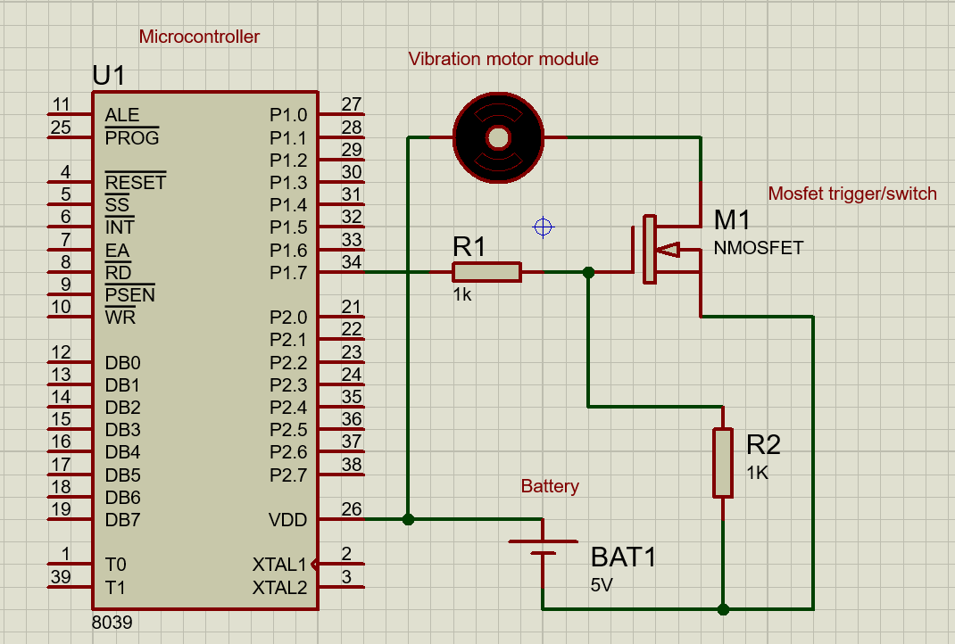
Figure 6 circuit diagram for the haptic feedback cuff
Communication between the mobile application and the wearable haptic cuff is handled over a short-range wireless link, established once when the cuff is first paired with the user’s phone and maintained automatically thereafter. Bluetooth and Wi-Fi are considerations for this link. Once a severely or extremely stressed state is classified by the data analysis layer, the mobile application transmits a short alert-tier message over this link to the wearable microcontroller, which drives the vibration actuator on the cuff for the specified duration. For remote notifications, the same mobile application instead uses the phone’s existing cellular or Wi-Fi internet connection to reach the user’s pre-selected emergency contacts once an extreme stress state is detected, since this requires reaching contacts who are not necessarily nearby.
Two general categories of vibration actuator were considered for the cuff: eccentric rotating mass (ERM) motors, which spin an offset weight to produce vibration, and linear resonant actuators (LRA), which oscillate a mass along a single axis. An LRA-type actuator is favoured for this design, as this category of actuator starts and stops vibrating more quickly than ERM motors, which better suits the short, discrete 5–10 second alert pulses specified for this system, and this category is also generally more power-efficient at the vibration frequencies used for haptic alerting [39]. Since this project is not focused on core electronic circuit design, an integrated module (with drivers and protective circuitry) is a stronger implementation choice as opposed to designing all circuitry from first principles.

Target/Performance metrics
In addition to the heart- and breath rate accuracies of 65-70%, HRV-based stress classification accuracy of 70% and alert-timing specifications previously noted, the following metrics are used to evaluate the system:
- End-to-end alert latency, defined as the time between a dangerous state being classified and a push notification reaching the user, targeted at under 60s
- False-alert rate, the rate at which alerts are triggered with no genuine dangerous physiological event present. The performance of Koldijk et al.’s model [33] can be translated to achieving a false-positive stress rate of 25-35% when considering standalone physiological features in non-clinical controlled settings; therefore this project will aim for a maximum false-alert rate of 35-40%.
- Wireless-link reliability, the proportion of alert-tier messages successfully delivered from the mobile application to the wearable cuff on the first attempt.

Feasibility of system
Beyond the sensing and computational feasibility discussed in the Feasibility study of the proposed solution, the feasibility of the system as a whole is considered here in terms of alert-dispatch latency, since the wireless link between the mobile application and the wearable cuff (Subsystem 3) introduces an additional delay that must still fit within the alert-timing specifications established earlier. The total time between a dangerous state being classified and the corresponding alert reaching the user $t_total$ (measured in seconds), can be broken down into three components:
$t_total = t_process + t_transmit + t_wait$ (7)
where $t_process$(s) is the time already budgeted for signal processing and classification (Subsystems 1 and 2), t_transmit (s) is the time taken to transmit the short alert-tier message from the phone to the cuff over the chosen wireless link, and $t_wait$(s) is the worst-case time spent waiting for the next scheduled communication opportunity on that link, which is governed by the connection interval, $I_conn$(measured in seconds, s), negotiated between the phone and the cuff. Because the alert message itself is small (only a few bytes are needed to represent the alert tier and duration), $t_transmit$is negligible relative to $I_conn$, so $t_wait$≈ $I_conn$dominates the communication delay. Configuring a conservative connection interval of $I_{conn}=0.2s$ means the wireless link contributes on the order of 0.2s to the total alert latency, which is negligible compared to the roughly 10-second margin left over after signal processing and classification within the overall 60-second alert-dispatch specification (see Literature Review and Requirements and specifications). This shows that the choice between a Bluetooth-based or Wi-Fi-based link for the cuff does not threaten the system's ability to meet its alert-timing specification; either is feasible from a latency perspective, which supports selecting between them primarily on power-consumption and range grounds instead (Subsystem 3).
The optical sensor device (Polar Verity Sense) is chosen primarily for its cost factor, presenting itself as the most budget-friendly option within the list presented earlier in the report. In addition to this, Polar provides an official repository of their software development kit, that contains multiple classes and functions to interact with their sensor devices[35]; other commercial devices, such as Apple[40], [41], do not provide this level of access to their device’s firmware to the general public; limited access to heart rate values, high-level HRV metrics like SDNN, step counts, and ambient motion metrics are provided only [40]; full access is restricted exclusively to approved academic research studies and through an explicit entitlement process, and data acquisition is strictly batch-oriented – making it unsuitable for low-latency applications[40]. It should be noted that these classes and functions (particularly for the Verity Sense) do not have capabilities of directly extracting heart rate variability metrics nor breath rate from the sensor, making this sensor choice highly applicable to this project where these features are calculated from first principles. Other aspects that improved the favourability of the Polar Verity Sense over other optical sensors such as Garmin[42] are that the Verity Sense allows for upper-arm placement, which provides a much higher signal-to-noise ratio (especially due to MAs), as opposed to wrist placed devices, which Garmin watches are limited by [43]; and that the device’s form factor is more compact and lighter (weighing only 5 grams) than competitors such as Apple[41] or Garmin[4], [42], resulting in a more ergonomic design.
All of the components required for this project can be sourced locally from electronic suppliers such as Mantech Electronics/DIY electronics/RS components (vibration motor modules, resistors, microcontrollers etc.), and the polar device can be sourced from dedicated sporting retail stores (such as Sportsman’s warehouse etc.).
The ethical feasibility of evaluating the Vitality Watchdog hinges on implementing low-risk, controlled stress-induction protocols that prioritize participant safety while generating valid physiological data. Standard, ethically validated methodologies from literature include numerous ways to do this – such as the Trier Social Stress Test (TSST)[44], the Stroop color-word interference task[45], continuous mental calculations[15], mild cold pressor tests[15] or noise exposure [15] can safely induce transient autonomic arousal without causing psychological or physical harm. To conduct testing responsibly, all trial procedures should be governed by strict ethical protocols: participants must provide fully informed, voluntary consent with the explicit right to withdraw at any point without penalty. Furthermore, real-time safety monitoring must be maintained throughout testing; continuous tracking of absolute physiological thresholds (e.g., heart rate exceeding 131bpm) serves as an automated safety cutoff to terminate the task immediately if extreme stress is detected. All collected biometric streams and user personal information must be kept private and stored locally on the user’s device for this project to comply with the Protection of Personal Information Act (POPIA) of South Africa [46].

Overview of progress
Below is a visualisation of the progress thus far and what aspects of the progress are yet to be completed:
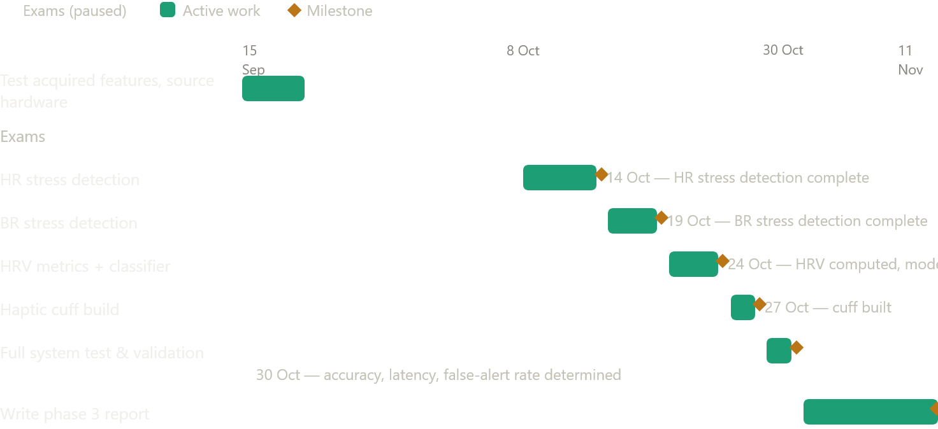

30 Oct - accuracy, latency, false-alert rate determined
Figure 7 GAANT chart of progress
The mobile application successfully builds on an android device and can detect nearby Bluetooth devices. It also pairs with a heart rate sensor recently acquired. The “Polar BLE SDK” has been acquired and some features are currently implemented yet remain untested. Further work is needed to test these and implement the remaining features to meet the other specifications of stress detection; more work is also needed on the stress detection model’s training and implementation and alert generation. Hardware components have been identified and will be acquired soon into the next phase. The project remains viable for completion within the remaining timeframe as the focus of the project now shifts towards implementation, as well as keeping within the allocated project budget.

Conclusion
Phase 2 of this project has established that a low-cost, privacy-preserving wearable capable of continuous heart-health and stress monitoring is technically feasible within the scope and budget available. The problem identification and literature review confirmed a genuine gap in the market: existing devices are either too expensive, too limited in feature scope, or lack any automated emergency-escalation capability, and the chosen combination of a baseline-deviation rule with a lightweight, dataset-trained decision-tree classifier offers a practical balance between accuracy and the computational constraints of an edge-processed, real-time system. The feasibility analysis further showed that the wireless link between the mobile application and the haptic cuff will not threaten the 60-second alert-dispatch specification, and that the Polar Verity Sense remains the most suitable sensor on cost, form-factor, and data-access grounds. Concrete progress has been made toward this design: Bluetooth pairing between the mobile application and the sensor is working, and initial features of the Polar BLE SDK integration have been implemented, though testing of these features is still outstanding. The core work remaining for Phase 3 is well defined — completing and validating heart rate and breath-rate stress detection, finishing HRV computation and classifier integration, building and integrating the haptic-cuff hardware, and carrying out full system testing to determine the achieved accuracy, alert latency, and false-alert rate against the specifications set out earlier in this report. Given the progress made and the manageable scope of what remains, the project is on track for completion within the remaining project timeframe.

References
[1] J. Park, H. S. Seok, S.-S. Kim, and H. Shin, “Photoplethysmogram Analysis and Applications: An Integrative Review,” Front. Physiol., vol. 12, Mar. 2022, doi: 10.3389/fphys.2021.808451.
[2] A. Rossi, D. Pedreschi, D. A. Clifton, and D. Morelli, “Error Estimation of Ultra-Short Heart Rate Variability Parameters: Effect of Missing Data Caused by Motion Artifacts,” Sensors, vol. 20, no. 24, p. 7122, Dec. 2020, doi: 10.3390/s20247122.
[3] “Google Fitbit Versa 4.” Accessed: Jul. 26, 2026. [Online]. Available: https://store.google.com/us/product/fitbit_versa_4?hl=en-US&pli=1
[4] Garmin and G. L. or its subsidiaries, “vívosmart® 5,” Garmin. Accessed: Jul. 26, 2026. [Online]. Available: https://www.garmin.com/en-US/p/782585/pn/010-02645-00/
[5] “Wellue O2Ring Smart Ring Pulse Oximeter. Overnight Tracking.,” Wellue. Accessed: Jul. 06, 2026. [Online]. Available: https://getwellue.com/pages/o2ring-oxygen-monitor
[6] “Polar H10 | Polar USA.” Accessed: Jul. 23, 2026. [Online]. Available: https://www.polar.com/us-en/sensors/h10-heart-rate-sensor
[7] “Polar Verity Sense | Polar USA.” Accessed: Jul. 23, 2026. [Online]. Available: https://www.polar.com/us-en/products/accessories/polar-verity-sense
[8] Q. Yong, L. Yang, A. Kardos, and Y. Zhao, “Non-invasive cardiovascular and vital signs monitoring techniques: review, challenges, and perspectives,” Measurement, vol. 258, p. 119472, Jan. 2026, doi: 10.1016/j.measurement.2025.119472.
[9] “Electrocardiogram (ECG),” nhs.uk. Accessed: Jul. 23, 2026. [Online]. Available: https://www.nhs.uk/tests-and-treatments/electrocardiogram/
[10] D. Wu, Guan-Zheng Liu, M. Y. M. Wong, and Y.-T. Zhang, “The accuracy of respiratory rate estimation using electrocardiography and photoplethysmography,” in Proceedings of the 10th IEEE International Conference on Information Technology and Applications in Biomedicine, Corfu, Greece: IEEE, Nov. 2010, pp. 1–3. doi: 10.1109/ITAB.2010.5687633.
[11] N. Molinaro et al., “Contactless Vital Signs Monitoring From Videos Recorded With Digital Cameras: An Overview,” Front. Physiol., vol. 13, p. 801709, Feb. 2022, doi: 10.3389/fphys.2022.801709.
[12] D. Dias and J. Paulo Silva Cunha, “Wearable Health Devices—Vital Sign Monitoring, Systems and Technologies,” Sensors, vol. 18, no. 8, p. 2414, Jul. 2018, doi: 10.3390/s18082414.
[13] J. Sacha, “Interaction between Heart Rate and Heart Rate Variability,” Noninvasive Electrocardiol, vol. 19, no. 3, pp. 207–216, May 2014, doi: 10.1111/anec.12148.
[14] J. S. Burma et al., “Heart Rate Variability and Pulse Rate Variability: Do Anatomical Location and Sampling Rate Matter?,” Sensors, vol. 24, no. 7, p. 2048, Mar. 2024, doi: 10.3390/s24072048.
[15] B. Villatte, S. A. D. Kizuk, J.-M. Lina, A. Vinet, and S. Hébert, “Heart rate variability (HRV) during acute stress: a comparison of three methods for time–frequency analysis,” Physiol. Meas., vol. 47, no. 3, p. 035001, Mar. 2026, doi: 10.1088/1361-6579/ae3ec7.
[16] T. Pereira, P. R. Almeida, J. P. S. Cunha, and A. Aguiar, “Heart rate variability metrics for fine-grained stress level assessment,” Computer Methods and Programs in Biomedicine, vol. 148, pp. 71–80, Sep. 2017, doi: 10.1016/j.cmpb.2017.06.018.
[17] A. Hernando et al., “Inclusion of Respiratory Frequency Information in Heart Rate Variability Analysis for Stress Assessment,” IEEE J. Biomed. Health Inform., vol. 20, no. 4, pp. 1016–1025, Jul. 2016, doi: 10.1109/JBHI.2016.2553578.
[18] Y.-Y. Tsai, Y.-J. Chen, Y.-F. Lin, F.-C. Hsiao, C.-H. Hsu, and L.-D. Liao, “Photoplethysmography-based HRV analysis and machine learning for real-time stress quantification in mental health applications,” APL Bioengineering, vol. 9, no. 2, p. 026103, Jun. 2025, doi: 10.1063/5.0256590.
[19] J. Luo et al., “Quantitative analysis of heart rate variability parameter and mental stress index,” Front. Cardiovasc. Med., vol. 9, p. 930745, Jul. 2022, doi: 10.3389/fcvm.2022.930745.
[20] W. Von Rosenberg, T. Chanwimalueang, T. Adjei, U. Jaffer, V. Goverdovsky, and D. P. Mandic, “Resolving Ambiguities in the LF/HF Ratio: LF-HF Scatter Plots for the Categorization of Mental and Physical Stress from HRV,” Front. Physiol., vol. 8, p. 360, Jun. 2017, doi: 10.3389/fphys.2017.00360.
[21] L. Salahuddin, J. Cho, M. G. Jeong, and D. Kim, “Ultra Short Term Analysis of Heart Rate Variability for Monitoring Mental Stress in Mobile Settings,” in 2007 29th Annual International Conference of the IEEE Engineering in Medicine and Biology Society, Lyon, France: IEEE, Aug. 2007, pp. 4656–4659. doi: 10.1109/IEMBS.2007.4353378.
[22] A. Arsalan, M. Majid, I. F. Nizami, W. Manzoor, S. M. Anwar, and J. Ryu, “Human Stress Assessment: A Comprehensive Review of Methods Using Wearable Sensors and Non-wearable Techniques,” 2022, arXiv. doi: 10.48550/ARXIV.2202.03033.
[23] D. M. Presby, S. R. Jasinski, and E. R. Capodilupo, “Wearable derived cardiovascular responses to stressors in free-living conditions,” PLoS ONE, vol. 18, no. 6, p. e0285332, Jun. 2023, doi: 10.1371/journal.pone.0285332.
[24] R. Chen, “Wearable Medical Devices: Regulatory Pathway Guide (FDA, EU MDR 2026).” Accessed: Jul. 17, 2026. [Online]. Available: https://meddeviceguide.com/blog/wearable-medical-devices-regulatory-pathway-guide
[25] A. Aliverti, “Wearable technology: role in respiratory health and disease,” Breathe, vol. 13, no. 2, pp. e27–e36, Jun. 2017, doi: 10.1183/20734735.008417.
[26] M. Harford, J. Catherall, S. Gerry, J. Young, and P. Watkinson, “Availability and performance of image-based, non-contact methods of monitoring heart rate, blood pressure, respiratory rate, and oxygen saturation: a systematic review,” Physiol. Meas., vol. 40, no. 6, p. 06TR01, Jun. 2019, doi: 10.1088/1361-6579/ab1f1d.
[27] J. E. Sharman et al., “Automated ‘oscillometric’ blood pressure measuring devices: how they work and what they measure,” J Hum Hypertens, vol. 37, no. 2, pp. 93–100, Feb. 2023, doi: 10.1038/s41371-022-00693-x.
[28] A. Natarajan, A. Pantelopoulos, H. Emir-Farinas, and P. Natarajan, “Heart rate variability with photoplethysmography in 8 million individuals: a cross-sectional study,” The Lancet Digital Health, vol. 2, no. 12, pp. e650–e657, Dec. 2020, doi: 10.1016/S2589-7500(20)30246-6.
[29] G. M. Peters, R. V. Peelen, V. J. Gilissen, M. V. Koning, W. H. Van Harten, and C. J. M. Doggen, “Detecting Patient Deterioration Early Using Continuous Heart rate and Respiratory rate Measurements in Hospitalized COVID-19 Patients,” J Med Syst, vol. 47, no. 1, p. 12, Jan. 2023, doi: 10.1007/s10916-022-01898-w.
[30] Royal College of Physicians, “National Early Warning Score (NEWS) 2: Standardising the assessment of acute-illness severity in the NHS,” Royal College of Physicians. [Online]. Available: https://www.rcp.ac.uk/media/a4ibkkbf/news2-final-report_0_0.pdf
[31] J. Nedoma et al., “Comparison of BCG, PCG and ECG signals in application of heart rate monitoring of the human body,” in 2017 40th International Conference on Telecommunications and Signal Processing (TSP), Jul. 2017, pp. 420–424. doi: 10.1109/TSP.2017.8076019.
[32] Roman М. Baevsky and Anna G. Chernikova, “Heart rate variability analysis: physiological foundations and main methods,” Cardiometry, no. 10, pp. 66–76, May 2017, doi: 10.12710/cardiometry.2017.10.6676.
[33] S. Koldijk, M. Sappelli, S. Verberne, M. A. Neerincx, and W. Kraaij, “The SWELL Knowledge Work Dataset for Stress and User Modeling Research,” in Proceedings of the 16th International Conference on Multimodal Interaction, Istanbul Turkey: ACM, Nov. 2014, pp. 291–298. doi: 10.1145/2663204.2663257.
[34] N. J. Harrington and C. Narayanaswami, “Method and system for improving driver safety and situational awareness,” US7692552B2, Apr. 06, 2010 Accessed: Sep. 12, 2026. [Online]. Available: https://patents.google.com/patent/US7692552B2/en
[35] “polar-ble-sdk/documentation/products/PolarVeritySense.md at master · polarofficial/polar-ble-sdk,” GitHub. Accessed: Sep. 15, 2026. [Online]. Available: https://github.com/polarofficial/polar-ble-sdk/blob/master/documentation/products/PolarVeritySense.md
[36] J. Lázaro et al., “Pulse photoplethysmography derived respiration for obstructive sleep apnea detection,” in 2017 Computing in Cardiology (CinC), Sep. 2017, pp. 1–4. doi: 10.22489/CinC.2017.273-229.
[37] I. Costanzo, D. Sen, L. Rhein, and U. Guler, “Respiratory Monitoring: Current State of the Art and Future Roads,” IEEE Rev. Biomed. Eng., vol. 15, pp. 103–121, 2022, doi: 10.1109/RBME.2020.3036330.
[38] M. Malik et al., “Heart rate variability: Standards of measurement, physiological interpretation, and clinical use,” European Heart Journal, vol. 17, no. 3, pp. 354–381, Mar. 1996, doi: 10.1093/oxfordjournals.eurheartj.a014868.
[39] “Haptic Technology 101: A Beginner’s Guide to the Different Types of Vibration Motors,” TITAN Haptics. Accessed: Sep. 13, 2026. [Online]. Available: https://titanhaptics.com/haptic-technology-101-a-beginners-guide-to-the-different-types-of-vibration-motors/
[40] “SensorKit | Apple Developer Documentation.” Accessed: Sep. 15, 2026. [Online]. Available: https://developer.apple.com/documentation/sensorkit
[41] “Buy Apple Watch,” Apple. Accessed: Jul. 26, 2026. [Online]. Available: https://www.apple.com/shop/buy-watch
[42] “Garmin Official Site.” Accessed: Sep. 15, 2026. [Online]. Available: https://www.garmin.com/en-US/
[43] J. J. Merrigan, J. H. Stovall, J. D. Stone, M. Stephenson, V. S. Finomore, and J. A. Hagen, “Validation of Garmin and Polar Devices for Continuous Heart Rate Monitoring During Common Training Movements in Tactical Populations,” Measurement in Physical Education and Exercise Science, vol. 27, no. 3, pp. 234–247, Jul. 2023, doi: 10.1080/1091367X.2022.2161820.
[44] A. P. Allen, P. J. Kennedy, S. Dockray, J. F. Cryan, T. G. Dinan, and G. Clarke, “The Trier Social Stress Test: Principles and practice,” Neurobiology of Stress, vol. 6, pp. 113–126, Feb. 2017, doi: 10.1016/j.ynstr.2016.11.001.
[45] StroopTest.run, “Free Online Stroop Test - Test Your Cognitive Control,” StroopTest.run. Accessed: Sep. 15, 2026. [Online]. Available: https://strooptest.run
[46] “Protection of Personal Information Act (POPI Act),” POPIA. Accessed: Sep. 15, 2026. [Online]. Available: https://popia.co.za/

AI APPENDIX
AI Tool Use Disclosure
1. | Tool Name and Version: | Gemini Nano Banana 2
1. | Purpose: | Image creation
1. | Scope of Use | Creation of conceptual block diagram

2. | Tool Name and Version: | Gemini Nano Banana 2
2. | Purpose: | Image creation
2. | Scope of Use | Creation of GAANT chart

3. | Tool Name and Version: | Claude Sonnet 5 medium
3. | Purpose: | Report writing
3. | Scope of Use | Grammer and punctuation correction, formalising language.

AI Tool Use Detailed Disclosure by Category

AI as a Writing Tool
Requirement | I wanted to make my work more formal and professional.
Specific use | Page 8 paragraph 2, pages 12-15.
Input/Prompt | Uploaded is a copy of my paper design report for a computer engineering design I am owkring on. Please do the following:  -read it thoroughky and understand what each section is and what each subsystem does.  -ensure all my references are correctly cited  -revise language and type of writing where it seems too informal and make it more technical.
Validation process | I read through my report after claude had generated it and verified that the areas I wrote in too informal English was rewritten to be more technical in nature.
Required evidence |   Figure a AI evidence – document editing  The resulting output is the generation of this document that has been further edited by me.

Requirement | I wanted to quickly create a gaant chart of my progress.
Specific use | Overview of progress section in this report
Input/Prompt | read this report and generate a GAANT/timeline. indicate that the week from 21 sep to 7 OCT is exams. indicate miilestones as follows: 14 oct = HR stress detection complete, 19 OCT = BR stress detection complete, 24 oct = HRV metrics computed and model working, 27 oct = haptic cuff built, 30 oct = system fully tested and validated: system accuracies, latency time and false alert rates determined, 11 november = p3 report done.  you may fill in the actual content by analysing my overview of progress.
Validation process | I looked at it and corrected aspects multiple times until I was satisfied with the final output that is seen in this report.
Required evidence | 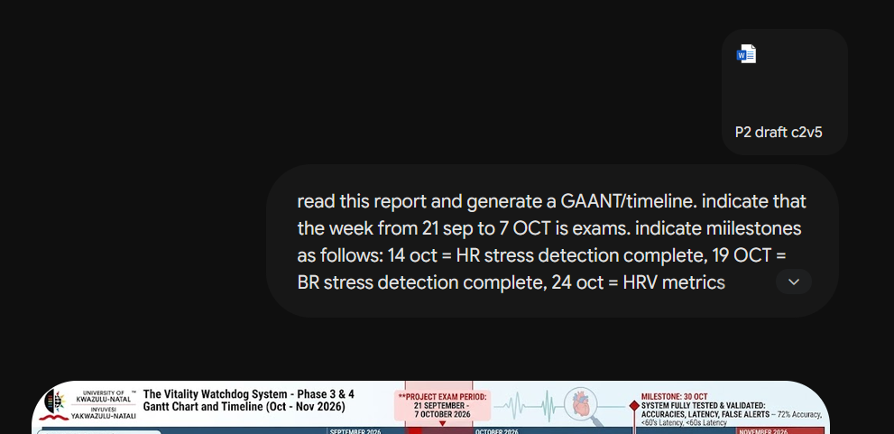  Figure b AI evidence – GAANT chart generation

Requirement | I wanted to create an easy to understand infographic of my system in operation.
Specific use | Page 2
Input/Prompt | Turn this handmade drawing into a conceptual block diagram for a report/brochure.
Validation process | I looked at it and corrected aspects multiple times until I was satisfied with the final output that is seen in this report.
Required evidence | 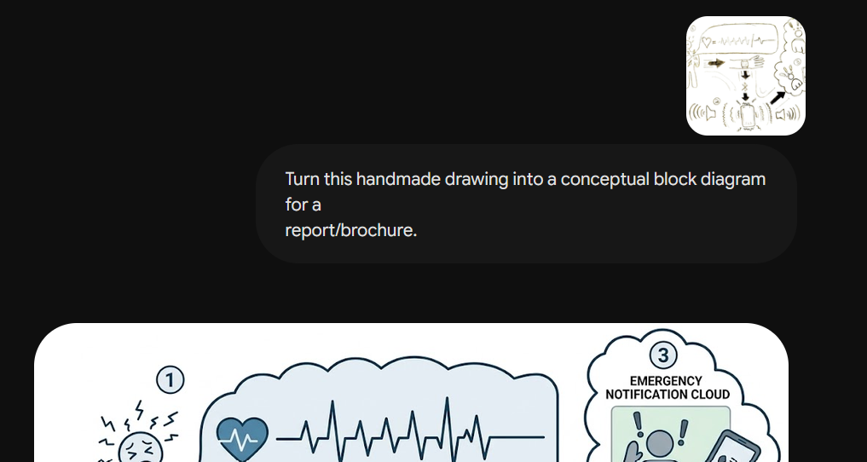  Figure c AI evidence – conceptual block diagram generation

Below is a snippet of the Turnitin score for this report


