i. Find the names of aircraft such that all pilots certified to operate them have salaries more than Rs.80,000.

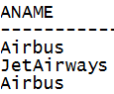

ii. For each pilot who is certified for more than three aircrafts, find the eid and the maximum cruising range of the aircraft for which she or he is certified

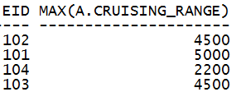

iii. Find the names of pilots whose salary is less than the price of the cheapest route from Bengaluru to Frankfurt.



iv. For all aircraft with cruising range over 1000 Kms, find the name of the aircraft and the average salary of all pilots certified for this aircraft.

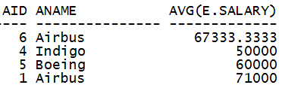

v. Find the names of pilots certified for some Boeing aircraft



vi. Find the aids of all aircraft that can be used on routes from Bengaluru to New Delhi.

