**PROGRAM 4: STUDENT FACULTY DATABASE**

**Consider the following database for student enrollment for course :**

**STUDENT(snum: integer, sname: string, major: string, lvl: string, age: integer)**

**CLASS(cname: string, meets at: time, room: string, fid: integer)**

**ENROLLED(snum: integer, cname: string)**

**FACULTY(fid: integer, fname: string, deptid: integer)**

The meaning of these relations is straightforward; for example, Enrolled has one record per student-class pair such that the student is enrolled in the class. Level(lvl) is a two character code with 4 different values (example: Junior: JR etc)

**Write the following queries in SQL. No duplicates should be printed in any of the answers.**

i. Create above mentioned tables

ii. insert records into each of the tables

1. Find the names of all Juniors (level = JR) who are enrolled in a class taught by
2. Find the names of all classes that either meet in room R128 or have five or more Students enrolled.
3. Find the names of all students who are enrolled in two classes that meet at the same time.
4. Find the names of faculty members who teach in every room in which some class is taught.
5. Find the names of faculty members for whom the combined enrollment of the courses that they teach is less than five.
6. Find the names of students who are not enrolled in any class.
7. For each age value that appears in Students, find the level value that appears most often. For example, if there are more FR level students aged 18 than SR, JR, or SO students aged 18, you should print the pair (18, FR).

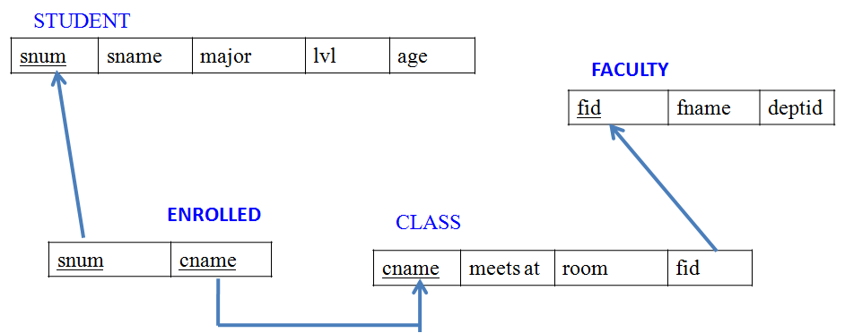

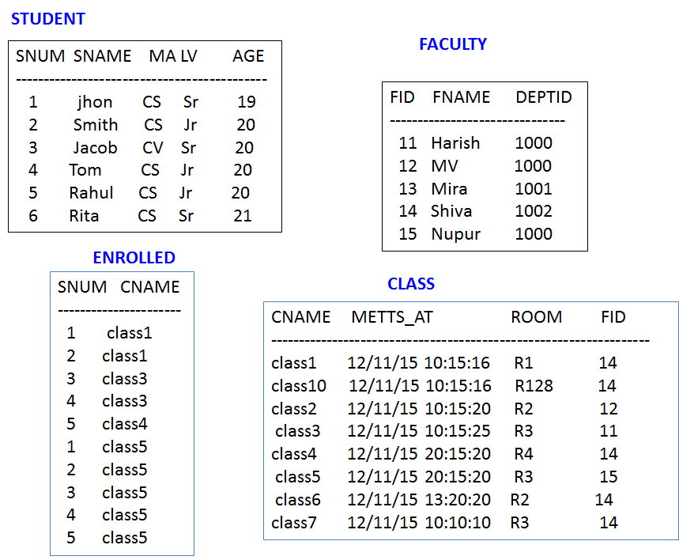

**SQL> CREATE TABLE student(**

**2 snum INT,**

**3 sname VARCHAR(10),**

**4 major VARCHAR(2),**

**5 lvl VARCHAR(2),**

**6 age INT, primary key(snum));**

**Table created.**

**SQL> desc student;**

Name Null? Type

----------------------------------------- -------- ----------------------------

SNUM NOT NULL NUMBER(38)

SNAME VARCHAR2(10)

MAJOR VARCHAR2(2)

LVL VARCHAR2(2)

AGE NUMBER(38)

**SQL> CREATE TABLE faculty(**

**2 fid INT,fname VARCHAR(20),**

**3 deptid INT,**

**4 PRIMARY KEY(fid));**

Table created.

**SQL> desc faculty;**

Name Null? Type

----------------------------------------- -------- ----------------------------

FID NOT NULL NUMBER(38)

FNAME VARCHAR2(20)

DEPTID NUMBER(38)

**SQL> CREATE TABLE class(**

**2 cname VARCHAR(20),**

**3 metts_at TIMESTAMP,**

**4 room VARCHAR(10),**

**5 fid INT,**

**6 PRIMARY KEY(cname),**

**7 FOREIGN KEY(fid) REFERENCES faculty(fid));**

Table created.

**SQL> DESC class;**

Name Null? Type

----------------------------------------- -------- ----------------------------

CNAME NOT NULL VARCHAR2(20)

METTS_AT TIMESTAMP(6)

ROOM VARCHAR2(10)

FID NUMBER(38)

**SQL> CREATE TABLE enrolled(**

**2 snum INT,**

**3 cname VARCHAR(20),**

**4 PRIMARY KEY(snum,cname),**

**5 FOREIGN KEY(snum) REFERENCES student(snum),**

**6 FOREIGN KEY(cname) REFERENCES class(cname));**

Table created.

**SQL> desc enrolled;**

Name Null? Type

----------------------------------------- -------- ----------------------------

SNUM NOT NULL NUMBER(38)

CNAME NOT NULL VARCHAR2(20)

**SQL> commit;**

**Commit complete.**

**INSERTION OF VALUES:**

**SQL> INSERT INTO STUDENT VALUES(&snum, '&sname', '&major', '&lvl', &age);**

Enter value for snum: 1

Enter value for sname: jhon

Enter value for major: CS

Enter value for lvl: Sr

Enter value for age: 19

old 1: INSERT INTO STUDENT VALUES(&snum, '&sname', '&major', '&lvl', &age)

new 1: INSERT INTO STUDENT VALUES(1, 'jhon', 'CS', 'Sr', 19)

1 row created.

SQL> /

Enter value for snum: 2

Enter value for sname: Smith

Enter value for major: CS

Enter value for lvl: Jr

Enter value for age: 20

old 1: INSERT INTO STUDENT VALUES(&snum, '&sname', '&major', '&lvl', &age)

new 1: INSERT INTO STUDENT VALUES(2, 'Smith', 'CS', 'Jr', 20)

1 row created.

SQL> /

Enter value for snum: 3

Enter value for sname: Jacob

Enter value for major: CV

Enter value for lvl: Sr

Enter value for age: 20

old 1: INSERT INTO STUDENT VALUES(&snum, '&sname', '&major', '&lvl', &age)

new 1: INSERT INTO STUDENT VALUES(3 , 'Jacob', 'CV', 'Sr', 20)

1 row created.

SQL> /

Enter value for snum: 4

Enter value for sname: Tom

Enter value for major: CS

Enter value for lvl: Jr

Enter value for age: 20

old 1: INSERT INTO STUDENT VALUES(&snum, '&sname', '&major', '&lvl', &age)

new 1: INSERT INTO STUDENT VALUES(4, 'Tom ', 'CS', 'Jr', 20)

1 row created.

SQL> /

Enter value for snum: 5

Enter value for sname: Rahul

Enter value for major: CS

Enter value for lvl: Jr

Enter value for age: 20

old 1: INSERT INTO STUDENT VALUES(&snum, '&sname', '&major', '&lvl', &age)

new 1: INSERT INTO STUDENT VALUES(5, 'Rahul', 'CS', 'Jr', 20)

1 row created.

SQL> /

Enter value for snum: 6

Enter value for sname: Rita

Enter value for major: CS

Enter value for lvl: Sr

Enter value for age: 21

old 1: INSERT INTO STUDENT VALUES(&snum, '&sname', '&major', '&lvl', &age)

new 1: INSERT INTO STUDENT VALUES(6, 'Rita', 'CS', 'Sr', 21)

1 row created.

**SQL> select * from student;**

SNUM SNAME MA LV AGE

---------- ---------- -- -- ----------

1 jhon CS Sr 19

2 Smith CS Jr 20

3 Jacob CV Sr 20

4 Tom CS Jr 20

5 Rahul CS Jr 20

6 Rita CS Sr 21

6 rows selected.

**SQL> INSERT INTO FACULTY VALUES(&FID, '&FNAME', &DEPTID);**

Enter value for fid: 11

Enter value for fname: Harish

Enter value for deptid: 1000

old 1: INSERT INTO FACULTY VALUES(&FID, '&FNAME', &DEPTID)

new 1: INSERT INTO FACULTY VALUES(11, 'Harish', 1000)

1 row created.

SQL> /

Enter value for fid: 12

Enter value for fname: MV

Enter value for deptid: 1000

old 1: INSERT INTO FACULTY VALUES(&FID, '&FNAME', &DEPTID)

new 1: INSERT INTO FACULTY VALUES(12, 'MV', 1000)

1 row created.

SQL> /

Enter value for fid: 13

Enter value for fname: Mira

Enter value for deptid: 1001

old 1: INSERT INTO FACULTY VALUES(&FID, '&FNAME', &DEPTID)

new 1: INSERT INTO FACULTY VALUES(13 , 'Mira', 1001)

1 row created.

SQL> /

Enter value for fid: 14

Enter value for fname: Shiva

Enter value for deptid: 1002

old 1: INSERT INTO FACULTY VALUES(&FID, '&FNAME', &DEPTID)

new 1: INSERT INTO FACULTY VALUES(14, 'Shiva', 1002)

1 row created.

SQL> /

Enter value for fid: 15

Enter value for fname: Nupur

Enter value for deptid: 1000

old 1: INSERT INTO FACULTY VALUES(&FID, '&FNAME', &DEPTID)

new 1: INSERT INTO FACULTY VALUES(15, 'Nupur', 1000)

1 row created.

**SQL> commit;**

Commit complete.

**SQL> select * from faculty;**

FID FNAME DEPTID

---------- -------------------- ----------

11 Harish 1000

12 MV 1000

13 Mira 1001

14 Shiva 1002

15 Nupur 1000

**SQL> commit;**

Commit complete.

**SQL> alter session set nls_timestamp_format = 'RR/MM/DD HH24:MI:SSXFF';**

Session altered.

**SQL> alter session set nls_date_language ='ENGLISH';**

Session altered.

**SQL> insert into class values('&cname', '&meets_at', '&room', &fid);**

Enter value for cname: class1

Enter value for meets_at: 12/11/15 10:15:16

Enter value for room: R1

Enter value for fid: 14

old 1: insert into class values('&cname', '&meets_at', '&room', &fid)

new 1: insert into class values('class1', '12/11/15 10:15:16', 'R1', 14)

1 row created.

Enter value for cname: class10

Enter value for meets_at: 12/11/15 10:15:16

Enter value for room: R128

Enter value for fid: 14

old 1: insert into class values('&cname', '&meets_at', '&room', &fid)

new 1: insert into class values('class10', '12/11/15 10:15:16', 'R128', 14)

1 row created.

SQL> /

Enter value for cname: class2

Enter value for meets_at: 12/11/15 10:15:20

Enter value for room: R2

Enter value for fid: 12

old 1: insert into class values('&cname', '&meets_at', '&room', &fid)

new 1: insert into class values('class2', '12/11/15 10:15:20', 'R2', 12)

1 row created.

SQL> insert into class values('&cname', '&meets_at', '&room', &fid);

Enter value for cname: class3

Enter value for meets_at: 12/11/15 10:15:25

Enter value for room: R3

Enter value for fid: 11

old 1: insert into class values('&cname', '&meets_at', '&room', &fid)

new 1: insert into class values('class3', '12/11/15 10:15:25', 'R3', 12)

1 row created.

SQL> /

Enter value for cname: class4

Enter value for meets_at: 12/11/15 20:15:20

Enter value for room: R4

Enter value for fid: 14

old 1: insert into class values('&cname', '&meets_at', '&room', &fid)

new 1: insert into class values('class4', '12/11/15 20:15:20', 'R4', 14)

1 row created.

SQL> /

Enter value for cname: class5

Enter value for meets_at: 12/11/15 20:15:20

Enter value for room: R3

Enter value for fid: 15

old 1: insert into class values('&cname', '&meets_at', '&room', &fid)

new 1: insert into class values('class5', '12/11/15 20:15:20', 'R3', 15)

1 row created.

SQL> /

Enter value for cname: class6

Enter value for meets_at: 12/11/15 13:20:20

Enter value for room: R2

Enter value for fid: 14

old 1: insert into class values('&cname', '&meets_at', '&room', &fid)

new 1: insert into class values('class6', '12/11/15 13:20:20', 'R2', 14)

1 row created.

SQL> /

Enter value for cname: class7

Enter value for meets_at: 12/11/15 10:10:10

Enter value for room: R3

Enter value for fid: 14

old 1: insert into class values('&cname', '&meets_at', '&room', &fid)

new 1: insert into class values('class7', '12/11/15 10:10:10', 'R3', 14)

1 row created.

SQL> select * from class;

CNAME

--------------------

METTS_AT

---------------------------------------------------------------------------

ROOM FID

---------- ----------

class1

12/11/15 10:15:16.000000

R1 14

class10

12/11/15 10:15:16.000000

R128 14

CNAME

--------------------

METTS_AT

---------------------------------------------------------------------------

ROOM FID

---------- ----------

class2

12/11/15 10:15:20.000000

R2 12

class3

12/11/15 10:15:25.000000

CNAME

--------------------

METTS_AT

---------------------------------------------------------------------------

ROOM FID

---------- ----------

R3 11

class4

12/11/15 20:15:20.000000

R4 14

class5

CNAME

--------------------

METTS_AT

---------------------------------------------------------------------------

ROOM FID

---------- ----------

12/11/15 20:15:20.000000

R3 15

class6

12/11/15 13:20:20.000000

R2 14

CNAME

--------------------

METTS_AT

---------------------------------------------------------------------------

ROOM FID

---------- ----------

class7

12/11/15 10:10:10.000000

R3 14

8 rows selected.

**SQL> commit;**

Commit complete.

SQL> insert into enrolled values(&snum, '&cname');

Enter value for snum: 1

Enter value for cname: class1

old 1: insert into enrolled values(&snum, '&cname')

new 1: insert into enrolled values(1, 'class1')

1 row created.

SQL> /

Enter value for snum: 2

Enter value for cname: class1

old 1: insert into enrolled values(&snum, '&cname')

new 1: insert into enrolled values(2, 'class1')

1 row created.

SQL> /

Enter value for snum: 3

Enter value for cname: class3

old 1: insert into enrolled values(&snum, '&cname')

new 1: insert into enrolled values(3, 'class3')

1 row created.

SQL> /

Enter value for snum: 4

Enter value for cname: class3

old 1: insert into enrolled values(&snum, '&cname')

new 1: insert into enrolled values(4, 'class3')

1 row created.

SQL> /

Enter value for snum: 5

Enter value for cname: class4

old 1: insert into enrolled values(&snum, '&cname')

new 1: insert into enrolled values(5, 'class4')

1 row created.

SQL> /

Enter value for snum: 1

Enter value for cname: class5

old 1: insert into enrolled values(&snum, '&cname')

new 1: insert into enrolled values(1, 'class5')

1 row created.

SQL> /

Enter value for snum: 2

Enter value for cname: class5

old 1: insert into enrolled values(&snum, '&cname')

new 1: insert into enrolled values(2, 'class5')

1 row created.

SQL> /

Enter value for snum: 3

Enter value for cname: class5

old 1: insert into enrolled values(&snum, '&cname')

new 1: insert into enrolled values(3, 'class5')

1 row created.

SQL> /

Enter value for snum: 4

Enter value for cname: class5

old 1: insert into enrolled values(&snum, '&cname')

new 1: insert into enrolled values(4, 'class5')

1 row created.

SQL> /

Enter value for snum: 5

Enter value for cname: class5

old 1: insert into enrolled values(&snum, '&cname')

new 1: insert into enrolled values(5, 'class5')

1 row created.

**SQL> select * from enrolled;**

SNUM CNAME

---------- --------------------

1 class1

2 class1

3 class3

4 class3

5 class4

1 class5

2 class5

3 class5

4 class5

5 class5

1. rows selected.

**iii. Find the names of all Juniors (level(lvl) = Jr) who are enrolled in a class taught by Harish.**

**SELECT DISTINCT S.Sname**

**FROM Student S, Class C, Enrolled E, Faculty F**

**WHERE S.snum = E.snum AND E.cname = C.cname AND C.fid = F.fid AND**

**F.fname = ‘Harish’ AND S.lvl = ‘Jr’;**

SNAME

----------

Tom

**vi. Find the names of all classes that either meet in room R128 or have five or more Students enrolled.**

**SQL>SELECT C.cname**

**FROM Class C**

**WHERE C.room = ‘R128’**

**OR C.cname IN (SELECT E.cname**

**FROM Enrolled E**

**GROUP BY E.cname**

**HAVING COUNT (*) >= 5);**

CNAME

--------------------

class10

class5

**v. Find the names of all students who are enrolled in two classes that meet at the same time.**

**SQL>SELECT DISTINCT S.sname**

**FROM Student S**

**WHERE S.snum IN (SELECT E1.snum**

**FROM Enrolled E1, Enrolled E2, Class C1, Class C2**

**WHERE E1.snum = E2.snum AND E1.cname <> E2.cname**

**AND E1.cname = C1.cname**

**AND E2.cname = C2.cname AND C1.meets_at = C2.meets_at);**

SNAME

----------

Rahul

**vi. Find the names of faculty members who teach in every room in which some class is taught.**

**SELECT DISTINCT F.fname**

**FROM Faculty F**

**WHERE NOT EXISTS ((SELECT C.roomFROM Class C )**

**MINUS**

**(SELECTC1.room**

**FROM Class C1**

**WHERE C1.fid = F.fid ));**

FNAME

--------------------

Shiva

**vii. Find the names of faculty members for whom the combined enrollment of the courses that they teach is less than five.**

**SQL>SELECT DISTINCT F.fname**

**FROM Faculty F**

**WHERE 5 > (SELECT COUNT (E.snum)**

**FROM Class C, Enrolled E**

**WHERE C.cname = E.cname**

**AND C.fid = F.fid)**

FNAME

--------------------

Harish

MV

Mira

Shiva

**viii. Find the names of students who are not enrolled in any class.**

**SELECT DISTINCT S.sname**

**FROM Student S**

**WHERE S.snum NOT IN (SELECT E.snum**

**FROM Enrolled E );**

SNAME

----------

Rita

**ix. For each age value that appears in Students, find the level value that appears most often. For example, if there are more FR level students aged 18 than SR, JR, or SO students aged 18, you should print the pair (18, FR).**

**SELECT S.age, S.lvl**

**FROM Student S**

**GROUP BY S.age, S.lvl**

**HAVING S.lvl IN (SELECT S1.lvl FROM Student S1**

**WHERE S1.age = S.age**

**GROUP BY S1.lvl, S1.age**

**HAVING COUNT (*) >= ALL (SELECT COUNT (*)**

**FROM Student S2**

**WHERE s1.age = S2.age**

**GROUP BY S2.lvl, S2.age));**

AGE LV

---------- --

19 Sr

20 Jr

21 Sr