create table Branch(branch_name varchar2(15),

branch_city varchar2(10),

assets float,

primary key(branch_name));

create table Accounts(accno int,

branch_name varchar2(15),

balance float,

primary key(accno),

foreign key(branch_name) references Branch(branch_name));

create table Depositor(cust_name varchar2(15),

accno int,

primary key(cust_name,accno),

foreign key(accno) references Accounts(accno));

create table Customer(cust_name varchar2(15),

cust_street varchar2(10),

cust_city varchar2(10),

primary key(cust_name));

create table Loan(loan_no int,

branch_name varchar2(10),

amount float,

primary key(loan_no),

foreign key(branch_name) references Branch(branch_name));

create table Borrower(cust_name varchar2(15),

loan_no int,

primary key(cust_name),

foreign key(cust_name) references Customer(cust_name),

foreign key(loan_no) references Loan(loan_no));

insert into Branch values('&branch_name','&branch_city',&assets);

select *from Branch;

insert into Accounts values(&accno,'&branch_name',&balance);

select *from Accounts;

insert into Depositor values('&cust_name',&accno);

select * from Depositor;

insert into Customer values('&cust_name','&cust_street','&cust_city');

select * from Loan;

insert into Loan values(&loan_no,'&branch_name',&amount);

insert into Borrower

Drop table Borrower;

Drop table Loan;

insert into Borrower values('&cust_name',&loan_no);

select * from Borrower;

Branch Borrower

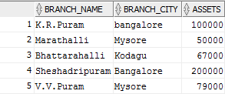

Accounts

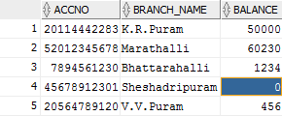

Depositor

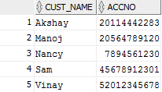

Customer

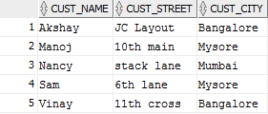

Loan

