Cairo University Faculty of Computers and Information



**CS352 – Software Engineering II**

**Phase 1 Template**

**2017**

**Project Team**

|  |  |  |  |
| --- | --- | --- | --- |
| **ID** | **Name** | **Email** | **Mobile** |
|  | 1st name is team leader |  |  |
|  |  |  |  |
|  |  |  |  |
|  |  |  |  |
|  |  |  |  |
|  |  |  |  |

**Staff:**

**Dr Amr Kamel** [a.kamel@fci-cu.edu.eg](mailto:a.kamel@fci-cu.edu.eg)

**Dr Khadiga Mohamed kelbedweihy@fci-cu.edu.eg**

**TAs: Eng. Omar Khaled Ali Ragab o.khaled@fci-cu.edu.eg**

Contents

Instructions [To be removed] 3

Review Check List 3

Testing 5

Git repository link 6

**Design and Code Review Checklist**

|  |  |  |
| --- | --- | --- |
| **Design Principles** | | |
| Does the design follow SOLID principles? | 40% | Single responsibility principle is violated in some classes. |
| Does the design follow OOP rules? | 70% | No Setters and getters, No access modifiers, Some variables should be private. |
| Is the design simple and easy to modify? | 30% | Spaghetti code and the design is not flexible, the code is not structured to be easily modified. Any change in code will break the software. |
| **Coding Standards** | | |
| Is the code understandable and readable? | 40% | The code is semi-readable; there are no white spaces, a lot of single-lined code and some bad variable names. |
| Does the code follow Java coding style? |  |  |
| Is indentation used properly? | 70% | Bad indentation making the code less readable |
| Do variables have good names? | 80% | There are some bad variable names that don’t describe their usage. |
| **Comments** | | |
| Is the code commented enough? | 0% | No useful comments at all |
| Is every class method commented? | 0% |
| Do comments follow Javadoc style | 0% |
| Is Javadoc generated for all the code? | 0% |
| Are there any useless comments? | 100% | All comments are useless |
| **Code Structure** | | |
| Does the code follow the design precisely? |  |  |
| Are there very long classes and methods? | 30% | Some classes have long methods that contain a lot of logic that can be separated into other methods. |
| Is there repeated code? | 60% | Some code is repeated and can be encapsulated in functions |
| **Error Handling** | | |
| Does the code handle errors and exceptions? | 0% | No exception handling at all |
|  |  |  |
| **Logic** | | |
| Do loops have good condition and bounds? | 100% |  |
| Do loops always terminate? | 100% |  |
| Are there any unnecessary loops? | 20% | Some loops can be merged into one |
| **General Issues** | | |
| Static variables are not accessed correctly | | |
| There are some unused variables | | |
| There are some unused imports | | |
| Bad Class names | | |

**Quality of design and code: 35%**

# Testing

**UserTesting Class:**

|  |  |  |  |  |
| --- | --- | --- | --- | --- |
| Number | Testing Function | Description | Test Case | Result |
| 1 | log_in(type, userName, password) | Testing function of user login to the application | Correct username and password | failed |
| Correct username, wrong password | passed |
| Wrong username, correct password | passed |
| Wrong username and wrong password | passed |
| 2 | register(User user) | Testing registeration function if it actually adds registered user | Username with numbers, password without | passed |
| Username and password with numbers | passed |
| Password with numbers, username without | passed |
| Password and username without numbers | passed |

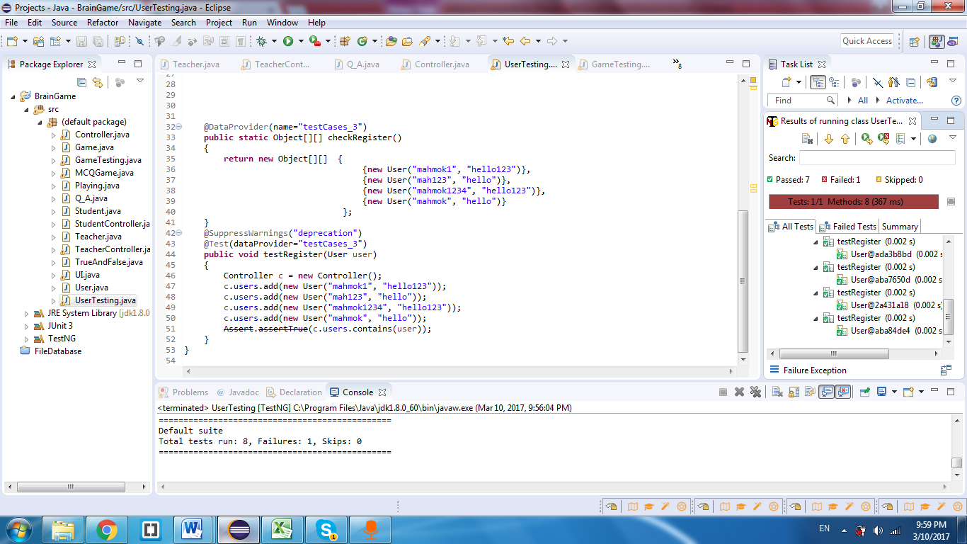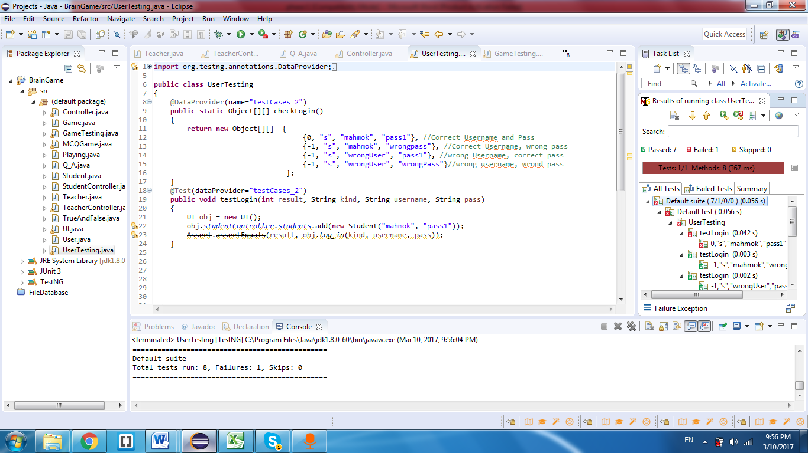

**GameTesting Class:**

|  |  |  |  |  |
| --- | --- | --- | --- | --- |
| Number | Testing Function | Description | Test Case | Result |
| 1 | checkMCQGame(name) | Testing if a game exists and belongs to a teacher | Game name exists | passed |
| Game name doesn't exist | passed |
| 2 | getMCQGame(name) | Testing fetching game to be played functionality | Game exists | passed |
| Game doesn’t exist | failed |

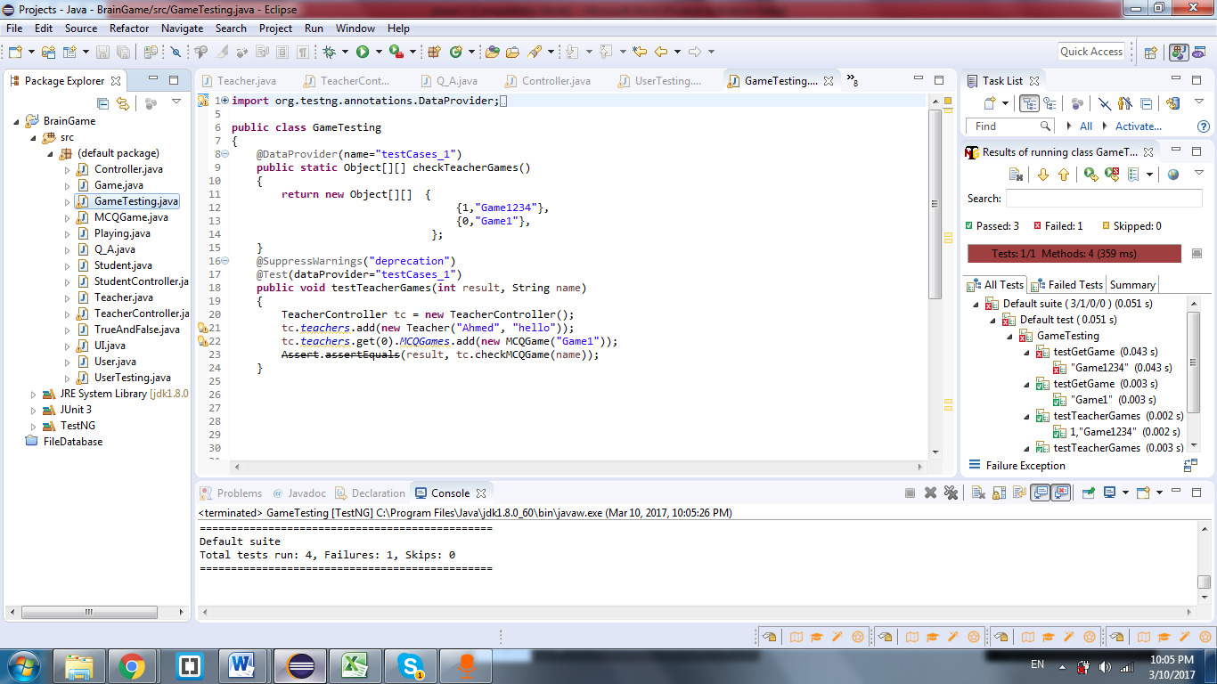

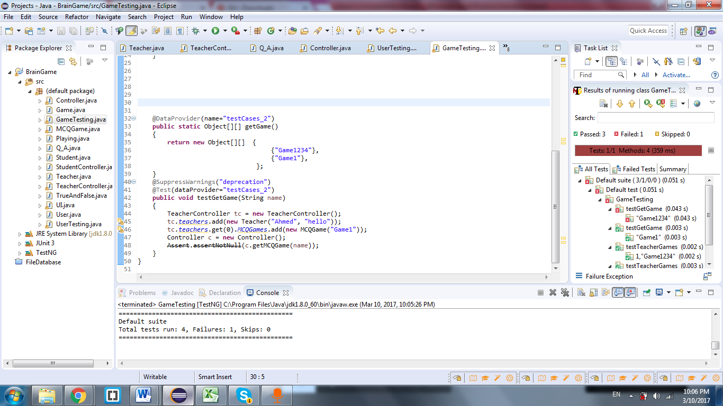

# Git repository link

**You should put here your git repository link**