Command of github
- To create git repository
git init
- To add all file
git add .
- Add commit with masg
git commit -m “Message”

- Check the state of repository
git status

- To create branch
git branch <branch name>

- List all branch
git branch -a

- Delete branch
git branch -d <branch name>

- To switch branch
git checkout <branch name>

- create and checkout
git checkout -b <branch name>

- Integrated branches togather
git merge <branch_name>

- Working with remote repository
git remote <remote_URL>

- Listed named repoitory
gti remote -v

- Create a directory locally with all files and repository history.
git clone <remte_URL>

- To get the latest version of a repository run git pull.
git pull origin <branch_name>

- Sends local commits to the remote repository.
git push -all
git push origin <branch_name>

- To show commit detail
git log

To generate server keys

- To Generate Key
ssh-keygen

- Get Public Key
cat .ssh/id_rsa.pub (cat is used to print file on console)

- View keys on server
vim .ssh/authorized_keys

- Use for testing image:
sudo docker run -p 7986:8000 695bc5bf9ea7
- To get file from image:
docker run -it --entrypoint=/bin/bash f072ebe1cf57
- To check server:
telnet 207.244.224.215 5701
- hazelsst : 5.189.160.196
rember frontend always live on 8080 instead of 8000

How to Live Backend:

First Place 3 Files in Code:
1)start.sh
2)runtime.txt
3)DockerFile

To build docker type this command:
sudo docker build .

If this show error then install docker by following commands in .sh file:

#Ubuntu-18

sudo apt update
sudo apt install apt-transport-https ca-certificates curl software-properties-common -y
curl -fsSL https://download.docker.com/linux/ubuntu/gpg | sudo apt-key add -
sudo add-apt-repository "deb [arch=amd64] https://download.docker.com/linux/ubuntu bionic stable"
sudo apt update
sudo apt install docker-ce -y

#Docker-compose
curl -L "https://github.com/docker/compose/releases/download/1.23.2/docker-compose-$(uname -s)-$(uname -m)" -o /usr/local/bin/docker-compose
chmod +x /usr/local/bin/docker-compose
~

Add this package in requirements.txt

gunicorn==19.7.1

change start.sh file and add 8000 port after that chmod +x start.sh

Then again docker build
sudo docker build .

To run build locally run this command:dc8 is the image name
sudo docker run -p 4466:8000 dc8d9ab63508

you can test your image on this url
http://localhost:4466/

you can tag your build by this command:
sudo docker tag dc8d9ab63508 cricket-backend

after that save that tag:
sudo docker save -o /home/cricket-backend.tar cricket-backend

Now you can move this build to any server:
scp -r cricket-backend.tar root@169.60.235.66:/home/amazon/9
on server you can cat this image and then run through run command I.e docker run

There is another good way u can create repository on docker hub and then follow bellow steps:

1)Login on your docker hub through this command
sudo docker login -u azharhassan

then add password:80406138071

You can tag your image by this command:
sudo docker tag dc8d9ab63508 azharhassan/cricket:1.1

now push your image to your repository
sudo docker push azharhassan/cricket:1.1

Now open Server and create
vim ubuntu.yml

Add following code in this file:

version: '3.0'

services:
amazon1:
image: azharhassan/cricket:1.1
hostname: cricket
container_name: cricket-backend
restart: always
ports:
#- 169.60.235.66:2211:22
- 169.60.235.66:4464:8000

#volumes:
#- .:/amazon
stdin_open: true
tty: true

then compose this file
docker-compose -f ubuntu.yml up -d

docker-compose -f ubuntu.yml up (This for testing)
apt-get install nginx -yapt-get install nginx -y

http://192.168.29.125:9000/
python manage.py runserver 192.168.29.125:9000
169.60.235.66:4474
http://127.0.0.1:8000

For installing ngnix
apt-get install nginx -y

Frist check status
service nginx status

service nginx restart

Then check ip of server if show welcome nginx or not

Now open following file.

vim /etc/nginx/sites-enabled/default

add following in this file:
server {
server_name cricket.brainwade.com;
location / { proxy_pass http://52.116.74.57:4747;
#proxy_pass http://devapis_sell4bids; proxy_set_header Host $host; proxy_set_header X-Real-IP $remote_addr; proxy_set_header X-Forwarded-For $proxy_add_x_forwarded_for; proxy_set_header X-Forwarded-Proto $scheme; proxy_http_version 1.1; proxy_set_header Upgrade $http_upgrade; proxy_set_header Connection "Upgrade"; }
}

Code Allignment
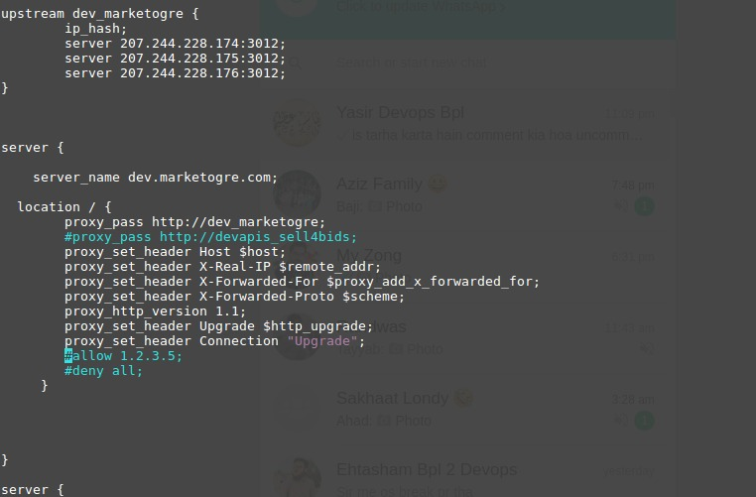

then below command.

service nginx reload

if password not save type this:
sudo apt install gnupg2 pass

bplmail.brainwade.com

IMPORTANT NOTES:
- Congratulations! Your certificate and chain have been saved at:
/etc/letsencrypt/live/bplmail.brainwade.com-0001/fullchain.pem
Your key file has been saved at:
/etc/letsencrypt/live/bplmail.brainwade.com-0001/privkey.pem
Your cert will expire on 2020-03-29. To obtain a new or tweaked
version of this certificate in the future, simply run
letsencrypt-auto again. To non-interactively renew *all* of your
certificates, run "letsencrypt-auto renew"
- If you like Certbot, please consider supporting our work by:

Donating to ISRG / Let's Encrypt: https://letsencrypt.org/donate
Donating to EFF: https://eff.org/donate-le

To Add site in your domain certificate
certbot --expand -d apis.clidster.com

update pg_database set encoding = pg_char_to_encoding('UTF8') where datname = 'kingbestmall'

Installation Video URL: https://www.youtube.com/watch?v=sW6myuKIAHY

Best Practices: https://wiki.zimbra.com/wiki/Best_Practices_on_Email_Protection:_SPF,_DKIM_and_DMARC

SSL: https://wiki.zimbra.com/wiki/Installing_a_LetsEncrypt_SSL_Certificate

zmcontrol restart

DB:

https://www.digitalocean.com/community/tutorials/how-to-backup-postgresql-databases-on-an-ubuntu-vps

Monit

http://storageserver.ogrespace.com:2812/

MongoDB
https://www.howtoforge.com/tutorial/deploying-mongodb-sharded-cluster-on-centos-7/

GITlab:
https://www.digitalocean.com/community/tutorials/how-to-install-and-configure-gitlab-on-ubuntu-16-04

Thanks
\

1042
add-apt-repository ppa:certbot/certbot
apt-get update && apt-get install python-certbot-nginx
apt-get install python-certbot-nginx
add-apt-repository ppa:certbot/certbot
nginx -t && nginx -s reload
certbot --nginx -d pgadmin.brainwade.com
apt install software-properties-common
add-apt-repository ppa:certbot/certbot
certbot --nginx -d pgadmin.brainwade.com
apt-get update
apt-get install python-certbot-nginx

Docker_Swarm:
https://docs.docker.com/engine/swarm/swarm-tutorial/create-swarm/
https://docs.docker.com/engine/swarm/swarm-tutorial/add-nodes/

login to jenkins
https://azhar_jenkins.brainwade.com/login?from=%2F
GitLab pipeline code
pipeline {
agent none
stages {
stage('git clone') {
agent any
steps {
git credentialsId: 'azhar613', url: 'http://git.brainwade.com/Ehtisham/rfp.git'
}
}
stage('compile'){
agent any
steps{
sh 'mvn compile'
}
}
stage('compile'){
agent any
steps{
sh 'mvn compile'
}
}
stage('compile'){
agent any
steps{
sh 'mvn compile'
}
}
}
}

https://www.youtube.com/watch?v=aAWALhp6wSE
https://www.youtube.com/watch?v=gdbA3vR2eDs&t=149s
https://medium.com/avmconsulting-blog/automated-ci-cd-with-jenkins-39b21c7c8035
https://opensource.com/article/19/9/intro-building-cicd-pipelines-jenkins
https://www.youtube.com/watch?v=13FpCxCClLY
To Build docker images in jenkins
https://medium.com/@karthi.net/docker-tutorial-build-docker-images-using-jenkins-d2880e65b74
https://medium.com/nonstopio/jenkins-django-8faddc26ab32
https://medium.com/@ssmak/how-to-enable-docker-remote-api-on-docker-host-7b73bd3278c6
server monitering
https://searchitoperations.techtarget.com/definition/Nagios#:~:text=Nagios%20is%20an%20open%20source%20monitoring%20system%20for%20computer%20systems.&text=Nagios%20software%20runs%20periodic%20checks,running%20processes%20and%20log%20files.
What is Monit?
Monit is a free, open-source process supervision tool for Unix and Linux. With Monit, system status can be viewed directly from the command line, or via the native HTTP(S) web server. Monit is able to do automatic maintenance, repair, and run meaningful causal actions in error situations.
Netdata tools use for monitoring server installation:
https://www.addictivetips.com/ubuntu-linux-tips/realtime-network-monitoring-on-linux/s
Vedio_URL: https://www.youtube.com/watch?v=vI-LF6obVrA
http://localhost:19999/#menu_disk_submenu_sda;theme=slate
Nagios:
To Close .cfg file after edit
:w !sudo tee % > /dev/null

