**Manual for NW-Algorithm.**

1. Start rEyeker

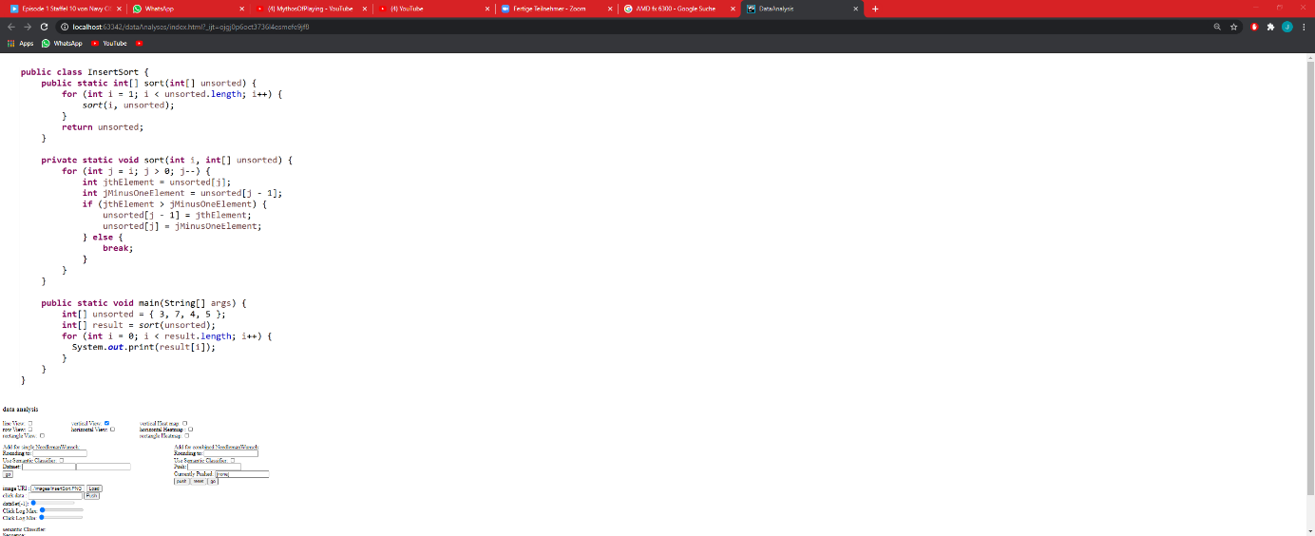

1. Insert datasets

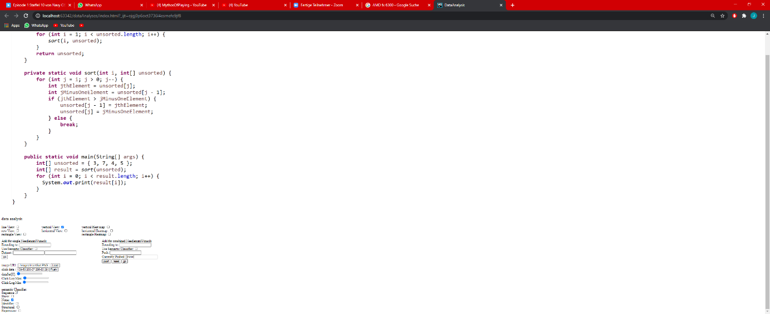

(2.1. Just an example that data is loaded)

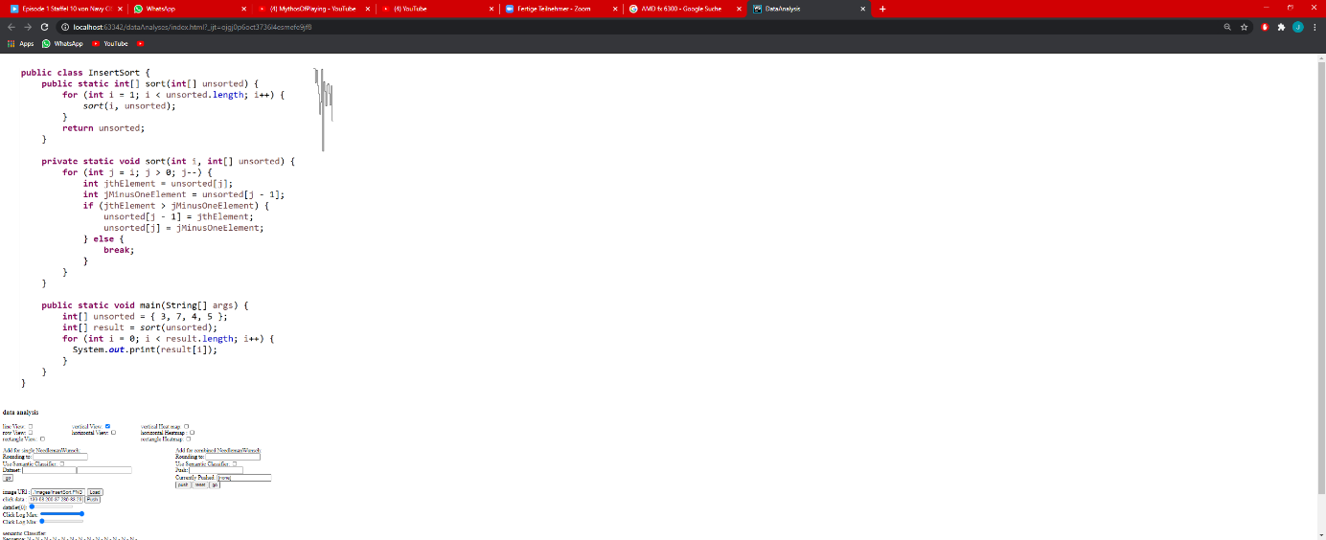

1. Set a rounding Value. This will be used to “normalize“ the input, and to get rid of noise.

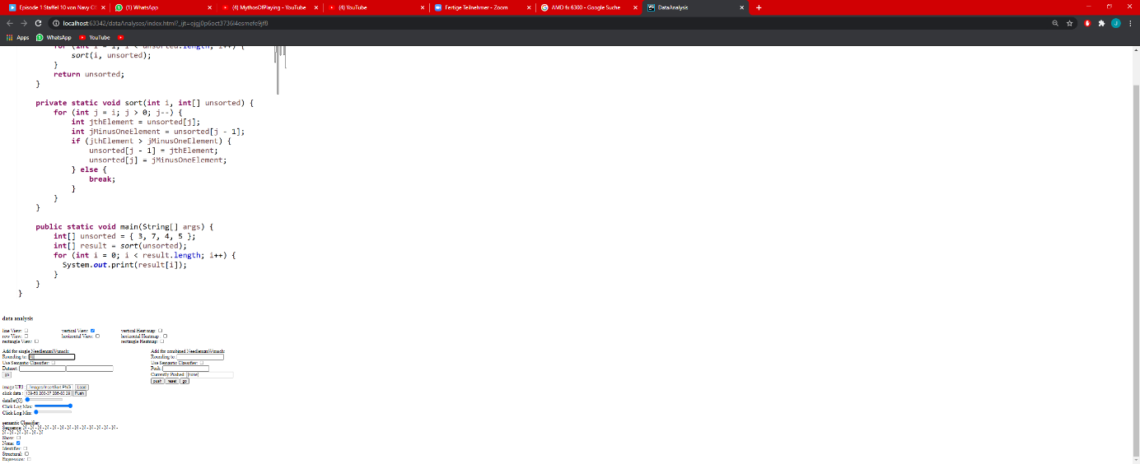

1. Choose the datasets to anaylze

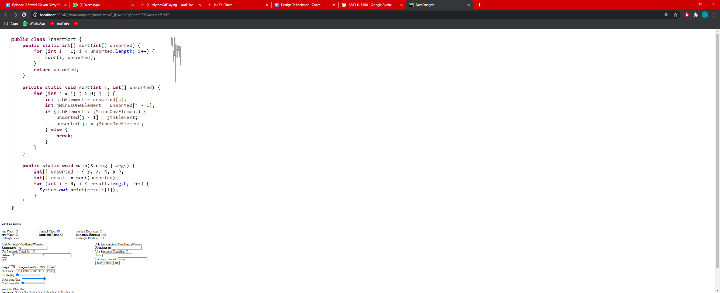

1. Look at the results, the left side will show you the minimal accordance and the right side will show you how to get there based from the first dataset. Green means a point was insertet. Red means a point was deletet. Black Means a point was keeped because he was alignt with the other dataset.

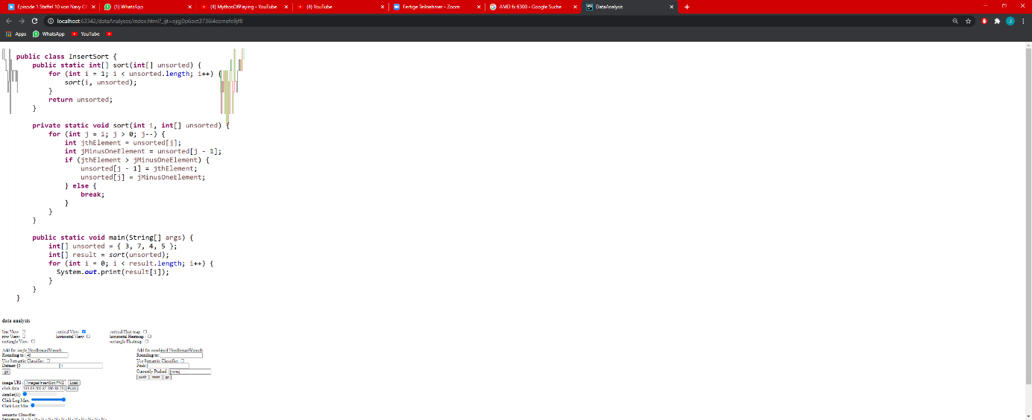

**Using Multiple Pair NW**

For the Multiple Pair NW Algorithm, use the right Interface and put the datset nummbers into the push input field. Then press push, if all required datasets are pushed you can apply the algorithm via the go button

**Using Semantic Classifiers**

For using the semantic classifiers you first need to set them. You can do this by checking the show box. After that you need to mark the areas based on the semantics. There are the options Indentifier for marking Identifiers. The option Structural for marking Structural behavior of the Program and Expression for marking Expressions. To Mark the Snippet, select the semantic Classifier via the Checkbox and then you can mark a range. This is done using the mouse (pressing on the image). Press “Shift“+“Left Click“ to set the Upper range and “Ctrl“+“Left Click“ to set the lower range. If you set all classifiers as you wished, you can check the “Use Semantic Classifier“ Checkbox in the NW section. This will make the Rounding Value redudant. All Inputs will be normalized to the middle of a semantic classifier