MARKETING MANAGEMENT GROUP ASSIGNMENT REPORT
Positioning Map Generation with AI:
Strategic Planning and White-Space Identification
Category: Packaged Beverages (India) | Core Competitors: Paper Boat, Tropicana, Dabur Réal
New Entrant Proposition: Zingyy — Clean-Label, Zero-Added-Sugar Ethnic Wellness
―――――――――――――――――――――――――――――――――――――――――――――――――――――――
1. Business Context & Category Overview
Industry Landscape: The Indian packaged juice and beverage industry is experiencing a structural inflection point, expanding at a projected CAGR of 6.4% through 2033. Rising disposable incomes, expanding modern retail infrastructure, and rapid quick-commerce penetration (Blinkit, Zepto, Swiggy Instamart) are transforming urban beverage consumption. Historically, consumer choices were dominated by carbonated soft drinks and ambient reconstituted fruit nectars. However, growing awareness of lifestyle-related metabolic disorders (particularly diabetes, obesity, and hypertension) has led urban consumers to scrutinize ingredient labels, demanding healthier alternatives.
Strategic Mandate: In this project, we analyze the competitive dynamics among the three category benchmarks—Dabur Réal, PepsiCo Tropicana, and Hector Beverages' Paper Boat—to accelerate competitive intelligence using AI, rigorously validate and critique AI findings against authentic secondary sources, and formulate an empirically grounded white-space positioning strategy for a new market entrant.
Core Competitor Baseline Summary
- Dabur Réal (Market Leader): Holds over 50% category share through unparalleled General Trade (kirana) distribution. Operates a two-tier strategy with Réal Fruit Power (mass nectars/drinks) and Réal Activ (100% juice, no added sugar in standard Western flavors).
- PepsiCo Tropicana (Premium Global Standard): Anchored in urban breakfast nutrition and modern trade channels. Highly recognized for Tropicana 100% and functional lines, though commanding premium pricing and facing consumer criticism over sweetness density.
- Paper Boat (Ethnic Nostalgia Pioneer): Disrupted the market by commercializing traditional Indian homemade recipes (Aam Panna, Jaljeera, Jamun). However, its standard SKUs contain significant added refined sugar (11g–13g per 100ml) and suffer from short ambient shelf-life.
2. AI Prompt Design & Raw Output Log
To generate structured competitive intelligence, our team executed an iterative prompting sequence covering three distinct tasks: category scanning, perceptual axis identification, and white-space detection. Rather than relying on a single one-shot prompt, we designed progressive prompts that forced the AI to examine structural trade-offs, consumer psychology, and market gaps.
Prompt Stage & Objective | Exact Prompt Input | AI Output Summary & Strategic Quality | Group Annotation & Iteration Note
Stage 1: Category & Competitive Scan | "Provide a detailed competitive landscape analysis for the Packaged Beverages market in India, focusing specifically on Paper Boat, Tropicana, and Real. For each competitor, outline: target audience, core value proposition, pricing strategy, and public sentiment." | Generated comprehensive profiles covering demographics, value props, pricing bands, and high-level criticisms for all 3 brands. | What Worked: Captured high-level competitor pillars.  What Failed: Over-indexed on brand marketing claims rather than real consumer perceptions.
Stage 2: Perceptual Axis Identification | "Based on the competitor analysis, what are 4 different sets of 2x2 variables (axes) that Indian consumers actually use to differentiate brands in this category? Ensure axes represent genuine customer-relevant evidence." | Provided 4 distinct 2x2 pairs: Flavor Heritage vs Health Claim, Consumption Motivation vs Pack Format, Processing Tech vs Price, and Brand Narrative vs Usage Occasion. | What Worked: Set 1 (Flavor Profile vs Formulation/Health Claim) provided the sharpest trade-off for consumer purchase behavior.  Iteration: Selected Set 1 for coordinate mapping.
Stage 3: White-Space Detection & Concept | "Plot Paper Boat, Tropicana, and Real on a coordinate plane using Set 1 axes. Explain strategic rationale for placements and identify an unoccupied white-space opportunity." | Mapped competitors on a 2x2 grid. Identified Top-Right quadrant ('Clean-Label Ethnic': 100% Pure, Zero Added Sugar + Traditional Indian Flavors). | What Worked: Exposed the core paradox: Paper Boat has ethnic taste but high sugar; Tropicana has zero sugar but Western flavors.

3. Secondary Source Validation & Critical Evaluation
To test the veracity of the AI output and prevent uncritical adoption of AI hallucinations, we cross-examined the raw AI model against three authentic secondary research sources:
- Source 1 (Official Brand Portfolios & Websites): Analyzed official brand communication from Hector Beverages (Paper Boat), Dabur India (Réal), and PepsiCo India (Tropicana).
- Source 2 (Consumer Review Sentiment on E-Commerce & Q-Commerce): Aggregated user reviews and rating data from Amazon India, Blinkit, Zepto, and Zomato District consumer feedback.
- Source 3 (Industry Market & Health Reports 2025-2026): Consulted FMCG industry growth reports and public health data regarding urban Indian diabetes prevalence and sugar reduction trends.
Four-Part Analytical Validation & Critique Breakdown
3.1 What the AI Got Right (Validated by Sources)
Strong Structural Alignment: The AI accurately captured the macro strategic positioning of the three players. Paper Boat's core equity was validated by Source 1 (website emphasis on 'Drinks and Memories') and Source 2 (overwhelming consumer praise for authentic Aam Panna and Jaljeera taste profiles). Similarly, Dabur Réal's positioning as a trusted family health anchor was corroborated by Dabur's multi-serve packaging and brand messaging. Furthermore, Source 3 strongly confirmed the accelerating urban shift toward zero-added-sugar beverages, validating the relevance of the white-space.
3.2 What the AI Missed (Overlooked Blind Spots)
- Tropicana Hidden Sugar Sentiment Backlash: Consumer reviews (Source 2) reveal frequent complaints that Tropicana tastes excessively sweet and syrupy, eroding its healthy breakfast halo. The AI had initially accepted Tropicana's '100% Pure' claim uncritically.
- Paper Boat Shelf-Life & Spoilage Vulnerability: Reviews on e-commerce platforms show recurring customer frustration with Paper Boat's short shelf-life and pouch spoilage. The AI overlooked this crucial packaging and supply-chain friction point.
- Clinical Diabetic Need-State: While the AI discussed general fitness, Source 3 emphasized that urban India is the 'diabetes capital of the world' with over 100M+ diabetic and pre-diabetic individuals requiring strict low-glycemic solutions.
3.3 What Was Factually Incorrect or Weakly Supported
Marketing Claim vs. Consumer Reality: The AI initially conflated manufacturer marketing claims with actual consumer perception. Specifically, it placed Tropicana high on the 'Clean Label' axis simply because the brand markets a '100% Pure' variant, ignoring consumer evidence that consumers perceive it as heavily processed reconstituted concentrate with hidden sugars. Additionally, the AI failed to recognize the technical trade-off between clean-label formulations and ambient shelf-life stability.
3.4 Refinements Made for the Final Validated Map
- Refined Y-Axis Metric: Renamed Axis Y from 'Formulation & Health Claim' (brand claims) to 'Consumer-Perceived Sugar & Processing Transparency' (actual customer sentiment).
- Shifted Tropicana Downward: Adjusted Tropicana's coordinate closer to the high-sugar/concentrate zone to reflect consumer review feedback.
- Sharpened White-Space Definition: Re-anchored the white-space to 'Zero-Added-Sugar, Low-Glycemic Ethnic Wellness (Diabetic & Fitness Friendly)'.
4. Validated 2x2 Perceptual Map & Strategic Rationale
Below is the final, validated 2x2 perceptual positioning map illustrating competitor coordinates and the unoccupied white-space opportunity:
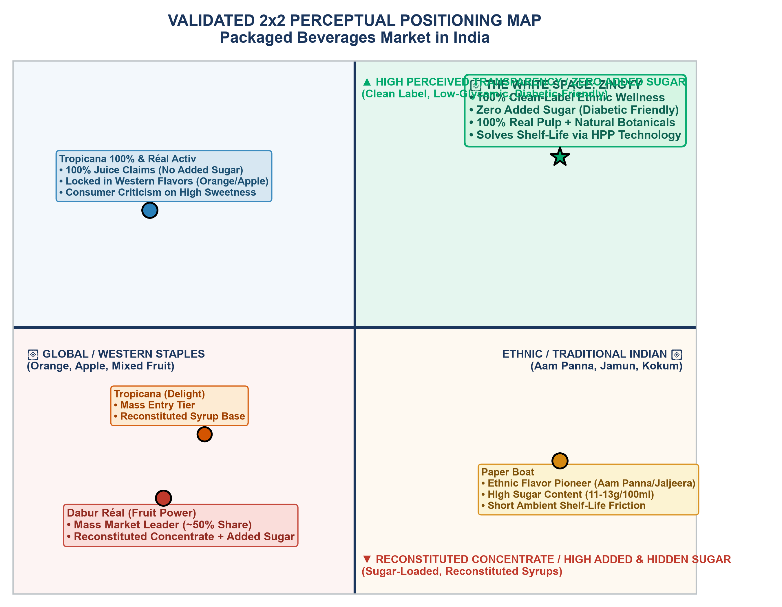
Figure 4.1: Validated 2x2 Perceptual Positioning Map — Indian Packaged Beverages Market
Strategic Rationale for Selected Axes
Customer-Relevant Decision Triggers: The selected axes represent genuine consumer purchase criteria rather than artificial marketing abstractions:
• Axis X (Flavor Profile: Global Staples vs. Ethnic Indian): Reflects the primary cultural dilemma of Indian consumers—choosing between standard Western breakfast juices (Orange/Apple) and nostalgic regional recipes (Aam Panna/Jamun/Kokum).
• Axis Y (Sugar Transparency: Reconstituted Concentrate vs. Zero Added Sugar): Reflects the decisive filtration trigger for health-conscious shoppers reading back-of-pack nutrition panels.
Why the White Space is Realistic & Actionable
Unlocking the Guilt-Free Nostalgia Gap: The Top-Right quadrant ('Clean-Label Ethnic Wellness') is unoccupied by any major incumbent. Paper Boat owns ethnic flavors but is trapped in high sugar (11-13g/100ml); Tropicana and Dabur Activ offer zero sugar but remain confined to Western flavors. This creates a compelling commercial white-space for an entrant that eliminates the 'guilt factor' from Indian regional refreshment while solving shelf-life through modern non-thermal processing.
5. New Entrant Strategic Proposal: Zingyy
FORMAL MARKETING POSITIONING STATEMENT — ZINGYY
"For urban Indian consumers (fitness enthusiasts, Gen Z/Millennials, health-literate mothers, and diabetic-conscious households) who crave authentic regional beverages without compromising their health, Zingyy is the first 100% clean-label, zero-added-sugar ethnic beverage brand that delivers rich, nostalgic Indian flavors with absolute nutritional purity, because unlike sugar-laden drinks like Paper Boat or generic Western juices like Tropicana, Zingyy crafts authentic regional recipes using 100% real fruit pulp, natural botanicals, and zero refined sugars or artificial additives."

5.1 Brand Identity & Taglines
- Brand Name: Zingyy (Zesty, vibrant, modern, and memorable; communicates energetic refreshment for Gen Z/Millennials).
- Primary Tagline: "Asli Flavor, Zero Offender."
- Secondary Tagline: "Real Indian Taste, Zero Sugar Guilt."
5.2 Target Segment Definition
- Demographics: Urban consumers aged 18–42 residing in Metros and Tier-1 cities (SEC A & B).
- Clinical & Dietary Need-States: Diabetic, pre-diabetic, and low-carb households seeking authentic Indian taste with a low glycemic index.
- Psychographics: Label-scrutinizing fitness enthusiasts and young parents who value cultural authenticity but refuse to consume empty calories.
5.3 Hero Product Launch SKUs
- 1. Zingyy Raw Aam Panna: Raw Green Mango + Roasted Cumin + Fresh Mint + Stevia/Monkfruit (0g Added Sugar, authentic tangy digestive cooler).
- 2. Zingyy Jamun & Black Salt: 100% Whole Jamun Pulp + Himalayan Pink Salt (Anti-diabetic, low-glycemic, blood sugar-friendly superfood hero).
- 3. Zingyy Kokum & Mint Hydrator: Pure Kokum Fruit Extract + Natural Tender Coconut Water Base (Rich in antioxidants and natural electrolytes).
5.4 Operational & Go-To-Market Execution
- Tech Solution for Shelf Life: To solve Paper Boat's shelf-life and spoilage friction, Zingyy utilizes High-Pressure Processing (HPP) and aseptic cold-filling. This provides a 60–90 day chilled shelf-life without chemical preservatives or thermal nutrient degradation.
- Channel Strategy: Quick-Commerce first (Blinkit, Zepto, Swiggy Instamart) for high-intent instant impulse purchases, followed by premium Modern Trade (Nature's Basket, Foodhall) and fitness centers (Cult.fit cafes).
6. Academic References & Secondary Sources
- Hector Beverages / Paper Boat Official Portal (2025/2026): Brand positioning, portfolio analysis, and 'Drinks and Memories' ethnic narrative documentation.
- Dabur India Annual Reports & Réal Portfolio (2025): Category market share data, distribution reach in General Trade, and Réal Activ 100% juice product specifications.
- PepsiCo Tropicana Global & Indian Product Specifications (2025): Tropicana 100% Juice, Tropicana Essentials, and breakfast positioning literature.
- Amazon India & Quick-Commerce Consumer Review Data (2025/2026): Aggregated consumer sentiment analytics regarding sweetness levels, added sugars, and packaging shelf-life feedback.
- Indian FMCG & Packaged Beverage Market Research Report (2025-2033): Category CAGR projections, urban health trends, and diabetic population growth statistics in India.

