**TABLE OF CONTENTS**

**I.** System Design………………………………………………………..……………........ 2

**II.** Database Schema ……………………………………………………………….……...5

**III.** ER- Diagram………………………………………………………..…….…..……….9

**IV.** System Flowchart………………………………………………………..…..…..……10

**V.** Data Flow Diagram (DFD)

1. Context Diagram …………………………………...…………………………18
2. Top Level Diagram ………………………………………………………..….19
3. Bottom Level Diagram ………………………………………………………..21

**VI.** Unified Modeling language (UML)

1. Class Diagram ………………………………………………………..…………23
2. Object Diagram ………………………………………………………..……….24
3. Component Diagram ………………………………………………………..….25
4. Deployment Diagram …………………………………………………………..26
5. Uses Cases Diagram ………………………………………………………..…..27
6. Sequence Diagram ………………………………………………………..……28
7. Collaboration Diagram …………………………………………………………29
8. State Chart ………………………………………………………..…………….30
9. Activity Diagram ………………………………………………………………..31

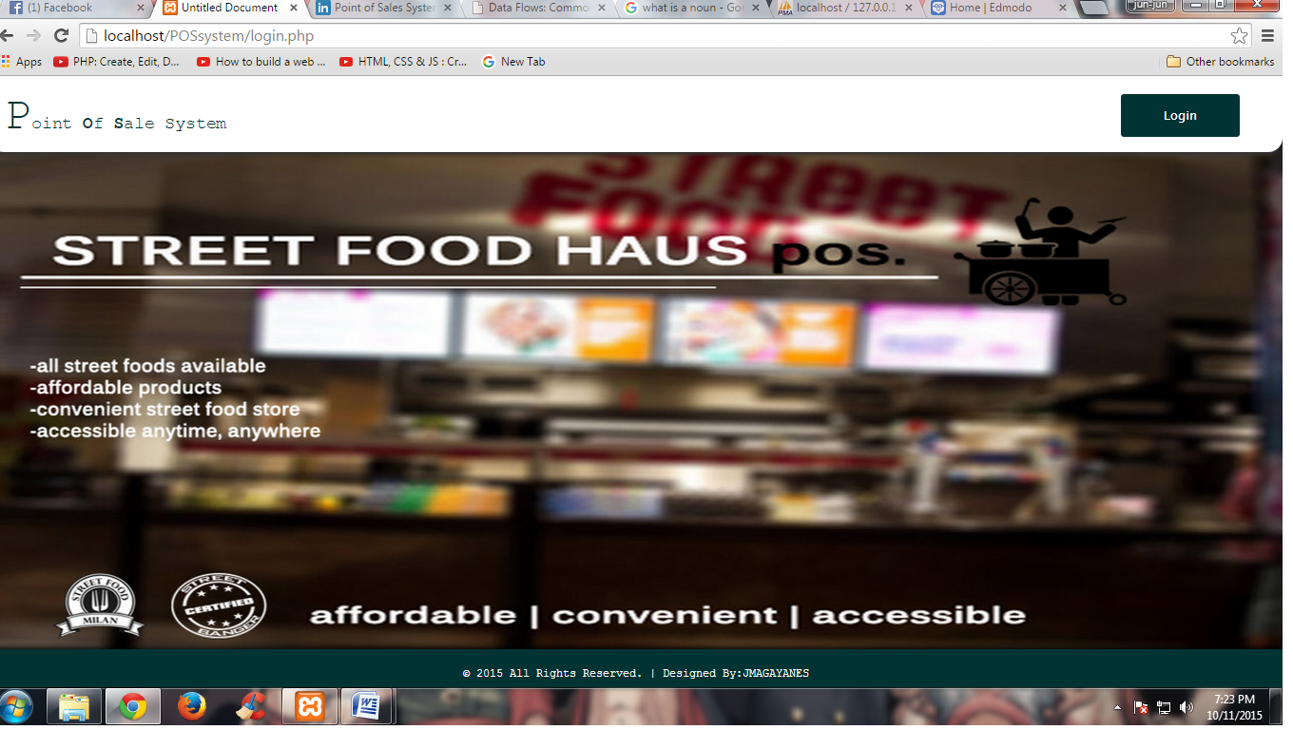 **I. System Design**

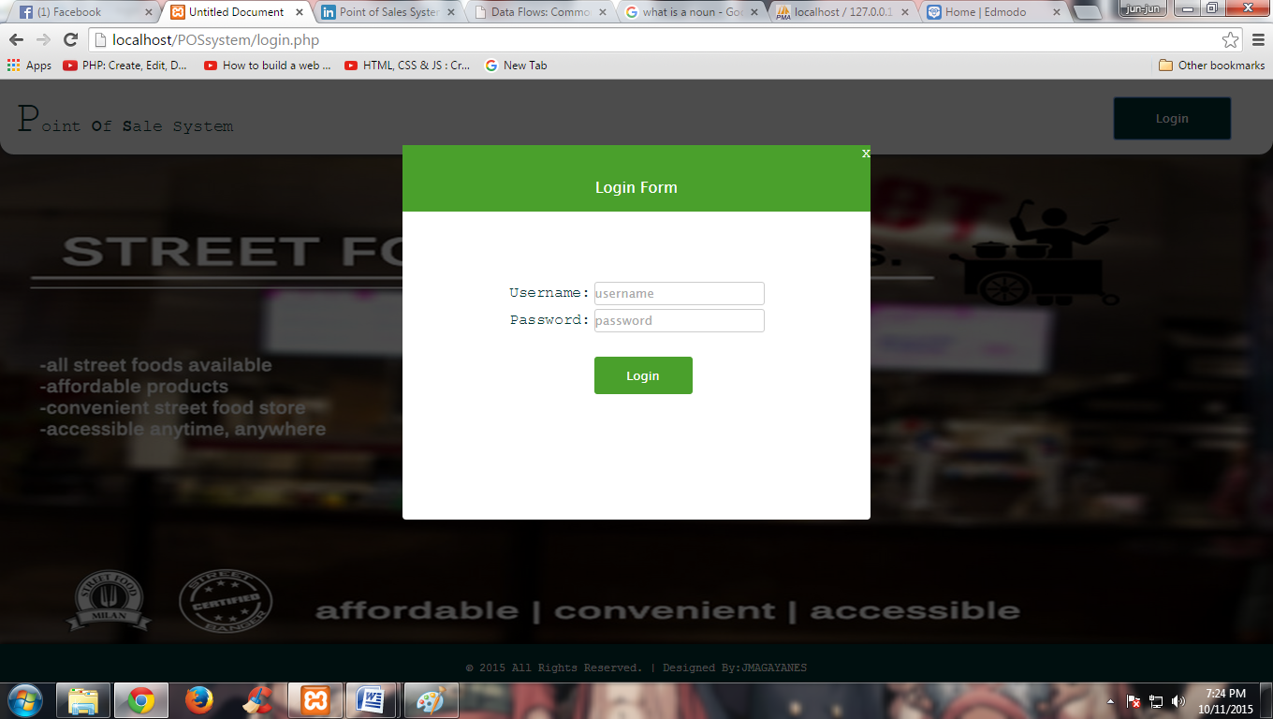

Figure 1.0 Index

Figure 2.0 Login Form

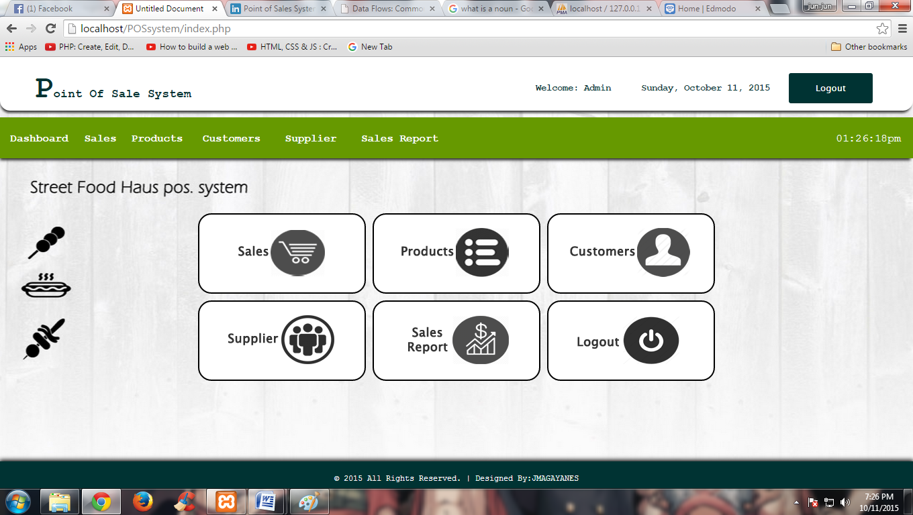

Figure 3.0 Dashboard

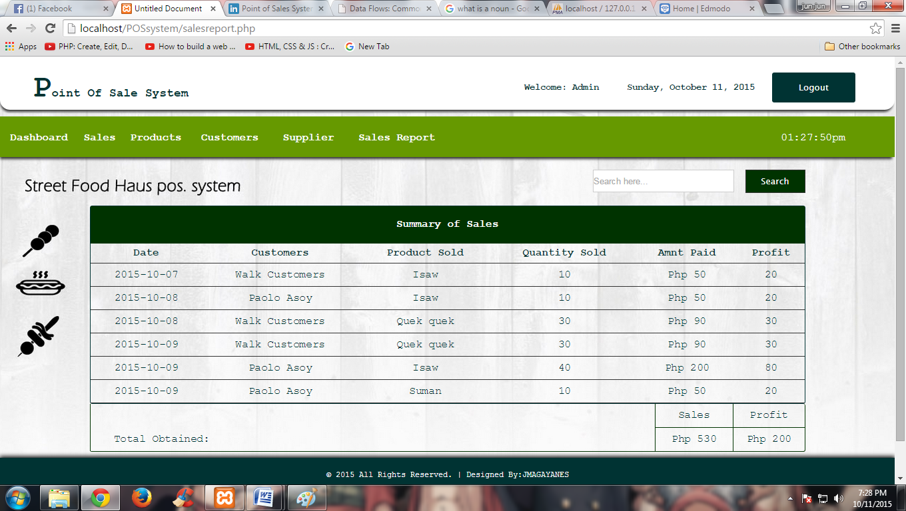

Figure 4.0 Sales Report

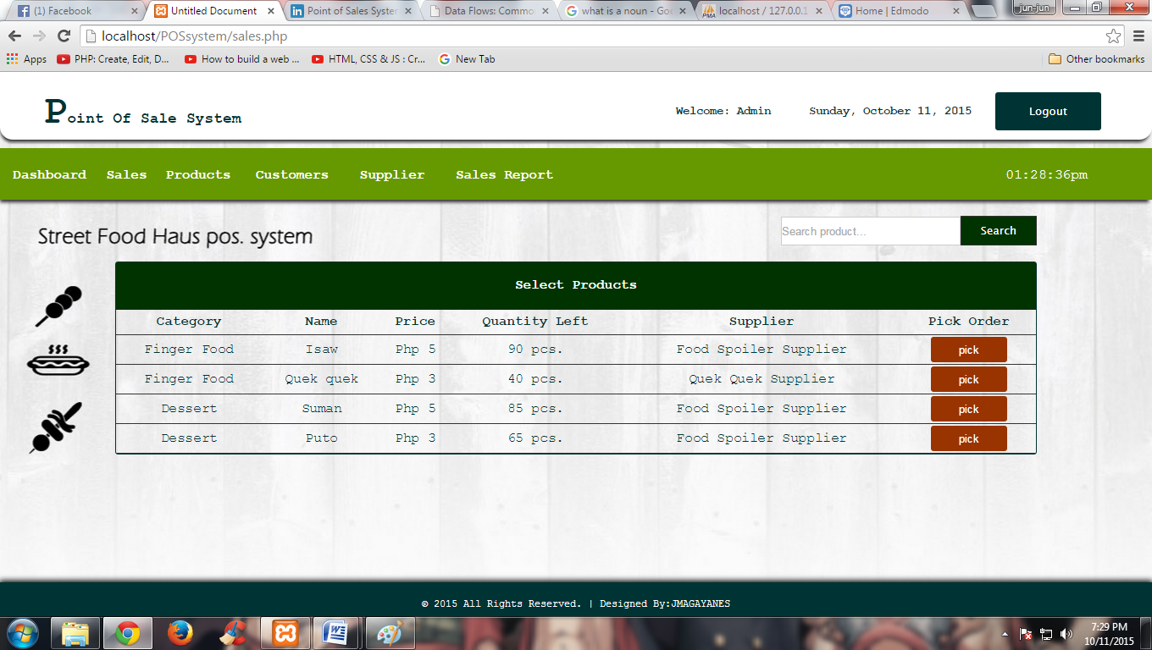

Figure 5.0 Sales

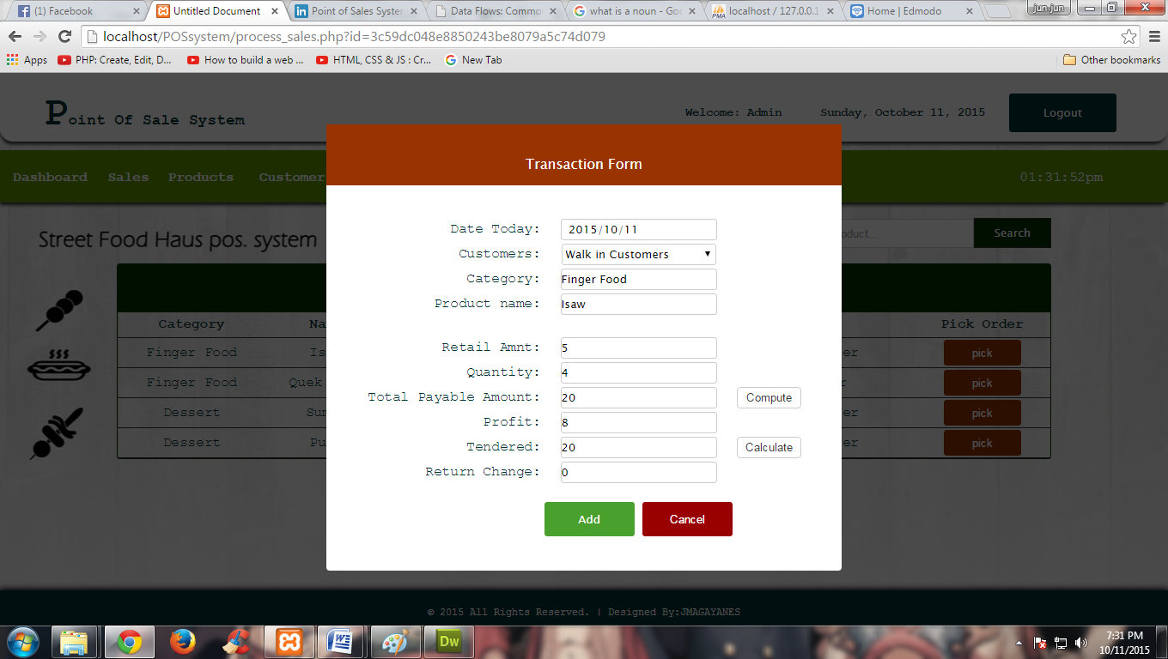

Figure 6.0 Transaction Form

**II. Database SCHEMA**

### Internal Schema

Table: Customers

**CREATE TABLE IF NOT EXISTS `customers` (**

**`id` int(11) NOT NULL,**

**`name` varchar(100) NOT NULL,**

**`contact` varchar(100) NOT NULL,**

**`address` varchar(100) NOT NULL,**

**`note` varchar(100) NOT NULL**

**) ENGINE=InnoDB DEFAULT CHARSET=latin1 AUTO_INCREMENT=12 ;**

**--**

**-- Dumping data for table `customers`**

**--**

**INSERT INTO `customers` (`id`, `name`, `contact`, `address`, `note`) VALUES**

**(7, 'Walk in Customers', 'na', 'na', 'na'),**

**(8, 'Paolo Asoy', '09456465465', 'Quezon City', 'na'),**

**(9, 'Carl Moneda', '09431215641', 'Valenzuela', 'na'),**

**(10, 'Ian Estabaya', '09644164565', 'Quezon City', 'na'),**

**(11, 'Jun Magayanes', '09641513561', 'Malabon', 'na');**

Table: Products

CREATE TABLE IF NOT EXISTS `products` (

`id` int(11) NOT NULL,

`category` varchar(100) NOT NULL,

`name` varchar(100) NOT NULL,

`quantity` int(11) NOT NULL,

`purchase` int(11) NOT NULL,

`retail` int(11) NOT NULL,

`supplier` varchar(100) NOT NULL

) ENGINE=InnoDB DEFAULT CHARSET=latin1 AUTO_INCREMENT=26 ;

--

-- Dumping data for table `products`

--

INSERT INTO `products` (`id`, `category`, `name`, `quantity`, `purchase`, `retail`, `supplier`) VALUES

(21, 'Finger Food', 'Beta max', 100, 3, 4, 'Mangboks betamax'),

(22, 'Finger Food', 'Quek quek', 100, 2, 3, 'Street Quek2x'),

(23, 'Finger Food', 'fish balls', 100, 1, 1, 'Stick Fishing ball'),

(24, 'Finger Food', 'Chicken Ball', 100, 3, 5, 'Stick Fishing ball'),

(25, 'Dessert', 'Puto', 100, 3, 5, 'kakanin atb.');

Table: Sales

CREATE TABLE IF NOT EXISTS `sales` (

`id` int(11) NOT NULL,

`dates` date NOT NULL,

`customers` varchar(100) NOT NULL,

`category` varchar(100) NOT NULL,

`name` varchar(100) NOT NULL,

`amnt` int(11) NOT NULL,

`quantity` int(11) NOT NULL,

`total` int(11) NOT NULL,

`profit` int(11) NOT NULL,

`tendered` int(11) NOT NULL,

`changed` int(11) NOT NULL

) ENGINE=InnoDB DEFAULT CHARSET=latin1 AUTO_INCREMENT=48 ;

Table: Supplier

**CREATE TABLE IF NOT EXISTS `supplier` (**

**`id` int(11) NOT NULL,**

**`suppliername` varchar(100) NOT NULL,**

**`contactperson` varchar(100) NOT NULL,**

**`address` varchar(100) NOT NULL,**

**`contactno` varchar(11) NOT NULL,**

**`note` varchar(200) NOT NULL**

**) ENGINE=InnoDB DEFAULT CHARSET=latin1 AUTO_INCREMENT=18 ;**

**--**

**-- Dumping data for table `supplier`**

**--**

**INSERT INTO `supplier` (`id`, `suppliername`, `contactperson`, `address`, `contactno`, `note`) VALUES**

**(13, 'Mangboks betamax', 'Juli Sanjuan', 'Malabon', '09215454654', 'na'),**

**(14, 'Siomai tbp.', 'Jezzy Jaime', 'Caloocan', '09646454564', 'na'),**

**(15, 'Stick Fishing ball', 'Nardo Besoza', 'Valenzuela', '06365465446', 'na'),**

**(16, 'kakanin atb.', 'Loui Cruz', 'Pasay', '09634654654', 'na'),**

**(17, 'Street Quek2x', 'Nilo Cruz', 'Pasig', '09765464164', 'na');**

Table: Users

**CREATE TABLE IF NOT EXISTS `users` (**

**`userid` int(11) NOT NULL,**

**`username` varchar(50) NOT NULL,**

**`password` varchar(50) NOT NULL,**

**`access` varchar(50) NOT NULL**

**) ENGINE=InnoDB DEFAULT CHARSET=latin1 AUTO_INCREMENT=3 ;**

**--**

**-- Dumping data for table `users`**

**--**

**INSERT INTO `users` (`userid`, `username`, `password`, `access`) VALUES**

**(1, 'admin', 'admin', 'Admin'),**

**(2, 'salesperson', 'salesperson', 'Salesperson');**

**--**

**-- Indexes for dumped tables**

**--**

**--**

**-- Indexes for table `customers`**

**--**

**ALTER TABLE `customers`**

**ADD PRIMARY KEY (`id`,`name`);**

**--**

**-- Indexes for table `products`**

**--**

**ALTER TABLE `products`**

**ADD PRIMARY KEY (`id`,`category`);**

**--**

**-- Indexes for table `sales`**

**--**

**ALTER TABLE `sales`**

**ADD PRIMARY KEY (`id`);**

**--**

**-- Indexes for table `supplier`**

**--**

**ALTER TABLE `supplier`**

**ADD PRIMARY KEY (`id`);**

**--**

**-- Indexes for table `users`**

**--**

**ALTER TABLE `users`**

**ADD PRIMARY KEY (`userid`);**

**--**

**-- AUTO_INCREMENT for dumped tables**

**--**

**--**

**-- AUTO_INCREMENT for table `customers`**

**--**

**ALTER TABLE `customers`**

**MODIFY `id` int(11) NOT NULL AUTO_INCREMENT,AUTO_INCREMENT=12;**

**--**

**-- AUTO_INCREMENT for table `products`**

**--**

**ALTER TABLE `products`**

**MODIFY `id` int(11) NOT NULL AUTO_INCREMENT,AUTO_INCREMENT=26;**

**--**

**-- AUTO_INCREMENT for table `sales`**

**--**

**ALTER TABLE `sales`**

**MODIFY `id` int(11) NOT NULL AUTO_INCREMENT,AUTO_INCREMENT=48;**

**--**

**-- AUTO_INCREMENT for table `supplier`**

**--**

**ALTER TABLE `supplier`**

**MODIFY `id` int(11) NOT NULL AUTO_INCREMENT,AUTO_INCREMENT=18;**

**--**

**-- AUTO_INCREMENT for table `users`**

**--**

**ALTER TABLE `users`**

**MODIFY `userid` int(11) NOT NULL AUTO_INCREMENT,AUTO_INCREMENT=3;**

Figure 7.0 Database Schema

**III. Entity Relationship DIAGRAM**

Contactno.

suppliername

name

note

contact

id

contactperson

address

SUPPLIER

CUSTOMERS

category

name

Prodname sold

customers

tendered

totalsales

Retail amnt

dates

profit

Quantity sold

id

dates

name

retail

quantity

name

purchase

quantity

id

note

ADD

REVIEW

ADMIN

SALES

RECORDS

SALESPERSON

SUPPLIES

PRODUCTS

SOLD

BOUGHT

Figure 8.0 Entity Relationship Diagram of Street Food Haus Pos System

**IV. system flowchart**

Start

Verify to dbpos

A

Homepage

yes

yes

Verify username password

Display Dashboard

If

Select Login

Input admin username

Input admin password

Verify to dbpos

B

no

no

A

yes

Verify username password

J

Display sales page

Input salesperson username

Input salesperson password

no

A

C

B

yes

If

Select Suppliers option

yes

Display Suppliers Page

If

Select Sales option

Display Sales Page

H

D

no

no

yes

If

Select Sales Report option

Display Sales Report Page

yes

If

Select Products option

Display Products Page

I

no

E

no

yes

If

Select Logout option

yes

If

Select Customers option

K

Display Customers Page

A

G

no

no

End

C

D

yes

Display Transaction Form Input quantity,tendered,customers

If

Select Pick item

no

yes

If

Select Submit Button

Save trandactions to sales table in dbpos

B

Calculate total payable amnt. & change

Transaction file

B

no

E

B

yes

yes

If

Select Submit Button

Display Add Item Form

Input Category,name,quantity,purchase amnt,retail,supplier

If

Select Add Button

Save info. To products table in dbpos

no

no

B

B

F

If

Select Search

no

No result

verify to dbpos

F

Verify if searched item exist

yes

yes

Display searched item

B

no

B

yes

yes

If

Select Edit Item

If

Select Update

Update info. To products table in dbpos

Display Edit Item Form

Edit name,quantity,purchase amnt,retail,supplier

B

no

no

B

If

Select Delete Item

yes

Delete info. To products table in dbpos

B

no

B

G

yes

yes

If

Select submit

If

Select Add button

Save info. To customers table in dbpos

Display Add Customers Form

Input name,contact,address note

no

no

verify to dbpos

B

B

yes

yes

no

Verify if searched item exist

Display searched item

No result

If

Select search

B

no

B

yes

If

Select delete

B

Delete info. To customer table in dbpos

no

B

H

yes

If

Select Submit Button

Display Add supplier Form

Input suppliername,contactperson,address,contact no.,note

Save info. To supplier table in dbpos

no

yes

If

Select add button

B

yes

no

verify to dbpos

Verify if searched item exist

Display searched item

B

no

yes

If

Select search

B

**V**

no

B

No result

yes

If

Select edit button

yes

B

Update info. To products table in dbpos

If

Select Update

no

Display Edit supplier Form

Edit suppliername,contact person,address,contact no.,note

B

no

yes

If

Select delete

Delete info. To supplier table in dbpos

B

B

no

I

verify to dbpos

yes

yes

Verify if searched item exist

If

Select search

Display searched item

B

no

no

B

No result

Display summary of sales

B

J

yes

If

Select pick item to be sold

Calculate total payable amnt. & change

Transaction file

Save trandactions to sales table in dbpos

K

K

yes

no

If

Select Submit Button

Display Transaction Form Input quantity,tendered,customers

no

yes

no

Display searched item

No result

yes

no

verify to dbpos

Verify if searched item exist

If

Select search

K

K

K

Figure 9.0 System Flow Chart Flow Chart of Street Food Haus Pos System

**V. DATA FLOW DIAGRAM**

1. **CONTEXT DIAGRAM**

VALIDATE ACCOUNT

ADMINISTRATOR

SALES REPORT

PRODUCTS

SUPPLIER

CUSTOMERS

ENTER AMNT. RECEIVED

0.0

STREET FOOD HAUS POS. SYSTEM

ENTER NO. OF PURCHASES

LOGIN SYSTEM

MODIFY PRODUCTS(ADD,EDIT,REMOVE)

VIEW PRODUCTS TABLE

LOGIN SYSTEM

MODIFY CUSTOMERS(ADD,REMOVE)

MODIFY SUPPLIER(ADD,EDIT,REMOVE)

GENERATE CHANGE

SALESPERSON

PRODUCE SALES REPORT/SUMMARY

VALIDATE ACCOUNT

Figure 10.0 Context Diagram of Street Food Haus Point of Sale System

1. **Top level**

2.0

VIEW DASHBOARD

1.0

LOGIN SYSTEM

ACCOUNT LOGIN

ADMIN

VALIDATE ACC.

VERIFY ACC.

A USERS

4.0

VIEW CUSTOMERS

5.0

VIEW SUPPLIER

3.0

VIEW PRODUCTS

EXIT ACCOUNT.

7.0

LOGOUT

6.0

VIEW SALES REPORT

Figure 11.0 Admin Top Level Diagram

VALIDATE ACC.

VERIFY ACC.

ACCOUNT LOGIN

A USERS

1.0

LOGIN SYSTEM

B PRODUCTS

3.0

SELECT PRODUCTS

2.0

VIEW PRODUCTS TABLE

CHECK PRODUCTS

SALESPERSON

CALCULATE NO. OF PURCHASES

COMPUTE CHANGE

RECEIVE CASH FROM CUSTOMERS

7.0

GENERATE CHANGE

6.0

ENTER AMNT RECEIVED

5.0

COMPUTE TOTAL PAYABLE AMNT

4.0

ENTER NO. OF PURCHASES

8.0

GENERATE DAILY SALES REPORT

C SALES

Figure 12.0 Salesperson Top Level Diagram

1. **BOTTOM LEVEL**

4.1

ADD CUSTOMER

4.2

DELETE CUSTOMER

B PRODUCTS

3.3

DELETE PRODUCTS

3.2

EDIT PRODUCTS

3.1

ADD PRODUCTS

REMOVE ITEM

SAVE ITEM

EDIT ITEM

SAVE CUSTOMER

REMOVE CUSTOMER

C CUSTOMERS

SAVE SUPPLIER

D SUPPLIER

5.3

DELETE SUPPLIER

5.2

EDIT SUPPLIER

5.1

ADD SUPPLIER

REMOVE SUPPLIER

EDIT ITEM

Figure 13.0 Admin Bottom Level Diagram

3.1

VIEW TRANSACTION FORM

C PRODUCTS

Figure 14.0 Salesperson Bottom Level Diagram

**Vi. unified modelling language (uml)**

1. Class diagram

**Records transaction**

Salesperson

Products

id

category

name

quantity

purchase

retail

supplier

Sales

Customers

id

name

contact

address

note

int(11)

varchar(100)

varchar(100)

varchar(100)

varchar(100)

**Process order transaction**

pick product

information

id

dates

customers

category

name

amnt

quantity

total

profit

tendered

changed

Admin

add

edit

delete

information

get id

get category

get name

get quantity

get purchase

get retail

get supplier

**Order**

int(11)

date

varchar(100)

varchar(100)

varchar(100)

int(11)

int(11)

int(11)

int(11)

int(11)

int(11)

int(11)

varchar(100)

varchar(100)

varchar(100)

varchar(11)

varchar(100)

id

suppliername

contactperson

address

contactno

note

Supplier

**Supplies**

**Sales records review**

**Add**

Figure 15.0 Class Diagram (UML) – Online Point of Sale System

1. OBJECT DIAGRAM

customer

order:Products

Quantity

Product sold

Salesperson

Profit

Purchase

Retail

Figure 16.0 Object Diagram (UML) – Online Point of Sale System

1. COMPONENT DIAGRAM

Sales

Salesperson

Products

Point of Sale System

Customer

Buy

Sold

Records

Figure 17.0 Component Diagram (UML) – Online Point of Sale System

Finish Ordering

1. DEPLOYMENT DIAGRAM

**<<Device>>**

**PC**

Php MyAdmin

**<<Device>>**

:sale

{Point of Sale}

:Sale

customer.sql

salesperson.sql

admin.sql

sales.sql

Figure 18.0 Deployment Diagram (UML) – Online Point of Sale System

1. USE CASE DIAGRAM

POS System

Buy Product

Enter quantity

Pay Bill

Process sales

**Salesperson**

Close Sale

Check inventory

**Customer**

Uodate Inventory

**Admin**

Figure 19.0 Use Case Diagram (UML) – Online Point of Sale System

F. SEQUENCE DIAGRAM

Sales

Salesperson

Product

Customer

**Buy**

**Sold**

**Records transaction information to**

**Bought by**

**From**

**Submitted by**

Figure 20.0 Sequence Diagram (UML) – Online Point of Sale System

G. COLLABORATION DIAGRAM

**2. Sold**

**1. Buy**

:Customer

:Salesperson

:Products

**4. Review**

**3. Records Transaction**

:Sales

:Admin

Figure 21.0 Collaboration Diagram (UML) – Online Point of Sale System

H. STATE CHART

Sold

Buy

Customer

Salesperson

Products

Sales

Records

Review

Admin

Figure 22.0 State Chart (UML) – Online Point of Sale System

I. Activity Diagram

Review

Transaction save to

Sold

Buy

Admin

Sales

Fill up ordered quantity, tendered

Salesperson

Products

Customer

Figure 23.0 Activity Diagram (UML) – Online Point of Sale System