**Website Building: Basic Layout**

HTML - Card

The following exercise contains the following subjects:

* CSS styling

**Instructions**

Create a basic card component like in the image below.

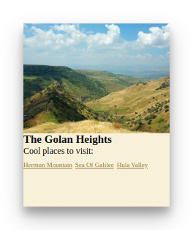

Do notice that the text has no space to breathe inside the card. Padding can fix this problem.

We will go over this in an upcoming lesson.