Background

Looks: Green, Wireframe grid/tron like

-takes the place of blue in game, see C in picture

Animation:

Background elements above character, that move, ex. pulses, circuits

-Supposed to act like the clouds of Mario

Trees that looks like Ethernet cable, see appendix A standing almost straight, Two-frame animation swinging back and forth, reflect the image and swap back and forth between them

* Supposed to look like the Trees in Mario, see D in picture

Platform- done in rectangular blocks to allow us to add and remove blocks and use them as platforms

Looks:

Top, compare to A in pic: neon pink top with darker pink 1’s and 0’s, see appendix B of varying size spread throughout

-this neon pink would take the place of the neon green on the ground, with the 1’s and 0’s taking the place of the little plants on the ground

Bottom, compare to B in pic: black with upright resistor symbols, see appendix C, in an accentuating color to the pink, they should act like columns

Character:

Looks: OG tesla, like what Brian put in the groupme

Animation: Everything can be done with two-frame animation for the most part

Check out this link to see the frame types we need: <http://www.retrogames.cz/play_006-NES.php?language=EN>

Essentially need a nonmoving character asset, and then another asset for him being in motion and then animate by switching between the two

Same for jumping, just one asset for jumping in the air.

Playing the game helps with deciding, but generally it’s just one asset frame for each things he does

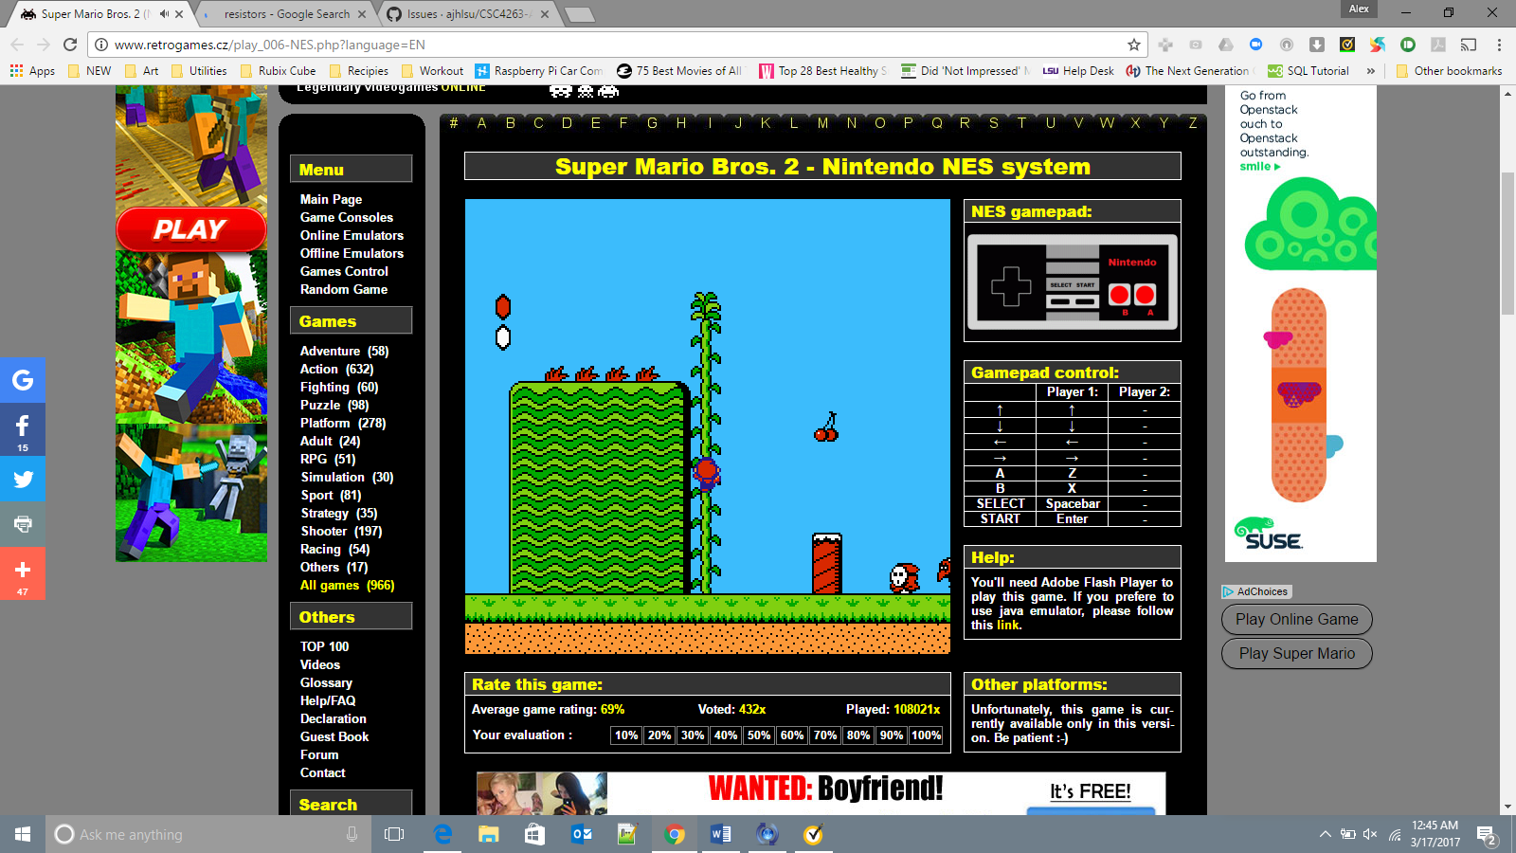

D

C

B

A

Appendix C

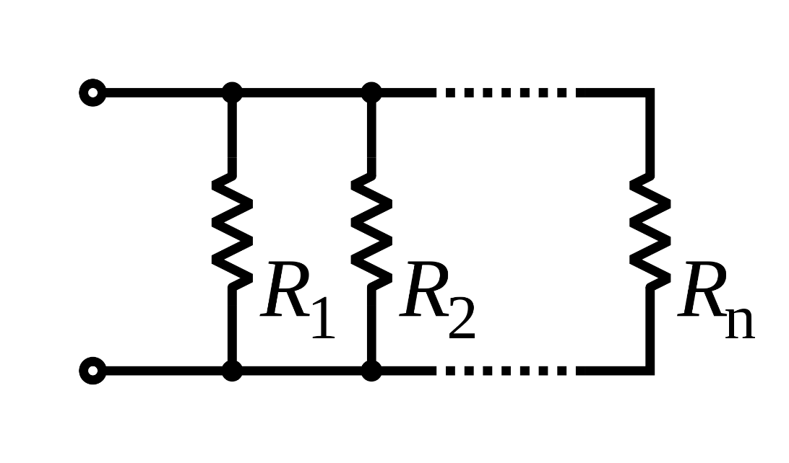

Appendix A

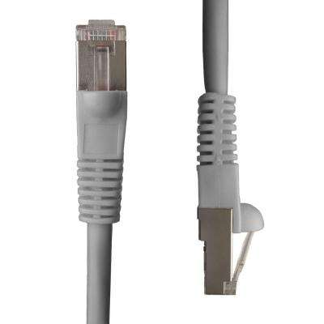

Appendix B

