Impact of Transmission Type on Fuel Efficiency in MTCARS Data Set

Allen Hammock

June 13, 2015

# Executive Summary

*To view the code for this report, check out the* [*repository on Github*](https://github.com/brainvat/RegressionModelsProject/blob/master/report.Rmd) *[1].*

At *Motor Trend*, a magazine about the automobile industry, we are interested in exploring the relationship between a transmission types and fuel efficiency measured in miles per gallon (MPG). We performed a study on 32 different models and found, as a group, that the motorcars with Automatic transmissions had an overall better mean fuel efficiency of 24.4 MPG versus vehicles with Manual transmissions which had an average 17.1 MPG.

However, when we look at *cars in different weight classes* and consider how many cylinders each vehicle has, we see that the transmission type has a much lower influence on fuel efficiency than these other factors. As the coeffecients on our linear model show, Manual and Automatic transmissions have approximately the same influence (less than 0.02 MPG difference) on fuel efficiency (MPG) if we hold the weight (wt coefficient) constant.

This is fairly intuitive, the fact that the heavier, "gas guzzling" cars with bigger engines tend to have a lower MPG suggests that the efficiences of automatic transmissions may be negligible compared to these other parameters.

**First Model: lm(mpg ~ TransType - 1, mtcars)**

From our initial fit ([the code](https://github.com/brainvat/RegressionModelsProject/blob/master/report.Rmd) [1] is hidden to save space), the expected value for MPG is just the coefficient, or the mean average of the fuel efficiency ratings for each transmission type. We have removed the intercept in all of our models.

## Estimate Std. Error t value Pr(>|t|)  
## TransTypeAuto 24.39231 1.359578 17.94109 1.376283e-17  
## TransTypeManual 17.14737 1.124603 15.24749 1.133983e-15

**Second Model: lm(mpg ~ wt + TransType - 1, mtcars)**

Now we adjust the outcome for the influence of both weight and transmission type. Here we see the difference between Manual and Automatic diminish dramatically.

## Estimate Std. Error t value Pr(>|t|)  
## wt -5.352811 0.7882438 -6.790807 1.867415e-07  
## TransTypeAuto 37.297936 2.0856607 17.883032 3.326182e-17  
## TransTypeManual 37.321551 3.0546385 12.217993 5.843477e-13

The t-test is significant and our confidence intervals for Manual vs. Automatic transmissions are very similar. The distribution of our residuals are normally distributed (**Figure 1**) for all three models so our assumptions that the errors are roughly iid $N(0,σ^{2})$ seem to hold.

## 2.5 % 97.5 %  
## wt -6.96 -3.74  
## TransTypeAuto 33.03 41.56  
## TransTypeManual 31.07 43.57

**Third Model: lm(mpg ~ wt + Cylinders + TransType - 1, mtcars)**

Finally we update the model to adjust for the total number of cylinders. As the number of cylinders increases, the MPG decreases. We see that having a Manual transmission accounts for a very small part of the variance now and that within the confidence interval the influence could be positive or negative since it is so close to zero.

In **Figure 2** we see a better dispersion of the residuals vs. the fitted values as we add these additional parameters suggesting that we have accounted for much of the systematic variance in our model.

We also did some digging for outliers and we found that the **Toyota Corolla** and **Fiat 128** are interesting examples to look at, as **Figure 3** suggests.

## Estimate Std. Error t value Pr(>|t|)  
## wt -3.1495978 0.9080495 -3.4685309 1.770987e-03  
## Cylinders4 33.9036951 2.0647406 16.4203170 1.412681e-15  
## Cylinders6 29.6463766 2.6989703 10.9843285 1.825314e-11  
## Cylinders8 27.8245763 3.2540014 8.5508802 3.644425e-09  
## TransTypeManual -0.1501031 1.3002231 -0.1154441 9.089474e-01

## 2.5 % 97.5 %  
## wt -5.01 -1.29  
## Cylinders4 29.67 38.14  
## Cylinders6 24.11 35.18  
## Cylinders8 21.15 34.50  
## TransTypeManual -2.82 2.52

# 

# Appendix

**Figure 1 -- Normal QQ**

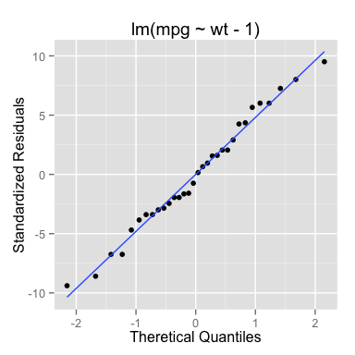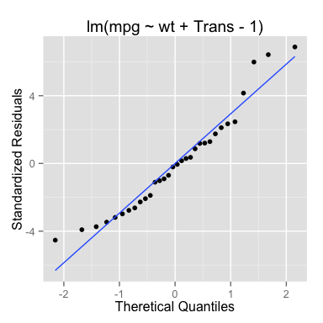 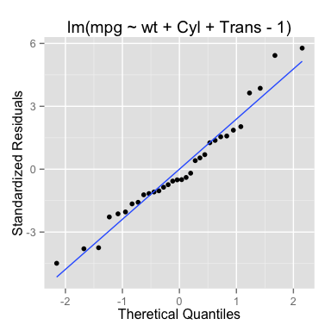

**Figure 2 - Fitted vs Residuals**

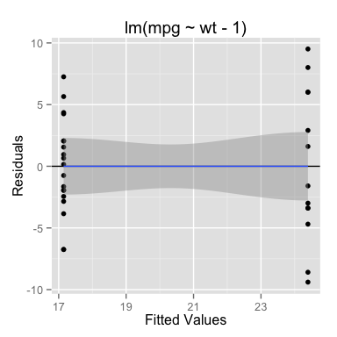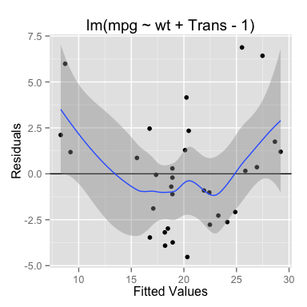 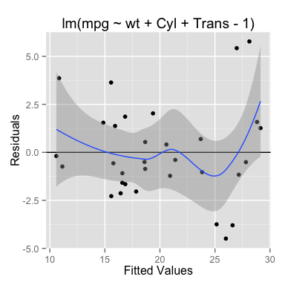

**Figure 3 - Outliers**

## mpg wt Cylinders TransType  
## Toyota Corolla 33.9 1.835 4 Auto  
## Fiat 128 32.4 2.200 4 Auto

|  |  |  |  |
| --- | --- | --- | --- |
|  | mpg ~ Trans | mpg ~ Trans | mpg ~ Cyl + Trans |
| Toyota Corolla | -28.05% | -18.95% | -17.04% |
| Fiat 128 | -24.72% | -21.23% | -16.75% |

**References**

<1> <https://github.com/brainvat/RegressionModelsProject/blob/master/report.Rmd>