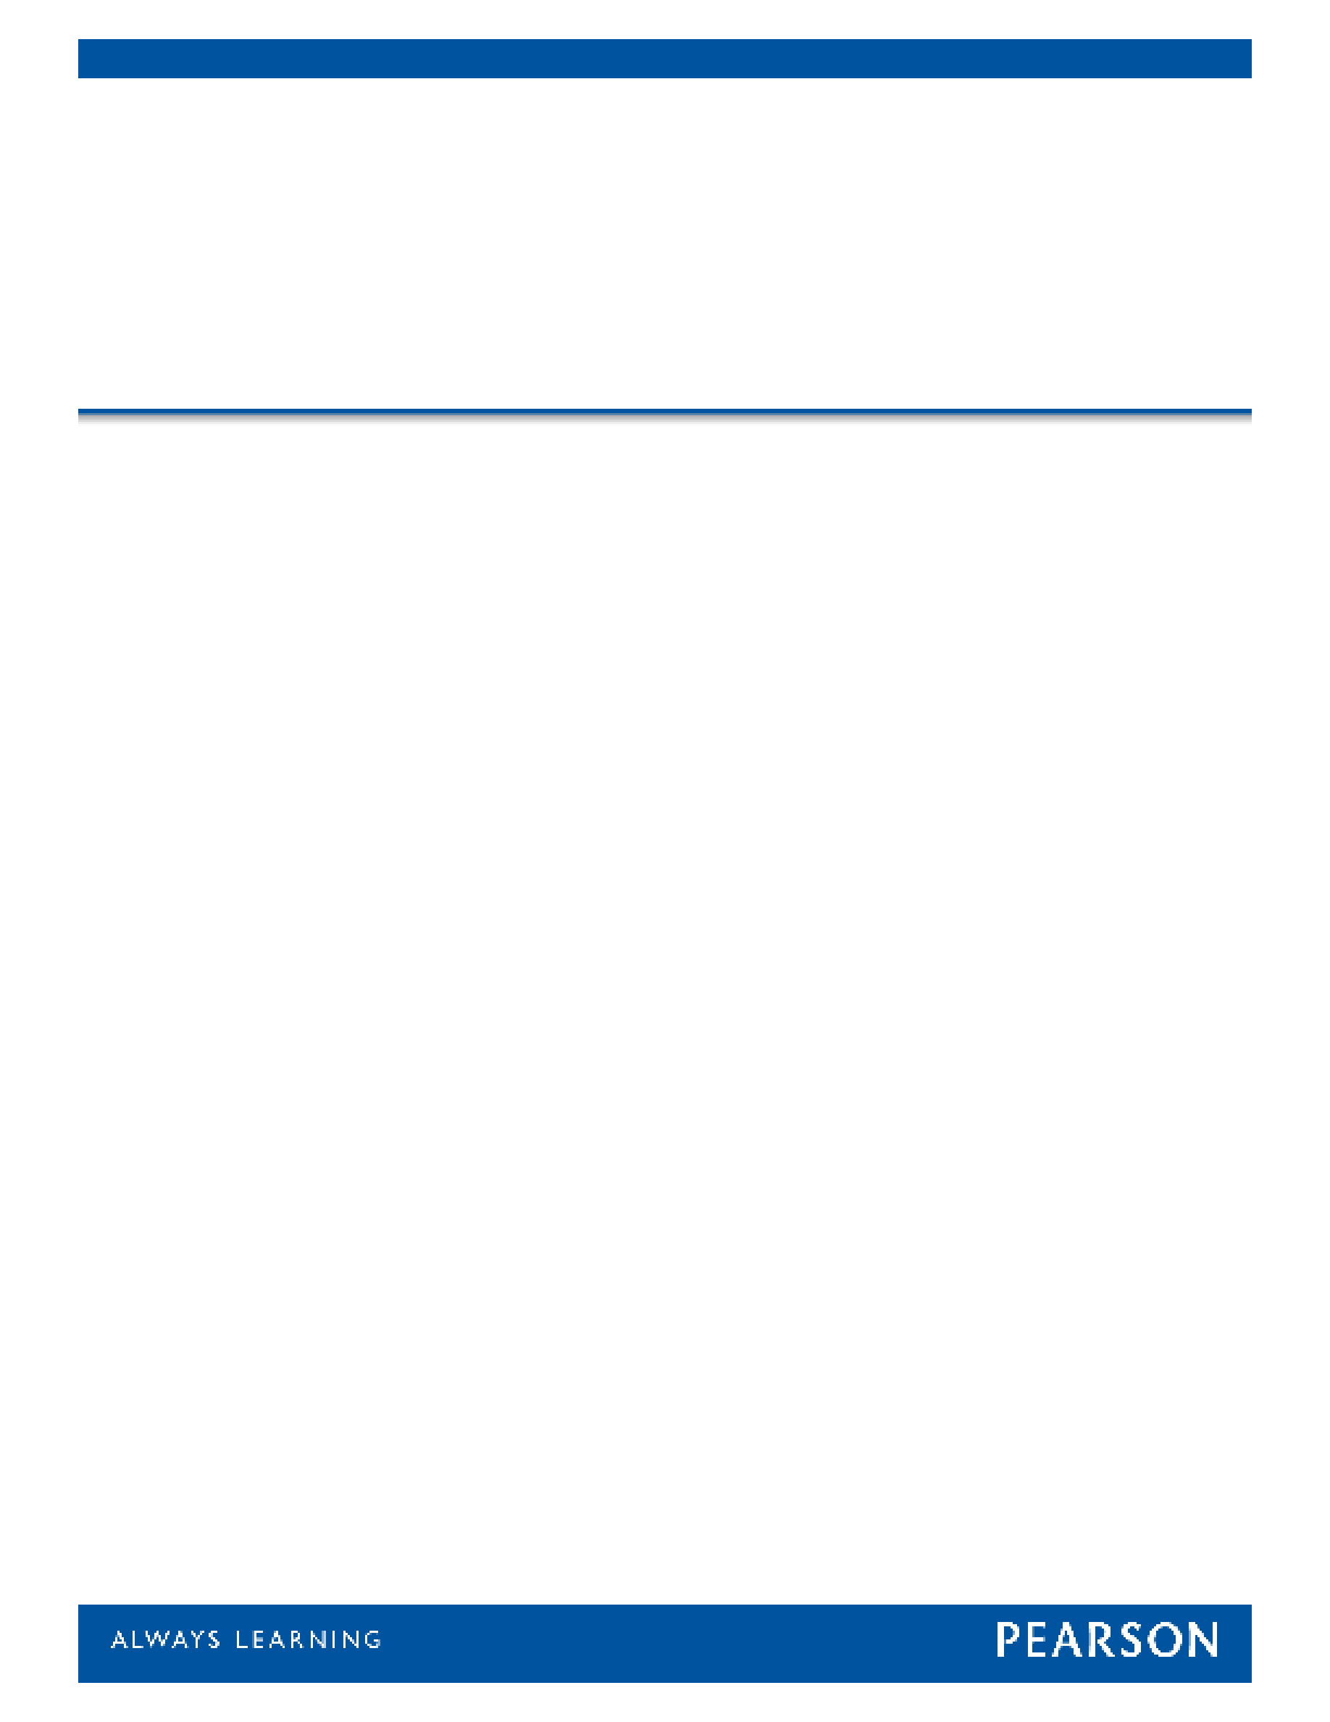



WAIS®-IV

Wechsler Adult Intelligence Scale®-Fourth Edition

Score Report



|  |  |  |  |  |  |  |
| --- | --- | --- | --- | --- | --- | --- |
| Examinee Name | Rosa Sierra |  | Date of Report | 2018/08/03 | | |
| Examinee ID | 8206 |  | Years of Education |  | | |
| Date of Birth | 1973/07/09 |  | Primary Language |  | | |
| Gender | Female |  | Handedness |  | | |
| Race/Ethnicity |  |  | Examiner Name | JOEY TRAMPUSH | | |
| Date of Testing | 2018/05/25 |  | Age at Testing | 44 years 10 months |  | Retest? No |

Comments:

|  |  |  |  |  |  |  |  |
| --- | --- | --- | --- | --- | --- | --- | --- |
| **Composite Score Summary** | | | | | | | |
| **Scale** | **Sum of**  **Scaled Scores** | **Composite**  **Score** | | **Percentile**  **Rank** | **95% Conf.**  **Interval** | | **Qualitative Description** |
| Verbal Comprehension | 35 | VCI | 108 | 70 | | 102-113 | Average |
| Perceptual Reasoning | 35 | PRI | 109 | 73 | | 102-115 | Average |
| Working Memory | 15 | WMI | 86 | 18 | | 80-94 | Low Average |
| Processing Speed | 21 | PSI | 102 | 55 | | 93-110 | Average |
| Full Scale | 106 | FSIQ | 104 | 61 | | 100-108 | Average |
| General Ability | 70 | GAI | 110 | 75 | | 105-115 | High Average |

Confidence Intervals are based on the Overall Average *SEM*s.

The GAI is an optional composite summary score that is less sensitive to the influence of working memory and processing speed. Because working memory and processing speed are vital to a comprehensive evaluation of cognitive ability, it should be noted that the GAI does not have the breadth of construct coverage as the FSIQ.

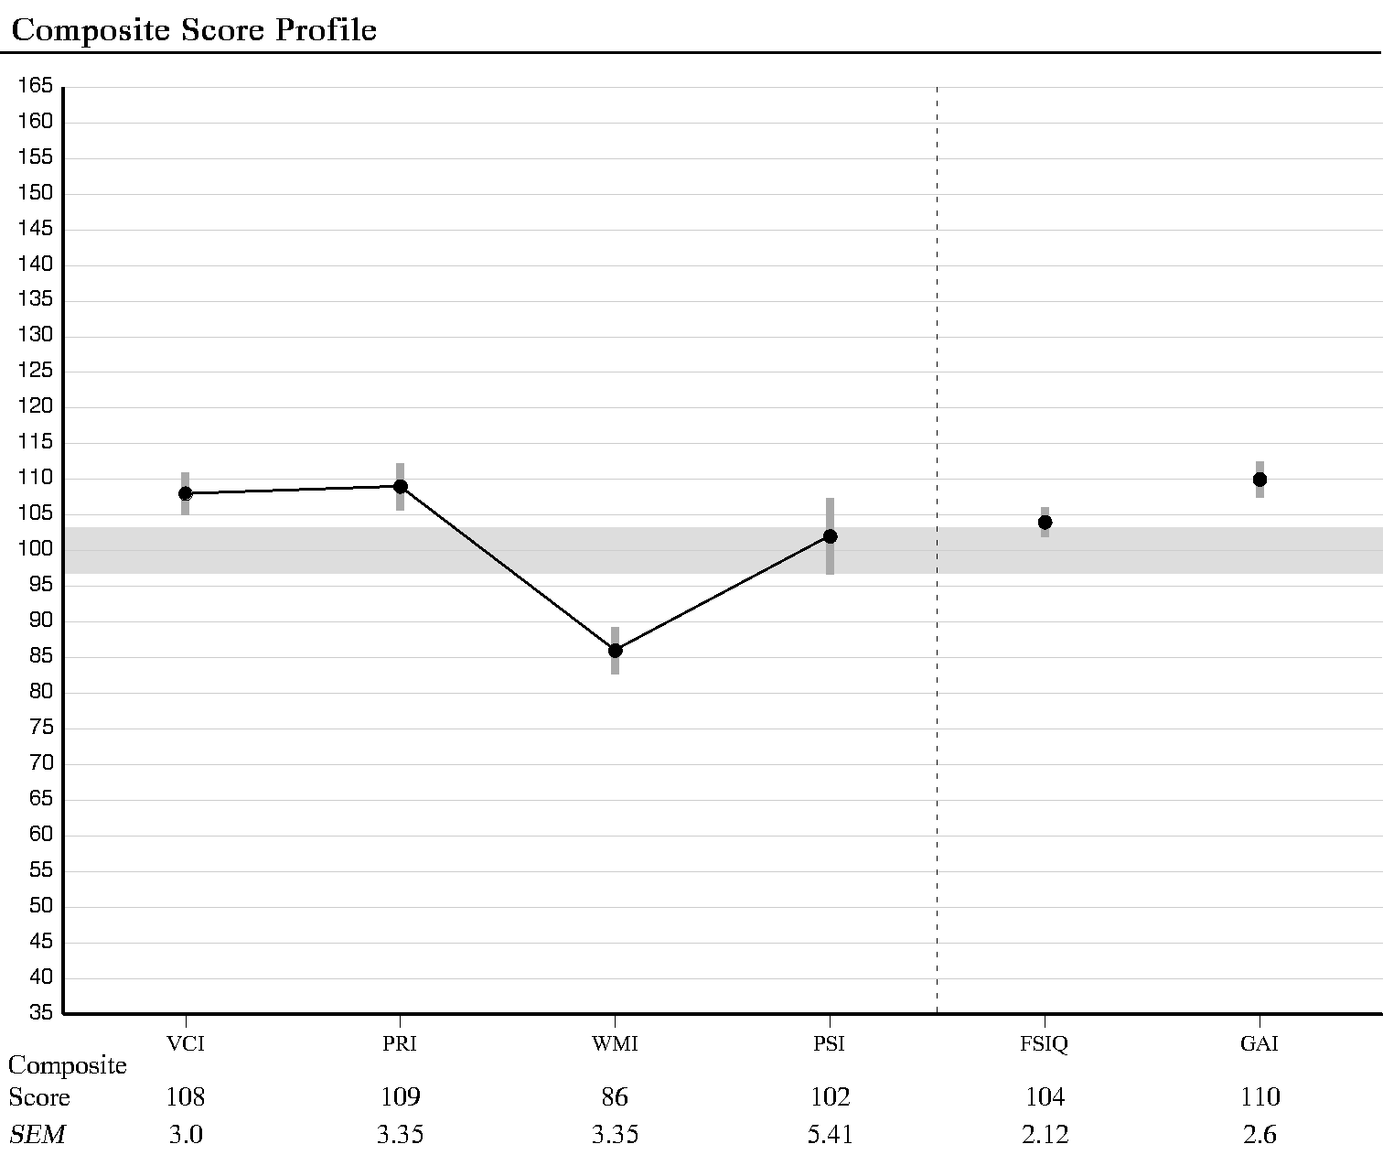

***Note.*** The vertical bars represent the standard error of measurement (*SEM*). *SEM* values are based on the examinee's age.

|  |
| --- |
| **ANALYSIS** |

|  |  |  |  |  |  |  |
| --- | --- | --- | --- | --- | --- | --- |
| **Index Level Discrepancy Comparisons** | | | | | | |
| **Comparison** | **Score 1** | **Score 2** | **Difference** | **Critical Value**  **.05** | **Significant Difference**  **Y/N** | **Base Rate by**  **Ability Level** |
| VCI - PRI | 108 | 109 | -1 | 8.81 | N | 46.7 |
| VCI - WMI | 108 | 86 | 22 | 8.81 | Y | 4.4 |
| VCI - PSI | 108 | 102 | 6 | 12.12 | N | 35.5 |
| PRI - WMI | 109 | 86 | 23 | 9.29 | Y | 4.1 |
| PRI - PSI | 109 | 102 | 7 | 12.47 | N | 30.4 |
| WMI - PSI | 86 | 102 | -16 | 12.47 | Y | 12.8 |
| FSIQ - GAI | 104 | 110 | -6 | 3.66 | Y | 15.4 |

Base Rate by Ability Level.

Statistical significance (critical value) at the .05 level.

|  |  |  |  |  |  |
| --- | --- | --- | --- | --- | --- |
| **Verbal Comprehension Subtests Summary** | | | | | |
| **Subtest** | **Raw Score** | **Scaled Score** | **Percentile Rank** | **Reference Group Scaled Score** | ***SEM*** |
| Similarities | 24 | 9 | 37 | 10 | 1.04 |
| Vocabulary | 46 | 12 | 75 | 13 | 0.73 |
| Information | 21 | 14 | 91 | 15 | 0.85 |

|  |  |  |  |  |  |
| --- | --- | --- | --- | --- | --- |
| **Perceptual Reasoning Subtests Summary** | | | | | |
| **Subtest** | **Raw Score** | **Scaled Score** | **Percentile Rank** | **Reference Group Scaled Score** | ***SEM*** |
| Block Design | 52 | 12 | 75 | 11 | 0.99 |
| Matrix Reasoning | 20 | 11 | 63 | 11 | 0.95 |
| Visual Puzzles | 17 | 12 | 75 | 11 | 1.04 |

|  |  |  |  |  |  |
| --- | --- | --- | --- | --- | --- |
| **Working Memory Subtests Summary** | | | | | |
| **Subtest** | **Raw Score** | **Scaled Score** | **Percentile Rank** | **Reference Group Scaled Score** | ***SEM*** |
| Digit Span | 25 | 8 | 25 | 8 | 0.73 |
| Arithmetic | 11 | 7 | 16 | 8 | 0.99 |
| (Letter-Number Seq.) | 19 | 9 | 37 | 9 | 1.12 |

|  |  |  |  |  |  |
| --- | --- | --- | --- | --- | --- |
| **Processing Speed Subtests Summary** | | | | | |
| **Subtest** | **Raw Score** | **Scaled Score** | **Percentile Rank** | **Reference Group Scaled Score** | ***SEM*** |
| Symbol Search | 35 | 11 | 63 | 10 | 1.56 |
| Coding | 70 | 10 | 50 | 9 | 1.20 |

|  |  |  |  |  |  |  |
| --- | --- | --- | --- | --- | --- | --- |
| **Subtest Level Discrepancy Comparisons** | | | | | | |
| **Subtest Comparison** | **Score 1** | **Score 2** | **Difference** | **Critical Value**  **.05** | **Significant Difference**  **Y/N** | **Base Rate** |
| Digit Span - Arithmetic | 8 | 7 | 1 | 2.57 | N | 42.80 |
| Symbol Search - Coding | 11 | 10 | 1 | 3.41 | N | 42.60 |

Statistical significance (critical value) at the .05 level.

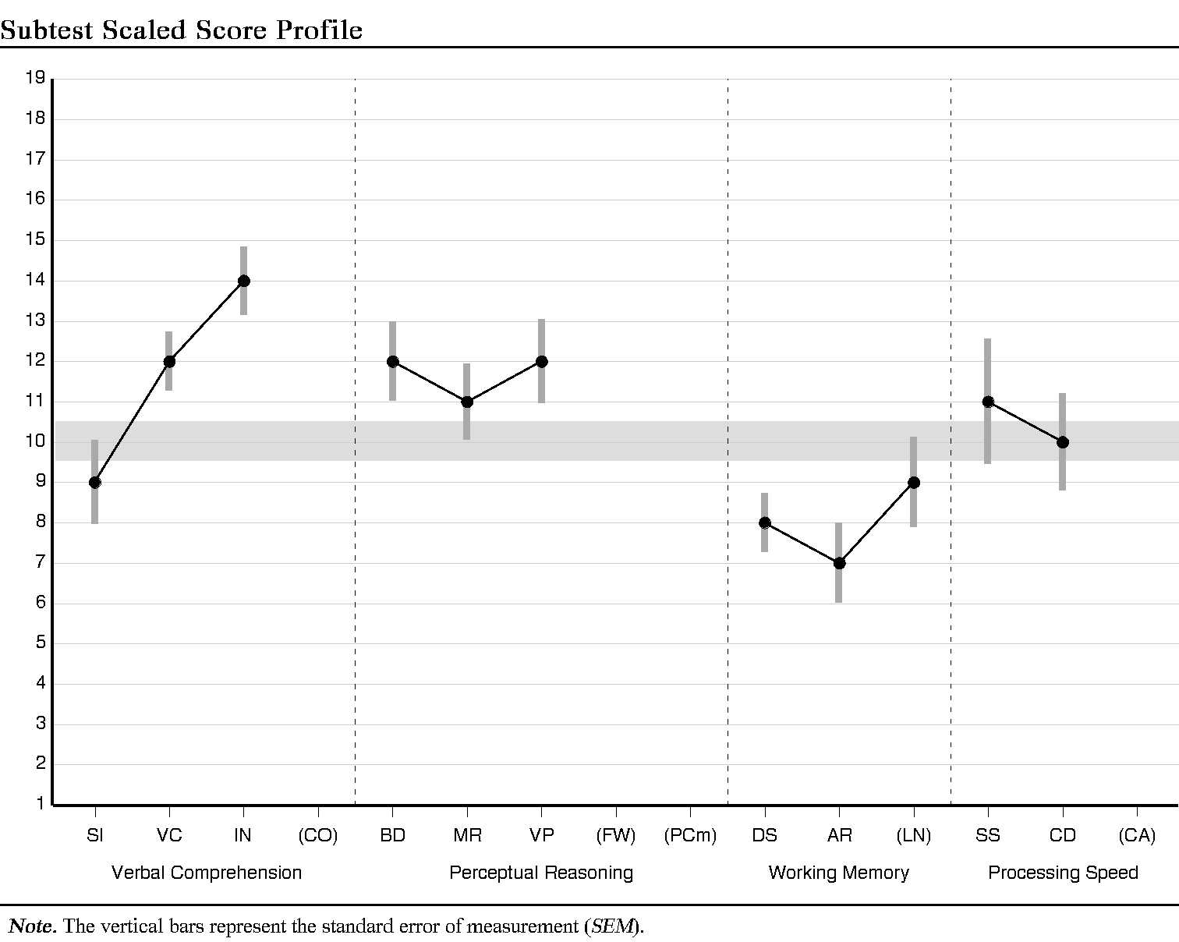

|  |
| --- |
| **DETERMINING STRENGTHS AND WEAKNESSES** |

|  |  |  |  |  |  |  |
| --- | --- | --- | --- | --- | --- | --- |
| **Differences Between Subtest and Verbal Comprehension and Perceptual Reasoning Mean of Subtest Scores** | | | | | | |
| **Subtest** | **Subtest**  **Scaled Score** | **Mean**  **Scaled Score** | **Difference** | **Critical Value .05** | **Strength or Weakness** | **Base Rate** |
| Block Design | 12 | 11.67 | 0.33 | 2.05 |  | >25% |
| Similarities | 9 | 11.67 | -2.67 | 1.91 | W | 5% |
| Matrix Reasoning | 11 | 11.67 | -0.67 | 1.92 |  | >25% |
| Vocabulary | 12 | 11.67 | 0.33 | 1.58 |  | >25% |
| Visual Puzzles | 12 | 11.67 | 0.33 | 1.99 |  | >25% |
| Information | 14 | 11.67 | 2.33 | 1.64 | S | 10% |

Verbal Comprehension: Mean = 11.67, Scatter = 5, Base rate = 12.1

Base Rate for Intersubtest Scatter is reported for 3 Verbal Comprehension Subtests.

Perceptual Reasoning: Mean = 11.67, Scatter = 1, Base rate = 97.5

Base Rate for Intersubtest Scatter is reported for 3 Perceptual Reasoning Subtests.

Statistical significance (critical value) at the .05 level.

|  |
| --- |
| **PROCESS ANALYSIS** |

|  |  |  |  |  |
| --- | --- | --- | --- | --- |
| **Perceptual Reasoning Process Score Summary** | | | | |
| **Process Score** | **Raw Score** | **Scaled Score** | **Percentile Rank** | ***SEM*** |
| Block Design No Time Bonus | 44 | 12 | 75 | 1.08 |

|  |  |  |  |  |  |
| --- | --- | --- | --- | --- | --- |
| **Working Memory Process Score Summary** | | | | | |
| **Process Score** | **Raw**  **Score** | **Scaled**  **Score** | **Percentile**  **Rank** | **Base Rate** | ***SEM*** |
| Digit Span Forward | 10 | 9 | 37 | -- | 1.20 |
| Digit Span Backward | 6 | 7 | 16 | -- | 1.12 |
| Digit Span Sequencing | 9 | 10 | 50 | -- | 1.24 |
| Longest Digit Span Forward | 6 | -- | -- | 81.0 | -- |
| Longest Digit Span Backward | 4 | -- | -- | 85.5 | -- |
| Longest Digit Span Sequence | 7 | -- | -- | 25.0 | -- |
| Longest Letter-Number Sequence | 5 | -- | -- | 77.0 | -- |

|  |  |  |  |  |  |  |
| --- | --- | --- | --- | --- | --- | --- |
| **Process Level Discrepancy Comparisons** | | | | | | |
| **Process Comparison** | **Score 1** | **Score 2** | **Difference** | **Critical Value**  **.05** | **Significant Difference**  **Y/N** | **Base Rate** |
| Block Design -  Block Design No Time Bonus | 12 | 12 | 0 | 3.08 | N |  |
| Digit Span Forward -  Digit Span Backward | 9 | 7 | 2 | 3.65 | N | 27.2 |
| Digit Span Forward -  Digit Span Sequencing | 9 | 10 | -1 | 3.60 | N | 45.2 |
| Digit Span Backward -  Digit Span Sequencing | 7 | 10 | -3 | 3.56 | N | 17.3 |
| Longest Digit Span Forward -  Longest Digit Span Backward | 6 | 4 | 2 | -- | -- | 61.5 |
| Longest Digit Span Forward -  Longest Digit Span Sequence | 6 | 7 | -1 | -- | -- | 13.5 |
| Longest Digit Span Backward -  Longest Digit Span Sequence | 4 | 7 | -3 | -- | -- | 12.5 |

Statistical significance (critical value) at the .05 level.

|  |  |  |  |  |  |  |
| --- | --- | --- | --- | --- | --- | --- |
| **Raw Scores** | | | | | | |
| **Subtest** | **Score**  **Range** | **Raw**  **Score** |  | **Process** | **Score**  **Range** | **Raw**  **Score** |
| Block Design | 0-66 | 52 |  | Block Design No Time Bonus | 0-48 | 44 |
| Similarities | 0-36 | 24 |  | Digit Span Forward | 0-16 | 10 |
| Digit Span | 0-48 | 25 |  | Digit Span Backward | 0-16 | 6 |
| Matrix Reasoning | 0-26 | 20 |  | Digit Span Sequencing | 0-16 | 9 |
| Vocabulary | 0-57 | 46 |  | Longest Digit Span Forward | 0, 2-9 | 6 |
| Arithmetic | 0-22 | 11 |  | Longest Digit Span Backward | 0, 2-8 | 4 |
| Symbol Search | 0-60 | 35 |  | Longest Digit Span Sequence | 0, 2-9 | 7 |
| Visual Puzzles | 0-26 | 17 |  | Longest Letter-Number Seq. | 0, 2-8 | 5 |
| Information | 0-26 | 21 |  |  |  |  |
| Coding | 0-135 | 70 |  |  |  |  |
| Letter-Number Seq. | 0-30 | 19 |  |  |  |  |
| Figure Weights | 0-27 |  |  |  |  |  |
| Comprehension | 0-36 |  |  |  |  |  |
| Cancellation | 0-72 |  |  |  |  |  |
| Picture Completion | 0-24 |  |  |  |  |  |

**End of Report**





WIAT®-III

Wechsler Individual Achievement Test®-Third Edition

Score Report



|  |  |  |  |  |  |  |
| --- | --- | --- | --- | --- | --- | --- |
| Examinee Name | Rosa Sierra |  | Date of Report | 2018/08/03 | | |
| Examinee ID | 8206 |  | Grade | N/A | | |
| Date of Birth | 1973/07/09 |  | Home Language | Not Specified | | |
| Gender | Female |  | Handedness | Not Specified | | |
| Race/Ethnicity | Not Specified |  | Examiner Name | JOEY TRAMPUSH | | |
| Date of Testing | 2018/05/25 |  | Age at Testing | 44 years 10 months |  | Retest? No |

Comments:

|  |  |
| --- | --- |
| **WIAT-III** | **Age Based Scores** |

|  |  |  |  |  |  |  |  |  |  |
| --- | --- | --- | --- | --- | --- | --- | --- | --- | --- |
| **Subtest Score Summary** | | | | | | | | | |
| **Subtest** | **Raw**  **Score** | **Standard**  **Score** | **95%**  **Confidence**  **Interval** | **Percentile**  **Rank** | **Normal**  **Curve**  **Equiv.** | **Stanine** | **Grade**  **Equiv.** | **Age**  **Equiv.** | **Growth**  **Score** |
| Listening Comprehension | - | 110 | 99-121 | 75 | 64 | 6 | N/A | N/A | N/A |
| Reading Comprehension | 391 | 98 | 86-110 | 45 | 47 | 5 | N/A | N/A | N/A |
| Math Problem Solving | 56 | 99 | 91-107 | 47 | 49 | 5 | N/A | N/A | N/A |
| Sentence Composition | - | 124 | 116-132 | 95 | 84 | 8 | N/A | N/A | N/A |
| Word Reading | 73 | 114 | 107-121 | 82 | 70 | 7 | N/A | N/A | N/A |
| Essay Composition | - | 103 | 92-114 | 58 | 54 | 5 | N/A | N/A | N/A |
| Pseudoword Decoding | 42 | 100 | 91-109 | 50 | 50 | 5 | N/A | N/A | N/A |
| Numerical Operations | 46 | 113 | 107-119 | 81 | 68 | 7 | N/A | N/A | N/A |
| Oral Expression | - | 112 | 102-122 | 79 | 67 | 7 | N/A | N/A | N/A |
| Oral Reading Fluency | 1231 | 86 | 79-93 | 18 | 30 | 3 | N/A | N/A | N/A |
| Spelling | 59 | 116 | 110-122 | 86 | 72 | 7 | N/A | N/A | N/A |
| Math Fluency-Addition | 48 | 112 | 100-124 | 79 | 67 | 7 | N/A | N/A | N/A |
| Math Fluency-Subtraction | 36 | 90 | 81-99 | 25 | 36 | 4 | N/A | N/A | N/A |
| Math Fluency-Multiplication | 40 | 118 | 109-127 | 88 | 75 | 7 | N/A | N/A | N/A |
| - Indicates a subtest with multiple raw scores (shown in the Subtest Component Score Summary). | | | | | | | | | |
| 1 Indicates a raw score that is converted to a weighted raw score (not shown). | | | | | | | | | |
| 2 Indicates that a raw score is based on a below grade level item set. | | | | | | | | | |

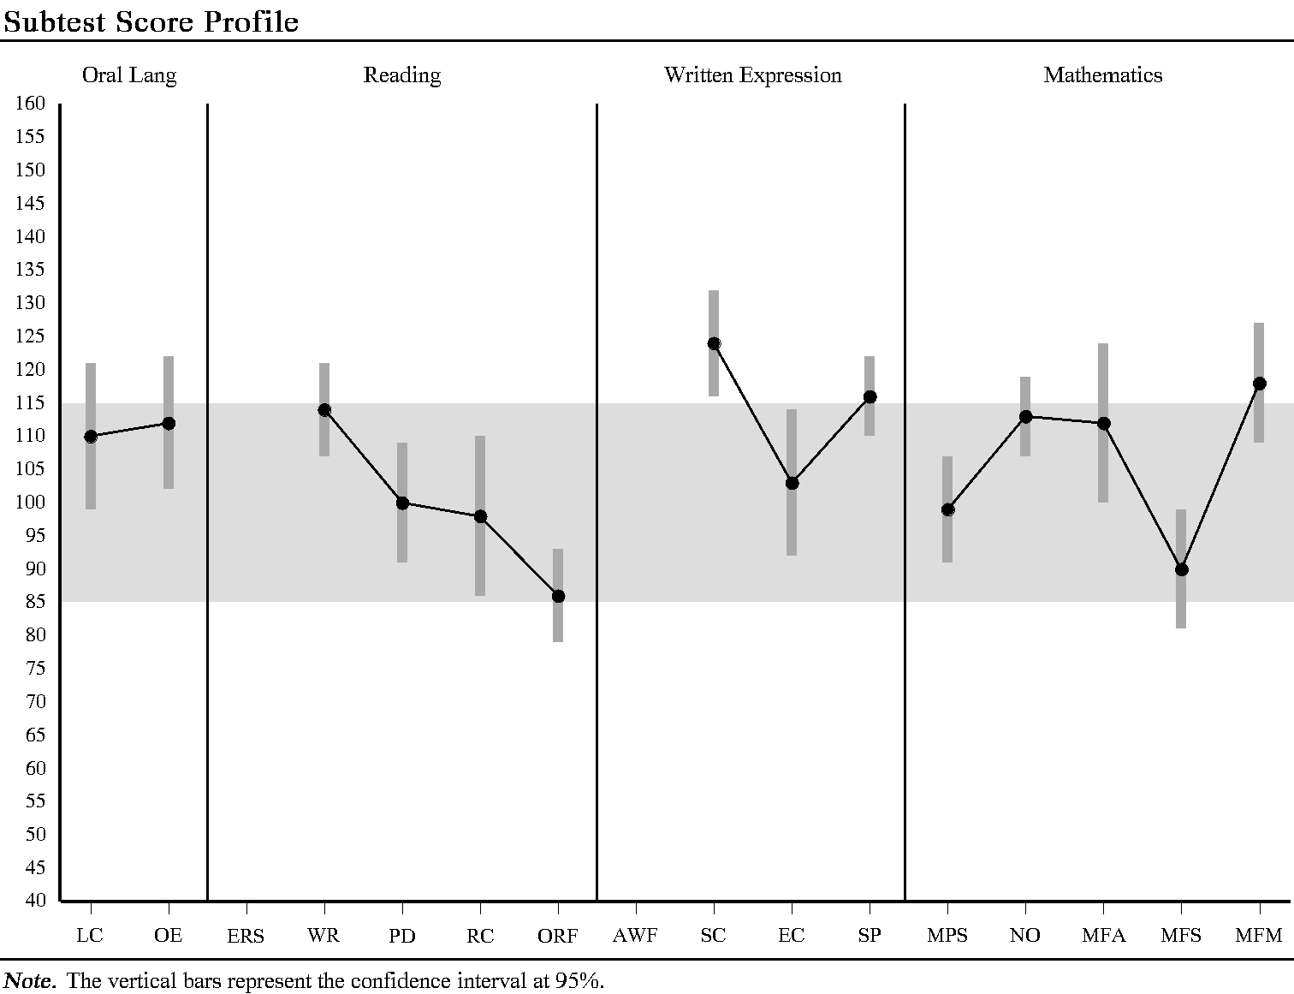

|  |  |  |  |  |  |  |  |  |  |
| --- | --- | --- | --- | --- | --- | --- | --- | --- | --- |
| **Supplemental Subtest Score Summary** | | | | | | | | | |
| **Subtest** | **Raw**  **Score** | **Standard**  **Score** | **95%**  **Confidence**  **Interval** | **Percentile**  **Rank** | **Normal**  **Curve**  **Equiv.** | **Stanine** | **Grade**  **Equiv.** | **Age**  **Equiv.** | **Growth**  **Score** |
| Oral Reading Accuracy | 370* | 88 | 73-103 | 21 | 33 | 3 | N/A | N/A | N/A |
| Oral Reading Rate | 181* | 88 | 80-96 | 21 | 33 | 3 | N/A | N/A | N/A |
| *Indicates a raw score that is converted to a weighted raw score (not shown). | | | | | | | | | |

|  |  |
| --- | --- |
| **Cumulative Percentages** | |
| **Word Reading Speed** | The score is the same as or higher than the scores obtained by 50% of students in the normative sample; 50% of students in the normative sample scored higher than this score. |
| **Pseudoword Decoding Speed** | The score is the same as or higher than the scores obtained by 50% of students in the normative sample; 50% of students in the normative sample scored higher than this score. |

|  |  |  |  |  |  |  |
| --- | --- | --- | --- | --- | --- | --- |
| **Subtest Component Score Summary** | | | | | | |
| **Subtest Component** | **Raw**  **Score** | **Standard**  **Score** | **Percentile**  **Rank** | **Normal**  **Curve**  **Equivalent** | **Stanine** | **Qualitative**  **Description** |
| **Listening Comprehension** |  |  |  |  |  |  |
| Receptive Vocabulary | 18 | 114 | 82 | 70 | 7 | Average |
| Oral Discourse Comprehension | 21 | 104 | 61 | 56 | 6 | Average |
| **Sentence Composition** |  |  |  |  |  |  |
| Sentence Combining | 24 | 124 | 95 | 84 | 8 | Above Average |
| Sentence Building | 28 | 116 | 86 | 72 | 7 | Above Average |
| **Essay Composition** |  |  |  |  |  |  |
| Word Count | 145 | 108 | 70 | 61 | 6 | Average |
| Theme Development and  Text Organization | 7 | 97 | 42 | 46 | 5 | Average |
| **Oral Expression** |  |  |  |  |  |  |
| Expressive Vocabulary | 16 | 112 | 79 | 67 | 7 | Average |
| Oral Word Fluency | 48 | 123 | 94 | 82 | 8 | Above Average |
| Sentence Repetition | 22 | 93 | 32 | 40 | 4 | Average |

|  |  |  |  |  |  |  |  |  |  |
| --- | --- | --- | --- | --- | --- | --- | --- | --- | --- |
| **Composite Score Summary** | | | | | | | | | |
| **Composite** | **Sum of Subtest**  **Standard Scores** | **Standard**  **Score** | **95%**  **Confidence**  **Interval** | **Percentile**  **Rank** | **Normal**  **Curve**  **Equiv.** | **Stanine** | **Qualitative**  **Description** |
| Oral Language | 222 | 113 | 105-121 | 81 | 68 | 7 | Average |
| Total Reading | 398 | 97 | 92-102 | 42 | 46 | 5 | Average |
| Basic Reading | 214 | 107 | 101-113 | 68 | 60 | 6 | Average |
| Reading Comprehension  and Fluency | 184 | 90 | 81-99 | 25 | 36 | 4 | Average |
| Written Expression | 343 | 119 | 113-125 | 90 | 77 | 8 | Above Average |
| Mathematics | 212 | 107 | 102-112 | 68 | 60 | 6 | Average |
| Math Fluency | 320 | 107 | 100-114 | 68 | 60 | 6 | Average |
| Total Achievement | 1059 | 108 | 104-112 | 70 | 61 | 6 | Average |

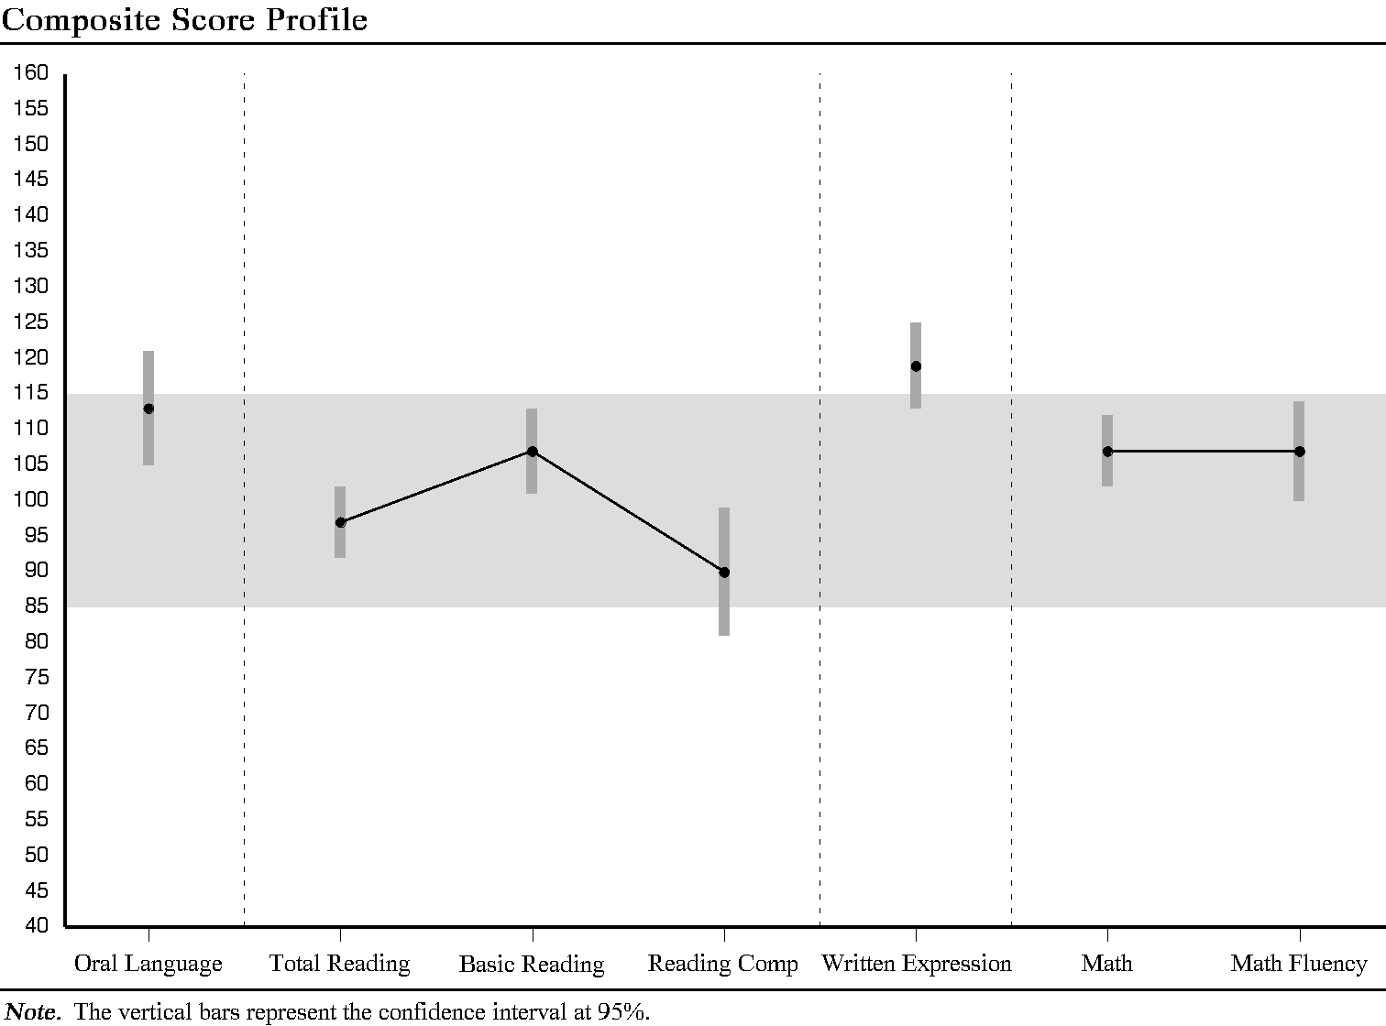

|  |  |  |  |  |
| --- | --- | --- | --- | --- |
| **Differences Between Composite Standard Scores** | | | | |
| **Comparison** | **Difference** | **Critical Value**  **(Significance**  **Level .01)** | **Significant**  **Difference**  **Y/N** | **Base Rate** |
| Oral Language vs. Total Reading | 16 | 10.66 | Y | >15% |
| Oral Language vs. Basic Reading | 6 | 10.85 | N | >15% |
| Oral Language vs. Reading Comprehension and Fluency | 23 | 13.20 | Y | <=5% |
| Oral Language vs. Written Expression | -6 | 11.91 | N | >15% |
| Oral Language vs. Mathematics | 6 | 10.66 | N | >15% |
| Oral Language vs. Math Fluency | 6 | 11.91 | N | >15% |
| Total Reading vs. Basic Reading | -10 | 8.31 | Y | <=10% |
| Total Reading vs. Reading Comprehension and Fluency | 7 | 11.21 | N | >15% |
| Total Reading vs. Written Expression | -22 | 9.66 | Y | <=5% |
| Total Reading vs. Mathematics | -10 | 8.06 | Y | >15% |
| Total Reading vs. Math Fluency | -10 | 9.66 | Y | >15% |
| Basic Reading vs. Reading Comprehension and Fluency | 17 | 11.39 | Y | <=15% |
| Basic Reading vs. Written Expression | -12 | 9.87 | Y | >15% |
| Basic Reading vs. Mathematics | 0 | 8.31 | N | >15% |
| Basic Reading vs. Math Fluency | 0 | 9.87 | N | >15% |
| Reading Comprehension and Fluency vs. Written Expression | -29 | 12.41 | Y | <=1% |
| Reading Comprehension and Fluency vs. Mathematics | -17 | 11.21 | Y | >15% |
| Reading Comprehension and Fluency vs. Math Fluency | -17 | 12.41 | Y | >15% |
| Written Expression vs. Mathematics | 12 | 9.66 | Y | >15% |
| Written Expression vs. Math Fluency | 12 | 11.02 | Y | >15% |
| Mathematics vs. Math Fluency | 0 | 9.66 | N | >15% |
| ***Note.*** A negative difference indicates that the second composite has a higher score than the first composite listed in the comparison. | | | | |

|  |  |  |  |  |
| --- | --- | --- | --- | --- |
| **Differences Between Subtest Standard Scores** | | | | |
| **Comparison** | **Difference** | **Critical Value**  **(Significance**  **Level .01)** | **Significant**  **Difference**  **Y/N** | **Base Rate** |
| Listening Comprehension vs. Reading Comprehension | 12 | 18.68 | N | >15% |
| Listening Comprehension vs. Math Problem Solving | 11 | 14.94 | N | >15% |
| Listening Comprehension vs. Sentence Composition | -14 | 16.98 | N | >15% |
| Listening Comprehension vs. Word Reading | -4 | 14.39 | N | >15% |
| Listening Comprehension vs. Essay Composition | 7 | 17.34 | N | >15% |
| Listening Comprehension vs. Pseudoword Decoding | 10 | 14.81 | N | >15% |
| Listening Comprehension vs. Numerical Operations | -3 | 13.82 | N | >15% |
| Listening Comprehension vs. Oral Expression | -2 | 16.61 | N | >15% |
| Listening Comprehension vs. Oral Reading Fluency | 24 | 14.39 | Y | <=10% |
| Listening Comprehension vs. Spelling | -6 | 13.97 | N | >15% |
| Listening Comprehension vs. Math Fluency-Addition | -2 | 18.79 | N | >15% |
| Listening Comprehension vs. Math Fluency-Subtraction | 20 | 16.00 | Y | <=15% |
| Listening Comprehension vs. Math Fluency-Multiplication | -8 | 16.37 | N | >15% |
| Reading Comprehension vs. Math Problem Solving | -1 | 16.72 | N | >15% |
| Reading Comprehension vs. Sentence Composition | -26 | 18.56 | Y | <=10% |
| Reading Comprehension vs. Word Reading | -16 | 16.23 | N | <=15% |
| Reading Comprehension vs. Essay Composition | -5 | 18.90 | N | >15% |
| Reading Comprehension vs. Pseudoword Decoding | -2 | 16.60 | N | >15% |
| Reading Comprehension vs. Numerical Operations | -15 | 15.73 | N | >15% |
| Reading Comprehension vs. Oral Expression | -14 | 18.22 | N | >15% |
| Reading Comprehension vs. Oral Reading Fluency | 12 | 16.23 | N | >15% |
| Reading Comprehension vs. Spelling | -18 | 15.86 | Y | <=15% |
| Reading Comprehension vs. Math Fluency-Addition | -14 | 20.23 | N | >15% |
| Reading Comprehension vs. Math Fluency-Subtraction | 8 | 17.67 | N | >15% |
| Reading Comprehension vs. Math Fluency-Multiplication | -20 | 18.01 | Y | >15% |
| Math Problem Solving vs. Sentence Composition | -25 | 14.79 | Y | <=10% |
| Math Problem Solving vs. Word Reading | -15 | 11.73 | Y | >15% |
| Math Problem Solving vs. Essay Composition | -4 | 15.21 | N | >15% |
| Math Problem Solving vs. Pseudoword Decoding | -1 | 12.24 | N | >15% |
| Math Problem Solving vs. Numerical Operations | -14 | 11.02 | Y | <=15% |
| Math Problem Solving vs. Oral Expression | -13 | 14.36 | N | >15% |
| Math Problem Solving vs. Oral Reading Fluency | 13 | 11.73 | Y | >15% |
| Math Problem Solving vs. Spelling | -17 | 11.21 | Y | <=15% |
| Math Problem Solving vs. Math Fluency-Addition | -13 | 16.84 | N | >15% |
| Math Problem Solving vs. Math Fluency-Subtraction | 9 | 13.66 | N | >15% |
| Math Problem Solving vs. Math Fluency-Multiplication | -19 | 14.09 | Y | <=15% |
| Sentence Composition vs. Word Reading | 10 | 14.23 | N | >15% |
| Sentence Composition vs. Essay Composition | 21 | 17.21 | Y | >15% |
| Sentence Composition vs. Pseudoword Decoding | 24 | 14.65 | Y | <=10% |
| Sentence Composition vs. Numerical Operations | 11 | 13.65 | N | >15% |
| Sentence Composition vs. Oral Expression | 12 | 16.47 | N | >15% |
| Sentence Composition vs. Oral Reading Fluency | 38 | 14.23 | Y | <=1% |
| Sentence Composition vs. Spelling | 8 | 13.80 | N | >15% |
| Sentence Composition vs. Math Fluency-Addition | 12 | 18.67 | N | >15% |
| Sentence Composition vs. Math Fluency-Subtraction | 34 | 15.86 | Y | <=5% |
| Sentence Composition vs. Math Fluency-Multiplication | 6 | 16.23 | N | >15% |
| Word Reading vs. Essay Composition | 11 | 14.66 | N | >15% |
| Word Reading vs. Pseudoword Decoding | 14 | 11.56 | Y | <=10% |
| Word Reading vs. Numerical Operations | 1 | 10.26 | N | >15% |
| Word Reading vs. Oral Expression | 2 | 13.79 | N | >15% |
| Word Reading vs. Oral Reading Fluency | 28 | 11.02 | Y | <=5% |
| Word Reading vs. Spelling | -2 | 10.46 | N | >15% |
| Word Reading vs. Math Fluency-Addition | 2 | 16.35 | N | >15% |
| Word Reading vs. Math Fluency-Subtraction | 24 | 13.05 | Y | <=10% |
| Word Reading vs. Math Fluency-Multiplication | -4 | 13.50 | N | >15% |
| Essay Composition vs. Pseudoword Decoding | 3 | 15.07 | N | >15% |
| Essay Composition vs. Numerical Operations | -10 | 14.10 | N | >15% |
| Essay Composition vs. Oral Expression | -9 | 16.84 | N | >15% |
| Essay Composition vs. Oral Reading Fluency | 17 | 14.66 | Y | >15% |
| Essay Composition vs. Spelling | -13 | 14.25 | N | >15% |
| Essay Composition vs. Math Fluency-Addition | -9 | 19.00 | N | >15% |
| Essay Composition vs. Math Fluency-Subtraction | 13 | 16.25 | N | >15% |
| Essay Composition vs. Math Fluency-Multiplication | -15 | 16.61 | N | >15% |
| Pseudoword Decoding vs. Numerical Operations | -13 | 10.84 | Y | >15% |
| Pseudoword Decoding vs. Oral Expression | -12 | 14.22 | N | >15% |
| Pseudoword Decoding vs. Oral Reading Fluency | 14 | 11.56 | Y | >15% |
| Pseudoword Decoding vs. Spelling | -16 | 11.03 | Y | <=15% |
| Pseudoword Decoding vs. Math Fluency-Addition | -12 | 16.72 | N | >15% |
| Pseudoword Decoding vs. Math Fluency-Subtraction | 10 | 13.51 | N | >15% |
| Pseudoword Decoding vs. Math Fluency-Multiplication | -18 | 13.95 | Y | >15% |
| Numerical Operations vs. Oral Expression | 1 | 13.19 | N | >15% |
| Numerical Operations vs. Oral Reading Fluency | 27 | 10.26 | Y | <=10% |
| Numerical Operations vs. Spelling | -3 | 9.66 | N | >15% |
| Numerical Operations vs. Math Fluency-Addition | 1 | 15.85 | N | >15% |
| Numerical Operations vs. Math Fluency-Subtraction | 23 | 12.42 | Y | <=15% |
| Numerical Operations vs. Math Fluency-Multiplication | -5 | 12.89 | N | >15% |
| Oral Expression vs. Oral Reading Fluency | 26 | 13.79 | Y | <=10% |
| Oral Expression vs. Spelling | -4 | 13.35 | N | >15% |
| Oral Expression vs. Math Fluency-Addition | 0 | 18.33 | N | >15% |
| Oral Expression vs. Math Fluency-Subtraction | 22 | 15.46 | Y | >15% |
| Oral Expression vs. Math Fluency-Multiplication | -6 | 15.84 | N | >15% |
| Oral Reading Fluency vs. Spelling | -30 | 10.46 | Y | <=1% |
| Oral Reading Fluency vs. Math Fluency-Addition | -26 | 16.35 | Y | <=10% |
| Oral Reading Fluency vs. Math Fluency-Subtraction | -4 | 13.05 | N | >15% |
| Oral Reading Fluency vs. Math Fluency-Multiplication | -32 | 13.50 | Y | <=5% |
| Spelling vs. Math Fluency-Addition | 4 | 15.98 | N | >15% |
| Spelling vs. Math Fluency-Subtraction | 26 | 12.58 | Y | <=5% |
| Spelling vs. Math Fluency-Multiplication | -2 | 13.05 | N | >15% |
| Math Fluency-Addition vs. Math Fluency-Subtraction | 22 | 17.78 | Y | <=5% |
| Math Fluency-Addition vs. Math Fluency-Multiplication | -6 | 18.12 | N | >15% |
| Math Fluency-Subtraction vs. Math Fluency-Multiplication | -28 | 15.20 | Y | <=1% |
| ***Note.*** A negative difference indicates that the second subtest has a higher score than the first subtest listed in the comparison. | | | | |

**PATTERN OF STRENGTHS AND WEAKNESSES ANALYSIS**

|  |  |  |  |  |  |  |  |  |  |
| --- | --- | --- | --- | --- | --- | --- | --- | --- | --- |
| Area of Achievement Weakness | | | WIAT-III | | | Reading Comprehension and Fluency: 90 | | | |
| Area of Processing Weakness | | | WAIS-IV | | | PSI: 102 | | | |
| Area of Processing Strength | | | WAIS-IV | | | VCI: 108 | | | |
|  | **Comparison** | **Relative**  **Strength**  **Score** | | **Relative**  **Weakness**  **Score** | **Difference** | | **Critical**  **Value**  **.01** | **Significant**  **Difference**  **Y/N** | **Supports SLD**  **hypothesis?**  **Yes/No** |
| **A** | Processing Strength/  Achievement Weakness | 108 | | 90 | 18 | | 13.41 | Y | Yes |
| **B** | Processing Strength/  Processing Weakness | 108 | | 102 | 6 | | 15.48 | N | No |

The PSW model is intended to help practitioners generate hypotheses regarding clinical diagnoses. The analysis should always be used within a comprehensive evaluation that incorporates multiple sources of information.

**Pattern of Strengths and Weaknesses Model**

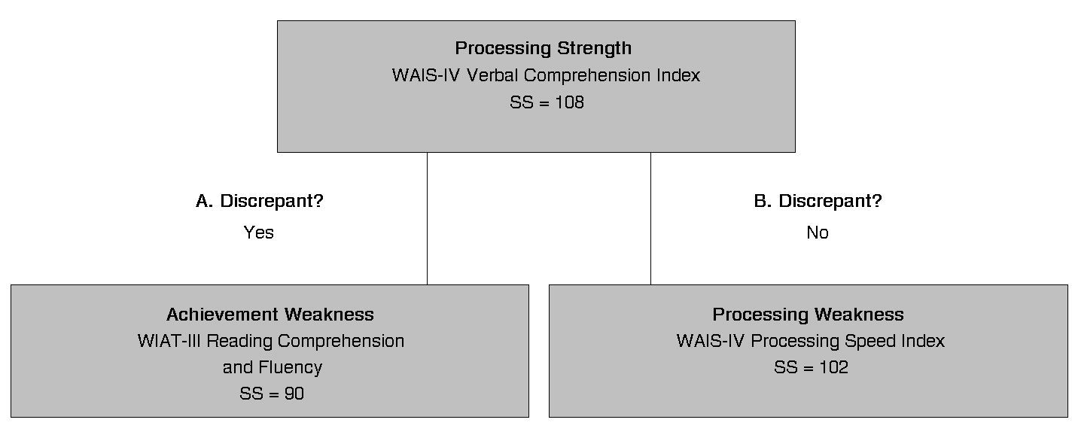**ABILITY-ACHIEVEMENT DISCREPANCY ANALYSIS**

Ability Score: WAIS-IV GAI: 110

Date of Testing: WAIS-IV 2018/05/25; WIAT-III 2018/05/25

|  |  |  |  |  |  |  |  |  |
| --- | --- | --- | --- | --- | --- | --- | --- | --- |
| **Predicted Difference Method** | | | |  | | | | |
|  | **Predicted**  **WIAT-III**  **Score** | **Actual WIAT-III Score** | **Difference** | | **Critical Value**  **.01** | **Significant**  **Difference**  **Y/N** | **Base**  **Rate** | **Standard Deviation Discrepancy > 1.5 SD** |
| **WIAT-III Subtest** |  |  |  | |  |  |  |  |
| Listening Comprehension | 107 | 110 | -3 | | 18.33 | N | N/A | N/A |
| Reading Comprehension | 107 | 98 | 9 | | 17.44 | N | >15% | N |
| Math Problem Solving | 106 | 99 | 7 | | 10.30 | N | >15% | N |
| Sentence Composition | 105 | 124 | -19 | | 14.30 | Y* | N/A | N/A |
| Word Reading | 106 | 114 | -8 | | 7.92 | Y* | N/A | N/A |
| Essay Composition | 104 | 103 | 1 | | 13.65 | N | >15% | N |
| Pseudoword Decoding | 104 | 100 | 4 | | 7.27 | N | >15% | N |
| Numerical Operations | 107 | 113 | -6 | | 8.88 | N | N/A | N/A |
| Oral Expression | 108 | 112 | -4 | | 14.90 | N | N/A | N/A |
| Oral Reading Fluency | 105 | 86 | 19 | | 10.05 | Y | <=10% | N |
| Oral Reading Accuracy | 102 | 88 | 14 | | 16.49 | N | >15% | N |
| Oral Reading Rate | 105 | 88 | 17 | | 9.28 | Y | <=10% | N |
| Spelling | 106 | 116 | -10 | | 8.60 | Y* | N/A | N/A |
| Math Fluency-Addition | 105 | 112 | -7 | | 14.37 | N | N/A | N/A |
| Math Fluency-Subtraction | 105 | 90 | 15 | | 13.84 | Y | <=15% | N |
| Math Fluency-Multiplication | 104 | 118 | -14 | | 13.17 | Y* | N/A | N/A |
| **WIAT-III Composite** |  |  |  | |  |  |  |  |
| Oral Language | 108 | 113 | -5 | | 13.36 | N | N/A | N/A |
| Total Reading | 107 | 97 | 10 | | 8.03 | Y | >15% | N |
| Basic Reading | 106 | 107 | -1 | | 6.60 | N | N/A | N/A |
| Reading Comprehension and Fluency | 106 | 90 | 16 | | 12.38 | Y | <=10% | N |
| Written Expression | 106 | 119 | -13 | | 9.54 | Y* | N/A | N/A |
| Mathematics | 106 | 107 | -1 | | 7.96 | N | N/A | N/A |
| Math Fluency | 105 | 107 | -2 | | 9.30 | N | N/A | N/A |
| Total Achievement | 108 | 108 | 0 | | 7.52 | N | N/A | N/A |
| ***Note.*** Base rates and standard deviation discrepancies are not reported when the actual achievement score equals or exceeds the predicted achievement score. | | | | | | | | |
| *Indicates that the actual achievement score exceeds the predicted achievement score. | | | | | | | | |

**WIAT-III SKILLS ANALYSIS REPORT**

|  |  |  |  |
| --- | --- | --- | --- |
| **Reading Comprehension** | | **Grades 9-12 Item Set** | |
| **Skill** | **Total Errors by Skill** | **Max. Errors by Skill** | **% Correct by Skill** |
| Literal | 1 | 11 | 91% |
| Inferential | 3 | 14 | 79% |

|  |  |  |  |  |  |
| --- | --- | --- | --- | --- | --- |
| **Math Problem Solving** | | | | | |
|  |  | **Total Errors** | **Max. Errors** | **%** | **Correct** |
| **Feature** | **Skill** | **by Skill** | **by Skill** | **By Skill** | **By Feature** |
| Basic Concepts | One-to-One Counting  Recognizing Shapes  Recognizing Numerals  Basic Concepts  Counting On  Naming Numerals (<11)  Comparing Numerals  Ordering Numerals  Addition and Subtraction of Objects | 0  0  0  0  0  0  0  0  0 | 5  2  2  5  1  3  3  3  3 | 100%  100%  100%  100%  100%  100%  100%  100%  100% | 100% |
| Everyday Applications | Interpreting Graphs  Measuring an Object  Interpreting a Number Line  Interpreting a Calendar  Completing Number Patterns  Money  Time  Identifying Place Value  Single-Operation Word Problems: General  Single-Operation Word Problems: Time  Mixed-Operations Word Problems: Money | 1  0  0  0  0  0  0  0  0  0  3 | 4  1  1  2  3  2  1  2  2  1  3 | 75%  100%  100%  100%  100%  100%  100%  100%  100%  100%  0% | 82% |
| Geometry | Interpreting Transformation of Figures  Finding Perimeter  Finding Angles and Sides/Distances  Finding Circumference  Geometry Word Problems | 1  0  0  -  1 | 2  1  1  -  1 | 50%  100%  100%  -  0% | 60% |
| Algebra | Making Fractions (Less Than Whole)  Ordering Fractions  Converting Fractions to Decimals  Fraction Word Problems  Algebra Word Problems  Solving Simultaneous Equations  Recognizing Prime Numbers  Solving Probability Problems  Solving Combination Problems  Mean, Median, Mode  Finding Slope and y-Intercept | 0  0  0  0  -  1  1  0  0  1  1 | 2  1  1  1  -  1  1  1  1  2  1 | 100%  100%  100%  100%  -  0%  0%  100%  100%  50%  0% | 67% |

|  |  |  |  |  |  |
| --- | --- | --- | --- | --- | --- |
| **Word Reading** | | | | | |
|  |  | **Total Errors** | **Max. Errors** | **%** | **Correct** |
| **Feature** | **Skill** | **by Skill** | **by Skill** | **By Skill** | **By Feature** |
| Morphology Types | Common Prefixes/ Word Beginnings  Common Suffixes/ Word Endings | 0  0 | 19  37 | 100%  100% | 100% |
| Vowel Types | VCE Syllables  Irregular Vowels  Single Short Vowels  Single Long Vowels  Schwa Vowel Sounds  Vowel Digraphs  Diphthongs  R-Controlled Vowels  Silent Vowels | 0  0  0  0  0  0  0  0  0 | 10  24  44  16  52  11  4  13  11 | 100%  100%  100%  100%  100%  100%  100%  100%  100% | 100% |
| Consonant Types | Consonant Digraphs  Single Consonants  Double Consonants  S as \z\ or \zh\  T as \sh\ or \ch\  C as \sh\  R-Family Blends  L-Family Blends  S-Family Blends  Consonant (Vowel) Blends/Clusters  Silent Consonants | 0  0  0  0  0  0  0  0  0  0  0 | 22  154  4  4  2  2  5  4  6  18  9 | 100%  100%  100%  100%  100%  100%  100%  100%  100%  100%  100% | 100% |
| Other | Insertions  Mis-Sequence of Sounds  Whole Word Error | 0  0  2 |  |  |  |

|  |  |  |  |  |  |
| --- | --- | --- | --- | --- | --- |
| **Numerical Operations** | | | | | |
|  |  | **Total Errors** | **Max. Errors** | **%** | **Correct** |
| **Feature** | **Skill** | **by Skill** | **by Skill** | **By Skill** | **By Feature** |
| Basic Concepts | One-to-One Counting  Numeral Formation  Discriminating Numbers From Letters  Number Formation and Order  Identifying Mathematical Symbols | 0  0  0  0  0 | 2  1  1  1  2 | 100%  100%  100%  100%  100% | 100% |
| Basic Math Operations | Addition With Single-Digit Numbers  Addition With Two-Digit Numbers  Addition With Three-Digit Numbers  Subtraction With Single-Digit Numbers  Subtraction With Two-Digit Numbers  Subtraction With Three-Digit Numbers  Multiplication With Single-Digit Numbers  Multiplication With Two-Digit Numbers  Multiplication With Three-Digit Numbers  Division  Long Division  Order of Operations  Calculating the Percent of an Integer  Adding Negative Integers | 0  0  0  0  0  0  0  1  0  0  3  0  1  0 | 8  1  1  2  2  2  4  1  1  1  4  2  1  1 | 100%  100%  100%  100%  100%  100%  100%  0%  100%  100%  25%  100%  0%  100% | 84% |
| Algebra | Addition of Fractions  Multiplication of Fractions  Division of Fractions  Simplifying Fractions  Solving Two-Step Equations  Solving Three-Step Equations  Solving Simplified Quad. Equations (Finding Roots)  Solving Simultaneous Equations  Finding Functions  Factoring  Simplifying Exponents and Radicals  Logarithms | 0  0  0  0  0  1  0  1  0  0  0  1 | 1  1  1  1  1  2  1  1  1  1  2  1 | 100%  100%  100%  100%  100%  50%  100%  0%  100%  100%  100%  0% | 79% |
| Geometry | Numerical Value of pi  Finding Area  Finding Sides of a Triangle | 0  1  1 | 1  1  2 | 100%  0%  50% | 50% |
| Advanced  Math | Trigonometry  Limits  Differentiation  Integration | 1  2  1  1 | 1  2  1  1 | 0%  0%  0%  0% | 45% |
| Other | Regrouping | 1 |  |  |  |

**WIAT-III INTERVENTION GOAL STATEMENTS REPORT**

**Reading Comprehension**

**Literal**

Items with Errors: 76

Annual Goal

- Given a/an (*circle*: expository, narrative) passage at a ____ reading level, the student will read the passage (*circle*: aloud, silently) and then answer ____ (*circle*: oral, written), (*circle*: open-ended, multiple-choice, true/false, yes/no) literal comprehension questions with ____ percent accuracy, looking back to the passage as needed to answer the questions.

Short-Term Objectives

- Given a/an (*circle*: expository, narrative) passage at a ____ reading level, the student will read the passage (*circle*: aloud, silently), listen to each of ____ oral, open-ended literal comprehension questions, and then point to/read the part of the passage that explicitly provides the answer to each question with ____ percent accuracy.

- Given a/an (*circle*: expository, narrative) passage at a ____ reading level, the student will read the passage (*circle*: aloud, silently) and then answer ____ (*circle*: oral, written), (*circle*: open-ended, multiple-choice, true/false, yes/no) literal comprehension questions about who, what, when, where, and why facts that were explicitly stated in the passage with ____ percent accuracy, looking back to the passage as needed to answer the questions.

- Given a/an (*circle*: expository, narrative) passage at a ____ reading level, the student will read the passage (*circle*: aloud, silently) and then answer ____ (*circle*: oral, written), (*circle*: open-ended, multiple-choice, true/false, yes/no) literal comprehension questions about the beliefs, thoughts, intentions, feelings, or emotions experienced by a specific character that were explicitly stated in the passage with ____ percent accuracy, looking back to the passage as needed to answer the questions.

- Given a/an (*circle*: expository, narrative) passage at a ____ reading level, the student will read the passage (*circle*: aloud, silently) and then sequence ____ events that were explicitly stated in the passage by ordering cards that show pictures/words that describe each event with no more than ____ errors, looking back to the passage as needed to answer the questions.

**Inferential**

Items with Errors: 63, 80, 82

Annual Goal

- Given a/an (*circle*: expository, narrative) passage at a ____ reading level, the student will read the passage (*circle*: aloud, silently) and then answer ____ (*circle*: oral, written), (*circle*: open-ended, multiple-choice, true/false, yes/no) inferential comprehension questions with ____ percent accuracy, looking back to the passage as needed to help answer the questions.

***Note:*** Teachers may encourage students to provide support/evidence for their answers by reading aloud parts of the text that provide the basis for their inferences. In some cases, students may tell about background information and personal experiences that led to an inference; students should be encouraged to apply such knowledge to the understanding of texts, but also to find text-based justification for their inferences.

Short-Term Objectives

- Given a/an (*circle*: expository, narrative) passage at a ____ reading level, the student will read the passage (*circle*: aloud, silently) and then answer ____ (*circle*: oral, written), (*circle*: open-ended, multiple-choice, true/false, yes/no) inferential comprehension questions about who, what, when, where, and why information that was not explicitly stated in the passage with ____ percent accuracy, looking back to the passage as needed to answer the questions.

- Given a/an (*circle*: expository, narrative) passage at a ____ reading level, the student will read the passage (*circle*: aloud, silently) and then answer ____ (*circle*: oral, written), (*circle*: open-ended, multiple-choice, true/false, yes/no) inferential comprehension questions about the beliefs, thoughts, intentions, feelings, or emotions experienced by a specific character and not explicitly stated in the passage with ____ percent accuracy, looking back to the passage as needed to help answer the questions.

- Given a/an (*circle*: expository, narrative) passage at a ____ reading level, the student will read the passage (*circle*: aloud, silently) and then sequence ____ events, some of which were not explicitly stated in the passage, by ordering cards that show pictures/words that describe each event with no more than ____ errors, looking back to the passage as needed to answer the questions.

- Given a/an (*circle*: expository, narrative) passage at a ____ reading level, the student will read the passage (*circle*: aloud, silently) and then answer ____ oral, open-ended inferential questions about predicting events and outcomes based upon what the text implies with ____ percent accuracy.

***Note:*** The student may also read a portion of a passage/chapter, predict events/outcomes, and then continue reading for confirmation.

- Given a/an (*circle*: expository, narrative) passage at a ____ reading level, the student will read the passage (*circle*: aloud, silently) and then identify (say/mark) whether a/an (*circle*: oral, written) statement is a main idea or a detail with no more than ____ errors, looking back to the passage as needed to answer the questions.

- Given a/an (*circle*: expository, narrative) passage at a ____ reading level, the student will read the passage (*circle*: aloud, silently) and then orally define ____ unfamiliar words, using context to help determine word meaning, with ____ percent accuracy.

**Math Problem Solving**

**Interpreting Graphs**

Items with Errors: 57

Annual Goal

- Given ___ mixed problems requiring the student to interpret data from a bar graph, a line graph, and a pie chart, the student will orally provide the answers with no more than ___ errors.

Short-Term Objectives

- Given ___ problems requiring the student to interpret and apply data from a pie chart involving (*circle*: whole numbers, percentages), the student will orally provide the answers with no more than ___ errors.

Example: Show a pie graph showing percentage of allowance spent last year in various categories ( $500 total: 20% on food, 30% on clothes, 40% on entertainment, 10% to savings). Ask the student what percentage of allowance was spent on food. Ask the student how much money was spent on food.

- Given ___ problems requiring the student to interpret and apply data from a line graph involving (*circle*: single-digit, two-digit, three-digit) numbers, the student will orally provide the answers with no more than ___ errors.

Example: Show a line graph of the number of students enrolled in a school over the last 5 years. Ask the student how many students were enrolled in 2014. Ask the student how many more students were enrolled in 2014 than 2012.

- Given ___ problems requiring the student to identify differences among data in a bar graph, the student will orally provide the answers with no more than ___ errors.

Example: Show a bar graph comparing the number of different animals at the zoo. Ask the student how many more lions there are than tigers.

- Given ___ problems requiring the student to interpret a bar graph involving (*circle*: single-digit, two-digit, three-digit) numbers, the student will orally provide the answers with no more than ___ errors.

Example: Show a bar graph comparing favorite fruits among students. Ask the student which is the most popular fruit.

- Given ___ problems with stacks of cubes to represent results from a survey, the student will point to the appropriate stacks that represent the most popular response with no more than ___ errors.

Example: Show 2 stacks of cubes that represent the results of a survey: the number of students in the class who have pets and do not have pets. Ask the student: Are there more students who have pets or don't have pets? (The correct answer is the stack with the greatest number of cubes.)

**Mixed-Operations Word Problems: Money**

Items with Errors: 55, 61, 64

Annual Goal

- Given ___ word problems involving money and mixed operations of (*circle two or more*: addition, subtraction, multiplication, division), the student will orally provide the solutions with no more than ___ errors.

Example: The recreational center charged 26 softball teams $15.50 to enter a tournament and $50 was given to the winning team. How much money did the recreational center make? (Student says: $353)

Short-Term Objective

- Given ___ word problems in which the student must compare price and weight of two products to determine the better purchase, the student will orally provide the answers with no more than ___ errors.

Example: Which is a better buy: a $3 box of granola bars that weighs 8 ounces or a $4.50 box of granola bars that weighs 14 ounces? (Student says: the $4.50 box.)

**Interpreting Transformation of Figures**

Items with Errors: 54

Annual Goal

- Given ___ problems requiring the student to identify a (*circle*: two-dimensional, three-dimensional) figure's image after a rotation of (*circle*: 90, 180, 270) degrees, the student will (*circle*: point to, circle) the answers with no more than ___ errors.

Short-Term Objective

- Given ___ problems requiring the student to physically rotate an object or figure (*circle*: 90, 180, 270) degrees, the student will rotate the object or figure with no more than ___ errors.

**Geometry Word Problems**

Items with Errors: 63

Annual Goal

- Given ___ word problems requiring the student to use geometry and mixed operations (*circle two or more*: addition, subtraction, multiplication, division), the student will write the solutions with no more than ___ errors.

Example: How many 2-inch by 1-inch pieces can be cut from a 10-inch by 5-inch board? (Student writes: 25.)

Short-Term Objective

- Given ___ word problems requiring the student to use geometry and a single operation (*circle*: addition, subtraction, multiplication, division), the student will write the solutions with no more than ___ errors.

Example: How many feet of fencing would be required to enclose a square yard that is 50 feet wide? (Student writes: 200.)

**Solving Simultaneous Equations**

Items with Errors: 59

Annual Goal

- Given ___ problems requiring the student to solve simultaneous equations, the student will write the solutions with no more than ___ errors.

Example: 2x - 3y = 1

x + 3y = 5

xy = ?

(Student writes: x = 2, y = 1, xy = 2.)

Short-Term Objectives

- Given ___ written problems requiring the student to solve simultaneous equations that do *not* include a pair of coefficients that cancel each other out, the student will apply the method of substitution (the student will solve one equation either x or y and then substitute the solution into the other equation) with no more than ___ errors.

Example: 2x + 3y = 8

x + 2y = 5

Student writes: x = 5 - 2y

2(5 - 2y) + 3y = 8

***Note:*** Solution of the final equation is not required for the purpose of meeting this goal.

- Given ___ written problems requiring the student to solve simultaneous equations that include a pair of coefficients that cancel each other out, the student will write the solutions with no more than ___ errors.

Example: 2x + y = 5

x - y = 10

Student writes: x = 5 y = -5

**Recognizing Prime Numbers**

Items with Errors: 60

Annual Goal

- Given ___ problems requiring the student to recall prime numbers, the student will (*circle*: write, say) the numbers with no more than ___ errors.

Example: What are the first 5 prime numbers? (Student writes/says: 2, 3, 5, 7, and 11.)

Short-Term Objective

- Given ___ problems requiring the student to recognize prime numbers out of a set of numerals, the student will circle the prime numbers with no more than ___ errors.

Example: Circle the prime numbers: 1, 2, 3, 4, 5, 6, 7, 8, 9, 10, 11. (Student circles: 2, 3, 5, 7, and 11.)

**Mean, Median, Mode**

Items with Errors: 65

Annual Goal

- Given ___ problems requiring the student to identify the mean, median, or mode of a data set and apply the answer to solve a problem, the student will (*circle*: write, say) the solutions with no more than ___ errors.

Example: A student has the following grades on tests: 87, 95, 76, and 88. The student wants an 85 or better average. What is the minimum grade the student must get on the last test in order to achieve that average? (Student writes/says: 79.)

Short-Term Objective

- Given ___ problems requiring the student to identify the mean, median and mode of a data set, the student will

(*circle*: write, say) the solutions with no more than ___ errors.

Example: 2, 3, 7, 1, 2, 8, 5 (Student writes/says: mean = 4, median = 3, mode = 2)

**Finding Slope and y-Intercept**

Items with Errors: 66

Annual Goal

- Given ___ written problems requiring the student to identify the slope and y-intercept of a line from its graph, the student will write the equations of each line with no more than ___ errors.

Short-Term Objective

- Given ___ written problems requiring the student to identify the slope and y-intercept of a line from its graph, the student will write the slopes and y-intercepts with no more than ___ errors.

**Sentence Composition**

**Semantics and Grammar**

Annual Goal

- When asked to write ____ sentences that each include a different target word, the student will write a complete sentence that uses the target word with no more than ____ errors in semantics, grammar, or syntax.

Target words will include (*circle*): nouns, verbs, adverbs, adjectives, pronouns, prepositions, articles, conjunctions

- When asked to combine (*circle*: two, three) written sentences into one complete sentence that means the same thing as the target sentences, the student will write a complete sentence that combines all essential information from the target sentences with no more than ____ errors in semantics, grammar, or syntax.

Example: My dog is friendly. My dog's name is Benji. My dog likes to run. (Student writes: Benji, my friendly dog, likes to run.)

Short-Term Objectives

- Given ____ carrier phrases, the student will write complete sentences that begin with each given carrier phrase with no more than ____ errors in semantics, grammar, or syntax.

Examples of carrier phrases: I have always...; I have never...; Today after school...; if I found a dog...

- Given ____ (*circle*: simple, compound, complex) sentences with a grammar/syntax error, the student will correct the grammar/syntax error with ____ percent accuracy.

Examples: I gave my dog their food; I have a brother who I love; That's where me and my mom like to go.

- Given ____ pictures (of social situations, landscapes, animals, etc.), the student will write a complete sentence about the picture with no more than ____ errors in semantics, grammar, or syntax.

- Given three written words, the student will write a complete sentence that uses the three words (in any order, adding as many words as needed, without changing the three target words) with no more than ____ errors in semantics, grammar, or syntax.

Example: cat small can (Student writes: I can see the small cat.)

**Mechanics**

Annual Goal

- When asked to write ____ sentences that each include a different target word, the student will write a complete sentence that uses the target word with no more than ____ errors in spelling, punctuation, or capitalization.

Target words will include (*circle*): nouns, verbs, adverbs, adjectives, pronouns, prepositions, articles, conjunctions

- When asked to combine (*circle*: two, three) written sentences into one complete sentence that means the same thing as the target sentences, the student will write a complete sentence that combines all essential information from the target sentences with no more than ____ errors in spelling, punctuation, or capitalization.

Example: My dog is friendly. My dog's name is Benji. My dog likes to run. (Student writes: Benji, my friendly dog, likes to run.)

Short-Term Objectives

- Given ____ (*circle*: simple, compound, complex) sentences with no capitalization or punctuation, the student will add correct capitalization and punctuation with ____ percent accuracy.

Examples: where are you going after school; i love to play soccer and i also like to play basketball; i saw my friend my sister and my brothers two friends.

- Given ____ pictures (of social situations, landscapes, animals, etc.), the student will write a complete sentence about each picture with no more than ____ errors in spelling, punctuation, and capitalization.

- Given three written words, the student will write a complete sentence that uses the three words (in any order, adding as many words as needed, without changing the three target words) with no more than ____ errors in spelling, punctuation, and capitalization.

Example: cat small can (Student writes: I can see the small cat.)

**Word Reading**

**Whole Word Error**

Items with Errors: 73, 75

Annual Goal

- Given a list of ____ (*circle/enter*: one, two, three, ____) -syllable words, the student will read the list aloud with no more than ___ whole word errors.

Short-Term Objectives

- Given a list of ____ visually similar words/nonwords that vary by only one (*circle*: morphology/vowel/consonant) feature at a time, the student will read the list aloud with no more than ____ errors.

List examples: spark, sperk, spork; spark, stark, start

***Note:*** To encourage reading with comprehension, the student may also be challenged to orally use each word in a sentence after reading each word aloud; if words and nonwords are formed, the teacher may ask, *Is this a word?* after the student reads each one.

- Given a target word and a list of ____ visually similar words/nonwords that vary slightly from the target word (with one or more instances of the target word appearing in the list), the student will read the target word aloud and then silently read/scan the list of words and circle all instances of the target word within the list with no more than ____ errors.

The target words will include (*circle*: one/two/three/four/five)-syllable words.

***Note:*** The student may also be challenged to decrease the time he/she takes to complete this task, as well as to improve his/her accuracy.

**Essay Composition**

**Productivity**

Annual Goal

- In response to a written (*circle*: expository, narrative) essay prompt that is read aloud to the student, the student will write an (*circle*: outline, essay) using at least ____ words.

Short-Term Objectives

- Given a written (*circle*: expository, narrative) essay prompt that is read aloud to the student, the student will say a list of ____ essential pieces of information that should be included in the essay.

- Given a written (*circle*: expository, narrative) essay prompt that is read aloud to the student and either an outline or a list of essential information to include in the essay, the student will write at least ____ words.

- In response to a written (*circle*: expository, narrative) essay prompt that is read aloud to the student, the student will speak his/her response into a tape recorder, say at least ____ words, and then write an (*circle*: outline, essay) with at least ____ words.

**Theme Development and Text Organization**

Annual Goal

- In response to a written (*circle*: expository, narrative) essay prompt that is read aloud to the student, the student will write a (*circle*: three, five) paragraph essay with no off-topic statements, including a thesis statement and introduction paragraph, one or more body paragraph(s) that include at least three complete thoughts/sentences that contribute to the body of the essay, and a conclusion paragraph that summarizes the information presented and re-states the thesis of the essay.

***Note:*** Disregard errors in grammar and mechanics for the purpose of meeting this goal.

Short-Term Objectives

- In response to a written (*circle*: expository, narrative) essay prompt that is read aloud to the student, the student will write an **outline**, or other graphic organizer, that summarizes the thesis, reasons, evidence/supporting details, and conclusion, and how the information will be organized within the essay.

***Note:*** Disregard errors in grammar and mechanics for the purpose of meeting this goal.

- Given a written (*circle*: expository, narrative) essay prompt and an outline that (*circle*: was, was not) written by the student, the student will write an **introduction paragraph** that includes a thesis statement and a summary of the reasons or events that will be presented.

***Note:*** If reading is an area of weakness, the teacher may read the prompt and outline to the student. Disregard errors in grammar and mechanics for the purpose of meeting this goal.

- Given a written (*circle*: expository, narrative) essay prompt and an outline and introduction that (*circle*: were, were not) written by the student, the student will write a **body paragraph** that includes at least three reasons/events that support the thesis of the essay, and includes an elaboration, or supporting detail, after each main reason/event.

***Note:*** If reading is an area of weakness, the teacher may read the prompt, outline, and introduction to the student. Disregard errors in grammar and mechanics for the purpose of meeting this goal.

- Given a written (*circle*: expository, narrative) essay prompt and an outline and introduction that (*circle*: were, were not) written by the student, the student will write a **body paragraph** that uses conjunctions and/or transition words before each of the three reasons/events provided that support the thesis of the essay, and includes an elaboration, or supporting detail, after each main reason/event.

***Note:*** If reading is an area of weakness, the teacher may read the prompt, outline, and introduction to the student. Disregard errors in grammar and mechanics for the purpose of meeting this goal.

- Given a written (*circle*: expository, narrative) essay prompt and an outline and introduction and body paragraphs that

(*circle*: were, were not) written by the student, the student will write a **conclusion paragraph** that summarizes the information presented and re-states the thesis of the essay.

***Note:*** If reading is an area of weakness, the teacher may read the prompt, outline, and introduction and body paragraphs to the student. Disregard errors in grammar and mechanics for the purpose of meeting this goal.

- Given a written (*circle*: expository, narrative) paragraph that (*circle*: was, was not) written by the student and includes informal language that resembles "talk written down," the student will revise, or re-write, the paragraph and replace each usage of informal language with more formal written language with no more than ____ informal phrases remaining.

Example: Revise "So that's why I love it. I mean, I play it like every day." to "These are three reasons that soccer is my favorite game, and why I enjoy playing it as often as I can."

**Grammar and Mechanics**

Annual Goal

- In response to a written (*circle*: expository, narrative) essay prompt that is read aloud to the student, the student will write, revise, and edit the essay with no more than ____ errors in grammar and no more than ____ errors in mechanics (spelling, capitalization, punctuation).

Short-Term Objectives

- Given a written (*circle*: expository, narrative), (*circle*: one, two, three, four, five) - paragraph essay/passage that

(*circle*: was, was not) written by the student and includes at least ____ grammar/syntax errors, the student will correct grammar and syntax errors in the essay/passage with ____ percent accuracy.

- Given a written (*circle*: expository, narrative), (*circle*: one, two, three, four, five) - paragraph essay/passage that

(*circle*: was, was not) written by the student and includes at least ____ mechanics (spelling, capitalization, punctuation) errors, the student will correct all mechanics errors in the essay/passage with ____ percent accuracy.

***Note:*** Use of a dictionary or similar resource may be permitted for correcting spelling errors.

- Given a written (*circle*: expository, narrative), (*circle*: one, two, three, four, five) - paragraph essay/passage that

(*circle*: was, was not) written by the student, the student will listen and follow along as the essay is read aloud, one sentence at a time, and identify (*circle*) grammar and syntax errors, including word omissions, incorrect/omitted word endings, awkward sentence structure, etc. with no more than ____ errors.

***Note:*** Students who demonstrate strong listening comprehension and oral expression (syntax) skills may benefit most from this activity.

- Given a written (*circle*: expository, narrative), (*circle*: one, two, three, four, five) - paragraph essay/passage that

(*circle*: was, was not) written by the student, the student will read the essay aloud and identify (*circle*) grammar and syntax errors, including word omissions, incorrect/omitted word endings, awkward sentence structure, etc. with no more than ____ errors.

***Note:*** Students who demonstrate strong reading and oral expression (syntax) skills may benefit most from this activity.

- Given a written (*circle*: expository, narrative), (*circle*: one, two, three, four, five) - paragraph essay/passage that

(*circle*: was, was not) written by the student, the student will read the essay aloud/silently and identify (circle) mechanics errors, including spelling, punctuation, and capitalization with no more than ____ errors.

**Numerical Operations**

**Multiplication With Two-Digit Numbers**

Items with Errors: 27

Annual Goal

- Given ____ written problems in which two two-digit numbers are multiplied (*circle*: with, without) regrouping/borrowing, the student will write the answers with no more than ____ errors.

Short-Term Objective

- Given ____ written problems (presented vertically) in which a two-digit number is multiplied with a single-digit number (*circle*: with, without) regrouping/borrowing, the student will write the answers with no more than ____ errors.

**Long Division**

Items with Errors: 31, 35, 39

Annual Goal

- Given ____written problems, presented in vertical/long division format, requiring division of a three-digit number by a two-digit number with no remainders in the quotient, the student will write the answers with no more than ____ errors.

Short-Term Objective

- Given ____ written problems, presented in vertical/long division format, requiring division of a three-digit number by a single-digit number with no remainders in the quotient, the student will write the answers with no more than ____ errors.

**Calculating the Percent of an Integer**

Items with Errors: 45

Annual Goal

- Given ___ written problems that require the student to calculate various percentages of an integer, including whole number percent, greater than 100 percent, and fractional/decimal percent, the student will write the solutions with no more than ___ errors.

Short-Term Objectives

- Given ___ written problems requiring the student to calculate the whole number percent (between 1% and 100%) of an integer, the student will write the solutions with no more than ___ errors.

Example: 75% of 120 (Student writes: 90)

- Given ___ written problems requiring the student to calculate the percent (greater than 100%) of an integer, the student will write the solutions with no more than ___ errors.

Example: 300% of 20 (Student writes: 60)

- Given ___ written problems requiring the student to calculate the fractional/decimal percent of an integer, the student will write the solutions with no more than ___ errors.

Example: 6.5% of 100 (Student writes: 6.5)

- Given ___ oral problems requiring students to calculate a common percent of an integer, the student will (orally) say the solutions with no more than ___ errors.

***Note:*** Common percentages may include: 10%, 25%, 33-1/3%, 50%, 75%, 100%, other: _____

Example: Teacher asks, "What is 25 percent of 200?" (Student says: 50)

**Solving Three-Step Equations**

Items with Errors: 40

Annual Goal

- Given ___ written problems requiring the student to solve a three-step equation, the student will write the solutions with no more than ___ errors.

Example: 5x - 2 = 3x + 4 (Student writes: 3)

Short-Term Objectives

- Given ____ written problems requiring the student to solve a three-step equation, the student will write the first two steps of the equations with no more than ____ errors.

Example: 5x - 2 = 3x + 4

Student writes: 5x = 3x + 4 + 2

5x = 3x + 6

5x - 3x = 3x + 6 - 3x

2x = 6

- Given ____ written problems requiring the student to solve a three-step equation, the student will write the first step of the equations with no more than ____ errors.

Example: 5x - 2 = 3x + 4

Student writes: 5x = 3x + 4 + 2

5x = 3x + 6

**Solving Simultaneous Equations**

Items with Errors: 48

Annual Goal

- Given ____ written problems requiring the student to solve simultaneous equations, the student will write the solutions with no more than ____ errors.

Example: 2x + 3y = 8

x + 2y = 5

Student writes: x = 1 y = 2

***Note:*** Students may be encouraged to apply the method of substitution when canceling out a pair of coefficients is not possible.

Short-Term Objectives

- Given ____ written problems requiring the student to solve simultaneous equations that do *not* include a pair of coefficients that cancel each other out, the student will apply the method of substitution (the student will solve one equation either x or y and then substitute the solution into the other equation) with no more than ____ errors.

Example: 2x + 3y = 8

x + 2y = 5

Student writes: x = 5 - 2y

2(5 - 2y) + 3y = 8

***Note:*** Solution of the final equation is not required for the purpose of meeting this goal.

- Given ___ written problems requiring the student to solve simultaneous equations that include a pair of coefficients that cancel each other out, the student will write the solutions with no more than ___ errors.

Example: 2x + y = 5

x - y = 10

Student writes: x = 5 y = -5

**Logarithms**

Items with Errors: 54

Annual Goal

- Given ____ written problems requiring the student to solve problems involving logarithms, the student will write the solution with no more than ____ errors.

Example: log5 x = 2 (Student writes: 25)

Short-Term Objective

- Given ____ written problems requiring the student to convert between exponents and logarithms, the student will write the solution with no more than ____ errors.

Example: log5 x = 2 (Student writes: x = 52)

**Finding Area**

Items with Errors: 47

Annual Goal

- Given ____ written problems requiring the student to find the area of a figure (*circle*: with, without) the use of a formula list, the student will write the solutions with no more than ____ errors.

Example: Find the area of the triangle: (Show a triangle with a base of 4 inches and an altitude of 6 inches.)

(Student writes: 12)

Short-Term Objective

- Given ____ regular figures, the student will orally say the formula for finding the area of the figure with no more than ____ errors.

Example: The student is shown a circle. (Student says: pi times radius squared)

**Finding Sides of a Triangle**

Items with Errors: 53

Annual Goal

- Given ____ written problems requiring the student to find the missing side(s) of a triangle using the Pythagorean Theorem, the student will write the solutions with no more than ____ errors.

Example: Find the length of the hypotenuse (show a right triangle with one leg marked 3 and the other leg marked 4). (Student writes: 5)

Short-Term Objective

- Given ____ written problems requiring the student to find the missing side(s) of a triangle using the Pythagorean Theorem, the student will orally say the equation used to find the solution with no more than ____ errors.

Example: Find the length of the hypotenuse (show a right triangle with one leg marked 3 and the other leg marked 4). (Student says: 3 squared plus 4 squared equals X squared)

**Trigonometry**

Items with Errors: 56

Annual Goal

- Given ____ written problems requiring the student to find the (*circle*: sine, cosine, tangent) of an angle in a right triangle, the student will write the solution with no more than ____ errors.

Example: Find sin A, cos A, tan A: (Show a triangle with legs AB = 6 and BC = 8 and a hypotenuse AC = 10.)

(Student writes: sin A = 8/10 = 4/5, cos A = 6/10 = 3/5, and tan A = 8/6 = 4/3)

Short-Term Objective

- Given ____ trigonometric functions, the student will orally say the ratio of the sides with no more than ____ errors.

Example: tan = opposite/adjacent, sin = opposite/hypotenuse, cos = adjacent/hypotenuse

**Limits**

Items with Errors: 58, 59

Annual Goal

- Given ____ written problems requiring the student to calculate the limit as x approaches (*circle*: 0, infinity), the student will write the solutions with no more than ____ errors.

Example: lim as x --> 0 of x2 + 3x + 4 (Student writes: 4)

Short-Term Objectives

- Given ____ written number sequences that (*circle*: converge to, approach) a (*circle*: right-hand, left-hand) limit, the student will write the limits that are expressed in each sequence with no more than ____ errors.

Example: 2.2, 2.1, 2.01, 2.001, 2.0001, 2.00001 (Student writes: x --> 2+)

**Differentiation**

Items with Errors: 60

Annual Goal

- Given ____ written problems requiring the student to calculate the derivative of a function, the student will write the solutions with no more than ____ errors.

Example: Differentiate: y = (4x - 1)2 (Student writes: y' = 8(4x - 1) = 32x - 8 )

Short-Term Objective

- The student will orally explain what a derivative is (and what it describes) in his/her own words with no errors.

Example: Student says: A derivative describes how a physical quantity changes relative to another variable at a given point.

**Integration**

Items with Errors: 61

Annual Goal

- Given ___ written problems requiring the student to calculate the (*circle*: definite, indefinite) integral of a function, the student will write the solutions with no more than ____ errors.

Example: Integrate: (from 1 to 2) 2x(x2 + 1)dx (Student writes: 10.5)

Short-Term Objective

- Given ____ written integration problems, the student will find the indefinite integrals with no more than ____ errors, evaluate the functions for the upper and lower limits with no more than ____ errors, and subtract the lower-limit result from the upper-limit result with no more than ____ errors.

**Regrouping**

Items with Errors: 27

Annual Goal

- Given ____ written (*circle*: two-digit, three-digit, four-digit), (*circle*: addition, subtraction, multiplication, division) problems, requiring the student to use regrouping to solve the problem, the student will write the solutions with no more than ____ errors.

Short-Term Objective

- Given ____ written (*circle*: addition, subtraction, multiplication, division) problems, requiring the student to use regrouping to solve the problem, the student will use base-ten blocks to solve the problems and (*circle*: write, say) the solutions with no more than ____ errors.

**Oral Reading Fluency**

**Fluency**

Annual Goal

- The student will read aloud a/an (*circle*: expository, narrative) passage at a ____ reading level at ____ correct words per minute with no more than ____ errors.

***Note:*** Published norms and school districts vary regarding the expected number of words that students in each grade should read correctly per minute. The following information is provided as a general guideline:

distr

1st grade: 60 correct words per minute

2nd grade: 90 correct words per minute

3rd grade: 114 correct words per minute

4th grade: 135 correct words per minute

5th grade: 150 correct words per minute

Short-Term Objectives

- Given ____ phrase cards (cards with short phrases printed on them) that the teacher holds and flips through as the student reads aloud, providing immediate feedback when a reading error occurs, the student will correctly read the phrase on each card aloud, and will reduce the time it takes to read the phrase cards correctly from ____ to ____ seconds.

Phrase examples: under the car; over the house; into the room; next to the dog; across the river

***Note:*** Phrases may begin with prepositional phrases and gradually expand to include participial, gerund, and infinitive phrases.

- The student will silently read ____ short declarative sentences containing true and false statements, and circle T or F to indicate true or false after each statement with no more than ____ errors and reduce the time it takes to complete the task from ____ to ____ seconds.

Sentence examples: A bird has wings. Snow is hot. Blue is a color. Ducks have four legs.

- Given a/an (*circle*: expository, narrative) passage at a ____ reading level, the student will read the passage aloud several times (repeated reading), receiving feedback from the teacher as needed to indicate when a reading error occurs, and will read at least ____ correct words per minute.

***Note:*** Feedback from the teacher to indicate when a reading error occurs may be verbal (e.g., "oops") or nonverbal (e.g., tap a pencil).

**End of Report**





WMS®-IV

Wechsler Memory Scale®-Fourth Edition

Score Report



|  |  |  |  |  |  |  |
| --- | --- | --- | --- | --- | --- | --- |
| Examinee Name | Rosa Sierra |  | Date of Report | 2018/08/03 | | |
| Examinee ID | 8206 |  | Years of Education | Not Specified | | |
| Date of Birth | 1973/07/09 |  | Home Language |  | | |
| Gender | Female |  | Handedness | Not Specified | | |
| Race/Ethnicity |  |  | Examiner Name | JOEY TRAMPUSH | | |
| Date of Testing | 2018/05/25 |  | Age at Testing | 44 years 10 months |  | Retest? No |

Comments:

**Index Score Profile**

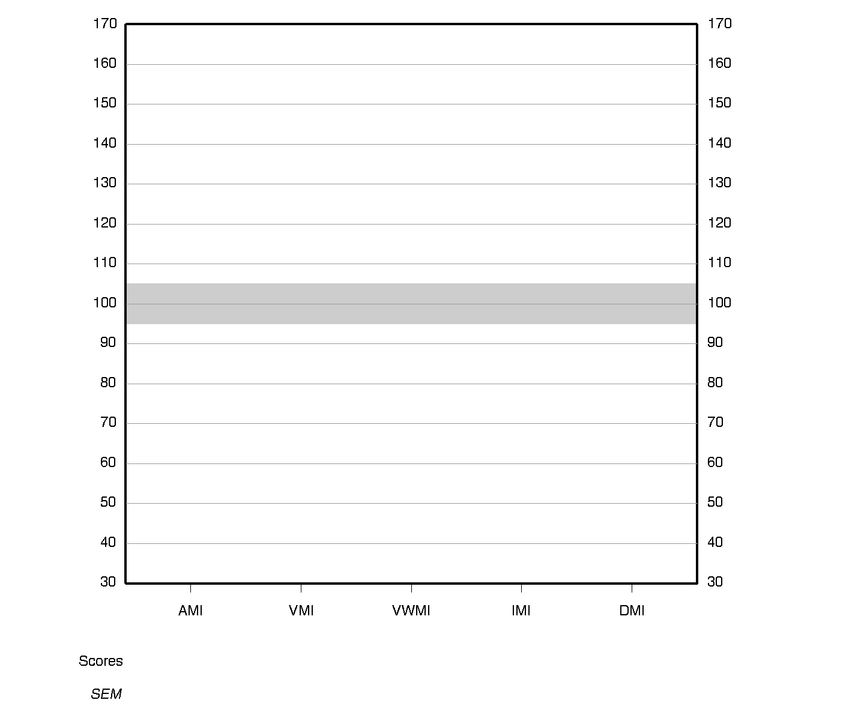

The vertical bars represent the standard error of measurement (*SEM*).

|  |  |  |  |  |
| --- | --- | --- | --- | --- |
| **Primary Subtest Scaled Score Summary** | | | | |
| **Subtest** | **Domain** | **Raw Score** | **Scaled Score** | **Percentile Rank** |
| Logical Memory I | AM | 22 | 9 | 37 |
| Logical Memory II | AM | 19 | 9 | 37 |
| Visual Reproduction I | VM | 36 | 10 | 50 |
| Visual Reproduction II | VM | 25 | 9 | 37 |
| Symbol Span | VWM | 21 | 8 | 25 |

**Primary Subtest Scaled Score Profile**

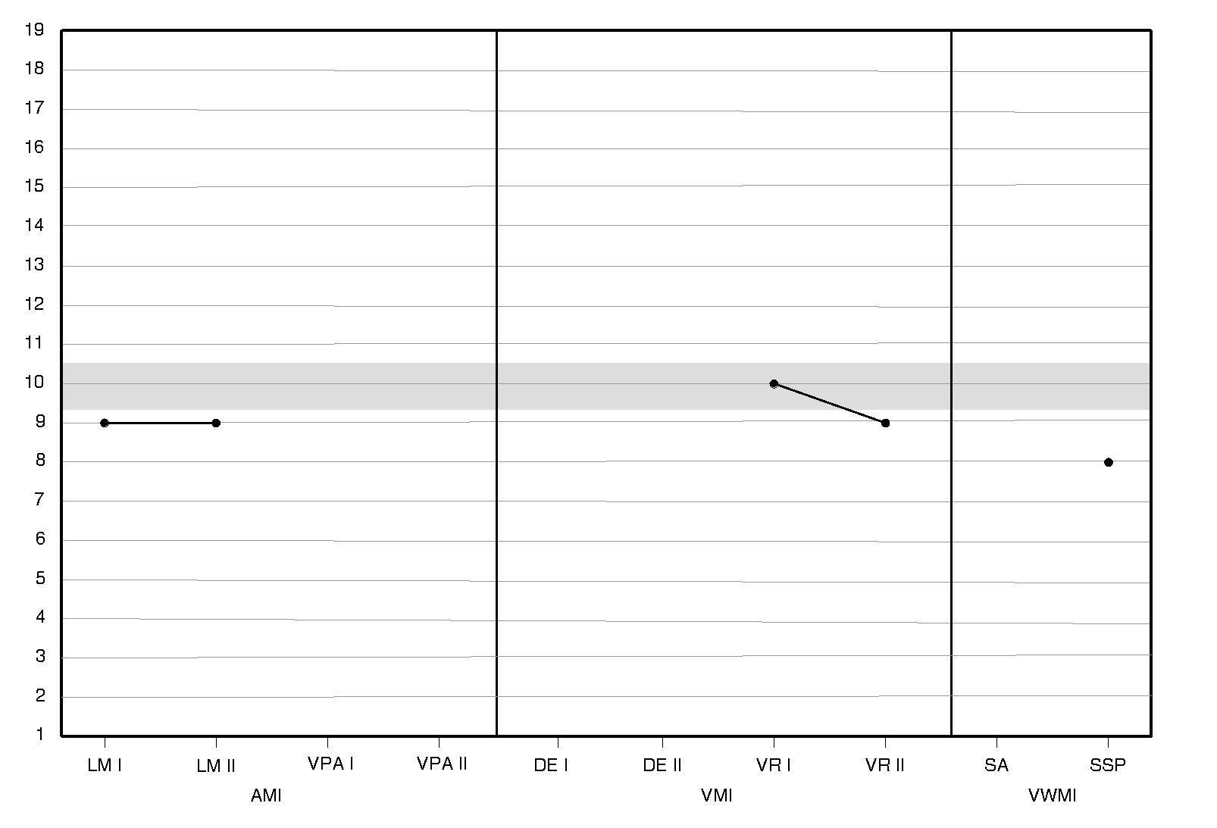

**PROCESS SCORE CONVERSIONS**

|  |  |  |  |  |
| --- | --- | --- | --- | --- |
| **Auditory Memory Process Score Summary** | | | | |
| **Process Score** | **Raw Score** | **Scaled Score** | **Percentile Rank** | **Cumulative Percentage**  **(Base Rate)** |
| LM II Recognition | 26 | - | - | 51-75% |

|  |  |  |  |  |
| --- | --- | --- | --- | --- |
| **Visual Memory Process Score Summary** | | | | |
| **Process Score** | **Raw Score** | **Scaled Score** | **Percentile Rank** | **Cumulative Percentage**  **(Base Rate)** |
| VR II Recognition | 7 | - | - | >75% |

**SUBTEST-LEVEL CONTRAST SCALED SCORES**

|  |  |  |  |
| --- | --- | --- | --- |
| **Logical Memory** | | | |
| **Score** | **Score 1** | **Score 2** | **Contrast Scaled Score** |
| LM II Recognition vs. Delayed Recall | 51-75% | 9 | 8 |
| LM Immediate Recall vs. Delayed Recall | 9 | 9 | 11 |

|  |  |  |  |
| --- | --- | --- | --- |
| **Visual Reproduction** | | | |
| **Score** | **Score 1** | **Score 2** | **Contrast Scaled Score** |
| VR II Recognition vs. Delayed Recall | >75% | 9 | 7 |
| VR Immediate Recall vs. Delayed Recall | 10 | 9 | 8 |

**RAW SCORES**

|  |  |  |  |
| --- | --- | --- | --- |
| **Subtest** | **Score Range**  **Adult** | **Score Range**  **Older Adult** | **Raw Score** |
| Brief Cognitive Status Exam | 0-58 | 0-58 |  |
| Logical Memory I | 0-50 | 0-53 | 22 |
| Logical Memory II | 0-50 | 0-39 | 19 |
| Verbal Paired Associates I | 0-56 | 0-40 |  |
| Verbal Paired Associates II | 0-14 | 0-10 |  |
| CVLT-II Trials 1-5 | 5-95 | 5-95 |  |
| CVLT-II Long-Delay | -5-5 | -5-5 |  |
| Designs I | 0-120 |  |  |
| Designs II | 0-120 |  |  |
| Visual Reproduction I | 0-43 | 0-43 | 36 |
| Visual Reproduction II | 0-43 | 0-43 | 25 |
| Spatial Addition | 0-24 |  |  |
| Symbol Span | 0-50 | 0-50 | 21 |
| **Process** | **Score Range**  **Adult** | **Score Range**  **Older Adult** | **Raw Score** |
| LM II Recognition | 0-30 | 0-23 | 26 |
| VPA II Recognition | 0-40 | 0-30 |  |
| VPA II Word Recall | 0-28 | 0-20 |  |
| DE I Content | 0-48 |  |  |
| DE I Spatial | 0-24 |  |  |
| DE II Content | 0-48 |  |  |
| DE II Spatial | 0-24 |  |  |
| DE II Recognition | 0-24 |  |  |
| VR II Recognition | 0-7 | 0-7 | 7 |
| VR II Copy | 0-43 | 0-43 |  |

**End of Report**







California Verbal Learning Test®, Third Edition (CVLT® 3)

CVLT 3 Standard Form

Expanded Report

*Dean C. Delis, Joel H. Kramer, Edith Kaplan and Beth A. Ober*

|  |
| --- |
|  |

|  |  |  |  |  |
| --- | --- | --- | --- | --- |
| **Examinee Information** | |  | **Test Information** | |
| ID: | 8206 |  | Test Date: | 05/25/2018 |
| Name: | Rosa Sierra |  | Examiner Name: | JOEY TRAMPUSH |
| Gender: | Female |  | | |
| Birth Date: | 07/09/1973 |  | | |
| Age at Testing: | 44 years 10 months |  | | |
| Years of Education: | 16 |  | | |
| Race/Ethnicity: |  |  | | |
| Handedness: |  |  | | |



Copyright © 2017 NCS Pearson, Inc. All rights reserved.

**Pearson**, **PSI** design, **PsychCorp**, **California Verbal Learning Test**, and **CVLT** are trademarks, in the US and/or other countries, of Pearson Education, Inc., or its affiliate(s).

This report contains copyrighted material and trade secrets. The qualified licensee may excerpt portions of this output report, limited to the minimum text necessary to accurately describe their significant core conclusions, for incorporation into a written evaluation of the examinee, in accordance with their profession’s citation standards, if any. No adaptations, translations, modifications, or special versions may be made of this report without prior written permission from Pearson.

v1.2



|  |
| --- |
| **Core Score Summary** |

**Immediate Recall**

|  |  |  |  |  |
| --- | --- | --- | --- | --- |
| |  |  |  |  | | --- | --- | --- | --- | | **Score** | **Raw score** | **Scaled score** | **Percentile rank** | |
| |  |  |  |  | | --- | --- | --- | --- | | Trial 1 Correct | 5 | 8 | 25 | |
| |  |  |  |  | | --- | --- | --- | --- | | Trial 2 Correct | 6 | 6 | 9 | |
| |  |  |  |  | | --- | --- | --- | --- | | Trial 3 Correct | 11 | 10 | 50 | |
| |  |  |  |  | | --- | --- | --- | --- | | Trial 4 Correct | 12 | 10 | 50 | |
| |  |  |  |  | | --- | --- | --- | --- | | Trial 5 Correct | 10 | 7 | 16 | |
| |  |  |  |  | | --- | --- | --- | --- | | List B Correct | 6 | 11 | 63 | |

**Delayed Recall**

|  |  |  |  |  |
| --- | --- | --- | --- | --- |
| |  |  |  |  | | --- | --- | --- | --- | | **Score** | **Raw score** | **Scaled score** | **Percentile rank** | |
| |  |  |  |  | | --- | --- | --- | --- | | Short Delay Free Recall Correct | 11 | 10 | 50 | |
| |  |  |  |  | | --- | --- | --- | --- | | Short Delay Cued Recall Correct | 12 | 10 | 50 | |
| |  |  |  |  | | --- | --- | --- | --- | | Long Delay Free Recall Correct | 10 | 9 | 37 | |
| |  |  |  |  | | --- | --- | --- | --- | | Long Delay Cued Recall Correct | 13 | 11 | 63 | |

**Yes/No Recognition**

|  |  |  |  |  |
| --- | --- | --- | --- | --- |
| |  |  |  |  | | --- | --- | --- | --- | | **Score** | **Raw score** | **Scaled score** | **Percentile rank** | |
| |  |  |  |  | | --- | --- | --- | --- | | Total Hits | 13 | 6 | 9 | |
| |  |  |  |  | | --- | --- | --- | --- | | Total False Positives | 0 | 13 | 84 | |
| |  |  |  |  | | --- | --- | --- | --- | | Recognition Discriminability (*d'*) | 3 | 9 | 37 | |
| |  |  |  |  | | --- | --- | --- | --- | | Recognition Discriminability Nonparametric | 94 | 9 | 37 | |

**Recall Errors**

|  |  |  |  |  |
| --- | --- | --- | --- | --- |
| |  |  |  |  | | --- | --- | --- | --- | | **Score** | **Raw score** | **Scaled score** | **Percentile rank** | |
| |  |  |  |  | | --- | --- | --- | --- | | Total Intrusions | 0 | 14 | 91 | |

**Forced Choice Recognition**

|  |  |  |  |
| --- | --- | --- | --- |
| |  |  |  | | --- | --- | --- | | **Score** | **Raw score** | **Base rate** | |
| |  |  |  | | --- | --- | --- | | Total Hits | 16.0 | 100.0 | |

**Scaled Score Profile**

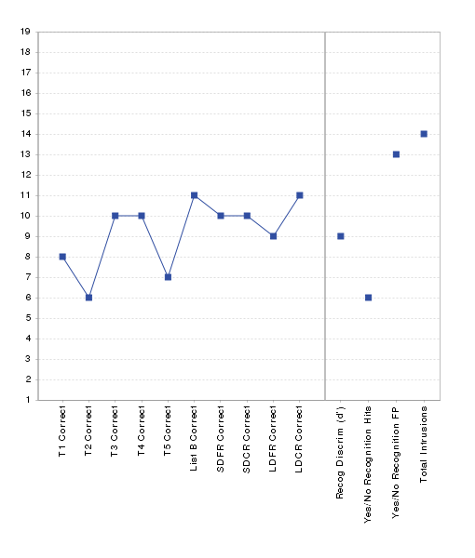

**Standard Score Summary**

|  |  |  |  |  |
| --- | --- | --- | --- | --- |
| |  |  |  |  | | --- | --- | --- | --- | | **Index** | **Sum of scaled scores** | **Index score** | **Percentile rank** | |
| |  |  |  |  | | --- | --- | --- | --- | | Trials 1–5 Correct | 41 | 90 | 25 | |
| |  |  |  |  | | --- | --- | --- | --- | | Delayed Recall Correct | 40 | 100 | 50 | |
| |  |  |  |  | | --- | --- | --- | --- | | Total Recall Correct | 92 | 95 | 37 | |

|  |
| --- |
| **Process Score Summary** |

**Immediate Recall**

|  |  |  |  |  |
| --- | --- | --- | --- | --- |
| |  |  |  |  | | --- | --- | --- | --- | | **Score** | **Raw score** | **Scaled score** | **Percentile rank** | |
| |  |  |  |  | | --- | --- | --- | --- | | Trial 5 Semantic Clustering (Chance Adjusted) | 3.2 | 11 | 63 | |
| |  |  |  |  | | --- | --- | --- | --- | | Trials 1–5 Semantic Clustering (Chance Adjusted) | 1.2 | 11 | 63 | |
| |  |  |  |  | | --- | --- | --- | --- | | Trials 1–5 Serial Clustering (Chance Adjusted) | 0.5 | 10 | 50 | |
| |  |  |  |  | | --- | --- | --- | --- | | Trials 1–5 % Recall Primacy | 34 | 12 | 75 | |
| |  |  |  |  | | --- | --- | --- | --- | | Trials 1–5 % Recall Middle | 43 | 9 | 37 | |
| |  |  |  |  | | --- | --- | --- | --- | | Trials 1–5 % Recall Recency | 23 | 8 | 25 | |
| |  |  |  |  | | --- | --- | --- | --- | | Trials 1–5 Recall Consistency | 65 | 5 | 5 | |
| |  |  |  |  | | --- | --- | --- | --- | | Trials 1–5 Learning Slope Analysis | 1.6 | 11 | 63 | |
| |  |  |  |  | | --- | --- | --- | --- | | Trials 1–2 Learning Slope Analysis | 1 | 7 | 16 | |
| |  |  |  |  | | --- | --- | --- | --- | | Trials 2–5 Learning Slope Analysis | 1.3 | 11 | 63 | |
| |  |  |  |  | | --- | --- | --- | --- | | Trials 1–5 Recall Discriminability | 2 | 9 | 37 | |

**Delayed Recall**

|  |  |  |  |  |
| --- | --- | --- | --- | --- |
| |  |  |  |  | | --- | --- | --- | --- | | **Score** | **Raw score** | **Scaled score** | **Percentile rank** | |
| |  |  |  |  | | --- | --- | --- | --- | | Short Delay Free Recall Semantic Clustering (Chance Adjusted) | 2 | 10 | 50 | |
| |  |  |  |  | | --- | --- | --- | --- | | Short Delay Free Recall Discriminability | 2.4 | 11 | 63 | |
| |  |  |  |  | | --- | --- | --- | --- | | Short Delay Cued Recall Discriminability | 2.6 | 11 | 63 | |
| |  |  |  |  | | --- | --- | --- | --- | | Long Delay Free Recall Semantic Clustering (Chance Adjusted) | 1.2 | 9 | 37 | |
| |  |  |  |  | | --- | --- | --- | --- | | Long Delay Free Recall Discriminability | 2.2 | 10 | 50 | |
| |  |  |  |  | | --- | --- | --- | --- | | Long Delay Cued Recall Discriminability | 2.8 | 11 | 63 | |
| |  |  |  |  | | --- | --- | --- | --- | | Cued Recall Discriminability | 2.7 | 11 | 63 | |
| |  |  |  |  | | --- | --- | --- | --- | | Delayed Recall Discriminability | 2.5 | 11 | 63 | |
| |  |  |  |  | | --- | --- | --- | --- | | Total Recall Discriminability | 2.2 | 10 | 50 | |

**Yes/No Recognition**

|  |  |  |  |  |  |
| --- | --- | --- | --- | --- | --- |
| |  |  |  |  | | --- | --- | --- | --- | | **Score** | **Raw score** | **Scaled score** | **Percentile rank** | | |
| |  |  |  |  | | --- | --- | --- | --- | | List A vs. List B Recognition Discriminability (*d'*) | 2.8 | 9 | 37 | | |
| |  |  |  |  | | --- | --- | --- | --- | | List A vs. Novel/Prototypical Recognition Discriminability (*d'*) | 2.8 | 10 | 50 | | |
| |  |  |  |  | | --- | --- | --- | --- | | List A vs. Novel/Unrelated Recognition Discriminability (*d'*) | 2.8 | 7 | 16 | | |
| |  |  |  |  | | --- | --- | --- | --- | | Response Bias | 0.6 | 16 | 98 | | |
| |  |  |  |  | | --- | --- | --- | --- | | Response Bias Nonparametric | -0.5 | 5 | 5 | | |
|  |
| |  |  |  | | --- | --- | --- | | **Score** | **Raw score** | **Base rate** | |
| |  |  |  | | --- | --- | --- | | Total List B False Positives | 0.0 | 100.0 | |
| |  |  |  | | --- | --- | --- | | List B/Shared False Positives | 0.0 | 100.0 | |
| |  |  |  | | --- | --- | --- | | List B/Nonshared False Positives | 0.0 | 100.0 | |
| |  |  |  | | --- | --- | --- | | Novel/Prototypical False Positives | 0.0 | 100.0 | |
| |  |  |  | | --- | --- | --- | | Novel/Unrelated False Positives | 0.0 | 100.0 | |

**Intrusion Errors**

|  |  |  |  |  |
| --- | --- | --- | --- | --- |
| |  |  |  |  | | --- | --- | --- | --- | | **Score** | **Raw score** | **Scaled score** | **Percentile rank** | |
| |  |  |  |  | | --- | --- | --- | --- | | Trials 1–5 | 0 | 13 | 84 | |
| |  |  |  |  | | --- | --- | --- | --- | | Free Recall | 0 | 13 | 84 | |
| |  |  |  |  | | --- | --- | --- | --- | | Cued Recall | 0 | 13 | 84 | |
| |  |  |  |  | | --- | --- | --- | --- | | Delayed Recall | 0 | 13 | 84 | |

**Repetition Errors**

|  |  |  |  |  |  |
| --- | --- | --- | --- | --- | --- |
| |  |  |  |  | | --- | --- | --- | --- | | **Score** | **Raw score** | **Scaled score** | **Percentile rank** | | |
| |  |  |  |  | | --- | --- | --- | --- | | Total Repetitions | 1 | 14 | 91 | | |
| |  |  |  |  | | --- | --- | --- | --- | | Total Target Repetitions | 1 | 14 | 91 | | |
|  |
| |  |  |  | | --- | --- | --- | | **Score** | **Raw score** | **Base rate** | |
| |  |  |  | | --- | --- | --- | | Total Correct/Total Correct + Intrusions Ratio | 1.0 | 100.0 | |
| |  |  |  | | --- | --- | --- | | Total Correct/Total Correct + Total Target Repetitions Ratio | 1.0 | 100.0 | |

*Note.* Ratio scores are not calculated if no intrusions or within trial repetitions were made by the examinee. Use caution when interpreting ratio scores calculated with low numbers of intrusions or within trial repetitions. See the CVLT 3 Manual for guidance on interpreting ratio scores.

**Other Errors**

|  |  |  |  |
| --- | --- | --- | --- |
| |  |  |  | | --- | --- | --- | | **Score** | **Raw score** | **Base rate** | |
| |  |  |  | | --- | --- | --- | | Cued Recall Target Category Errors | 0.0 | 100.0 | |

**Standard Score**

|  |  |  |  |  |
| --- | --- | --- | --- | --- |
| |  |  |  |  | | --- | --- | --- | --- | | **Score** | **Sum of raw scores** | **Standard score** | **Percentile rank** | |
| |  |  |  |  | | --- | --- | --- | --- | | Total Recall Responses | 97 | 89 | 23 | |

**Contrast Scores**

|  |  |  |  |  |
| --- | --- | --- | --- | --- |
| |  |  |  |  | | --- | --- | --- | --- | | **Score** | **Score 1** | **Score 2** | **Contrast scaled score** | |
| |  |  |  |  | | --- | --- | --- | --- | | List B Correct vs. Trial 1 Correct | 11 | 8 | 12 | |
| |  |  |  |  | | --- | --- | --- | --- | | Short Delay Free Recall Correct vs. Trial 5 Correct | 10 | 7 | 15 | |
| |  |  |  |  | | --- | --- | --- | --- | | Long Delay Free Recall Correct vs. Trial 5 Correct | 9 | 7 | 14 | |
| |  |  |  |  | | --- | --- | --- | --- | | Long Delay Free Recall Correct vs. Short Delay Free Recall Correct | 9 | 10 | 8 | |
| |  |  |  |  | | --- | --- | --- | --- | | Long Delay Free Recall Correct vs. Recognition Discriminability (*d'*) | 9 | 9 | 10 | |
| |  |  |  |  | | --- | --- | --- | --- | | Long Delay Free Recall Discriminability vs. Recognition Discriminability (*d'*) | 10 | 9 | 11 | |

**Forced Choice Recognition**

|  |  |  |  |
| --- | --- | --- | --- |
| |  |  |  | | --- | --- | --- | | **Score** | **Raw score** | **Base rate** | |
| |  |  |  | | --- | --- | --- | | Number of Target Words Recalled on Immediate/Delay  but Missed on Forced Choice Recognition | 0.0 | 100.0 | |
| |  |  |  | | --- | --- | --- | | Number of Hits on Yes/No Recognition but Missed on  Forced Choice Recognition | 0.0 | 100.0 | |

**Intrusion Frequency**

|  |  |  |  |
| --- | --- | --- | --- |
| |  |  |  | | --- | --- | --- | | **Type** | **Raw score** | **Base rate** | |
| |  |  |  | | --- | --- | --- | | Noncategory | 0.0 | 100.0 | |
| |  |  |  | | --- | --- | --- | | Across-List | 0.0 | 100.0 | |
| |  |  |  | | --- | --- | --- | | Synonym/Subordinate | 0.0 | 100.0 | |

|  |
| --- |
| **Demographically Adjusted Core Scores Summary** |

**Immediate Recall**

|  |  |  |  |
| --- | --- | --- | --- |
| |  |  |  | | --- | --- | --- | | **Score** | **Scaled score** | **Demographically adjusted score** | |
| |  |  |  | | --- | --- | --- | | Trial 1 Correct | 8 | 37 | |
| |  |  |  | | --- | --- | --- | | Trial 2 Correct | 6 | 30 | |
| |  |  |  | | --- | --- | --- | | Trial 3 Correct | 10 | 43 | |
| |  |  |  | | --- | --- | --- | | Trial 4 Correct | 10 | 45 | |
| |  |  |  | | --- | --- | --- | | Trial 5 Correct | 7 | 34 | |
| |  |  |  | | --- | --- | --- | | List B Correct | 11 | 50 | |

**Delayed Recall**

|  |  |  |  |
| --- | --- | --- | --- |
| |  |  |  | | --- | --- | --- | | **Score** | **Scaled score** | **Demographically adjusted score** | |
| |  |  |  | | --- | --- | --- | | Short Delay Free Recall Correct | 10 | 45 | |
| |  |  |  | | --- | --- | --- | | Short Delay Cued Recall Correct | 10 | 45 | |
| |  |  |  | | --- | --- | --- | | Long Delay Free Recall Correct | 9 | 42 | |
| |  |  |  | | --- | --- | --- | | Long Delay Cued Recall Correct | 11 | 48 | |

**Yes/No Recognition**

|  |  |  |  |
| --- | --- | --- | --- |
| |  |  |  | | --- | --- | --- | | **Score** | **Scaled score** | **Demographically adjusted score** | |
| |  |  |  | | --- | --- | --- | | Total Hits | 6 | 30 | |
| |  |  |  | | --- | --- | --- | | Total False Positives | 13 | 55 | |
| |  |  |  | | --- | --- | --- | | Recognition Discriminability (*d'*) | 9 | 42 | |

**Recall Errors**

|  |  |  |  |
| --- | --- | --- | --- |
| |  |  |  | | --- | --- | --- | | **Score** | **Scaled score** | **Demographically adjusted score** | |
| |  |  |  | | --- | --- | --- | | Total Intrusions | 14 | 59 | |

**Standard Score**

|  |  |  |  |
| --- | --- | --- | --- |
| |  |  |  | | --- | --- | --- | | **Score** | **Standard score** | **Demographically adjusted score** | |
| |  |  |  | | --- | --- | --- | | Total Recall Responses | 89 | 37 | |

**Demographically Adjusted Standard Score Summary**

|  |  |  |  |
| --- | --- | --- | --- |
| |  |  |  | | --- | --- | --- | | **Index** | **Index score** | **Demographically adjusted score** | |
| |  |  |  | | --- | --- | --- | | Trials 1–5 Correct | 90 | 36 | |
| |  |  |  | | --- | --- | --- | | Delayed Recall Correct | 100 | 44 | |
| |  |  |  | | --- | --- | --- | | Total Recall Correct | 95 | 39 | |

**End of Report**