Schizophrenia RT
Jane Doe^{1,2,✉}, John Q. Doe¹, Peder Ås¹, Juan Pérez³, and Max Mustermann
December 17, 2022
Text of abstract
¹ Formatting Open Science Group
² Federation of Planets
³ Acme Corporation
✉ Correspondence: Jane Doe <janedoe@fosg.org>
Keywords: keyword 1; keyword 2; keyword 3
Highlights: These are the highlights.

Introduction
Here is a citation (Marwick, 2017)

Background

Methods

Results
# Note the path that we need to use to access our data files when rendering this document
library(languageserver)
library(httpgd)
my_data <- read.csv(here::here('analysis/data/raw_data/my_csv_file.csv'))
plot(rnorm(10))
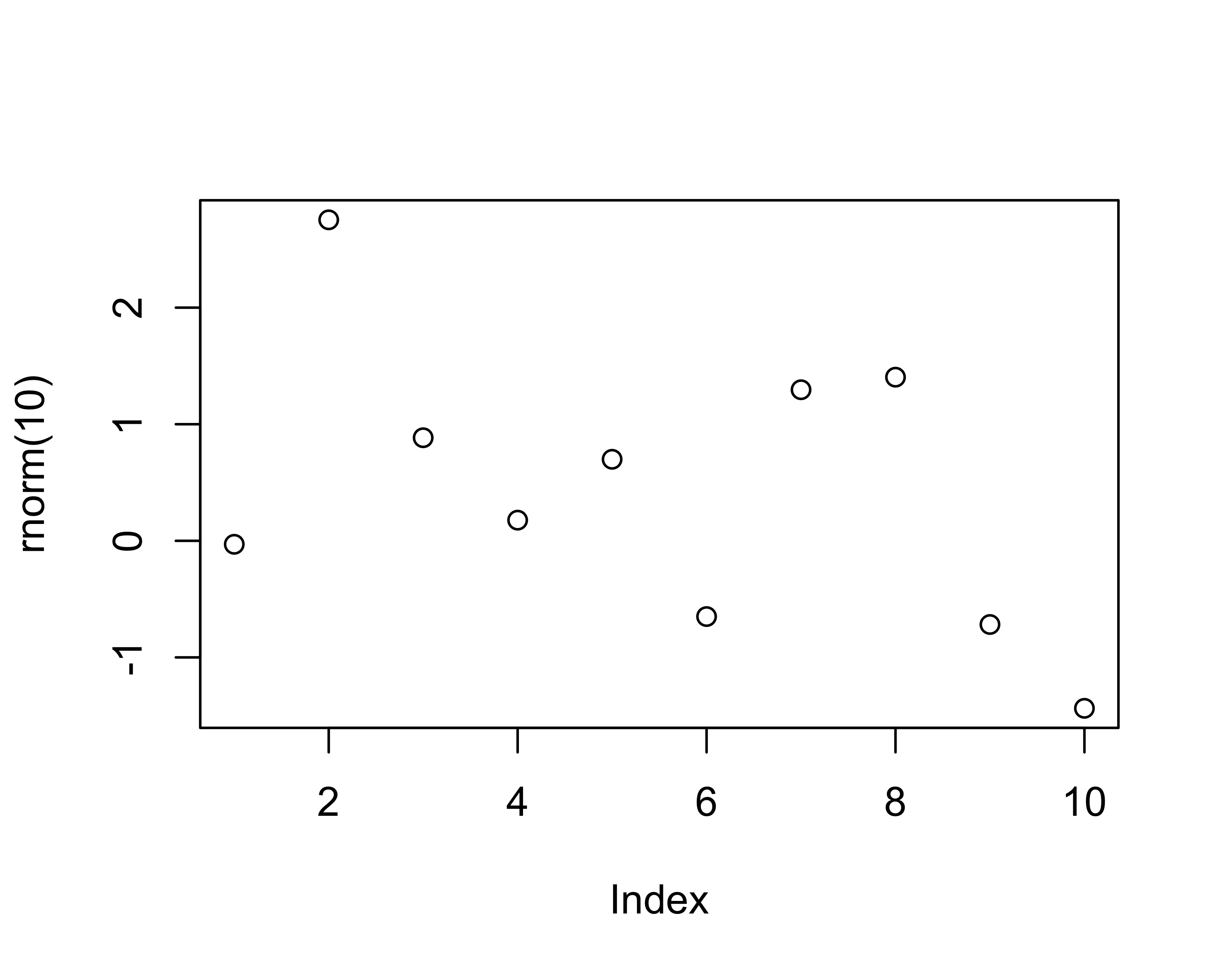
Figure 1: A plot of random numbers
Figure Figure 1 shows how we can have a caption and cross-reference for a plot. Note that figure label and cross-references must both be prefixed with fig-
Here is an example of inline code 3.14 in the middle of a sentence.

Discussion

Conclusion

Acknowledgements

References
Marwick, B., 2017. Computational reproducibility in archaeological research: Basic principles and a case study of their implementation. Journal of Archaeological Method and Theory 24, 424–450. https://doi.org/10.1007/s10816-015-9272-9

Colophon
This report was generated on 2022-12-17 17:19:17 using the following computational environment and dependencies:
# which R packages and versions?
if ("devtools" %in% installed.packages()) devtools::session_info()
─ Session info ───────────────────────────────────────────────────────────────
setting value
version R version 4.2.2 Patched (2022-12-14 r83470)
os macOS Big Sur ... 10.16
system x86_64, darwin17.0
ui X11
language (EN)
collate en_US.UTF-8
ctype en_US.UTF-8
tz America/Los_Angeles
date 2022-12-17
pandoc 2.19.2 @ /usr/local/bin/ (via rmarkdown)
─ Packages ───────────────────────────────────────────────────────────────────
package * version date (UTC) lib source
askpass 1.1 2019-01-13 [1] CRAN (R 4.2.0)
cachem 1.0.6.9000 2022-06-03 [1] https://r~
callr 3.7.3.9000 2022-11-03 [1] https://r-lib.r-universe.dev (R 4.2.2)
cli 3.4.1.9000 2022-11-09 [1] https://r-lib.r-universe.dev (R 4.2.2)
crayon 1.5.2 2022-09-29 [1] CRAN (R 4.2.0)
credentials 2.0.0 2022-09-22 [1] https://ropensci.r-universe.dev (R 4.2.1)
devtools 2.4.5.9000 2022-10-11 [1] https://r-lib.r-universe.dev (R 4.2.1)
digest 0.6.31 2022-12-11 [1] CRAN (R 4.2.0)
ellipsis 0.3.2.9000 2022-06-23 [1] https://r-lib.r-universe.dev (R 4.2.0)
evaluate 0.19.1 2022-12-14 [1] https://r-lib.r-universe.dev (R 4.2.2)
fastmap 1.1.0.9000 2022-05-15 [1] https://r~
fs 1.5.2.9000 2022-05-26 [1] https://r-lib.r-universe.dev (R 4.2.0)
glue 1.6.2.9000 2022-11-21 [1] Github (tidyverse/glue@5a16502)
htmltools 0.5.4.9000 2022-12-07 [1] https://rstudio.r-universe.dev (R 4.2.2)
htmlwidgets 1.6.0 2022-12-15 [1] CRAN (R 4.2.0)
httpuv 1.6.7.9000 2022-12-15 [1] https://rstudio.r-universe.dev (R 4.2.2)
jsonlite 1.8.4 2022-12-06 [1] CRAN (R 4.2.0)
knitr 1.41.2 2022-12-13 [1] https://yihui.r-universe.dev (R 4.2.2)
later 1.3.0.9000 2022-05-15 [1] https://r~
lifecycle 1.0.3.9000 2022-10-07 [1] https://r-lib.r-universe.dev (R 4.2.1)
magrittr 2.0.3.9000 2022-05-29 [1] https://tidyverse.r-universe.dev (R 4.2.0)
memoise 2.0.1.9000 2022-05-28 [1] https://r~
mime 0.12.1 2022-06-25 [1] https://yihui.r-universe.dev (R 4.2.1)
miniUI 0.1.1.1 2018-05-18 [1] CRAN (R 4.2.0)
openssl 2.0.5 2022-12-06 [1] CRAN (R 4.2.0)
pkgbuild 1.4.0.9000 2022-11-27 [1] https://r-lib.r-universe.dev (R 4.2.2)
pkgload 1.3.2.9000 2022-11-16 [1] https://r-lib.r-universe.dev (R 4.2.2)
prettyunits 1.1.1.9000 2022-05-10 [1] https://r~
processx 3.8.0.9000 2022-10-26 [1] https://r-lib.r-universe.dev (R 4.2.1)
profvis 0.3.7.9000 2022-04-27 [1] https://rstudio.r-universe.dev (R 4.2.0)
promises 1.2.0.9000 2022-04-28 [1] https://rstudio.r-universe.dev (R 4.2.0)
ps 1.7.2.9000 2022-10-27 [1] https://r-lib.r-universe.dev (R 4.2.1)
purrr 0.9000.0.9000 2022-09-14 [1] https://tidyverse.r-universe.dev (R 4.2.1)
R6 2.5.1.9000 2022-11-27 [1] https://r-lib.r-universe.dev (R 4.2.2)
Rcpp 1.0.9 2022-07-08 [1] CRAN (R 4.2.0)
remotes 2.4.2 2021-11-30 [1] CRAN (R 4.2.0)
rlang 1.0.6.9000 2022-10-05 [1] https://r-lib.r-universe.dev (R 4.2.1)
rmarkdown 2.19.1 2022-12-18 [1] Github (rstudio/rmarkdown@c5cf103)
sessioninfo 1.2.2.9000 2022-05-14 [1] https://r~
shiny 1.7.4.9000 2022-12-16 [1] https://rstudio.r-universe.dev (R 4.2.2)
stringi 1.7.8 2022-07-11 [1] CRAN (R 4.2.0)
stringr 1.5.0.9000 2022-12-07 [1] https://tidyverse.r-universe.dev (R 4.2.2)
sys 3.4.1 2022-10-18 [1] CRAN (R 4.2.0)
urlchecker 1.0.1.9000 2022-05-14 [1] https://r~
usethis 2.1.6.9000 2022-12-13 [1] Github (r-lib/usethis@a98a0e6)
vctrs 0.5.1.9000 2022-12-18 [1] Github (r-lib/vctrs@2d7de76)
xfun 0.35.1 2022-11-16 [1] https://yihui.r-universe.dev (R 4.2.2)
xtable 1.8-6 2022-04-14 [1] https://r-forge.r-universe.dev (R 4.2.0)
yaml 2.3.6 2022-10-18 [1] CRAN (R 4.2.0)
[1] /Users/joey/.Rlibrary
[2] /Library/Frameworks/R.framework/Versions/4.2/Resources/library
──────────────────────────────────────────────────────────────────────────────
The current Git commit details are:
# what commit is this file at?
if ("git2r" %in% installed.packages() & git2r::in_repository(path = ".")) git2r::repository(here::here())
Local: main /Users/joey/dev/pj.rrtools
Remote: main @ origin (https://github.com/brainworkup/pj.rrtools.git)
Head: [28b3aff] 2022-12-18: NOT (dropbox) allowing to work

