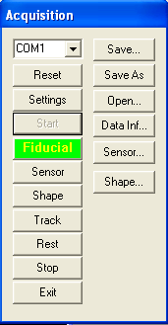
Digital Tracking Acquisition Window

COM1: The first combox is provided for selecting the port to be connected. All the available ports are listed here, user can selected the right port corresponding to the hardware to conduct digital tracking.

Reset: It allow user to reset the hardware port. Please note that not all hardware allows for port reset.

Setting: It provides a user interface for setting and testing serial port. This function is designed for professional users, like computer experts.

Start: It opens the port for acquiring data.

Fiducial: It is dynamically reading the port and defining the fiducial points: Left, Right, Front, Top, Back and Bottom: This button is dynamically changing for guiding user(s) to define the co-ordinates. It will automatically change color to show the expected points. Professional version provides sound prompt.

Sensor: It allows users to define the positions of sensors such as electrodes or MEG sensors.

Shape: If it becomes red, it indicates that the current model is digitalizing shape, such as head shape.

Track: If it becomes red, it indicates that the current model is tracking the digitizing point, such as the stylus. Depending on the settings of the display, a pointer or an arrow will be displayed for showing the current position in bother 2D and 3D view.

Rest: It will keep reading the port, however, the data will not be processed and displayed. This allows user to work on other stuff while the digitizing system is standby.

Stop: It will stop reading and close the port. User needs to start again to conduct digitalizing.

Exit: It will hide the dialog. If use did not stop reading, a warning window will be displayed. User can continue digitalization while hide the window.

Save: It will save the current configuration of data acquisition and allow for later use .

Save As: It will save the current configuration of data acquisition as a new file for later use.

Open: It will open the configuration of data acquisition saved for the current digitalizing.

Data Info: It will show the data information for troubleshooting. It is designed for power users.

Sensor: It will show the all sensor data for user to edit data. It works both real time and off-line.

Shape: It will show the all shape data for user to edit data. It works both real time and off-line.

