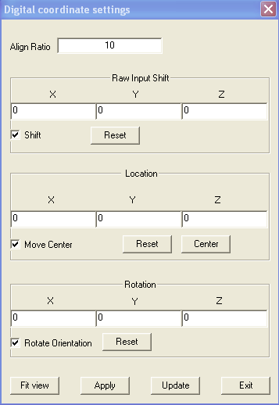
Digital Tracking Coordinate Window

The coordinate function is used for changing the location and orientation of the digitalized data. It is different from the Transform, which changes the orientation of axes.

Align Ratio: The Align Ratio allows you to change the ratio between the software and hardware, such as from cm to mm in real time. This ratio is also used for aligning the digitalized data with other data, such MRI. This function is necessary because the two datasets may use different unit system or one dataset has system error.

Raw Input Shift: In real time tracking, at least two sensors are used. One of the two will monitor the motion of the measured object. To correct the relative position or allow real time adjust, the Raw Input Shift is used to correct the raw input. You can uncheck the Shift to disable the function. The Reset function will reset the center to zero.

Location: The X, Y and Z parameter represent the center location of the digitalized data in the 3D coordinate. You can uncheck the Move Center to disable the function. The Reset button will reset the moving to zero.

Rotation: The X, Y and Z parameter indicates the orientation of the digitalized data. The rotation parameters are keeping tracking the orientation. You can uncheck the Rotate Orientation to disable this function. The Reset function will reset rotation to zero.

Fit View: This function fit the whole data into the view. The fit view button will fit all data into one window and the align ratio allows for adjusting perfect match.

Apply: It applies all the changes to the dataset.

Update: It gets the updated information from the dataset to this window

Exit: It exits this window.

