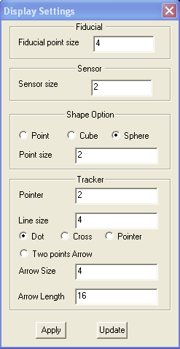
Digital Tracking Display Settings

This window allows user to design how the data will be displayed in 2D and 3D viewers.

Fiducial Point Size: it allows user to decide the size of the fiducial points in 2D and 3D viewers.

Sensor Point Size: it allows user to decide the size of the sensor points in 2D and 3D viewers.

Shape Option: it allows user to decide how the shape will be displayed.

Tracker: This group of functions decides how the tracker will be displayed. Tracker can be display as one point: either a dot, cross or a pointer. This one point indicates the last position of the digitizer, such as stylus. In addition, the tracker can be displayed as an Arrow, which is depended on two points. As a rule, the arrow points from the first point to the second point (the last position of the digitizer is the second point).

Apply: it applies the settings to the 2D and 3D viewers.

Update: it update the settings changed by other modules.

