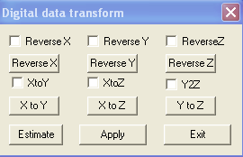
Digital Tracking Transform Window

This window allows you change the co-ordinate of the digitalized system. You can reverse and exchange X, Y and Z coordinates by clicking the corresponding buttons. Basically, it changes the orientation of the digitalized data.

ReverseX: The check box will let the digital system to reverse the data in X-axis for all data. The button will change prompt and temporally.

ReverseY: The check box will let the digital system to reverse the data in Y-axis for all data. The button will change prompt and temporally.

ReverseZ: The check box will let the digital system to reverse the data in Z-axis for all data. The button will change prompt and temporally.

XtoY: The check box will let the digital system to exchange X value to Y valued for all data. The button will change prompt and temporally.

XtoZ: The check box will let the digital system to exchange X value to Z valued for all data. The button will change prompt and temporally.

YtoZ: The check box will let the digital system to exchange Y value to Z valued for all data. The button will change prompt and temporally.

Estimate: This function will estimate the data and decide how to exchange the data if it can do it, otherwise, it will not change the coordinates system.

Apply: This function will apply all the settings to the digitalization system.

Exit: This function will hide the window.

